Postirradiation characterization of AFC metallic fuel alloys concepts

LUCA CAPRIOTTI
Idaho National Laboratory
PO Box 1625, Idaho Falls, ID, USA 83415
Email: luca.capriotti@inl.gov

JASON M. HARP
Oak Ridge National Laboratory
1 Bethel Valley Road, Oak Ridge, TN, USA

Abstract

A long-term objective of the Advanced Fuels Campaign (AFC) is to investigate technologies that allow for improving nuclear fuel performance and for the transmutation of minor actinides in a sodium fast reactor. As part of this development, candidate fuel compositions and forms are irradiated in cadmium-shrouded positions at the INL’s Advanced Test Reactor (ATR), and they are subsequently examined at the Material Fuel and Complex (MFC) facilities. In addition to and complementary to ATR experiments, systematic characterization of experiments irradiated in true fast reactors (e.g. Phenix, EBR-II, FFTF) are also performed in order to assess ATR simulated fast reactor testing effectiveness.
Irradiation experiments have explored new alloys and geometric forms beyond what has historically been irradiated (U-10Zr / U-20Pu-10Zr, 75% smeared density, sodium bonded fuel) to overcome limiting performance factors, such as: high swelling rate at higher burnup and fuel cladding chemical interaction (FCCI) from lanthanide fission products and to assess the performance of adding minor actinides (Am, Np) to the metallic fuel systems.
The minor actinides behavior has been assessed through a suite of characterization techniques on three transmutation metallic fuel experiments and focus was concentrated on microstructural evolution under irradiation. Metallic fuel samples were taken from sibling experiments AFC-1H (experiment in ATR) and DOE1 FUTURIX-FTA (experiment in Phenix) both comprising metallic fuel alloys of 35U-29Pu-4Am-2Np-30Zr composition. In addition, samples were analyzed from a unique transmutation experiment in EBR-II, X501, with a fuel composition of U-20.2Pu-9.1Zr-1.2Am-1.3Np. Results show, so far, the fuel performance is not affected by the addition of minor actinides.
Regarding the innovative fuel design, engineering scale postirradiation examination have been performed to understand the overall behavior of this new fuel form at relatively low burnup (between 2-4 %FIMA) from various irradiation experiments in ATR (AFC-3 and -4 series). The main alloys studied were U-10Zr, U-10Mo, U-10Zr with Pd addition and, early indications from these tests are that the fuel has performed acceptably well.

INTRODUCTION

One goal of the Nuclear Technology Research & Development (NTRD) program is to develop and demonstrate the technologies to improve nuclear fuel performance and to transmute long-lived transuranic actinide isotopes contained in spent nuclear fuel into shorter-lived fission products [1]. As part of this development, candidate fuel compositions and forms are irradiated in a cadmium shrouded position at the INL Advanced Test Reactor (ATR). The cadmium shroud creates a pseudo-fast spectrum irradiation environment in this thermal test reactor that emulates the radial fission profile fuel typically experienced in a fast reactor [2,3]. Figure 1 shows the neutron spectrum comparison between a normal ATR position, a Cd-shrouded position and a prototypical SFR. The fuel form and HT-9 cladding are placed in a stainless-steel capsule and the gap between the cladding and capsule is used to control the temperature of the fuel. After irradiation, the fuel is shipped to the INL Materials and Fuels Complex (MFC) Hot Fuel Examination Facility (HFEF) for postirradiation examination (PIE). PIE of these materials provides data on the in-reactor fuel performance and input into future fuel design choices.
In addition to ATR testing, the FUTURIX-FTA irradiation was performed at the Phénix reactor in France to investigate the fuel performance of several fuel compositions designed to efficiently destroy transuranics (Np, Pu, Am) and to confirm that behavior observed in ATR testing was representative of a true fast neutron reactor spectrum. This irradiation experiment subjected a subset of fuel compositions from AFC testing in ATR to a real fast neutron spectrum. Irradiation tests designated AFC-1B, AFC-1D, AFC-1F, AFC-1G, AFC-1H, FUTURIX-FTA DOE1 and FUTURIX-FTA DOE2 contain pins with low-fertile and non-fertile actinide bearing metallic alloy fuel compositions. An earlier irradiation of minor actinide bearing metallic fuel for fast reactors was included in the X501 experimental assembly irradiation in EBR-II. Two sister pins (X501-G582 & X501-G591) were fabricated by counter-gravity injection casting and were irradiated in EBR-II. However, PIE was limited and only performed on X501-G582 [6]. Table 1 reports the details of the transmutation fuel experiments.

In order to address increasingly high burnup demands on metallic fuel, a number of design innovations are under investigation [4,5]. There were two primary factors that limited the life of metallic fuel. At high burnups, solid fission products began to fill the porosity in the fuel resulting in fuel pin swelling. Fuel cladding chemical interaction (FCCI) where lanthanide fission products began to attack the HT-9 cladding reducing the effective cladding thickness. To mitigate these two performance factors, fuel with lower smear densities, alternative alloys, and additives designed to prevent FCCI are being irradiated for further investigation.
The AFC-3 irradiation series focus on testing this innovation design [4]. Fuel performance of candidate fuels (irradiation matrix details is shown in Table 2) is compared against the performance of the large irradiation testing history of U-10Zr, 75% smeared density, sodium bonded, HT-9 clad fuel.

Fig. 1. Neutron Spectrum in an ATR Position, a Cd Shrouded Position, and a prototypic Sodium Fast Reactor (SFR) [3]

TABLE 1. Transmutation fuel irradiation experiments details in several nuclear reactors.

Name | Fuel Type | Composition | Reactor irradiation | Burnup (at%) | Peak inner cladding temperature (PICT, ℃)
FUTURIX-FTA | Metallic low & non-fertile | U-29Pu-4Am-2Np-30Zr  Pu-12Am-40Zr | Phenix | 9.1  15.5 | 550  545
AFC-1 | Metallic low & non-fertile | U-29Pu-4Am-2Np-30Zr  Pu-12Am-40Zr | ATR | 26  20 | 495  425
X501 | Metallic fuel | U-20.2Pu-9.1Zr-1.2Am-1.3Np | EBR-II | 7.6 | 540

TABLE 2. AFC-3 series irradiation matrix details in ATR.

Rodlet ID | Fuel composition | Bond Material | Nominal Smear Density | Burnup (at%) | Peak cladding temperature (℃)
3A-R1 | U-10Mo | Sodium | 75% | 2.3 | 575
3A-R2 | U-10Mo | Helium | 55% | 3.3 | 570
3A-R4 | U-10Zr | Helium | 55% | 3.2 | 540
3A-R5 | U-1Pd-10Zr | Sodium | 75% | 2.5 | 580
3B-R1 | U-4Pd-10Zr | Sodium | 55% | 2.7 | 505
3B-R2 | U-4Pd-10Zr | Helium | 55% | 3.6 | 575
3B-R4 | U-10Mo | Sodium | 55% | 2.4 | 525
3B-R5 | U-10Mo | Sodium | 55% | 2.4 | 520
3C-R1 | U-10Mo | Sodium | 75% | 2.3 | 660
3C-R2 | U-10Mo | Helium | 55% | 3.2 | 625
3C-R3 | U-10Zr | Solid | 65% | 2.8 | 615
3C-R4 | U-10Zr | Helium | 55% | 3.4 | 615
3C-R5A | U-1Pd-13Zr | Sodium | 75% | 2.8 | 680
3C-R5B | U-2Pd-13Zr | Sodium | 75% | 2.8 | 660
3D-R1 | U-10Zr | Helium | 55% | 4.6 | 600
3D-R2 | U-4Pd-13Zr | Sodium | 55% | 2.8 | 620
3D-R3 | U-10Mo | Sodium | 55% | 2.2 | 620
3D-R4 | U-10Mo | Helium | 55% | 4.6 | 600
3D-R5 | U-4Pd-13Zr | Helium | 55% | 2.9 | 600

PIE status
The following exams are typically performed on the fuel pin or rodlet at HFEF: visual exams, neutron radiography, gamma spectrometry, dimensional inspection, fission gas release evaluation and optical microscopy. After optical microscopy select samples of high interests are prepared for electron microscopy and other advanced exams at MFC facilities like the Irradiated Material Characterization Laboratory (IMCL) or Electron Microscopy Laboratory (EML). The status of the different PIE campaigns is reported here below in Table 3. Highlights of the results of a subgroup of these PIE exams are the scope of this paper.

TABLE 3. STATUS OF THE PIE CAMPAIGNS

Examination | X501 | FUTURIX-FTA | AFC-1 | AFC-3
Visual | X | X | X | X
Neutron radiography | X | X | X | X
Profilometry | X | X | X | X
Gamma scan | X | X | X | X
Fission gas analysis | X | X | X | X
Sectioning | X | X | X | X
Chemistry / burnup | X | X | X | X
Metallography | X | X | X | X
SEM | X | X | Partially | On going

PIE RESULTS TRANSMUTATION FUEL
Non-destructive and destructive PIE for the transmutation fuel pins have been completed for all three experiments presented in Table 1. The addition of minor actinides does not affect the overall safe behaviour of these fuel pins and the fuel performance is comparable to well-studied and documented metallic fuel alloys U-10Zr or U-20Pu-10Zr [6,7].

One of the important parameters for transmutation fuel is the helium release due to the presence of α decay from the minor actinides and it must be considered in high burnup situation because of its impact on plenum pressure. The helium release for X501-G591 was 91%, and it is similar to literature values: METAPHIX reported a release around 100% [8] and the earlier examination of EBR-II X501-G582 experiment reported a release of 90% [9]. The FUTURIX-FTA pins and AFC-1 rodlets had a lower He release near 60% [3,10], but these alloys are quite different from the other more standard U-20Pu-10Zr mentioned. Additionally, there is not a large historical database for He release from minor actinide bearing fuels, and the uncertainty on such measurements is quite high.

In order to assess if the minor actinides addition could (and how) affect the microstructure of the metallic fuel, optical microscopy and scanning electron microscopy (SEM) have been used extensively. As example, some optical microscopy of X501-G591 is reported in Figure 2 at different axial heights along the fuel pin. Restructuring process, indicated by various microstructure morphologies exhibiting different phase compositions, has been observed along the irradiated metallic fuel radius and studied extensively [7,11–13]. Restructuring is strongly dependent on the irradiation temperature and is driven by changes in Zr solubility and mobility in different phases of the U-Pu-Zr ternary system [14]. When the fuel central temperature is higher than approximately 650 ℃, for an alloy U-19Pu-10Zr, a bcc γ phase is formed, and the cross section of the fuel pin exhibits a 3-ring structure [7,11,12], as it can been seen in Figure 2b-c (axial height x/L=0.4, 0.75). Very large fission gas bubbles are present in the center region, characteristic of the high temperature phase (γ-phase).The intermediate radius region is characterized by a dense phase, considered to be ζ-phase [7,15] and, in the periphery, a non-spherical porosity phase and a second phase are present, inferred to be rich in lanthanides precipitates. If the temperature condition to form γ phase is not met (fuel center temperature below 650℃), a 2-ring structure is normally observed [7,11] where the dense phase is observed in the central of the fuel cross section (Figure 2a from x/L=0.15).

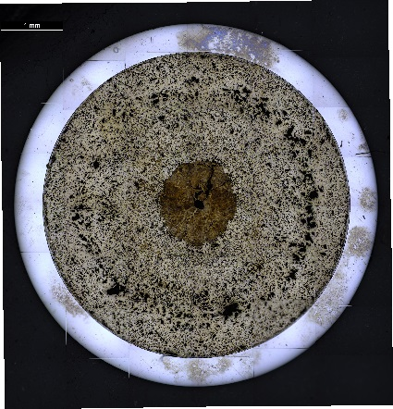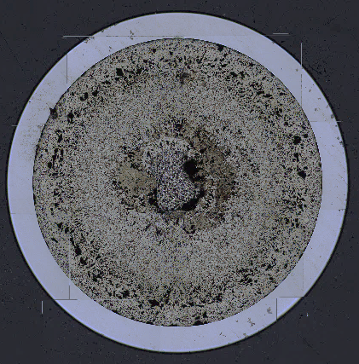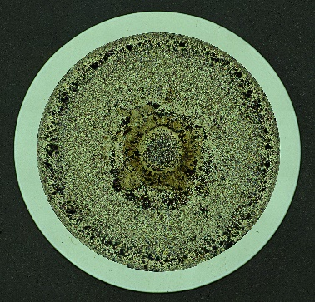
- b) c)
Fig. 2. Optical microscopy images of X501-G591 taken at different axial heights along the fuel pin: a) x/L=0.15; b) x/L=0.4; c) x/L=0.75

SEM examinations have been performed on three irradiated low fertile transmutation metallic fuel samples taken respectively from X501-G591, AFC-1H and FUTURIX-FTA experiments. The microstructure of X501 sample (Figure 3a) presents 3 main regions, as shown also from optical microscopy, while the AFC-1H (Figure 3b) and FUTURIX-FTA (Figure 3c) show a predominant central region that expands for more than half of the cross sections. Energy dispersion X-ray (EDX) line scan measurements revealed that the Zr element redistribution largely occurs in the same manner between AFC-1H and FUTURIX-FTA samples and it is less readily apparent compared to X501-G591 sample and with historically U-20Pu-10Zr metallic fuel. Zr concentration is higher in the center regions of the 3 fuel samples compared to the as fabricated compositions, inferring the existence of a cubic-like structure (gamma phase). Elsewhere in the fuels there are several different phases with different amount of Zr, U and Pu. Of note is a phase in the intermediate region of X501-G591 where the Zr content drops to 2.5 wt.% (inferred from optical microscopy to be ζ-phase), this phase is not well understood and to assess its impact on the fuel solidus temperature further research is needed.
Minor actinides act similarly in all the three samples, Np behaves very similar to U and it is present in the fuel matrix and Am is behaving like a lanthanide and it is segregated in precipitates / secondary phases also with noble metals. More details on Am/Np behavior are reported in complementary studies [16,17].
Finally, the interaction of these fuel alloys with different cladding materials is interesting and peculiar. FUTURIX-FTA with AIM1 cladding (austenitic steel) present an intergranular infiltration of Am and Sm into the cladding, as shown in Figure 4 on the left-hand side. This infiltration is very different from AFC-1H and X501-G591 (Figure 4, right) in which is present a planar front of Am. This difference is likely largely driven by the difference in cladding composition where the AFC-1H and X501 experiments were clad with a ferritic-martensitic steel (HT-9), but more research into the phenomenon is needed.
The overall microstructure evolution seems not affected by minor actinides addition compared to expected behavior of conventional U-19Pu-10Zr ternary metal fuels.

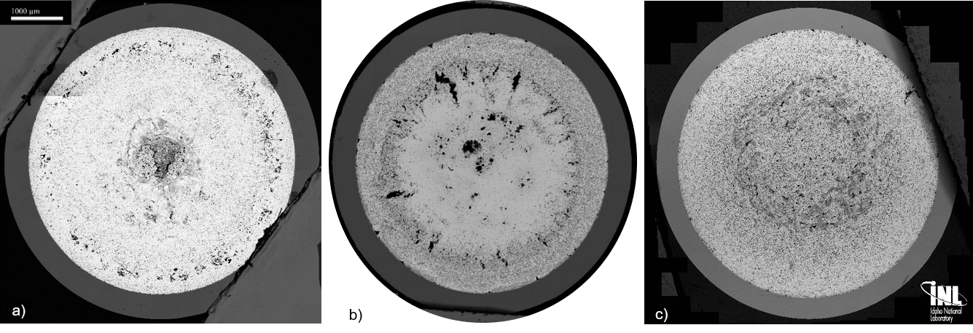
Fig. 3. SEM BSE macrographs of a) X501-G591; b) AFC-1H; c) FUTURIX-DOE1

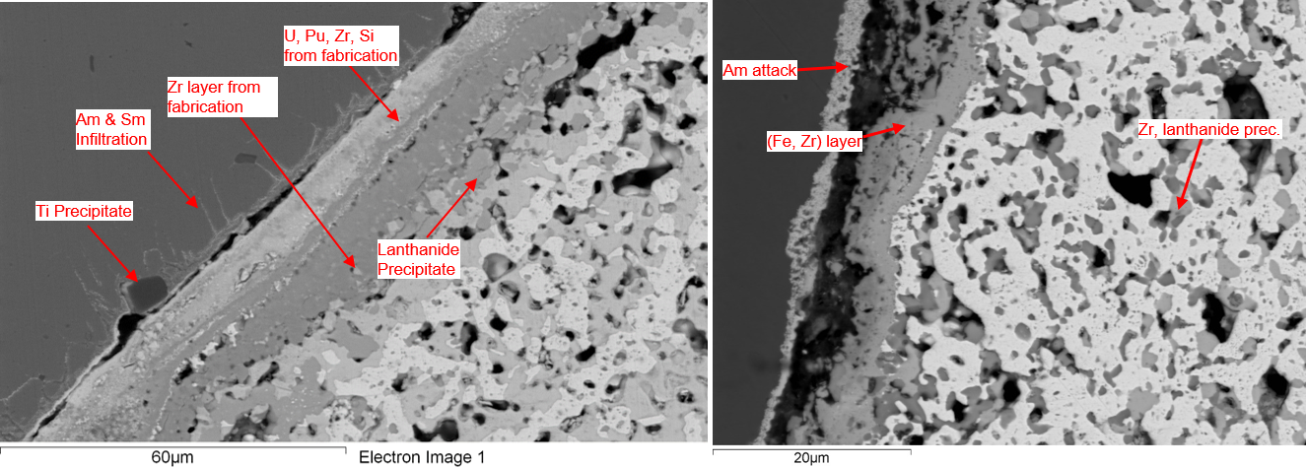
Fig. 4. SEM BSE images of FCCI region of FUTURIX-FTA (left) and X501-G591 (right). Images reproduced from [10,17]

PIE RESULTS ON ADVANCE FUEL DESIGN
Many different fuel compositions and designs have been tested in AFC-3 series as it is possible to see from Table 2. Non-destructive and destructive PIE have been completed for all fuel rodlets [18] and some earlier PIE results on AFC-3A/3B have been also reported in literature [19]. Here below recent results from AFC-3C/3D is presented. The general performance of AFC-3C&3D appears to be satisfactory according to exams performed so far.
Gamma spectrometry have been performed on the AFC-3C/D rodlets to evaluate the distribution of fission products in the fuel and to compare new design with well-known solid U-10Zr. Figure 5 reports the axial distribution of select fission products for AFC-3C R3 (solid, 65% smeared density, U-10Zr) and AFC-3D R1 (55% smeared density, U-10Zr).
In new design metallic fuel fission products tend to stay in or near the fuel although Cs will migrate towards the cooler axial ends of the fuel (Figure 5b). However, in a solid fuel rodlet with sodium bonding the majority of the Cs migrates on the top of the fuel as shown in Figure 5a.
The RuRh-106 distribution is fairly flat across both fuel rodlets indicating it is well incorporated into the fuel. The Mn-54 shown in Figure 5 indicates the location of the endcaps and the cladding. Neutron radiography for both these fuel rodlets is superimposed in Figure 5.
The U-10Zr in AFC-3D R1, appears to have maintained its annuli. On the other hand, AFC-3C R3 seems to have swelled radially to the cladding, as expected, and some attenuation at the center of the rodlet can be seen and it could be associated with redistribution of the heavier elements towards the periphery (e.g. U) and higher porosity.
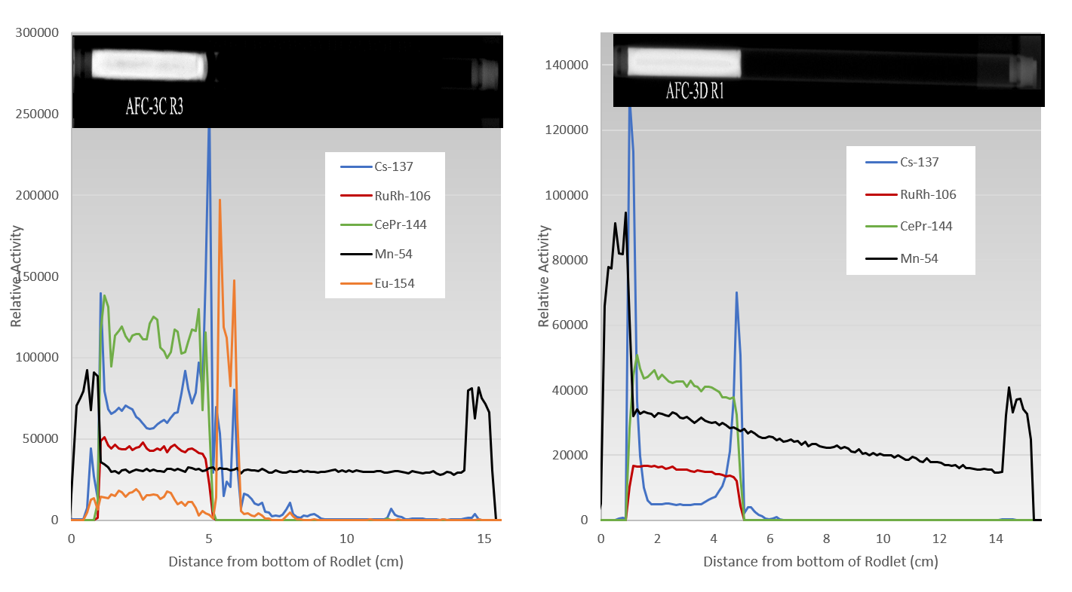
a) b)
Fig. 5. Precision gamma spectroscopy for a) AFC-3C-R3 (solid U-10Zr, 65% smeared density) and b) AFC-3D-R1 (U-10Zr, 55% smeared density). Neutron radiography of the two AFC rodlets is also superimposed.

Profilometry on all AFC-3C rodlets indicated some degree of diametrical strain present in all the rodlets of AFC-3C. None of the rodlets from AFC-3D had any measurable change in diameter. The AFC-3C rodlets were quite hot during irradiation with PICT in excess of 600°C for the majority of the time during irradiation, while the AFC-3D rodlets tended to run cooler [18]. A maximum diametrical strain of 0.7% was observed for AFC-3C.
Metallography has been also performed on all AFC-3C/3D rodlets and here an example of U-Zr with Pd additive is reported for discussion. Figure 6a presents metallography cross section of AFC-3C-R4, 55% smeared density, U-10Zr. It is possible to observe various degree of porosity indicated possible Zr redistribution and different phases formation. The annuli remained open at this level of burnup (~3 at%). Furthermore, elevated level of FCCI can be seen and it can be associated to the elevated PICT, mentioned before, that this rodlet experienced. Constituent redistribution and the high PICT may have caused most of the Zr to migrate away from the cladding. Once this occurred, the free uranium would have interacted with the cladding. This did not happen in AFC-3C R5A (Figure 6b), U-1Pd-13Zr, solid, 75% smeared density, in spite of the PICT being higher than in 3C R4. Based on the lack of interaction, some Zr must have remained near the outer radius of the fuel. Furthermore, the sensitivity of the temperature profile across fuel-cladding gap at the beginning of life between sodium bonded and He bonded rodlets might play a role and further investigation is needed. Finally, in AFC-3C R5A Pd as additive is characterized. Pd was proposed as an additive to metallic fuel to help prevent lanthanide-initiated FCCI in U-Zr alloys at high burnup [20,21]. This concept was tested in out-of-pile tests, and lanthanide-palladium precipitates have been observed in both U-5Fs and irradiated U-10Zr [22,23]. During fabrication, Zr and Pd form a stable intermetallic compound, and Pd was expected to release Zr and form stable intermetallic compounds with lanthanides. This had mixed success in AFC-3A/B [19]. Some of the issues in AFC-3A/B were attributed to Zr-Pd intermetallics that removed Zr from the U matrix, and then the U was more free to interact with the cladding. To help alleviate this problem in AFC-3C/D, additional Zr (13% not 10%) was added to the Pd bearing rodlets. Overall, this appears to have helped improve performance of these rodlets. In these tests, the Pd bearing rodlets do not have any obvious performance difference between U-Zr pins with the same geometry; electron microscopy will shed more light on Pd phases and its effectiveness in preventing FCCI.

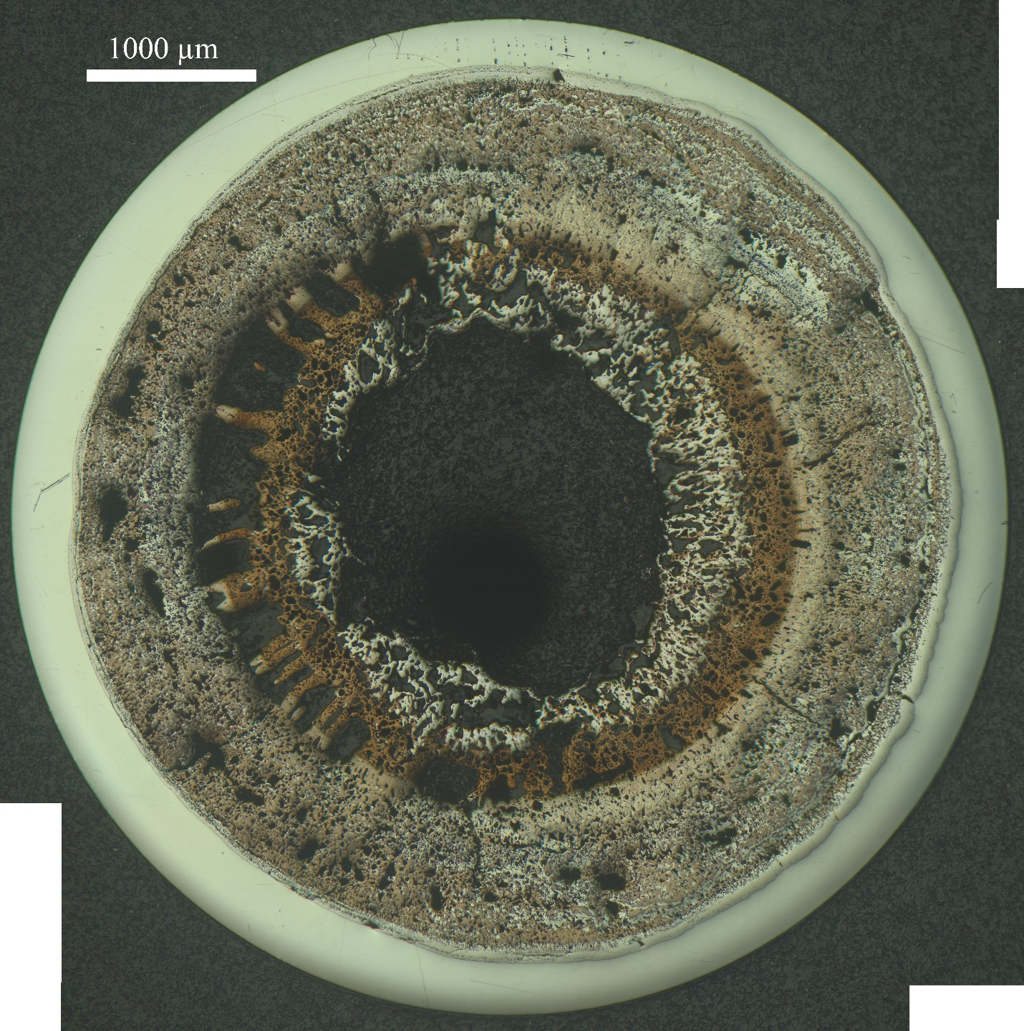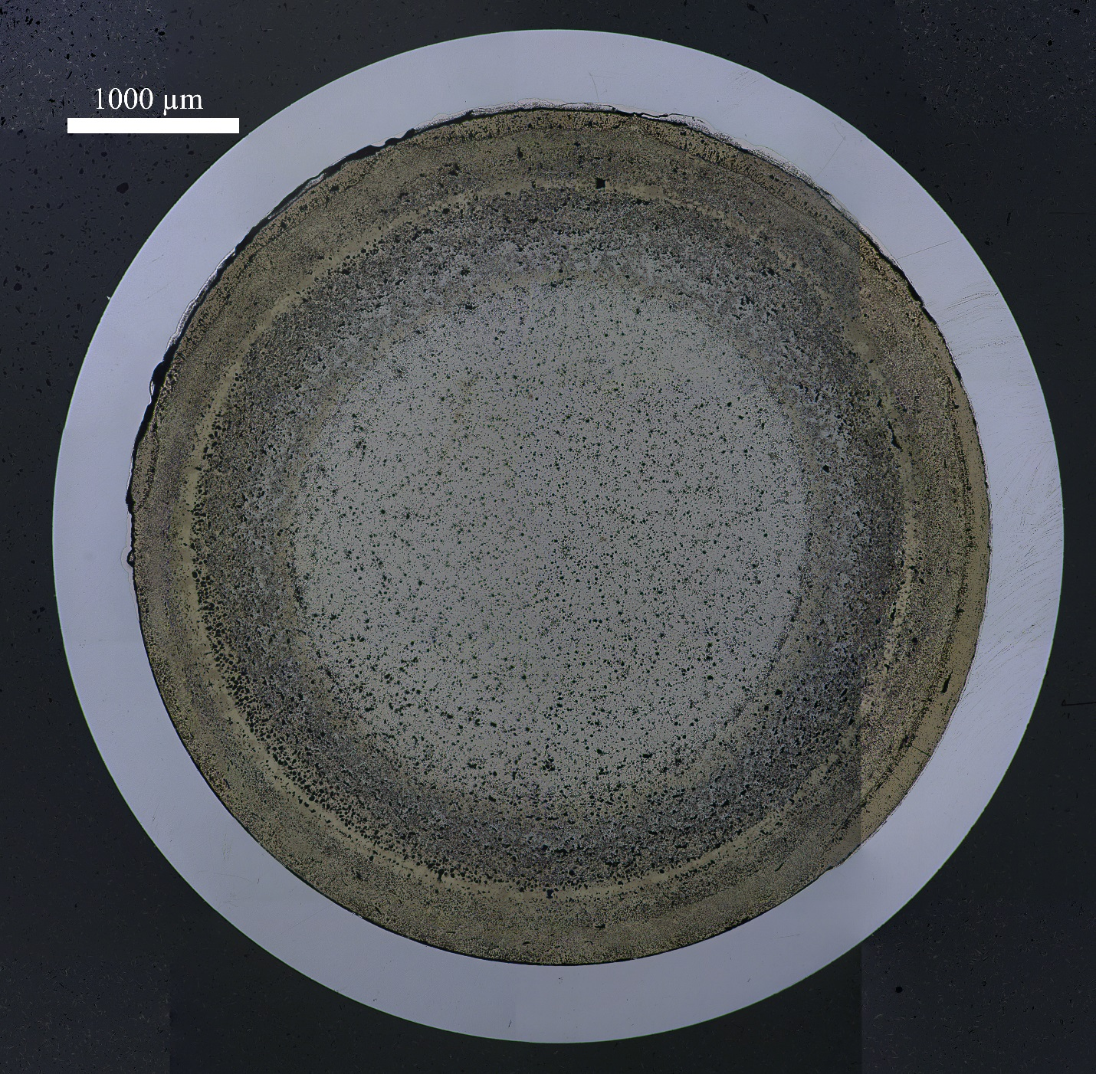
- b)
Fig. 6. Metallography cross section for a) AFC-3C-R4 (U-10Zr, 55% smeared density, 3.4 at% burnup) and b) AFC-3C-R5A (solid, U-1Pd-13Zr, 75% smeared density, 2.8 at% burnup).

- CONCLUSION AND FUTURE WORK

This paper reports several PIE campaigns on different metallic fuel systems. Regarding results on transmutation fuel alloys, the fuel performance is not affected by the addition of minor actinides and they behaved very close to well-known U-Pu-Zr fuel system. Considering novel fuel forms and designs, early indications from these tests are that the fuel has performed acceptably well and more tests are needed to explore fuel performance at higher burnup and under transient/accident conditions. Data collected from these examinations will be used to inform future irradiation testing and possibly the design of advanced driver fuel for a potential new fast test reactor.

ACKNOWLEDGEMENTS
The authors would like to acknowledge the DOE AFC as sponsor and funding source. Furthermore, all HFEF and EML staff is acknowledged for the support operation of the different PIE campaigns.

References
[1] Report to Congress on the Advanced Fuel Cycle Initiative: The Future Path for Advanced Spent Fuel Treatment and Transmutation Research, (2003).
[2] P. Medvedev, S. Hayes, S. Bays, S. Novascone, L. Capriotti, Testing fast reactor fuels in a thermal reactor, Nucl. Eng. Des. (2018). https://doi.org/10.1016/j.nucengdes.2017.12.034.
[3] J.M. Harp, S.L. Hayes, P.G. Medvedev, D.L. Porter, L. Capriotti, Testing Fast Reactor Fuels in a Thermal Reactor: A Comparison Report, Idaho Natl. Lab. Rep. (2017) INL/EXT-17-41677. https://doi.org/10.2172/1458766.
[4] H.J.M. Chichester, S.L. Hayes, D. Dempsey, J.M. Harp, Advanced Reactor Fuels Irradiation Experiment Design Objectives, INL/EXT-16-39923, Rev. 0. (2016).
[5] G.L. Povirk, D. Dempsey, J.M. Harp, S.L. Hayes, Developmental Objectives for Advanced Reactor Fuels, INL/EXT-16-39923, Rev. 1. (2017).
[6] G.L. Hofman, L.C. Walters, T.H. Bauer, Metallic fast reactor fuels, Prog. Nucl. Energy. (1997). https://doi.org/10.1016/0149-1970(96)00005-4.
[7] T. Ogata, Metal Fuel, in: Compr. Nucl. Mater., Elsevier, 2012: pp. 1–40. https://doi.org/10.1016/B978-0-08-056033-5.00049-5.
[8] H. Ohta, T. Ogata, S. Van Winckel, D. Papaioannou, V. V. Rondinella, Minor actinide transmutation in fast reactor metal fuels irradiated for 120 and 360 equivalent full-power days, J. Nucl. Sci. Technol. 53 (2016) 968–980. https://doi.org/10.1080/00223131.2015.1086706.
[9] M.K. Meyer, S.L. Hayes, W.J. Carmack, H. Tsai, The EBR-II X501 minor actinide burning experiment, J. Nucl. Mater. 392 (2009) 176–183. https://doi.org/10.1016/J.JNUCMAT.2009.03.041.
[10] J.M. Harp, L. Capriotti, H.J.M. Chichester, Postirradiation Examination of FUTURIX-FTA metallic alloy experiments, J. Nucl. Mater. 515 (2019) 420–433. https://doi.org/10.1016/J.JNUCMAT.2018.12.051.
[11] G.L. Hofman, L.C. Walters, T.H. Bauer, Metallic fast reactor fuels, Prog. Nucl. Energy. 31 (1997) 83–110. https://doi.org/10.1016/0149-1970(96)00005-4.
[12] G.L. Hofman, S.L. Hayes, M.C. Petri, Temperature gradient driven constituent redistribution in UZr alloys, J. Nucl. Mater. 227 (1996) 277–286. https://doi.org/10.1016/0022-3115(95)00129-8.
[13] W.J. Carmack, D.L. Porter, Y.I. Chang, S.L. Hayes, M.K. Meyer, D.E. Burkes, C.B. Lee, T. Mizuno, F. Delage, J. Somers, Metallic fuels for advanced reactors, J. Nucl. Mater. 392 (2009) 139–150. https://doi.org/10.1016/J.JNUCMAT.2009.03.007.
[14] Y.S. Kim, G.. Hofman, S.. Hayes, Y.. Sohn, Constituent redistribution in U–Pu–Zr fuel during irradiation, J. Nucl. Mater. 327 (2004) 27–36. https://doi.org/10.1016/J.JNUCMAT.2004.01.012.
[15] L. Capriotti, S. Brémier, K. Inagaki, P. Pöml, D. Papaioannou, H. Ohta, T. Ogata, V. V. Rondinella, Characterization of metallic fuel for minor actinides transmutation in fast reactor, Prog. Nucl. Energy. 94 (2017) 194–201. https://doi.org/10.1016/j.pnucene.2016.04.004.
[16] K.E. Wright, J.M. Harp, L. Capriotti, Electron Probe Microanalysis of Irradiated FUTURIX-FTA U-Pu-Zr Alloy with Added Minor Actinides, J. Nucl. Mater. (n.d.) under review.
[17] L. Capriotti, J.M. Harp, Characterization of a minor actinides bearing metallic fuel pin irradiated in EBR-II, J. Nucl. Mater. 539 (2020). https://doi.org/10.1016/j.jnucmat.2020.152279.
[18] J.M. Harp, L. Capriotti, F. Cappia, Baseline Postirradiation Examination of the AFC-3C, AFC-3D, and AFC-4A Experiments, INL/EXT-18-51447. (2018).
[19] J.M. Harp, H.J.M. Chichester, L. Capriotti, Postirradiation examination results of several metallic fuel alloys and forms from low burnup AFC irradiations, J. Nucl. Mater. (2018). https://doi.org/10.1016/j.jnucmat.2018.07.003.
[20] G.W. Egeland, R.D. Mariani, T. Hartmann, D.L. Porter, S.L. Hayes, J.R. Kennedy, Reduction of FCCI effects in lanthanide–iron diffusion couples by doping with palladium, J. Nucl. Mater. 440 (2013) 178–192. https://doi.org/10.1016/j.jnucmat.2013.04.060.
[21] R.D. Mariani, D.L. Porter, V. Blackwood, Z. Jones, D. Olson, B. Mishra, J.R. Kennedy, S.L. Hayes, R.D. Mariani, D.L. Porter, V. Blackwood, Z. Jones, D. Olson, B. Mishra, J.R. Kennedy, S.L. Hayes, New Fuel Alloys Seeking Optimal Solidus and Phase Behavior for High Burnup and TRU Burning, in: Int. Conf. Fast React. Relat. Fuel Cyles Safe Technol. Sustain. Scenar., 2013.
[22] J.M. Harp, D.L. Porter, B.D. Miller, T.L. Trowbridge, W.J. Carmack, Scanning electron microscopy examination of a Fast Flux Test Facility irradiated U-10Zr fuel cross section clad with HT-9, J. Nucl. Mater. 494 (2017) 227–239. https://doi.org/10.1016/j.jnucmat.2017.07.040.
[23] J.M. Harp, L. Capriotti, D.L. Porter, J.I. Cole, U-10Zr and U-5Fs: Fuel/cladding chemical interaction behavior differences, J. Nucl. Mater. 528 (2020). https://doi.org/10.1016/j.jnucmat.2019.151840.

