Presentation of the new European project PUMMA
devoted to Plutonium management in the whole fuel cycle

N. CHAUVIN¹, F. ÁLVAREZ-VELARDE², V. BLANC¹, Z. HOZER³, S. VAN TIL⁴, K. BOBORIDIS⁵, C. MAHER⁶, N.B KAMPATA⁷

¹COMMISSARIAT A L’ENERGIE ATOMIQUE ET AUX ENERGIES ALTERNATIVES, Centre de Cadarache, DES/IRESNE/DEC/SESC Bat 151 – F 13108 St Paul Lez Durance, France
²CENTRO DE INVESTIGACIONES ENERGETICAS, MEDIOAMBIENTALES Y TECNOLOGICAS, CIEMAT, established in Avenida Complutense 40, Madrid 28040, Spain
³CENTRE FOR ENERGY RESEARCH, Konkoly Thege Miklos út 29-33, Budapest 1121, Hungary
⁴NUCLEAR RESEARCH AND CONSULTANCY GROUP, established in Westerduinweg 3, Petten 1755 LE, Netherlands
⁵European Commission, Joint Research Centre (JRC), Karlsruhe, Germany
⁶NATIONAL NUCLEAR LABORATORY LIMITED, established in Chadwick House Warrington Road, Warrington WA3 6AE
⁷LGI SUSTAINABLE INNOVATION, established in 6 Cité de l’Ameublement, 75011 Paris, France

Abstract
The European project PUMMA (plutonium Management for More Agility) is dedicated to the different plutonium management options in 4th generation systems to assess the impact on the entire fuel cycle. Fast neutron reactors with associated fuel cycle strategies have been chosen to cope with these options because they are flexible: they offer the possibility of isogeneration, burning or breeding of plutonium.
The fuel cycle scenarios associated with the different strategies will be evaluated. The behaviour of MOX fuel with plutonium contents of 45% will be studied experimentally through the characterizations of fuels from three irradiations carried out under nominal conditions (in MTR and SFR) and incidental (in MTR). PUMMA will provide additional results on the thermo-mechanical properties of this fuel covering the full range of composition and effect of irradiation. These studies will be supplemented by dissolution tests on spent fuels with high plutonium contents because to date, the studies have been limited to concentrations below 30%.
The construction of this project was carried out with complementarity between the disciplines of the fuel cycle and with a close exchange between simulation and experimental verification for each of the fields: fuel behaviour under irradiation, material properties, spent fuel dissolution and partitioning. PUMMA will be the link between Europe and other international organizations: fuel cycle studies at IAEA and OECD, GEN-IV systems at ESNII and GIF, studies on fuel materials at OECD.
Another objective is to maintain the expertise and skills on the management of plutonium in Europe involving the young generation of researchers with experts who have contributed to these projects for over 20 years.
22 participants will contribute to this project with a total budget of around 7 M€.

INTRODUCTION - CONTEXT
For several decades, the operation of nuclear reactors in Europe has led to the production of several hundred tons of plutonium, which is sometimes partly recycled as MOX fuels in the pressurized water reactors (PWRs). Once through recycling as operated in France allows already saving of about 18% of the natural uranium resources. In the future context of sustainable nuclear energy, fast neutron reactors (FNR) are needed to efficiently multi-recycle plutonium and to reach a close and fully sustainable nuclear fuel cycle.
The Generation-IV reactors will be able to use and recycle the accumulated plutonium (Pu) but also to overcome the use of fresh uranium (U) coming from ores, given that the conversion ratio in these reactors can be equal or larger than one, reducing hence the use of natural fissile resources (see Figure 1), following the sustainability criteria supported by the SNE-TP. The flexibility of fast neutron reactors towards plutonium management is due to their ability to burn plutonium coming from other systems (with more than 40% loaded in the driver fuel), to multirecycling it (increase in plutonium content compensating the isotopy) or to equilibrate the production/consumption inventory.
The multiple recycling of plutonium and uranium in fast reactors will result in the following fuel cycle improvements:
- Only use of depleted uranium.
- Use more than 80% of the uranium natural resource instead of 0.6 – 0.7% in current LWR systems.
- Providing additional burning of fissile plutonium and avoiding its accumulation in spent fuel stockpiles, decreasing the risk of diversion (resistance to proliferation).
- Once through recycling in PWR leads today to a reduction in High Level Waste (HLW) by a factor of 3.6 compared to a LWR fleet operating an open cycle. Used MOX multi recycling in fast reactors will allow an additional reduction by a factor of 2.5. This is a key point for reducing the footprint of the geological repository.

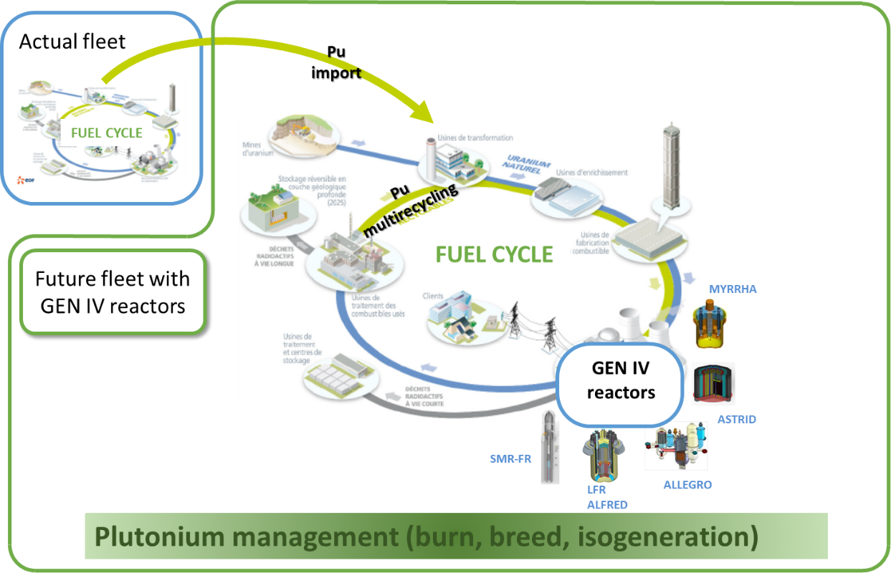
FIG 1: Plutonium management with a future fleet of GENIV reactors

Although plutonium can eventually be used in different chemical forms (MOX in SFR, carbide in GFR, nitride in LFR), the foreseen technology demonstrators and prototypes (MYRRHA, ALFRED, ALLEGRO, SMR and SFR prototypes) will use MOX (with various concentration of plutonium) in these reactors concepts as the most mature fuel technology for Generation-IV systems. This choice has been emphasized by past and on-going EU projects, in particular ESNII+, MAXSIMA, MYRTE, ESFR-SMART, etc.
The evolution of the fuel composition with the increase of plutonium content compared to previous driver fuels (20 to 30% Pu), justify the need to launch new studies in all the fuel cycle steps including reactors with fuel containing more than 30% Pu.

objectives
The PUMMA project will define different options for plutonium management in Generation-IV systems and evaluate the impact on the whole fuel cycle in addition to safety and performance aspects.
The project has determined three High Level Objectives:
- To study the plutonium management in Generation-IV reactors (SFR, GFR, LFR, FAST-SMR) and to understand its impact on fuel cycle parameters
- To assess the impact of plutonium management on fuel safety limits
- To share the expertise and the skills on the management of plutonium in fast reactors

The High-Level Objectives will be achieved by performing the Specific Technical Objectives (STO) described in Table 1.

HLO | Specific technical objective | Expected results
HLO1:  To study the plutonium management in Gen-IV reactors and understand its impact on fuel cycle parameters | STO1.1 Identification of fuel cycle scenarios | Choice of scenarios corresponding to each individual EU member states strategies in terms of existing and future fleet, as well as assumption on transition and power demand and production.  Description of the characteristics of each scenario (fleet composition, installed nuclear capacity, increase in electrical demand, …)
 | STO1.2 Characterization of scenarios regarding fuel cycle parameters | Production of results describing the selected scenarios (in terms of inventory U, Pu, MA, capacities of fuel plants, wastes production, fuel characteristics,…). Sensitivity studies of each scenario
 | STO1.3 Assessment of spent fuel reprocessing with various fuel composition | Impact of Pu content on the dissolution in the conditions of the PUREX industrial process (dissolution kinetics, % of Pu left in residues) and test of advanced dissolution steps for Pu quantitative dissolution
 | STO1.4 Quantification of fuel cycle options on isotopic inventory | Evaluation of inventories by isotope and for each fuel cycle facility - intermediate and non-intermediate (fabrication, reprocessing, reactor, transportation, cooling storage, aging storage)
 | STO1.5 Quantification of fuel cycle options on economy | Impact on the fuel cycle cost
HLO2:  To assess the impact of plutonium management on fuel safety limits | STO2.1 Assessment of fuel behaviour under irradiation with a range of fuel compositions (Pu: 20% to 45%) | Benchmark exercise (code to code and code to experiment) on high Pu content with previous set of properties and new one. Impact of Pu content on fuel safety (margin to fuel melt, margin to clad failure)
 | STO2.2 Extension of validation data base of fuel performance codes with irradiation results | Assessment of safety parameters evaluation for fuel with large Pu content under steady state and overpower conditions
 | STO2.3 Improvement of reliability of fuel properties with extended fuel composition | Measurements, calculation and updated correlations of thermal and mechanical properties of MOX on a large range of composition (20 to 45% Pu)
 | STO2.4 Definition of common MOX fuel properties | Common set of MOX properties for all Generation-IV systems and codes
 | STO2.5 Definition of standards for MOX safety evaluation | Common safety standards for MOX fuel available for all Generation-IV systems
HLO3:  To share the expertise and the skills on the management of plutonium in fast reactors | STO3.1 Knowledge transfer and preservation through production of educational tools and young generation involvement | Production of online courses, and database of courses. Invitation to the workshops. Secondment of students to dedicated experimental facilities
 | STO3.2 Effective dissemination to share research and technical expertise on nuclear safety of Generation-IV reactors | Presentation at dedicated conferences and publications in various scientific journals. 4 workshops on PUMMA’s topics and open to the European and International communities
 | STO3.3 Early involvement of the stakeholders, TSO and fuel and fuel cycle experts and end-users | Creation of an End-users group (EUG) ensuring the link with SNETP, ESNII, GIF, NEA, AIEA and industry in particular. Technical expertise shared effectively within European communities through workshops and meetings dedicated to the EUG
Table 1: Objectives of the PUMMA project

CONCEPT
In Europe, each country has a different existing reactor fleet, but the common points are that all of them consume natural uranium and produce plutonium, which can be recycled in order to valorise its energetic potential, to reduce the use of natural resources and the waste long-term radiotoxicity.
The concept of this project is built on the following facts:
- Generation II or III reactors, such as PWRs, currently allow the recycling of plutonium. However, this strategy has the limit that Pu can only be recycled once and in limited quantities because the MOX fuel cannot be loaded at more than 12% Pu.
- Generation-IV fast neutron spectrum reactors such as SFRs or LFRs are able to integrate large amounts of Pu into their cores, with isotopic compositions that can be very degraded compared to Pu historically used in SFR. In addition fast reactors can recycle Pu many times (multi recycling). This advantage allows to qualify Generation-IV fast reactors of flexible and efficient towards the management of Pu and the sustainability of nuclear energy.
- The only industrially mature fuel for all Generation-IV fast reactors is oxide fuel (U, Pu)O₂.
Thus it can be concluded that even though each European country has its own policy with regard to nuclear energy production, a common fuel and fuel cycle program for this 4th generation is relevant and an opportunity for the European future. This is why many organizations in many European countries have joined to build together this PUMMA project which aims to demonstrate the capacity of fast reactors to manage the Pu and evaluate the performance that could be achieved.
This demonstration concerns the qualification of the fuel and the qualification of the first step of the fuel treatment (dissolution) on extended domains of composition and conditions. Given that the MOX fuel is qualified on a scale of TRL 7-8 for a limited area of composition and use, the PUMMA project aims to extend this area of qualification for much wider composition and conditions and covering all configurations.
This concerns the domain of the behaviour of fissile materials under irradiation, the properties of the fuels and the reprocessing of these Pu fuels. The scientific issues on these items have been discussed among experts that have built the PUMMA project and integrated in the technical content of the project.
This context common to all Gen-IV fast spectrum systems will also make it possible to define a common safety approach applied to MOX fuels. The qualification includes safety analysis in nominal and off-normal based on these new standards.
The qualification of the MOX will be revisited to meet the safety criteria of the Generation-IV taking into account options on fuel cycles with Pu management.

The Figure 2 illustrates the fuel cycle situation towards Pu management and the main items of PUMMA project.
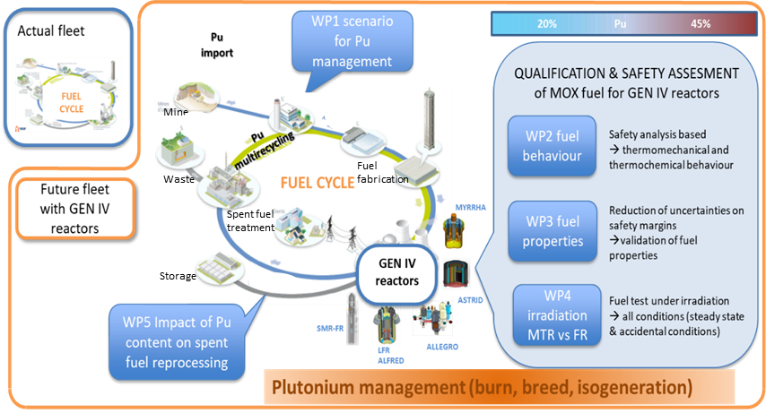
Waste
Fuel fabrication
FIG 2: PUMMA concept

METHODOLOGY
PUMMA will apply a new methodology to achieve the goal of demonstrating the management flexibility of Pu in Generation-IV systems assuming that the starting point is the licensing requirements for a safety assessment of the whole system (fuel and fuel cycle). This new methodology consists of three separate phases as shown in Figure 3. First, a licensing qualification process will help to detect the current TRL (Technological Readiness Level) in every field treated by the project; then, a code validation procedure will help to check the current and new capabilities of the computational systems; and finally, an experimental programme will be developed to provide the detected R&D requirements needed to reach the desired objectives.
The whole project is structured in three R&D topics (see details in Table 2): Fuel scenarios, fuel safety and fuel properties.
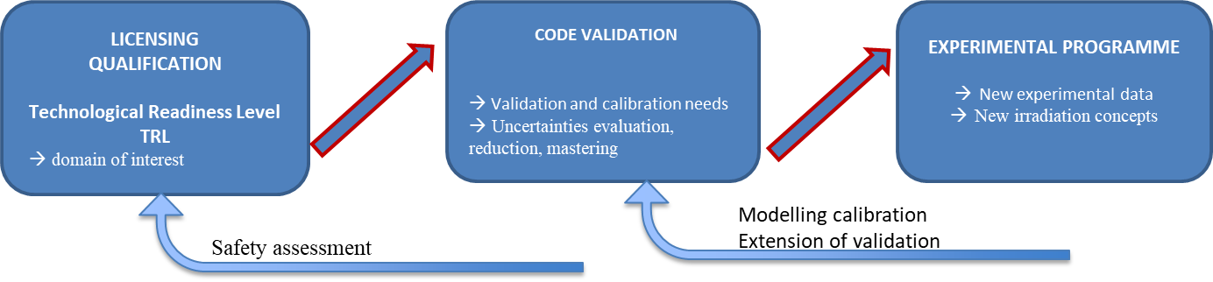
FIG 3: Methodology of PUMMA
This new methodology will allow reaching high TRL whatever the fuel cycle options.

Extension of the validation domain
The licensing domain of fuel and fuel cycle needs to be extended because of the several options for Generation-IV systems and associated fuel cycle. We want to provide data and safety methodology that will be used by countries or organizations and adapted to their strategies.
As the first step in our methodology, for each topic an in-depth analysis will be performed to help the consortium to understand what is needed to extend the MOX fuel licensing domain. This initial licensing qualification process is summarized in the Table 4.

TOPIC | LICENSING TRL  Domain of interest | CODES | Experimental data needed for code validation | PUMMA content
SCENARIO, FUEL CYCLE and REPROCESSING | Pu multirecycling& burning  Generation-IV systems | Fuel cycle scenario codes | Dissolution tests for different compositions (Pu%) and performances (burn-up) | WP1 & WP5
FUEL SAFETY | Reactor conditions : nominal & incidental conditions | Fuel Performance codes | PIE on irradiated fuels with different composition and irradiation conditions  Irradiation needs in Fast Reactors and MTR | WP2 & WP4
FUEL PROPERTIES | Fuel composition  Irradiation conditions | Atomistic codes  Thermodynamic codes | Properties measurements on fresh and irradiated fuel with different compositions | WP3
Table 2: Initial licensing qualification process for the Pu management as MOX fuel

The Generation-IV reactors and the associated fuel are therefore qualified at a TRL 7-9 scale for SFRs and MOX compositions containing up to 25-28% Pu. In the PUMMA project, this qualified domain is foreseen to be significantly extended as shown in Figure 4.
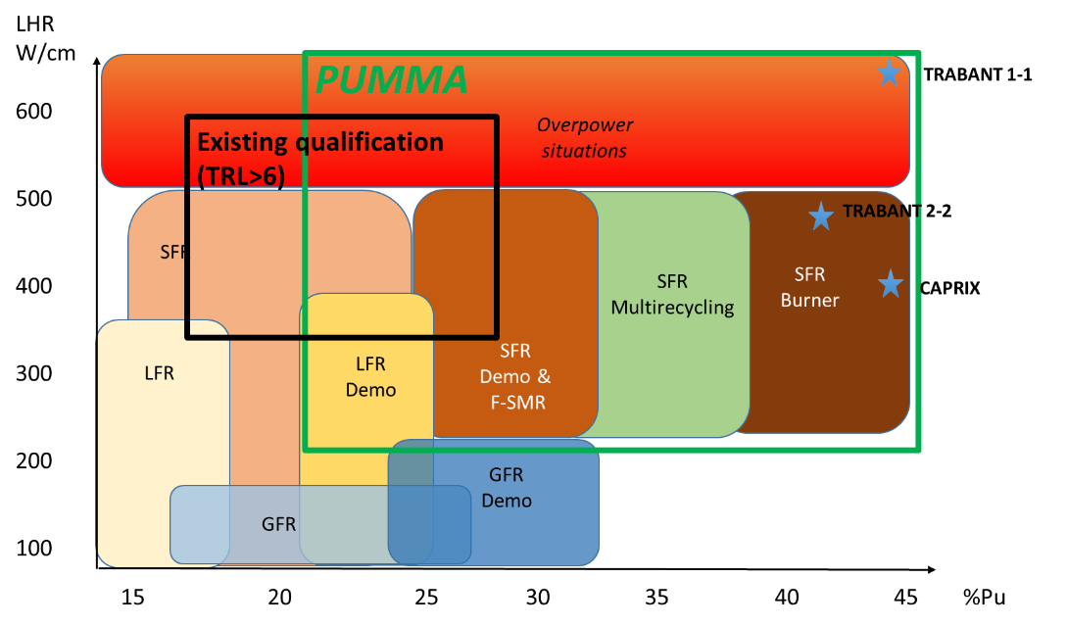
Linear Heat Rate
FIG 4: Generation-IV reactors parameters for PUMMA – fuel qualification

Figure 5 illustrates the complementarity of the existing set of MOX properties and the knowledge that will be generated PUMMA’s proposal. With PUMMA we will cover the composition of MOX fuel needed whatever the strategy on the fuel. As thermal and mechanical properties contributes at a primary level on the safety margins, these new data will increase reliability on the safety analysis.
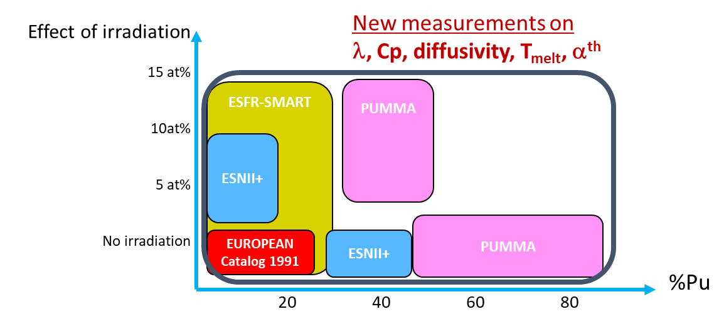
Figure 5: New MOX properties to be covered by PUMMA.

The dissolution of spent MOX fuel is fully qualified (TRL 8-9) for a standard MOX up to 30% Pu. For higher Pu content, the PUREX process was not tested and the PUMMA project will provide results to reach a qualification level of around TRL 4 (Figure 6).
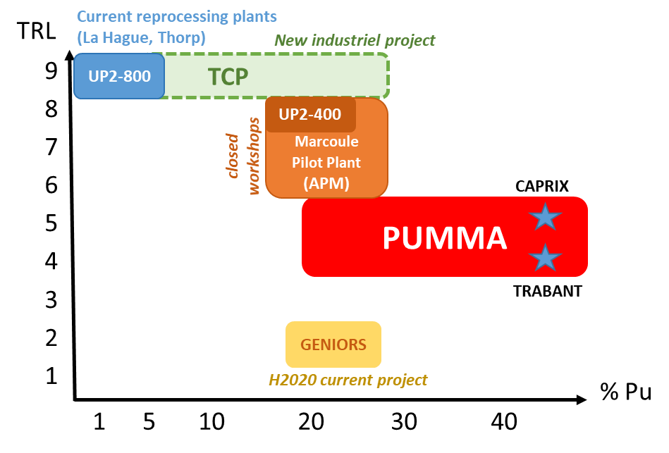
FIG 6: Generation-IV reactors parameters for PUMMA – reprocessing qualification

Codes calibration and validation methods
Validation and calibration of the codes have been achieved with the results coming from past projects studying reactors and fuel cycles.
The extension of validation and calibration will be performed through 3 different activities:
- Benchmark exercises between codes
- New experimental results
- Uncertainties evaluation
The list of codes is given in Table 3 together with a very short description of the research area in which the code will be used in the project. All these codes will be calibrated, validated or at least compared to other codes predictions.
It is necessary to make comparisons between many codes on the same subject because the treated cases are outside the validation domains of these codes. Moreover, the models of each code being different, significant differences in the results are expected, which could be observed in other benchmarking exercises (ESFR-SMART project). It is therefore important for an in-depth analysis to have all these tools available and tested.

TOPIC | CODE | BRIEF DESCRIPTION
Fuel cycle scenarios | COSI | Isotopes inventory in the cycle
 | COSAC | Isotopes inventory in the cycle
 | WIMS | Isotopes inventory in the cycle
 | MAUA | Non proliferation evaluation in fuel cycle
 | SITON | Fuel cycle scenarios
 | DESAE | Evaluation of resources for given fleet
 | NFCSS | Neutronic
 | ERANOS | Neutronic
 | SERPENT | Neutronic
 | TR-EVOL | Inventory, costs, optimization, uncertainty propagation
 | MCNP | Neutronic
Fuel Performance | FRED | Thermomechanic
 | FINIX | Thermomechanic
 | FUROM | Thermomechanic
 | GERMINAL | Thermomechanic
 | FEMAXI | Thermomechanic
 | MACROS, | Thermomechanic
 | TRANSURANUS | Thermomechanic
 | TRAFFIC | Thermomechanic + thermochemistry
 | OFFBEAT 3D | thermomechanic
 | OPEN-CALPHAD | thermochemistry
 | EVOL-CODE | thermomechanic
 | SIMMER | thermomechanic
Fuel properties | LAMPPS | Monte Carlo
 | GIBBS | Monte Carlo
 | OPENCALPHAD | thermochemistry
Table 3: List of codes used in the PUMMA project

The uncertainties in the input parameters propagated to the whole fuel cycle can lead to underestimation or overestimation of the capacity of facilities, the inaccuracy to calculate the amount of wastes to manage and hence economic risks. Additionally, when the fuel cycle scenario is very close to having a minimum in the amount of available resources, uncertainties may lead to a disruption or broken scenario, causing that there is a lack of material to be reprocessed or fabricated when needed. Uncertainties in the input parameters are usually chosen from expert judgement.

Experimental programme
PUMMA deals with fuel cycle, fuel behaviour and fuel reprocessing, the facilities involved (Table 4) are mainly: hot cells for irradiated fuels, fabrication and characterisations lab (glove box).

Facility | BRIEF DESCRIPTION | PUMMA actions
NNL | Fabrication lab and hot cells | Fabrication of high Pu content fuel  Dissolution test on fresh fuels
JRC-Karlsruhe (Germany) | Hot cells on post duel irradiation characterisation  Hot cells on fuel properties measurement | Fuel properties measurement  Characterisation of the irradiated fuel
LECA CEA-Cadarache (France) | Hot cells on post irradiation characterisation | Characterisation of the irradiated fuel
ATALANTE CEA-Marcoule (France) | Fabrication lab and hot cells | Dissolution test on fresh and irradiated fuels  Isotopic and elementary analysis after dissolution of the irradiated fuel  Spent fuel characterisations
NRG | Hot cells | Characterisation of the irradiated fuel
Table 4: List of the facilities involved in the experimental programme of PUMMA

Project IMPLEMENTATION
The project work plan is composed of seven inter-linked workpackages (WP) as partially described in Figure 2.

WP1 Study of plutonium management in connection with the fuel cycle: scenario studies
The main objective of WP1 is to highlight the flexibility of the Gen-IV reactors on the management of the plutonium (breeding, burning or iso-generation). This objective will be achieved by means of the study of the performances and impact of these plutonium management options on all the operations involved on the fuel cycle scenario (manufacturing, storage, transportation, reprocessing, core design, and fuel behaviour).

WP2 Fuel PIN behaviour in reactor with high Pu content: Nominal and transient
The WP2 is devoted to the behaviour of SFR fuel with high plutonium content, including simulation and experimentations, and the sizing associated methodology. This goal will be achieved by doing PIE on three experimental fuel pins, comparing a large set of simulations of these experiments obtained with various fuel performance codes, and on the basis of the results comparisons, propose safety analysis methodology and recommendations.

WP3 Fuel properties with high plutonium content: Measurements and modelling
WP3 will be devoted to the evaluation of the main properties of irradiated and non-irradiated MOX fuel in order to reduce the significant sources of uncertainty in the safety evaluation:
- In nominal conditions uncertainties of thermal and mechanical properties will be reviewed and the margin to melting of pellet will estimated.
- In transients, incidents and accidents the effect of uncertainties of mechanical properties on cladding failure and the uncertainties of thermal properties on fuel melting fraction will be evaluated.

WP4 Comparison of irradiation results in fast spectrum vs thermal spectrum
Objectives: This WP is intended to go further in the analysis on how MTR fuel irradiations can be compared to irradiation in a fast reactor, i.e. to what extent are MTR irradiations representative for performance in a fast neutron spectrum. The main objectives of this WP are:
- Study of the design differences of the irradiation devices in MTR vs FR
- Interpretation of irradiation results in MTR and FR; starting at core characteristics and including experiment designs
- Analysis of the advantages / disadvantages of irradiations in FRs / MTRs for future programs
- Contribution of MTR and experimental FR irradiations to the fuel qualification (steady state and transients)

WP5 Impact of Impact of plutonium content on reprocessing
It is assumed that plutonium contents will be in the range of 10-45%, that is typical fuels for Generation IV fast reactors. The factors that will be investigated are:
- Pu dissolution rate
- Pu and FP distribution in solid residues
- Impact of irradiation of high Pu content fuel in SFR on Pu dissolution behaviour

WP6 Education and training, dissemination and communication
Education and Training is essential for future development of fast reactors systems and associated fuel cycles. The main objectives of this WP6 are:
- to encourage mobility of PhD students, post-doc...;
- to organize workshops for PhD students, post-docs, designers, stakeholders, etc., highlighting the issues related to fuel cycle scenarios, fuel behavior and spent fuel reprocessing;
- to improve educational tools and learning methodologies taking advantage of past workshops and seminars organized over the last 30 years in the various European projects related to multi-recycling and closed fuel cycles;
- Disseminate the outcomes of the project to a larger audience.

WP7 Project Management
This WP ensures the achievement of the project’s objectives, in terms of scientific quality, timely delivery, and contribution to the expected impact of the project.

Impacts

Scientific and technical impact
The impact at the scientific level will be:
- Thermal and mechanical properties of the fuel: new measurements with extended parameters
- Coupling of thermomechanical and thermochemical simulation for fuel behavior to improve the consideration of coupled phenomena
- Contribution of atomistic and thermodynamic modelling in the evaluation of thermal properties
- Better knowledge of the dissolution of Pu-rich MOX fuels (rate, kinetics, residues)

Technological impact
The impact at the technological level will be:
- Impact of fuel cycle options on reactor, cycle and waste performance
- Impact on the cycle facilities (manufacturing, reprocessing, intermediate storage) and transport
- Analysis and recommendations on MTR irradiation devices for qualification of fast fuels
- Evaluation of the performance of the industrial process for the dissolution of irradiated fuel

Political impact
The study of all cycle options allows each EU nation to have data in support of the decisions on nuclear strategy. Decisions about reactor types and cycles are taken into account on safety and cost, facilitating coherence and a hope for a better acceptance of the public. Proliferation is one of the main concerns when new nuclear technologies are in debate. The inclusion of greater extent of plutonium in the fresh fuel increases the radiological barrier which contributes to proliferation resistance. The absence of uranium enrichment also contributes to proliferation resistance. Moreover, PUMMA studying the feasibility of higher burn up rate with greater content of plutonium will place the EU at the forefront of using existing plutonium stockpile which can affect other States to take a step for deployment of such reactors.

Economic impact
The different fuel cycle choices will be evaluated from an installation and performance impact perspective with a cost analysis on all stations. PUMMA evaluating the cost of each fuel cycle scenario will highlight the feasible solutions that are favourable for the decision makers for the deployment of Generation-IV.
In addition, PUMMA evaluating plutonium management as a whole with reduction of resources use (need only of depleted uranium that comes from reprocessing), it will result in reduction of the fuel cycle cost with:
- No new uranium needs, no enrichment
- Reduction of High Level Waste by a factor 9 compared to open cycle.

Conclusion and perspectives
PUMMA started in October 2020 for 4 years and 22 organizations are involved in this project.

The experimental programme started with :
- the post irradiation examinations of CAPRIX, TRABANT1 and TRABANT2 experiments,
- the fabrication of MOX samples at different Pu content for the properties measurements
- the first reprocessing tests on fresh and irradiated MOX fuel at 45%Pu.

The calculations also started with benchmark activities on :
- the impact of Pu management on the whole fuel cycle,
- the behaviour of high Pu content MOX with fuel performance codes
- the prediction of fuel properties with atomistic calculations.

The in-depth analysis of irradiation conditions and devices in MTR and SFR has started also.

Training the young generation on these subjects is implemented at all levels (workshop, secondments, PhD funded, …)

