Potential Role of Fast Reactors with Heterogeneous Fuel Assembly in Development Nuclear Power Structure.

E.A. Andrianova, A.V. Grol, Ya.A. Kotov, P.A. Fomichenko, V.A. Nevinitsa, S.A. Subbotin
National Research Center “Kurchatov Institute”

Abstract
To assess the capabilities of a fast reactor with heterogeneous fuel assembly in a two-component system of the Russian nuclear power industry in present paper material balances of fissile nuclides were calculated. For this purpose, three scenarios were considered: one with the traditional BN-1200 core layout, and two scenarios with heterogeneous fuel assembly of BN-1200. One of them provided for joint reprocessing of spent MOX-fueled rods and raw fuel rods, and the second – separate.

1 Introduction
The current stage of nuclear power development is often characterized by directly opposite trends: on the one hand, there is a growing understanding of the need to transition to a closed fuel cycle, and on the other hand, there is a very large uncertainty about the growth rates of nuclear power capacity needed at the present time. In such conditions, the main driver of the transition to SNF is not the need for capacity building and accelerated commissioning of fast reactors for extended fuel reproduction, but the need to reduce the amount of SNF accumulated in storage. In other words, at the transition stage of NPS development as a system, the main problem is to reduce the volume of SNF in VVER reactors by reprocessing SNF.
In such conditions, the main driver of the transition to a closed nuclear fuel cycle (SNF) is not the need to increase capacity and accelerate the commissioning of fast reactors for extended fuel reproduction, but the need to reduce the amount of spent nuclear fuel (SNF) accumulated in storages. In other words, at the transition stage of the development of nuclear power as a system, the main problem is to reduce the volume of spent nuclear fuel in VVER reactors by reprocessing it. In other words, the task of providing extended fuel reproduction is not an immediate solution and can be postponed to a later time. As a result, there is time for the preparation of the technological basis – the development of the technology of dense fuel, which is necessary for extended reproduction and does not currently have enough reference. As a first step for this purpose, fuel assemblies can be used, in which the dense fuel does not carry the main load for energy production. For this purpose, certain changes can be made to the FA of fast reactors, which can provide sufficiently comfortable operating conditions for poorly justified fuels and provide the necessary energy processing, as well as the reactivity reserve at the expense of well-justified fuels.

2 Fuel Assembly with intra-cassette heterogeneity
As shown by the research carried out at NRC KI [1,2], this problem can be solved by using a fast neutron reactor fuel assembly with intra-cassette heterogeneity, which contains two types of fuel elements (Figure 1): oxide fuel rods with a high content of plutonium (MOX fuel), as well as reproducing fuel rods made of dense fuel, for example, depleted uranium metal. The challenge of ensuring the reactivity and energy producing (especially at the beginning of micro-campaign)) is assigned to the fuel elements made of MOX fuel, and the problem of compensation of reactivity and ensuring of reproduction rests is assigned to the raw metal fuel rods made of depleted uranium, which practically do not bear heavy load at the beginning of the campaign. At the end of the campaign the fall of energy production of MOX-fueled rods is compensated by the growth of energy production of the raw fuel rods. Thus, the dense fuel located in the raw fuel rods reaches the limits of its operability only before unloading from the core (Figure 2.

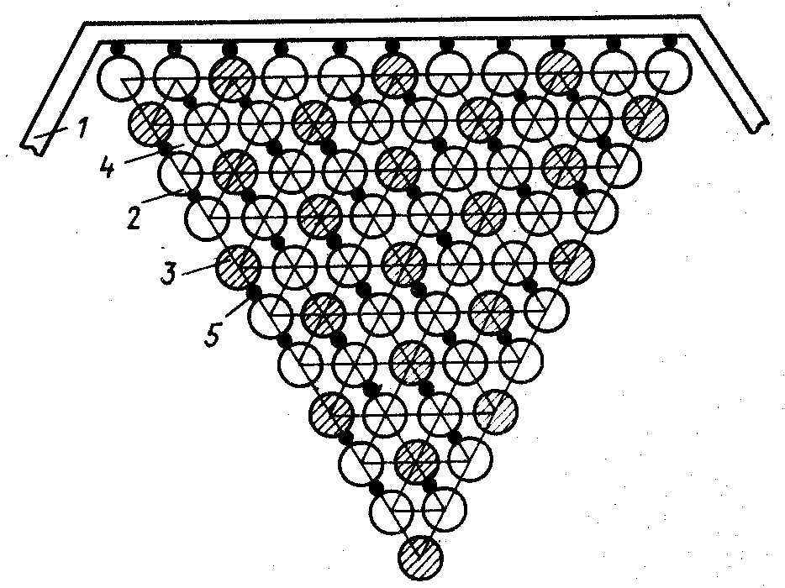
1 – FA cover; 2 – fuel rod; 3 – fertile rod; 4 – coolant;
5 – spacing element
Fig. 1 – Fuel Assembly with which contains two types of fuel elements (MOX and fertile)

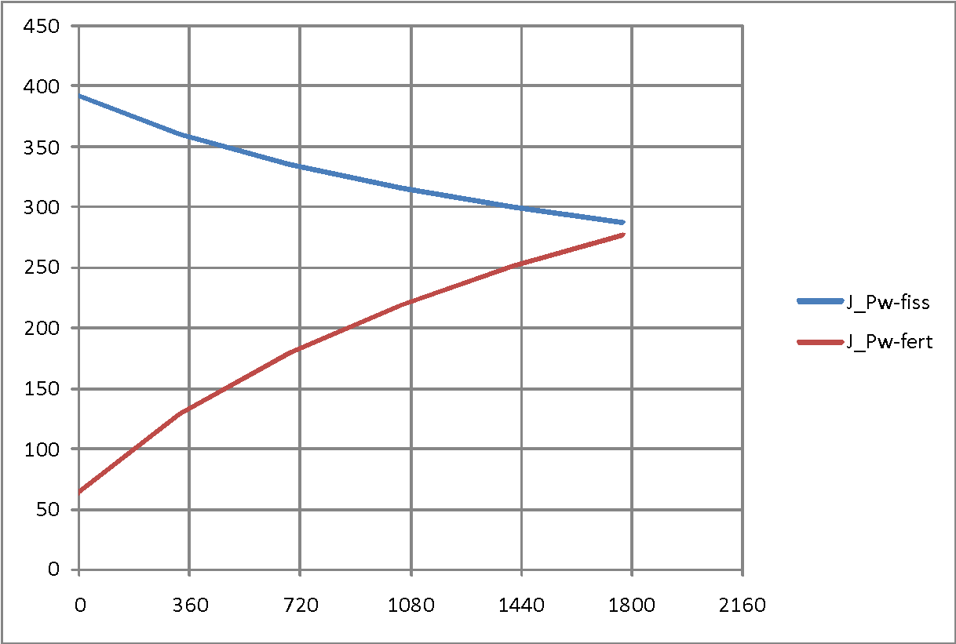
Irradiation time, days
Loading, Wt/cm
Fig. 2 – Time Dependence [Wt/cm] fissile (fiss) и fertile (fert) rods during FA campaign

The features of this arrangement of fuel assemblies allow organizing separate processing of oxide (ignition) and metal (reproducing) fuel elements [3]. Fuel rods made of uranium metal with a lower heat release and radiation level can be recycled earlier than fuel rods made of dioxide, which have a high burnout. Dioxide fuel rods can be recycled after a long exposure, when the levels of their radiation and residual heat release are reduced to acceptable values.
3 Calculations of scenarios of Russian Nuclear Power Development
To assess the capabilities of a fast reactor with heterogeneous fuel assembly in a two-component system of the Russian nuclear power industry in present paper material balances of fissile nuclides were calculated. For this purpose, three scenarios were considered and compared: one with the traditional BN-1200 core layout, and two scenarios with heterogeneous fuel assembly of BN-1200. One of them provided for joint reprocessing of spent MOX-fueled rods and raw fuel rods, and the second – separate:
- with conventional arrangement of BN-1200 core
- with intra-assembly heterogeneity and co-reprocessing of fuel rods
- with intra-assembly heterogeneity and separate reprocessing of fuel rods.
Fig.3 presents a base scenario of nuclear energy system development [4]. Base scenario was calculated for BN-1200 with MOX fuel. According to the scenario, commercial operation of five BN-1200 reactors will begin from 2014 to 2035. Pilot Demonstration Center (or ODC) will begin work in 2018. The reprocessing plant with capacity of 250 tHM/year will reprocess VVER-1000 spent fuel. The first stage of RT-2 plant will operate in 2025. Its capacity will be 700 tHM/year. Then demand in reprocessing capacities is defined to minimize the volume of separated plutonium in storage. RT-1 will be stopped because of reaching the end-of-life in 2030. Graph of reprocessing plants commission is the same for all scenarios.

Fig.3. Scenario of Russia’s nuclear energy development
It is assumed that the rate of reactor commission after 2035 is two reactors per year: one VVER-TOI and one BN-1200. Reactors reached end-of-life will be decommissioned. According to the scenario, the nuclear energy system will achieve the equilibrium level by 2090, namely, the quantity of commissioned and decommissioned reactors per year will be the same.
RBMK, VVER-440, VVER-1000 are currently operated reactors and will be stopped as they reach end-of-life. RBMK’s spent fuel is cooled at NPP storage then it is transported to long-term storage and left there.VVER-440’s spent fuel is also cooled at NPP storage and then transported to RT-1 for reprocessing. Almost the whole volume of VVER-440’s spent fuel will be reprocessed to 2030 when RT-1 will be closed. VVER-1000’s spent fuel is reprocessed by RT-2. This nuclear energy structure will stop the growth of natural uranium consumption, enrichment capacities to the end of the XXI century and reach a constant equilibrium level (Fig.4).

Fig.4. The annual demands for natural uranium and enrichment services, t/year

The annual fast reactors’ demand for plutonium for different fuel assembly types and ways of their reprocessing are shown in Fig.5.

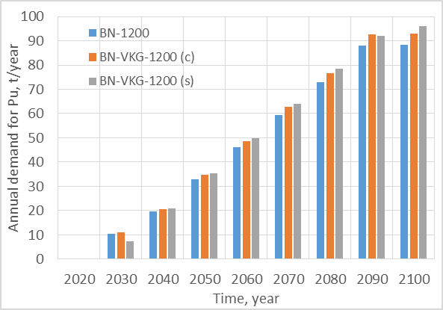
Fig. 5. The annual fast reactors’ demand for Pu, t/year
BN-VKG requires slightly more plutonium for fuel loading at the same fast reactors’ capacity as shown in Fig.5. This fact relates to initial data for fuel loading per reactor. Demand for plutonium after 2090 will stay constant because fast reactors' capacity will not be changed.
The annual amount of plutonium in spent fuel for different types of fast reactor fuel assembly is shown in Fig.6. BN-1200 spent fuel has less quantity plutonium so fast reactors with intra-heterogeneity assemblies are more effective.

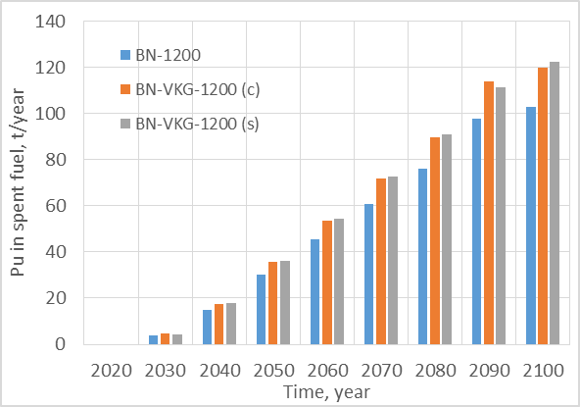
Fig. 6. Annual amount of Pu in spent fuel, t/year (c - co-reprocessing, s – separate –reprocessing)
Separated plutonium balance in the system is shown in Fig.7. Capacities of the reprocessing plants were selected to minimize amount of plutonium for the base scenario with BN-1200. Plutonium amount values for scenarios with heterogeneity assemblies become negative at certain moment, so there will be a lack of plutonium. At the same time, there is a lot of spent fuel for these reactors on long-term storage and it continues to accumulate (Fig.8), therefore lack of reprocessing plants for these scenarios is observed.

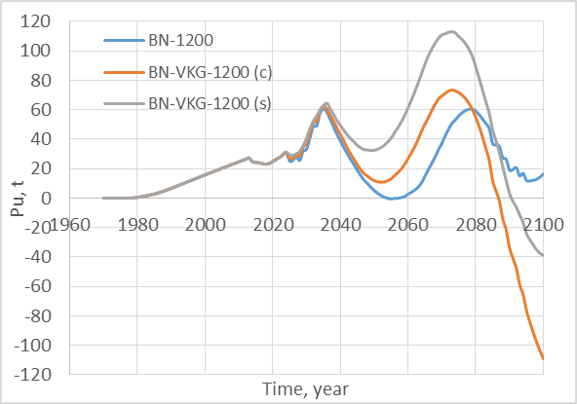
Fig.7. Separated Pu (fissile isotopes) balance, t

The advantage of fertile and fissile fuel rods' separate reprocessing is shown in Fig.7. In this case, separated plutonium is returned in the fuel cycle faster. But additional reprocessing capacities or reducing external fuel cycle duration will be also required for these scenarios near the end of the XXI century. Another solution for this situation will be an increase of BN’s spent fuel reprocessing plant capacity. It will allow increasing of plutonium amount that may be utilized in additional reactors.
VVERs’ and BN-1200s’ spent fuel accumulated in long -term storages is shown in Fig.8. The spent fuel amount is reprocessed partially because of a request for the minimum separated plutonium in the nuclear energy system. It allows to provide security and economy of separated plutonium storage.
The lowest accumulated spent fuel amount is for the scenario with the conventional BN-1200 as shown in Fig.8. Reprocessing capacities are the same for all scenarios, but axial blankets’ loading is significantly less for BN-1200. In case of full plutonium reprocessing there will be plutonium excess in the system for all variants. It should be noted that the whole spent fuel volume for BN-VKG scenarios is significantly larger than BN-1200 one, so it is possible to recover more plutonium. In prospect, this plutonium may be used for VVER like MOX fuel or replace them with additional BNs. Anyway, it allows to reduce natural uranium consumption.

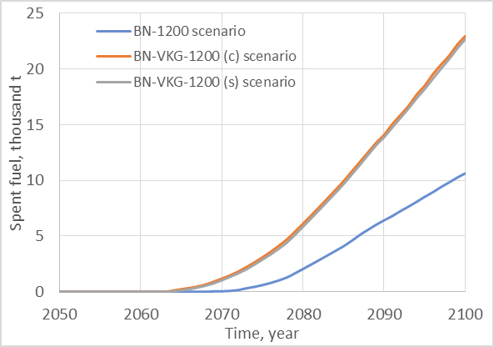
Fig.8 Spent fuel accumulated in long-term storages, thousand t

The difference between BN-1200 b BN-VKG is not fully demonstrated for presented different scenarios' calculations. BN-1200 scenario is balanced while BN-VKG scenarios require additional reprocessing capacities or shorter external fuel cycle. Separate reprocessing gives some advantages like fast plutonium return, but it requires a high reprocessing rate. Larger amount of separated plutonium may potentially improve fuel usage in two-component nuclear energy system for example because of its usage in VVER. It will allow reducing annual natural uranium consumption.
From the INPRO methodology point of view, the considered variants do not respond to the base principles of sustainable development. Natural uranium consumption is too much, significant accumulated spent fuel volume leaves further generations and etc. Thus, additional calculations were made for detection of optimal nuclear energy system structure with investigated fast reactor types.
It is suggested reprocessing of the full spent fuel's amount to reduce the burden for the next generations. It allows getting the additional volume of plutonium for the fuel cycle (Fig. 9).

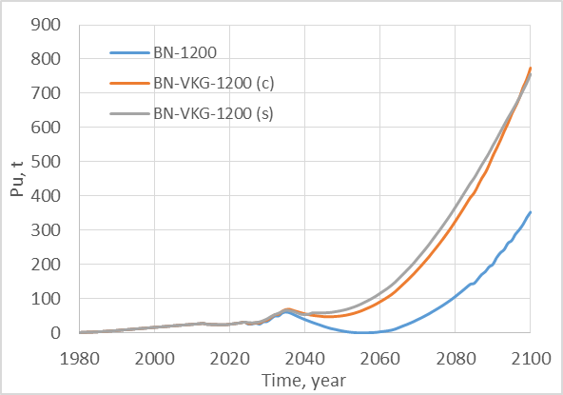
Fig.9. Separated Pu (fissile isotopes) balance in case of unlimited reprocessing capacity, t

There is an excess of separated plutonium for all variants as shown in Fig.9. The difference between co- and separate reprocessing of BN-VKG fuel is insignificant. So further analysis is performed for the variant with co-reprocessing of fissile and fertile isotopes radiated in BN-VKG. Separated plutonium for BN-VKG scenario is accumulated twice as much as BN-1200 scenario because of bigger fuel loading in core and blankets for BN-VKG. This plutonium should be used in a nuclear energy system to reduce natural uranium consumption or put into operation additional NPP capacity if it is necessary. Also, it should be noticed that plutonium storage requires significant expenses and its isotopic composition becomes worse with time.
There is suggested that the NPP capacities will achieve ultimate values by the end of the XXI century so the launching of new reactors operated on plutonium is not considered. Excess plutonium should be utilized inside the established NES. Breeding ratio of fast reactors is more than 1, so usage of plutonium excess there is not efficient. It leads to an additional plutonium accumulation. Consequently, the variant with plutonium utilization in thermal reactors is considered. It will allow reducing natural uranium consumption in conditions of the limited scale of power capacity and a fixed share of fast reactors in NES structure. The part of VVER-TOI fuel loading is replaced by MOX fuel to realize it.
Plutonium will start accumulating after 2060 for the variant with conventional BN-1200 as shown in Fig.9. Therefore it will be loaded in thermal reactors in this period also.

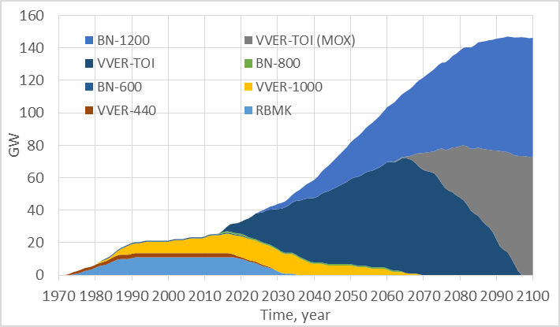
Fig. 10. Installed capacity (BN-1200 scenario), GW
There is enough plutonium to replace part of VVER loading with MOX fuel for all VVERs by the end of the century as shown in Fig.10. Thereby plutonium involvement in the fuel cycle will allow reducing natural uranium consumption.

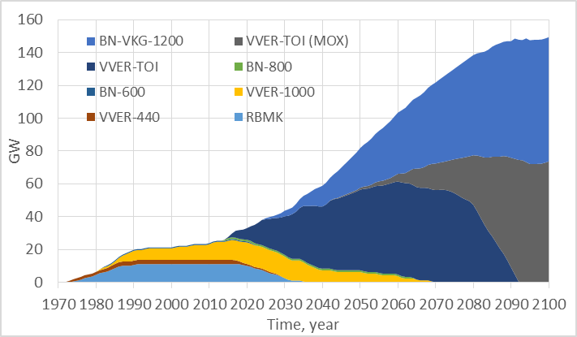
Fig. 11. Installed capacity (BN-VKG-1200 scenario), GW
VVER UOX fuel will be replaced by MOX fuel early for BN-VKG scenario because of plutonium excess on storage. By 2090 all VVERs will be loaded with plutonium (Fig. 11). Significant plutonium stays unused even in the case of partial core loading of VVERs by MOX-fuel (Fig. 12).

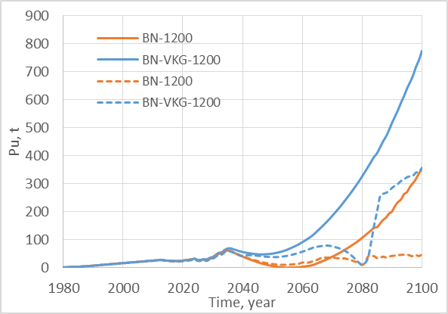

Fig.12. Separated Pu balance for different scenarios (— -reprocessing plant capacities were selected for minimizing of separated Pu, - - – spent fuel is reprocessed completely)

The conventional BN-1200 variant looks more balanced from point of plutonium usage view as shown in Fig. 12. But there is no reserve for unseen circumstances, for example, lack of reprocessing plant capacities or shifting their start operation year. In this case, the sensitivity of BN-VKG variant to change of start operation year for reprocessing plants is lower.
Figure 13 shows the annual VVER-TOI natural uranium requirements for the various options. The capacities of the other types of thermal reactors do not change from option to option, and after the 2030s-2040s, this type of reactor will remain the only one using enriched uranium.
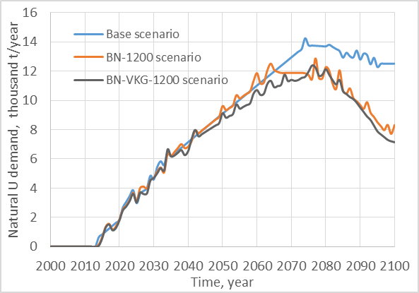
Fig.13. VVER-TOI annual natural uranium demand, thousand t/year
Since the share of fast reactors in all variants is the same and the total power of nuclear power plants does not change, the reduction in natural uranium consumption is carried out by using plutonium in thermal reactors. Figure 13 shows that this approach reduces the annual natural uranium requirements for VVER-TOI by 1.7 times compared to the basic version. Further reduction could be achieved by increasing the share of either fast reactors in the structure of nuclear power plants, or MOX fuel in VVER. In the first case, most of the VVER-TOI has not yet worked out its service life and stopping them ahead of time is not economically profitable, in the second – there is no sufficient justification for the safety of such an arrangement of core.

6 Conclusion
Thus, within the framework of the accepted limitations on the scale of the development of nuclear power plants, a scenario was found that implements the transition to a two-component system with BN and VVER-TOI reactors running on MOX fuel. The advantages of the scenario are:
● Reducing the need for a limited natural resource,
● Removing the burden on future generations,
● Less stringent requirements for the timing of commissioning and the scale of processing capacity,
● Justification of dense fuel.

References

- Zverkov Yu.A, Slessarev I.S., Stukalov V.A., Subbotin S.A. Fast Reactor Fuel Assembly, patent SU 1003676 A. (in Russian)
- Novikov V.M., Slessarev I.S., Alekseev P.N., Subbotin S.A.. et al. Nuclear Reactors with Improved Safety Properties. M.: Energoatomizdat, 1993. (in Russian)
- Alekseev P.N., Balanin A.L., Grol A.V., Nevinitsa V.A., Subbotin S.A., Fomichenko P.A. Assessments of the possibility of minimizing the radiation load in the fuel cycle when using fuel assemblies of fast neutron reactors with intra-cluster heterogeneity. Report of the VI Scientific Seminar «Fuel cycle technology simulation» 24 – 27 Jan 2017. Snejinsk, Chelyabinsk Region, Russian Federation. (in Russian)
- Two-component nuclear power system with thermal and fast reactors in a closed nuclear fuel cycle. Alekseev P.N. et.al ; editor Ponomarev-Stepnoi N.N. — М. : Technosphera, 2016. (in Russian)

