Fuel cycle closure for high power fast neutron reactor

A. Egorov, V. Rachkov, E. Rodina, I. Khomiakov

JSC «Proryv», State Atomic Energy Corporation «Rosatom» Russian Federation, Moscow

E-mail: rea@proryv2020.ru

Abstract
The Russian Federation is developing a number of technologies within the «Proryv» project for closing the nuclear fuel cycle utilizing mixed (U-Pu-MA) nitride fuel. Key objectives of the project include improving fast reactor nuclear safety by minimizing reactivity changes during fuel operating period and improving radiological and environmental fuel cycle safety through Pu multi-recycling and MA transmutation.
This advanced technology is expected to allow operating the reactor in an equilibrium cycle with a breeding ratio equaling approximately 1 with stable reactivity and fuel isotopic composition. Nevertheless, to reach this state the reactor must still operate in an initial transient state for a lengthy period (over 10 years) of time, which requires implementing special measures concerning reactivity control.
The results obtained from calculations show the possibility of achieving a synergetic effect from combining two objectives. To sustain the required reactivity margin on burnup the initial fuel loading includes MA from thermal reactor spent fuel. This should be combined with using reactivity compensators in the first fuel micro-campaigns. The work also considers various options of the core including with axial layer.
The work presents the findings obtained from modeling the entire lifecycle of a 1200 MWe fast reactor, the transition to an equilibrium state and the changes occurring in spent nuclear fuel nuclide and isotopic composition. The work also demonstrates the possibility of completely utilizing MA from thermal and fast reactor spent fuel in next generation FRs without the need of special actinide burners.

Key words: fast reactor, core, minor actinides, nuclear safety

Introduction
Within the «Proryv» project in the Russian Federation a number of technologies are developed as applied to the advanced large-scale nuclear power based on fast reactors operating in the closed nuclear fuel cycle using mixed (U-Pu-MA) nitride fuel.
The use of high-density fuel, such as nitride fuel in the new generation reactors may result in the core breeding ratio close to 1 and feasibility of equilibrium mode with stable reactivity and fuel isotopic composition [1-4].
Since there is controlling influence of reactor characteristics on the requirements to technologies of closed nuclear fuel cycle (CNFC) and arrangement of technologies functioning, then the possibility of associated calculations of fast reactor core and CNFC closing processing stage should be provided. This is necessary for taking into account the effect of possible variations in core arrangement, initial loading, strategy of reaching equilibrium mode, and spent nuclear fuel (SNF) composition on technology components performance and CNFC arrangement.
The substantial problem is caused by the transient from the initial fuel loading based on non-equilibrium composition plutonium extracted from thermal reactors SNF or low active plutonium with small content of even isotopes. As a result of multiple fuel recycling both reactivity behavior and fuel composition show significant changes until their stabilization when reaching equilibrium values.
In order to solve these problems it was necessary to carry out special study using simulation of the core life cycle over the long time period (up to 30-60 years), and to develop necessary instruments (computer codes) and approaches.
Below presented are the results of analytical studies showing the possibility of synergetic effect caused by a combination of two tasks, i.e. implementation of equilibrium mode and utilization of minor actinides (MA) from SNF of fast and thermal reactors. Power fast reactors of the new generation are considered. These reactors are capable of combining cost-effective energy production and radioactive waste reduction without using special actinide burners.

Problem statement and reactor life cycle simulation technique
It was already shown at the stage of preliminary study that during transient period of the reactor operation special measures would be required for controlling excess reactivity over the core lifetime depending on isotopic composition of the initial fuel loading. Physically it is related to successive changes of isotopic composition of the basic fuel components (Pu and U) in the course of their recycling. In order to compensate for these changes and maintain core critical we have adopted a technique of correction of plutonium mass fraction in the mixed fuel to maintain effective multiplication factor keff value at the beginning of each reactor run.
However reactivity behavior with the fuel burn-up depends on isotopic composition of Pu even though fuel breeding ratio maintenance by the above method is taken into account. An additional tool is required to control reactivity behavior. We consider adding MA to the fuel in various proportions to be such a tool.
Another physical process influencing reactivity behavior should be also noted. In the initial core loading there are no fission products, so it has high excess reactivity which should be compensated by means of introduction of fixed absorber-based reactivity compensators (FRC) replacing one row of the fuel subassemblies. This approach was used at the early stage of operation of the Russian fast reactors BN-600 and BN-800. However fuel breeding ratio of the initial core loading is also high, and it also has an effect on reactivity curve in the course of the fuel burn-up. In this paper presented are the results of an effort to use FRC in the optimal way for controlling core BR at the early stage of reactor operation in closed nuclear fuel cycle.
The main problems encountered in the stage of analytical studies included not only the need to equalize fuel composition in the course of reactor refueling during transient operation period before equilibrium reactor mode is reached, but also simulation of refueling system taking into account installation and replacement of fixed absorber-based reactivity compensators at the early operation stage.

Software package RTM-2
RTM-2 software package (SP) has been developed within the framework of “Proryv” since 2013. It is meant for optimization of the core refueling pattern on the basis of actual fuel composition taking into account closing process stages of the fuel cycle. The model assures automatic and on-line calculation of the life cycle of the core fuel within at least 20-30 years time fence taking into account refueling and fuel recycles, this being crucial for correct analysis.
RTM software package is based on computer code set forming digital model of all CNFC process stages:
- core model simulating in detail changes of nuclide composition of each SA fuel during core life time (RTM-R);
- model of intermediate storage, where nuclide composition changes caused by decay of unstable isotopes are monitored (RTM-FC);
- digital models of reprocessing modules describing, as well, discreteness of loading of process stages related to SNF reprocessing (RTM-FC);
- life cycle of containers with reprocessed fuel and nuclide composition of the fuel (RTM-FC);
- fabrication of fuel using raw material on-demand from repository (RTM-FC).
RTM-2 software package is capable of solving the following problems:
- automatic detailed calculation of time-response characteristics of fuel consumption and breeding for all reactor runs in the three main stages: initial loading and partial fuel adding until the start of recycle, transient period until the equilibrium mode is reached, and equilibrium mode operation;
- detailed calculation of fuel nuclide (isotopic) composition and analysis of its effect on reactor performance;
- multiple-option calculations to evaluate the effect of general technological approaches on characteristics of nuclear fuel cycle closure in the stage of development and implementation of Pilot and Demonstration Economic Complex and Industrial and Economic Complex with the aim of choosing ideal options.
The software package ERANOS can be considered as the closest foreign analogue [5].

Results of analysis of life cycle of the core having no axial layer
Sodium cooled large size reactor [6] with mixed nitride uranium-plutonium (MNUP) fuel was chosen for detailed analysis of the whole core life cycle. Its model is presented in Fig. 1. The main characteristics of refueling pattern are given in Table 1.
The core of sodium cooled fast reactor of 2800 MW thermal power consists of 432 hexagonal fuel subassemblies (SA) and 31 control rods.
Studies were performed on the evenly-fractional core refueling pattern used when entering steady state operation mode and during steady state operation period. This pattern implies equal number of subassemblies handled during each refueling cycle and equal refueling intervals. In Table 1 presented is the average number of the core subassemblies replaced during one refueling cycle. Taking into account actual SA refueling groups depending on operation interval, the number of replaced SA is 96 to 101.

1–7 – fuel subassemblies; 8 – control rod; 9 - 10 – shim rods; 11 – safety rod; 12 – passive safety rod (actuated on coolant temperature change); 13 – passive safety rod (actuated on temperature change); 14 – 15 – boron shielding
Fig. 1 – Fast reactor core map

TABLE I – Main characteristics of the core model
Characteristics | Values
Thermal power, MW | 2800
Number of subassemblies | 432
Reactor run duration, eff. days | 330
Number of cycles | 4/5/6
Reactor shut-off for refueling, eff. days | 30
Duration of external fuel cycle, years | 2
Number of takeoff runs, in which “native” fuel is not used | 3
Design lifetime, years | 60

Scenarios under consideration

The following types of fuel have been considered in scenarios under study (Table 2):
- MNUP fuel based on stockpile low active plutonium with addition of waste uranium (0.1% U-235);
- MNUP fuel fabricated on the basis of plutonium having near-equilibrium reactor-grade isotope composition (long-term storage of thermal reactor’s SNF before its reprocessing);
- MNUP fuel on the basis of stockpile reactor-grade plutonium from VVER with high Pu-241 content after the short-term storage.
It is shown hereafter that Pu-241 content is a critical factor influencing reactivity behavior with the fuel burn-up (the closer to equilibrium content about 3-4 %, the better). Maximum Pu-241 content 9.3 % was adopted, while its minimum content in low active plutonium was about 1 % (option 2). MA involvement into the nuclear fuel is effective not only from the standpoint of their transmutation but also with regard to excess reactivity minimization. That is why studies were carried out on all options of fuel isotopic compositions with added MA. The logic was simple: if SNF from thermal reactor is used as plutonium source for fast reactor start-up, then after its reprocessing it is desirable to use not only plutonium, but also all other actinides in the proportion they are present in SNF. In thermal reactor’s SNF max fraction of each actinide (Np and Am) is about 8.5% relative to plutonium amount, in the whole making 17 %, i.e. up to 2.2 % of the total mass of heavy atoms in reactor fuel. Depending on the time of spent fuel storage, Pu-241 and Am-241 fractions will vary, their sum remaining constant. MA fraction in SNF of VVER reactor can be as high as 25 % relative to Pu. As regards fast reactor fuel taking into account Pu enrichment (mass fraction) about 13-14 %, MA fraction in the fuel can reach 3 % value. The ratio between Am and Np is used: Am = 1.2, Np-237 = 1.0. Am isotopic composition: Am-241 = 86.15%, Am-242m = 0.06%, Am-243 = 13.79%.
Initial fuel loadings are characterized by high core BR value, this resulting sometimes in the increase of reactivity with the fuel burn-up and in high value of max excess reactivity. Physically it is caused by the fact that in the initial fuel loading there is no neutron absorption by fission products and, hence, core neutron balance in fresh fuel is better than that in the end of the core lifetime. In order to get over the difficulty it is proposed for the initial operation stage to replace some fraction of the fuel with absorbing material, which would act as a fixed (in contrast to the movable shim rods) reactivity compensator and simulate neutron absorption by fission products.

TABLE II – Isotopic compositions of transuraniums (Pu and MA) in the fuel taken for calculations
Isotopes | Option 1 | Option 2 | Option 3 | Option 4
Pu-238 | 0,015 | 0,0013 | 0,0240 | 0,012
Pu-239 | 0,614 | 0,9172 | 0,6130 | 0,683
Pu-240 | 0,247 | 0,0655 | 0,2180 | 0,232
Pu-241 | 0,0715 | 0,0117 | 0,0930 | 0,028
Pu-242 | 0,049 | 0,0043 | 0,0520 | 0,042
Np-237 | – | – | – | –
Am-241 | 0,0035 | – | – | 0,003
Сумма | 1,000 | 1,000 | 1,000 | 1,000

Results of analysis of fuel composition effect on reactivity balance for the core without axial layer

Results of comparative estimates of reactivity behavior with the fuel burn-up for various compositions of loaded fuel are presented in Fig. 2. It should be noted that reactivity behavior in transient period strongly depends on isotopic composition of initial Pu. Max value of excess reactivity for the fuel burn-up varies from ~0.4 % Δk/k to ~0.8 Δ%k/k with equilibrium value of ~0.2 %Δk/k or even less.
Correlation between excess reactivity and Pu-241 fraction can be seen for reactor-grade plutonium: the higher initial Pu-241 fraction, the more durable and more troublesome transient period. However, in case of low active plutonium having large fraction of the other fissionable isotope Pu-239, as well, stabilization of reactivity curve at the equilibrium level takes maximum time, and maximum value of ~0.8 % ∆k/k is reached. It should be noted that in these options there were no MA in the initial fuel loading, but then their gradual accumulation and recycling took place (except for Cm isotopes).
Results of simulation of transient mode with Np and Am from thermal reactor’s SNF added to the initial fuel loading are presented in Fig. 3. Amount of MA in the fuel varied. It can be seen from the results, that within the framework of adopted approach with realistic МА concentrations reactivity change becomes more favorable, i.e. both reactivity overshoot (reactivity change during the reactor run) and transient period duration decrease.
So, minor actinides act as certain specific “burnable poison”, and their fraction in the fuel can be used as an additional parameter for excess reactivity optimization (Fig. 3).
However the problem arises in the initial reactor runs. It can be seen in Fig. 3 that excess reactivity for the initial fuel loading is present in all options but option 2. It is this fact that is caused by excessive fuel breeding in the early stage of core operation.

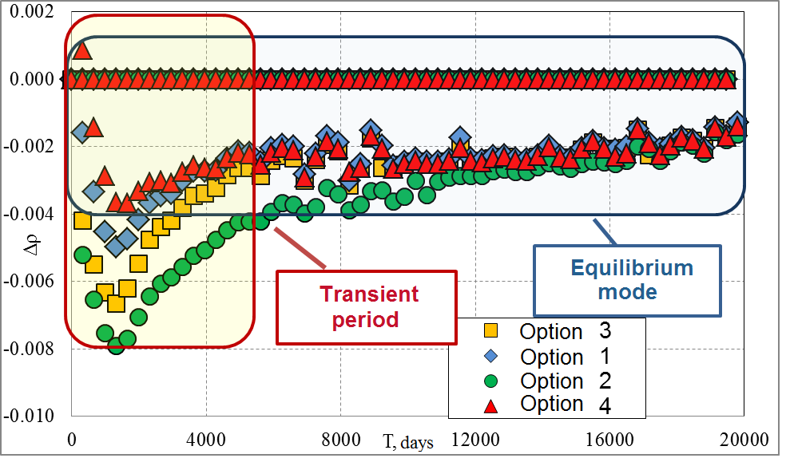
Fig. 2 – Reactivity behavior for the initial options

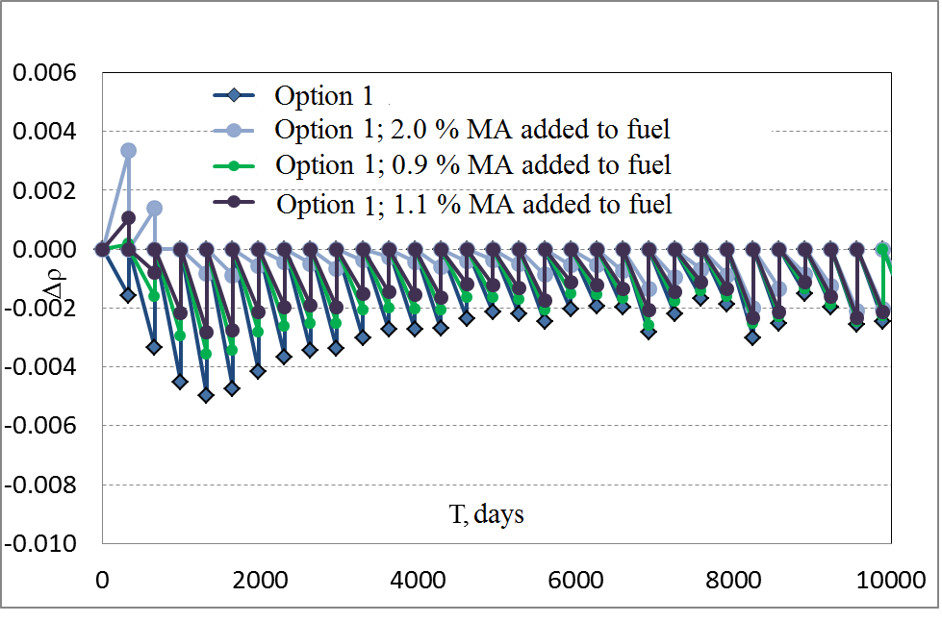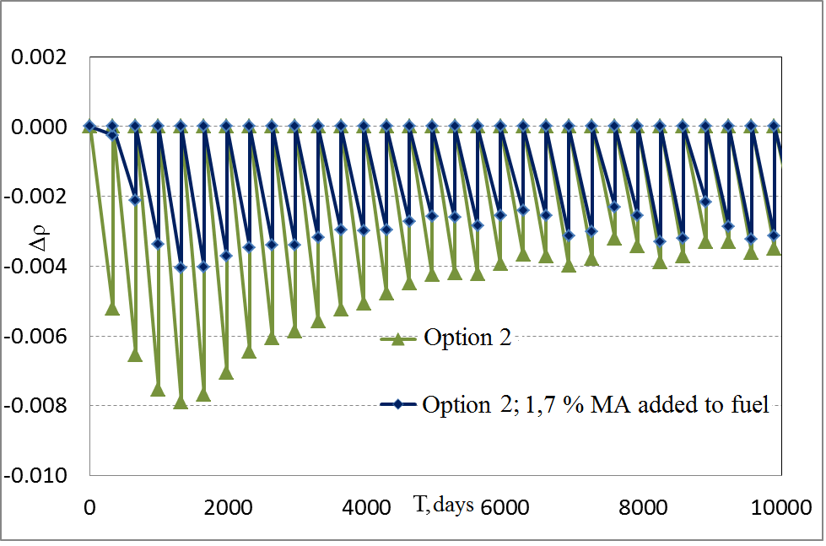
Fig. 3 – Reactivity behavior in the core with minor actinides added to the initial fuel loading (option 1, 2)
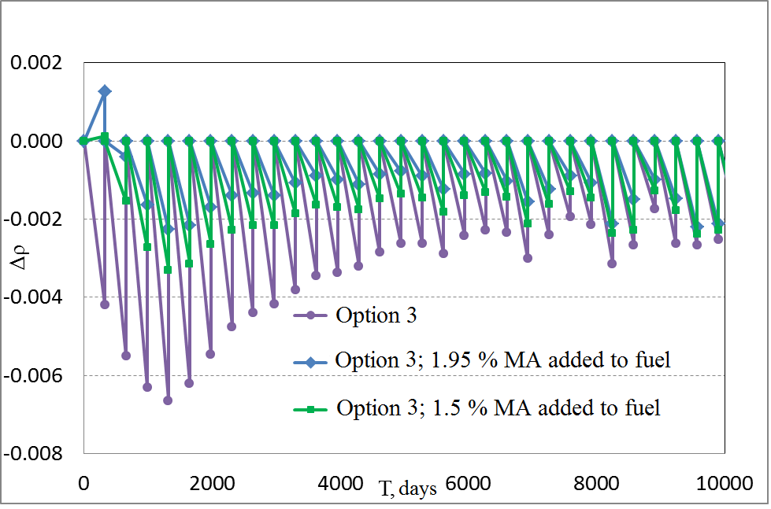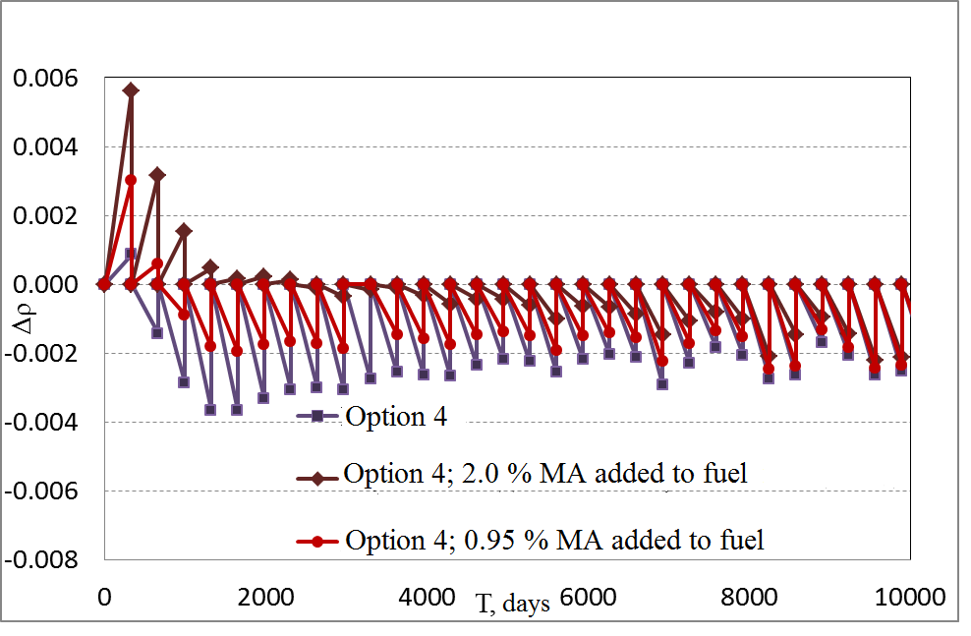
Fig. 3 – Reactivity behavior in the core with minor actinides added to the initial fuel loading (option 3, 4)
Fixed absorber-based reactivity compensators (FRC) were installed in the initial core loading for the purpose of compensation of excess reactivity. Time of FRC presence in the core was optimized according to the goal. The results are presented in Fig. 4. The final MA content was: for option 1 - 1.1%, for option 2 - 1.7%, for option 3 - 1.5%, for option 4 - MA were not added.
It can be stated that simulation has shown the possibility to correct the initial state of reactivity behavior by fitting it within the range of equilibrium state.

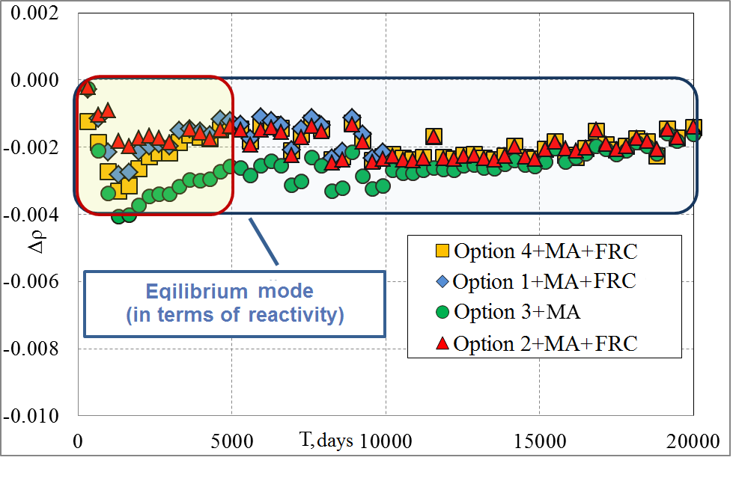
Fig. 4 – Reactivity behavior in the core with minor actinides added to the fuel and installed FRC
Results of calculations presented above have shown that reactivity is being stabilized rather rapidly, characteristic time corresponding to the fuel lifetime. Plutonium composition comes to equilibrium during rather long time period: about 20 years for reactor-grade plutonium and 50 - 60 years in case of using low active Pu. Stabilization of MA isotopic composition takes rather long time: about 30 - 60 years, equilibrium concentration being equal approximately to 0.4 wt.%. This means that MA from VVER’s SNF are completely burnt, and there is a balance between produced and burnt MA of fast reactors, i.e. the rate of MA production is equal to that of their incineration. This can be interpreted as the mode of complete incineration of “native” MA.
Maintaining proper value of excess reactivity for several initial irradiation cycles is most critical from the standpoint of nuclear safety. Besides, reactivity equilibrium is reached much earlier than the entire asymptotic equilibrium state characterized by similarity of compositions of loaded and unloaded fuel, its breeding characteristics and stable reactivity of the whole reactor core.

Results of analysis of SA neutron flux and power patterns
SA replacement with fixed reactivity compensators causes change of SA power and, hence, fuel element linear power. As an example, there presented are the results of calculation of radial power profile of the reactor core for option 1 of fuel composition without FRC and with 6 FRC installed in the core at the beginning of interval (Fig. 5 ).
After 6 FRCs were installed, max power of SA in the bulk increased from 8.13 up to 8.72 MW, and for SA in the outer but one row the increase was from 6.05 up to 6.13 MW. Max linear power of central core subzone SA increased from 448 up to 485 W/cm, and for SA in the outer but one row the change was insignificant, namely: from 477 up to 463 W/cm. So, replacement of 6 fuel subassemblies with FRC resulted in 8 % increase of max linear power of the fuel elements.

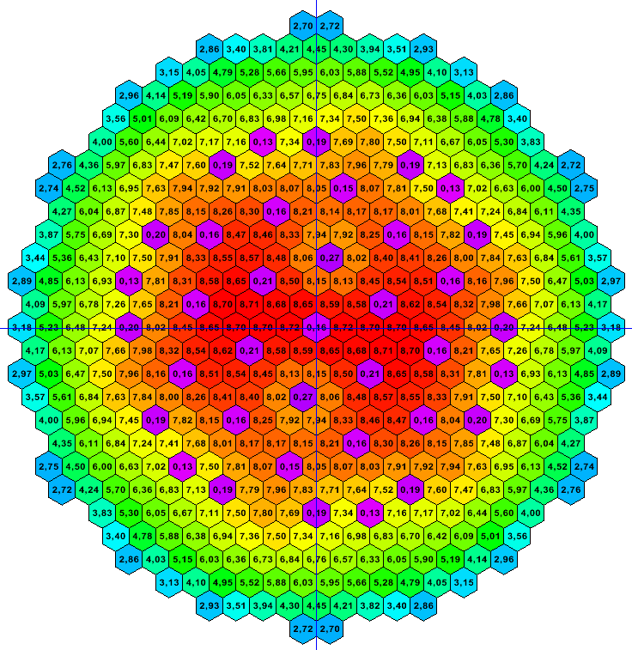
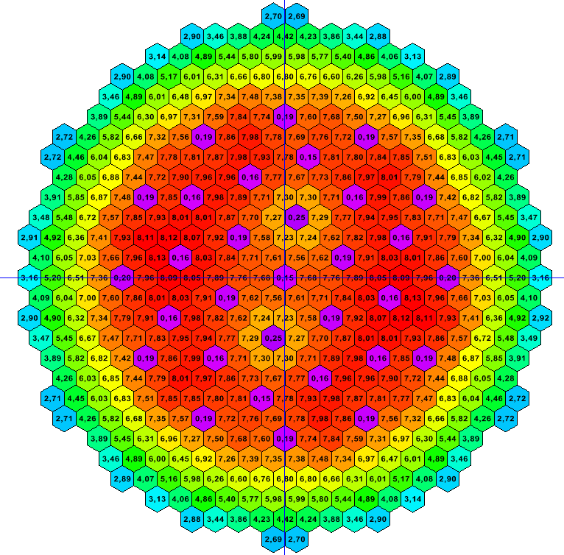

a) b)
Fig.5 – Radial power distribution in the core without FRC (a) and with 6 FRC (b), MW

Results of analysis of life cycle of the core with axial layer
The authors have developed several measures mentioned above allowing reactor to operate within the equilibrium and, hence, safe range reactivity values in the initial transient stage, as well. Thus, the possibility of implementation of equilibrium mode over the entire life time of sodium cooled fast reactor (SFR) has been demonstrated, and so called “time to reach equilibrium state” can be considered almost equal to zero.
In this section described is the effort to elaborate methodology of minimization of excess reactivity by adding MA from VVER SNF to the initial loading of SFR. This methodology has shown its effectiveness in giving the above results on the new core design with axial layer of MNUP fuel. Taking into account modified core structure this option hereafter will be called “heterogeneous”. It is also planned to consider and substantiate the issues of reaching equilibrium mode of CNFC taking into account all possible sources of initial Pu loading.
Longer core life time did not cause any changes in the core arrangement and composition, as well as in refueling pattern. The basic change is the introduction of axial breeding layer into the fuel section.
Fuel scenarios studied here are the same as those considered for the core having no axial layer.
Fig. 6 shows reactivity behavior with the fuel burn-up for various options of the core with axial breeding layer. It can be seen that excess reactivity for the fuel burn-up is sensitive to the isotopic composition of initial plutonium loading and the fuel added during reactor operation. In the initial stage of transient operation period before equilibrium asymptotic mode is reached, reactivity change during one reactor run can be as large as 0.6 % ~k/k because of variations in isotopic composition of the initial plutonium loading.

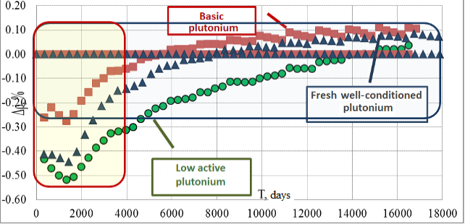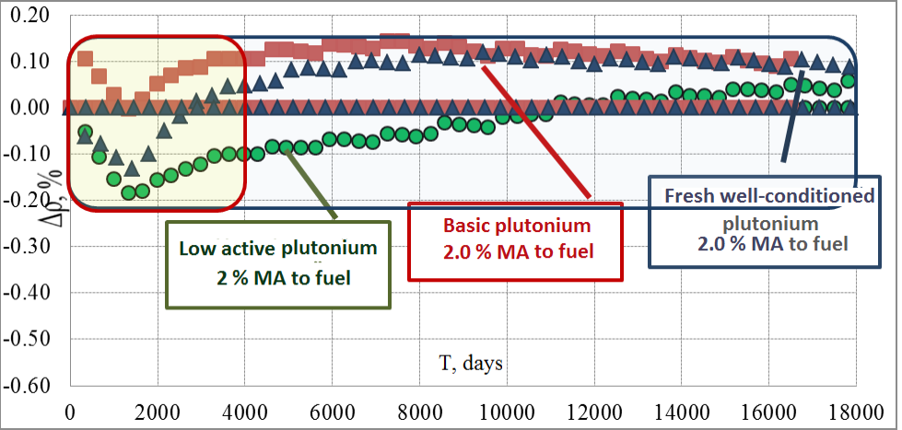
Fig. 6 – Reactivity behavior for the initial Fig. 7 – Reactivity behavior in the core
options with minor actinides added to the fuel

In order to decrease excess reactivity value for the fuel burn-up, minor actinides produced in VVER reactors were introduced into the fuel cycle in amount of 2.0 % of heavy metal fuel, as it was in case of the care without axial layer. Results of analysis are presented in Fig. 7. MA concentration value seems to be sufficient for incineration of both native MA and those taken from reprocessed SNF of VVER.
Results of calculation show that this makes it possible to meet the requirement of max excess reactivity value 0.4%. In this case, in the core operating in equilibrium mode there are excess fuel breeding and positive reactivity growth.
Studies were carried out on the option with MA added to the axial breeding layer and MA recycle in the layer, i.e. heterogeneous incineration of MA in the fuel elements was simulated. Calculation results are given in Fig. 8. Adding MA to the axial layer did not result in the decrease of excess reactivity value during the first reactor run. Starting from the second reactor run the effect of MA on excess reactivity became significant. Calculations have shown that upon completion of the first reactor core life time excess reactivity meets the requirement of max permissible value 0.4%.

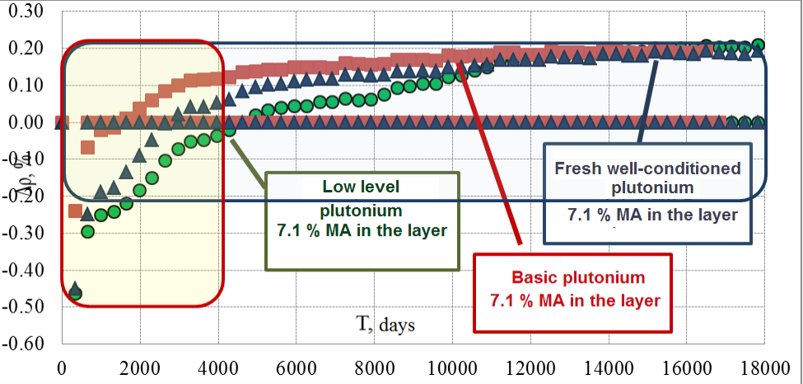
Fig. 8 – Reactivity behavior in the core with minor actinides added to axial breeding layer
Proceeding from CNFC conditions, reactor mainly operates in equilibrium (in terms of reactivity) mode requiring significantly lower excess reactivity value for the fuel burn-up:
- homogeneous core: 0.2%Δk/k – CNFC, as compared to 0.5% Δk/k (for basic composition) and up to 0.8% – open nuclear fuel cycle (ONFC);
- heterogeneous core in equilibrium mode is always characterized by positive reactivity overshoot, i.e. good excess fuel breeding;
- this core in ONFC has negative reactivity overshoot up to 0.5 % Δk/k.
Open nuclear fuel cycle implies fuel delivery to the reactor from the repository during the whole reactor life time.
This may mean the difference in the choice of optimal core design depending on its commitment to either ONFC or CNFC.
Excess fuel breeding can be used for further core optimization, for instance, to increase MNUP fuel burn-up.

Conclusion
Set of studies performed has shown the possibility of organic combination of solving MA transmutation problem with assurance of high level of nuclear safety inherent to fast neutron reactors with equilibrium core. In contrast to the other factors, MA application has a positive impact on max excess reactivity value, and MA mass fraction parameter can be used for optimization of the transient mode preceding equilibrium mode of CNFC.
Calculations show the possibility of operation of various core designs with equilibrium reactivity maintained over the whole life cycle of the reactor. It is proposed to specify and separate concepts of “equilibrium core”, i.e. the core in which reactivity change value with the fuel burn-up during the core lifetime does not exceed keff, and “equilibrium fuel” which is formed in the course of multiple recycling of reprocessed fuel irradiated in the equilibrium core with BR~1.
Hereby, U and Pu multiple recycling and MA transmutation in power fast reactors facilitate solving the problem of utilization of radwaste from thermal reactors SNF reprocessing with subsequent complete incineration of produced Np and Am in fast reactor fuel without introduction of purpose-designed burner reactors into the nuclear power system.
References:
[1] V.I. Rachkov, E.O. Adamov, A.V. Lopatkin, V.A. Pershukov, and V.M. Troyanov. Fast reactor development programme in the Russian Federation (FR 13) // INTERNATIONAL ATOMIC ENERGY AGENCY, Fast Reactors and Related Fuel Cycles: Safe technologies and sustainable scenarios. March 4‐7, 2013, Paris, France, pp. 93-102.
[2] E.O. Adamov, V.V. Orlov, V.I. Rachkov, et al. Nuclear power with inherent safety: exchange of obsolete paradigm, and criteria // Proceedings of the Russian Academy of Sciences. Power Engineering, 2015, No.1, pp.13-29.
[3] E.O. Adamov, L.M. Zaboud’ko, V.I. Matveev, et al. Comparative analysis of advantages and drawbacks related to the use of metal and mixed uranium-plutonium nitride fuel in fast reactors// Proceedings of the Russian Academy of Sciences. Power Engineering, 2015, No.2, pp.3-15.
[4] E.O. Adamov, A.V. Lopatkin, V.I. Rachkov, et al. Radiation-equivalent circulation of radioactive nuclides in nuclear fuel cycle – effective alternative to the deferred solution of the problem of accumulation of spent nuclear fuel// Proceedings of the Russian Academy of Sciences. Power Engineering, 2015, No.6, pp.15-25.
[5] Jiri Krepel, Vladimir Brankov, Konstantin Mikityuk. Selection of initial fuel composition for the ESFR core based on the knowledge of its equilibrium closed cycle parameters // (FR 13) // INTERNATIONAL ATOMIC ENERGY AGENCY, Fast Reactors and Related Fuel Cycles: Safe technologies and sustainable scenarios. March 4‐7, 2013, Paris, France (IAEA-CN-199-159)
[6] B.A. Vasiliev, et al. Development of the new generation power unit with the BN-1200 reactor. (FR 17) // INTERNATIONAL ATOMIC ENERGY AGENCY, Fast Reactors and Related Fuel Cycles, June 26-29, 2017, Yekaterinburg, Russian Federation (IAEA-CN-245-402).

