**THE INITIAL STAGE OF CLOSING THE NFC OF TWO-COMPONENT NUCLEAR POWER. CHALLENGES AND SOLUTIONS**

A.V. GULEVICH

State Scientific Center of the Russian Federation - Leypunsky Institute for Physics and Power Engineering, Joint-Stock Company (IPPE JSC)

Obninsk, Russian Federation

V.M. DEKUSAR

IPPE JSC

Obninsk, Russian Federation

E-mail: decouss@ippe.ru

A.L. MOSEEV

IPPE JSC

Obninsk, Russian Federation

V.V. KOROBEINIKOV

IPPE JSC

Obninsk, Russian Federation

**Abstract**

When transferring to two-component nuclear energy system (NES) at the initial stage of closing the nuclear fuel cycle (NFC) in Russia, the number of fast breeder reactors BN type fuelled with plutonium do exist to a small extent, and stocks of separated plutonium already are sizable and continue to grow due to pilot reprocessing spent nuclear fuel (SNF) of VVERs. Therefore, for this period of time, it is proposed to abandon reprocessing the SNF from the BN reactors, i.e. to operate in the "open in plutonium" cycle with storage of this SNF. The results of scenario studies show that the amount of plutonium extracted from VVER SNF is sufficient for commissioning and continuing operation of a small series of BN reactors. In addition, it is possible to abandon a radial fertile blanket (RFB) in a fast reactor. According to our estimates, it is worthwhile to start full-scale reprocessing of BN SNF closer to the middle of this century, when we can expect the quantity of BN SNF to be sufficient to reduce significantly the reprocessing unit cost. This approach will reduce the levelized unit fuel cost (LUFC) of electricity production by ~25%, while reducing the total levelized unit electricity cost (LUEC) to 5%.

The transfer of the Russian nuclear power (NP) to the regime of a two-component nuclear power system (NPS) with thermal and fast reactors in accordance with the Development Strategy of the Russian NP [1] is the strategic goal of ROSATOM State Corporation for the coming decades. In this regard, the governing body of Rosatom sets the task of accelerating the closure of the fuel cycle of thermal and fast reactors at the pilot-industrial level. At present, when there are opportunities for variable scenarios for achieving this goal, due to objective technological uncertainties, as well as the uncertainty of the country's economic development rates, reasonable planning and implementation of the initial stage of NFC closure is the most difficult and crucial moment. In this case, when choosing a scenario for the initial stage of NFC closure, one of the possible criteria is the criterion of minimum capital costs.

In order to select the most effective option, a feasibility study was carried out for the commissioning scenarios of the head unit and a small series of fast reactors. The BN-800 reactor, which has been in operation since 2016, and high-power BN reactors (BR = 1.2) with MOX fuel, were considered as fast reactors. For high-power BN reactors, a variant with an axial layer and with an average core fuel burnup of about 13% was considered.

The chosen scenario is an innovative development of the existing NP, mainly with thermal reactors with the closure of the fuel cycle using BN reactors. In the scenario up to 2035, 17 VVER-1200 reactors using uranium oxide fuel are commissioned. In addition to them, while ensuring the values ​​of the installed capacity at the "control points" in 2035 (~ 39 GW) and in 2050 (~ 40 GW), and falling into the corridor of the installed capacity of 60–90 GW in 2100, 9 power units of commercial reactors of the BN type of high power are commissioned until 2050. SNF from all thermal reactors, except for RBMK-1000, is completely reprocessed and all plutonium is used to make MOX fuel for the BN-800 reactor and BN reactors of high power.

This option ensures a steady increase in the installed capacity of the system up to 91 GW by 2100, as well as complete disposal of VVER SNF by 2050. It should be noted that the limitation imposed in this scenario on the corridor of the attainable installed capacity for 2100 does not allow the complete utilization of BN SNF until 2100 - about 900 t of BN SNF remain in the remainder. At the same time, the volume of separated plutonium corresponds to the operational reserve for regular loadings and launch of new reactors. The consumption of natural uranium in the NP is about 520 thousand tons of U up to the design life of all commissioned thermal reactors.

The complete disposal of the specified remainder of plutonium together with the VVER SNF reprocessed "off the wheels" makes it possible to develop the installed capacity of the system up to ~ 120 GW by 2130. Another additional ~ 5 GW can be obtained by using regenerated uranium in thermal reactors.

After 2130, all uranium-fuelled thermal reactors are decommissioned through exhausting natural uranium reserves and the system goes into an almost stationary state ‒ the installed capacity growth is possible with a doubling time of about 100 years. It is assumed that, under certain conditions, thermal reactors using uranium fuel can be replaced by thermal reactors of the next generation using MOX fuel. Figure 1 shows the structure of the installed capacities of the considered scenario.

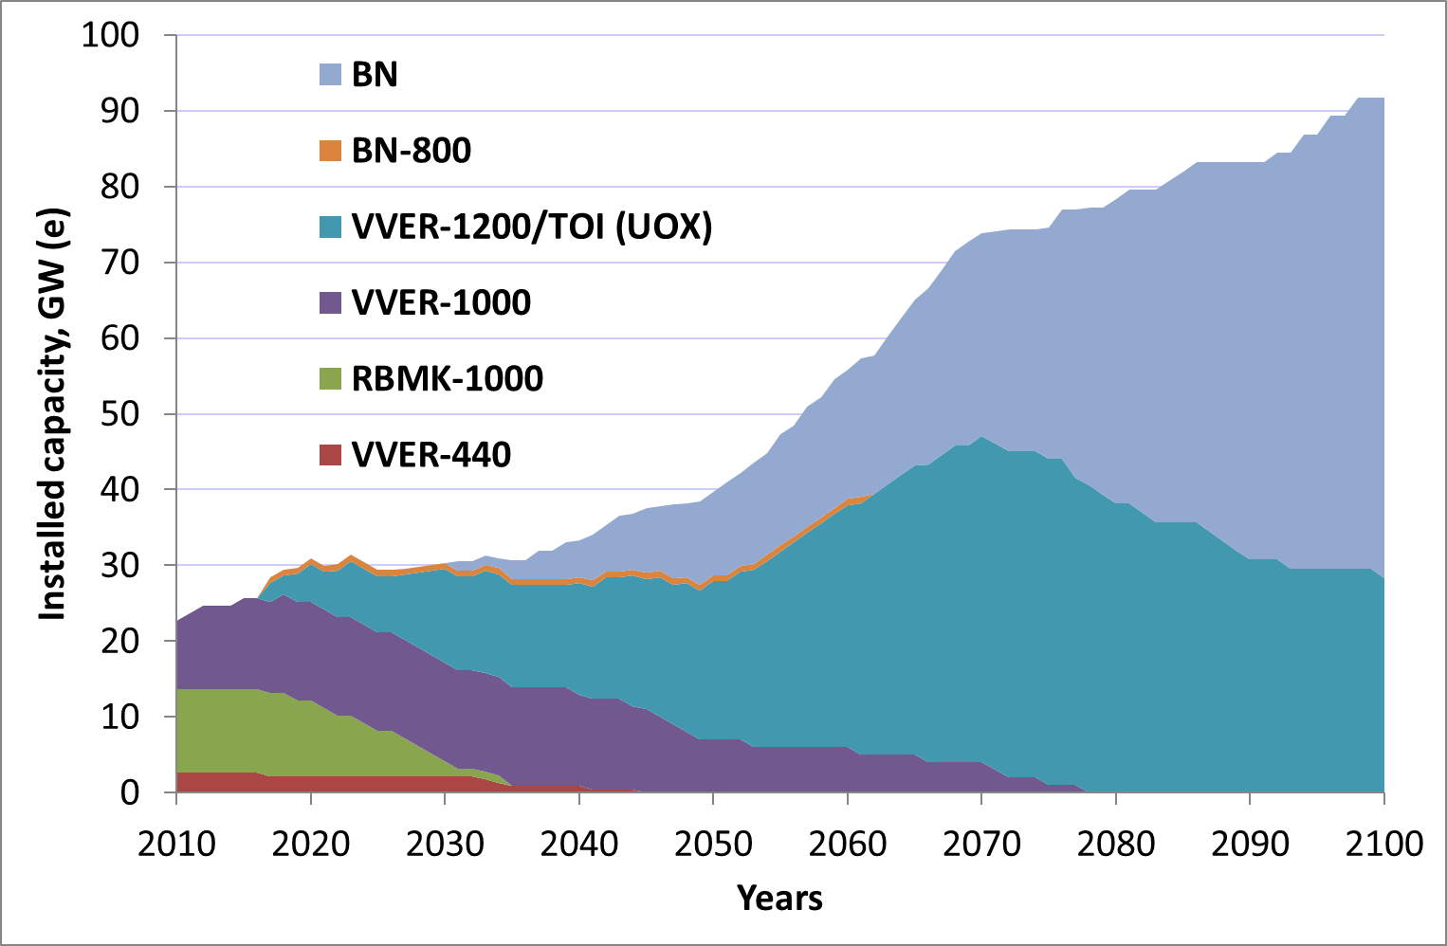

*FIG. 1. Power structure in the considered scenario VVER (UOX) + BN (MOX)*

The SNF reprocessing scenario is based on the condition that the operational stock of separated plutonium during the considered time interval does not exceed 100 tons. At the same time, despite the fact that the separated plutonium stocks are at the operational level, and the amount of SNF from VVER and BN is minimized, the accumulation of plutonium in SNF of the external fuel cycle is significant - by 2050 it reaches 300 tons, and by 2100 - 500 tons.

Analysis of the current state of plutonium stockpiles (about 60 tons by 2019) and the results of fuel cycle modeling showed a significant amount of plutonium available in thermal reactor SNF by the time the head commercial BN reactor will be put into operation. Its quantity turns out to be sufficient for starting up and continuing to operate the head unit until the end of its design life (60 years). Moreover, this plutonium turns out to be sufficient for the launch of several more serial BN reactors. Thus, a deficit of plutonium in the considered scenario of the NP development is not expected at least until the middle of the century.

Under these conditions, it seems expedient to consider the scenario of the initial stage of the transition to a two-component NPS with fast reactor MOX SNF delayed reprocessing for the period after 2040. BN reactors essentially operate during this period in an "open" plutonium cycle.

Refusal from the head and first serial BN reactor SNF immediate reprocessing leads to the abandonment of the capital expanses for low-tonnage economically ineffective reprocessing, as well as, accordingly, to a noticeable decrease in the annual fuel expenses of nuclear power plants. This is due to the fact that the specific cost of reprocessing substantially depends on the productivity of the radiochemical plant for reprocessing, which in turn is determined by the amount of BN SNF to be reprocessed in the fuel cycle. The performed analysis showed that the reprocessing of spent nuclear fuel from a single fast reactor cannot be economically justified. From this point of view, an acceptable number of power units BN type reactors of high power, at which a significant (approximately 2 times) reduction in the specific cost of reprocessing is achieved, is the number of at least 6-9 power units (Figure 2).



*Fig. 2. - Specific cost of SNF reprocessing on plant productivity*

In addition, in the conditions of the plutonium excess and the absence of a sharp increase in demand for electricity, at the initial stage it is possible to abandon the radial fertile uranium blanket, which is currently envisaged in the BN reactor design, temporarily replacing it with a steel one. In this case, the costs for its manufacture and reprocessing, which are included in the fuel expenses, are eleminated.

Table 1 shows the results of the assessment of the levelized unit fuel cost (LUFC) of electricity generation at a power unit with a high-power BN-type reactor in case of refusal to reprocess core fuel assembly (FA) SNF. In this case, a variant of the reactor without a radial fertile blanket (RFB) is considered, too. Naturally, the cost of its manufacture is also eleminated. However, an option with a RFB is also possible, but with postponed reprocessing until the needs for plutonium. The choice in favor of one or another option is possible in the future based on the projected demand for electricity.

The calculations were carried out using the FCCBNN code [4] with the recommended in [2] the fuel cycle conversion specific costs, which correspond to the above-mentioned 6-9 power units of the BN type. In this case, the discount rate was adopted equal to 5%.

As can be seen from the presented data, the abandonment of the BN SNF reprocessing, as well as from the radial fertile blanket, at the initial stage leads to a significant decrease in the LUFC.

Table 1. LUFC values, US$/MWh (10-3US$/kWh)

|  |  |  |
| --- | --- | --- |
| Fuel cycle stage | With fertile blanket | With steel blanket |
|  | Front-end | |
| Core FA manufacturing | 5,13 | 5,13 |
| RFB FA manufacturing | 0,21 | - |
| Fresh core FA transportation to NPP | 0,14 | 0,14 |
| Fresh RFB FA transportation to NP | 0,07 | - |
| Total for front-end stages | 5,56 | 5,27 |
|  | Back-end | |
| Spent core FA transportation to reprocessing | 0,09 | 0,09 |
| Spent RFB FA transportation to reprocessing | 0,04 | - |
| Intermediate storage of core spent FA | 0,01 | 0,01 |
| Intermediate storage of RFB spent FA | 0,01 | - |
| Core spent FA reprocessing | 0,67 | - |
| RFB FA reprocessing | 0,30 | - |
| RW final isolation | 0,10 | - |
| Total for back-end | 1,22 | 0,10 |
|  | Total cost | |
| Total cost | 6,78 | 5,37 |

from US$ 6.8/MWh to US$ 5.4/MWh, or by 26%, and the overwhelming part (21%) of the decrease is due precisely to the refusal to reprocess spent nuclear fuel. Taking into account that the fuel cost for fast reactors usually amounts to about 15 - 20% of the total cost, we find that the refusal to reprocess SNF leads to a decrease in the total cost by about 4-5%.

At the same time, in order to eleminate a possible shortage of plutonium for launching new fast reactors in the long term, as well as in order to improve the plutonium vector from MOX fuelled thermal reactor [2, 3], it is worthwhile to provide for the possibility of returning a radial fertile blanket during reactor operation. On the other hand, an excess of plutonium associated with the reprocessing of foreign SNF from thermal reactors or RBMK reactors is not ruled out in the future. In this regard, proposals for a BN-type reactor with controlled plutonium breeding become relevant [5].

Thus, at the initial stage of the transition to a two-component nuclear power system with a closed fuel cycle, the duration of which is determined by the rate of commissioning of BN and VVER reactors and the plutonium stockpile , fresh fuel for initial loading and regular loading is made on the basis of plutonium separated from VVER SNF. In doing so, there are a rapid decrease in the amount of the SNF and its conversion into a more concentrated form of plutonium fuel for fast reactors. As the plutonium reserves are depleted and the SNF from thermal reactors is reduced, plutonium from the spent nuclear fuel of VVER reactors is replaced by plutonium from the BN reactor spent nuclear fuel. If by this time the number of BN units in operation will noticeably increase, reprocessing their spent nuclear fuel (as well as manufacturing fresh MOX fuel) will become significantly cheaper, then closing the fuel cycle will become more economically justified. Preliminary estimates show that the transition to a large-scale NP based on fast reactors, but with SNF reprocessing, can lead to a decrease in LUFC to values ​​of about 4 US$/MWh, which will lead to a decrease in the levelized unit electricity cost by 8-11% .

**References**

1. ALEKSEEV P.N., GAGARINSKY A.YU., KALUGIN M.A. and others. Towards a strategy for the development of nuclear power in Russia, Atomic Energy, vol. 126, no. 4, p. 183-187, 2019.
2. Two-component nuclear power system with thermal and fast reactors in a closed nuclear fuel cycle. Edited by Academician of the Russian Academy of Sciences Ponomarev-Stepniy N.N., Technosphere - Moscow, 2016.
3. ELISEEV V.V, KLINOV D.A., CAMARCAT N., LEMASSON D., MÉRIOT C., PERSHUKOV V., TROYANOV V., VELARDO H.. On the possibility to improve mixed uranium-plutonium fuel in fast reactors. Nuclear Energy and Technology, 6 (2): 131-135 (25 Jun 2020).– URL: <https://nucet.pensoft.net/issue/2955/>
4. DEKUSAR V.M., KOLESNIKOVA M.S., CHIZHIKOVA Z.N. Methodology and the code for calculating the fuel cost of electricity production at nuclear power plants with thermal and fast reactors. Preprint IPPE, FEI-3243, Obninsk, 2014.
5. MOSEEV A.L., DEKUSAR V.M., KOROBEINIKOV V.V., ELISEEV V.A. Investigations of the potential of a two-component nuclear power system under different conditions of its development VANT, Series Nuclear-reactor constants, Issue 2, 2019, pp. 195-21