**ANALYSIS OF THE SGTR ACCIDENT FOR SAFETY JUSTIFICATION OF TWO-CIRCUIT LEAD COOLED REACTOR**

I.E. SHVETSOV

JSC «Proryv»

Moscow, Russian Federation

Email: [shuye@proryv2020.ru](mailto:shuye@proryv2020.ru)

I.S. KHOMYAKOV, V.I. RACHKOV, I.R. SUSLOV

JSC «Proryv»

Moscow, Russian Federation

**Abstract**

Lead cooled reactor BREST-OD-300 design is under development as part of a Russian federal project "PRORYV". Two circuits are used for heat removal from the reactor. The special feature of the two-circuit heat removal system is the potential risk of steam ingress into the core in case of large leak in the steam generator as a result, for example, of steam generator tube rupture (SGTR). The main concern is caused by the possibility of positive reactivity insertion in case of steam ingress into the central section of the core because this can have an impact on nuclear safety.

The analysis of physical phenomena that are important for correct prediction of SGTR accident consequences was performed and it was concluded that for correct modelling of the transient in the core in the case of steam injection the following procedures are required:

a) Accurate modelling of neutronics and thermal-hydraulics taking into account their coupling;

b) 3D modelling of the accident considering strong non-symmetry of spatial distribution of concentration of steam entering the reactor core during the accident.

3D multi-physics (neutronics + thermal-hydraulics) UNICO-2F code was developed for studying SGTR accident. The code is capable of calculating transient 3D spatial distributions of coolant velocity, pressure and temperature, as well as steam concentration and power density in the core.

The analysis of BREST-OD-300 reactor parameters under SGTR accident conditions was performed and it was shown that even for the most conservative scenario of the accident maximum (during the transient) fuel pin cladding temperature was kept within permissible limits. Therefore, the self-protection of BREST-OD-300 reactor in case of SGTR accident was confirmed.

## INTRODUCTION

The Lead cooled 700 MWth BREST-OD-300 reactor design is under development in the Russian Federation within the framework of “Proryv” project. Two circuits are used for heat removal from the reactor, without intermediate heat transport system. A consequence of the elimination of such system is the need to address the potential risk of steam ingress into the core in case of large leak in the steam generator (SG).

The main concern is caused by the following two aspects of the initial failure:

A) possible loss of integrity of the primary circuit caused by internal pressure increase; and

B) possible positive reactivity insertion because of steam penetration into the central section of the reactor core resulting in its excessive temperature increase.

Until now, attention has been mainly paid to the first one of the above two problems. The review [1] presents information about the progress in the area of mathematical and experimental simulation of phenomena of water or steam injection into some volume or the circuit filled with heavy metal coolant. Analytical studies of consequences of SG tube double-ended guillotine rupture are described in [2] as applied to the medium size European Lead Fast Reactor (ELFR) [3]. Calculations made using SIMMER-III code have shown that pressure increase in this accident could result in structural damage of the steam generator, however, more likely, it would be no threat for reactor structure.

In [4] presented are the results of analytical studies of behaviour of parameters of small size (10 MW) reactor in case of SG tube double-ended guillotine rupture as an initial event. Studies were made using new Chinese Neutronics and Thermal-hydraulics Coupled Code (NTC). Pressure change in the area of the tube rupture is shown, as well as the process of steam transport in the primary circuit to the reactor core. It was shown that although steam reached the reactor core, its volume fraction was within 0.1%.

Detailed analytical studies of the process of steam propagation through the primary circuit of the medium-size European lead cooled reactor ELSY were made using CFD code [5]. Bubbles movement was simulated within the framework of Lagrangian approach. The flow rate of steam and its amount entering the reactor core were evaluated for various leakage locations, steam bubble sizes and amounts of impurities in the coolant. However, the overall goal of the reactor safety analysis is justification for the fact that under this accident conditions no safe operation limits specified for the reactor are exceeded, including max permissible temperature of the fuel element cladding. In order to reach this goal, the following procedures should be performed:

a) Accurate modelling of neutronics and thermal-hydraulics taking into account their coupling, and

b) 3D modelling of accident considering significant non-symmetry of spatial distribution of concentration of steam entering the reactor core and strong dependence of void reactivity effect on radius.

Multi-physics (neutronics + thermal-hydraulics) UNICO-2F 3D code was developed for studying SGTR accident. The code is capable of calculating transient 3D spatial distributions of coolant velocity, pressure and temperature, steam concentration in the coolant and power density in the core, as well as fuel and cladding temperatures distribution over the core.

## Some features of BREST-OD-300 reactor design

Heat is removed from BREST-OD-300 reactor core (Fig. 1) by four independent loops with two steam generators connected in parallel in each loop.

In case of SG leakage, steam from damaged tube first enters SG shell side, and then the generated bubbles carried away by the coolant flow are moving along the path “main pump suction chamber – main pump – main pump pressure chamber (MPPC) – inlet ring duct – reactor downcomer section – core diagrid – core”. Steam fraction supplied to the core inlet depends on several factors and, primarily, on the steam bubble size, since this parameter governs the effectiveness of bubbles separation into gas plenum of the reactor on their way to the reactor core. The initial bubble size is determined by the conditions in the rupture point, in particular, by the rupture configuration and actual pressure difference between the primary and the secondary circuits. Moreover, steam bubbles formed after SG tube rupture have different sizes, and bubble size spectrum depends on the outflow conditions. SG tube double-ended guillotine rupture is usually taken as an initial event for safety analysis. The steam flows out of two ends of failed tube. It should be noted that, from the standpoint of steam entrainment to the core, the consequences of double-ended guillotine rupture of SG tube are less adverse than those of appearance of a long narrow crack in the tube wall, since in the latter case the probability of small size bubbles formation is higher, and the small bubbles are not readily separated. While moving in liquid lead, steam bubbles would either break down into smaller bubbles or, vice versa, coalesce into larger bubbles, depending on flow characteristics, ultimately reaching the reactor gas plenum.



*FIG. 1. Lead flow in the primary circuit and decay heat removal system circuit.*

Many publications have been devoted to determination of raising velocity of bubbles in liquid. In particular, relationships worked out by Peables and Garber [6] are considered the most universal [6]. These relationships are also recommended for studying cases with significant density difference between liquid and gas. Similar relationships obtained on the basis of criterial analysis were proposed by Berdnikov (Fig. 2) [7].



*FIG. 2. Gas bubble raising velocity bubble radius in liquid lead and liquid steel (according to V.I. Berdnikov [7]).*

The primary circuit of BREST-OD-300 reactor was intentionally designed to assure to max extent separation of the steam into the cover gas though free surfaces while it passes through MPPC. In this view the main pump pressure chamber in which the pressure is low (1bar in MPPC gas cavity) works as effective separator. Steam pressure and, hence, volumetric steam quality depends on the local pressure in the given point. Vapor bubbles entering into the chamber are expanded and are raised up to the free surface. If steam volumetric fraction reaches some critical value, namely: max possible packing density of balls in a volume φ*max*= 0.74048, then it means that all bubbles in this volume unit, without regard to their size, would coagulate to form one large steam bubble having raising velocity sufficiently high for it to inevitably separate. This imposes constraint on pass-through function of the MPPC. According to estimate, steam pass-through capacity of BREST-OD-300 reactor is limited by value – Gv = 0.58 kg/s (Knowing coolant mass flow rate through the MPPC and pressure in it one can estimate the dependence of vapor volume fraction in the flow crossing the MPPC on mass flow rate of vapor entering the chamber. Vapor volume fraction grows up with increasing of vapor mass flow rate and at Gv = 0.58 kg/s it reaches the value 0.74048). It is very important that this limitation does not depend on either size of bubbles moving through the MPPC or flow rate of steam entering MPPC. Thus, the limitation will remain in force if the possibility of multiple ruptures of steam generating tubes is postulated, although this accident is extremely improbable since impossibility of escalation of single tube rupture to multi-rupture accident has been proved experimentally for the steam generator of BREST-OD-300 reactor [8].

The only exception is hypothetical accident, when large leaks occur simultaneously in several loops, however, the probability of such event is extremely negligible.

## UNICO-2F code and analytical model

The UNICO-2F code structure is shown in Fig. 3.

The code consists of three main modules, their functions being described below.

«SVIR» - calculation of velocity, pressure and temperature of coolant within computational domain, which, in this case, includes reactor downcomer section and reactor core, and temperature of structural elements, fuel and cladding (heat and mass transfer equations set is solved to approximation of the model of viscous ideal liquid flowing in porous body in Cartesian or cylindrical coordinate system; there is a model of thermal conductivity of multilayer cylindrical element bounded by the coolant flow, which can be used for evaluation of 3D temperature distribution in the fuel elements).

«DENS_V» - calculation of steam concentration within computational domain.

«MAG» - calculation of reactor core power profile taking into account steam concentration variable (MAG neutronics module was designed on the basis of similarly-named code [9], which was meant to solve steady state and transient neutron transport equations within the framework of diffusion approximation using parameterized constants method).



*FIG. 3. General structure of UNICO-2F code.*

Computational domain (Fig. 4) is covered by non-uniform Cartesian difference mesh having 39×75×58 nodes in X, Z, and Y (I, K, and J) directions and has the size: X0=6 m, Z0=9.5 m Y0=6 m,. The domain includes in itself: downcomer, inlet header, core and upper plenum.

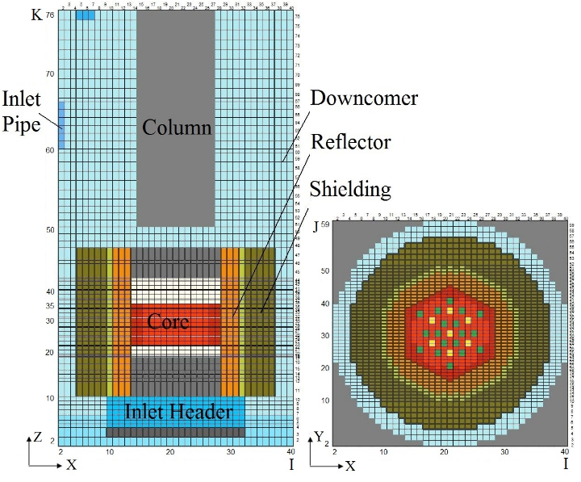

a) K = 35 b) J = 27

*FIG. 4. Horizontal a) and vertical b) sections of computational domain.*

Conditions at the inlet of the reactor downcomer section are used as input data. These include flow rate and temperature of lead and steam, as well as steam bubble size (it is assumed that all incoming bubbles have the same given size, which then changes in the process of their movement depending on external temperature and pressure).

## Reactor parameters behavior in case of SG large leakage

### Scenario reference option

The main features of the reference scenario are presented below.

A) Double-side guillotine rupture of one SG tube is assumed as the initial event of accident, and flow rate of steam entering reactor downcomer section in this case remains constant (Gv = 0.73 kg/s) ) over time, without accounting for variations that are expected at the beginning of the transient and when SG isolation is anticipated to start transient termination. Steam is only supplied through the nozzles of failed loop (two nozzles out of eight in case of one failed loop). That corresponds to about 0.3 vapor volume fraction in the entering coolant.

B) Total failure of safety system takes place (control rods position does not change, and the main pumps are still in operation).

C) Failure occurs when reactor is operating on rated power, and power behaviour is only determined by temperature and void reactivity effects.

D) Diameter of incoming steam bubbles was assumed to be as small as Dbub = 0.00001 m. As a results relative gas bubble raising velocity becomes negligibly small (in the core less than 0.0003m/s)

Results of analysis of steam velocity and concentration patterns behaviour for the reference option are shown in Fig. 5. Steam concentration distribution is presented in relative units, i.e. steam concentration in the inlet nozzle is taken equal to 100 %.



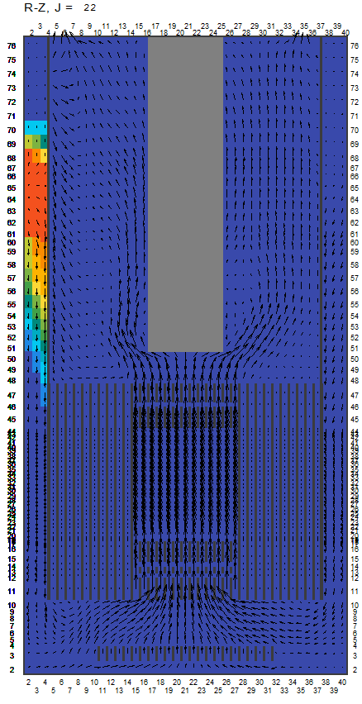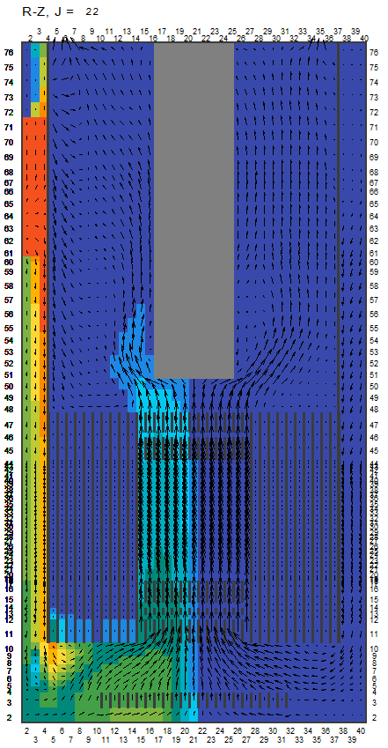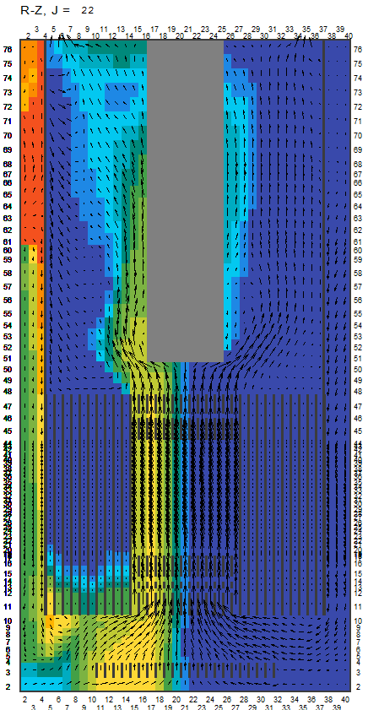

 a) τ = 4 s b) τ = 22 s c) τ = 40 s

*FIG. 5. Distribution of steam velocity and relative concentration in section J = 22, Gv = 0.73 kg/s.*

There are two specific stages of the process of steam propagation through the reactor. The first stage starts when the steam enters downcomer section of the reactor. Then steam-lead mixture “plume” moves downward in the downcomer section and on 22-nd second the steam enters the left part of the core. This stage is characterized by strongly pronounced azimuthal non-symmetry of steam distribution in the downcomer and in the core. As a result, the first sudden change of steam content occurs in the core (Fig. 6) resulting in the change of reactor power and temperature (Fig. 7).

In the second stage (after first 50 seconds of transient) , the downcomer is gradually filled with steam-lead mixture , because it also starts floating up and fills in steps the whole downcomer volume. Steam accumulated in the downcomer section is taken up by the lead flowing from the other (intact) loops and brought to the reactor core. From this moment (approximately after 40-th second) the amount of steam entering the core starts increasing again, and now pattern of steam supply to the core is azimuthally symmetric. The second stage is finished by steady state onset (Fig. 6, 7), when the amount of steam entering reactor through the inlet nozzles becomes equal to that leaving the reactor.



FIG. 6. Steam mass (xMc9) and max local vapor fraction (FiC) in central section of the core and steam mass (xMc10) in peripheral section.



*FIG. 7. Behavior of reactor power and max cladding temperature.*

Max reactor power achieved during the transient exceeds rated value by 25%, and max fuel element cladding temperature is 679°С, this being significantly lower than the corresponding safe operation limit.

### On the Effect of Steam Bubble size

Flow pattern in the downcomer section and effectiveness of steam separation to the gas plenum of the reactor depends on the size of bubbles (Fig. 8). Large bubbles are floating up immediately after their arrival from the inlet nozzles forming upward flow plume, and entering reactor gas plenum. Small bubbles are brought downward by the flow and they reach the reactor core mostly in its periphery. Ratio of numbers of separated steam bubbles and those brought to the reactor core strongly depends on the bubble size (Fig. 9).



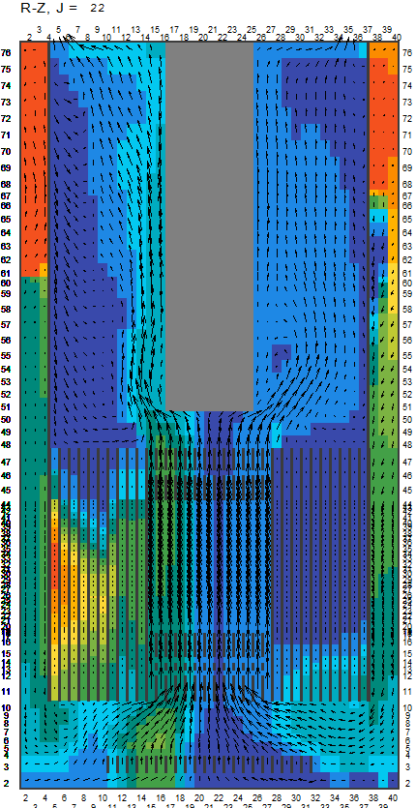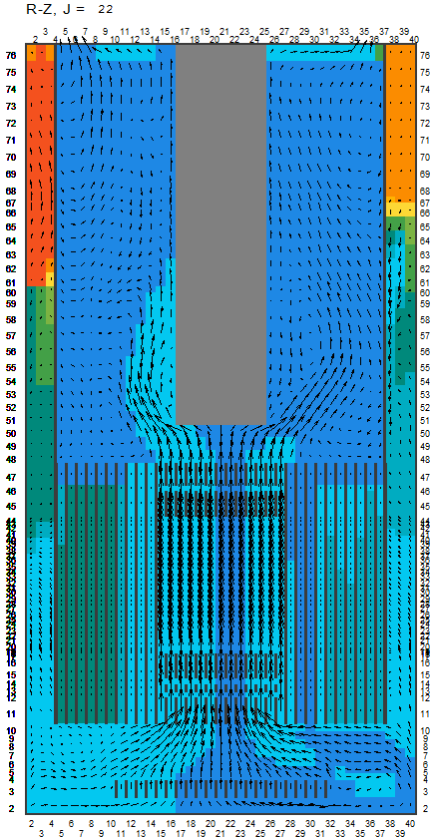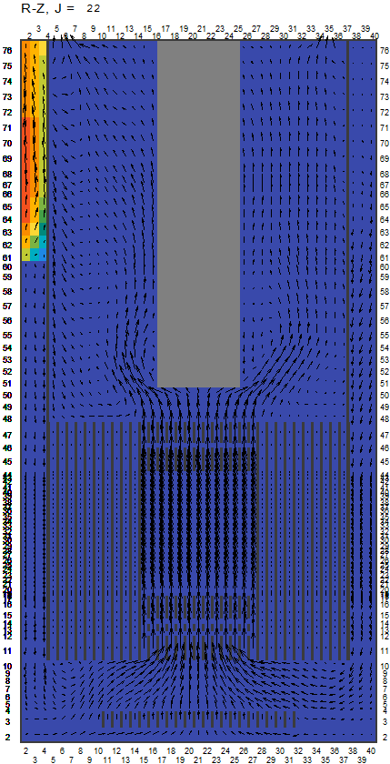

a) 0.00001 м b) 0.0001 м c) 0.001 м

*FIG. 8. Distribution of steam velocity and relative concentration in section J = 22 under steady state conditions for various bubble sizes.*



FIG. 9. Relative flow rates of steam separated in the downcomer section (Gsep) and that entering the reactor core (Gcore) as a function of steam bubble diameter.

### On the Effect of Hydrogen Contribution

Effect of vapor penetration to the reactor core (with nitride fuel) has two main components:

–void reactivity effect caused by lead displacement. This effect is positive for central zones of the core, and it is positive (+0.594%) in the core of BREST-OD-300 reactor in case of lead uniform displacement from the whole core.

–reactivity effect related to the presence of hydrogen. An increased capture on hydrogen and decreased number of neutrons per fission due to moderation provide negative hydrogen effect on reactivity as direct calculations using both Monte-Carlo and diffusion theory show. This effect is negative (-0.375% in case of lead uniform displacement from the whole core) and its magnitude increases with the increase of hydrogen content. Lead and hydrogen density variations are taken into account in the whole calculative domain including region above the core.

It can be seen from comparison of curves in Fig. 10 that positive void reactivity effect caused by lead displacement is partly compensated by the negative effect from hydrogen presence, and it is hydrogen presence that slows down power build-up rate approximately on 30%. Coolant temperature heat-up also decreases, as well as max value of the fuel element cladding temperature.



1 – spectrum degradation isn’t taken into account;

2 – all reactivity components are taken into account

FIG.10. Max power values in case of SG leak depending on reactivity effect components taken into account.

### Hypothetic Accident: Large Leaks Occurring Simultaneously in Several SG

It is clear that the probability of large leakages occurring simultaneously in two or more loops is extremely low, and common cause failure is excluded by the independence of each primary loop. Nevertheless, for the sake of deep insight into the accidental processes and reactor self-protection margins analytical studies were carried out on the accident with simultaneous SG tube double-ended guillotine ruptures in two or more loops as an initial event. It has been found that in case of a sudden emergence of large leaks simultaneously in two SGs transient nature is the same and, as usual, after two fluctuations core power and temperature become stable (Fig. 11).



FIG. 11. Behavior of fuel element cladding temperature in some fuel assemblies in the outlet core cross section, G*v*  = 0.73*2 kg/s.

Moreover, safe operation limit in terms of max fuel element cladding temperature (it is allowed to expose cladding to 900°С no longer than for 10 minutes) is not reached (Table 1).

TABLE 1. MAX VALUES OF PARAMETERS DEPENDING ON NUMBER OF FAILED LOOPS

|  |  |  |
| --- | --- | --- |
| Parameter | Number of failed loops | |
| 1 | 2 |
| Steam flow rate, G*v* kg/s | 0.73 | 1.46 |
| Steam mass xМc9, kg | 0.26 | 0.52 |
| Steam massМc10, kg | 0.14 | 0.28 |
| Max power, MW | 930 | 1415 |
| max cladding temperature, °С | 680 | 815 |

## Conclusion

On the basis of analytical study it can be stated that safety of BREST-OD-300 reactor in case of SG leakage has been proved by wide margins even with the most conservative assumptions (negligibly small gas bubble raising velocity due to small specified diameter of incoming steam bubbles, neglecting of possible decrease of vapor flow rate through the breakup during the transient, total failure of safety system). Max cladding temperature in the entire transient is well below safe operation design limit, and transient is ended with safe and stable reactor condition. Moreover, even in hypothetic accident with simultaneous tube ruptures in two steam generators in two different loops cladding temperature safe operation limit is not exceeded.

References

1. GANG WANG, “A Review of Research Progress in Heat Exchanger Tube Rupture Accident of Heavy Liquid Metal Cooled Reactors”, Annals of Nuclear Energy, 109, 1 (2017).
2. E. BUBELIS at al., “LFR Safety Approach and Main ELFR Safety Analysis Results”. IAEA-CN-199/297 Int. Conference on Fast Reactors and Related Fuel Cycles: Safe Technologies and Sustainable Scenarios (FR13), Paris, France,4 – 7 march 2013.
3. A. ALEMBERTI et al., “The Lead Fast Reactor – Demonstrator (ALFRED) and ELFR Design”, T1-CN-199/024 Int. Conference on Fast Reactors and Related Fuel Cycles: Safe Technologies and Sustainable Scenarios (FR13), Paris, France,4 – 7 march 2013.
4. ZHIXING GU et al., “Preliminary Investigation on the Primary Heat Exchanger Lower Head Rupture Accident of Forced Circulation LBE-cooled Fast Reactor”, Annals of Nuclear Energy, 81, 84 (2015).
5. M. JELTSOV et al., “Steam Generator Leakage in Lead Cooled Fast Reactors: Modelling of Void Transport to the Core”, Nuclear Engineering and Design, 328, 255 (2018).
6. G. YOLLIS, One-Dimensional Two-Phase Flows, Mir, Moscow (1972).
7. В.И.БЕРДНИКОВ, А.М.ЛЕВИН, “О Скорости Всплывания Газовых Пузырей в Металлических и Шлаковых Расплавах”, Известия ВУЗов, Черная металлургия, 12, 24 (1977).
8. А.В. АБРАМОВ и др., “Экспериментальное обоснование безопасности реакторной установки БРЕСТ-ОД-300 при разгерметизации теплообменных труб”, 3-я Межд. Научно-Техническая Конференция “Инновационные проекты и технологии ядерной энергетики” ОАО «НИКИЭТ», Москва, 7-10 октября 2014 года, 1, 251, ОАО «НИКИЭТ» (2014).
9. Suslov I.R., Babanakov D.M., MAG – The Code for Fine Mesh VVER Calculations, *Proc. of 6-th Symposium AER*, 1996.