# Thermal hydraulic assessment of the

# performance of secondary sodium system

# based decay heat removal circuit

Anurag Samantara*, K. Natesan, S. Raghupathy

Reactor Design & Technology Group

Indira Gandhi Centre for Atomic Research, Kalpakkam-603102, India

*Email of corresponding author: [anurag10101@igcar.gov.in](mailto:anurag10101@igcar.gov.in)

**Abstract**

In order to improve the safety of future sodium cooled fast reactor, alternative Decay Heat Removal (DHR) path is envisaged through secondary sodium main circuit. Secondary Sodium Decay Heat Removal System (SSDHRS) transfers heat from secondary sodium to ambient through Air Heat Exchanger (AHX). SSDHRS is planned to operate in forced circulation mode using emergency power supply. SSDHRS in addition to Safety Grade Decay Heat Removal System will help in demonstrating failure of DHR function is highly unlikely, so as to be regarded as practically eliminated. Analysis of SSDHR System is carried out using system dynamics code Flownex. Different components of the system, viz., Intermediate heat exchangers, AHX, stack, secondary sodium Pump (SSP), blower are modeled through appropriate component models. Single zone model of core is also developed to represent the decay heat source. Heat transfer capacity of each SSDHR system is found to be 15.17 MW at 544 °C temperature of hot pool sodium. Parametric studies have been carried out by varying hot pool temperature in the range of 200 °C to 650 °C and primary sodium flow rate, and their effect on performance of SSDHRS is studied. Transient analysis of 'off-site power failure' event is carried out and the predicted hot pool and cold pool temperatures are found to be within the design safety limits. Further study is carried out to assess performance of SSDHRS during natural circulation of secondary sodium and air. Study is also carried out to assess the performance of SSDHRS, when all the circuits are under natural circulation mode.

## INTRODUCTION

Decay heat removal (DHR) from the reactor core without exceeding design safety limits (DSL) is essential for safety of the reactor components. In order to improve safety of the reactor, it is envisaged to have alternate DHR paths incorporated in future Fast Breeder Reactors (FBR). In this context, decay heat removal through secondary sodium main circuit using Secondary Sodium Decay Heat Removal System (SSDHRS) is one of the options being studied. SSDHRS envisaged for future reactors have the following benefits.

* Reduce the demand on Safety Grade Decay Heat Removal System (SGDHRS) which adopt sodium to sodium heat exchangers dipped in sodium pool for decay heat removal
* To demonstrate that failure of decay heat removal function is highly unlikely to be regarded as practically eliminated. In this scenario, the SGDHR system would satisfy the decay heat removal requirements under Design Extension Condition (DEC) (Defense in Depth (DiD) level 4) and SSDHRS would cater to the requirement of DiD level 3.

In addition to these various advantages of SSDHRS are, viz., (a) minimal delay in bringing into operation, (b) location of AHX inside steam generator building and forced circulation of air, which ensure its availability during severe cyclonic condition (a design extension condition).

Towards achieving these objectives, SSDHRS is being designed for future FBRs. The process design is carried out for a heat removal capacity of 15 MW/per secondary sodium loop [1]. It is important to establish the heat removal capacity of SSDHRS under various temperature conditions of reactor pool and also to bring out its performance during natural convection conditions. Moreover, the performance needs to be established under transient conditions as well. With these objectives, modeling and analysis of SSDHRS is carried out using commercial system dynamics software Flownex, which is validated with in-house developed code DHDYN [2] for SGDHRS. These results will be helpful in assessing the performance of the system for various scenarios.

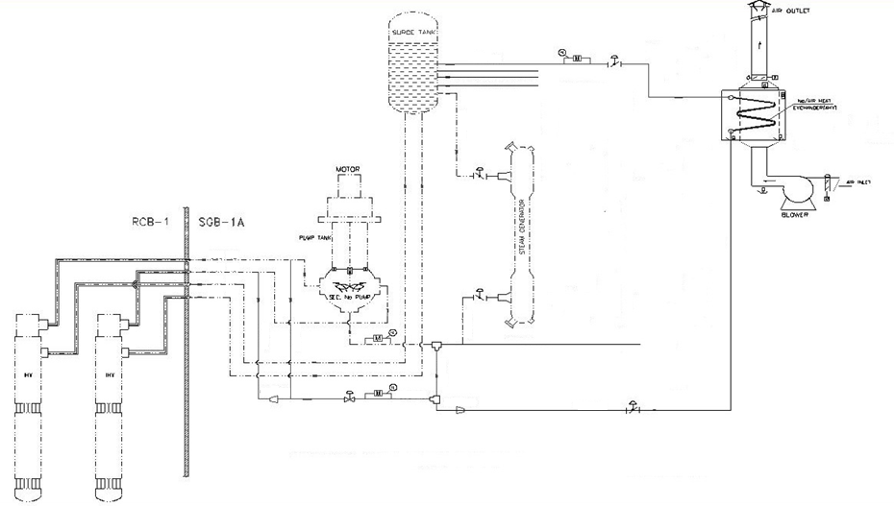

Control valve

Bypass path

Control valve

SSP inlet bypass joint

Surge Tank

SSP outlet bypass joint

IHX-2

IHX-1

To SG

SSP

Blower

AHX

SG outlet header

*FIG. 1: Schematic of SSDHRS*

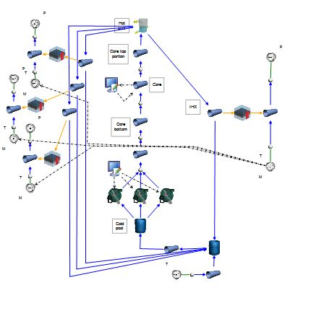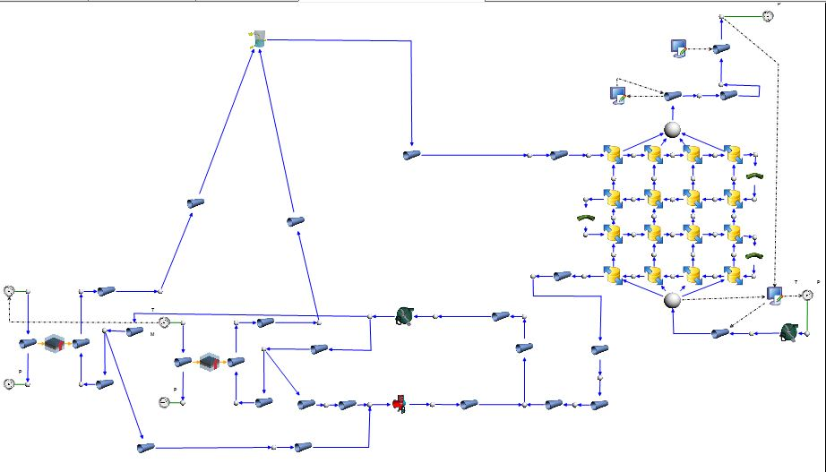

Cold pool

PSP

IHX

Core

Hot pool

Blower

AHX

Stack

ST

SSP

IHX

*FIG. 2.1: SSDHRS model in Flownex FIG. 2.2 Primary circuit model in Flownex*

PSP

Cold pool

## SYSTEM DESCRIPTION AND MODELING DETAILS

The SSDHR system is envisaged to cater to the decay heat removal in a pool type fast reactor of capacity 1500 MWt. There are two secondary sodium main circuits (SSMC) in the reactor and one circuit of SSDHRS is connected to each SSMC. Figure 1 shows the schematic of SSDHRS system. In this system, the decay heat received by primary sodium from the core is transferred to the secondary sodium flowing in the tube side of intermediate heat exchangers (IHX). From IHX, heat is transported to sodium flowing in air heat exchanger (AHX) which in turn is transferred to ambient air.

SSDHRS loop is integrated to the Secondary Sodium Main Circuit (SSMC). In the present design [1], AHX is connected parallel to SG modules between surge tank outlet and the common header of SG. During the SSDHRS operation, all the SG modules are expected to be isolated by closing the valves in the circuit. Sodium and air flow in the SSDHRS take place by forced circulation. Primary and secondary sodium circulations are by the primary sodium pump (PSP) and secondary sodium pump (SSP) present in the primary and secondary circuits respectively. A blower is provided in the air circuit which forces required air flow through AHX. The blower is provided with emergency power supply, so that DHR can be achieved during the non-availability of off-site power. The emergency power is provided by diesel generators (Class-III power), which can come into operation within 30 s post off-site power failure. The total class-III power required for SSDHRS operation is estimated as ~400 kW.

As per the present design, both primary and secondary sodium pumps run at 20% and 26 % of nominal flow respectively [1] during the operation of SSDHRS. Out of the 26% secondary sodium flow, 4% flows through AHX, and the remaining flow bypasses through a separate bypass path (Fig. 1).

A stack of 30 m height is provided in the air circuit so that DHR is possible even when blower is not running. During this scenario, the SSDHRS works in passive mode with a reduced capacity.

### Modeling details

Various components of the SSDHR system, viz., IHX, AHX, stack, SSP, blower are modeled in Flownex. IHX is modeled as a counter current sodium to sodium heat exchanger using ‘composite heat transfer’ (CHT) element. Grid independent study is carried out to arrive at suitable number of grids in axial direction. The shell side [3] and tube side heat transfer coefficients are calculated using the Nusselt number correlations given by Marcellin C. et. al. [3] and is mentioned below.

For shell side: Nu=6+0.006Pe 30<Pe<4000; 1.2<p/d<1.75 (1)

For tube side: Nu=4.82+0.0185Pe0.827 50<Pe<13100 (2)

Where, Pe: Peclet number, p: circumferential pitch of tubes, d: tube diameter. A margin of 10 % on convective heat transfer coefficient is considered in shell side and tube side.

AHX is a multi-pass cross flow finned tube heat exchanger. AHX is modeled using user defined ‘compound component’. It is discretized into four grids in both sodium as well as air flow directions as shown in Fig. 2.1. The adequacy of number of grids is also checked using grid independent study. The ‘compound component’ is a user defined component which provides flexibility in defining and reusing the component. It consists of multiple library components available in Flownex and is clubbed together to form a single component. In the present model, a single compound component represents one element of the AHX, which consists of sodium flowing in tube side, air flowing in shell side and a CHT element which transfers heat from the tube side to shell side. Fin efficiency, effective air side heat transfer coefficient and cross flow correction factor are incorporated into the AHX element using user defined script. Tube side Nusselt number correlation used is same as that used in IHX tube side mentioned in previous paragraph. For the air side, correlation given by Zukauskas [4] is used for estimation of heat transfer coefficient and is given below.

Nu=0.19(a/b)0.2(s/d)0.18(h/d)-0.14Re0.65Pr0.33 100<Re<20000 (3)

Where a: s1/d, b: s2/d, d: outer diameter of tubes (m), s: fin spacing (1/No. of fins), s1: transverse pitch of the tubes (m), s2: longitudinal pitch of the tubes (m), h: fin height (m), Re: Reynolds number, Pr: Prandtl number.

‘Basic centrifugal pump’ model of Flownex is used for modeling secondary sodium pump and blower in the sodium and air circuits respectively. Head developed at best efficiency point (BEP), volumetric flow at BEP and rated speed are provided as input data in the pump model. Specific speed of the pump and efficiency are estimated in the model and is found to be close to design values. Stack and secondary sodium pipes are modeled using pipe element and heat loss through the outer wall is neglected.

The control valve is modeled using valve element of Flownex. Flow coefficient, valve diameter and fraction of opening of valve are specified as inputs in the model.

### Estimation of pressure drops in secondary sodium and air circuits

Various pressure drops in the air circuit considered are those due to bird screen, louver, inlet damper, outlet damper, bends, finned tubes, stack, exit hood and other form losses. Friction pressure drop in various pipelines are calculated using in built Swamee-Jain correlation in Flownex. Various correlations for estimation of the pressure drop coefficient are taken from the reference [5]. These correlations are assigned to Flownex using user defined script.

Various pressure drops considered in the secondary sodium circuit are those due to IHX tubes, sodium side of AHX, connecting pipes, surge tank, tee joints, bends, diffusers and control valve etc.

### Primary circuit model

One zone model of the core representing the decay heat generation and pressure drop in the subassemblies (SAs) is developed to predict natural circulation flow rate and heat transfer in the primary circuit (Fig. 2.2). The core is modeled as one zone with 757 SAs. PSP is modeled using ‘basic centrifugal pump’ model of Flownex. Pressure drop coefficient in the core SA is estimated using Rehme correlation [6], and is incorporate into the model using user defined script.

The primary circuit model is verified with respect to full power condition during which three pumps operate at rated speed. During this condition, the pool temperatures and sodium flow rate are estimated and found to be close to their design values.

## RESULTS AND DISCUSSIONS

Analysis has been carried out considering 40 °C temperature of ambient air. The steady state performance of SSDHRS is assessed at 544 °C hot pool temperature, which is the temperature of hot pool during normal operation. The primary sodium flow rate corresponds to 20 % speed of PSP is 477.1 kg/s. The heat removal capacity is found to be 15.17 MW. Flow rates of secondary sodium in AHX is estimated as 133 kg/s. Inlet and outlet temperature of sodium in AHX are 544 °C and 453.6 °C respectively. Primary sodium outlet temperature in the IHX is 532°C. Air flow rate and outlet temperature are estimated as 59.5 kg/s and 290.3 °C respectively.

**3.1 SSDHRS performance at various hot pool sodium temperature**

Steady state performance of SSDHRS is analyzed by varying the temperature of hot pool sodium in the range of 200 °C to 650 °C and the result is shown in Fig 3. Heat removal capacity increases with increase in primary sodium temperature. The variation of capacity is linear. Maximum heat removal capacity is found to be 18.5 MW at 650 °C hot pool temperature. AHX sodium inlet, outlet and air outlet temperatures are also depicted in the figure. All the temperatures increase with the increase in hot pool temperature and change in temperatures are nearly linear. The AHX inlet sodium temperature is close to hot pool temperature due to the high heat transfer area of IHX.

**3.2 Effect of primary sodium flow rate on SSDHRS performance**

Effect of primary sodium flow rate on SSDHRS performance is studied by changing the primary sodium flow rate from 20% to 2% and is shown in Fig. 4. Hot pool temperature is taken as 544 °C in all the cases. It is seen that the heat removal capacity remains nearly constant up to 4% flow. The capacity reduces marginally to 14.2 MW when the primary sodium flow is 2% of nominal flow. This is due to the decrease in inlet sodium temperature at AHX for low flow rates. At higher primary sodium flow rates, the hot end temperature difference of IHX is negligible and hence the heat removal capacity remains unchanged. Thus, it can be concluded that, heat removal capacity is a weak function of primary sodium flow in the range above 4 %.



*FIG. 3: Heat removal capacity and AHX terminal temperatures of SSDHR loop during forced circulation at various hot pool temperatures*

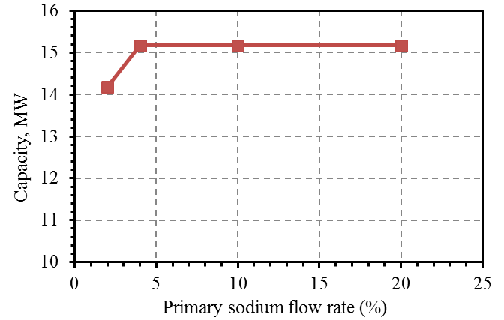

*FIG. 4: Heat removal capacity of SSDHRS with change in primary sodium flow rate*

**3.3 Study of off-site power failure event**

Analysis is carried out to study category-2 ‘off-site power failure’ event. Following the event, the reactor is shutdown by SCRAM (dropping of control rods). Decay heat is generated in the core and the change of decay heat with time is estimated based on the data given in the reference [7]. Primary sodium pump coast down with a flow halving time of 8 s and is operated at 20% speed using emergency power. Secondary sodium pump coast down with a flow halving time of 4 s and is operated at a speed of 26 % with emergency power supply. Heat transfer in SG is neglected following SCRAM. The SSDHRS comes into operation after half an hour following SCRAM. The half an hour delay time is considered so that the SSDHR can be started manually, if it doesn’t start automatically following SCRAM signal. Evolution of hot pool and cold pool temperature is shown in Fig. 5. From the figure, it can be seen that, hot pool temperature reduces initially, and reaches a minimum value in ~ 10 min, after which it starts rising. Cold pool temperature rises continuously due to loss of heat transfer in SG. It is seen that the maximum hot pool and cold pool temperatures are 513 °C and 498 °C respectively which is well within the design safety limit of category 2 event.

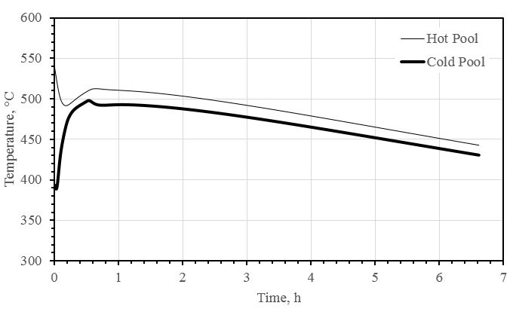

*FIG. 5: Evolution of hot pool and cold pool temperature during SSDHRS operation following Off-Site power failure event*

* 1. **SSDHRS performance during natural circulation of secondary sodium and air**

Heat removal capacity during natural circulation of secondary sodium and air is estimated for various hot pool temperatures and the results are shown in Fig.6. Heat removal capacity is 8.78 MW at 544 °C primary sodium inlet temperature, which is ~58% of the capacity during forced flow condition. Predicted secondary sodium flow rate and air flow rates are 75.6 kg/s and 27.5 kg/s respectively. AHX sodium inlet, outlet and air outlet temperatures are estimated as 544 °C, 452 °C and 352.6 °C respectively. Heat removal capacity increases linearly with hot pool temperature as depicted in the figure. The maximum heat removal capacity at 650 °C temperature of hot pool is found to be 11.07 MW. Secondary sodium flow rate and air flow rate increases with the increase in hot pool temperature. The variation of flow rates is seen to be non-linear. AHX sodium inlet, outlet and air outlet temperatures at various hot pool temperature is shown in Fig. 7. It can be seen that the variation in temperatures are nearly linear.

* 1. **SSDHRS performance in passive mode**

Analysis is carried out to estimate the heat removal capacity when all the three circuits, viz., primary sodium circuit, secondary sodium circuit and air circuit are under natural circulation. Maximum heat removal capacity is estimated considering the rise in hot pool temperature to 650 °C. Heat removal capacity of one SSDHR circuit is found to be 9.775 MW. Thus, it is ~52% of the capacity obtained in active mode configuration. Natural circulation flow of primary sodium at IHX shell side is 24.2 kg/s and the total flow rate through the core is 96.8 kg/s. Natural circulation flow rates of secondary sodium and air in AHX are estimated as 72.7 kg/s and 27.9 kg/s respectively.

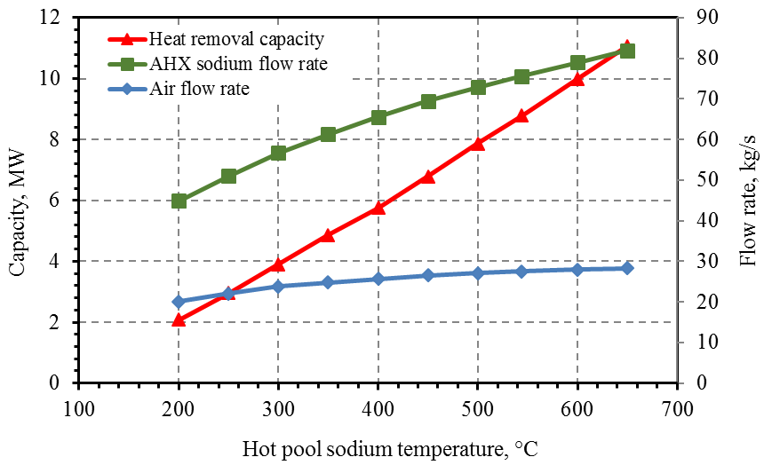

*FIG. 6: Heat removal capacity and flow rates of SSDHR loop during natural circulation at various hot pool temperatures*

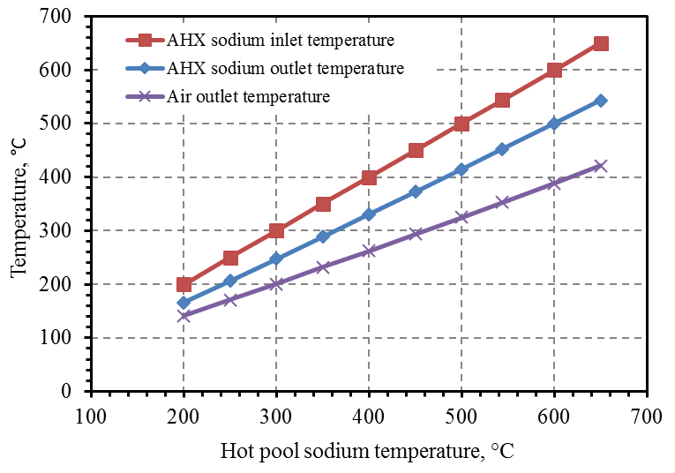

*Fig. 7: AHX terminal temperatures of SSDHR loop during natural circulation at various hot pool temperatures*

4. CONCLUSION

Analysis of SSDHR system is carried out using system dynamics code Flownex. Different components of the system, viz., IHX, AHX, stack, SSP, blower are modeled through appropriate component models. The primary circuit is modelled using single zone model of core. Heat transfer capacity of each SSDHR system is found to be 15.17 MW at 544 °C temperature of hot pool sodium. Forced circulation flow rates of secondary sodium and air are estimated as 133 kg/s and 59.5 kg/s respectively. Parametric studies have been carried out by varying hot pool temperature in the range of 200 °C to 650 °C and primary sodium flow rate, and their effect on performance of SSDHRS is studied. Transient analysis of 'off-site power failure' event is carried out and the predicted hot pool and cold pool temperatures are found to be within the design safety limits. Further study is carried out to assess performance of SSDHRS during natural circulation of secondary sodium and air. Heat removal capacities at 544 °C and 650 °C primary sodium temperature are 8.78 MW and 11.07 MW respectively. Study is also carried out to assess the performance of SSDHRS, when all the three circuits are under natural circulation mode. The maximum heat removal capacity is found to be 9.775 MW when the hot pool temperature reaches 650 °C.

References

1. ‘Design and Thermal Hydraulic Analysis of Secondary Sodium Based Decay Heat Removal System for FBR 1&2’, IGC Annual report 2020.
2. Anurag Samantara, U. Parthasarathy, ‘Analysis of SGDHRS Type-A using Flownex’, Internal note: PFBR/34000/DN/1051/R-A, (2018).
3. C. Marcellin, J. Guidez, “Hydrodynamic behavior of intermediate heat exchangers in pool type fast breeder reactor”; Proc. Int. Conf. on Liquid Metal Engineering and Technology; BNES, London; pp.211-214, (1984).
4. A Zukauskas, “Heat Exchanger design handbook‟, volume 2, Hemisphere publishing corporation, Washington, published under auspices of the international center for heat and mass transfer, (1983).
5. I.E. Idelchik, „Handbook of Hydraulic Resistance‟, 3rd edition, CRC Press, 1993.
6. K. Rehme, “Pressure drop correlations for fuel element spacers”. Nuclear Technology 17, 15–23, (1973).
7. M.S. Sridaran, ‘Total Decay Heat Estimates in PFBR’, Internal note: PFBR/01115/DN/1118/R-A, (2003).

ABBREVIATIONs

AHX Air heat exchanger

CHT Composite Heat Transfer

DEC Design Extension Condition

DHDYN In house code for studying Decay Heat Removal

DHR Decay Heat Removal

DiD Defense in Depth

DSL Design Safety Limit

FBR Fast Breeder Reactor

IHX Intermediate Heat Exchanger

PSP Primary Sodium Pump

SA Sub-Assembly

SCRAM Safety and Control Rod Accelerated Movement

SG Steam Generator

SSDHRS Secondary Sodium Decay Heat Removal System

SSMC Secondary Sodium Main Circuit

SSP Secondary Sodium Pump