The Severe Accident Management

of the high-power SFR with loss

of the heat removal from the core

I. PAKHOMOV,
IPPE JSC
Obninsk, Russia
Email: bagd@ippe.ru

Kamaev A. (IPPE JSC)
Obninsk, Russia
Email: bagd@ippe.ru

Abstract

The accident at the Fukushima Nuclear Power Plant (NPP) (Japan) showed that the design of the power unit should consider the unforeseen excess of the external influence intensity. The accidents for internal reasons can be predicted on the basis of knowledge and it depends, first of all, on the designers approach, but it is impossible to foresee catastrophic external influences.
This method is propose to remove the heat from the vessel by air for a high-power SFR, Reactor Vessel Auxiliary Cooling System (RVACS). This report proposes to limit heat dissipation - not to exceed the cladding temperature of 800 °C in a severe beyond design basis accident such as the accident at the Fukushima NPP.
The air duct composition of the Severe Accident Management (SAMG) proposed method consist of: cold air supply pipes, a hot air heat-insulated exhaust pipe and an air duct around the safety vessel, created by cladding with a gap.
Heat transfer to air is carried out due to the transfer of heat by radiation to the safety vessel and cladding and due to heat removal from the safety vessel and cladding surface to the air in the gap between them, during air circulation through the air path. The thermal balance of the sodium and the vessel are established by intense circulation flows of sodium, which are forced by the core decay heat and the heat outflow to the air. Many-hour processes are considered, so there is no delay in the temperature of structural elements from the sodium.
As a SAMG including the gap between the main and safety vessel to the air cooling system and filling this gap with sodium is considered like option.
It is shown that taking into account heat exchange by radiation provides a safety SAMG regime for the fast reactors with a sodium coolant for removing heat from the reactor vessel through the channels of natural air circulation around the reactor. Even it’s possible to keep the reactor vessel temperature below the limit of 800 °C with heat removal only through the safety vessel - cladding channel.

INTRODUCTION
The Fukushima NPP (Japan) accident has shown that design of the power unit should consider the unforeseen excess of the intensity of external influence. If accidents for internal reasons can be predicted on the basis of knowledge and this depends primarily on the approach of NPP designers, then it is impossible to foresee catastrophic external influences. This is shows by statistical data on the growth in the number and intensity of natural disasters [1]: from 1950 to 2000, the number of disasters increased by 7 times, economic losses increased by about 6 times. The latest catastrophic events in Russia also confirm this trend - unusual phenomena for the regions: tornadoes in the European part, extreme floods in the east of Siberia, etc.
For the Beloyarsk area, where it is possible to build a NPP unit BN-1200 [2], the main external impact is an earthquake. Studies [3] shows:

- the difficulty of predicting the place, time and energy of earthquakes, satisfying both the requirements of accuracy and reliability;
- impossibility of forecasting, as evidenced by the occurred catastrophic earthquakes;
- an increase in the number of earthquakes - in the twentieth century there were 2000 with a rate of magnitude more than 7, in 65 of them it was higher than magnitude 8. In the Russian Federation, earthquakes magnitudes 7 or more are possible on 25% of its area.

For the earthquake risk assessment, seismic zoning is unacceptable and an example is the Ashgabat earthquake in 1948, the intensity of which was a complete surprise [4].
From the regulatory document [5] follows:

- if even two units with a resource of 50 years operate in a given area, then the maximum design earthquake realization probability in one of them is equal to 10-2 1/reactor*year, which is hundreds of times more than the probability of beyond design basis accidents required in regulatory documents ( 10-7 1/reactor*year);
- the maximum design earthquake probability may be even greater.

Some experts argue that in fact the reactor cooling system was destroyed by an earthquake and fuel melting was inevitable without a tsunami at the Fukushima NPP accident [6].
The above considerations put forward the requirements for the need to take into account the possibility of earthquakes with a higher intensity than the maximum design earthquake, as well as other catastrophic external influences. The need to develop technical controls for managing beyond design basis accidents in the NPP design is provided for by NP-001.

NATURAL SAFETY CHARACTERISTICS OF FAST REACTORS AND THE PROPOSED METHOD FOR MANAGING SEVERE ACCIDENT.
In natural safety, let us note those properties that make it possible to create simple and effective design tools for managing severe accidents [7]:

- extremely low corrosiveness of sodium and insignificant mechanical stress on the reactor vessel, allowing a short-term (tens of hours) increase in the temperature of the vessel wall;
- huge heat capacity of the integral primary circuit, allowing for a long time to provide normal radiation and other conditions for the operating personnel actions in the management of severe accident. For the BN-1200 reactor, for example, this is at least 3 hours from the time of the complete loss of all power supply sources and the absence of any heat removal from the primary circuit.

Taking into account these properties, the projects adopted and justified the following temperature limits for the reactor pressure vessel: safe operation limit - 600^{о}С; the limit of leakage and possible release of radionuclides 800ºC within several tens of hours.
For a small power reactor, a method is proposed for removing heat from the vessel by air in [8]. This method was also considered by Russian designers, but it was assessed as a means of creating an emergency heat removal system, which should not exceed the reactor vessel operation safety limit. This is impossible for fast reactors of high power. In this article, it is proposed to limit heat removal - not to exceed the vessel temperature 800 °C in the conditions of a severe accident such as the accident at the Fukushima NPP. The air path design diagram of the proposed method to managing a severe accident is shown in Fig. 1, the path parameters are given in the initial calculation data (see below); characteristics of local resistances in Table 1.
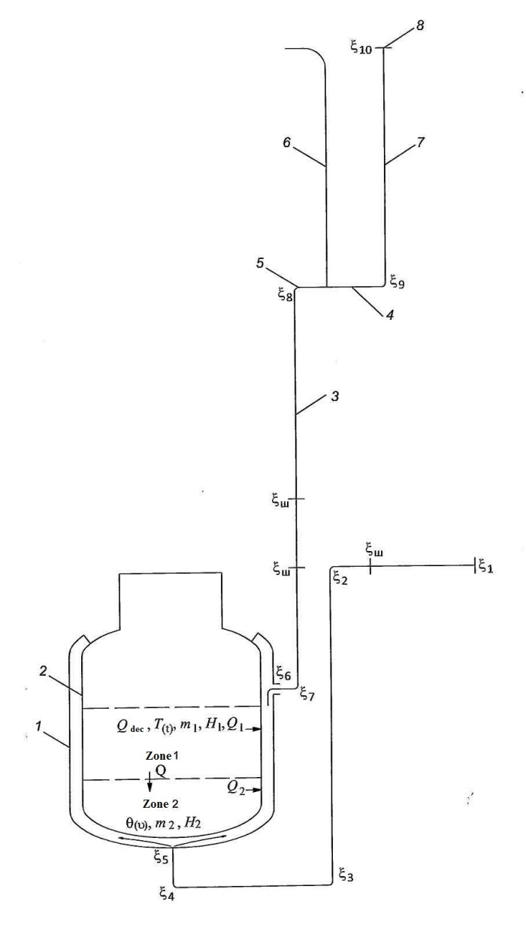
Fig. 1. Air path calculation diagram: 1 - cladding; 2 - safety vessel; 3 - part of the chimney inside the reactor building; 4 - +75 m/ level of the outlet of the chimney from the reactor building when the other part of the building collapses (in the annex); 5 - exit to the environment; 6 - wall of the reactor building; 7 - part of the chimney in the annex; 8 - +120 m. level of the chimney exit from the annex
The arrangement of the cold air inlet pipe can be made based on the convenience of general arrangement solutions. A heat-insulated hot air chimney is installed along the wall inside the main building before entering the annex. Dampers on cold and hot pipes should be located as close as possible to the body and be tight to prevent unwanted heat transfer during normal operation. The air path around the safety vessel is created by the lining with a 100 mm gap. The load-bearing section of the cladding consists of rigid vertical rods located every 1 m in circumference, connected to the safety vessel in the upper and lower parts and reinforced with transverse steel strips every 2 m in height. The load-bearing section of the cladding consists of cells measuring 1x2 m. On the length of the cylindrical part of the safety vessel ~ 12 m high, the cladding itself consists of a strong aluminum alloy with a thickness of about 10 mm with vertical ribs every 100 mm around the circumference and a height equal to or slightly less than the gap between the wall of the safety vessel and the cladding. Thus, on the cylindrical part of the air duct lining, ~ 500 channels with a square or nearly square shape are formed. On the pit side, the cladding is provided with approximately 100 mm thick insulation. The mass of a 1x2 m cladding element will be about 100 kg. The cladding elements are fixed in the load-bearing cells section in such a way that they can be removed for access to the safety vessel. In the lower part of the safety vessel (zone 2), the removable cladding elements are not provided with ribs.
The load-bearing section of the lining must follow possible changes in the shape of the safety vessel, but not create unacceptable loads. The cladding surface facing the safety vessel is coated with a heat-resistant black paint to improve radiation heat transfer.

TABLE 1. LOCAL RESISTANCES OF THE AIR PATH ACCORDING TO [9]

The value of local resistances indicated in Fig.1 | Name of element | Section assignment
ξ₁=0.1 | Inlet in a cold pipe from the environment | Cold pipe d=2 m
ξ₂=ξ₃=ξ₄=0.15 | Smooth turning on a cold pipe d/2r=0,2 | The same
ξ_{d}=0.2 | Damper on the cold pipe | d=2 m
ξ₇+ξ₈=ξ₉=0.15 | Smooth turning on a hot pipe d/2r=0,2 | Hot pipe d=2 m
ξ_{d}=0.2 | Damper on the hot pipe | d=2 m
ξ₅=0.75 | Outlet form the cold pipe into the gap | Cold pipe d=2 m
ξ₆=1.5 | Outlet from the gap into the hot pipe | Hot pipe d=2 m
ξ₁₁=1 | Outlet from the hot pipe to the environment | The same
* The height of the hot pipe during the collapse of its part in the building is determined by the height before its exit to the outside through the wall of the dome of the reactor building.

PHYSICAL MODEL OF THE PROCESS AND BASIC PREREQUISITES
Heat transfer to air is carried out by:

- due to the transfer of heat by radiation to the safety vessel and cladding according to known laws [10];
- due to heat removal from the walls of the safety vessel and the lining to the air flow in the gap between them during air circulation through the air path.

Heat transfer coefficients and hydraulic calculation are carried out in accordance with the recommendations [9, 10]. Heating of the lining ribs due to thermal conductivity when they touch the safety vessel is not taken into account.
The sodium thermal regime and the vessel temperature in zone 1 are determined by intense circulating flows of sodium, which are initiated by the core decay heat Qdec (τ), the heat outflow Q1 (τ) to the air, and Q (τ) to zone 2. In the physical model of the thermal regime in zone 2, we neglect the presence of circulation flows and assume that it is determined by the heat flux Q (τ) from zone 1 to zone 2 by the sodium layer thermal conductivity and heat removal to air Q₂. Since many hours processes are considered, it is considered that there is no lag of the structural elements temperature from the sodium temperature. This statement is supported by an analysis of the heat transfer between sodium and a 60 mm thick steel plate washed on both sides. It can be noticeable only at a time significantly less than 0.05 hours.
The sodium temperature change in zone 2 with a sodium layer thick H₂≈3 m will depend on the ratio of Q (τ) and Q₂ (τ). The heat flux Q (τ) is determined within the frame of the parabolic approximation [11] by the relation^
$Q\left(τ\right)=\frac{t\left(τ\right)-θ\left(τ\right)}{R}S$, | (1)
where S = 230 m² is the section through which the heat Q (τ) flows; R = H₂⁄3λ_{Na} - thermal resistance of a sodium layer with a thickness of H₂ = 3 m and a thermal conductivity of 60 kcal / (m⋅h⋅ºC). As a result, Q (τ) = 3.83 [t(τ) -θ (τ)] kcal⁄s.
The temperature change ϑ (τ) is determined by the equation:
$$\frac{dϑ}{dτ}=\frac{Q\left(τ\right)-Q_{2}\left(τ\right)}{m_{2}}$$ | (2)
where m₂ = 0.16 106 kcal⁄degree.
The zone 1heating is determined by the equation:
$$\frac{dt}{dτ}=\frac{Q_{dec}\left(τ\right)-Q\left(τ\right)-Q_{1}\left(τ\right)}{m_{1}}$$ | (3)
where m₁ = 0.9 10⁶ kcal⁄degree.

THE PROCESS AND INITIAL PARAMETERS MATHEMATICAL DESCRIPTION
The main assumptions are as follows:

- the average sodium and vessel temperature in zones 1 and 2 is calculated;
- the safety vessel heat capacity is not taken into account;
- the surfaces of the vessel and the safety vessel in the zones are equal, due to the large diameter of the body (~ 17 m), the surface of the cladding in zone 1 increases by 3 times due to the ribs.

Equation for the natural circulation flow rate determining is:
$$∆P_{l}=∆P_{p}$$ | (4)
where $∆P_{l}=\sum_{i}{\left(ξ_{i}+λ_{i}\frac{λ_{i}}{d_{i}}\right)\frac{W_{i}^{2}}{2g}γ_{i}}$- hydraulic losses in the air path; $∆P_{p}=\sum_{i}{H_{i}\left(γ_{X}-γ_{i}\right)}$ - pressure (thrust) of natural circulation; λ_{i}, W_{i}, γ_{i} - coefficient of friction, air speed, air density in the i^{th} section of the tract; γ_{X} is the density of the ambient air.
The remaining parameters designations and values are given below in the text and in Table 1.
The correspondence between the parameters obtained from this equation and the parameters calculated and specified in the remaining equations is achieved by several iterations at each time step (see the next section).
In the case of forced air circulation with a given flow rate, this equation is not used.
Zone 1 Equations is
$C_{К}F_{К1}\left[{\left(\frac{T}{100}\right)}^{4}-{\left(\frac{T_{С}}{100}\right)}^{4}\right]=Q_{1}$;
$F_{К1}C_{о}\left[{\left(\frac{T_{С}}{100}\right)}^{4}-{\left(\frac{T_{О}}{100}\right)}^{4}\right]{=α}_{1}F_{0}\left(T_{0}-T_{в1}\right)$;
$F_{К1}α_{1} \left(Т_{С}-Т_{в1}\right)+F_{0}α_{1} \left(T_{0}-T_{в1}\right)=Q_{1}$.
Zone 2 Equations is
$C_{К}F_{К2}\left[{\left(\frac{θ}{100}\right)}^{4}-{\left(\frac{θ_{С}}{100}\right)}^{4}\right]=Q_{2}$;
$С_{о}\left[{\left(\frac{θ_{С}}{100}\right)}^{4}-{\left(\frac{θ_{О}}{100}\right)}^{4}\right]{=α}_{2} \left(θ_{0}-θ_{в2}\right)$;
$F_{К2}α_{2} \left(θ_{С}-θ_{в2}\right)+F_{К2}α_{2} \left(θ_{0}-θ_{в2}\right)=Q_{2}$.
Closing equations is
$Q\left(τ\right)=b\left(t-ϑ\right)$;
$m_{1}\frac{dt}{dτ}=Q_{dec}\left(τ\right)-Q\left(τ\right)-Q_{1}\left(τ\right)$;
$m_{2}\frac{dυ}{dτ}=Q\left(τ\right)-Q_{2}\left(τ\right)$
Initial data for the air path, not previously given:
$C_{К}=3,3{kcal}/{\left(h∙m^{2}∙K^{4}\right)} \left(ε_{п}=0,67\right)$; $C_{О}=3,92 {kcal}/{\left(h∙m∙K^{4}\right)} \left(ε_{п}=0,8\right)$;
$F_{K1}=600 м^{2}$ - heat transfer surface of the vessel and the safety vessel of zone 1; $F_{0}=1800 м^{2}$ - heat transfer surface of cladding with ribs of zone 1; $F_{K2}=400 м^{2}$ - heat transfer surface of the vessel, safety vessel and cladding of zone 2; $t\left(0\right)=515 °C$; $υ\left(0\right)=410 °C$; δ3 = 0,14 m - gap between vessel and safety vessel; Н₁ = 12 м, L₁ = 12 m - channel height and length of the of zone 1; Н2 = 3 m, L2 = 12 m - channel height and length of zone 2; α - heat transfer coefficient, calculated according to [10].
The environment between the vessel and the safety vessel is argon, between the vessels only the heat transfer by radiation is taken into account. Decay heat generation is calculated according to well-known formulas for the case of continuous operation of the unit at nominal power for 300 days.
The air temperature at the inlet was taken equal to 20 ° C.

Calculation results and their analysis
The calculation method and the code are based on splitting the all heat exchange path by height into 10 sections (four in zone 2, six in zone 1), the heat transfer surface from the vessel and the safety vessel at each section is taken equal to 100 m², the cladding surface is covered with black paint; the square of one section in zone 2 is also equal 100 m², the cladding surface in zone 1 is ribbed, so that the surface of each section is equal 300 m². The dynamics of the process is calculated with a variable time step: it is equal to 1 min in the interval 0 <τ <10 min, 10 min - 10 <τ <100 min, 100 min at τ> 100 min until the end of the count.
The calculations were carried out for both natural circulation and a forced air flow rate of 70 kg/s, required the installation of a gas compressor on the bypass of a cold pipe with a pressure of about 200 mm of water column. The inlet and outlet dampers are held in a closed position by the pulling from the bottom due to the power supply, at the moment of loss of which they opening under the influence of gravity (passive principle of switching on air cooling).
Note that in the adopted heat removal scheme there are no problems of sodium freezing or the unacceptable stresses in structures occurrence, regardless of the ambient temperature. The main regime is natural circulation. The forced circulation needs is determined by the operating personnel, depending on the beyond design basis accident evolution.
The calculation results are shown in Table 2 for modes implemented since the power was turned off - options 1 - 3; in option 2, the outlet pipe height is reduced to 60 m instead of 75 m.

The gap between the housing and the safety housing in the air heat removal system
The gap between the vessel and the safety vessel inclusion in the air cooling system presupposes the elimination of the superposition of two severe accidents: significant vessel failure and external influence leading to common failures of all systems, except those located in the reactor building. This option changes the established canons regarding the tasks of the safety vessel. At the same time, there are no unsolving engineering difficulties in preserving the traditional functions of this structure while simultaneously giving it an important additional task in the severe accidents management, thereby significantly increasing the reactors safety. At the same time, the physical and mathematical models differ from those stated only in designations and in the number of equations and initial data. Therefore, we restrict ourselves to the presentation of calculations (Fig. 2).
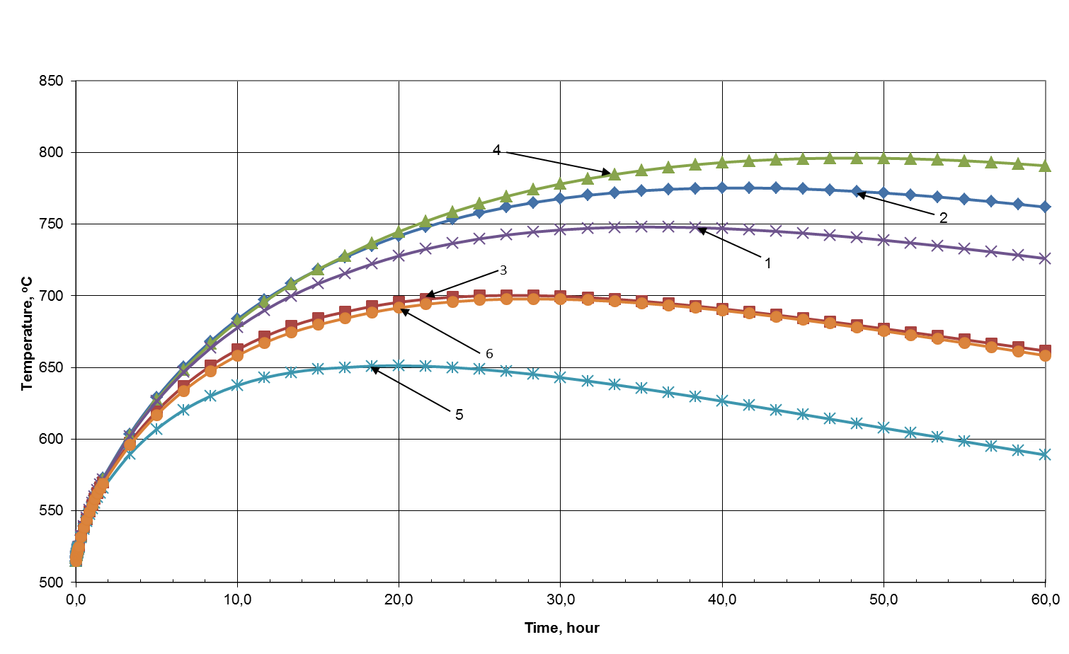
Fig. 2. Changes dynamics in the maximum vessel temperature for options 1-6 inTable 2.

The option with air channel using a gap between the vessel and the safety vessel was considered. The analysis showed that with a gap of 140 mm without heat transfer intensifiers and a hydraulic channel diameter of 280 mm, despite an approximate heat source, all other things being equal, heat removal from the reactor vessel decreases by about 15% with an excess of the maximum temperature. In the mode of natural circulation, the vessel temperature with a hot pipe height 105 m reaches 800 °C, heat power removal - about 14 MW. If heat exchange intensifiers are provided, conditions for the reactor vessel will be provided better.
The option with two independent air channels, including a gap between the vessel and the safety vessel without heat exchange intensifiers and a channel between the safety vessel and the ribbed cladding was considered. The independence of the channels is achieved by the physical features of radiation heat transfer. Calculations have shown that even with a hot pipe height of 30 m, natural thrust will not exceed the maximum vessel temperature of 700 °C and the heat removal capacity of about 17 MW. In calculating the options for natural circulation, the characteristics of cold and hot air pipelines were assumed to be similar.
Options with the use of the gap between the vessel and the safety vessel for heat removal are considered to identify proposed method additional possibilities. Since this is associated with additional gap technological functions the compared to traditional ones, such a decision must be specially justified. Option 6 is calculated with the height of the outlet pipe inside the building, conventionally limited to 30 m.

TABLE 1. Cooling parameters calculation results for six options

Parameter | Option
 | 1 | 2 | 3 | 4 | 5 | 6
Air circulation | Natural circulation |  | Forced circulation | Natural circulation
Hot pipe height, m | 105 | 60 | − | 105 | 105 | 30
Time to reach maximum temperature (τ_{max}) zone 1, h | 36 | 42 | 27 | 48.3 | 20 | 28.3
Parameters in τ_{max}:
The vessel zone 1 maximum temperature t₁, ^{о}С | 748 | 775 | 700 | 796 | 651.2 | 697.8
Zone 2 temperature, ^{о}С | 517 | 540 | 475 | 510 | 399 | 445.6
Air flowrate, kg/sec | 37.7 | 33.4 | 70 | 40.2 | 39 / 36.8 | 25.3 / 23.9
Air temperature in outlet from the gap t_{г}, ^{о}С | 423.4 | 496 | 258.2 | 367 | 251.1 / 266.5 | 308.4 / 399.4
Power dissipated by air, MW | 15.6 | 15.1 | 16.9 | 14.4 | 18.1 | 17
Air flow circulation channel | cladding | cladding | cladding | v-sv gap* | v-sv gap* /cladding | v-sv gap* /cladding
Intensifier in zone 1 (ribs) | no | yes | no | no | no/yes | no/yes
General characteristics and main calculated parameters in the zone 1 outlet section at the moment τ_{max}:
The nominal gap δ, mm | 100 |  |  | 140 | 140 / 100 | 140 / 100
The gap hydraulic diameter in zone 1, d1, mm | 100 |  |  | 280 | 280 / 100 | 280 / 100
The gap hydraulic diameter in zone 2, d2, mm | 200 |  |  | 280 | 280 / 200 | 280 / 200
The heat transfer coefficient in the gap of the outlet section in zone 1, kcal/(m²⋅h⋅^{о}С) | 22.9 |  |  | 14.7 | 13.7 / 21.2 | 9.9 / 15.8
The heat flux through the reactor vessel in the outlet section in zone 1, q, kcal/(m²⋅h⋅^{о}С) 10⁴ | 1.4 |  |  | 1.2 | 1.8 | 1.5
$$q/{α\left(t_{1}-t_{г}\right)}$$ |  |  |  | 1.9 | 3.33 | 3.85
*v-sv gap - gap between vessel and safety vessel

From Table 2 shows the radiation role in the total heat removal from the vessel. It is determined by the ratio of the total heat flux q from the reactor vessel to the heat flux by convective heat exchange from the vessel surface q_{α} in the variants of including the gap between the vessel and the safety vessel in the air cooling. The analysis was carried out for the zone 1 outlet section at the moment of reaching the maximum vessel temperature (τ_{max}).

Conclusion
Thus, taking into account heat exchange by radiation provides a regime for managing a severe accident for fast reactors with sodium coolant by removing heat from the reactor vessel through natural air circulation channels around the reactor. Even with heat removal through only one channel, the safety vessel – cladding, only a short-term (several hours) increase in the temperature of the vessel to 750^{о}С is possible with a long-term power failure, which excludes the primary circuit (vessel) failure.
Optimization of hydraulic resistance and heat transfer intensifiers in air channels can significantly reduce the limiting temperature of the main vessel.
References
- VELIKHOV, E., GAGARINSKIY, A., SUBBOTIN, S., TSYBULSKIY, V., Energy Challenges of the 21st Century, Nuclear society No 2-3, 2006, 25-36
- RACHKOV, V., POPLAVSKIY, V., TSIBULYA, A., The concept of a advanced power unit with a fast sodium reactor BN-1200, Atomic Energy, No 4, 2010, 201-206.
- KORONOVSKIY, N., NAYMARK, A., Earthquake: Is a Forecast Possible?, Science and Life, No 3, 2013, 36-43
- SHAYDEGGER A., Physical foundations of natural disasters, Nedra, Moscow, 1981.
- Record of external natural and human-induced impacts on nuclear facilities, NP 064-17, 2017
- Country Rosatom, No 33, 2013, 3
- BAGDASAROV, Y., POPLAVSKIY, V., MATVEEV, V., ELISEEV, V., Natural safety of a promising nuclear technology based on BN-800, Atomic Energy, No 6, 2001, 438-444.
- INTERNATIONAL ATOMIC ENERGY AGENCY, Status of Liquid Metal Cooled Fast Reactor Technology, TECDOC – 1083, IAEA, Vienna (1999), 438-444
- IDELCHIK, I., Handbook on hydraulic resistance (coefficients of local resistance and combustion resistance), Gosenergoizdat, Moscow, 1960.
- MIKHEEV, M., Heat Transfer Basics, Gosenergoizdat, Moscow, 1956.
- BAGDASAROV, Y., PINKHASIK, M., KUZNETSOV, I., Technical problems of fast reactors, Atomizdat, Moscow, 1969.

