Modeling and Simulation of Source Term for Sodium-Cooled Fast Reactor under Hypothetical Severe Accident: Sodium Fire and Radionuclide Transport in Containment

J.E. CHANG
TerraPower, LLC (TP)
Bellevue, USA
Email: jchang@terrapower.com

S. LI and L. REN
China Institute of Atomic Energy (CIAE)
Beijing, China

H. SUN and Y. ZHANG
Xi’an Jiaotong University (XJTU)
Xi’an, China

C. LIEGEARD
Commissariat à l'énergie atomique et aux énergies alternatives (CEA)
Cadarache, France

JOHN ARUL A. and S. RAGHUPATHY
Indira Gandhi Centre for Atomic Research (IGCAR)
Kalpakkam, India

N.A. MOSUNOVA and O.V. TARASOV
Nuclear Safety Institute of the Russian Academy of Sciences (IBRAE RAN)
Moscow, Russian Federation

L.E. HERRANZ and M. GARCIA
Centro de Investigaciones Energéticas, Medioambientales y Tecnológicas (CIEMAT)
Madrid, Spain

E-mail contact of main author: jchang@terrapower.com

Abstract

The main objective of the coordinated research project (CRP) is to simulate the fission product (FP) transportation behavior of the reference pool-type sodium-cooled fast reactor (SFR) of 1250 MWth capacity with mixed oxide fuel under severe accident conditions. The accident considered is an unprotected loss of flow accident (ULOFA) resulting in a core damage event with release of radionuclides. The work package 3 (WP-3) essentially models and simulates the ‘in-containment phenomena’ after the postulated severe accident, which includes sodium chemical reactions and aerosol mass evolution in the containment.
Seven organizations from six countries participated in WP-3. CIAE, CEA, and TerraPower used CONTAIN-LMR code and its derivatives. XJTU used REBAC-SFR code and IGCAR used PFIRE and PANDICA codes. IBRAE RAN used multiphysics EUCLID/V2 code and CIEMAT used ASTEC-Na code.
To decouple this part of analysis from previous stages of calculation, the stand-alone calculation was defined for WP-3, which uses a set of pre-defined release fractions. The stand-alone case is appropriate for inter-comparison with respect to assessing the tools of WP-3 calculations. In the coupled case, the release fractions of radionuclides computed at the previous work packages were used as initial conditions. Both IGCAR and IBRAE RAN participated in this coupled simulation. The purpose of this effort is to demonstrate the conservatism built in the stand-alone WP-3 inputs such as release fractions, chemical forms, and sodium ejection amounts. The obtained discrepancies in activities of airborne FP in containment take place mainly due to differences in modeling of FP release from molten fuel and of aerosol growth and deposition.
In both stand-alone and coupled calculations, the sodium fire and subsequent radionuclide release are modeled in two separate cases: (1) sodium spray fire with instantaneous reaction that results in the highest containment pressure while the containment does not leak, and (2) sodium pool fire that results in a prolonged burning of sodium in a compartment while the containment is leaking at the design leak rate.
The sodium spray fire exercise sets the baseline for the participants to compare the results based on the relatively straightforward boundary conditions. The pool fire case shows observable differences among the organizations due to the complexity of the sodium reaction phenomena, which also drive the aerosol release into the containment via the small compartment. In conclusion, there is broad consensus among the predicted results in WP-3 with respect to the stand-alone case.
Key Words: source term, containment phenomena, sodium fire codes

INTRODUCTION
The purpose of the coordinated research project (CRP) organized by International Atomic Energy Agency (IAEA) is to perform realistic estimation of fission product (FP) and fuel particle inventory inside reference pool-type, sodium-cooled fast reactor (SFR) volumes (i.e., in-primary vessel, cover gas system and in-containment building) at different time scales (few seconds for the instantaneous source terms and several days for the long-term source term), under severe accident conditions. The objective is to improve the understanding of the key phenomena involving radioactive material transport inside the reactor vessel and the containment compartments, in order to reduce uncertainties in estimation of the releases to the environment under severe accident conditions in an SFR. Therefore, the CRP intended to extend the predictive capabilities of simulation tools devoted to SFR design and safety analysis in order to make informed decisions on enhancing the safety of the proposed SFR designs [1].
Scope of analysis was divided into three parts, defined as work packages of the CRP: (1) in-vessel source term estimation, (2) primary system/containment system interface source term estimation, and (3) in-containment phenomenology analysis. The in-vessel source term consists of the transport of fuel and FPs from the damaged fuel pins to the cover gas volume through the sodium matrix. It can be divided into two components: an instantaneous source term, associated with the energetics of the assumed accident scenario, and a long-term source term associated with the release of FPs (and potentially fuel particles) from the sodium matrix of the primary system.
The primary system/containment system interface source term is also defined by two components: one being the release of FPs from the primary coolant and cover gas directly into the Reactor Containment Building (RCB), and the other one being the long-term leakage into the containment system. The first component also includes the associated mass of primary sodium instantaneously ejected through the leak paths in the vessel head into the RCB.
The in-containment phenomena are essentially defined by the transport of FPs through various containment compartments under the prevailing thermodynamic conditions, basically governed by the SFR specific processes such as sodium spray fire, sodium pool fire and various aerosol dynamics processes. The simulation exercise was carried out for a reference mixed oxide fuelled, pool-type SFR of 1250 MWth capacity with assumed initial conditions such as pressure and temperature corresponding to specified energy release estimated by deterministic calculations for an unprotected loss of flow accident [2].

radiological source term and containment phenomena

Accident Sequences to be Considered
The accident sequence to be considered here is an unprotected loss of flow accident (ULOFA). This event is assumed to result in a core damage event with release of radionuclides into the primary coolant and cover gas. ULOFA will be the typical scenario to be analysed for determining the core bubble fraction, pressure, and temperature evolution. ULOFA transient is initiated due to a loss of primary coolant flow resulting from a loss of power to both the primary pumps and failure to shut down the reactor. This leads to coolant temperature rise but there is an initial decrease in power and fuel temperature due to negative core expansion feedback. However, since the power to flow ratio is high, eventually this event results in coolant temperature rise and voiding in the upper part of highly rated channel.
As void spreads radially outward and axially inward towards core center, large positive reactivity is introduced. This leads to power excursion and finally to clad dry out that leads to rapid increase in clad and fuel temperatures, which results in clad and fuel melting. At this stage, molten fuel is likely to be swept out of the core by shearing force of the coolant and clad vapors for fresh fuel and in addition by fission gas pressure for irradiated fuel. Due to inherent uncertainties in modeling this phase, a conservative approach is followed for energy release calculation based on simplified fuel slumping assumptions. The transient moves to the disassembly phase when the peak fuel temperature reaches boiling point. This continued in the disassembly phase till reactor becomes subcritical.
This work essentially models and simulates the ‘in-containment phenomena’ after the postulated ULOFA, which includes sodium chemical reactions and aerosol mass evolution (e.g., agglomeration, wall plating, gravitational sedimentation etc.) in the containment. In this work, two approaches were taken to accelerate the CRP; (1) the stand-alone simulations were performed based on the pre-defined initial and boundary conditions for both sodium spray fire and sodium pool fire, and (2) the coupled simulations were also performed that cover the entire phases of the event without the pre-defined initial and boundary conditions.

Radionuclide Release Fractions and Sodium Ejection Rates
The radionuclide inventory of the referenced SFR is given in TABLE II of Reference [2]. The radionuclide release fractions and sodium release fractions for the stand-alone calculation are given in Table 1 and Fig. 1. A total of 350 kg of sodium at 600°C is released within 0.53 second through various gaps in the reactor vessel head.

TABLE 1. CORE INVENTORY RELEASE FRACTIONS TO CONTAINMENT BUILDING USED AS AN INPUT FOR THE STAND-ALONE CALCULATIONS

Group | Elements | Release Fractions
Noble Gases | Xe, Kr | 1.0
Halogens | I, Br | 0.1
Alkali Metals | Cs, Rb | 0.1
Tellurium Group | Te, Sb, Se | 1.0E-4
Barium, Strontium | Ba, Sr | 0.1
Noble Metals | Ru, Rh, Pd, Mo, Tc, Co | 1.0E-4
Lanthanides | La, Zr, Nd, Eu, Nb, Pm, Pr, Sm, Y, Cm, Am | 1.0E-4
Cerium | Ce, Pu, Np | 1.0E-4

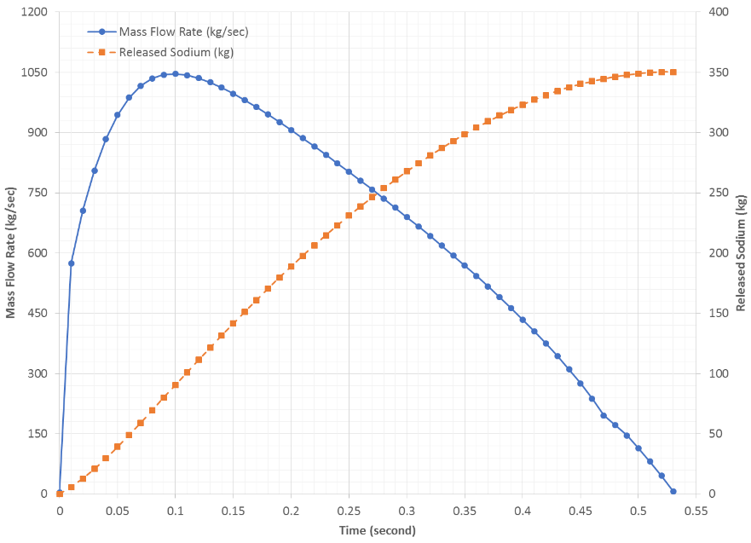
FIG. 1. Sodium Ejection Rate during ULOFA

Containment Building Geometry, and Initial and Boundary Conditions
The reactor containment building (RCB) houses the reactor and its coolant system. The RCB is designed to mitigate the consequences of postulated events that may release FPs to the environment. The net free volume of the RCB is 74,000 m³ and its effective height is 55 m as shown in Fig. 2. The RCB walls and ceiling is made of 1-meter-thick concrete. The enclosure above the reactor vessel head is a cylindrical structure, which is 14-meter diameter, 4-meter height, 30 mm thick, and made of carbon steel. The floor area of the enclosure is 150 m², where a sodium pool may form after the sodium ejection. The enclosure volume is connected to the RCB with an open area of 5 m².
The RCB is maintained at -0.7 kPa with the ventilation system during normal operations and its temperature and relative humidity are initially 30°C and 50%, respectively. The ambient conditions are similar to the initial RCB conditions except the relative humidity at 60%. The design leak rate of the RCB is 0.1 vol.% per hour at 25 kPa, which is its design pressure.

FIG. 2. Reactor Containment Building

simulation capabiliteis of sodium fire and containment phenomena
Seven organizations from six countries participated in this sodium fire and containment phenomena simulation for the WP-3 of the CRP. China Institute of Atomic Energy (CIAE), Commissariat à l'énergie atomique et aux énergies alternatives (CEA), and TerraPower, LLC (TP) used CONTAIN-LMR and its derivatives [3]. CONTAIN-LMR is a special version of the CONTAIN computer code that has been provided with extra capabilities to model liquid metal reactor (LMR) applications. CONTAIN-LMR includes models for sodium chemistry, sodium-concrete interactions, debris bed phenomena and other LMR-specific models in an integrated manner. The integrated nature and the wide spectrum of models available make CONTAIN-LMR well suited for analysis of accidents in containment, ranging from relatively benign scenarios to severe core melt accidents involving release of radioactive materials to the environment.
Xi’an Jiaotong University (XJTU) has been developed REBAC-SFR during the CRP. The main function of REBAC-SFR program is to simulate the diffusion and migration of sodium pool fire, sodium spray fire, oxide and FP aerosols in compartment. The code includes several modules: thermal hydraulic module, sodium pool fire module, sodium spray fire module, FP aerosol module, and nuclides decay module.
Indira Gandhi Centre for Atomic Research (IGCAR) used PFIRE, and PANDICA codes [4][5]. PFIRE calculating the temperature and pressure evolution in the containment is based on modified SOFIRE-II one cell code [6]. The code considers sodium pool fire, decay heat and solar radiation input to calculate temperature evolution. The model has been validated with the FAUNA 5, 6 and LTV Test 4 experiments and the estimates are well within bounds. PANDICA simulating polydisperse aerosol agglomeration and removal process in the containment uses a finite difference semi-implicit scheme to solve the aerosol dynamic equation.
Nuclear Safety Institute of the Russian Academy of Sciences (IBRAE RAN) used an integral multi-physics code for fast reactor accident analysis, EUCLID/V2, which includes system and subchannel thermal hydraulics, fuel rods, neutronics, core disruption, in-vessel corium retention, secondary criticality, core-concrete interaction, tritium transport, and FPs modules [7]. Besides, it allows modeling both sodium and lead (lead-bismuth) cooled reactor units. A feature of the EUCLID/V2 aerosol module is the ability to simulate multicomponent aerosols taking into account their different sources. For example, the formation of mixed aerosols consist of sodium combustion products, fission products and aerosols of the molten core-concrete interaction (MCCI). At the moment, the aerosol module has the ability to take into account the presence of up to one hundred different radionuclides in vapor phase and aerosol particles. The code includes models of nucleation, evaporation and condensation, coagulation of polydisperse particles, water absorption, transport, deposition, spontaneous decay and radioactivity of fission products. The model of sodium pool fire is similar to SOFIRE-II, which can also simulate simultaneous spray and pool fire. This model is validated on ABCOVE experiments AB1, AB2 [9] and pool and spray fires models are validated on SOLFA-2 [10]. The model of spray fire is similar to that in FEUMIX code.
Centro de Investigaciones Energéticas, Medioambientales y Tecnológicas (CIEMAT) used ASTEC-Na, which is being developed to simulate postulated accidents in SFR, particularly severe accidents [11]. A significant progress has been made in the development of source term models, their implementation in the code and the specific validation of the code module ASTEC-Na CPA. The code incorporated the pool fire combustion model, which is based on the SOFIRE-II model [6] that is present in CONTAIN-LMR [3]. A model for particle generation during pool fires and the subsequent chemical reactions of airborne particles with steam and carbon monoxide have been implemented.

sodum fire simulatIon results

Peak Containment Pressure with Sodium Spray Fire
The sodium is ejected into the RCB within 0.53 seconds as spray drops in order to maximize the containment pressure, which can be used to set the RCB design pressure. No leakage to the environment was assumed. In Fig. 3(a), most of cases all the sodium is burnt during the ejection phase except CEA and CIEMAT. Similar trend is also shown in the sodium burn energy release in Fig. 3(b).
Some organizations (CIAE, XJTU, and IGCAR) utilized the detailed sodium ejection profile from Fig. 1 and some others (CEA, CIEMAT, IBRAE RAN and TP) assumed a constant ejection profile. CIEMAT profile results from modeling a sodium spray fire as a sodium pool fire by an equivalent pool surface. Although the time scale may show some exaggeration in timing due to the semi-logarithmic scale, the overall pressure and temperature responses are fairly consistent as shown in Fig. 3(c) and Fig. 3(d). The initial pressure of the CEA may not be consistent with the rest. Considering the pressure increase from the initial value, the pressure difference appears to be similar to the rest. The peak pressure increase is approximately 14 kPa and the peak temperature increase is 40 K. IBRAE RAN calculation was not focused on detailed analysis of first several seconds. Such approach does not give correct temperature dependence during first seconds, but after t = 100 s the total amount of energy transferred to RCB atmosphere is correct.

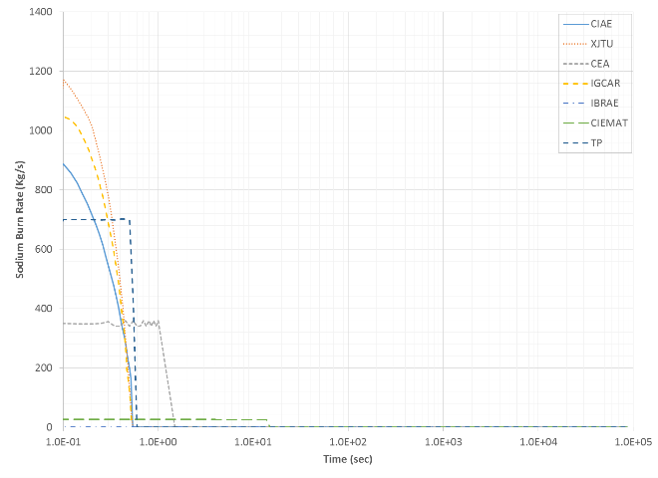 | 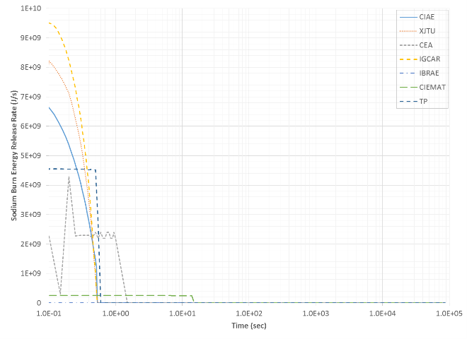
(a) Sodium Burn Rate | (b) Energy Release Rate
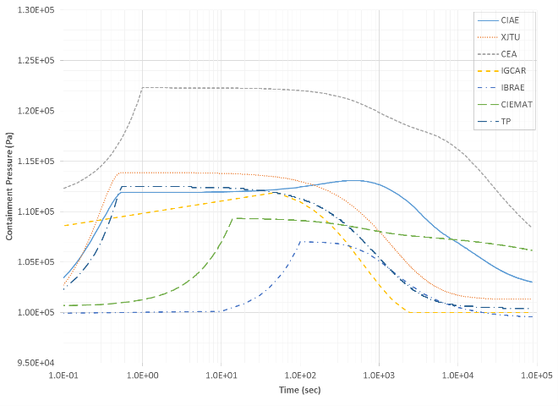 | 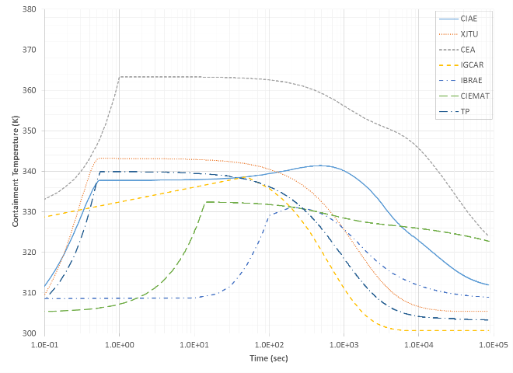
(c) Containment Pressure | (d) Containment Temperature
FIG. 3. Comparison of Sodium Spray Fire and Containment Responses

Containment Response with Sodium Pool Fire
Since burning of the sodium pool within the enclosure space takes time due to the limited sodium reaction area, it takes a few hundred seconds to a few thousand seconds from Fig. 4(a) and Fig. 4(b). The initial high energy release rate from TP in Fig. 4(b) is due to the burning of the initially ejected sodium during the short ejection period, i.e., 0.53 second.
Unlike the sodium spray fire case, both the design leak rate of the RCB and the enclosure above the reactor vessel head were modeled in this sodium pool fire simulation, which results in more realistic results. The enclosure structure plays an important role to mitigate the immediate sodium burn such that the liquid sodium spreads on the entire floor and slowly burn inside the enclosure. The air exchange rate between the RCB and the enclosure affects primarily the RCB temperature as well as the RCB pressure. Compared with Fig. 3(c) and Fig. 3(d), the RCB pressure (Fig. 4(c)) and temperature (Fig. 4(d)) are much lower as such the enclosure provides an additional mitigation layer during the sodium fire. The RCB pressure drives the leak of the radionuclides to the environment and this pressure reduction due to the enclosure will further decrease the radiological consequences to the public. In IBRAE RAN calculation, due to no oxygen starvation, pool temperature does not change significantly, and burning rate is nearly constant.

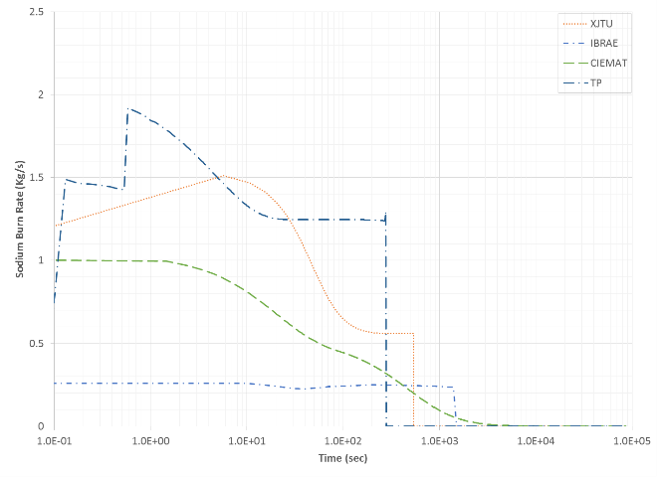 | 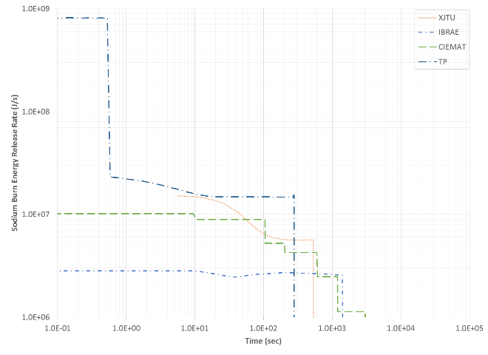
(a) Sodium Burn Rate | (b) Energy Release Rate
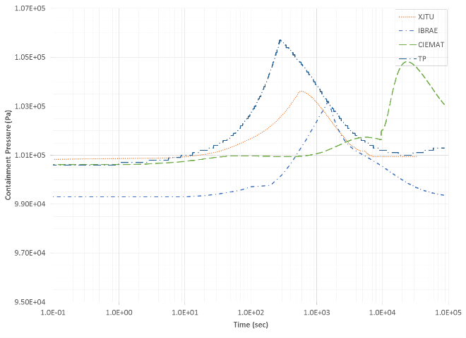 | 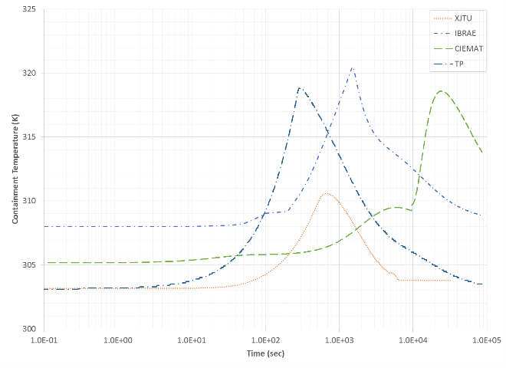
(c) Containment Pressure | (d) Containment Temperature
FIG. 4. Comparison of Sodium Pool Fire Simulation and Containment Responses

aerosol dynamIcs and radionulcides release
In this section, the sodium pool fire results are shown since this case represents more realistic event due to the physical configuration of the enclosure in the reference SFR.

Noble Gases
The noble gases will escape along with the ejected sodium so the release timing of the noble gases is expected to be similar to the sodium ejection profile in Fig. 2. Fig. 5(a) and Fig. 5(b) show the noble gas mass in the RCB. It is noted that IBRAE RAN and TP accounted for the decay of noble gases so that the short-lived xenon in the RCB decreases toward the end of the simulation. In IBRAE RAN calculations, the release of FPs into atmosphere was modeled as instantaneous due to strong convection driven by the sodium burning. It gives correct total mass of fission products after ejection ends but does not show how noble gases are released with the sodium ejection. It is believed that the mixing between the enclosure and the RCB took more time for XJTU and CIEMAT compared with IBRAE RAN and TP.

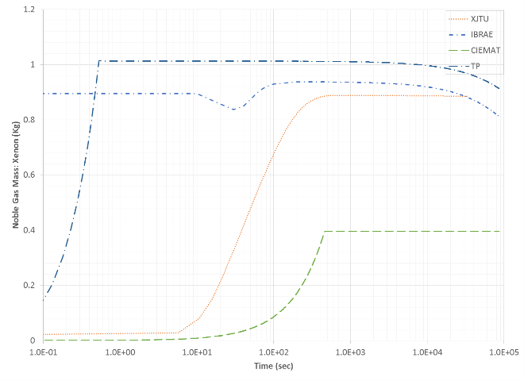 | 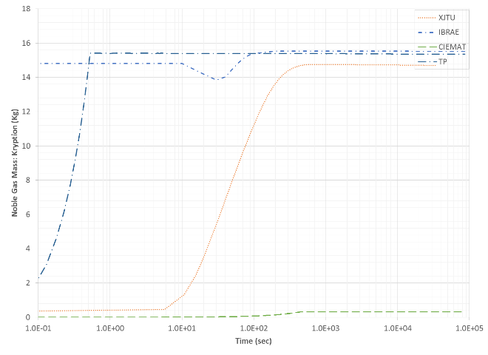
(a) Xenon | (b) Krypton
FIG. 5. Comparison of Noble Gas Mass in Containment

Fission Products and Aerosols
The FP aerosols will be released with the sodium chemical reaction with oxygen and water vapor in the RCB. In Fig. 6(a) and Fig. 6(b), TP accounts for aerosols from the sodium chemical reaction and the FPs. Overall, the aerosol generation and natural deposition are quite different among the participating organizations. Modeling of the sodium chemical products, i.e., sodium peroxide and sodium monoxide, makes observable difference in the total aerosol mass as well as the sodium burn energy release.

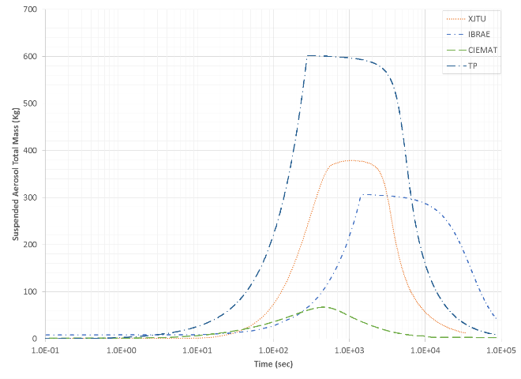 | 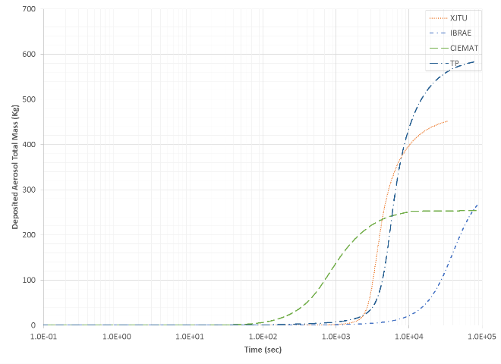
(a) Suspended Aerosol Mass | (b) Deposited Aerosol Mass
FIG. 6. Comparison of Total Aerosol Distributions in Containment
Typically iodine release especially iodine-131 (I-131) is a dominant dose contributor due to its high dose coefficients to organs. The rest of aerosol behaviors are similar to the iodine behavior so only two cases (i.e., iodine and cesium) are shown in Fig. 7(a) and Fig. 7(b). Similar to the noble gas case, IBRAE RAN results do not show how FP aerosols are released with the sodium ejection due to the coarse time step sizes but after ejection is over, total mass of each FP in enclosure and RCB atmosphere is correct. CIEMAT predicts the same release profile of FP aerosols and noble gases since FP transport in ASTEC-Na is based on the concept of host, i.e., the FPs released are carried by the aerosols. It is also noted that there are some differences in cesium mass – IBRAE RAN vs. XJTU, CIEMAT, and TP.

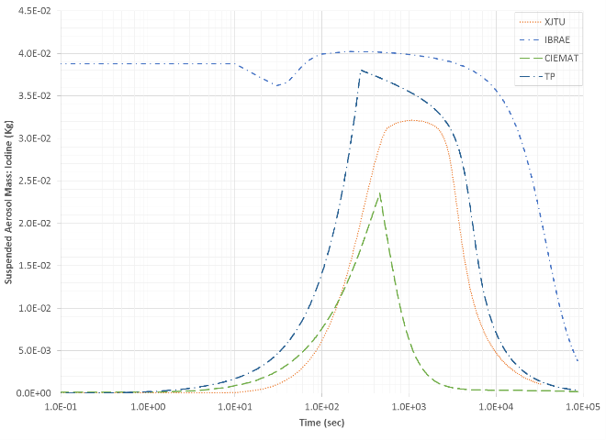 | 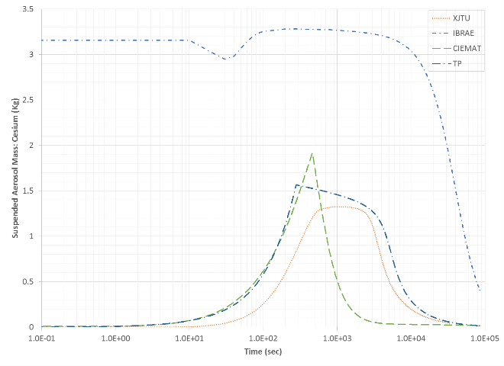
(a) Suspended Iodine Mass | (b) Suspended Cesium Mass
FIG. 7. Comparison of Suspended Halogen Mass in Containment
IBRAE RAN estimated no release of zirconium and plutonium, and CIEMAT did not consider plutonium in this calculation as shown in Fig. 8(a) and Fig. 8(b), whereas TP and XJTU assumed same fractional release of these elements. Generally, non-volatiles would not be released if there is no driving force due to a very low vapor pressure. During the sodium fire, the FP particles in sodium may be excited and dragged by the sodium chemical reactants and disperses in the air. However, its relatively high density and the natural deposition to the RCB may occur much faster.

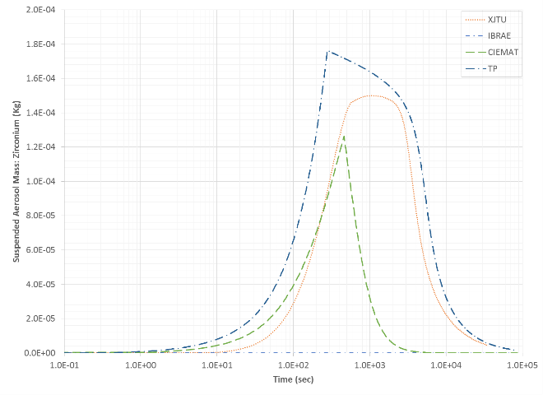 | 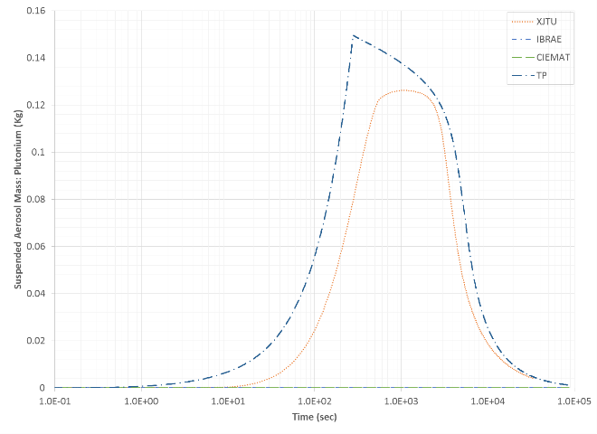
(a) Suspended Zirconium Mass | (b) Suspended Plutonium Mass
FIG. 8. Comparison of Suspended Mass in Containment
The modeling of mechanistic aerosol generation processes is still challenging and many simulation tools rely on empirical or semi-empirical correlations that are validated in very specific ranges. For example, the aerosol dynamics models in CONTAIN-LMR and ASTEC-Na are fundamentally based on MAEROS [12]. Sometime a user needs to select input parameters that should be supplemented by experiments [13].
One of key assumptions in aerosol dynamics that affect the natural deposition process is the mass mean diameter of aerosols – usually Sauter mean diameter is used. Several organizations did various benchmarks and sensitivity studies during the CRP. Each used their own inputs that are believed to be more appropriate.

coupled simulation of radionuclides and sodium releaes
IGCAR and IBRAE RAN performed the coupled simulation to quantify the conservative assumptions made for the stand-alone simulations. The comparison of the IGCAR and IBRAE RAN release fractions at the end of the work package no. 2 (WP-2) calculations (i.e., interfacing system phase) are shown in Fig. 9. The lower values of release fractions in the IGCAR calculation could be due to the consideration of only cover gas volume in the constant volume problem of the thermo-chemical equilibrium model.

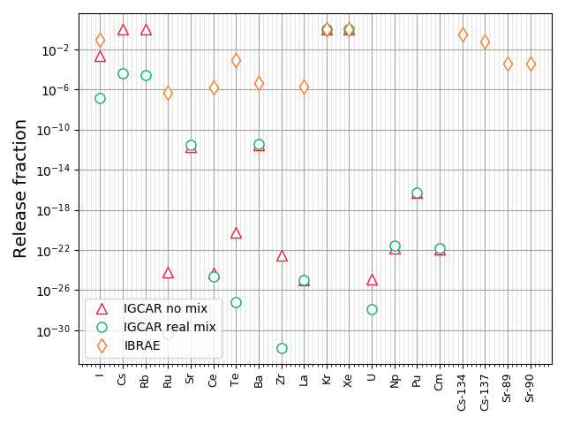
FIG. 9. Comparison of Release Fractions from Coupled Simulations

For the calculation of suspended mass, IGCAR has assumed no leak through containment, which will give the maximum containment activity in the containment. Whereas IBRAE RAN has performed with the RCB design leak rate (i.e., 1 vol.%/hour). There is a good agreement between IBRAE RAN and IGCAR on total mass in the containment of Xe, shown in Fig. 10(a) and Kr. For iodine, IGCAR no mixture case and IBRAE RAN predictions agree within an order of magnitude as shown in Fig. 10(b). However, for Sr and Ba IGCAR predictions are in the trace amounts as Sr is found to form oxide condensate in sodium. For IBRAE RAN suspended Sr is about 0.1 grams and Ba is in milligrams. Large differences are found in the predicted suspended mass of Te, Ru, La, Zr, Cm, Ce, Ba, which is likely due to differences in the in-vessel release models and very different release fraction estimates of IBRAE RAN and IGCAR. However, this difference has negligible effect on activity in containment because total leak into environment is less than 0.1% of it in IBRAE RAN and IGCAR calculations.
In IBRAE RAN calculations activity release into RCB is determined by results of WP1 and WP2 because all FPs in sodium pool or spray are supposed to release into RCB atmosphere as aerosols or gases. Then activity decreases due to the following two mechanisms: spontaneous decay (important for FPs with half-lives shorter than several days) and gravitational aerosol deposition (important for longer-lived FPs, which form aerosols). In conservative calculation with 1.3 μm particles activity of such FPs halves every 2.4 days while in realistic calculation with larger polydisperse aerosols due to coagulation it halves every 6 hours. Most complicated is to model activities of FPs with long half-lives that form aerosols, like Sr-89. After 24 hours activity of such FPs in conservative and realistic calculations differs by 1 order of magnitude. Release into environment is determined by activity and overpressure in RCB. The main user-defined parameters which affect overpressure are fraction of burning energy transferred to gas phase and heat transfer coefficient between gas and walls. Release into environment ends in several hours so RCB activity decrease due to aerosol phenomena does not affect it strongly. However, aerosol sizes obtained may be important for further modeling of FP in environment.

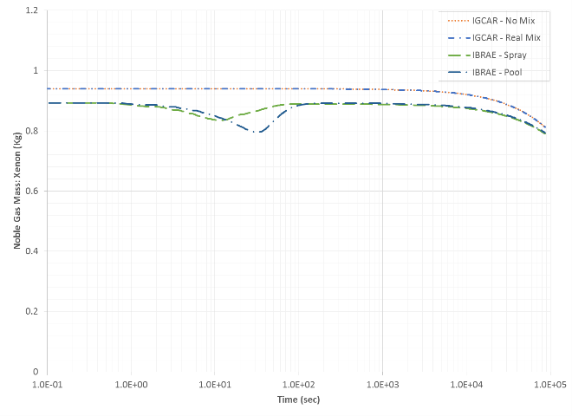 | 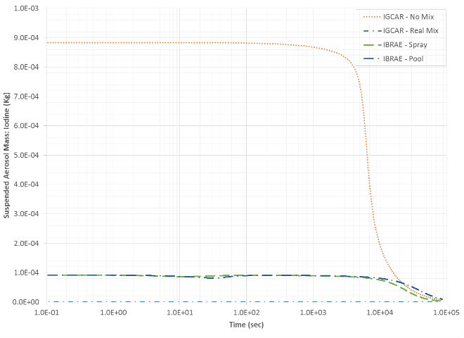
(a) Xenon Mass | (b) Suspended Iodine Mass
FIG. 10. Comparison of Xenon Gas and Suspended Iodine Aerosol Mass in Containment from Coupled Simulations

conclusions
The IAEA CRP on “Radioactive Release from the Prototype Sodium Cooled Fast Reactor under Severe Accident Conditions” was devoted to realistic numerical simulation of FPs and fuel particles inventory inside the reference SFR volumes under severe accident conditions at different time scales, from few initial seconds for the instantaneous source terms to several days for the long-term source term.
For this in-containment phenomenology analysis, largely three separate cases were simulated: (1) the stand-alone sodium spray pool fire to estimate the peak containment pressure without the RCB leak, (2) the stand-alone sodium pool fire to evaluate the FP and aerosol releases with the RCB leak, and (3) the coupled case to identify the conservatism in the stand-alone cases. The stand-alone cases use a set of pre-defined sodium ejection rate and fuel as well as FP release fractions.
Among the participating organizations, the sodium spray fire results got broad consensus on the containment responses that determine the peak containment pressure. However, the sodium pool fire results were not as consistent as the sodium spray fire results due to the complexity of the sodium chemical reaction. The sodium burn rates and durations vary widely among the participants. The modeling of the enclosure above the reactor vessel head is a key to mitigating the immediate burn of the ejected sodium. Majority of sodium pool fire tools rely on less mechanistic but rather empirical correlations or user inputs, which require further validation and justification.
The aerosol dynamics and its natural deposition processes need more improvement generally. Similar to the sodium fire models, many of aerosol dynamics inputs are empirical nature and a user should have an insight to choose appropriate ranges unless one has data from experiments. During the CRP period, many organizations performed various benchmarks to validate their analysis tools and those efforts will be continued to address the safety concerns in design and licensing of SFRs. The noble gas behaviors were relatively consistent but the FP aerosols showed some variations depending on assumptions that each organization made. Halogens are typically significant contributors to the off-site dose consequences. The overall trend seems consistent among the participants.
The coupled simulations further identified conservatisms carried by the initial and boundary conditions used throughout the three work packages of the CRP. The differences between the stand-alone and coupled results were insignificant for noble gases due to the instant release and no deposition mechanism. However, the aerosol results showed very significant differences, e.g., reduced by an order of magnitude.

References
- INTERNATIONAL ATOMIC ENERGY AGENCY, Modelling and Simulation of Source Term for Sodium Cooled Fast Reactor under Hypothetical Severe Accident, TECDOC-XXXX, IAEA, Vienna (To be Published).
- ARUL, J. et al., “Source term estimation for radioactivity release under severe accident scenarios in sodium cooled fast reactors”, Fast Reactors and Related Fuel Cycles: Next Generation Nuclear Systems for Sustainable Development FR17 (Proc. Int. Conf., Yekaterinburg, 2017), IAEA, Vienna (2018), Paper CN245-335.
- Murata, K.K. et al., CONTAIN LMR/1B-Mod.1, A Computer Code for Containment Analysis of Accidents in Liquid-Metal Cooled Nuclear Reactors (SAND91-1490), Sandia National Laboratories, Albuquerque, NM, USA, 1993.
- P.R. Patel, A. John Arul, G. Pandikumar, Study of the impact of decay heat on the in-containment temperature and pressure evolution following a hypothetical severe accident in a SFR, Annals of Nuclear Energy. 138 (2020) 107189.
- P. R. Patel, A. John Arul, Mechanistic modelling of aerosol evolution and thermal loadings in an SFR containment during a hypothetical severe accident, submitted (unpublished), in: International Conference on Fast Reactors and Related Fuel Cycles: Sustainable Clean Energy for the Future (FR22), Beijing, China, 2022.
- Beiriger, P. et al., SOFIRE II User Report (AI-AEC-13055), Atomics International, Canoga Park, California, USA, 1973.
- Butov, A.A., et al., The EUCLID/V2 code physical models for calculating fuel rod and core failures in a liquid metal cooled reactor, Thermal Engineering 66 5 (2019) 293–301.
- Alipchenkov, V.M., et al., “Models of the integral EUCLID/V2 code for numerical simulation of severe accidents in a sodium-cooled fast reactor with MOX and MNUP fuels”, International Conference on Fast Reactors and Related Fuel Cycles: Sustainable Clean Energy for the Future (FR22) (Proc. Int. Conf., Beijing, China, 2022), IAEA, Vienna (2022), Paper CN291-113.
- Hilliard R.K., MCcormack J.D., Postma A.K., 1979. Aerosol behavior during sodium pool fires in a large vessel - CSTF tests AB1 and AB2. Report No. HEDL-TME 79-28 UC-79, 79p, Hanford Engineering Development Laboratory.
- Ohno S., Uchiyama N., Kawata K., Miyake O., 1996. Sodium Columnar Fire Test and Code Development at PNC, IAEA/IWGFR Technical Committee Meeting on “Evaluation of Radioactive Materials Release and Sodium Fires in Fast Reactors,” IWGFR/92, 385-396.
- Girault, N. et al., “The European JASMIN project for the development of a new safety simulation code, ASTEC-Na, for Na-cooled fast neutron reactors”, International Congress on Advances in Nuclear Power Plants, ICAPP 2013: Nuclear Power - A Safe and Sustainable Choice for Green Future (Proc. Int. Conf., Jeju Island, Korea, 2013), Seoul, Korea (2013), Paper FA056.
- Gelbard, F., MAEROS User Manual (NUREG/CR-1391), Sandia National Laboratories, Albuquerque, NM, USA, 1983.
- Gordeev, S. et al., “Simulation of sodium aerosol behaviour with CONTAIN-LMR code”, International Congress on Advances in Nuclear Power Plants, ICAPP 2014 (Proc. Int. Conf., Charlotte, USA, 2014), Red Hook, NY, USA (2014), Paper 14016.

