Mechanistic modelling of aerosol evolution in an SFR containment following a hypothetical severe accident

Parthkumar Rajendrabhai Patel
Homi Bhabha National Institute and,
RSDD, NSDG, Indira Gandhi Centre for Atomic Research
Kalpakkam, India
Email: parthpdpu@gmail.com

A. John Arul
RSDD, NSDG, Indira Gandhi Centre for Atomic Research and
Homi Bhabha National Institute
Kalpakkam, India

S. Raghupathy
RDTG, Indira Gandhi Centre for Atomic Research
Kalpakkam, India

Abstract

In the problem of radioactive source term estimation with intact containment, the phenomenon of aerosol growth and removal in the containment plays a significant role governing the final quantity of RN available for release. In present work, a medium-size oxide fuelled sodium-cooled fast reactor (1250 MWt) is chosen as the reference design, wherein a whole core melt accident initiated by the loss of primary coolant pumps with the simultaneous failure of both the shutdown systems (ULOFA) is considered. The temperature and pressure transients due to the burning of ejected sodium are studied. Additionally, the evolution of the RN and sodium aerosols generated from the sodium fire is analysed. For realistic estimates of the in-containment source term, in-vessel release fractions calculated from a thermo-chemical equilibrium model using MINICHEM are used as input. The present calculations are performed for the two sets of in-vessel release fractions viz., 1) No mixture 2) Real mixture to be used as input. We found that following an accident, Cs, Rb, I, Xe, and Kr are the dominant suspended species in the containment. Additionally, it is observed that after 5 hours, less than ~15% of the total initial aerosol mass is suspended. After 24 hours less than ~2% of the total initial aerosol mass is suspended. The present calculations indicate that a leak tight containment, effectively holding RN for the first 24 hours would be helpful to reduce the radioactivity available for release. Further work is in progress to include aerosol generation models and multi-component distributed aerosol modelling.

INTRODUCTION
Post severe accident, the sodium released in the containment vigorously reacts with the containment atmosphere. Since, these reactions are exothermic in nature, the temperature and pressure in the containment are expected to rise. Further, the reaction products (mainly Na₂O and Na₂O₂), start to nucleate, condense, and coagulate, leading to the formation of sodium aerosols. These sodium aerosols along with the released RN remain suspended in the containment till they settle down or leak. To study the containment functional requirement, in terms of the allowable leak rate, two aspects need to be analysed viz., i) thermal loading on the containment and ii) amount of RN inventory suspended in the containment available for release as a function of time. The present manuscript analyses the amount of RN in the containment following a postulated severe accident using both best estimate approach as well as conservative estimate approach.
In this study, in-containment source term is determined for a reference medium sized sodium cooled fast reactor. For the analysis, Unprotected Loss of Flow Accident (ULOFA) and the resulting whole core melt scenario is considered. The detailed specification of the reference reactor and accident progression can be found in P R Patel, A. John Arul, and P. Chellapandi et. al. [1, 2]. Some important phenomena pertaining to the RN release with respect to the specific postulated accident scenario are as follows: As per the deterministic code simulations, at about 16-17 seconds post initiating event, claddings at the centre top portion of the fuel pins are expected to fail. This leads to the release of most of the non-condensable gases (e.g., Xe and Kr), JOG and volatile RNs from the fuel pin plenum. These RNs and non-condensable gases will be released to the cover gas in the form of non-condensable bubble swarm. Most of the non-volatile RNs in the bubbles will be scrubbed in the sodium as there is sufficient distance between core top and the cover gas space (distance: 5 m). Eventually, since the power to flow rate is high, the sodium voiding is expected to start at about 25 seconds near highly rated fuel sub-assemblies. Subsequently, the fuel melt will lead to core bubble formation [3]. The expansion of core bubble leads to impact of sodium to the roof slab, failure of roof slab and sodium release from the roof slab. The RN released from the fuel during the pre-disassembly and disassembly phases of the accident, will be released with the ejected sodium. It may be noted here that the RN dissolved in the top portion of sodium only will be released with the ejected sodium. The released sodium reacts with the containment atmosphere, forming RN and sodium aerosol suspended in the containment. The late phase release will be from the evaporation of the suspended RN from the primary pool.
The objectives of the current analysis are to determine the containment temperature and pressure transients due to the burning of ejected sodium, determination of the amount of suspended and deposited sodium aerosols generated from combustion and the determination of the amount of suspended radio nuclides in the containment with time. The analysis performed here is for the case of a leak tight containment.
The temperature and pressures are determined for the instantaneous spray fire, where the released sodium spray from the reactor vessel instantaneously reacts with the available oxygen in the containment. This gives us the bounding temperature and pressures in the containment due to sodium fires. Additionally, since, there is significant uncertainty involved in the determination of the in-vessel source term which is being used as input, the in-containment source was determined using three sets of the in-vessel release fractions, viz. i) conservative in-vessel release fractions derived from the various LWR literatures [4–8] ii) in-vessel release fraction arrived from the thermo-chemical equilibrium calculation with no mixture assumption [1], where the vapor fractions correspond to the vapor pressure of the particular species iii) in-vessel release fraction arrived from the thermo-chemical equilibrium calculation with real mixture assumption, where the solubility of the species and the excess functions are considered.
The article is structured as follows: Section 1 discusses about the temperature and pressure evolution following sodium fire in the containment. Section 2 gives a brief description of the population balance equation used in the analysis. Section 3 compares the in-containment source term with stand-alone cases and integral case. Section 4 concludes our findings.

evolution of the temperature and pressure in the containment
The containment integrity is an important aspect of the release of RN to the environment post severe accident. In the present section, the temperature and pressure evolution in the containment due to sodium fire is studied. For the current analysis, it is assumed that the expelled sodium will be released in the form of a spray. The released sodium spray instantaneously reacts with the containment air, leading to temperature and pressure rise in the containment. The estimated temperature and pressure will be bounding temperature and pressure in the containment due to sodium fire. The temperature and pressure evolution are simulated using PFIRE code[9], which is based on the SOFIRE-II code. These temperatures are used as an input for the RN aerosol dynamics.

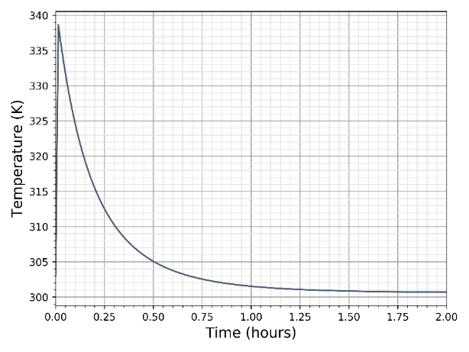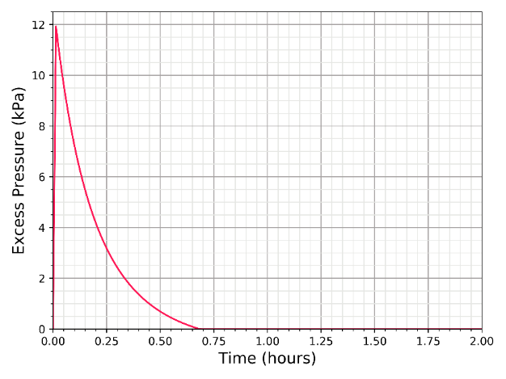
- (b)
FIG. 1 (a) temperature evolution in the containment following sodium spray fire (b) pressure evolution following sodium spray fire
For the temperature and pressure evolution in the containment, 100% formation of Na₂O was assumed. The temperature and pressure evolution in the containment is given in the Fig. 1. As shown in the figure, the peak temperature in the containment is about 340 K, whereas the peak pressure in the containment is about 12 kPa, which is well below the design pressure of 25kPa [10]. The temperatures reach room temperature after the 2-3 hours.

Population balance equation FOR AEROSOLS
The sodium along with the RNs that are ejected into the containment during the bubble expansion phase would form aerosols in the containment atmosphere. The subsequent rate of removal or deposition of these aerosols would depend on the condensation rate, size distribution, ambient conditions, agglomeration and removal mechanisms and the surface area available for settling. The evolution of the aerosol owing to coagulation and removal can be given by the following integro-differential equation (popularly known as Smoluchowski equation or population balance equation) [11],

$$\begin{aligned}\frac{∂n\left(v\right)}{∂t}= \frac{1}{2}\int_{0}^{υ}{β\left(u,v-u\right)}n\left(v-u\right)n\left(u\right)du -\int_{0}^{∞}{β\left(u,v\right)n\left(v\right)n\left(u\right)du} –R\left(v\right)n\left(v\right)+S\left(v\right)\#\left(1\right)\end{aligned}$$

Where $u$ and $v$ are the volumes of coagulating particles, $n(v)$ is the time-dependent number concentration (particles per unit medium volume per particle volume, n dv is the number of particles per unit medium volume with size between v and v+dv), $β(u,v)$is the agglomeration kernel (including collision efficiency) of the two colliding particles (unit medium volume per particle per unit time). In Eq. (1) terms related to nucleation, condensation and break up are not shown. For the current analysis agglomeration due to gravity, Brownian diffusion, turbulent diffusion, and turbulent inertia is considered. Fig. 2 depicts various phenomenon responsible for the evolution of the aerosol in the containment.

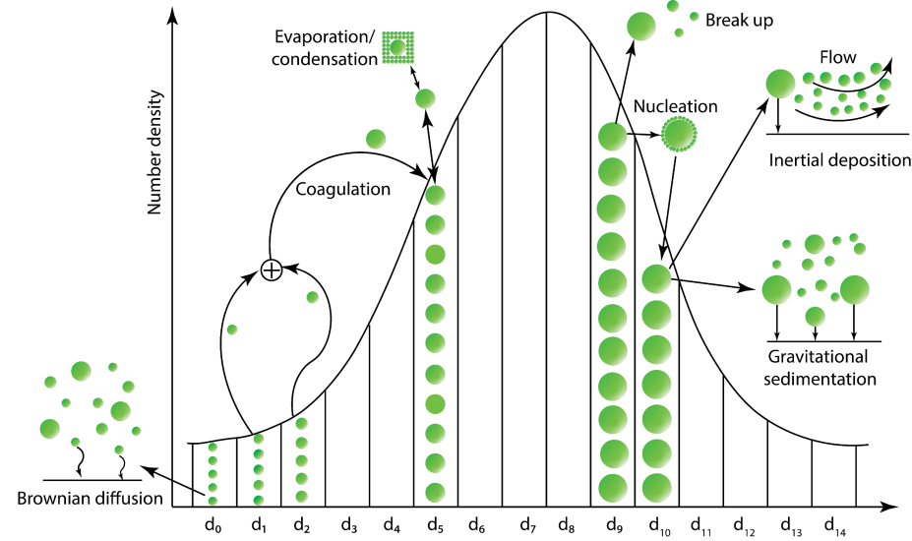
FIG. 2 Various agglomeration and removal phenomena responsible for the evolution of the RN aerosols in the containment
First term on the R.H.S of Eq. (1) is for the formation rate of particles of volume v from particles of volume (v-u) and particles of volume u. The second term on the R.H.S is the removal rate of particles volume v owing to coagulation with particles of all sizes. The first integral in Eq. (1) is multiplied by 0.5 to eliminate double counting of production terms. R(v) is the particle removal rate (per unit time) due to various removal mechanisms such as gravitational sedimentation, diffusion and thermophoretic removal. S(v) dv is the source term, i.e., aerosol generation rate per unit volume of particle size between v and v+dv. The Eq. (1) can be discretised in various discrete size bins as,

$$\begin{aligned}\frac{dn_{k}}{dt}=\sum_{j=1}^{k-1}{β_{k-j, j}n_{k-j,t}n_{j,t}}-\sum_{j=1}^{∞ }{β_{k, j}n_{k,t}n_{j,t}}-{R_{k}n_{k,t}+S}_{k,t}\#\left(2\right)\end{aligned}$$

Where, k or j is the k^{th} or j^{th} size bin in the aerosol size distribution. Eq. (2) is numerically solved using the semi-implicit method. The aerosol size distribution is divided into K no of the size bin. The Eq. (2) is implemented in python and named PANDICA (Particle Agglomeration and Deposition In Containment Analysis) for solving the aerosol evolution in the containment with time. The in-house developed code is openly available on GitHub (https://github.com/parthigcar/PANDICA). The aerosol evolution calculated from PANDICA code is given in Fig. 3 for a typical case of initial lognormal distribution. The code had been validated by analytical solution of Smoluchowski equation for constant coagulation kernel [12,13].
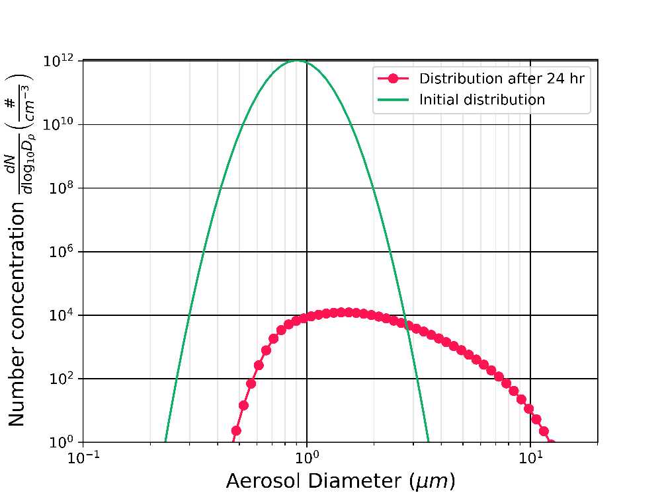
FIG. 3 Aerosol evolution calculated from PANDICA. The initial distribution is log-normal distribution with size range from 1E-3 micron to about 10 micron (number concentration less than one are not shown)

Aerosol evolution in the containment
Since, there is considerable uncertainty in the in-vessel source term estimation used as input for this calculation, two broad cases (total three cases) are considered for the analysis viz., i) stand-alone case, where the conservative set of in-vessel release fractions are compiled from the LWR literature ii) integral case, where the in-vessel release fractions are calculated using thermo-equilibrium calculations (using MINICHEM) [1]. The integral case has two sub cases depending on the in-vessel release fraction calculation assumptions, viz. i) in-containment dynamics with the no-mix assumption ii) in-containment dynamics with real-mix assumption. The no mix assumption means that the RN release will be as per the RN vapor pressure, which gives the bounding in-vessel release fraction estimates. The real mix case estimates the RN release with the consideration of the RN solubility in the sodium as well as the use of excess functions. The in-vessel source term with the real mix assumption is expected to give a realistic estimate. The groupwise RN in-vessel release fraction for different cases are given in the Table-1 and Table-2. Here, it should be noted that the release fractions less than 1E-18 are truncated.

TABLE 1 In-vessel release fractions used as input for the standalone case
Group | Elements | Designated release fractions
Noble Gases | Xe, Kr | 1
Halogen | I, Br | 0.1
Alkali metals | Cs, Rb | 0.1
Tellurium group | Te, Sb, Se | 1.0E-04
Barium | Ba, Sr | 0.1
Noble metals | Ru, Rh, Pd, Mo, Tc, Co | 1.0E-04
Lanthanides | La, Zr, Nd, Eu, Nb, Pm, Pr, Sm, Y, Cm, Am | 1.0E-04
Cerium | Ce, Pu, Np | 1.0E-04

TABLE 2 Release fraction used for the integral case, as obtained from in-vessel source term calculation. The release fraction less than 1E-18 is truncated to 1E-18 to avoid unrealistic released values
Representative  element |  | Element group | No mix  (873K) | Real mix  (873 K)
Xe | He, Ne, Ar, Kr, Xe, H, N |  | 1 | 1
Cs | Li, Na, K, Rb, Cs, Fr, Cu |  | 0.91 | 3.18E-5
Ba | Be, Mg, Ca, Sr, Ba, Ra, Es, Fm |  | 2.77E-12 | 1.48E-7
I | F, Cl, I, Br, At |  | 2.17E-03 | 1E-18
Te | Os, Se, Te, Po |  | 1E-18 | 1E-18
Ru | Ru, Rh, Pd, Re, Ir, Pt, Au, Ni |  | 1E-18 | 1E-18
Mo | V, Cr, Fe, Co, Mn, Nb, Mo, Tc, Ta, W |  | 1E-18 | 1E-18
Ce | Ti, Zr, Hf, Ce, Th, Pa, Np, Pu, C |  | 5E-17 | 1E-18
La | Al, Sc, Y, La, Ac, Pr, Nd, Pm, Sm, Eu, Gd, Tb, Dy, Ho, Er, Tm, Yb, Lu, Am, Cm, Bk, Cf |  | 1E-18 | 1E-18
U | U |  | 1E-18 | 1E-18
Cd | Cd, Hg, Zn, As, Sb, Pb, Tl, Bi |  | 1E-18 | 1E-18
Sn | Sn, Ga, Ge, In, Ag |  | 1E-18 | 1E-18
B | B, Si, P |  | 1E-18 | 1E-18

For the analysis, the containment is assumed to be leak tight. The leak tight assumption is conservative for the activity estimates in the containment. The free containment volume for the reference reactor is 74,000 m³. Total floor and walls area available for deposition is about 1400 m³ and 5600 m³. The total mass of aerosols is from complete combustion and condensation of 350 kg of sodium released during the accident. Formation of 100% Na₂O is used in the calculations. However, sensitivity studies were done with formation of 100% Na₂O₂. Based on experiments reported in Alleleinet al. [12], the initial aerosol size distribution was assumed to be log-normal distribution with median diameter 1 micrometre and standard deviation ($σ$=) 3. For the analysis, aerosol size ranging from 0.001 $μm$ to 100 $μm$ is considered. The aerosol size distribution is discretised into 150 size bins with size spaced geometrically. The volume ratio for the current calculation is ~1.2.
The evolution of the sodium aerosol mass in the containment is shown in Fig. 4. As seen in the figure, it is observed that after 5 hours, less than ~15% of the total aerosol mass is suspended. After 24 hours less than ~2% of the total aerosol mass are suspended. Hence, most of aerosols are not available for the release to the environment if the containment were to fail after 24 h or has a low leak rate such that the total amount leaked in the first day is a small fraction of the containment volume. However, it should be noted that, later the deposited RN aerosol can resuspend and become available for release during later times. The contribution from the Xe and Kr is ~2 kg and ~16 kg respectively.
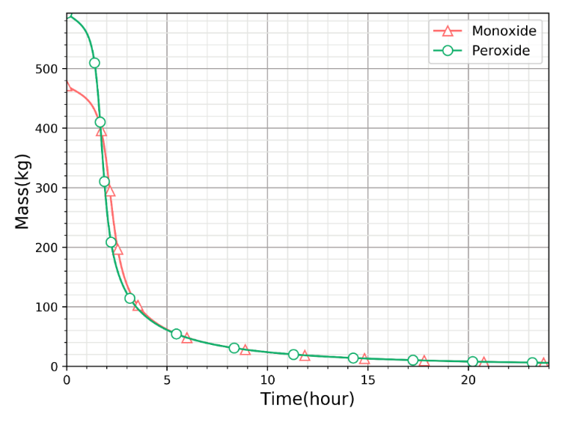
FIG. 4 Aerosol evolution for monoxide and peroxide

Comparison of RN aerosol evolution in containment for standalone and integral cases
In this section, the RN aerosol evolution for the standalone and integral case (no mix and real mix in vessel source term inputs) are compared. Here, the suspended mass is sum of stable and un-stable isotopes. The evolution of the suspended Cs in the containment is shown in the Fig. 5. For the stand-alone case and no mix case, Cs is found to be present in the containment at higher concentrations compared to the real mixture case. At t=0 hours, about 60 kg of Cs is in the suspended form for the no-mix assumption (Fig. 5). For the stand-alone case, at t = 0 hours, about 8 kg of Cs is in the suspended form. For the real mixture case, only about 2 gram of the Cs is in the suspended form at t = 0 hours (Fig. 5).
After 5h, less than 5 kg of Cs is suspended in the containment for the no mix case, whereas less than 1 kg of the Cs is suspended for the stand-alone case. It should be noted that, here the no mix case provides the conservative estimates for the suspended RN in the containment.

The evolution of the volatile and non-volatile RN aerosol is given in Fig. 6 and 7. The similar release trend is observed for I, Rb, Sr and Ba for the stand-alone case as the release fraction for the I, Rb, Sr & Ba are same (RF: 0.1). Similarly, for the non-volatile RNs similar release trend is observed (RF: 1E-04) for the stand-alone case. From the figures, it can be seen that, after 5-10 hours, about an order mass decrease is observed in the suspended form. This implies that an effective leak tightness containment for at least first 24 hours would be helpful to reduce the radioactivity available for release.

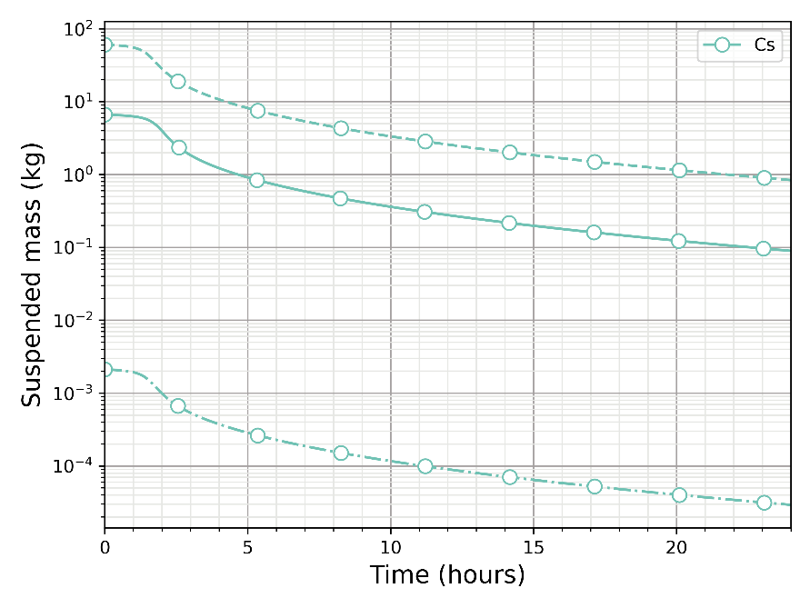
FIG. 5 Evolution of the suspended Cs RN in the containment, (dash-dash line is no mix case, dash-dot is real mix, solid line is stand-alone case)
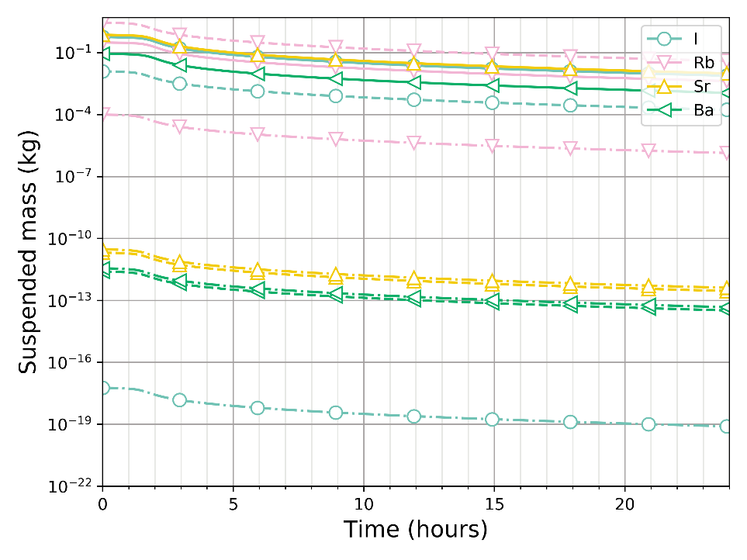
FIG. 6 Evolution of volatile RN in the containment (dash-dash line is no mix case, dash-dot is real mix, solid line is stand-alone case)
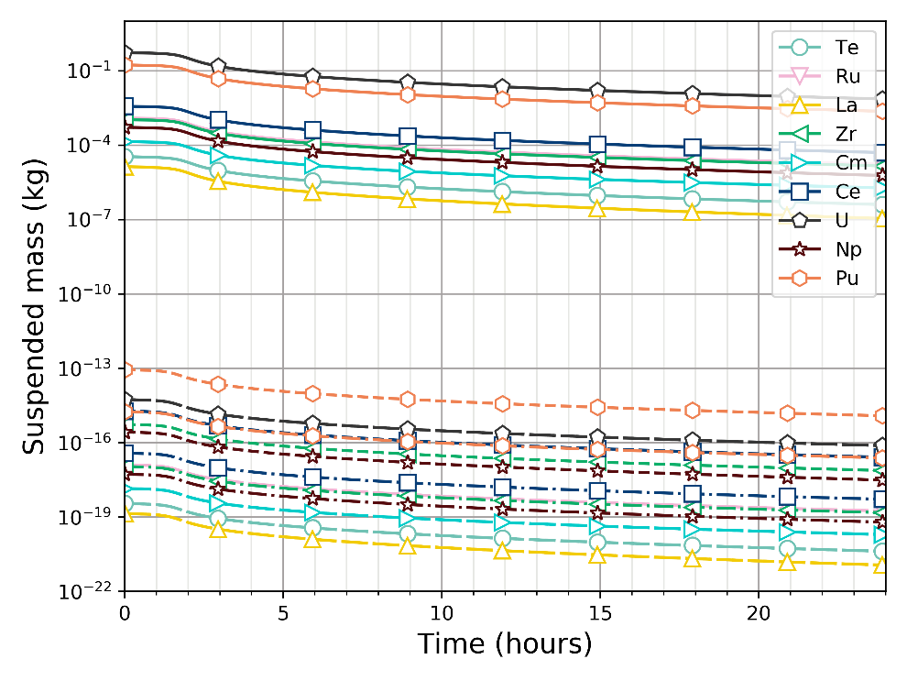
FIG. 7 Evolution of non-volatile RN in the containment (dash-dash line is no mix case, dash-dot is real mix, solid line is stand-alone case)
The higher released mass of U and Pu in the stand-alone case compared to Ce, Zr, and Cm is due to high core inventory (about 6 tonnes and 2 tonnes respectively) and very conservative RF used in this case. The conservative release fraction of 1E-4 for the stand-alone case will lead to release of ~0.1-0.2 kg in the containment. After 24 hours, the suspended mass in the containment is about 1 gram for stand-alone case. However, U and Pu are non-volatile RN and from the chemical equilibrium calculations from the real mix and no mix shows that most of the U and Pu is retained in the sodium pool (negligible mass is released in the containment). This is confirmed from past experiments where higher retention of the fuel material in the reactor vessel is seen [15].

conclusion
The temperature and pressure evolution in the containment was modelled using in-house developed PFIRE code. It is found that the pressure rise in the containment is well below the specified design pressure. The sodium and RN aerosol evolution was studied using in-house developed code PANDICA and the suspended and deposited RN aerosol masses in the containment were analysed. It is observed that after 5 hours, less than ~15% of the total aerosol mass is suspended. After 24 hours less than ~2% of the total aerosol mass are suspended. The present calculations indicate that an effective leak tightness containment for at least first 24 hours would be helpful to reduce the radioactivity available for release. However, it should be noted that, later the deposited RN aerosol can resuspend and be available for the late phase release. The chemical evolution of RN in the containment and aerosol generation by nucleation and condensation are not modelled in the present study. Further experiments or experimental validation of sodium fire aerosol generation and evolution is required to increase the confidence in the code predictions. The calculations performed here is valid for the short-term/instantaneous source term. Work is in progress to include aerosol generation models and multi-component distributed aerosol modelling.
ACKNOWLEDGEMENTS
The assistance provided by the Department of Atomic Energy (DAE), for this project is gratefully acknowledged.

References
[1] P.R. Patel, A. John Arul, In-vessel source term calculation using chemical equilibrium approach for a medium sized sodium cooled fast reactor, Nucl. Eng. Des. 362 (2020) 110583. https://doi.org/10.1016/j.nucengdes.2020.110583.
[2] P. Chellapandi, K. Velusamy, S.C. Chetal, S.B. Bhoje, H. Lal, V.S. Sethi, Analysis for Mechanical Consequences of a Core Disruptive Accident in Prototype Fast Breeder Reactor, (n.d.) 9.
[3] O.P. Singh, R. Harish, Energetics of core disruptive accident for different fuels for a medium sized fast reactor, Ann. Nucl. Energy. 29 (2002) 673–683. https://doi.org/10.1016/S0306-4549(01)00070-6.
[4] J.J. Dinunno, F.D. Anderson, R.E. Baker, F.C. Waterfield, Calculation of distance factors for power and test reactor sites, US Atomic Energy Commission, Washington, D. C., 1962.
[5] L. Soffer, S.B. Burson, C.M. Ferrell, R.Y. Lee, J.N. Ridgely, Accident source terms for light-water nuclear power plants, NUREG-1465. 6 (1995). http://www.iaea.org/inis/collection/NCLCollectionStore/_Public/26/050/26050072.pdf (accessed July 20, 2017).
[6] F. Balard, B. Carluec, Evaluation of the LMFBR cover gas source term and synthesis of the associated R and D, in: Japan, 1996. http://inis.iaea.org/Search/search.aspx?orig_q=RN:31044835.
[7] S. Guntay, D.A. Powers, L. Devell, The Chernobyl reactor accident source term: Development of a consensus view, in: International Atomic Energy Agency, Vienna, Austria, 1996: p. 183.
[8] U.N.R. Commission, Reactor safety study: an assessment of accident risks in US commercial nuclear power plants, NRC, 1974.
[9] P.R. Patel, A. John Arul, G. Pandikumar, Study of the impact of decay heat on the in-containment temperature and pressure evolution following a hypothetical severe accident in a SFR, Ann. Nucl. Energy. 138 (2020) 107189. https://doi.org/10.1016/j.anucene.2019.107189.
[10] P. Chellapandi, K. Velusamy, S.C. Chetal, S.B. Bhoje, H. Lal, V.S. Sethi, Analysis for mechanical consequences of a core disruptive accident in prototype fast breeder reactor, in: 2003: pp. 17–22. https://www.researchgate.net/profile/K_Velusamy/publication/266455315_Analysis_for_Mechanical_Consequences_of_a_Core_Disruptive_Accident_in_Prototype_Fast_Breeder_Reactor/links/557ed62208aec87640dded7d.pdf (accessed August 10, 2017).
[11] M. v Smoluchowski, Versuch einer mathematischen Theorie der Koagulationskinetik kolloider Lösungen, Z. Für Phys. Chem. 92 (1918) 129–168.
[12] G.M. Hidy, J.R. Brock, The dynamics of aerocolloidal system, Elsevier, n.d.
[13] J.H. Seinfeld, S.N. Pandis, Atmospheric Chemistry and Physics: From Air Pollution to Climate Change, John Wiley & Sons, 2016.
[14] H.-J. Allelein, A. Auvinen, J. Ball, S. Guntay, L.E. Herranz, A. Hidaka, A.V. Jones, M. Kissane, D. Powers, G. Weber, State of the art report on nuclear aerosols, Organization for Economic Cooperation and development. Nuclear Energy Agency. Committee on the safety of nuclear installations. NEA/CSNI, 2009.
[15] G. Berthoud, A.W. Longest, A.L. Wright, W.P. Schütz, Experiments on liquid-metal fast breeder reactor aerosol source terms after severe accidents, Nucl. Technol. 81 (1988) 257–277. http://www.ans.org/pubs/journals/nt/a_34096 (accessed June 7, 2017).

