# application of a risk-informed performance-based approach for the authorization of the versatile test reactor (vtr)

JASON P. ANDRUS

Idaho National Laboratory

Idaho Falls, Idaho, United States

Email: Jason.Andrus@inl.gov

DAVID GRABASKAS

Argonne National Laboratory

Lemont, Illinois, United States

MATTHEW BUCKNOR

Argonne National Laboratory

Lemont, Illinois, United States

DOUGLAS GERSTNER

Idaho National Laboratory

Idaho Falls, Idaho, United States

TROY REISS

Idaho National Laboratory

Idaho Falls, Idaho, United States

**Abstract**

The Versatile Test Reactor (VTR) is a fast spectrum test reactor currently being developed in the United States under the direction of the US Department of Energy (USDOE), Office of Nuclear Energy. The mission of the VTR is to enable accelerated testing of advanced reactor fuels and materials required for advanced reactor technologies. The conceptual design of the 300 MWth sodium-cooled metallic-fueled pool-type fast reactor has been led by US National Laboratories in collaboration with General Electric-Hitachi and Bechtel National Inc.

The VTR is utilizing a risk-informed performance-based approach for authorization by the USDOE. This approach is applied by tailoring guidance developed under the US industry led Licensing Modernization Project as recently approved by the US Nuclear Regulatory Commission in Regulatory Guide 1.233 “Guidance for a Technology-Inclusive, Risk-Informed, and Performance Based Methodology to inform the Licensing Basis and Content of Applications for Licenses, Certifications and Approvals for Non-Light Water Reactors.” This work summarizes how the guidance initially developed for commercial license applicants was tailored for application to a USDOE reactor and the implications and lessons learned from VTR. The work reported in this summary is the result of studies supporting a VTR conceptual design, cost, and schedule estimate for DOE-NE to make a decision on procurement. As such, it is preliminary.

## INTRODUCTION

The USDOE is currently pursuing the design and development of the VTR which is intended to be a 300 MWth fast neutron irradiation capability to support materials and fuels irradiations for both advanced and existing reactors as well as additional future scientific capabilities. In conjunction with design and analysis activities to support the VTR, significant efforts are ongoing to support development of risk informed and performance-based approaches to analysis and licensing of advanced reactors. These efforts such as the Licensing Modernization Project (LMP) are often being developed as cooperative actions between the USDOE, the US Nuclear Regulatory Commission and commercial reactor developers and operators. To the extent practical the VTR is utilizing these new approaches to facilitate efficiency in the VTR design and safety case as well as to provide early demonstration of the feasibility of the proposed processes and help to identify any potential improvements or enhancements.

## Brief overview of Versatile Test Reactor

The Versatile Test Reactor (VTR) is a proposed 300 megawatt thermal (MWth) pool-type sodium-cooled fast reactor (SFR) test facility that will meet the requirements of the Department of Energy Office of Nuclear Energy, need for advanced fast neutron irradiation capability. The VTR conceptual design benefits from strong favorable reactivity feedbacks that, together with the low-pressure sodium coolant and reference metallic fuel, provide passive shutdown and safety behavior under various reactor upset conditions. Since the primary mission of the reactor is reliable, fast flux testing, the VTR reactor plant will have no power conversion system and rejects its core heat to the atmosphere via sodium-to-air heat exchangers (SAHXs) located outside the reactor building.

The conceptual VTR reactor core targets generation of about 4.0 × 1015 n/cm2-s of neutron flux above 0.1 MeV at a power level of 300 MWth. The core consists of 313 core assemblies. The design includes up to 66 positions for U-20Pu-10Zr driver fuel assemblies, which generate the neutron flux; six boron carbide control rod absorber assemblies; and three boron carbide safety rod absorber assemblies. In its conceptual configuration, the VTR reactor core provides multiple fast flux test locations with the capability of both instrumented and static capsule locations. Since VTR is an irradiation test reactor, the composition and arrangement of the core are subject to change to meet varying testing requirements.

The primary heat transport system (PHTS) is installed inside of the reactor vessel in a pool-type configuration. The PHTS incorporates two intermediate heat exchangers (IHXs), one for each of the two heat rejection system (HRS) secondary sodium loops. Four submersible electromagnetic (EM) linear induction annular-cavity pumps (EM pumps) provide primary sodium circulation through the reactor. Each EM pump is provided with its own system to provide a flow coastdown (i.e., the sodium flow will not abruptly stop, similar to a flywheel on a mechanical pump) in the event of loss of normal alternating current (AC) electrical power or pump trip.

The conceptual design provides that heat is removed by the PHTS, through the IHX, and finally rejects the heat through the HRS to the atmosphere via the SAHXs. The HRS incorporates two secondary sodium loops. Each secondary loop incorporates one IHX, five SAHXs, and two EM pumps in parallel. The pool-type reactor design, with an external guard vessel, precludes a loss of coolant accident. This approach also reduces facility radiological dose rates, a desirable feature from an as low as reasonably achievable standpoint.

The VTR also incorporates a reactor vessel auxiliary cooling system that is a completely passive natural circulation air cooling system for ultimate removal of decay heat if other HRS mechanisms fail. The RVACS is always in operation providing an additional heat transport pathway to the air atmosphere heat sink.



Figure 1: VTR General Plant Layout showing Experiment Hall and Sodium to Air Heat Exchangers

## Background of Regulations

This section provides a background on the relevant regulatory processes and approaches that are being employed and utilized in support of the design and development of the safety authorization documents in support of the VTR. The VTR is proposed to be owned and authorized by the USDOE and as such is required to comply with applicable USDOE requirements for safety and quality in operations principally 10 CFR 830 and associated sub-tier DOE orders and standards. An approach to complying with the USDOE regulatory and authorization requirements while leveraging Risk Informed and Performance Based Approaches as described in NEI-18-04, “Risk-Informed Performance-Based Technology Guidance for Non-Light Water Reactors” [1] is being used to provide early insights of process application and to support demonstration of the viability of the proposed approaches in a practical application.

### United States Department of Energy Safety-in-Design Process

A primary element of the development process of new nuclear facilities under the USDOE regulations is appropriate integration between facility design and analysis efforts and development of the safety case throughout the project lifecycle. The USDOE provides project and program management guidance associated with project design and management phases in DOE O 413.3B “Program and Project Management for the Acquisition of Capital Assets.”[2] The guidance in DOE O 413.3B breaks the project up into various project phases each culminating with a Critical Decision (CD) submittal requiring preparation of key design, safety and project management documents and requiring approval by appropriate department officials prior to proceeding to subsequent project phases. Figure 2 below identifies the typical acquisition flow path for a USDOE capital asset project as outlined in DOE O 413.3B. Acronyms used in the figure but not spelled out elsewhere in this paper include project engineering and design (PED), Critical Decision (CD) which represents DOE hold points for approval decisions, total project cost (TPC), External Independent Review (EIR). Additionally, PARS II is the system that DOE utilizes to report project financial and milestone status.

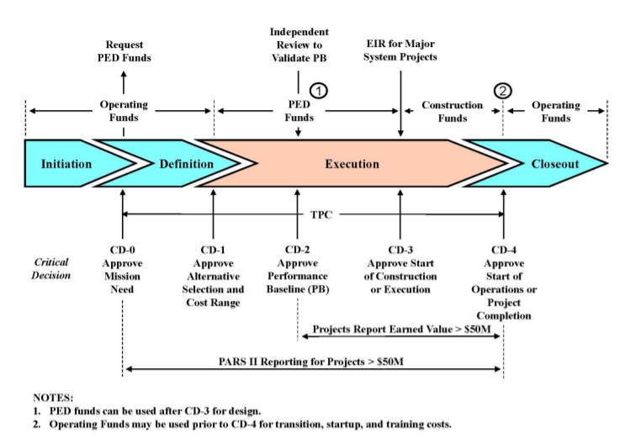

Figure 2: Typical USDOE Acquisition flowpath for a capital asset project

For USDOE facilities involving sufficient radioactive material to be considered a nuclear facility per the guidance of DOE-STD-1027, “Hazard Categorization of DOE Nuclear Facilities” [3] the safety documents in support of each project CD are expected to be developed according to the guidance captured in DOE-STD-1189, “Integration of Safety into the Design Process.” [4] For VTR the proposed safety documents to be developed and submitted with each design phase are documented in Table 1.

Table 1: VTR Safety Deliverables by Project Phase

|  |  |  |
| --- | --- | --- |
| **CD Phase** | **Safety Basis Deliverable** | **Status** |
| CD-1 | Safety Design Strategy | Approved by DOE |
| CD-1 | Conceptual Safety Design Report | Approved by DOE |
| CD-3A | Draft Preliminary Safety Analysis Report supporting any long lead procurement needs. | To be developed based upon project need. |
| CD-2/3 | Preliminary Safety Analysis Report | Initial Planning Initiated |
| CD-4 | Final Safety Analysis Report and Technical Safety Requirements | To be initiated after CD-2/3 completion. |

### Licensing Modernization Project

The authorization approach for the VTR has committed to following a process consistent with the Licensing Modernization Project (LMP) approach documented in NEI-18-04 for identification of appropriate safety basis accidents (similar to Design Basis Accidents as defined in LMP) to analyze in order to demonstrate adequate plant safety. One distinction for the VTR application was that safety basis accidents also included accidents within all the frequency ranges greater than 1E-6 per year. This was done to meet DOE requirements and essentially just ensures that some of the licensing basis events that would have been evaluated under LMP also get more conservative treatment in the accident analysis. In addition to the identification and evaluation of key safety basis or licensing basis events and associated design basis accidents, the LMP approach focuses on a risk informed identification of potential licensing basis events and accidents, and a performance based evaluation of defense-in-depth and ultimately selection of both safety related and non-safety related with special treatment SSCs as well as identification of requirements that ensure the capability of performing plant safety functions.

## Versatile Test Reactor Application of a Risk-informed based approach

VTR is employing a modified approach to the LMP identified safety SSC classification criterion in order to comply with DOE regulatory requirements and integrate with DOE guidance on special treatment requirements. The specific rules employed in performing VTR safety system classification have been previously published and are focused on preservation of safety to the public and workers as well as some adaptations to support compliance with guidance from the DOE regulator [5]. It is important to note however, that these changes in criteria did result in strict classification of some systems which otherwise might have been evaluated in the risk analysis as alternatives for classification. This simplified the potential analysis space while not overly constraining the design. A specific example of this is associated with the classification of the primary coolant sodium boundary as a safety class system. This system prevents severe oxygen-sodium reactions at elevated temperature. Absent these modified criteria a design option to place the safety credit on an inerted confinement structure instead of the primary sodium boundary could have been evaluated, however from a practical perspective that would have likely been a far less desirable control.

The safety analysis process for the VTR project for compliance with 10 CFR 830 will follow a process consistent with the LMP as outlined in NEI-18-04, “Risk-Informed Performance-Based Guidance for Non-Light Water Reactor Licensing Basis Development,” and supporting documents. The process outlined in the LMP will be adapted to fit DOE regulatory requirements as applicable and appropriate. This approach provides an acceptable means for addressing the identification and analysis of potential facility hazards and upset events as well as selection of appropriate safety structures systems and components and supports derivation of their applicable safety function controls. In general, the modifications applied to the LMP process to support the VTR authorization involved a modification to the frequency consequence curve to align with previously established DOE dose limits for safety classification. As opposed to the thresholds being iso-risk between anchor points as is with LMP guidance, the thresholds are iso-consequence in a waterfall approach for various frequency bins. This revised chart can be seen in Figure 3. It is important to note that this revised frequency consequence curve represents expectations for identifying safety classification of systems and not a risk acceptance curve. To clarify, events which fall within the unacceptable region are anticipated to have additional structures, systems or components identified at a Safety Class (DOE equivalent to Safety Related) level to reduce their risk. Events which fall outside the unacceptable region are not prescriptively required to identify additional Safety Class level equipment or controls, however they are expected to be minimized to an acceptable level through the incorporation of defense in depth through the use of normal plant equipment, special treatments and operational safety programs.

In order to support application of NEI-18-04 process an initial probabilistic risk assessment of the VTR has been developed and is continuing to be developed and refined as the design progresses [6].

The result is a modernized technology-inclusive, risk-informed, and performance-based (TI RIPB) framework for the VTR and can play a critical role in a modernized framework for demonstration of compliance with the requirements of 10 CFR 830 Subpart B for DOE reactors

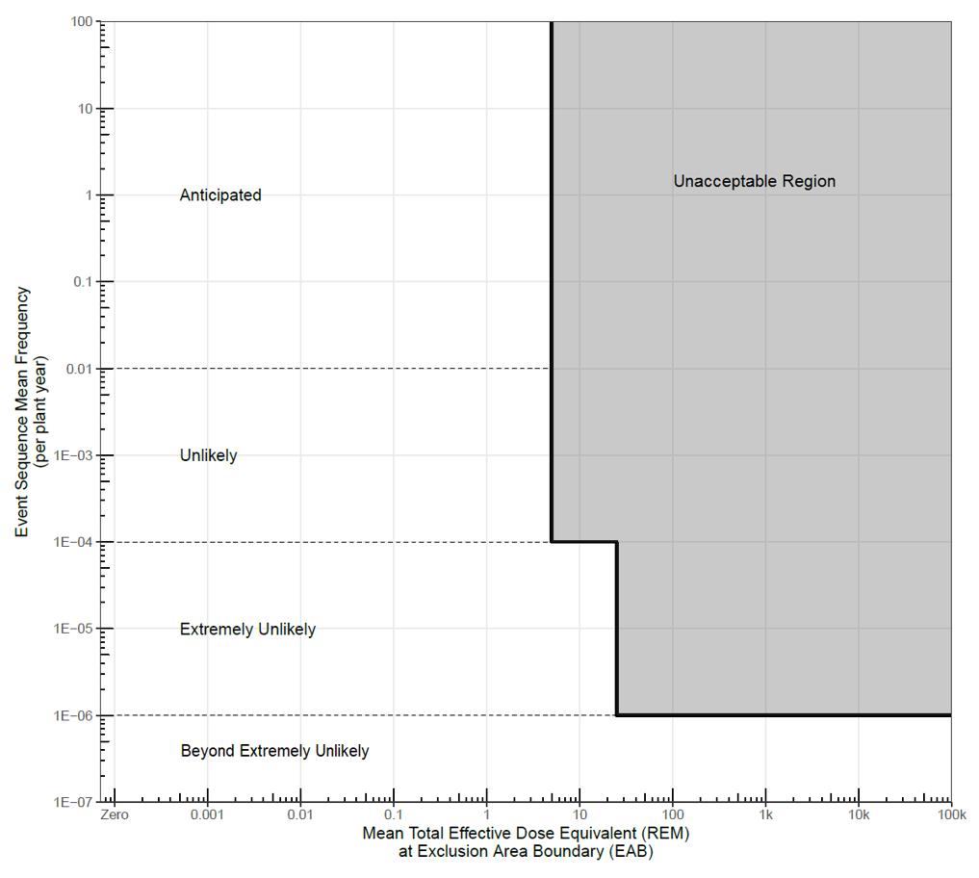

Figure 3: Revised Frequency Consequence chart for Selection of VTR Safety SSCs based upon DOE guidance.

The LMP process is a foundation for establishing the technical requirements to facilitate a TI-RIPB based design for an advanced non-LWRs such as VTR. Such a process acknowledges enhancements in safety achievable with advanced designs and reflects current states of knowledge regarding safety and design innovation, creating an opportunity for reduced regulatory complexity, with increased levels of safety.

The insights and decisions made utilizing this approach to selection of accidents and safety systems will then be summarized into safety basis documents developed consistent with established DOE guidance on safety basis submittals as described in DOE-STD-1189

## Conclusion

The VTR will utilize a risk-informed and performance based method for identification of appropriate abnormal conditions and accidents as well as leverage those insights in the selection and specification of performance requirements for safety SSCs to ensure adequate protection of the public and workers. This information will be summarized in the safety basis document submittals required by USDOE processes and procedures consistent with design and project development as the project proceeds through design and construction. This process will ensure compliance with USDOE project and safety requirements while simultaneously providing an appropriate approach to ensuring safety of the system and supporting early demonstration of the proposed approaches currently under development.

ACKNOWLEDGEMENTS

The submitted document has been created by Battelle Energy Alliance, LLC, Operator of Idaho National Laboratory (INL). Idaho National Laboratory’s work was supported by the U.S. Department of Energy, Office of Nuclear Energy under contract DE-AC07-05ID14517. The work reported in this summary is the result of ongoing efforts supporting the Versatile Test Reactor.

References

1. Nuclear Energy Institute, "Risk-Informed Performance-Based Guidance for Non-Light Water Reactor Licensing Basis Development," NEI 18-04, (2019).
2. DOE O 413.3B, Program and Project Management for the Acquisition of Capital Assets Chg 6, United States Department of Energy, (2021).
3. DOE-STD-1027-2018, Hazard Categorization of DOE Nuclear Facilities, United States Department of Energy (2018).
4. DOE-STD-1189-2016, Integration of Safety into the Design Process, United States Department of Energy, (2016).
5. D. Grabaskas *et al.*, "Structures, Systems, and Components Classification Criteria for the Versatile Test Reactor," *Transactions of the American Nuclear Society, ANS Winter Meeting,* vol. 123, no. 1, pp. 997-999, 2020.
6. D. Grabaskas *et al.*, "Development of the Versatile Test Reactor Probabilistic Risk Assessment," *Proceedings of the International Conference on Fast Reactors and Related Fuel Cycles FR21,* 2021.