COUPLED NEUTRONIC/THERMAL-HYDRAULIC

SIMULATION OF UNPROTECTED LOSS OF FLOW

TEST AT FAST FLUX TEST FACILITY

ĐORĐE PETROVIĆ
Belgian Nuclear Research Centre (SCK•CEN)
Mol, Belgium
Email: dorde.petrovic@sckcen.be

KONSTANTIN MIKITYUK
Paul Scherrer Institute (PSI)
Villigen, Switzerland
Email: konstantin.mikityuk@psi.ch

Abstract

Fast Flux Test Facility (FFTF) was a research Sodium-cooled Fast Reactor (SFR) operated in the 1980’s with a goal to demonstrate the inherent and passive safety characteristics of the SFR design. In the frame of the study, an attempt has been made to develop a model of FFTF suitable to predict the system’s behavior during the Unprotected Loss Of Flow (ULOF) accident. Special attention is devoted to Gas Expansion Modules (GEM) and their potential to drive the reactor core into the safe shutdown state upon the occurrence of the initiators of the ULOF accident. In addition, an assessment of representativeness of GEM devices in modelling the coolant boiling within the fast reactor cores is conducted. Obtained results are further compared to the measurements collected during the Loss Of Flow WithOut SCRAM (LOFWOS) Test #13 performed during the FFTF’s operation. According to the outcome of the aforementioned comparison, LOFWOS Test #13 can be successfully reproduced by employing the Fast-spectrum Advanced Systems for power production and resource managemenT (FAST) code system. Spatial Reactor Kinetics (SRK) model is proven able to reproduce the evolution of the reactor core parameters. However, by employing a fairly simple Point Reactor Kinetics (PRK) model, a conclusion is drawn that the aforementioned modelling approaches perform comparatively similar in modelling the neutronics of the reactor cores of similar geometry, size and fuel composition as FFTF’s. Furthermore, it is proven that the axial power profile of the core does not suffer significant degradation in the process of the activation of GEM devices. Moreover, on the basis of the comparison to the performance of the sodium plenum of the Advanced Sodium Technological Reactor for Industrial Demonstration (ASTRID), GEMs are proven to be a good representative of the passive reactivity control systems based on the coolant boiling (sodium plenum).

1. INTRODUCTION
The FFTF at the Hanford site in Washington was designed by the Westinghouse Electric Corporation for the U.S. Department Of Energy (DOE). The FFTF was a liquid sodium cooled test reactor, built to assist the development and testing of the advanced fuels and materials for fast breeder reactors.
After reaching criticality in 1980, FFTF operated until 1992, providing DOE with the means to test fuels, materials and other components in a high fast neutron flux environment. In July 1986, a number of the unprotected transients were performed at the FFTF as a part of the Passive Safety Testing (PST) program. The PST program included static tests to measure reactivity feedbacks and conservative dynamic tests to demonstrate transient behaviour due to the reactivity feedbacks. As a part of the program, a set of 13 unprotected (with the plant protection systems intentionally disabled) LOFWOS tests was performed during the FFTF’s cycle 8C in order to: determine the core’s safety margins, demonstrate the benefits of specific safety design features and to obtain data to validate computational tools and improve design models. [1]
Proposed and evaluated during the cycle 8C of the FFTF’s operation are GEMs, passive reactivity control devices designed to introduce high negative reactivity in the core, play crucial role in the evolution of the core parameters during the ULOF accident and ultimately prevent the core meltdown. This study therefore focuses on their role in paving the road towards the intrinsic safety of liquid metal cooled nuclear reactors of next generation.

2. benchmark specifications
The FFTF LOFWOS Test #13 Benchmark is proposed jointly by the Pacific Northwest National Laboratory and the Argonne National Laboratory (ANL) within the scope of the International Atomic Energy Agency (IAEA) coordinated research project entitled ‘Benchmark Analysis of FFTF Loss of Flow Without Scram Test’. This benchmark is intended to support the collaborative efforts within the international partnerships on the validation of the simulation tools and models in the area of the SFR safety. Validated tools and models are needed to evaluate the SFR’s inherent safety characteristics and assess the effectiveness of the passive design features in response to the various accident initiators. Comparisons with the available experimental data and the other safety code predictions create a unique opportunity to improve the computational codes and methods employed in the field of the SFR technology. [1]

2.1. Overview of Fast Flux Test Facility
The FFTF was a 400 MW(th) powered, mixed-oxide fuelled, loop type SFR prototype. Generated heat was removed from the reactor core by the liquid sodium circulating under the low pressure. Sodium exited the reactor vessel into one of the three primary sodium loops. Intermediate heat exchangers separated activated sodium coolant in the primary loops from nonradioactive sodium in the secondary loops. The FFTF did not generate electricity, instead rejecting all the produced heat to the environment via 12 air dump heat exchangers. [1]
The FFTF’s core accommodated 199 hexagonal assemblies, among which eight different types could be identified: driver fuel assembly, in-core shim assembly, reflector assembly, Control Rod (CR), Safety Rod (SR), materials open test assembly, fracture mechanics assembly and GEM assembly. [1]

2.1.1. Gas Expansion Modules

GEMs were initially introduced during the LOFWOS tests in order to demonstrate their ability to mitigate the consequences of the ULOF transients. Each GEM was inserted into an assembly position within the inner row of the radial reflector region. Approximately 30 dm³ of Ar gas was trapped by a plug at the top of the module and exposed to the sodium at the bottom of the module. [1]
At the nominal full flow conditions, the pressure of the sodium compressed the gas to a level above the top of the active fuel column. The exact level of the sodium within each GEM depended on the inlet sodium pressure, which was a function of the primary system flow rate and the temperature of the gas, both affected by the reactor power level and the core inlet temperature. During the loss of flow transient, the pressure exerted on the gas by the sodium decreased, allowing the gas to expand. At the low flow rates, the sodium-gas interface level within each GEM would be below the bottom of the fuel column. The displaced sodium at the periphery of the core led to the increased radial neutron leakage and a corresponding negative reactivity feedback. [1]

2.2. Loss Of Flow WithOut SCRAM Test #13
LOFWOS Test #13 was performed on July 18, 1986. Starting at 50% power and 100% flow, the test was initiated by simultaneously tripping the primary sodium pumps. The secondary loop sodium pumps remained operational throughout the test. On top of that, plant protection system was modified to allow the test to run without the CRs being inserted prematurely. [1]

2.2.1. Physics of Loss Of Flow WithOut SCRAM Test #13

Physics of the LOFWOS tests performed at the FFTF as a part of the PST program is based on the interplay of several reactivity feedbacks, out of which two are particularly important and almost exclusively guide the ULOF transient. Evolution of the core reactivity and its subsequent decomposition on the reactivity components is presented in Fig. 1, along the side of the evolution of the of the row 2 Proximity Instrumented Open Test Assembly (PIOTA) outlet temperature. [2]
Almost immediately upon the trip of the primary pumps, the FFTF’s unique passive protection system introduced large amounts of the negative reactivity by reducing the sodium free level in GEMs and consequently increasing the radial neutron leakage. As initial sudden drop of the reactivity is followed by an immediate drop in the fuel temperature, positive reactivity is promptly introduced in the core as a consequence of the fuel temperature reactivity feedback hence resulting in the first ‘hump’ of the curve representing the total reactivity of the core.
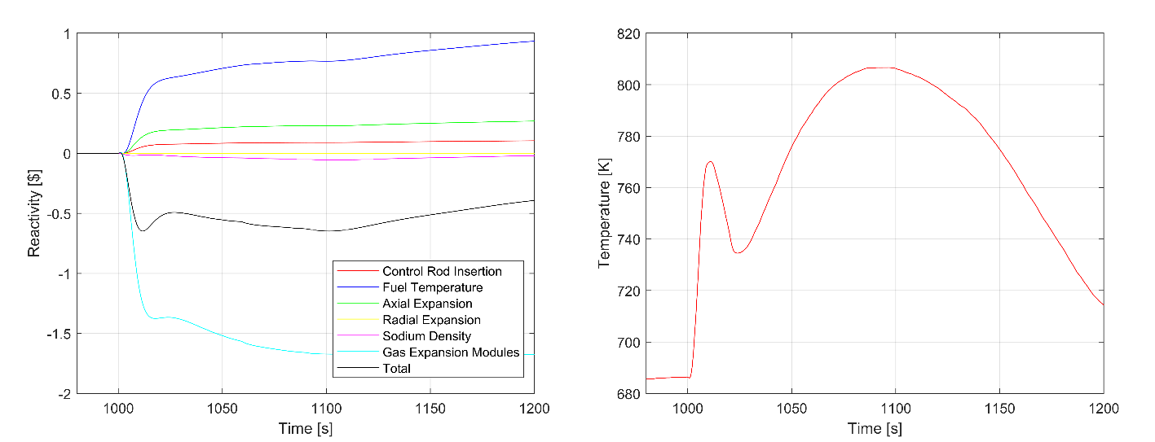
FIG. 1. Evolution of the core reactivity and its decomposition (left) and of the row 2 PIOTA outlet temperature (right).

Further reduction of the core reactivity happened as a consequence of the natural circulation of the sodium and its subsequent displacement from the inlet plenum to the core and the outlet plenum thus ensuring the reduction of the sodium pressure and an even further decline of the sodium free level in GEMs.
Special attention should also be devoted to the evolution of the row 2 PIOTA outlet temperature. The initial rapid rise of the PIOTA outlet temperature is attributed to the fast flow coastdown. First ‘hump’ of the coolant outlet temperature is further followed by an almost instant drop as a consequence of the drop in the core reactivity introduced by the activation of GEM devices and the corresponding decrease in the core power. This drop of the reactor power is quick enough to compensate and overtake the effects of the reduced flow rate in the primary loop. However, Doppler effect and the corresponding increase in the core reactivity result in the new rise of the coolant temperature, which eventually starts to decrease due to the decrease in the generated power and the establishment of the natural circulation.
It should therefore be highlighted that GEM devices are proven to be efficient in mitigating the consequences of the ULOF accident. Together with the inherent core reactivity feedback mechanisms, GEMs managed to make the core subcritical with a modest peak coolant temperature transient that reached 120 °C above the pretransient value and always maintained a >380 °C margin to the sodium boiling point (910°C).

3. SIMULATION TOOLS APPLIED
In what follows, a list of modifications introduced to the codes widely used in the field of the nuclear reactor design and nuclear reactor safety evaluation is presented. These modifications are put in place as necessary in order to enable modelling of the specificities of the LOFWOS Test #13 and modelling of the FFTF in general.
Serpent 2 is a multi-purpose three-dimensional continuous-energy Monte Carlo (MC) neutron and photon transport code. The interaction physics is based on the classical collision kinematics, Evaluated Nuclear Data File (ENDF) reaction laws and the probability table sampling in the unresolved resonance region. Interaction data is available for 432 nuclides at 6 temperatures ranging from 300 K to 1800 K. Within the scope of this study, ENDF/B-VII.0 nuclear data libraries are consistently used.
The Purdue Advanced Reactor Core Simulator (PARCS) is a three-dimensional reactor core simulator which solves the steady state and the time-dependent, multi-group neutron diffusion equation along with the delay neutron precursor balance equation. Of particular importance for this study is the fact that the PARCS core kinetics code is capable of handling the non-orthogonal geometries in order to treat reactors with hexagonal assemblies. Furthermore, as PARCS reactor kinetics code has been developed for the Light Water-cooled Reactor (LWR) applications, the default Cross-Section (XS) parametrization is defined accordingly. This has been reviewed for the fast spectrum systems analysis in the frame of the FAST code system. [3] In particular, in LWRs the dominant transient reactivity feedback effects are the Doppler effect and the change in the coolant density, while in the fast spectrum systems other feedback effects are of equal importance, e.g. the fuel and the core structure thermal expansion, which changes both the core dimensions and the effective fuel density therefore influencing both the neutron leakage and the reactor core reactivity.
The TRAC/RELAP Advanced Computational Engine (TRACE) has been designed to perform the best-estimate analyses of the loss of coolant accidents, operational transients and other accident scenarios in LWRs. Models used include multidimensional two-phase flow, non-equilibrium thermo-dynamics, generalized heat transfer, as well as various models of reflooding and coolant level tracking. Of particular importance for this study are modifications implemented in TRACE in order to enable it to simulate SFR features. Rehme introduced an effective velocity to account for the swirl flow velocity around the rods caused by the wire-wraps. [4] The aforementioned effective velocity is employed to define a modified friction factor to be further used in the calculation of the pressure drop. Rehme’s correlation for the calculation of the friction factor is valid over a broad range of the geometrical parameters as a function of which it is calculated. This correlation is of particular importance due to the fact that the hexagonal fuel bundles within the FFTF’s core are wire-wrapped. In addition, due to the higher contribution to the total heat transfer from the thermal conductivity in the case of the liquid metals, a correction of the TRACE build-in heat transfer models had to performed. This is carried out according to the correlation proposed by Mikityuk [5], which is proven to be general and valid across the broad range of the reactor states therefore making it practically applicable in the transient analysis codes.

3.1. Fast-spectrum Advanced Systems for Power Production and Recourse ManagemenT Code System
Among the main goals of the FAST project one can find the development of a general tool for the analysis of the core static and dynamic behaviour of advanced, fast spectrum reactor concepts, and its further application to a selection of the Generation IV reactors. A suitable and detailed fast reactor dynamics code system has been assembled from the already existing codes, which, where necessary, have been modified to simulate the features present in the fast reactor cores. The core of this scheme is a mutual coupling of the MC code Serpent 2, reactor kinetics code PARCS, plant system code TRACE and the fuel rod thermal-mechanics code FRED. [3]
In brief, the application of the FAST code system starts with the acquisition of the static core neutronics solution by employing the Serpent 2 MC code. In parallel with the static core neutronics model, Thermal-Hydraulics (TH) model of the FFTF is built by employing the TRACE plant system code. Coupling of the above-described codes starts with the application of the Serpent 2 output data, mainly energy group constants, kinetic parameters and the calculated XS derivatives, as an input to building the PARCS kinetics model of the core. However, full coupling is achieved when TRACE and PARCS are fully interconnected and start exchanging data. This coupling can be referred to as ‘implicit’: reactor kinetics code PARCS is included in TRACE plant system code as a subroutine and the two codes therefore exchange information at every time step. Upon the successful coupling, PARCS provides data on the power distribution to the TRACE, which in turn provides PARCS with the data on the coolant density and the fuel temperature. Predefined reference XSs defined in PARCS are further corrected according to the obtained data, upon which the newly obtained neutronic parameters and the power distribution information are returned to the TRACE.
The above described coupling of the employed codes is graphically illustrated in Fig. 2.

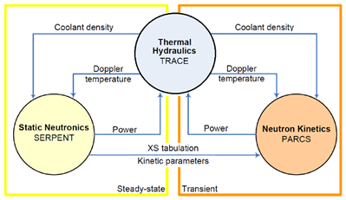
FIG. 2. Coupling scheme employed in the framework of FAST code system..

4. Application to Fast flux test facility
The FFTF and its peculiar passive reactivity control mechanism are modelled to a rather high degree of detail. In order to achieve the aforementioned goals, simulation tools described in the previous chapter were extensively applied. This chapter provides an overview of both the neutronic and the TH model of the FFTF used in order to achieve a successful simulation of the LOFWOS Test #13.
4.1. Static Neutronics Model
Basis on top of which the static neutronics model of the FFTF is built is data provided in the frame of the FFTF LOFWOS Test #13 Benchmark and kindly supplied to its participants by the ANL. Model itself is built by employing the Serpent 2 MC code. Having in mind rather high importance of the herein described model for the later stages of this study, core and its surroundings are modelled in high detail.
It is furthermore important to highlight the fact that the concentration of the fission products is reported by ANL as a lumped sum and subsequently modelled according to the cumulative fission yield curve, which indicates the amount of nuclides produced either directly in the fission or by decay of the other nuclides. Cumulative fission yield curve is adopted from Joint Evaluated Fission and Fusion (JEFF) 3.1 database.
Among the goals of the FFTF LOFWOS Test #13 Benchmark one can find the code-to-code comparison of the simulation tools applied in the modelling of the fast spectrum systems. Within the scope of this benchmark, comparison of this particular type is performed by comparing the values of, among the other parameters, Reactivity Feedback Coefficients (RFC) calculated by employing the static neutronics model.
4.2. Neutron Kinetics Model
Application of the FAST code system to the FFTF proceeds with building the neutron kinetics model of the core. This is performed by employing the reactor kinetics code PARCS. First step in implementing the PARCS represents building the standalone model of the core, followed by its modification in order to achieve coupling to the plant system code TRACE. In order to simplify coupled TRACE/PARCS model, static neutronics model of the FFTF built by employing the Serpent 2 MC code is reduced to the core and its immediate surroundings. Other than the axial albedo at the top of the core, which is set to portray neutronics of the sodium plenum [6], values of the radial albedo and of the albedo at the bottom of the core are set to designate the zero incoming current in order to simulate high absorbing XSs of the surrounding materials. By doing this, system’s parameters of the highest importance for the successful simulation of the LOFWOS Test #13 are preserved. Axial and radial view of the PARCS model of the FFTF is illustrated in Fig. 3.

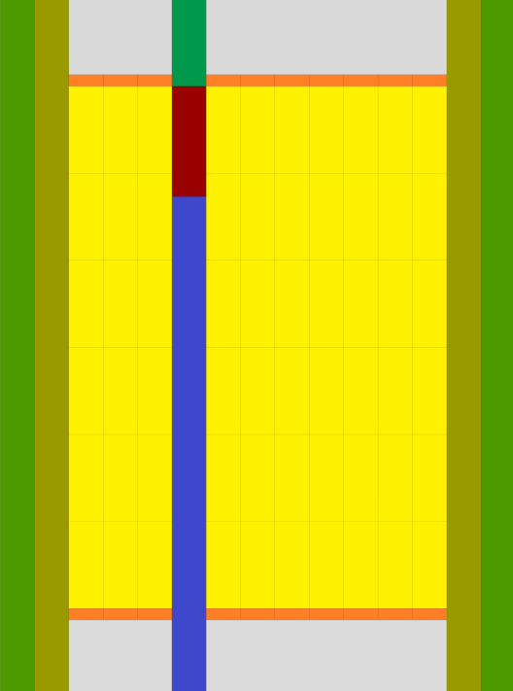
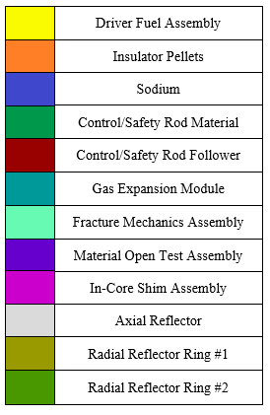

FIG. 3. Axial (left) and radial (right) view of the PARCS model of the FFTF.

On top of that, special attention is devoted to the modelling of GEM devices. Namely, due to their nature, as well as working principle, GEM devices can be modelled in the identical manner as CRs.
FFTF was equipped with a rather specific Core Restraint System (CRS) which was introduced to ensure that the core radial motion during the power transients results in an overall negative reactivity feedback. At the current level of complexity, model of the aforementioned CRS is not included in the herein described neutron kinetics model. However, since the presence of the CRS can affect radial expansion reactivity feedback effect to a significant extent, introduction of its explicit model is considered as an essential task in the future work.
4.3. Thermal-Hydraulics Model
By employing TRACE plant system code, explicitly modelled are the reactor core and the corresponding assemblies, core vessel, all three primary loops and their components and one secondary loop. Namely, reactor core and the corresponding assemblies other than the reactor shielding are modelled by a combination of pipes and heat structures. Reactor vessel model is among the most complex components and is tightly interconnected with the core assemblies and three primary loops. Primary loops are modelled explicitly and in high detail by introducing all of their constitutive elements, among which primary pumps are the most important for this study. Secondary loop is not modelled in as high level of detail as the reactor vessel and the primary loops are. It is modelled to account for all the existing secondary loops and is mostly accounted for through the adjustment of the correct boundary conditions. Overview of the TRACE model of the FFTF is presented in Fig. 4.

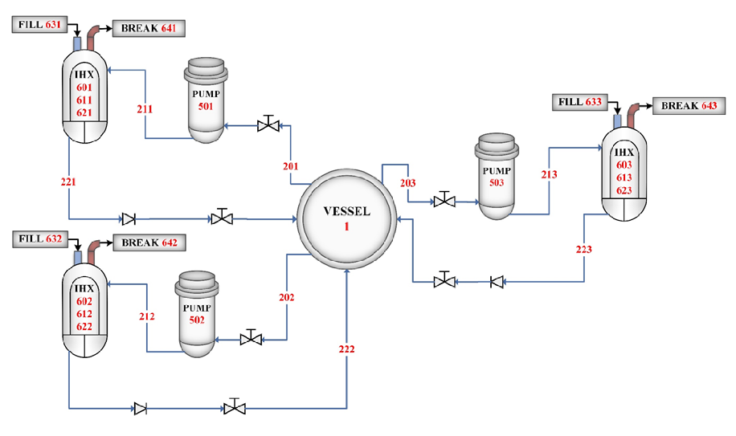
FIG. 4. Overview of the TRACE model of the FFTF.
4.4. Coupling Scheme
Data exchange between TRACE and PARCS is achieved through the tight coupling of the corresponding cells and nodes. As a reactor core simulator that makes the use of the neutron diffusion theory and the SRK model, PARCS provides TRACE with the data on the power distribution within the core. Having the power distribution data delivered, plant system code TRACE implements it by accordingly setting the value of the power of the power generating components. On the other hand, data on the temperature and the density fields within the reactor core are returned to the PARCS. This data is further used in PARCS in order to modify the reference XSs.
Specificity of this study lies within the modelling of GEM devices in the frame of the coupled TRACE/PARCS simulation of the LOFWOS Test #13. As already mentioned, GEMs are defined within the PARCS model in the same way as CRs, the only difference being that the CRs are absorption based, while GEMs are radial leakage based reactivity control mechanisms. Thanks to the coupling of the control logic in the TRACE and the position of CRs and ‘GEM rods’ in the PARCS, sodium free level and the corresponding reactivity effect are modelled accurately and as a function of the core flow rate. The exact level of the sodium is forwarded to the PARCS and according to which the position of the ‘GEM rods’ is set therefore yielding the new value of the core reactivity. Tight coupling of the core flow rate and the corresponding reactivity effect allows the newly introduced passive safety system to be fully incorporated in the SRK model of the FFTF.

5. Results
5.1. Static Neutronics Simulation
Results obtained by running the Serpent 2 MC simulation of the FFTF along with the corresponding confidence intervals, as well as further calculated RFCs, are presented in Table 1. These are followed by the map of the Assembly Power Peaking Factors (APPF) illustrated in Fig. 5.
As expected, absorption by CRs introduces negative reactivity of significantly greater magnitude when compared to the negative reactivity introduced by the radial neutron leakage promoted by the activation of GEMs.
5.2. Coupled Simulation
Results of the coupled neutronic/TH simulation of the LOFWOS Test #13 are presented in Fig. 6. which illustrates the evolution of the core power, as well as the evolution of the row 2 PIOTA outlet temperature. All of the presented results are further compared to the measurements obtained during the LOFWOS Test #13. [2]
TABLE 1. RESULTS OF STATIC NEUTRONICS SIMULATION OF FFTF
Core Parameter |  | Value ± Confidence Interval
Effective Multiplication Factor |  | 1.00574 ± 0.00003
Reactivity |  | 571 ± 3 pcm
Delay Neutron Fraction |  | (3.209 ± 0.001) ∙10⁻³
Prompt Neutron Lifetime |  | (5.524 ± 0.001) ∙10⁻⁷ s
RFC | Axial Expansion | -0.221 ± 0.007 pcm/K
 | Radial Expansion | -1.522 ± 0.012 pcm/K
 | Fuel Doppler Constant | -658 ±10 pcm
 | Fuel Density | -1.363 ± 0.020 pcm/K
 | Structure Density | -0.039 ± 0.009 pcm/K
 | Sodium Density | -0.274 ± 0.023 pcm/K
Reactivity Worth | SR | -5809 ± 10 pcm
 | CR | -6014 ± 10 pcm
 | GEM | -475 ± 7 pcm
Incremental Reactivity Worth | CR | -8.95 ± 0.65 pcm/mm
 | GEM | -0.49 ± 0.01 pcm/mm

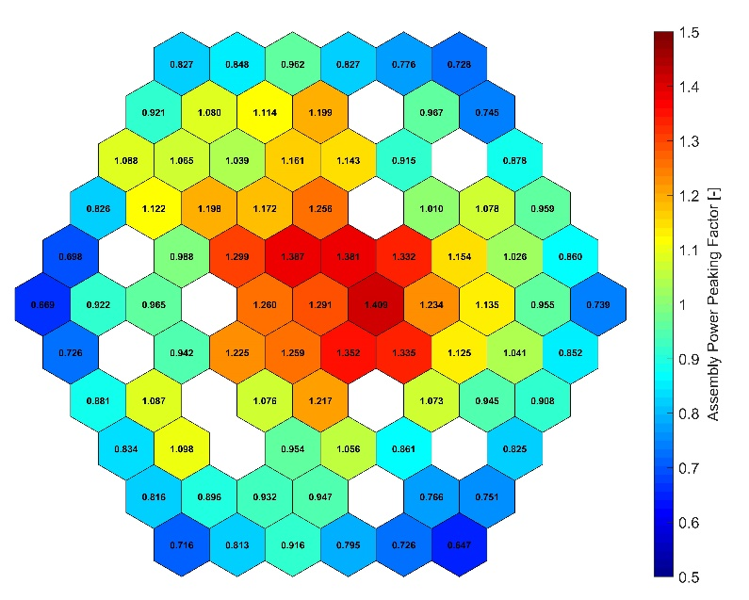
FIG. 5. Map of APPFs of the FFTF’s core.
According to the presented comparison, results of the simulation could be referred to as in correspondence with the measurements.
The observed underestimation of the sodium temperature during the second peak indicates that the simulated heat transfer by interassembly flow and the radial core heat transfer might be overestimated. It is shown in [7] that a more detailed nodalization of the interassembly region, as well as of the reactor vessel component is necessary, especially when a significant deviation of the subassembly power-to-flow ratio along the radial core direction exists. The time shift of the second peak is mainly attributed to inappropriate heat transfer coefficient between primary and secondary loop and a possible error in thermal inertia of intermediate heat exchangers. [7] On top of that, a contribution to the observed discrepancies might arise due to the employed model of GEM devices. Namely, level of the sodium in GEMs as a function of the core flow rate is modelled according to the proposed correlation that was derived by employing the ideal gas law and assuming a constant gas temperature. It therefore does not account for any temperature changes within GEMs during the loss of flow transient. Implementation of an explicit model of GEM devices in the TRACE model according to the available geometry, pressure and the temperature data is therefore considered as a task of a high priority in the future work.
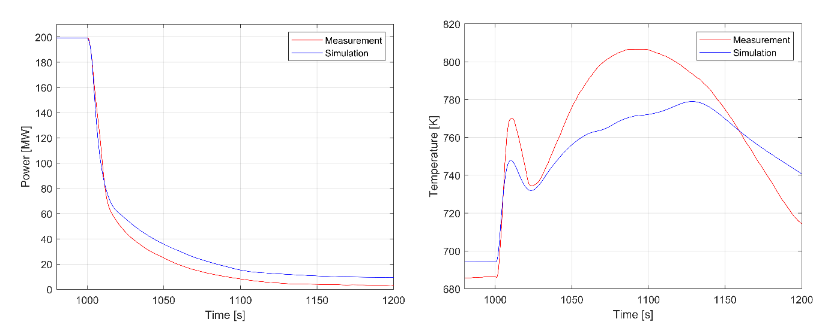
FIG. 6. Comparison of the calculated and the measured core power (left) and the row 2 PIOTA outlet temperature (right).
5.2.1. Evolution of Axial Power Profile during Loss Of Flow WithOut SCRAM Test #13

Due to the reduction of the sodium free level and the corresponding increase in the radial neutron leakage in the ‘unshielded’ section of the core, axial power profile undoubtedly evolved during the course of the test. Evolution and the extent to which the change of the axial power profile at the assembly position 1601 is assumed to happen are illustrated in Fig. 7.
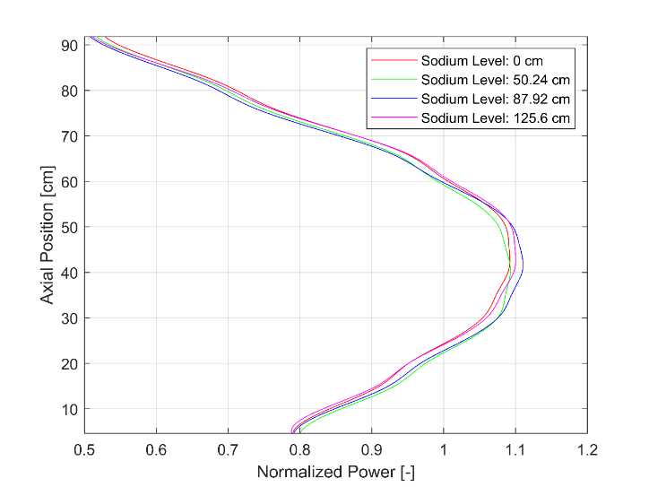
FIG. 7. Axial power profile evolution during the LOFWOS Test #13.
Differences of the presented axial power profiles are definitely negligible hence indicating that there is no significant change of the axial power profile during the LOFWOS Test #13. Having in mind previously stated and the main assumptions of the PRK model, it can be expected that the PRK approach will perform comparatively good in modelling the neutronics of the LOFWOS Test #13.
5.3. Representativeness of Gas Expansion Modules in Modelling Purposeful Voiding of Fast Reactor
Cores
A trend is observed in designing the so-called low-void reactor cores. Low-void core design is characterized by the negative coolant reactivity feedback in some regions of the reactor core. This is to be further utilized by designing reactivity control mechanisms whose working principal is based on the increase of the neutron leakage in order to make the best use of the previously described low-void design. Within the scope of this study, two such designs are compared, namely FFTF’s GEM devices and the ASTRID’s sodium plenum, and further assessment of GEMs in modelling the purposeful voiding of the fast reactor cores is performed.
ASTRID’s sodium plenum is aimed at the passive reduction of the power should the coolant boiling occur: design of the core is such that sodium boiling results in reduction of the coolant density in sodium plenum and inevitable increase in the axial neutron leakage. This ‘purposeful’ voiding of targeted areas that are characterized by the negative coolant void reactivity feedback results in the achievement of passive safety in terms of reactivity control. Introducing GEM devices in FFTF core has a similar effect: promotion of neutron leakage in the zones of the core characterized by the negative coolant void reactivity feedback. In this case, reduction of the sodium density is not achieved by sodium boiling like in ASTRID but by reduction of sodium inventory of GEMs upon the occurrence of the trip of the primary pumps.
Even though they are not based on the entirely same physical principles, these two passive systems can be referred to as analogous. In order to assess the representativeness of GEM devices in modelling the purposeful voiding of fast reactor cores, their performance is compared to the performance of the ASTRID’s inner sodium plenum [6] within Table 2. Figure of merit introduced for the purposes of the aforementioned comparison is referred to as the surface reactivity worth. This parameter is calculated as the ratio of the reactivity worth of fully voided reactivity control mechanism to its outward facing surface under fully voided conditions (maximum outward facing surface).
According to the obtained results, GEMs and inner sodium plenum perform comparatively similar in promoting the neutron leakage and are effective in mitigating the consequences of the ULOF accident. Hence, GEM devices can be referred to as representative in modelling the purposeful voiding of fast reactor cores and can therefore be used to validate passive reactivity control mechanisms based on the purposeful voiding of targeted areas of the reactor cores.
TABLE 2. COMPARISON OF FFTF’S GEM DEVICES AND ASTRID’S INNER SODIUM PLENUM
Parameter | GEM Devices | Inner Sodium Plenum
Leakage Direction | Radial | Axial
Total Reactivity Worth | -475 ± 7 pcm | -1386 ± 21 pcm
(Maximum) Outward Facing Surface | 1.814 m² | 5.920 m²
Surface Reactivity Worth | -262 ± 4 pcm/m² | -234 ± 4 pcm/m²
5.4. Sensitivity Studies
5.4.1. Point Reactor Kinetics vs. Spatial Reactor Kinetics

This sensitivity study deals with the assessment of how good is PRK approach in modelling the neutronics of the LOFWOS Test #13. In what follows, presented are results obtained by running the TRACE standalone simulation with its built-in PRK model and further compared to the results of the coupled TRACE/PARCS simulation with its enacted SRK model, as well as to the measurements obtained during the LOFWOS Test #13.
Namely, Fig. 8 represents the comparison of the evolution of the core power and the evolution of the row 2 PIOTA outlet temperature. On the basis of the presented comparison, one can conclude that the discrepancies among the results obtained by employing PRK and SRK in modelling the neutronic aspects of the LOFWOS Test #13 are minor, as well as that PRK approach performs comparatively good when compared to the SRK approach.
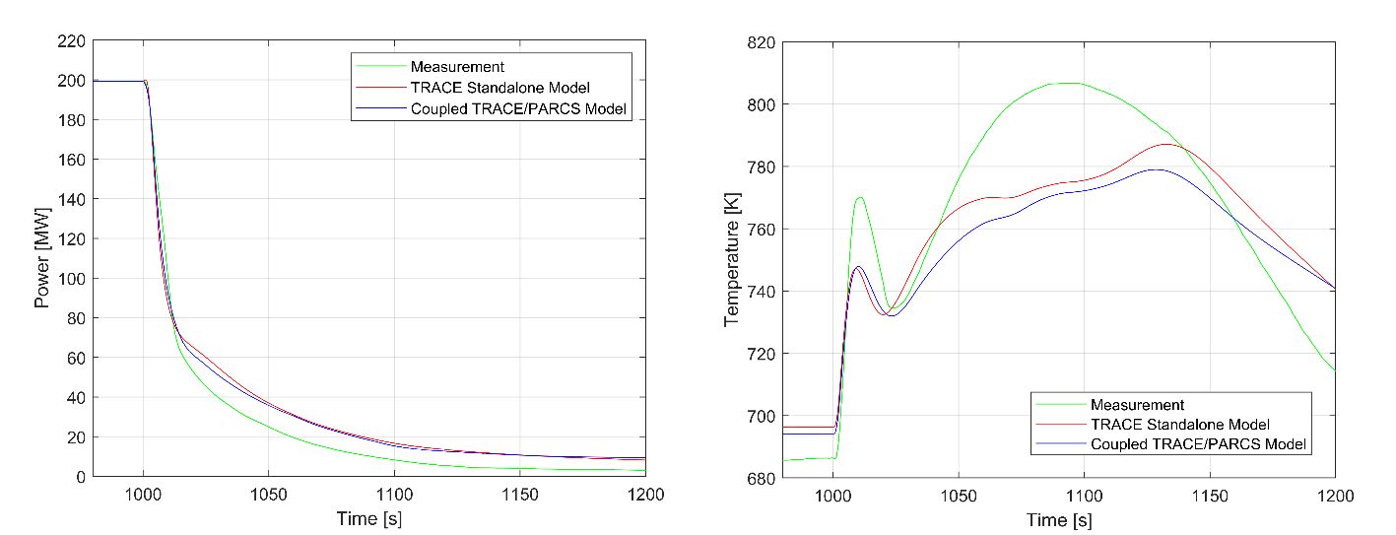
FIG. 8. Comparison of the core power (left) and of the row 2 PIOTA outlet temperature (right) measured during the
LOFWOS Test #13 to the values obtained by the TRACE standalone and the coupled TRACE/PARCS model.

To be more precise, Fig. 8 illustrates that the PRK approach outperforms SRK in modelling neutronics of the LOFWOS Test #13. One of the possible explanations is as follows: due to the small size of the reactor core and the presence of the strong absorbers in the form of CRs and SRs, some of the basic assumptions of the neutron diffusion theory are violated. On the other hand, all of the conditions of validity of PRK model are fulfilled during the entire course of the transient since there is no significant change of the power profiles during the LOFWOS Test #13. Having previously stated in mind, better performance of the PRK when compared to the SRK is fully reasoned and justified.

5.4.2. Sensitivity of Point Reactor Kinetics Model to its Input Parameters

In what follows, presented are results of the sensitivity of the output of the PRK model to its input parameters. Values of the employed input parameters are assessed by the means of the simple, purposefully developed, PRK solver and further confirmed by the more complex PRK solver implemented in the TRACE.
Measurement of the evolution of the core reactivity and therefore the evolution of the core power and the row 2 PIOTA outlet temperature could be reproduced with a higher degree of accuracy by either reducing the value of the effective delay neutron fraction to 0.8 of its calculated value, by increasing the reactivity worth of GEM devices to 1.25 of its calculated value or by reducing the value of Doppler constant to 0.7 of its calculated value. The above-mentioned bridging of the observed discrepancies and increase of the accuracy of the obtained results are respectively credited to the reduced neutronic stability of the core, more pronounced initial drop of the core reactivity upon the activation of GEM devices and the weakening of the reactivity component, namely fuel temperature Doppler effect, that eventually overturns the overall evolution of the core reactivity.
5.4.3. Loss Of Flow WithOut SCRAM Test #13 Guided by Different Reactivity Feedback Effects
Purpose of this sensitivity study is to assess if any of the reactivity feedback effects could drive the reactor core in the safe shutdown state upon the trip of the primary pumps on its own. In addition, assessment of the importance of the GEMs as passive protection devices and the FFTF’s intrinsic safety in general is performed.
Namely, no matter the activated reactivity feedback effect, coolant boiling would occur within the first 100 seconds of the transient. The only exception to the previously stated is the activation of the GEM devices. Evolution of the core reactivity guided only by this reactivity feedback effect could be seen in Fig. 1. Without counterbalance of the Doppler effect and the axial expansion reactivity feedback effect, core reactivity ultimately takes the negative value equal to the reactivity worth of the GEMs therefore allowing GEM devices to drive the reactor core in the safe shutdown state on their own. Furthermore, simulation of the LOFWOS Test #13 guided by all the reactivity feedback effects other than the activation of GEM devices results in the occurrence of the coolant boiling 67 seconds after the beginning of the LOFWOS Test #13. This proves that GEM devices play a crucial role in preserving the intrinsic safety of the FFTF’s core during the cycle 8C.

6. Summary and conclusions
This study deals with the safety aspects of the nuclear energy systems of the next generation, namely with the ULOF accident and the mitigation of its consequences in the SFR fast breeder reactor. Coupled neutronic/TH simulation of the LOFWOS Test #13 has been performed in order to provide fruitful basis for the evaluation of the SFR’s inherent safety characteristics and assess the effectiveness of the novel passive design features.
Upon the simulation of the LOFWOS Test #13, conclusions on the reproducibility of the measurements obtained during the test have been drawn. It is further proven that the GEM devices are effective in mitigating the consequences of the ULOF accident and that their performance is comparatively similar to the performance of the ASTRID’s sodium plenum. By proving that GEM devices could be referred to as a representative of modelling the purposeful voiding of the fast reactor cores, a method to investigate neutronic performance of passive systems that could not be easily tested and/or activated, mostly due to the corresponding consequences, has therefore been brought into existence. On top of that, one of the most important conclusions drawn from the numerous sensitivity studies is that due to the small size of the reactor core and the presence of the strong absorbers in the form of CRs and SRs, as well as due to the negligible change in the power profiles of the reactor core, PRK approach performs comparatively well to the SRK in modelling the neutronics of the reactor cores of the similar geometry, size and the fuel composition as FFTF’s.
Authors would like to wrap up this study with the following conclusion: This work proves that the core of the SFR type features an enormous potential to achieve inherent safety by the means of meticulous approach in the design stage and the plausible introduction of the passive safety features in the later stages the reactor’s lifecycle. Lessons learned during the operation of the FFTF prove the superiority of GEM devices in mitigating the consequences of the ULOF accident hence laying the foundations of an era of the self-protected and intrinsically safe fast reactors.
References
- SUMNER, T., MOISSEYTSEV, A., HEIDET, F., WOOTAN, D.W., CASELLA, A.M., NELSON, J.V., Benchmark Specification for FFTF LOFWOS Test #13, internal report, Argonne National Laboratory and Pacific Northwest National Laboratory, Lemont, 2017.
- LUCOFF, D. M., “Passive safety testing at the Fast Flux Test Facility”, International Conference on Fast Breeder Systems, (Proc. Int. Conf., Richland, 1987), U.S. Department of Energy, Washington D.C. (1987).
- MIKITYUK, K., PELLONI, S., CODDINGTON, P., BUBELIS, E., CHAWLA, R., FAST: An advanced code system for fast reactor transient analysis, Ann. Nucl. Energy, (2005) 1613-1631.
- RHEME, K., Pressure drop correlations for fuel element spacers, Nucl. Technol., (1972) 15-23.
- MIKITYUK, K., Heat transfer to liquid metal: Review of data and correlations for tube bundles, Nucl. Eng. Des., (2009) 680-687.
- BELTJENS, E., Modelling of the Low-Void SFR Core during ULOF with Spatial Kinetics, master’s thesis, École Polytechnique Fédérale de Lausanne, Lausanne, 2017.
- WANG, S., MIKITYUK, K., PETROVIC, D., ZHANG, D., SU, G., QUI, S., TIAN, W., Validation of TRACE capability to simulate unprotected transients in Sodium Fast Reactor using FFTF LOFWST Test #13, Ann. Nucl. Energy 164, (2021) 108600.

