Activities of the GIF Safety and Operation Project of the Sodium-Cooled Fast Reactors

H. YAMANO
Japan Atomic Energy Agency (JAEA)
4002, Narita, Oarai, Ibaraki, 311-1393 Japan
Email: yamano.hidemasa@jaea.go.jp

H. TSIGE-TAMIRAT
European Commission Joint Research Center (JRC)
Westerduinweg 3, 1755 LE Petten, The Netherlands

S. H. KANG
Korea Atomic Energy Research Institute (KAERI)
989-111 Daedeok-daero, Yuseoung-gu, Daejeon, Korea

T. SUMNER
Argonne National Laboratory (ANL)
9700 S Cass Ave, Argonne, IL 60439, USA

M.S. CHENAUD
Commissariat a l'energie Atomique et aux Energies Alternatives (CEA)
BP1, 13108 St Paul Lez Durance, France

E. ROZHIKHIN
Institute for Physics and Power Engineering (IPPE)
Obninsk, Kaluga Region, Russia

J. WANG
China Institute of Atomic Energy (CIAE)
Beijing 102413, China

Abstract

The Generation IV (Gen-IV) international forum is a framework for international co-operation in research and development for the next generation of nuclear energy systems. Within the Gen-IV sodium-cooled fast reactor (SFR) system arrangement, the SFR Safety and Operation (SO) project addresses the areas of safety technology and reactor operation technology developments. The aims of the SO project include (1) analyses and experiments that support establishment of the safety approaches and validate the performance of specific safety features, (2) development and verification of computational tools and validation of models employed in safety assessment and facility licensing, and (3) acquisition of reactor operation technology, as determined largely from experience and testing in operating SFR plants. The tasks in the SO topics are categorized into the following three work packages (WP): WP-SO-1 “Methods, Models and Codes” is devoted to the development of tools for the evaluation of safety. WP-SO-2 “Experimental Programs and Operational Experience” includes the operation, maintenance and testing experiences in experimental facilities and SFRs (e.g., Monju, Phenix, BN-600, EBR-II and CEFR), and WP-SO-3 “Studies of Innovative Design and Safety Systems” relates to safety technologies for Gen-IV reactors such as active and passive safety systems and other specific design features. This paper reports various activities in 2019 within the SO project.

INTRODUCTION
The Generation IV (Gen-IV) International Forum (GIF) is a framework for international cooperation in research and development (R&D) for the next generation of nuclear energy systems [1]. The cooperation on sodium-cooled fast reactor (SFR) nuclear systems in the GIF framework started in 2006 based on the system arrangement among the members. Three projects were signed in 2007, including the Advanced Fuel (AF), Component Design and Balance-of-Plant (CD&BOP), and Global Actinide Cycle International Demonstration (GACID). The Safety and Operation (SO) project commenced in 2009 with four members: Commissariat a l'energie Atomique et aux Energies Alternatives: CEA (FR), Japan Atomic Energy Agency: JAEA (JP), Korea Atomic Energy Research Institute: KAERI (KR), and Department of Energy: DOE (US), and was amended in 2012 to include China Institute of Atomic Energy: CIAE (CN), European Atomic Energy Community: EURATOM (EU) and State Atomic Energy Corporation: ROSATOM (RU). In addition, cooperation of the System Integration and Assessment (SIA) for the SFR design study was signed in 2014. The SO project arrangement was extended for an additional ten years from June 2019.
The aims of the SO project include: (1) analyses and experiments that support establishment of the safety approaches and validate the performance of specific safety features, (2) development and verification of computational tools and validation of models employed in safety assessment and facility licensing, and (3) acquisition of reactor operation technology, as determined largely from experience and testing in operating SFR plants.
In detail, in the safety area, main activities cover the following topics:
- Severe accidents analysis including modelling and experimental programs
- Conceptual studies in support of the design of safety provisions
- R&D for preliminary assessment of passive/active safety issues
- A framework and methods for analysis of safety architecture
In the operation area, main activities cover the following topics:
- Fast reactor safety tests and analysis of reactor operations
- Feedback from decommissioning
- In service inspection technique development from existing reactors to future SFRs
- Sodium chemistry

In order to perform the activities, three work packages (WPs) were formed in the SO project. WP-SO-1 on “Methods, models and codes” is devoted to the development of tools for the evaluation of safety. WP-SO-2 is on “Experimental programs and operational experiences” including the operation, maintenance and testing experiences in experimental facilities and SFRs (e.g., Monju, Phenix, BN-600 and CEFR). WP-SO-3 is on “Studies of innovative design and safety systems” related to the safety technology for the Gen-IV reactors such as passive safety systems.
Since 2016, in-depth discussion has been conducted to strengthen the collaboration. It is intended to develop technical categories to establish resources for key safety topics based on outcomes in this project and common activities.
So far, the SO activities have been reported in various conferences [2-6]. This paper summarizes the topical activities in 2019 in the above WPs as well as the identified technical categories and common activities in the SO project.

TECHNICAL ACHIEVEMENTS

2.1 WP SO 1 – Methods, models and codes

2.1.1 Impact of neutronic parameters in a LOF transient simulation of a low-void SFR core (CEA)
CEA studied the impact of the neutronic calculation methodology on the simulation of an unprotected loss of flow (ULOF) transient scenario for a low-void SFR core concept. Several set of point kinetics parameters have first been prepared with the APOLLO3 code according to different cross section preparation strategies and core solvers. The point kinetics parameters have then been furnished to a transient simulation tool (MACARENa) and their impact on the outcome of the ULOF was discussed. As a result, it was confirmed that the point kinetics parameters (in particular the sodium-void reactivity worth) are strongly affected by three-dimensional (3D) angular effects. Meanwhile, the transient simulation results were not very different judging from the transient calculation result indicating only about 7 s delay at about 45 s on the departure of the boiling crisis. For transient simulations with simplified tools and point kinetics models, there is no need to improve the neutronic calculation strategy beyond a certain threshold. Hence, the most significant progress is probably to be found in improving the neutronic/thermo-hydraulic coupling.

2.1.2 ASTRID core instrumentation definition strategy (CEA)
CEA has recently developed the safety methodology for the definition of ASTRID core instrumentation, based on lines of defense (plus a line of mitigation) [7]. For each event which can lead to the severe accident, the instrumentation architecture consists of at least two strong lines of defense which are strictly independent and technologically diversified to make the architecture robust to common cause failure. The core instrumentation systems enable to control the reactor power and to command shutdown. On-line safety monitoring can detect incidental or accidental events. Five measurement systems have been identified: neutron flux monitoring, thermal measurement, hydraulic measurement, contamination measurement and geometry measurement systems [8]. ASTRID protection sub-systems were allocated for each potential core meltdown initiating event. New features in ASTRID compared to previous SFRs were identified. Detection of control rod withdrawal can be expected by two independent and diversified measurements (temperature measurement at the outlet of the assemblies around the control rod and in core high temperature fission chambers). A pump connection pipe rupture can be detected by core outlet temperature measurements and Power/Flowrate monitoring by using the core inlet pressure measurement. Fuel assembly defect detection was improved in terms of robustness to spurious tripping by the implementation of three temperature sensors above each sub-assembly plus a 2/3 electronic voting logic unit. Neutron counting is available at low power but also at reactor shutdown states and for fuel handling operations. Continuous monitoring permits the detection of multiple fuel handling mistakes.

2.1.3 Benchmark analysis for EBR-II shutdown heat removal tests SHRT-17 and SHRT-45R (CIAE)
The EBR-II Shutdown Heat Removal Tests benchmark specification was originally created for an International Atomic Energy Agency (IAEA) Coordinated Research Project (CRP). As part of a Cooperative Research and Development Agreement (CRADA) between the CIAE and ANL, CIAE has obtained the simulation results of EBR-II Shutdown Heat Removal Tests SHRT-17 and SHRT-45R benchmark [9]. The EBR-II SHRT test is simulated by CIAE’s FR-Sdaso/FASYS code. For EBR-II SHRT-45R benchmark simulation [10, 11], power is used as input data to compare flow and temperature simulation results in phase 1, reactivity and power are calculated and power, flow and temperature simulation results are compared in phase 2. For EBR-II SHRT-17 benchmark simulation, power is used as input data, and the flow and temperature simulation results are compared. The calculated flow rate and temperatures were well simulated in spite of discrepancy in some temperatures.

2.1.4 Preliminary analysis of the post-disassembly expansion phase and structural response under unprotected loss of flow accident for Monju (JAEA)
JAEA has developed an evaluation method of the consequence of energetics in post-disassembly expansion (PDE) phase during a ULOF accident for the prototype SFR in Japan: Monju [12]. In the first licensing of Monju, pressure-volume relation (P-V relation) was evaluated based on the maximum theoretical work energy possible for an expanding core, which is called fuel vapor work potential (FVWP). This can be calculated by integrating fuel vapor pressure along P-V relation of isentropic path to atmosphere considering the heat of condensation of the fuel vapor and enthalpy decrease of the liquid fuel. It was adopted in structural response analyses of the reactor vessel as the input. In the successive studies of the energetics, mechanical energy was evaluated with the code implementing mechanistic modelling of core expansion and it is expected to reduce the actual work potential (AWP) by an order of magnitude below FVWP. In order to evaluate the realistic structural response of the reactor vessel using the AWP, it is necessary to develop a method which converts the AWP to the P-V relation. Therefore, JAEA has developed the method to obtain realistic P-V relation based on the AWP by tracing the surface of the expanding core, and then we evaluated the mechanical energy and structural response under energetics during ULOF accident in Monju using the developed method. The AWP is evaluated to 3 MJ based on the result of the latest ULOF analysis in which FVWP was evaluated to 30MJ, and sodium slug does not impact on the lower surface of the shield plug and no residual strain of the reactor vessel is evaluated. When FVWP is assumed to be 500 MJ as a hypothetical condition covering the conservative energy production, corresponding AWP is evaluated to 33 MJ. Material distribution calculated using the SIMMER code is shown in Fig. 1. In this case, sodium slug impacts on the lower surface of the shield plug and residual strain of the reactor vessel of 0.008% at the maximum is evaluated, however the integrity of the primary boundary is still maintained.

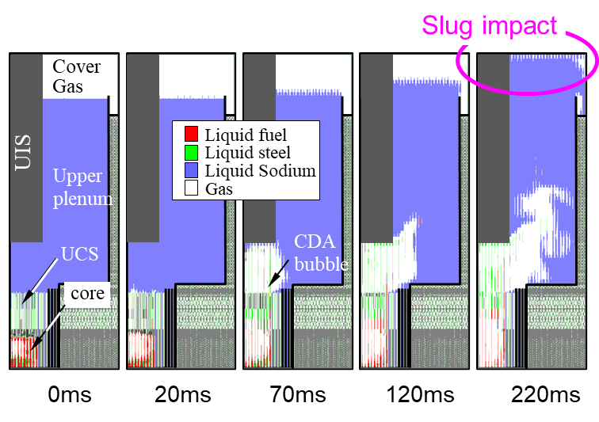
Fig. 1. Material distribution calculated by JAEA (pessimistic temperature condition case).

2.1.5 Comparative Safety Analysis with MARS-LMR and SAS4A/SASSYS-1 Codes for PGSFR (KAERI)
In order to obtain licensing approval for the developed code (MARS-LMR) for PGSFR [13, 14], KAERI carried out a collaborative analysis with ANL on representative protected transients by comparing the MARS-LMR safety analysis results with SAS4A/SASSYS-1 code. The comparative safety analysis was conducted to confirm safety margins for three transients and those are Protected Transient Overpower (PTOP), Protected Loss of Flow (PLOF), and Protected Loss of Heat Sink (PLOHS), respectively. All the transients analyzed in this work are protected events, meaning that the reactor protection system works as designed in these events and scrams the reactor when a trip signal is initiated. Figure 2 shows a typical calculated result in the PLOHS event assuming 1/2 failure and maintenance of decay heat removal system (DHRS) under the loss of-offsite power. The DHRS operated in 20 s after the reactor tripped at about 120 s. The results of transient simulations for the PTOP, PLOF, and PLOHS events from each code showed good agreements and indicated that no immediate safety concerns are raised in these transients, as significant margins to coolant boiling and fuel melting are maintained in all results.

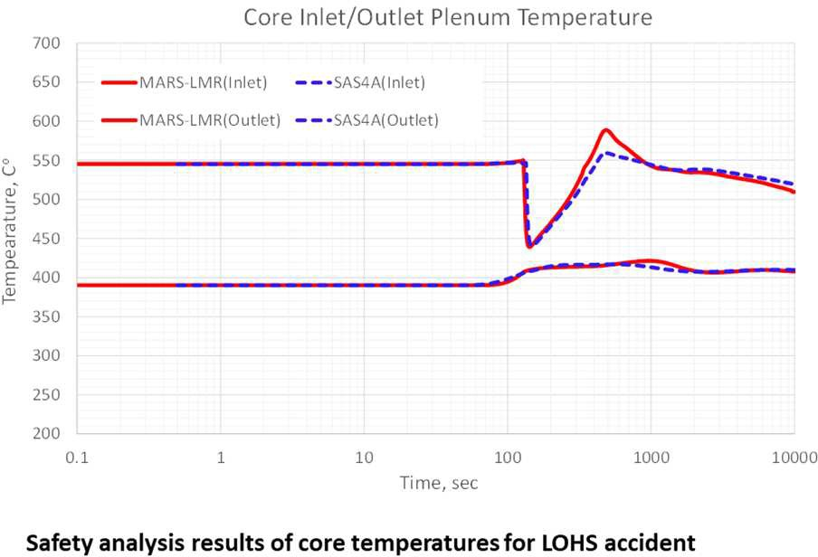
Fig. 2. Comparison between MARS-LMR and SAS4A/SASSYS-1 codes.

2.1.6 Calculational investigations of LOF and ULOF accidents by 3D version of COREMELT (ROSATOM)
IPPE (ROSATOM) continued developing 3D severe accident analysis code COREMELT3D. The 3D model of the reactor gas system (from the gas volume under the sodium level in the reactor through the expansion tank up to the ventilation system) has been developed and implemented into the code. This model has been integrated with the primary circuit 3D thermohydraulic model, it is necessary for simulating transport of gaseous fission products from disintegrated fuel pins up to ventilation system, and consequently into the environment. IPPE has performed integral analysis of the consequences of the severe accidents in BN-1200. There have been used the following codes: COREMELT3D (core, primary and intermediate circulation loops, emergency system of heat removal, reactor gas system), KUPOL- BR (ventilation system), VYBROS-BN (transport of radioactive products in the environment under different meteorological conditions, doses). IPPE has performed preliminary experiments with thermite compositions to obtain melt of stainless steel with high temperature. This technique will be used in a facility (which is being designed now) to simulate transport of melt in the SFR conditions.

2.2 WP SO 2 – Experimental programs and operational experiences

2.2.1 Heat Transfer Analysis of CEFR Damaged Spent Fuel Assemblies in Closed Space (CIAE)
CIAE has carried out a series of experiments with an electrically heated 37-element rod bundle enclosed in a pressure vessel filled with argon, simulating spent fuel assemblies in a closed cleaning chamber for sodium washing. The effects of ambient temperature and heating power on temperature distribution in the rod bundle are investigated. Based on the experimental data, the following findings are concluded for the in-wrapper heat transfer: (1) the circulation flow rate through the rod bundle driven by buoyancy and the corresponding heat removal are negligible; (2) convection does not play an important role in the radial heat transfer in the rod bundle, and the heat transfer is in the conduction regime; (3) based on the known wrapper temperature the Manteufel-Todreas model [15] can give satisfactory prediction of central rod temperature. Another important aspect for heat dissipation from the fuel assembly to the high-temperature ambient is heat transfer on the wrapper surface where radiative heat transfer plays a dominant role. From the comparison with the experiment, it has been concluded that the natural convection on the vertical wrapper surface can be reasonably predicted. However, according to the sensitivity analyses, the uncertainty in emissivity, the axial conduction in the wrapper and the non-uniform temperature distribution on the wrapper wall were the causes to the discrepancy between the calculation result and the experiment data.

2.2.2 CHUG: new facility for studying the chugging flow regime (EURATOM)
SFR core show the occurrence of stabilized chugging sodium boiling regime that can be classified as a new safety measure acting as a level of defence preventing severe accidents [16]. In order to better understand and simulate the chugging boiling regime condition and to gather new experimental data, the ESFR-SMART project envisaged the construction of a new simple facility named CHUG (see Fig. 3) to be planned and designed using water as sodium simulant in order better understand and simulate the chugging boiling regime condition because of opaque sodium. The Euratom contribution discussed the new facility designed and built-in frame of the ESFR-SMART project to study the main phenomena associated with the chugging flow regime after confirming the motivation for the study in the context of the sodium fast reactor safety analysis. The first phase includes the main phenomenology of the chugging boiling regime and the pre-test calculation results, as well as the facility layout for the first phase of the test, including the main parts and the instrumentation. Moreover, preliminary results and main outcomes of first phase of experiments were summarized. In addition, EURATOM carried out analytical simulations of the experiment conducted using the thermal-hydraulics code TRACE to assess the validity of the code for the simulation of chugging boiling.

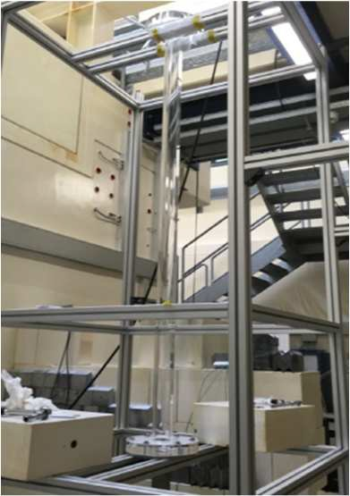
Fig. 3. Layout of the CHUG facility.

2.2.3 Design guidelines for sodium loops (EURATOM)
The aim of this activity was to provide an overview of the design guidelines for sodium loops. Using liquid sodium at high temperatures in test facilities requires defining rules specific to this technology to ensure that operations are safe and reliable. Such facilities can be operated under optimal safety conditions when a certain number of safety principles are adopted as early as the design phase. The purpose of this contribution is to explain the safety rules to be incorporated by the designer during the definition of a project to build a facility implementing sodium at high temperature. These design rules are applicable to the various functions that the facility must provide under the best possible conditions of safety; for this reason, rules pertaining to construction or system operations are not covered. The recommendations take into account European feedback on safety issues related to the design of sodium facilities. However, they do not under any circumstances replace the regulations in force applicable to each subject discussed.

2.3 WP SO 3 – Studies of innovative design and safety systems

2.3.1 Self-actuated shutdown system for passive reactor shutdown (JAEA)
A self-actuated shutdown system (SASS) is one of innovative technologies to be applied to Generation-IV loop-type Sodium-cooled Fast Reactor designed in Japan to cope with anticipated transient without scram (ATWS) in case of active shutdown failure [17]. The SASS is a passive device, which can detach a control rod for reactor shutdown in response to excessive increase in coolant temperature. A detachment temperature, which triggers release of a control rod, and a response time are identified as important parameters for validity analyses. JAEA has investigated the response time and the detachment temperature, and performed safety analysis to see feasibility of the SASS in a low power operation which is required at the start-up. [18]. For this purpose, design modifications were made to shorten the response time and 3D thermal-hydraulic analysis in the low power operation was carried out in order to confirm the response time. Moreover, optimal detachment temperature was determined. The resulting detachment temperature level is lower than previous studies, leading to improved safety parameters. Based on improved parameter, safety analysis to see feasibility of the SASS in low power was carried out as shown in Fig. 4. From this safety evaluation, it was confirmed that core damage can be prevented by the SASS with flow collector in the case of loss-of-flow type ATWS event. Since the margin is small in the safety analysis, further design improvement would be neccesary to enlarge the margin.

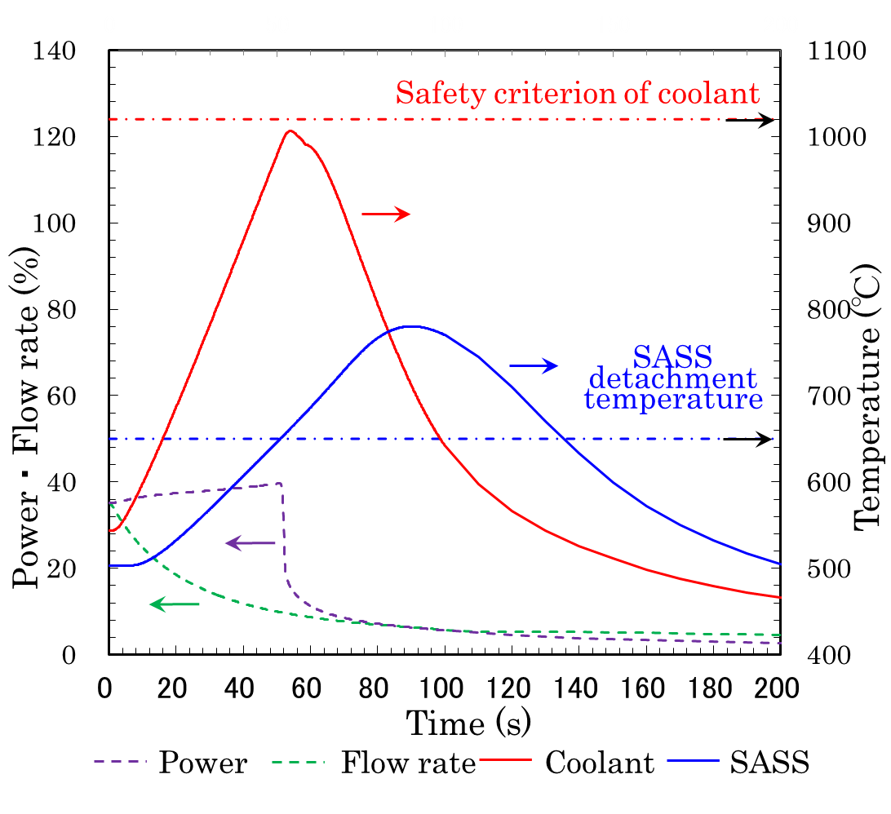
Fig. 4. Calculated transient results in low power operation.

IDENTIFIED TECHNICAL CATEGORIES AND COMMON ACTIVITY
In the recent study, the SO members made efforts to identify technical categories to establish resources (references, experimental data, experiences and recommendations) for key safety topics after reviewing the past outcomes in SO-WPs. The following technical categories have been identified.
- Core
- Decay heat removal, natural circulation
- Severe accidents, sodium boiling, fuel degradation, core catcher
- External events
- Shutdown systems
- Containment and source term
- Benchmarking, code V&V
- Probabilistic risk assessment
- Sodium / water / concrete interactions
- In-service inspection
- Safety and design (passive/inherent safety)
- Safety analysis (design-basis modeling)

Based on these technical categories, common benchmark activities were agreed in the SO project. The following benchmark calculation cases have been selected.
- EBR-II tests BOP-301 and BOP-302R [19, 20]
- PHENIX dissymmetric test [21]

The EBR-II benchmark has been started in the SO project last quarter of 2019. The first phase of the benchmark analysis (“blind phase”) is scheduled to take 2 years. ANL provided benchmark specifications for the EBR-II blind phase analysis.

CONCLUSION
In the framework of the GIF SFR SO project, a large range of activities are being developed both on modeling and experiments by China, France, Japan, Republic of Korea, Russian Federation and Euratom.
The activities for the WP SO-1 include the impact of neutronic parameters in a LOF transient simulation of a low-void SFR analysis and the ASTRID core instrumentation definition strategy by CEA, the benchmark analysis for EBR-II shutdown heat removal tests SHRT-17 and SHRT-45R by CIAE, the preliminary analysis of the PDE phase and structural response under ULOF accident by JAEA, the comparative Safety Analysis with MARS-LMR and SAS4A/SASSYS-1 Codes for PGSFR by KAERI, and the calculational investigations of LOF and ULOF accidents by 3D version of COREMELT by ROSATOM. The activities for the WP SO-2 are the heat transfer analysis of CEFR damaged spent fuel assemblies in closed space by CIAE, the CHUG: new facility for studying the chugging flow regime and the design guidelines for sodium loops by EURATOM. The WP SO-3 is the SASS for passive reactor shutdown by JAEA.
The SO project has also identified technical categories to establish resources the common benchmark activities: EBR-II tests BOP-301 and BOP-302R, and PHENIX dissymmetric test. The EBR-II benchmark has been started in the SO project last quarter of 2019. The blind phase analysis is scheduled to take about 2 years. After the blind phase, the SO project will carry out further analyses (open phase) to improve the analyses model based on the blind phase summary.

ACKNOWLEDGEMENTS
Authors are representative members from each country’s government and organization. Authors would like to show our thanks to all related members to organize the co-operative project.
Argonne National Laboratory's work on the EBR-II test analyses was supported by the U.S. Department of Energy, Office of Nuclear Energy, under contract DE-AC02- 06CH11357.
References
- OECD Nuclear Energy Agency for the Generation IV International Forum, GIF R&D Outlook for Generation IV Nuclear Energy Systems: 2018 Update, June 2019, https://www.gen-4.org/gif/upload/docs/application/pdf/2019-06/7411_gif_r_and_d_outlook_update_web.pdf
- VASILE, A., SOFU, T., JEONG, H.Y., SAKAI, T., “GIF Sodium Fast Reactor Project R&D on Safety and Operation,” International Congress of Advances in Nuclear Power Plants ICAPP’12 (Proc. Int. Conf., Chicago, IL., USA, June 24-28, 2012), ANS, Chicago (2012), Paper 12358.
- SAKAI, T., REN, L., TSIGE-TAMIRAT, H., VASILE, A., KANG, S.H., ASHURKO, Y., FANNING, T., “Activities of the Safety and Operation Project for the International Research and Development of the Sodium-Cooled Fast Reactor in the Generation IV International Forum,” 24th International Conference on Nuclear Engineering ICONE24 (Proc. Int. Conf., Charlotte, North Carolina, USA, June 26-30, 2016), ASME, New York (2016), ICONE24-60502.
- VASILE, A., REN, L., FANNING, T., TSIGE-TAMIRAT, H., YAMANO, H., KANG, S.H., ASHURKO, I., “Recent Activities of the Safety and Operation Project of the Sodium-Cooled Fast Reactor in the Generation IV International Forum,” Fast Reactors and Related Fuel Cycles: Next Generation Nuclear Systems for Sustainable Development FR17 (Proc. Int. Conf., Yekaterinburg, Russia, June 26-29, 2017), IAEA, Vienna (2018), CN245-133.
- YAMANO, H., VASILE, A., KANG, S.H., SUMNER, T., TSIGE-TAMIRAT, H., WANG, J., ASHURKO, I., Activities of the GIF Safety and Operation Project of the Sodium-Cooled Fast Reactor Systems, 27th International Conference on Nuclear Engineering ICONE27 (Proc. Int. Conf., Tsukuba, Ibaraki, Japan, May 19-24, 2019), JSME, Tokyo (2019), ICONE27-1025.
- YAMANO, H., CHENAUD, M.S., KANG, S.H., SUMNER, T., TSIGE-TAMIRAT, H., WANG, J., ROZHIKHIN, E., Activities of the GIF Safety and Operation Project of the Sodium-Cooled Fast Reactor Systems, 28th International Conference on Nuclear Engineering ICONE28 (Proc. Int. Conf., Online, Aug. 4-6, 2021), ASME, New York (2021), ICONE28-66385.
- TRÉVISIOL, M., COSTES, L., BONNIN, J., GAUTHÉ, P., JAMMES, C., FILLIATRE, P., “ASTRID Core Instrumentation Strategy,” International Congress of Advances in Nuclear Power Plants ICAPP2019 (Proc. Int. Conf., Juan-les-pins, France, May 12-15, 2019), SFEN, Paris (2019), Paper 000256.
- BONNIN, J., CAVARO, M., GAUTHÉ, P., HAUBENSACK, D., GIRARD, M., IHLI, S., JAMMES, C., LHUILLIER, C., M’HAMMEDI ALAOUI, F.Z., NAVACCHIA, F., PAUMEL, K., JEANNOT, J.P., “Progress in the Development of the Core Control and Monitoring Measurements System of the French GEN-IV SFR,” International Congress of Advances in Nuclear Power Plants ICAPP2019 (Proc. Int. Conf., Juan-les-pins, France, May 12-15, 2019), SFEN, Paris (2019), Paper 000133.
- SUMNER, T., WEI, T.Y.C., Benchmark Specifications and Data Requirements for EBR-II Shutdown Heat Removal Tests SHRT-17 and SHRT-45R, Argonne National Laboratory Report, ANL-ARC-226 (Rev 1), May 31, 2012.
- FEI, T., MOHAMED, A., KIM, T. K., Neutronics Benchmark Specifications for EBR-II Shutdown Heat Removal Test SHRT-45R – Revision 1, Argonne National Laboratory Report, ANL-ARC-228 (rev. 1), January 23, 2013.
- SUMNER, T., MOISSEYTSEV, A., Results of EBR-II SHRT-45R Simulations, Argonne National Laboratory Report, ANL-CIAE-SFR-18-04, Dec. 1, 2017.
- ONODA, Y., MATSUBA, K., TOBITA, Y., SUZUKI, T., “Preliminary analysis of the post-disassembly expansion phase and structural response under unprotected loss of flow accident in prototype sodium cooled fast reactor,” Mech. Eng. J. 4,3 (2017) No.16-00597.
- CHOI, C., JEONG, J., HONG, J.G., YEOM, S., KIM, J.M., JEONG, J.Y., LEE, Y.B., HA, K., “Validation of MARS-LMR Code for Heat Transfer Models in the DHRS of the PGSFR,” 16th International Topical Meeting on Nuclear Reactor Thermal Hydraulics NURETH-16 (Proc. Int. Conf., Chicago, IL, USA, Aug. 30 - Sep. 4, 2015), ANS, Chicago (2016) pp.4576-4589.
- LEE, K.L., HA, H.S., JONG, J.H, CHOI, C.W., JEONG, T.K., “An Assessment of Transient Over-Power Accident in the PGSFR,” Fast Reactors and Related Fuel Cycles: Next Generation Nuclear Systems for Sustainable Development FR17 (Proc. Int. Conf., Yekaterinburg, Russia, June 26-29, 2017), IAEA, Vienna (2018), CN245-172.
- MANTEUFEL, R.D., TODREAS, N.E.,. Effective Thermal Conductivity and Edge Conductance Model for a Spent-Fuel Assembly. Nuclear Technology 105, (1994) 421-440.
- MIKITYUK, K., PANADERO, A.L., MAMBELLI, S., “Chugging Boiling in Low-Void SFR Core: New Phenomenology,” Fast Reactors and Related Fuel Cycles: Next Generation Nuclear Systems for Sustainable Development FR17 (Proc. Int. Conf., Yekaterinburg, Russia, June 26-29, 2017), IAEA, Vienna (2018), CN245-451.
- YAMANO, H., KUBO, S., SHIMAKAWA, Y., FUJITA, K., SUZUKI, T., KURISAKA, K., Safety design and evaluation in a large-scale Japan sodium-cooled fast reactor, Science and Technology of Nuclear Installations, 2012, (May 2012) Article ID 614973.
- SAITO, H., YAMADA, Y., OYAMA, K., MATSUNGA, S., YAMANO, H., KUBO, S., “Safety Evaluation of Self Actuated Shutdown System for Gen-IV SFR,” International Congress on Advances in Nuclear Power Plants ICAPP2017 (Proc. Int. Conf., Fukui and Kyoto, Japan, April 24-28, 2017) AESJ, Tokyo (2017) No.17439.
- INTERNATIONAL ATOMIC ENERGY AGENCY, Benchmark Analysis of EBR-II Shutdown Heat Removal Tests, IAEA-TECDOC-1819, IAEA, Vienna (2017).
- SUMNER, T., ZHANG, G., FANNING, T. H., BOP-301 and BOP-302R: Test Definitions and Analyses, ANL-GIF-20-2018-2, SFR-SO-2018-010, Argonne National Laboratory, Dec. 31, 2018.
- UITSLAG-DOOLAARD, H.J., GEFFRAY, C., GERSCHENFELD, A., ALCARO, F., KRAUS, A., BRUNETT, A., WANG, X., “Results of the PHENIX Dissymmetric Test Benchmark Exercise”, International Congress of Advances in Nuclear Power Plants ICAPP2019 (Proc. Int. Conf. Juan-les-pins, France, May 12-15, 2019), Paris, 2019, Paper 243.

