# THE WESTINGHOUSE LEAD FAST REACTOR:

# design OVERVIEW AND update on DEVELOPMENT ACTIVITIES

P. FERRONI1, C. STANSBURY1, J. LIAO1, F. FRANCESCHINI2, S.J. LEE3, M. ICKES1, M. EPSTEIN3, D. ADORNO4, M. JONSON4, T. LOEBIG1, N. GRIXTI5, A. PATEL5, J. ARNDT1, D. WISE1, R. WRIGHT1, P. GRECO1, M. DURSE1, A. LEVINSKY1, E. TATLI1, C. CANTARERO1, C. CHRZANOWSKI1, J. WILLIS1, C. CMAR1, A. PARSI1, I. HAY5, P. BARNES5, P. CUADRADO6

1 Westinghouse Electric Company LLC, Cranberry Township, PA, USA

2 Westinghouse Mangiarotti, Monfalcone - (GO), Italy

3 Fauske & Associates LLC, Burr Ridge, IL, USA

4 Westinghouse Electric Sweden AB, Västerås, Sweden

5 Westinghouse Electric Company UK Limited, Springfields, United Kingdom

6 Westinghouse Electric Spain, Madrid, Spain

Email contact of corresponding author: [ferronp@westinghouse.com](mailto:ferronp@westinghouse.com)

**Abstract**

Westinghouse continues to develop its Next Generation high-capacity nuclear power plant (NPP) based on Lead‐cooled Fast Reactor (LFR) technology. By leveraging its long experience in NPP commercialization as well as selected partnerships, Westinghouse is progressing the plant’s design and overall development program. With a power of approximately 950 MWt (~450 MWe) the Westinghouse LFR is a competitive, medium-size, simple, scalable and passively safe plant harnessing a liquid lead-cooled, fast neutron spectrum core operating at high temperatures in a pool configuration reactor. The paper describes the overall plant design and details the main development activities, with special focus on those being funded by the United Kingdom Department for Business, Energy & Industrial Strategy (BEIS) as part of Phase 2 of the Advanced Modular Reactor (AMR) program. In this program Westinghouse and its partners carry out a wide spectrum of development activities, primarily centered on the demonstration of key LFR’s materials, components, systems and phenomena through the operation of eight state-of-the-art test rigs being set up at various locations in the UK and entering operation in 2022.

## INTRODUCTION

Westinghouse is continuing development of its Next Generation high-capacity nuclear power plants based on LFR technology. With a power of approximately 950 MWt (~450 MWe), the Westinghouse LFR’s primary mission is to reduce front-end capital cost and generate flexible and cost-competitive electricity for global markets, while offering mission versatility and satisfying the highest safety and sustainability standards. The Westinghouse LFR is envisioned to be developed through a staged approach that commences with a lower-power, nearer-term demonstration LFR. This plant operates with reduced duty conditions (coolant temperature, burnup) to maximize use of higher readiness materials and is intended to demonstrate LFR technology’s overall safety and performance characteristics. Its power output has not been finalized yet, as it depends on cost considerations and siting opportunities currently being evaluated, as well as on constraints imposed to ensure sufficient prototypicality for key components with respect to the 450 MWe plant. Experimental data and operating experience accumulated with the demonstration LFR will be used to support the development of the larger plant which is envisioned to operate at more demanding conditions (coolant temperature, burnup) to further enhance economic performance. The ~450 MWe plant is currently near completion of conceptual design. Development activities have recently been accelerated by support from the UK Department for Business, Energy & Industrial Strategy (BEIS) as part of Phase 2 of the Advanced Modular Reactor (AMR) program. Specifically, in 2020 BEIS awarded approximately £10M to Westinghouse to carry out, in collaboration with several partners, a set of activities primarily aimed at demonstrating key materials, components, systems and phenomena of the Westinghouse LFR [1]. As part of the same program, which will be completed in early 2023, Westinghouse is also engaging the UK Regulators with the purpose of receiving their feedback on plant design and associated safety case, with the goal of streamlining subsequent licensing activities. Experimental activities are envisaged to continue in the UK after Phase 2, leveraging the significant test capabilities enabled by the AMR program. This paper provides an overview of the Westinghouse LFR plant design (Section 2) and a summary of the development activities (Section 3).

## design overview

The Westinghouse LFR is a mid-size (950 MWt, ~ 450 MWe) passively-safe plant based on a pool-type, lead-cooled fast reactor coupled to an air-cooled supercritical water power conversion system (PCS). The plant has load-following capabilities, achieved not by changing the core power but by means of a thermal energy storage system connected to the PCS. Based on modular construction, the plant is envisioned as independent unit for a single- or two-unit site. Moreover, being the PCS cooled by air, the plant does not require vicinity to large water bodies thus enhancing siting opportunities. TABLE 1 lists high-level plant characteristics while Fig. 1 shows a notional representation of the reactor coolant system (RCS) and a rendering of a potential two-unit site.

TABLE 1. Westinghouse LFR high-level characteristics

|  |  |  |
| --- | --- | --- |
| **Parameter** | **Unit** | **Value** |
| Rated power (thermal / Net electric) | MW | 950 / ~ 450 |
| Primary coolant | - | Liquid lead |
| Secondary coolant | - | Supercritical water |
| Reactor coolant system configuration | - | Pool-type |
| Number of heat exchanger | - | 3 |
| Number of Reactor Coolant Pumps and location | - | 3, in the cold leg |
| Reactor vessel outer diameter / height | m | ~6.7 / ~9 |
| Fuel type | - | Oxide fuel (Phase I), Adv. fuel (Phase II) |
| Fuel cycle length | yr. | 8-20 (depending on fuel) |
| Refuelling strategy | - | Direct transfer to casks, w/o assembly shuffling |
| Operating pressure (primary / secondary) | MPa | Approx 0.1 / 34 |
| Lead coolant min / max bulk temperature | °C | Approx 390 / up to 530 (Phase I)  Approx 390 / 650 (Phase II) |
| Ultimate heat sink | - | Atmosphere |
| Plant site configuration | - | Independent unit for single or two-unit site |

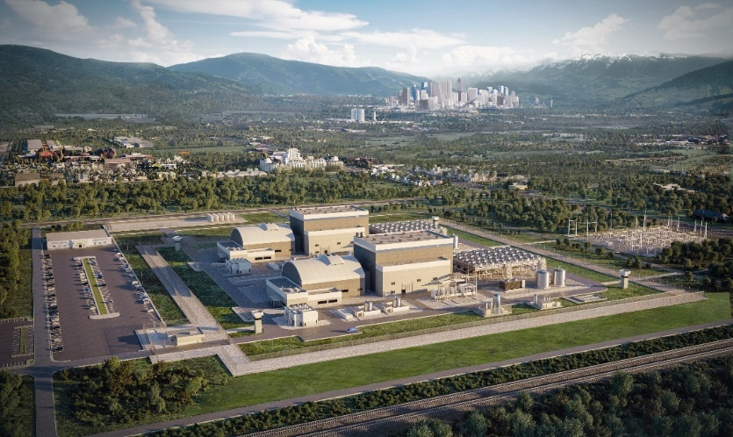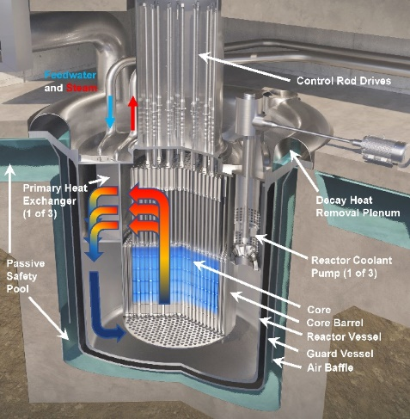

Fig. 1. Notional representation of the Westinghouse LFR primary system (left) and artistic rendering of a two-unit Westinghouse LFR site

### Core design, refuelling and fuel cycle

The development of the Westinghouse LFR core is driven, in addition to performance metrics, by the need to ensure flexibility in fuel and fuel cycle options. Such flexibility is pursued to accelerate LFR technology demonstration and early deployment (Phase I) through implementation of high-maturity UO2 fuel, while also providing the opportunity for potential transition to higher-performance but lower-maturity fuel options (Phase II) – primarily uranium nitride (UN) – which Westinghouse is exploring for both LFR and LWR technologies due to its superior characteristics in terms of heat transfer properties and heavy metal density. To further enhance flexibility, a mixed oxide (MOX)-fueled core option is also devised which, in addition to leveraging fast reactor operating experience with this fuel type, suits countries with spent fuel management policies that support reprocessing and reuse of plutonium, either now or in the future. Also leveraging experience gained with advanced fuel systems as part of the LWR Accident Tolerant Fuel program, Westinghouse has been investigating tradeoffs in the use of different fuels for LFR for several years, as documented in [2], [3] and, more recently, in [4].

The requirement to minimize redesign activities and replacement of internal structures or components imposes these three LFR core configurations to fit the same core barrel, lay on the same core support plate and utilize sets of control/shutdown assemblies that do not necessitate the reactor vessel head to be replaced to accommodate fuel transitions. This latter requirement is facilitated by the use of the same assembly footprint regardless of the fuel type, resulting in the core configuration depicted in Fig. 2 which is common to all three fuels. Intra-assembly lattices (fuel pellet characteristics, fuel rod diameter and pitch, and number of fuel rods per assembly) can instead differ among the fuels, driven by performance goals accounting for the different properties of the fuels. The Westinghouse LFR core features 325 fuel assemblies arranged in three radial regions of different enrichment, which in turn feature axially-variable enrichment for power-shaping purposes. The core also includes 24 lattice positions for managing reactivity, comprising six safety (shutdown) assemblies and 18 control assemblies. The latter, split in two banks and partially inserted during most of the cycle, are used for reactivity control but also for main and auxiliary shutdown, with the safety assemblies instead dedicated to emergency shutdown leveraging a passive actuation mechanism. Although some aspects of core design are evolving, more details on the current configuration can be found in [4].

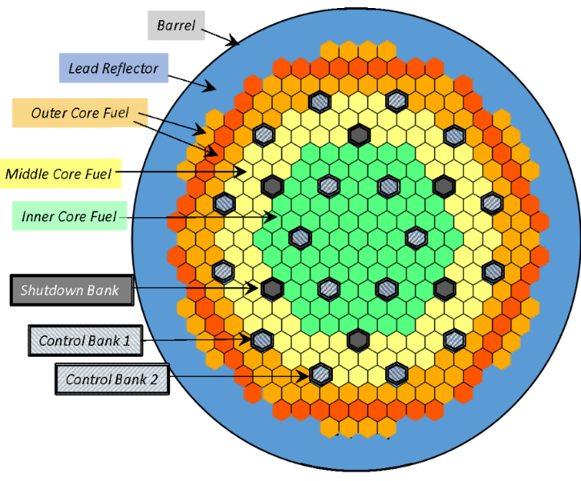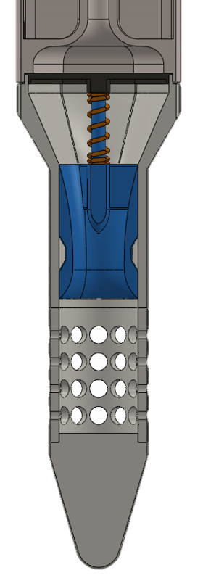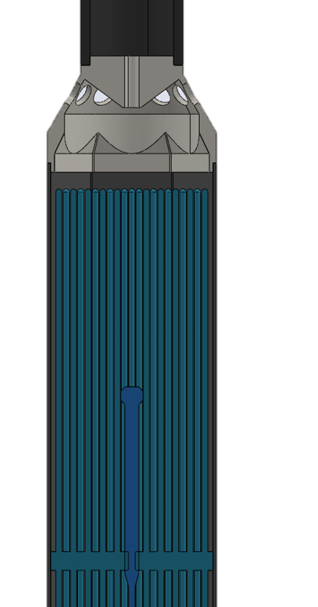

Fig. 2. Radial configuration of the Westinghouse LFR core (left) and fuel assembly axial view (right)

The LFR core configurations are designed to operate at high temperatures consistent with the LFR deployment phase they refer to (i.e., Phase I and Phase II in TABLE 1) and thus feature fuel rod cladding materials suited to the peak temperature and DPA limit characterizing each phase. As indicated in Section 2.4, the focus for the fuel rod cladding material to be used in the near-term is primarily on optimized Ti-modified 15Cr-15Ni austenitic stainless steels with a corrosion-resistant coating. This material choice is supported by irradiation experience of similar steels (e.g., D9 and AIM-1 steels) in sodium fast reactors and is also facilitated by the relatively mild irradiation doses targeted by the Westinghouse LFR in the first deployment phases, with a peak below approximately 100-120 DPA and therefore in line with recommended irradiation conditions for these steels [5]. In addition, when coated with a thin film of Al2O3 through Pulsed Laser Deposition (PLD), corrosion resistance in lead at 550°C up to 4000 hours has been shown even at low dissolved oxygen concentration [6]. This coating has been shown to exhibit metal-like properties and plastic deformability up to a few percent, as well as good radiation tolerance under heavy ions with irradiation up to approximately 150 DPA in the coating and up to 480 DPA in the steel substrate [7], making this material system a promising candidate for LFR’s fuel assemblies. Moreover, PLD-Al2O3 coatings have shown anti-diffusion and anti-permeation capability against several gaseous species [6], which is relevant in relation to the confinement of tritium produced through fission in fuel rods and through neutron capture by boron in control rod material.

To address the lower state of knowledge characterizing materials’ performance at the more demanding operating conditions of subsequent LFR evolutions, i.e. Phase II, Westinghouse is considering multiple material options whose corrosion performance in liquid lead has (e.g. [8]) and will continue to be investigated (see Section 3.1) through joint experimental campaigns aimed at down-selecting materials as to progressively enhance cost-effectiveness of the material development program. Materials considered include both advanced steels, such as Alumina Forming Austenitic (AFA) steels and FeCrAl ODS, as well as ceramics (primarily SiC-SiC composite). It should be noted that promising results on corrosion performance of certain materials in liquid lead up to approximately 750°C have already been reported in the literature (e.g., [8] through [13]).

The Westinghouse LFR adopts a long-life, single-batch core design with no assembly shuffling, no need for traditional spent fuel pool, and refueling to occur through direct transfer of used fuel from the core to dry casks. Cycle lengths on the order of 8-10 years for UO2 and up to 15-20 years for MOX and UN are considered, enabled primarily by a large heavy metal inventory obtained by increasing the fuel active height relative to most liquid metal reactors. A shorter cycle length is envisioned during initial LFR demonstration phase. All these design choices are intimately linked to each other. As in-vessel-storage of used fuel is not envisaged, the direct transfer of used fuel to casks requires the fuel to remain in the core for a certain amount of time after shutdown, to allow the decay heat to decrease below acceptable levels for safe transfer. This waiting time, which would likely be unacceptable in conventional, short-length fuel cycle designs because of its detrimental effect on plant economics, is instead acceptable for the Westinghouse LFR by virtue of the low frequency of refueling outages which results in a reduced impact of a relatively long refueling outage on plant economics. Overall, in addition to simplifications in plant design and operations, with ensuing cost benefits, the long fuel cycle and the elimination of a traditional spent fuel pool significantly reduce opportunities for used fuel diversion, thus benefitting security and proliferation resistance. Moreover, aware that some circumstances may require a more rapid de-fuel, e.g., for replacing a failed fuel assembly, the plant is also provided with special provisions to permit such operation.

Due to the abundance of natural uranium resources for the currently installed global nuclear capacity, and in consideration of the lack of fuel reprocessing facilities in most countries, the Westinghouse LFR adopts an open fuel cycle as reference. However, consistent with the flexibility principle discussed above, the design can also accommodate semi-open and closed fuel cycle options. This allows the plant to address changes in fuel cycle policies worldwide which may potentially occur as a result of increased sensitivities by government and societies to fuel cycle sustainability and/or as a result of an increase in installed nuclear capacity and ensuing pressure on uranium natural reserves and used fuel repositories.

### Reactor Coolant System

The reactor coolant system (RCS), schematically shown in Fig. 1, is enclosed within a reactor vessel (RV) surrounded by a Guard Vessel (GV) and features three high power density, diffusion-bonded, microchannel-type primary heat exchangers (PHE) developed in collaboration with a specialized vendor. The PHEs are integral to the upper part of the core barrel and are fed radially by the primary coolant as it moves upward in the upper core plenum. The secondary coolant enters and exits the PHE axially, with most of the heat transfer however taking place with counter-current flow relative to the lead flow. The compactness of the selected PHE type/design reduces the overall height and volume of the RV, thus not only making the RV more compact but also alleviating RV support challenges resulting from the otherwise heavier RV should more conventional shell-and-tube heat exchangers be used. With no welds in the main body and very small (<2 mm in diameter) secondary side channels within diffusion bonded plates, a robust PHE structure capable of maintaining extreme pressure differentials is created. When combined with the lack of exothermic reaction between liquid lead coolant and water, and with the placement of the secondary headers outside of the RV, these elements allow to significantly alleviate the risk of PHE failure, resulting in a reduced likelihood of in-vessel rupture (due to PHE’s robust core structure) and negligible RV pressurization in case of PHE failure (as the headers’ ex-RV location allows limiting RV pressurization to that possible from the microchannels only). Leaks of < 2 mm size are most-easily addressed using rupture discs installed on the RV head. Overall, these inherent attributes of lead coolant and of the PHE design strengthen the case for eliminating the need for an intermediate heat transport loop present in other advanced reactors, resulting in a more cost competitive plant. As discussed in Section 3, ad-hoc test facilities for assessing PHE performance in prototypic liquid lead conditions, including PHE failure, are being set up in the UK and testing is planned to start in 2022.

Three mechanical reactor coolant pumps (RCP) are located downstream of the PHE, in the cold pool. The reduced temperature in this region of the RCS, together with the impeller tip velocity being well below 10 m/s, help avoiding corrosion/erosion phenomena on this component. While the RCP design is progressing through definition of impeller blade parameters and diffusor characteristics, confirmatory corrosion/erosion testing of candidate impeller materials will soon be performed in ad-hoc test rigs in the US and in the UK (see Section 3).

### Passive Heat Removal System

The Passive Heat Removal System (PHRS) is a key pillar of the LFR’s safety case. This system, shown in Fig. 3, is designed to passively remove decay heat following an accident, should the Normal Decay Heat Removal system fail or be unavailable, by means of:

* Conducting heat through the RV wall
* Transferring heat via radiative and convective heat transfer from the RV wall to the GV wall
* Conducting heat through the GV wall
* Transferring heat via natural convection and boiling to a large volume of water outside of the GV, whose level remains constant for at least 7 days due to communication with an upper pool
* Transitioning to natural convection air cooling, circulating outside of the GV when water is depleted

The PHRS is always on, even during normal reactor operation and shutdown, thus resulting in continuous thermal losses. In these operational modes, however, the RV temperature (370-390°C) is not sufficient to promote significant radiative heat transfer from the RV to the GV, thus limiting these losses to low values. These losses are acceptable from the plant’s efficiency standpoint, and do not pose a challenge to lead freezing as, even in a hypothetical extended shutdown scenario with lead heating system assumed to fail, lead freezing would occur after a long time (> 1 month, during which time period adequate measures can be taken to ensure the primary pool to remain in liquid state). Instead, when the lead pool temperature increases as a result of an accident, the PHRS starts to remove more and more heat, thus increasing its effectiveness just when it is needed. No operator intervention, signals of intelligence or moving parts are required for the actuation and operation of the PHRS, consistent with the IAEA Passive Safety Category B currently targeted as a goal by the Westinghouse LFR.

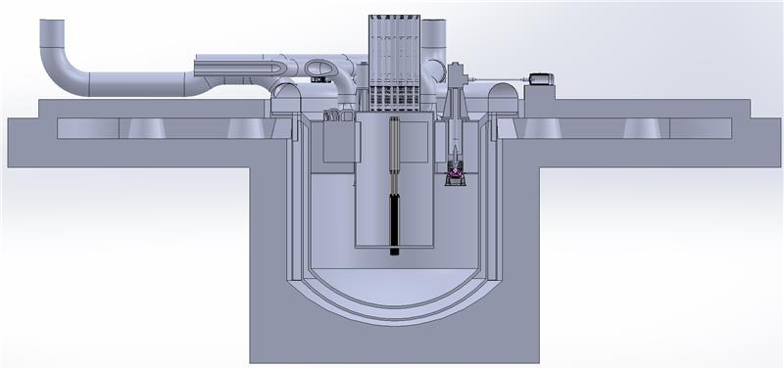

**Reactor vessel**

**Guard vessel**

**Lower and upper water pools (communicating)**

**Baffle**

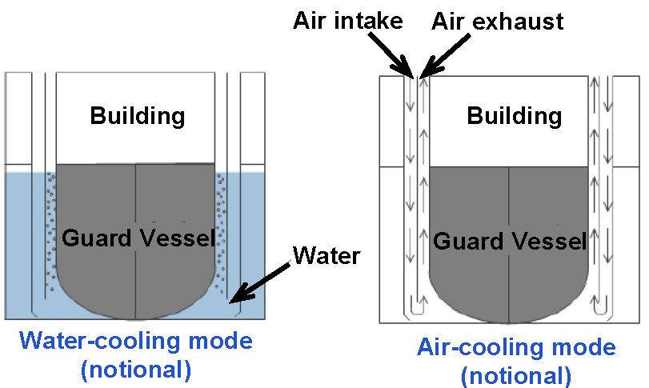

Fig. 3. Passive Heat Removal System: working principle (top) and notional representation of geometry (bottom)

As discussed in detail in the companion paper [14], Westinghouse analyzes the performance of the PHRS by coupling, at the RV boundary, the SAS4A/SASSYS-1 (SAS) system code [15] to the GOTHIC computer code [16]. Validation and verification of these codes is progressing using experimental data collected in the past with lead-based pool-type facilities (e.g., [17]) and will achieve an important milestone in 2022, i.e., the setup and operation of a dedicated, full-height test facility reproducing an azimuthal “slice” of the Westinghouse LFR’s PHRS called Passive Heat Removal Facility (PHRF) (see Section 3). Of particular interest, as anticipated by the Phenomena Identification and Ranking Table (PIRT) on LFR’s safety [18], is the PHRS’ heat transfer capability during the transition between water and air cooling, which will be investigated within the PHRF experimental campaign. More details on safety analysis methodologies of the Westinghouse LFR can be found in [19].

### Candidate materials for Reactor Coolant System components

The Westinghouse LFR adopts a staged approach to material implementation due to the need to accelerate LFR technology demonstration and early deployment (Phase I), while at the same time assessing the viability of higher performance materials for subsequent LFR evolutions (Phase II). Phase I will maximize the use of existing qualified materials eventually provided, when needed, with protective coatings/cladding to mitigate the effects of lead on the material properties. Phase II will utilize advances in materials to further increase the operating temperature, building upon R&D and testing campaigns some of which have already started and others to be enabled by dedicated testing facilities to be soon erected (see Section 3). TABLE 2 list the main candidate materials currently being investigated. In both Phase I and Phase II the dissolved oxygen concentration of the liquid lead during reactor operation will be controlled to 10-6 – 10-88, with a target of 10-7 weight percent. This oxygen concentration provides substantial margin against oxidizing the liquid lead while ensuring sufficient oxygen to allow reformation of the protective oxide layer on structural components should it be damaged.

TABLE 2. Westinghouse LFR’s main candidate materials

|  | **Phase** | **Max steady-state T (°C)** | **Pb velocity** | **Candidate materials** |
| --- | --- | --- | --- | --- |
| **Guard Vessel** | I | <100 | N.A. | AISI 316a |
| II | <100 | N.A. | AISI 316a |
| **Reactor Vessel** | I | ~390 | <<1 | AISI 316a |
| II | ~390 | <<1 | AISI 316a, 15-15Tia, AFA |
| **Reactor Internals** | I | Up to 530 | <1 | AISI 316a,15-15Tia |
| II | ~650 | <1 | AISI 316a,15-15Tia, AFA |
| **Heat Exchanger** | I | Up to 530 | <1 | AISI 316a |
| II | ~650 | <1 | AISI 316a, AFA |
| **Fuel rod cladding** | I | Up to 600 | ≤2 | 15-15Ti a |
| II | ~730 | ≤2 | 15-15Ti a, AFA, FeCrAl ODSa, SiC/SiC |
| **Fuel assembly structures** | I | Up to 530 | ≤2 | 15-15Tia |
| II | ~650 | ≤2 | 15-15Ti a, AFA, FeCrAl ODSa, SiC/SiC |
| **RCP impeller** | I | ~390 | <10 | AISI 316a, Tantalum |
| II | ~390 | <10 | AISI 316a, AFA, Tantalum |

a Clad/coated (e.g., FeCrAl clad or aluminizing)

### Power Conversion System and Energy Storage

The Westinghouse LFR utilizes an air-cooled supercritical water (sH2O) power conversion system (PCS). It should be noted that the adoption of sH2O as PCS fluid was not immediate as earlier development work focused instead on supercritical CO2 (sCO2). However, subsequent analyses revealed that, in addition to recent advances in sH2O turbines (e.g. General Electric STF-D1250 [20]), for the specific operating conditions of the Westinghouse LFR a sH2OPCS would lead the same or slightly higher efficiency performance than a sCO2 PCS, however with some important advantages in terms of technology readiness, much smaller size of secondary piping (which ease layout and reduce piping cost), more compact PHEs with approximately 30°C higher secondary fluid outlet temperature, and the possibility to condense secondary fluid in case of breaks. Moreover, recognizing the increasing pressure on thermal power plants to avoid use of water, as well as uncertainty around climate change-induced changes to those reservoirs over a long plant life, the PCS is air-cooled. The use of air-cooling and lack of significant water needs in primary systems allow the LFR to be sited away from water bodies and be served by city water connections or on-site wells. This reduces the owner’s costs associated with land purchase, eases siting studies, reduces likelihood of impacting sensitive ecosystems, and permits more targeted placement on the grid.

Recognizing the current market realities facing nuclear power plants around the world, since its inception the LFR design has always considered integrated thermal storage as a key to its operating strategy [21]. Thermal storage allows to address the significant price pressure resulting from penetration of non-dispatchable resources backed up by historically low-priced natural gas, and further exacerbated, in many markets, by manipulated policies which do not fully value all characteristics of generation in proportion to their current importance to grid stability. The thermal energy storage system permits the plant to load follow without changing reactor output, maximizing the realized capacity factor and allowing periods of output above the typical nominal output. Westinghouse has been developing thermal energy storage technologies since 2015, using a unique, modular concrete and oil storage element which allows heat storage at atmospheric pressure conditions at temperatures up to ~330°C. When integrated into a steam turbine of sufficient oversizing, manipulation of process flows allows more or less steam to be passed through the turbine at any given time. This allows a varied output power without the reactor “feeling” the effects of this change [21]. It is anticipated that this system will allow variation of power between 65% and 125% of nominal output while maintaining the core at full output.

The capacity of the energy storage system will be market-specific and dependent on local generation profile, climate, anticipated weather and seasonal effects, as well as governmental and grid policy / pricing. Capacities of 1 GWh-e or larger have been envisioned in more challenging markets and further expansion of non-dispatchable generation in the future may suggest even larger capacities. As each incremental increase in capacity becomes less useful and more expensive on a levelized basis, system sizing will not encompass all possible grid events. Thus, scenarios will exist during which the energy storage system capacity is either full or exhausted and the plant reverts to a traditional load follow approach. During this, rod position, reactivity feedback, and pump speed will be modulated to follow generation needs within the usable operating range of the turbine generator.

## development activities

The Westinghouse LFR is being developed leveraging capabilities of various Westinghouse’s offices worldwide and collaborating with global organizations on selected topics. Westinghouse carries out most design and analysis work, encompassing plant design and analysis, system and component design, safety analysis, etc. Key collaborators in various aspects of the program are Ansaldo Nucleare and ENEA, which have extensive experience in the development of LFR technology, matured as part of multiple European LFR programs over the past 15 years. Important development work on modelling and simulation tools is carried out with Argonne, leveraging their experience in fast reactor R&D. Joint activities with Argonne have so far encompassed:

* The adaptation/enhancement of the SAS4A/SASSYS-1 (SAS) computer code for use in the safety analysis of the Westinghouse LFR ([22], [23])
* The enhancement of fuel rod performance analysis capabilities of the SAS code ([24], [25])
* Coupling ([26], [27]) of the SAS code to the radioisotope transport code FATE developed by Fauske & Associates [28], to enable mechanistic source term analysis of the Westinghouse LFR. This work will soon be followed by the actual use of the coupled code for source term analysis [29]
* Preliminary work toward SAS validation using experimental data from a Pb-based facility [17]
* Enhancement of the Argonne Computer Code (ARC) software by extending the Workbench/PyARC user interface to better support effective design and analysis of the Westinghouse LFR core, including application of the coupling between the DAKOTA optimization software and PyARC for multi-criteria optimization of LFR fuel and core designs [30]

Important development work on AFA steel has been ongoing at Oak Ridge National Laboratory (ORNL), and Westinghouse has partnered with ORNL in a DOE-sponsored program to optimize and test this material for liquid lead facing applications. This project demonstrated excellent compatibility of AFA with liquid lead, including in a flowing thermal convection loop test operated with a 650° hot leg and a 550°C cold leg [12].

Supportive of the need to restore irradiation testing capabilities on US soil that can prototypically reproduce chemistry and irradiation field conditions of advanced reactors, Westinghouse is also participating in the US DOE Versatile Test Reactor (VTR) program, as an industry member within the team designing the Pb cartridge that is envisioned for placement in the VTR core to test fuels and materials in LFR prototypical conditions [31]. This effort also included synergistic work on material development for the Westinghouse LFR, in collaboration with the University of New Mexico ([32], [33]). Westinghouse is also working with the same university for advancing the state-of-knowledge associated with the prediction of radioisotope retention capability of liquid lead [34].

A key role in accelerating the Westinghouse LFR development is played by the program started in 2021 in the United Kingdom, which is discussed in detail in Section 3.1.

**3.1 Development activities in the United Kingdom**

As introduced in Section 1, since 2018 Westinghouse has been participating in the Advanced Modular Reactor program funded by the UK Department for Business, Energy & Industrial Strategy (BEIS). As a result of developing, in collaboration with several organizations in Phase 1 of this program, a feasibility study covering both technical, economic and business aspects of the Westinghouse LFR, in 2020 Westinghouse was awarded approximately £10M [1] to carry out an experimentally-focused program comprised of twelve Work Packages (WP), which are summarized in TABLE 3. The partner organizations supporting the execution of this program span private companies, research centers and academic institutions, and comprise: Ansaldo Nucleare S.p.A. (Italy) and its UK subsidiary Ansaldo Nuclear Ltd (UK), ENEA (Italy), Frazer-Nash Consultancy (UK), Jacobs (US/UK), National Nuclear Laboratory NNL (UK), Nuclear Advanced Manufacturing Research Center (UK), University of Bangor (UK), University of Manchester (UK) and Vacuum Process Engineering (USA).

TABLE 3. Scope of Phase 2 of the UK-BEIS Advanced Modular Reactor program for the Westinghouse LFR

|  |  |  |
| --- | --- | --- |
| **WP** | **WP title** | **Area** |
| **1** | Training on lead technology and lead R&D | Training on Pb R&D |
| **2** | Corrosion/erosion testing of materials at very high temperature in liquid Pb | Material testing |
| **3** | Liquid lead chemistry control in pool-type configuration | Coolant chemistry |
| **4** | Structural materials mechanical property assessment in liquid lead | Material testing |
| **5** | High-priority component testing and demonstration: PHE and fuel rod assembly mockup | Comp/sys testing |
| **6** | Fuel system development - Part 1 | Material testing |
| **7** | Passive Heat Removal System testing and demonstration | Comp/sys testing |
| **8** | Pump testing and demonstration | Comp/sys testing |
| **9** | Testing of relevant phenomena: PHE failure and Pb freezing | Comp/sys testing |
| **10** | Testing of high-priority instrumentation: under-lead viewing technology | Comp/sys testing |
| **11** | Plant layout and modularization | Modularization |
| **12** | Fuel system development - Part 2 | Material testing |

The main goal of the AMR Phase 2 program is to de-risk the Westinghouse LFR by demonstrating key materials, system, components, and phenomena identified as high-importance but low state-of-knowledge items, with “importance” defined with respect to LFR’s technical feasibility, economic performance and licensability. Enablers for such demonstration are eight state-of-the-art test facilities, whose design, procurement, installation, and operation represent the main objective of the AMR Phase 2 program. These facilities, which are being installed at the Westinghouse site in Springfields (UK) and at some of the partner organizations, are briefly discussed below and are anticipated to start operation in the second half of 2022. TABLE 4 summarizes their main characteristics.

* **Stagnant lead corrosion test rig**: this rig, to be installed at Jacobs – Warrington (UK), features two, oxygen-controlled stagnant corrosion test capsules envisioned to support material screening and down-selection prior to conducting flowing lead corrosion tests.
* **High-temperature flowing lead corrosion test rig**: this rig, to be installed at Westinghouse – Springfields (UK), will be used to perform corrosion testing of materials in flowing lead and controlled oxygen up to very high temperatures. It features two test sections: one operating up to 650°C and to be used to support material performance investigations in conditions bounding normal operation (including those anticipated for the high-performance LFR evolutions), and the other capable to reach 800°C to represent postulated accident conditions.
* **High-velocity flowing lead corrosion/erosion test rig**: to be installed at the University of Bangor, this test rig will be used to test the simultaneous effect of corrosion and erosion, under high-velocity, oxygen-controlled flowing lead conditions, to assess performance characteristics of materials including those envisioned for the LFR pump impeller.
* **Mechanical property characterization test rig**: this test rig, to be set up by Jacobs at their location in Warrington (UK), will be used to assess the potential effect that oxygen-controlled liquid lead may have on mechanical properties of candidate materials.
* **Versatile Loop Facility (VLF)**: this 500 kW test facility, being installed by Ansaldo Nuclear at their workshop in Wolverhampton (UK), will be mainly used to test the following components:
  + A 19-rod, grid spacer-supported, 1.3m active length, electrically heated rod bundle mock-up capable to reach linear powers up to 250 W/cm. This bundle mock-up is aluminized to withstand operation up to 650°C.
  + A diffusion-bonded, reduced-scale geometrically prototypical mock-up of the Westinghouse LFR’s PHE discussed in Section 2.2, fed by the two VLF’s operating fluids, i.e., liquid Pb and sH2O.
* **Passive Heat Removal Facility (PHRF):** this 500 kW test facility is being installed by Ansaldo Nuclear at their workshop in Wolverhampton (UK), with the purpose of assessing the performance of the Westinghouse LFR’s PHRS. The facility features a series of ~7m tall slabs/regions reproducing a “slice” of the PHRS and therefore featuring components/regions representative of the RV, GV and lower water pool including the baffle which, upon water depletion, separates the downflow air region (downcomer) from the upflow air region (riser). Downcomer and riser are connected to inlet and outlet chimneys, with the latter up to ~20 m tall, to allow for natural circulation.
* **Lead freezing and under-lead viewing technology test rig**: this test rig, to be installed at Westinghouse Springfields (UK), will be used to assess the potential mechanical effects (such as deformations) that may occur on components immersed in, or adjacent to, liquid lead subject to freezing/re-melting. These components include cylindrical rods[1] immersed in a lead-filled vessel as well as valves along a line where lead is trapped, and its solidification is induced. In addition, the test rig will also be used to test under-lead viewing technology, currently being developed by NNL.
* **Primary heat exchanger failure test rig**: this test rig, also to be installed at Westinghouse Springfields (UK), will be used to test some of the phenomena resulting from injection of highly-pressurized water in a high-temperature liquid lead pool, through orifices properly engineered to reproduce the secondary channels in the Westinghouse LFR’s PHEs. Parameters/phenomena such as blowdown flow rate, propagation of pressure waves in lead, and fluid mechanical dynamic load exerted on structures due to the blowdown jet impingement will be assessed using this test facility.

All these test facilities will be highly instrumented, thus allowing computational models developed throughout the program to be benchmarked against experimental data generated using these facilities, to ultimately enhance confidence in the models’ use for application to the Westinghouse LFR. Moreover, in addition to the above test facilities, the program leverages already-existing test facilities at ENEA to generate experimental results while the UK facilities are being set up, such as the CIRCE facility (for oxygen control testing) and the RACHEL laboratory and the BIDONE test rig (for corrosion testing).

In consideration of the experimental focus of the AMR Phase 2 program, since its inception emphasis was given to the need to provide all involved stakeholders with an adequate training on lead technology, which was offered in WP-1 by ENEA, a world leader in the development, testing and modelling of LFR technologies.

In addition to the experimental campaigns enabled by the above-mentioned test facilities, the AMR Phase 2 program also features development and testing of advanced fuel, primarily uranium nitride (UN) in collaboration with NNL and the University of Manchester. Specifically, the program is assessing the manufacturability of UN via UF6 (as to ensure industrial scalability) and will be characterizing some of its properties including its chemical compatibility with both liquid lead and with cladding materials of interest.

TABLE 4. Key characteristics of test facilities being designed, set up and operated in the UK as part of the Westinghouse’s AMR Phase 2 program

|  |  |  |  |  |  |  |  |
| --- | --- | --- | --- | --- | --- | --- | --- |
| **Test rig** | **Location** | **Mission** | **Test rig footprint (LxWxH) (m)** | **Operating fluid(s)** | **Lead inventory (kg)** | **Operating fluid temperature in test section (°C)** | **Fluid velocity in test section (m/s)** |
| Stagnant lead corrosion test rig | Jacobs – Warrington, UK | Materials corrosion tests in stagnant lead | 2 x 2 x 1.5 | Liquid lead | 114 | Up to 800 | 0 (stagnant) |
| High-temperature flowing lead corrosion test rig | Westinghouse-Springfields, UK | Material corrosion tests in flowing lead | 7.5 x 2.3x 2.3 | Liquid lead | 4500 | Up to 800 | Up to 3 |
| High-velocity flowing lead corrosion/erosion test rig | University of Bangor, UK | Material corrosion/erosion tests in high-velocity liquid lead | 5.9 x 2.4x 2.3 | Liquid lead | 2700 | Up to 450 (flow test)  Up to 600 (stagnant) | Up to 6 (samples)  Up to 12 (rel. velocity at impeller blade) |
| Mechanical property characterization test rig | Jacobs – Warrington, UK | Measurement of potential effect of liquid lead on mechanical properties of materials | 0.5 x 0.5x 2.2 | Liquid lead | 6 kg/ capsule | Up to 800 | 0 (stagnant) |
| Versatile Loop Facility for components testing | Ansaldo Nuclear – Wolverhampton, UK | Demonstration and performance assessment of LFR’s key components (e.g. fuel bundle and primary heat exchanger mockups) | 10 x 10 x 10 | Liquid lead | 3500 | 390 – 530  (AMR Phase 2)  390 – 650  (after AMR Phase 2) | Up to 3 (bundle)  0.4 –0.6 (piping) |
| Passive Heat Removal Facility | Ansaldo Nuclear  –  Wolverhampton, UK | Demonstration and performance assessment of LFR’s Passive Heat Removal System at relevant scale | 8 x 9 x 23 | Water, steam, air | N.A. | Up to 250 | Up to 3 (steam or air) |
| Lead freezing and under-lead viewing test rig | Westinghouse-Springfields, UK | Test lead freezing  Test under-lead viewing technology | 5.8 x 2.3x 2.3 | Liquid lead | 1760 | Up to 600 | 0 (stagnant) |
| Heat exchanger failure test rig (a.k.a. supercritical H2O-to-liquid Pb interaction rig) | Westinghouse-Springfields, UK | Assess phenomena associated with interaction between high-pressure supercritical water and liquid lead | 4.8 x 2.3x 2.3 | Liquid lead, supercritical water | 1300 | Pb – 415  Water – 415 | Pb -0 (stagnant);  Water – up to 370 m/s |

## CONCLUSIONS

Westinghouse continues development of its Next Generation high-capacity nuclear power plant based on Lead-cooled Fast Reactor (LFR) technology. With economic competitiveness and market versatility as primary missions, the Westinghouse LFR also features an enhanced level of safety relative to traditional plants, which is effectively achieved by leveraging inherent attributes of liquid lead coolant together with selected engineering solutions. Development activities, which are carried out in collaboration with domestic and international partners, will soon achieve an important milestone with the installation and operation of eight state-of-the-art test facilities currently being procured as part of Phase 2 of the Advanced Modular Reactor program, funded by the UK Department for Business, Energy & Industrial Strategy. The operation of these test facilities is anticipated to support demonstration of key LFR’s materials, systems, components, and phenomena, both during and after Phase 2, which will in turn accelerate plant development and support licensing activities.

ACKNOWLEDGEMENTS

Westinghouse would like to acknowledge the support provided by the UK Department for Business, Energy & Industrial Strategy as part of Phase 2 of the Advanced Modular Reactor (AMR) program. In this context, the authors would like to acknowledge the contribution provided by the following institutions in carrying out AMR Phase 2 activities and beyond: ENEA (Dr. Mariano Tarantino, Dr. Giacomo Grasso, and respective teams), Ansaldo Nucleare (Dr. Marco Caramello, Dr. Michele Frignani and team), Frazer-Nash Consultancy (Ms. Carolyn Howlett and team), Jacobs (Dr. Andy Wisbey and team), the UK National Nuclear Laboratory (Dr. David Goddard, Dr. Steve Walters, and respective teams), Nuclear Advanced Manufacturing Research Center (Dr. Agostino Maurotto and team), Servizi di Ricerche e Sviluppo (SRS) (Dr. Ulisse Pasquali and team), University of Bangor (Dr. Simon Middleburgh and team), University of Manchester (Dr. Dean Wilson and team), Vacuum Process Engineering (Dr. Dereje Amogne). Acknowledgment is also expressed to the US Department of Energy for supporting collaborative programs with US National Laboratories and universities.

References

1. UK Department for Business, Energy & Industrial Strategy, Advanced Modular Reactor Feasibility and Development Project - Details of the 2-phase Advanced Modular Reactor Feasibility and Development Project, Jul 2020. Available at:

<https://www.gov.uk/government/publications/advanced-modular-reactor-amr-feasibility-and-development-project>

1. FRANCESCHINI, F., GRASSO, G., FERRONI, P., Advanced fuel cost performance assessment for the Westinghouse LFR, International Congress on Advances in Nuclear Power Plants (ICAPP), Charlotte, NC, USA, April 8-11, 2018.
2. GRASSO, G., LEVINSKY, A., FRANCESCHINI, F., FERRONI, P., A MOX-fuel core configuration for the Westinghouse Lead Fast Reactor. International Congress on Advances in Nuclear Power Plants (ICAPP), Juan-les-pins France, May 12-15, 2019.
3. FERRONI, P., et. al., Westinghouse LFR. National Academy of Sciences Meeting on Merits and Viability of Different Nuclear Fuel Cycles and Technology Options and the Waste Aspects of Advanced Nuclear Reactors. October 2021. At: <https://www.nationalacademies.org/event/10-14-2021/docs/D972825C5D46290E49534F0CC68225E278B56ED6C49D>
4. LE FLEM, M., et al., Status of the French R&D on ASTRID Core Materials. Proceedings of ICAPP 2014. Charlotte, USA, April 6-9, 2014.
5. BASSINI, S., et. al., (2020). Material Performance in Lead and Lead-Bismuth Alloy. In: Konings, Rudy JM and Stoller Roger E (eds.) Comprehensive Nuclear Materials 2nd edition, vol. 4, pp. 218–241. Oxford: Elsevier. <http://dx.doi.org/10.1016/B978-0-12-803581-8.00749-9>
6. GARCIA FERRE’, F., et al., Radiation Endurance in Al2O3 Nanoceramics,” Sci. Rep. 6, 33478; doi: 10.1038/srep33478 (2016).
7. BASSINI, S., et. al., Exposure Tests of Different Materials in Liquid Lead for LFRs: Effect of the Dissolved Oxygen on Corrosion. In: The Minerals, Metals & Materials Society (eds) TMS 2021 150th Annual Meeting & Exhibition Supplemental Proceedings. Springer, Cham. <https://doi.org/10.1007/978-3-030-65261-6_57>
8. DOMSTEDT, P., LUNDBERG, M., SZAKALOS, P., Corrosion Studies of Low‑Alloyed FeCrAl Steels in Liquid Lead at 750 °C. Oxidation of Metals (2019) 91:511–524. <https://doi.org/10.1007/s11085-019-09896-z>
9. DOMSTEDT, P., et. al., (2020), Corrosion studies of a low alloyed Fe–10Cr–4Al steel exposed in liquid Pb at very high temperatures. Journal of Nuclear Materials. 531. 152022. 10.1016/j.jnucmat.2020.152022.
10. CHEN, L., et al., Investigation of microstructure and liquid lead corrosion behavior of a Fe-18Ni-16Cr-4Al base alumina-forming austenitic stainless steel. Mater. Res. Express 7 (2020) 026533. <https://doi.org/10.1088/2053-1591/ab71d1>
11. PINT, B.A., SU, Y.F., BRADY, M.P., et. al., Compatibility of Alumina-Forming Austenitic Steels in Static and Flowing Pb. JOM 73, 4016–4022 (2021). https://doi.org/10.1007/s11837-021-04961-y
12. TAKAHASHI, M., KONDO, M., Corrosion resistance of ceramics SiC and Si3N4 in flowing lead-bismuth eutectic. [Progress in Nuclear Energy](https://www.sciencedirect.com/science/journal/01491970), [Volume 53, Issue 7](https://www.sciencedirect.com/science/journal/01491970/53/7), September 2011, Pages 1061-1065. <http://refhub.elsevier.com/B978-0-12-803581-8.00749-9/sbref146>
13. WISE, D., LIAO, J., LEE, S.J., WRIGHT, R., FERRONI, P., Passive heat removal system analysis for the Westinghouse Lead Fast Reactor. International Conference on Fast Reactors and Related Fuel Cycles: Sustainable Clean Energy for the Future (FR22). Vienna, Austria. April 2022.
14. FANNING, T.H., The SAS4A/SASSYS-1 Safety Analysis Code System, ANL/NE-12/4, Argonne Nat. Laboratory, 2012.
15. ELECTRIC POWER RESEARCH INSTITUTE, GOTHIC Thermal Hydraulic Analysis Package, Version 8.3, Nov 2018.
16. O’GRADY, D.J., et al., Assessment of SAS4A/SASSYS-1 against CIRCE-HERO Loss of Flow Test. *Proc. of 19th Internat. Topical Meeting on Nuclear Reactor Thermal Hydraulics (NURETH-19),* Brussels, Belgium, March 2022.
17. LIAO, J., et. al., Development of phenomena identification and ranking table for Westinghouse lead fast reactor's safety,” Progress in Nuclear Energy, Volume 131, 2021.
18. LIAO, J., et. al., Progress in the Westinghouse LFR Safety Analysis in Support of the UK Advanced Modular Reactor Programme. NURETH-19, Brussels, Belgium, March 6 – 11, 2022.
19. STF-D1250 and STF-D2250 Advanced Ultra Supercritical reheat steam turbines. Available at: <https://www.ge.com/steam-power/products/steam-turbines/stf-d1250-d2250>
20. STANSBURY, C.S., Westinghouse Modular Heat Storage: A Flexible Approach to Next Generation Grid Needs. Heat Storage for Gen IV Reactors for Variable Electricity from Base-Load Reactors, Idaho State University, July 2019. At: <https://art.inl.gov/Meetings/Heat%20Storage%20for%20Gen%20IV%20Reactors%20Workshop%20July%2023-24/Presentations/09_Stansbury_Westinghouse_Heat.pdf>
21. LIAO, J., et al., “Joint SAS4A/SASSYS-1 Development for Lead Cooled Fast Reactor Safety Analysis,” American Nuclear Society Winter meeting, 2020.
22. O’GRADY, D.J., BRUNETT, A.J., FANNING, T.H., Implementation of an Extended Reactor Vessel Heat Rejection Modeling Capability in SAS4A/SASSYS-1,” ANS Winter meeting, 2020.
23. ANL/NSE-C2017-17215. Joint Development of SAS4A Code in Application to Oxide-fueled LFR Severe Accident Analysis. Final CRADA report. April 2020.
24. KARAHAN, A., et al., “A Stochastic Clad Damage Propagation Model for Lead Fast Reactors,” ANS Winter Meeting, Chicago, USA, 2020.
25. LEE, S.J., et. al., SAS4A-FATE Source Term Assessment Capability Applied to the Westinghouse Lead Fast Reactor. International Congress on Advances in Nuclear Power Plants, Juan Les Pins, France, 2019.
26. HUA, T.Q., et. al., Development of a Radionuclide Release Module for an Integrated Source Term Analysis Tool for Liquid Metal Cooled Fast Reactors. NURETH- 18, Portland, USA, 2019.
27. PLYS, M.G., et al., “Fuel Cycle Facility Safety Analysis and Source Term Tool FATE,” Proc. ICAPP 2017, Fukui and Kyoto, Japan, April 24–28, 2017, Atomic Energy Society of Japan, 2017.
28. O’GRADY, D.J, LIAO, J., Capability Enhancement for System-level Thermal Hydraulic Modeling of Lead Fast Reactors. US-DOE Technology Commercialization Fund program, TCF-21-24769. To be started in 2022.
29. STAUFF, N., FRANCESCHINI, F., Enhancement of PyARC for Westinghouse Electric Company’s Lead Fast Reactor Design and Modeling. US-DOE Technology Commercialization Fund program, TCF-21-24979. To be started in 2022.
30. KIM, S.J., et al., Development of Conceptual Lead Cartridge Design to Perform Irradiation Experiments in VTR. Nuclear Science and Engineering, Nov 2021. <https://doi.org/10.1080/00295639.2021.2011572>
31. ANDEROGLU, O., et al., Establishment of a Lead Loop Facility to Support Lead Cooled Fast Reactor Design. TMS 2021, March 15-18, 2021
32. ANDEROGLU, O., et al., Materials Compatibility Testing with Molten Lead up to 700°C. TMS 2021, March 2021
33. GHOSH, S., et al., Investigation on the Evaporation Rate of Liquid Lead and Radioisotope Retention Capability of Molten Lead as Coolant. TMS 2021, March 2021.

1. Although no lead freezing is anticipated to ever occur in the LFR core, the interest for the potential effect of freezing extends to applications which could take place in other regions of the plant where liquid lead could be stored and, even on purpose, let solidify.