**DESIGN OF SECONDARY SODIUM SYSTEM BASED DECAY HEAT REMOVAL SYSTEM FOR FUTURE FAST BREEDER REACTOR**

Pritam Kumar Patel, R Nandakumar, Amzad Pasha, Partha Sarathy Uppala*

Indira Gandhi Centre for Atomic Research (IGCAR)

Kalpakkam, India

*Email contact of corresponding author: [ups@igcar.gov.in](mailto:ups@igcar.gov.in)

**Abstract**

Fast Breeder Reactor 1&2 (FBR 1&2) are the sodium-cooled, pool type, Mixed Oxide (MOX) fuelled twin reactors each planned to operate on two sodium loops (primary and secondary) in series. This reactor is designed based on experiences from Fast Breeder Test Reactor (FBTR) and Prototype Fast Breeder Reactor (PFBR). Decay Heat Removal (DHR) system removes decay heat from the reactor after shutdown to ensure proper cooling of core sub-assemblies. PFBR has two diverse paths for decay heat removal: Safety Grade Decay Heat Removal System (SGDHRS) and Operation Grade Decay Heat Removal System (OGDHRS). OGDHR system requires at least one secondary loop, steam-water system and off-site power supply. SGDHR system is operated when the OGDHR system is not available. To improve the reliability of the DHR system, it is planned to have another DHR system using secondary sodium, thus reducing the dependency on the SGDHR system. The design of Secondary Sodium based Decay Heat Removal System (SSDHRS) for FBR-1&2 was carried after reviewing the design and operational experiences of BN 800, SUPERPHENIX, and MONJU available in various forums. SSDHRS is a part of the Secondary Sodium Main Circuit (SSMC). It operates only during shutdown conditions for decay heat removal. The system is designed for a heat removal capacity of 15MW. It is provided with an Air Heat Exchanger (AHX) with sodium flow through the tube side forced by a Secondary Sodium Pump (SSP) and air flow over the tubes forced by the blower. Heat removal capacity of the system with passive operational mode was also studied and seen to be about half of the active capacity. System optimization was carried out to arrive at the sizing of various equipment of SSDHRS like size of AHX, blower capacity, height of stack, and circuit design. Parametric studies have been carried out to find the effects of primary sodium temperature and its flow rate on heat removal capacity.

## INTRODUCTION

The Decay Heat Removal (DHR) system removes the decay heat generated (by radioactive decay of fission products) in the core after reactor shutdown, thereby ensuring proper cooling of core subassemblies and limiting the primary sodium and structural temperatures within safe limits. In PFBR, there are two diverse paths for DHR operation, namely Safety Grade Decay Heat Removal System (SGDHRS) and Operation Grade Decay Heat Removal System (OGDHRS). OGDHR circuits ride on the main steam-water system. It can be used only when at least one secondary loop, DHR related steam-water circuits, and off-site power supply is available. SGDHR system circuit is used when the OGDHR system is not available or when both the secondary loops are not available for DHR.

For Fast Breeder Reactor 1&2 which is planned adjacent to PFBR, to improve the reliability of the DHR system compared to PFBR, it is planned to have an additional DHR system riding on secondary sodium circuits (SSDHRS), which reduces the number of demands on SGDHRS. All the three decay heat removal system (such as SGDHRS, OGDHRS and SSDHRS) planned in FBR 1&2 are shown in figure 1.

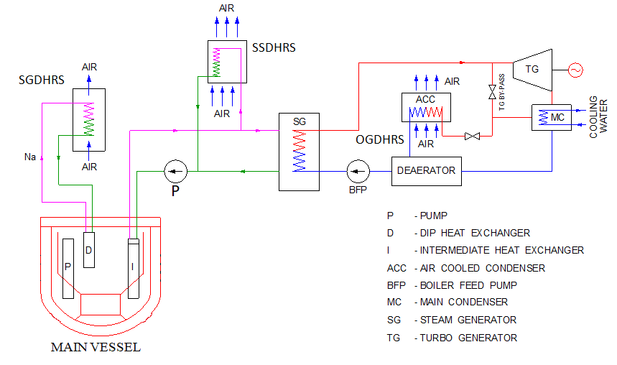

FIG. 1. Decay heat removal systems for FBR 1&2

## LITERATURE REVIEW

LMFBRs utilizing secondary sodium systems for decay heat removal requirements are studied based on the available literature, about the size of the reactor, details of decay heat removal path & type of flow (natural or forced), and consolidated based on literature review.

### BN 800

BN800 is a pool-type reactor with an 800MW electrical power rating. In BN800 SFR, Decay Heat Removal (DHR) system, which can operate in both active and passive mode, is being used to remove the residual heat through Air Heat Exchanger (AHX) connected to every loop of the Secondary Sodium System (SSS) [1, 2]. The process path is shown in figure 2.

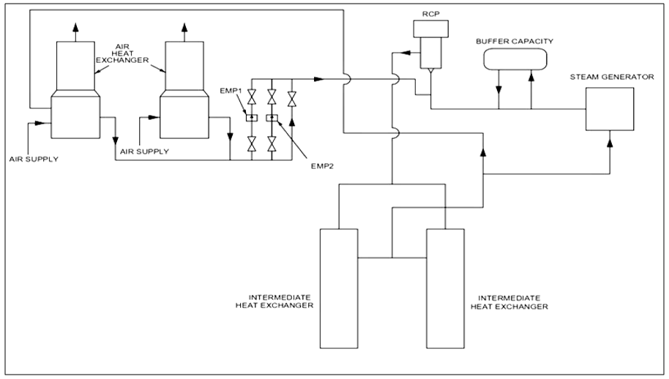

FIG. 2. Emergency reactor cooling system used in secondary sodium system of BN 800 (Adopted from [1])

### Superphenix

In super Phenix, SSS is designed to take part in the residual decay heat removal [3] (known as BPR) by both passive and active means, and a sodium air exchanger is placed for this purpose [3]. The heat removal capacity is 4 x 12.5 MWt = 50 MWt by forced circulation and 4 x 5.4 MWt = 21.6 MWt (i.e, 43% of forced circulation rating) by natural circulation for 550˚C average temp of reactor block. The process path is shown in figure 3.

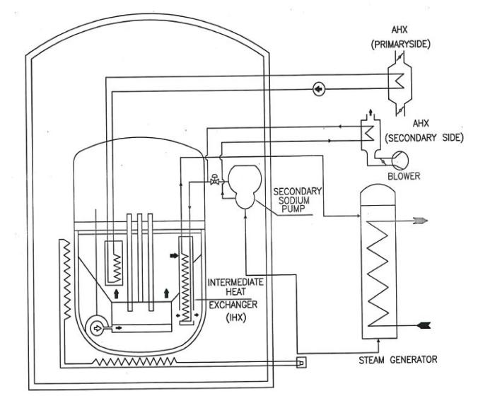

FIG. 3. Process flow chart of Decay heat removal circuit used in SSS of Super Phenix (adopted from [3])

Experiences:

1. During the trial, the AHX performance is lower than expected on the secondary side.
2. Due to excitation of the blade at the natural frequency, blade breaks occur on a BPR fan.
3. To avoid the chance of sodium freezing at the AHX tube outlet, an anti-freezing system is used.

### Monju

It is a loop-type reactor with a capacity of 280 MWe. It has three loops. This reactor has a DHR system in the SSS [4]. The process path is shown in figure 4. The heat from the main loop to the DHR system was transferred via heat transfer coils placed within the IHX shells. Though the secondary coolant of the DHR system in SSS was driven by EMPs, elevation in piping and equipment are so chosen that it will enforce natural circulation. The thermal center difference of nearly 9 m between core and IHX and nearly 25 m between IHX and air cooler was provided to ensure adequate flows.

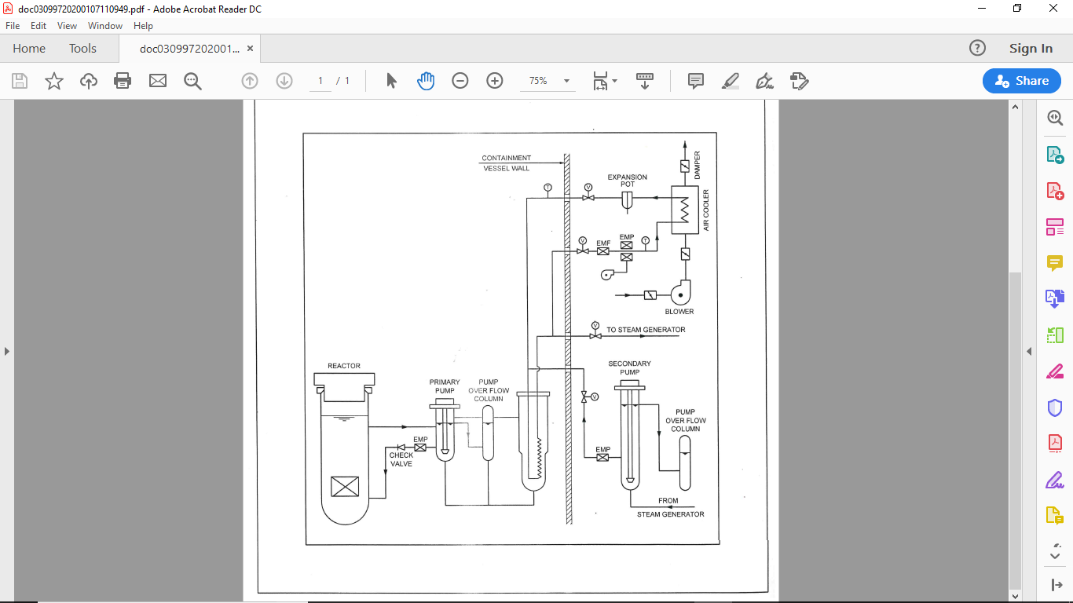

FIG. 4. The process flow path of secondary sodium cooling system in MONJU (adopted from [4])

## Decay HEAT removal capacity

In PFBR, SGDHR is designed to remove 24 MWth, with 3 out of 4 AHX available (i.e., n-1 criteria). This heat removal capacity is ~1.92% of the total thermal power of 1250 MWth of the reactor. For FBR 1&2, in addition to SGDHR (with n-1 criteria) and OGDHR systems, an additional DHR system called SSDHRS is also planned. While deciding the heat removal capacity of SSDHRS for FBR 1&2 (2×600MWe), a proportional value is considered. Considering the 1500 MWth rated capacity of FBR 1&2, the minimum decay heat removal capacity required is ~28.8 MWth. Being an additional system, SSDHRS is designed for removing 15 MWth in each secondary sodium loop with both the loops available.

## SSDHRS SYSTEM DESCRIPTION

SSDHRS loops are integrated into the Secondary Sodium Main Circuit (SSMC). Each SSMC is provided with one SSDHR circuit, as shown in (Figure 5). This is an active system with forced circulation on both sodium and airside. There also exists a provision to remove heat with a reduced capacity using natural circulation. Each SSMC consists of Intermediate Heat Exchangers (IHX), Surge Tank (ST), Steam Generators (SGs), and Secondary Sodium Pump (SSP). Each SSDHR system is provided with one AHX of rated capacity. The inlet to the AHXs is taken from the ST located in the hot leg of SSMC. The discharge line of the AHX is joined to the inlet header of SSP. On the airside, bird screen, louver, inlet damper, blower, expansion bellow at the exit of AHX, outlet damper, stack, and hood are provided in each loop similar to SGDHR system.

* 1. **Air heat exchanger (AHX)**

It is a cross-flow type shell and tube Heat Exchanger (HX) with finned tubes for airflow on the shell side. The HX has inlet and outlet headers. The inlet and outlet header are connected by a serpentine finned tube bundle having three-row arranged in four banks with three U bends. The Schematic of AHX is shown in figure 6. The AHX is placed inside the Steam Generators Building (SGB) at 52 m elevation, just below ST, to facilitate gravity flow to AHX. Ambient air is induced through the AHX tube bank by a blower. The AHX casing is designed as leak-tight to avoid hot air entry into SGB.

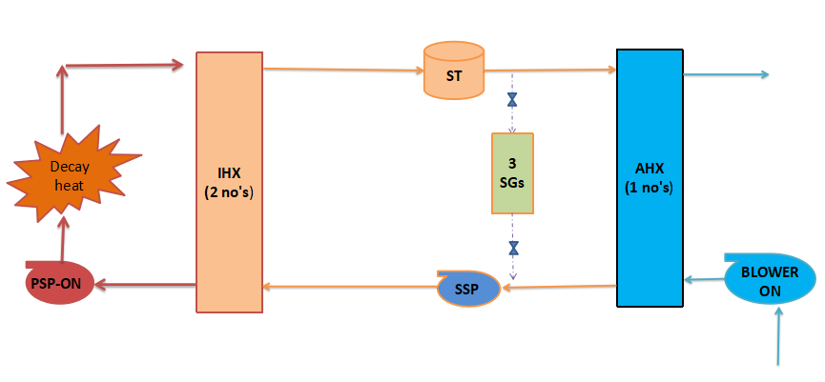

To atmosphere

FIG. 5. Schematic of secondary sodium-based decay heat removal system



FIG. 6. Sectional view of air heat exchanger

* 1. **Blower**

The blower is used to supply air from the atmosphere to AHX and exhaust back to the atmosphere. One blower of total capacity is recommended for the SSDHR system. To increase the availability, the blower is also provided with a diesel power supply. The blower is placed on the inlet side of the AHX at 45 m elevation. After heat exchange in AHX, the hot air is exhaust to the atmosphere through the stack.

## Requirements, advantages & drawbacks of SSDHR system

The major considerations for the requirements of SSDHR system are discussed below.

1. In the SSDHR system, the airside flow is maintained by the blower to take care of severe cyclonic conditions.
2. The SSDHR system is provided with diesel generator power supply, and it is independent of the steam-water system. Hence, it can cater to fuel handling and other maintenance conditions instead of the OGDHR system, which requires an off-site power supply, recirculation pumps, condenser cooling fans, steam generators, etc.
3. SSDHR system can be seismically qualified compared with the OGDHR system, which depends on the steam water system located away from the nuclear island and not qualified for SSE events. Hence the reliability of the SSDHR system improves the reliability of the overall DHR system significantly.
4. Eliminates loss of complete DHR systems when there is a common cause failure leading to loss of all SGDHR circuits

The advantages and disadvantages of SSDHRS are discussed below.

Advantages:

1. This system could be brought into operation with minimal time delay.
2. This system's reliability is higher than OGDHRs due to its independence of off-site power supply and steam water system components.
3. The Air Heat Exchangers (AHX) for SSDHRS can be placed inside Steam Generator Building (SGB), below surge tank, which allows gravity flow of sodium from the surge tank to AHX and hence, there is no need for an extra tank for expansion of sodium as surge tank is a part of this system.
4. Since AHX is placed inside SGB, this system will be available during design extension conditions (i.e., severe cyclone) with air blower.
5. This system can be designed for a specified capacity of heat transfer through natural circulation.

Drawbacks:

1. More floor space in SGB is required to accommodate AHX, blower, etc.
2. To increase the availability of SSDHRS, secondary sodium systems may be designed for a higher safety class, or diesel generator power supply to SSP, blower, etc., needs to be provided.

## Process design for forced circulation flow

The SSDHRS process path consists of 2 IHXs, surge tank, AHX, SSP, associated piping and one blower on air side. The process design of AHX, associated piping is carried out with design data of IHXs (designed based on heat removal capacity of SSMC). The SSDHRS process design is carried out by considering the 20% of nominal flow on primary sodium pump (PSP), Secondary sodium pump (SSP) with a reduced flow and blower on air side. The process design is carried out using the visual basic code.

To design the AHX all the four inlet and outlet temperature are estimated. The air side inlet temperature (TAi) is taken as atmospheric and outlet temperature (TAo) is limited to 287 °C similar to SGDHR in PFBR. The blower capacity required for air side is estimated from using equation-1.

$$Q=m_{a}C_{pa}\left({TA}_{o}-{TA}_{i}\right) (1)$$

To estimate the sodium inlet and outlet temperatures to AHX, primary side sodium temperature to inlet (TPi) and outlet (TPo) to IHX are estimated. The hot pool temperature of 544 °C is taken as inlet to both the IHX and the flow on the primary side (mp) is assumed to be maintained as 20 % of nominal of each PSP. The outlet temperature from IHX on primary side is 531.5 °C as estimated using equation-2.

$$Q=m_{p}C_{pn}\left({TP}_{i}-{TP}_{o}\right) (2)$$

The secondary inlet temperature to IHX (TSi), secondary outlet temperature from IHX (TSo), no of tubes required for AHX (n) are estimated using equation 3-5 by assuming a secondary side flow (ms). The similar design of AHX is being used in PFBR. Hence other dimensions except number of tubes of AHX are taken as constant. $$Q=m_{s}C_{pn}\left({TS}_{o}-{TS}_{i}\right) (3)$$

$$Q={(UAθ_{LMTD }) }_{IHX } \left(4\right)$$

$$Q={(UAθ_{LMTD }) }_{AHX } \left(5\right)$$

As the other parameter is constant the heat transfer through AHX is dependent on Area of heat exchanger and velocity inside the tube. The tube diameter and length are adopted similar to PFBR. nceHenHENHEHE Hence the heat transfer is dependent on no of tube on AHX and velocity inside the tube. To arrive at the optimal number of tube and mass flow rate, following studies are carried out. The graph (shown in figure 7) is plotted between velocity in AHX, percentage flow of secondary sodium pump and number of tubes. It is seen that as the secondary sodium flow is increasing, the number of tubes are decreasing, the rate of decrease are very high up to 10 % and tube velocity are increasing linearly. The ideal flow percentage is around 6 % of secondary sodium full flow. However to limit the sodium velocity below 2 m/s the secondary sodium flow rate is kept as 4 % of nominal flow rate. For the 4 % flow, the secondary inlet temperature to IHX, secondary outlet temperature from IHX, no of tubes required for AHX (n) are 454 °C, 544 °C and 129 tubes respectively.

Studies are also carried out to find the air velocity in shell side of AHX with respect to air flow rate and respective air outlet temperature. The results are plotted in figure 8. Figure 8 also depicts the number of tubes required to meet given heat removal rate with respect to air flow rate in shell side of AHX. From the study the optimal numbers of tubes are found to be 120. The chosen numbers of tubes (129 tubes) are very close optimal value. The respective chosen air flow rate is 52 m3/s and velocity in shell side is ~5 m/s which is to be considered for FIV studies for tube bundle supporting requirement.

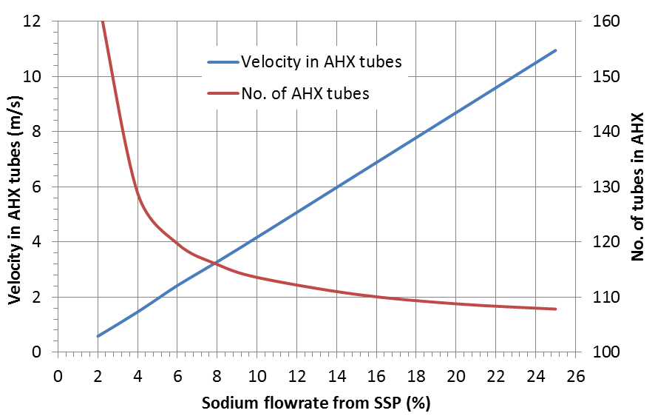

FIG. 7. Velocity inside AHX tubes and number of tubes with respect to % flow from secondary sodium pump

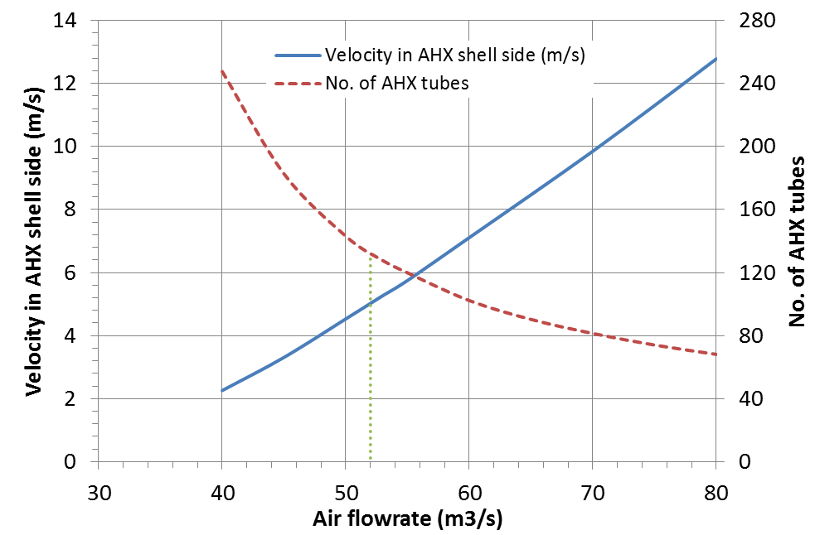

FIG.8 Air velocity in AHX shell side and no. of tubes required with respect to air flow rate from blower operation

**6.1 Sodium pump selection**

The flow rate required to meet the DHR requirement is 569 m3/h for FBR 1&2. The EM pumps are not capable to meet such flow rates. Hence secondary sodium pump with the reduced flow is used in the SSDHRS for FBR 1&2.

Typical pump system characteristic curve for SSDHRS and SSMC is shown in figure 9 below. The head generated by SSP for 4 % flow of rated capacity is not adequate for SSDHRS circuit.

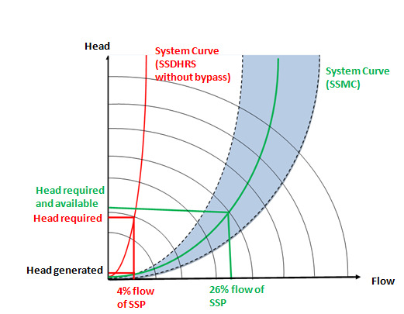

FIG. 9. Typical pump system characteristic curve for SSDHRS and SSMC

Hence, a bypass line is provided from SSP outlet to SSP inlet line (or AHX outlet line) with a control valve. The total pressure drop of SSDHR line together with bypass ­line is matched with the pressure drop of SSMC system curve to enable the SSP to operate near to the best efficiency point.

After implementing the by-pass line, the flow through the SSP is estimated as 26 % of rated capacity (863 kg/sec), of which 4% flow is sent through AHX of SSDHRS and remaining flow is bypassed through bypass line.

## Process design for natural circulation flow

The SSDHRS is primarily designed for forced circulation, but provision is also made to cater for natural circulation without aiding active components such as pumps and blowers. The process path is shown in figure 9. The provision includes elevation in piping and equipment is so chosen to enforce natural circulation. Also thermal centre difference of nearly 33 m between IHX and AHX and 30 m tall chimney for air side were provided to ensure adequate flows.

The process design calculation is carried out using an in house developed code. The flow chart of the code for natural circulation is given in figure 11. In the primary side, it is assumed as forced circulation using primary pumps with constant 20 % flow (477 Kg/sec) of IHX rated capacity.

For natural circulation flow in both secondary sodium and air side, heat removal capacity for each SSDHR system is estimated with respect to reactor sodium temperature and plotted in figure 12. The heat removal capacity is compared with respect to forced convection flow which uses secondary sodium pump. For nominal reactor temperature of 550 °C, the heat removal capacity is 8.6 MWt for natural circulation flow which is 57% of the heat removal capacity during forced circulation flow. The evolution of secondary sodium flow rate and air flow rate with natural circulation flow for various reactor sodium temperatures are predicted and plotted in figure 13.

For Design Extension Conditions (DEC), the minimum heat removal capacity to meet the design safety limits (DSL) is below 1% of reactor power. For FBR 1&2 it works to be 15 MWt. As the heat removal capacity with natural circulation is 8.6 MWt for one loop, considering both the loops, the total capacity of 17.2 MWt meets the design requirement.

The effect of chimney height on heat removal capacity during the natural circulation flow in air side of AHX is studied for the nominal sodium temperature of 550 °C and plotted in figure 14. Chimney height of 30 m is considered to be optimum for natural circulation flow in air exit of AHX and the same is proposed for FBR 1&2.

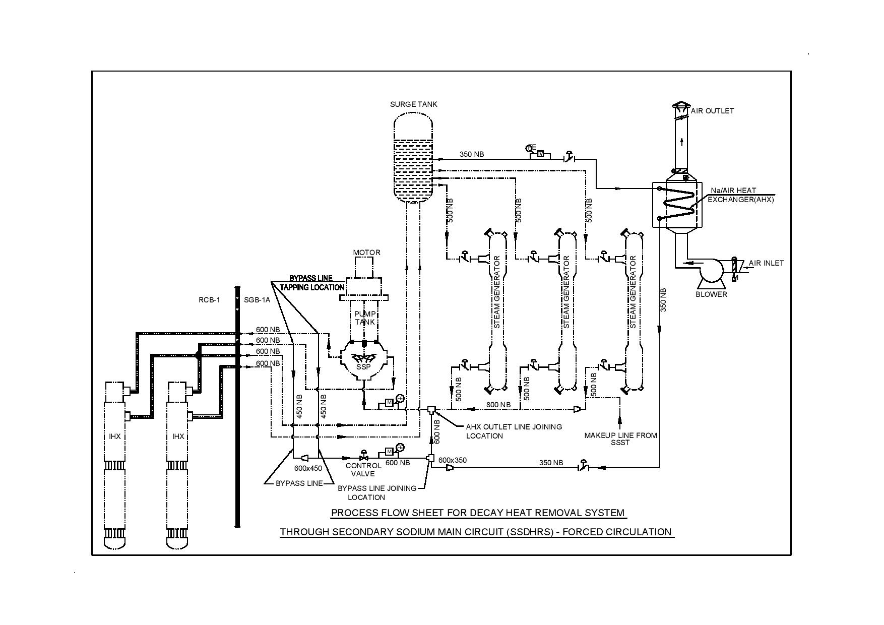

FIG.10. Schematic of secondary sodium based decay heat removal system (forced circulation)

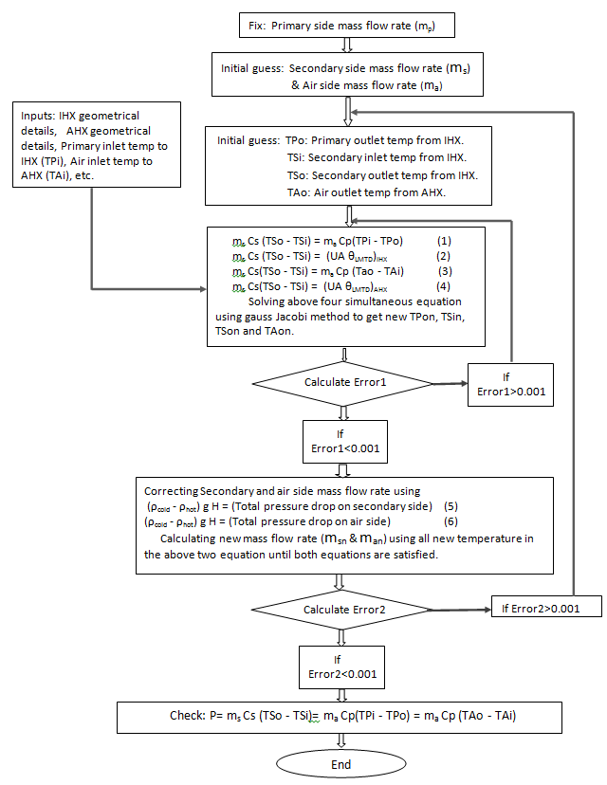

FIG.11. Flowchart for process design calculations for natural circulation flow in SSDHR system

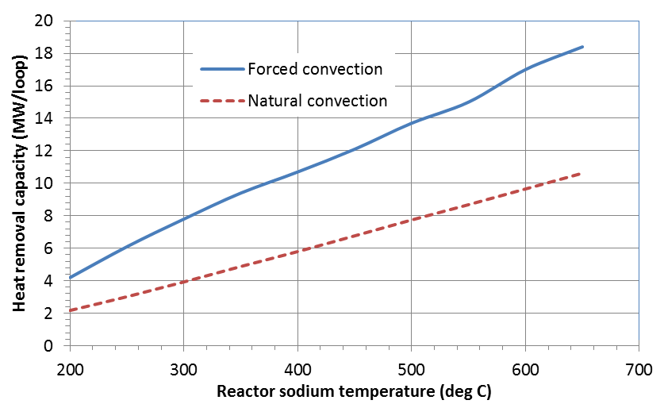

FIG. 12. Heat removal capacity between forced and natural convection

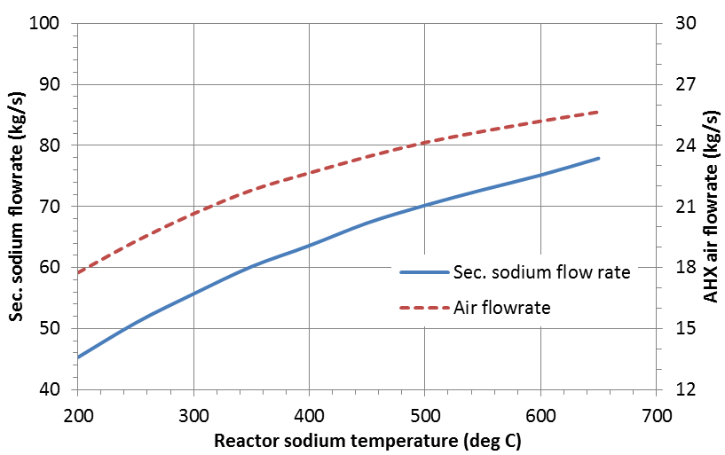

FIG. 13. Evolution of secondary sodium and air flow rate during natural convection

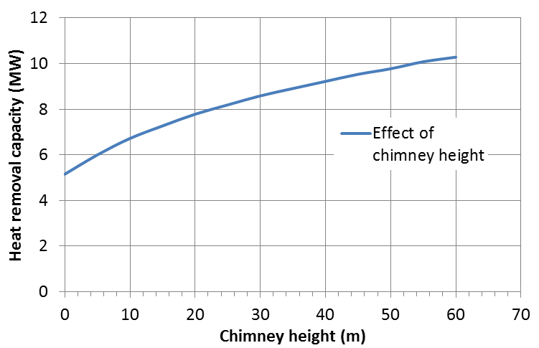

FIG.14. Effect of chimney height on heat removal capacity by natural circulation

## COnclusion

Process design of SSDHRS is carried out for both forced circulation and natural circulation modes of flow through both secondary sodium and air side. For forced circulation mode, the heat removal capacity arrived is 15MWth per secondary sodium loop (SSP). For forced circulation flow, secondary sodium main pump is used for secondary sodium flow and a blower is used for air side flow. One AHX of 15MWt rating is considered in these studies.

Studies are carried out for natural circulation capacity considering, SSP and blower in OFF condition. The heat removal capacity is estimated as 8.6 MWth per SSDHR loop which is about 57% of capacity achieved during forced circulation flow. With two secondary sodium loops available, SSDHR system alone would also satisfy the DHR requirements as a diverse DHR system. The process path, piping layout and component locations are finalized considering the proposed FBR 1&2 (2×600MWe) layout.

References

1. Y. M. ASHURKO, A presentation on Sodium cooled Fast Reactors: Current status and proposal for the second workshop, 5th GIF/INPRO interface meeting, IAEA HQs, Austria, (2011).
2. Joint stock Company St. Petersburg Research and Design institute, BN-800 NPP, (2011).
3. Joel Guidez, Gerard Prele, Superphenix Technical and Scientific Achievements, (2017).
4. Nuclear Engineering International, (June 1975).