DESIGN AND DEVELOPMENT STUDIES FOR
FUTURE FBRs

- RAGHUPATHY¹, SRIRAMACHANDRA AITHAL¹, K.DEVAN¹, L. SURESH¹, V. VINOD¹,
U. PARTHASARATHY¹, K.NATESAN¹, B.VENKATRAMAN¹

¹Indira Gandhi Center for Atomic Research, Kalpakkam, India.

Email contact of corresponding author: rags@igcar.gov.in

Abstract

India has a well conceived nuclear power programme. Fast Breeder Reactors are expected to provide the much needed energy security to the country through efficient uranium utilization and through the effective utilization of the vast thorium resources available within the country. The 40MWt/12MWe Fast Breeder Test Reactor is in operation since 1985 and the 500 MWe Prototype Fast Breeder Reactor is in advanced stage of commissioning at Kalpakkam. Beyond PFBR, it is proposed to construct six more oxide fuelled fast breeder reactors and metal fuelled reactors thereafter. This paper highlights the recent design and development studies carried out for future FBRs. For future FBRs, it is proposed to provide hydraulic suspended absorber rods (HSAR) to take care of the untripped loss of flow event. The HSAR can act as both active and passive device. It is provided with a drive mechanism, which engages and lifts it out of the core during normal operation. The HSAR is disengaged after the flow is raised above 50%. On active SCRAM, the lower part of the mechanism falls pushing the rod into the core. During a loss of flow event, the rod is designed to drop into the core at flow less than 50%. Design of a 500 MWe core with three HSARs and sizing of reactor assembly has been carried out. Theoretical and experimental studies carried out for HSAR are described in this paper. For the decay heat removal system, both safety grade decay heat removal through dedicated heat exchangers dipped in the hot pool as well heat removal through the secondary sodium main circuit through separate air heat exchangers are described. The heat removal capacity of the secondary sodium based decay heat removal system for both active and passive modes of heat removal has been worked out and the same is also covered in the paper.

INTRODUCTION
Beyond PFBR, it is planned to construct six more MOX fuelled sodium-cooled fast breeder reactors with improved safety and economy. These reactors will be designed to meet the revised AERB safety criteria, which are under finalisation. The first twin unit of these six reactors (FBR 1&2) will be located at Kalpakkam, while the site for the remaining four is yet to be finalised. The design of FBR 1&2 incorporates the experiences learnt from the design, R&D, safety review, construction and commissioning of PFBR. Recent studies carried out for the design and development of FBR 1&2 include sizing of reactor assembly for a improved 500 MWe core reflecting incorporation of hydraulic suspended absorber rods, theoretical and experimental works on hydraulic suspended absorber rods, and improvements in the decay heat removal system. This paper outlines the details of the above mentioned studies carried out for future FBRs.

SIZING OF REACTOR ASSEMBLY FOR IMPROVED 500 MWe CORE
The physics design of a 500 MWe core was carried out taking PFBR core as reference design. Several core configurations were studied to suitably incorporate the additional safety provision of Hydraulically Suspended Absorber Rods (HSAR) of 76% enriched B₄C. PFBR core includes nine control & safety rods and three Diverse safety rods. These form the two independent and diverse shutdown systems. In FBR 1&2, three hydraulic suspended absorber rods (HSAR) are additionally provided. Fig. 1 shows the proposed core configuration with incorporation of HSAR.
A Stroke Limiting Device (SLD) is provided in the Control & Safety Rod Drive Mechanism, which acts as a mechanical stopper and restricts the withdrawal distance of control rod at a given time. This helps to restrict the reactivity addition to minimum thereby avoiding uncontrolled withdrawal of control rod thereby avoiding untripped transient over power accident. Similarly, provision of HSAR serves to avoid untripped loss of flow accident (ULOFA). Thus both UTOPA & ULOFA are avoided, the two major reasons for Anticipated Transient Without Scram (ATWS) type of events and the key initiators of core disruptive accident. The beginning of life core has a sodium void coefficient of 2.3$. The breeding ratio for the BOL core is 1.14 and about 1.07 for the equilibrium core. Three rows of reflector subassemblies are provided to facilitate provision for increasing radial blanket in the future for achieving higher breeding.
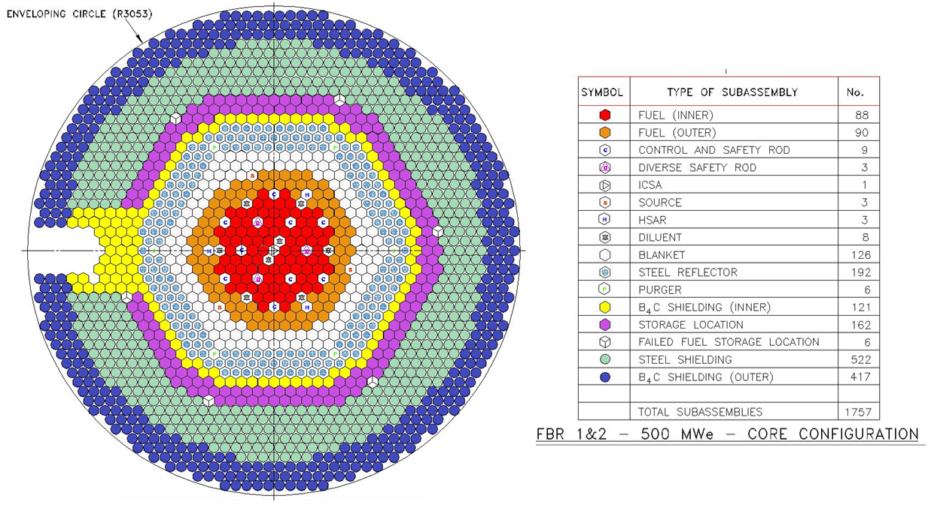
Fig 1: Core Configuration for Optimised 500 MWe FBR 1&2
For the recommended core configuration, layout of components supported over control plug (CP) was finalized first considering various engineering and physics constraints. This includes 9 CSRDMs, 3 DSRDMs, 3 HSARDMs, 3 FFLMs, 219 thermocouples in six groups, 6 neutron detectors & one Central Canal Plug / SNDHM. The skirt shell diameter of control plug is 2320 mm and the flange diameter of control plug is 2620 mm. The typical layout of items in control plug is shown in Fig. 2.
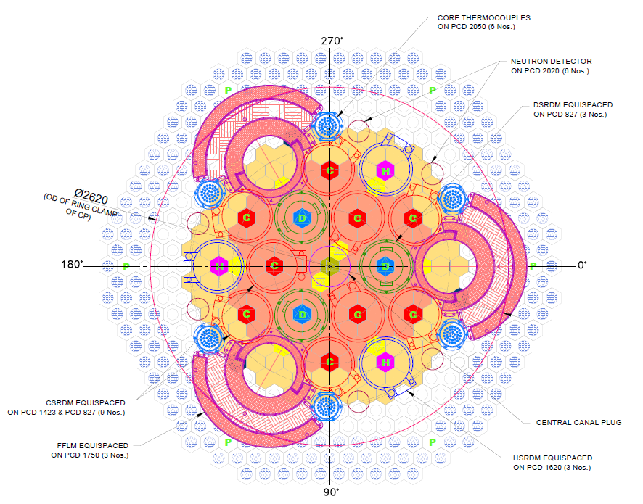
Fig 2: Layout of Components in Control Plug
An eccentricity of 685 mm is provided between the centrelines of the small and the large rotatable plug. Considering offset arm handling machine same as in PFBR, the SRP and LRP diameters were worked out to be 4990 mm & 7420 mm respectively. These are slightly larger than that of PFBR. One of the feedback from PFBR is requirement of increasing the gaps between control plug - SRP and SRP – LRP for installation of complementary shield blocks as well as for carrying out de-coupling / coupling of rotatable plugs with top & middle ring for replacement of seals and maintenance of bearing. Hence, various gaps like CP-SRP, SRP-LRP, LRP-IHX and IHX-RS support shell are increased by 50 - 105 mm so that sufficient free space will be available for carrying out maintenance activities. Further, based on the layout of pump and intermediate heat exchangers, the mean PCD of major equipment location is worked out to be 13450 mm whereas the main vessel diameter is worked out to be 13800 mm based on top shield level layout considerations. Similarly, the height of the reactor assembly was worked out as 15200 mm as compared to 15000 mm in PFBR. The cross section details of reactor assembly finalised is shown in Fig. 3.
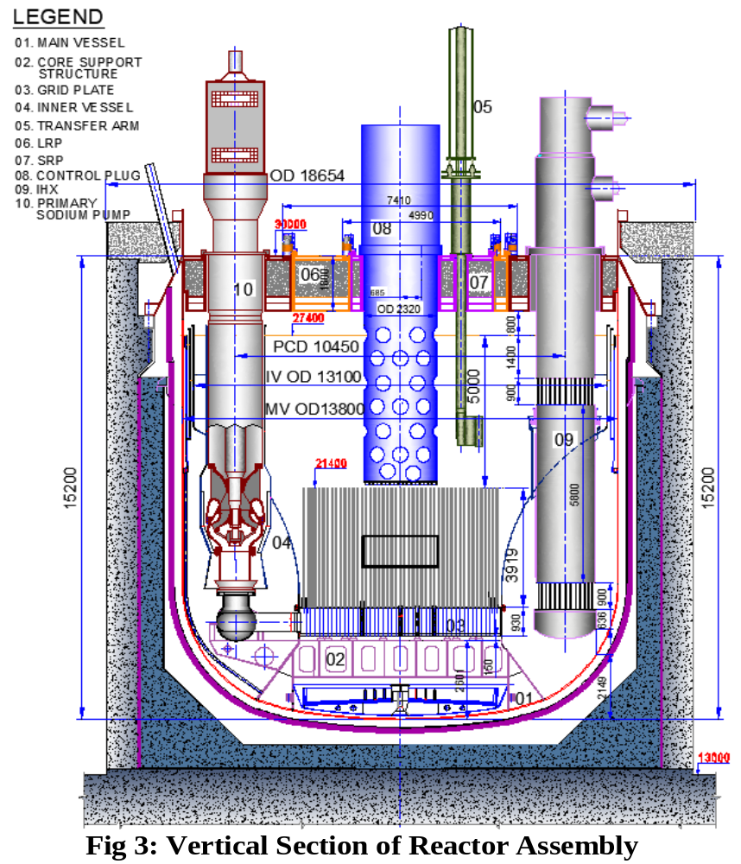
Fig 3: Sizing of Reactor Assembly for 500 MWe FBR 1&2

DESIGN AND DEVELOPMENT OF HYDRAULIC SUSPENDED ABSORBER RODS
The Hydraulically Suspended Absorber Rod (HSAR) is a passive shutdown device provided in the core. In the event of failure of reactor protection system to scram the reactor following a loss of flow event, the HSAR automatically falls under gravity into the reactor core and shuts down the reactor.
The HSAR is suspended in its normal operating position with hydraulic force developed by flowing sodium (Fig. 4). In case of a loss of flow event, the hydraulic force reduces significantly, resulting in automatic drop of the absorber rod. The HSAR is raised to the operating position with the help of its drive mechanism. This mechanism also forces HSAR into active core during normal SCRAM. Thus HSAR also contributes to negative reactivity insertion for every scram. The HSAR consists of B4C pellets enriched with B10. The HSAR is housed within its hexagonal sheath like any other core assembly. HSAR is designed to shutdown the reactor in case of unprotected pump trip event. Bulk sodium boiling for unprotected pump trip event starts at 24s. HSAR will start descending after flow reduces to less than 50%, i.e., after 8s. Estimated drop time of HSAR is ~2s. The time range in which HSAR will operate is 8-12 s, which is well within the limit for sodium boiling. Fig.5 depicts the scenario.
Fig. 4 Hydraulic Suspended Absorber Rod
The following are the design criteria for the design of HSAR : (i) At flow greater than 50% of nominal value the hydraulic force developed shall be sufficient to suspend the HSAR in its normal operating position. (ii) The HSAR shall not lift from its bottom position even at 110% nominal flow. (iii) Minimum flow through HSAR Sub Assembly (HSAR SA) shall be greater than 3 Kg/s in order to effectively remove the heat generated in the HSAR in case of accidental fall of one HSAR during full power operation. The HSAR is suspended in its normal operating position mainly by form drag and the contribution from friction drag is intentionally kept minimum. This is achieved by the pressure drop at the top region of HSAR subassembly when the head of HSAR is butted against the seat in HSAR SA. This is to make hydraulic suspending force less dependent on flow and in-turn to reduce the drop time. The following are some of the important design parameters arrived at by iterative detailed design. The flow through HSAR subassembly is fixed at 3.9 Kg/s. When HSAR is at normal operating position and sodium flow is 50% of nominal value, a net downward force is available to drive down the HSAR to shutdown the reactor. When HSAR is deposited and sodium flow is 110% of nominal value the net downward force is such that HSAR will not eject from its bottom position.
Fig. 5 Expected HSAR Drop Zone

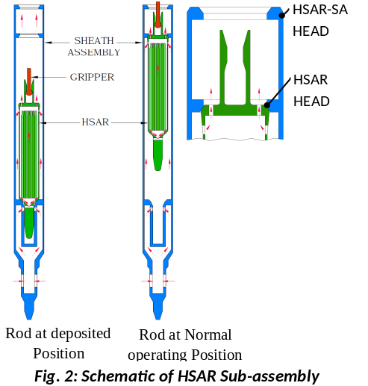
Fig. 4 Hydraulic Suspended Absorber Rod

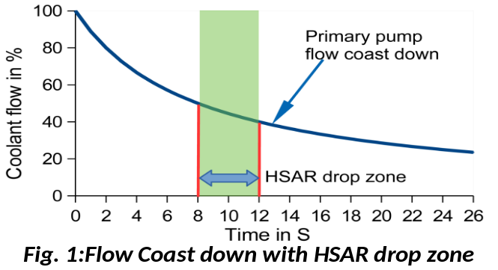
Fig. 5 Expected HSAR Drop Zone

3.1 Experimental Studies for HSAR

A detailed experimental programme has been drawn up to validate the design of HSAR. This includes studies at component level as well as full scale level. The top head of HSAR plays a key role in keeping the rod suspended. Fig. 6 shows the top region of the HSAR. First the pressure drop across the orifices provided in the top head was validated. Further, a full scale top head was experimentally verified for drop vs flow characteristics. It was observed that the performance was repeatable and drop occurred at ~ 51% of the flow. A full scale HSAR subassembly was manufactured and qualified by hydraulic tests. Further, tests in sodium are planned.

- DESIGN OF DECCAY HEAT REMOVAL SYSTEM

Detailed design studies of decay heat removal options have been carried out the twin unit of 1500 MW(th)/600MW(e) future FBR. Hence, the studies presented here apply to this reactor and need to be repeated for the twin unit of 1200 MW(th)/500 MW(e) reactor, which is planned further.
4.1 Process Design and Thermal Hydraulic Assessment of Secondary Sodium System based Decay Heat Removal System
In order to improve reliability of Decay Heat Removal (DHR) system compared to PFBR, it is planned to have an additional DHR system riding on secondary sodium circuits (SSDHRS) which reduces the number of demands on SGDHRS. This also eliminates loss of complete DHR systems when there is a common cause failure leading to loss of all SGDHR circuits. Conceptual and process design for SSDHRS was carried for both active and passive mode of decay heat removal. A preliminary layout of SSDHRS was made, followed by design of AHX (Air Heat Exchanger) with detailed sizing, estimation of blower capacity on air side, determination of sodium pipe sizes in hot & cold legs of SSDHRS and temperatures at all critical points in the circuit
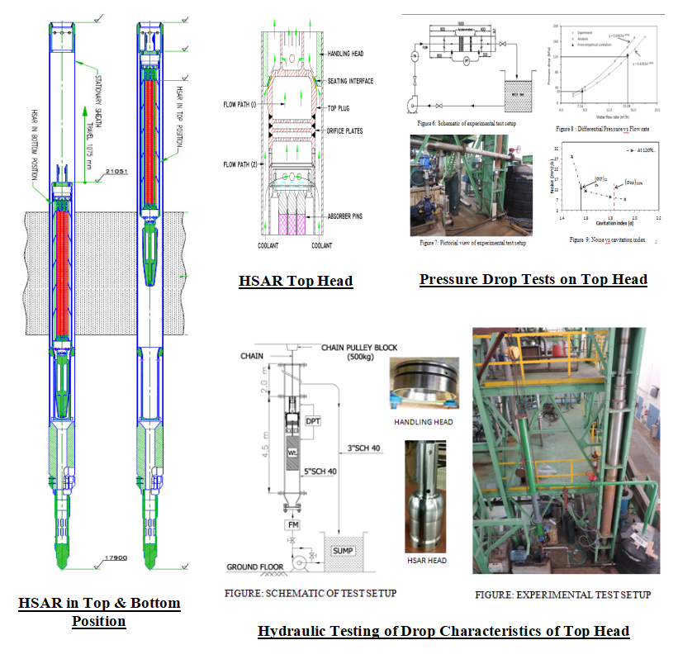
Fig. 6 Experimental Tests on Hydraulic Suspended Absorber Rod
.Each secondary sodium main circuit (SSMC) consists of Intermediate Heat Exchangers (IHX), Surge Tank (ST), Steam Generators (SGs) and Secondary Sodium Pump (SSP). Each SSDHR is provided with one AHX of 15MW capacity. The inlet to the AHXs is taken from the surge tank located in hot leg of SSMC. The discharge line of the AHX is joined to the inlet header of secondary sodium pump. During normal operation of SSDHRs, primary and secondary sodium pumps run at 20% and 26 % of rated flow respectively and all steam generators are isolated. Forced circulation configuration was designed for a heat removal capacity of 15 MW per secondary sodium loop. For same layout, decay heat removal capacity with natural circulation was worked out as 8.6 MW per SSDHRS loop.
Analysis of the heat removal performance of the reference layout of SSDHRS has been carried out using the general purpose system dynamics code FLOWNEX. Suitable numerical models have been developed for various components of the SSDHRS, viz., IHX, AHX, stack, secondary Sodium Pump, blower and piping. IHX and AHX are modeled using conjugate heat transfer element and user defined compound components respectively. Basic centrifugal pump models have been adopted for simulating the secondary sodium pump and blower in the circuit. Stack and secondary sodium pipes are modeled using pipe elements.
Steady state analysis is carried out by considering forced circulation of primary sodium, secondary sodium and air. The heat removal capacity under this condition is estimated to be 15.1 MW at 544 °C temperature of hot pool sodium. Parametric studies by varying the sodium temperature of hot pool in the range of 200 °C - 650 °C have been carried out and the predicted heat removal capacity and terminal temperatures of AHX are shown in Figs. 7 and 8 respectively. Further studies have been carried out to estimate the heat removal capacity of SSDHRS under natural convection conditions. The maximum heat removal capacity for a hot pool sodium temperature of 650 °C with natural convection in secondary sodium and air circuits is 9.7 MW. When primary sodium system is also in natural convection, the same get reduced to 8.65 MW. Parametric studies carried out for this condition include the estimation of natural convection heat removal capacity of the system for various values of hot pool sodium temperature. Thus, the effectiveness of the SSDHRS for decay heat removal both under natural as well as forced convection conditions is established through one dimensional analysis.
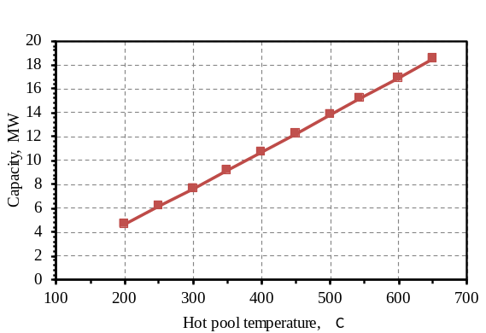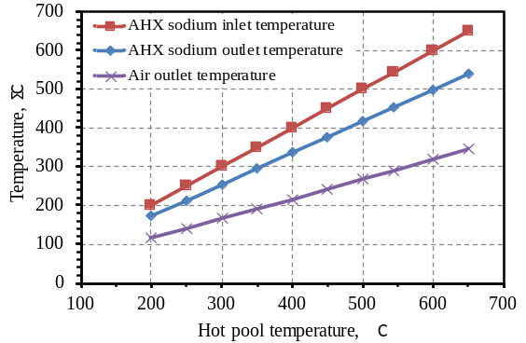
Fig. 7 Heat removal capacity of SSDHRS at various hot pool temperature
Fig. 8 AHX terminal temperatures at various hot pool temperature

4.2 Safety Grade Decay Heat Removal System (SGHDRS)

The Safety Grade Decay Heat Removal System (SGDHRS) consists of four circuits each having 10 MWth capacity working in passive mode. Thermal sizing of various components of SGDHRS and layout have been carried out. The important parameters arrived at are (i) Number of DHX tubes (108), (ii) DHX tube diameter (OD 24 mm), (iii) DHX Heat transfer length (4.075 m), (iv) Number of tubes in AHX (151), (v) AHX tube diameter (OD 38.1 mm), (vi) Heat transfer length of AHX tube (10.8 m), (vii) intermediate circuit pipe size (250 NB, 40 Sch.) and (viii) Thermal center difference between DHX and AHX (50 m). With this design, the SGDHRS capacity is estimated as 10 MWth/circuit when the hot pool is at 547 °C. Fig 9 shows the SGDHRS circuit capacity for various hot pool temperatures in the range of 300 °C -650 °C. The computer code DHDYN-V2.0 is used for SGDHRS studies. Category II enveloping events viz., off-site power failure (OSPF) and loss of steam water system (LOSWS) have been analyzed. Fig 10 shows the evolution of hot pool temperature following these two events. It can be seen that the maximum hot pool temperature is 575 °C (Cat II Limit 600 °C).

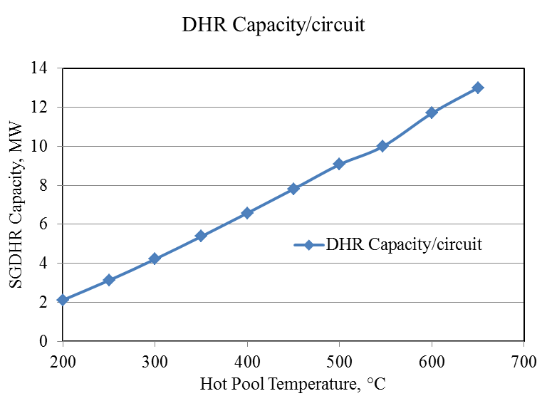  Fig. 9 Heat loss through SGDHRS at various hot pool temperatures. | 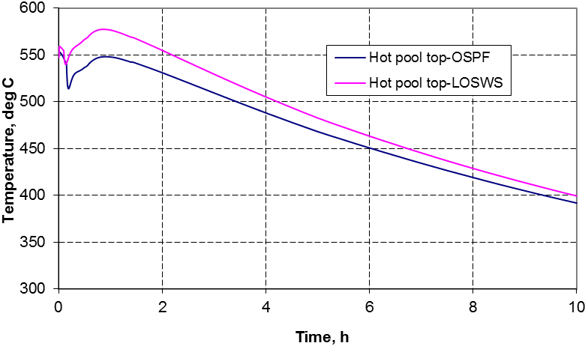  Fig. 10 Evolution of hot pool temperature predicted by DHDYN-V2.0.
5. CONCLUSION
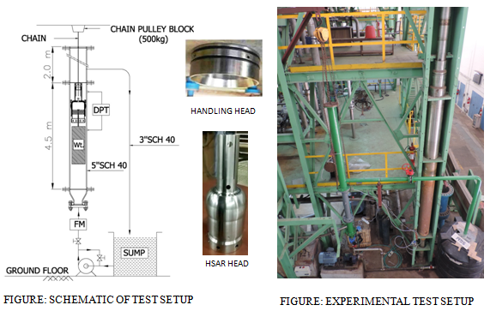
Hydraulic Testing of Drop Characteristics of Top Head

Beyond PFBR, it is proposed to construct six more oxide fuelled reactors, two at Kalpakkam and the rest at a site to be decided. A new 500 MWe core with provision of hydraulically suspended absorber rod has been worked out. The corresponding reactor assembly size for this core has also been arrived at. Considerable progress has been made with the design and development of hydraulic suspended absorber rods. The performance of the top head design of the HSAR has been experimentally verified for its drop characteristics with variation in flow. A full scale HSAR has also been hydraulically tested. Detailing of additional option of decay heat removal through the secondary sodium main circuit utilising an air heat exchanger has also been studied for both forced and natural convection modes of heat removal. This study has been done for the 1500MWth/600MWe design and is planned to be repeated for the 1200MWt/500 MWe design. The effectiveness of decay heat removal through secondary sodium route has been verified.

