Pilot Demonstrational Fast Reactor with Lead Coolant BREST-OD-300

E.O. ADAMOV, V.V. ORLOV, A.V. KAPLIENKO, V.V. LEMEKHOV, A.V. MOISEEV,
V.S. SMIRNOV, O.A. YARMOLENKO, M.K. SARKULOV, A.A. BAZHANOV, M.E. CHEKOV, R.R. SALIKHOV, A.V. PROUKHIN, O.P. ARKHIPOV, V.P. VASYUKHNO, A.A. PULINETS,
D.A. AFREMOV, E.A. SHIVERSKIY

JSC NIKIET, Moscow, Russian Federation

Email contact of corresponding author: lemekhov@nikiet.ru

Abstract

To overcome contradictions between safety requirements and economic efficiency when designing a new-generation fast reactor, a new approach to selecting fundamental engineering solutions was proposed. It involves successive implementation of the inherent (or intrinsic) safety principle achieved not by building up expensive engineering barriers or complex safety systems, and not by increasing requirements for personnel qualification, but mainly due to natural laws, physical and chemical fuel and coolant properties and the design solutions that contribute to realization of these properties to the fullest extent possible.
BREST-OD-300 innovative lead-cooled fast reactor is developed as a pilot demonstration prototype for base-type commercial reactor facilities of the future nuclear power industry with the closed nuclear fuel cycle. To date, experimental justification of components, elements and equipment of reactor facilities has been carried out using small- and medium-scale mock-ups and pilot models. Verified and certified software tools were used for computational design justification. The safety analysis showed that the probability of severe accidents with conservative scenarios due to internal causes was no more than 6,48∙10⁻⁹ 1/year. In such accidents, there is no loss of reactor core integrity with fuel and cladding meltdown, coolant boiling, and the radioactive release does not exceed the daily reference value. In severe accidents at the unit, with a probability of 3.2∙10⁻⁸ 1/year, there is no need for population evacuation and resettlement.
The developed design documentation makes it possible to proceed to the construction of the BREST-OD-300 power unit as part of a pilot and demonstration energy complex (PDEC) with concurrent completion of activities aimed at bringing safety justification documentation to conformity with current common and developed specific standards for lead-cooled reactor facilities. At the PDEC site, pilot operation of the BREST-OD-300 reactor will be carried out in the closed nuclear fuel cycle (NFC) conditions, endurance characteristics of the reactor facility and its equipment will be demonstrated, and an extensive R&D program, which is also required for commercial lead-cooled reactor facilities, will be carried out.

INTRODUCTION. INCEPTION OF THE BREST REACTOR CONCEPT
Based on the world experience in the creation and operation of nuclear power reactors, the first two co-authors of the paper in the mid-eighties of twentieth century formulated the main directions for the development of the concept of large-scale nuclear power industry based on NPPs with fast reactors and the closed NFC, which could take on the main increase in electricity production. The high cost of nuclear power plants is, first of all, a payment for safety, and these two conflicting requirements can be harmonized only by increasing safety, not by building up expensive engineering barriers, devices and systems, but mainly by implementing the physical features of a fast reactor, but as well as a favorable combination of natural regularities, properties and qualities inherent in fuel, coolant, structural materials and other components of the reactor, subject to their appropriate purposeful choice. Of course, at the same time, design solutions aimed at realizing these properties and regularities in full are also important. Such an approach to the problem required an awareness of the need to change the paradigm in the development of nuclear energy based on fast reactors: the transition from a fast breeder reactor with high power density and high breeding ratio to the paradigm of a naturally safe fast reactor with a moderate power density and a core breeding ratio ~1, operating at low reactivity margin, using the fuel of equilibrium composition with feeding by depleted uranium.
The Chernobyl accident and the analysis of its causes made the concept of nuclear power development based on inherent safety fast reactors even more relevant. At present, with the aggravation of environmental requirements, one should expect the inclusion of nuclear power in the number of generations that meet the requirements of the energy transition, only if severe accidents are excluded and the SNF problem is finally, and not postponed, resolved. All this corresponds to the concept developed back in the 90s of the last century, which currently underlies the Proryv project being implemented in the Russian Federation.
At the end of the eighties of the last century (1988), NIKIET and IAE began work on a project for a fast natural safety reactor with a lead coolant and mixed nitride uranium-plutonium fuel operating in a closed nuclear fuel cycle. The purpose of these works was to justify the possibility of developing large-scale nuclear power on the basis of nuclear power plants with fast reactors and a closed nuclear fuel cycle, which would meet the following requirements:
- Removal of restrictions on fuel resources due to efficient use of uranium raw materials during multiple recycling of nuclear fuel in the closed NFC;
- Exclusion of severe accidents at nuclear power plants with radiation consequences requiring evacuation and, especially, resettlement of the population;
- Technological enhancement of the nuclear non-proliferation regime;
- Closing the nuclear fuel cycle with the disposal of radioactive waste in a radiation-equivalent and onco-equivalent state in relation to the uranium raw material produced;
- Economic competitiveness with other energy sources.

DESIGN BASIS OF THE BREST REACTOR TECHNOLOGY
Preliminary studies carried out at the time by NIKIET with the participation of specialists from Kurchatov Institute, IPPE and other institutes provided sufficient grounds for choosing a specific reactor technology that meets these requirements – the BREST lead-cooled fast reactor with uranium-plutonium nitride fuel operating in the closed NFC, with an integral layout of the lead circuit equipment and a double-circuit heat removal arrangement.
Cooling of the core with a high-boiling-temperature (Tb > 1749 °C), radiation-resistant and little-activated lead coolant, inert when in contact with water and air, does not require high pressure in the circuit, excludes radiation loss-of-coolant accidents, fires, steam and hydrogen explosions. The integral layout of the primary circuit and the high freezing point of lead (~ 327 °C), which contributes to the healing of possible cracks in the metal-and-concrete vessel, virtually eliminate the risk of loss of coolant and the cooling of the core.
The use of a lead coolant with little neutron-moderating capacity opens up the possibility of expanding the lattice of fuel elements without deteriorating the physical characteristics of the core while increasing the flow area, which contributes to a decrease in the coolant velocity in the core, lowers hydraulic losses and pumping costs. The chemical inertness of the lead coolant in contact with the environment makes it possible to effect the reactor cooling through an intermediate heat exchanger located in the primary circuit, directly with atmospheric air. Such an ability to remove residual heat lifts the restrictions on the duration of passive cooling of the reactor.
When choosing the fuel, oxide, metallic and carbide fuels were considered along with nitride ones. When using oxide fuel, due to its low density, the achievement of BRC ~ 1, which makes it possible to operate with a low reactivity margin (Δρ<β_{eff}), is possible only at a relatively high thermal power (N> 3000 MW) and a large core size. The low thermal conductivity of the oxide results in a high operating temperature and small margin before fuel melting, low retention of gaseous and volatile fission products in the fuel matrix, and a large power effect of reactivity (Δρ>β_{eff}).
Disadvantages of metallic fuels include high swelling during burnup, which requires deep alloying and the formation of significant porosity, and the presence of phase transitions at relatively low temperatures near the operating temperature of lead. Phase transitions of metallic fuel and especially its interaction with steel cladding with the formation of low-melting point eutectic (510 ºС for Pu, 710 ºС for U and 750 ºС for U+15% Pu +10% Zr) determine small rupture margin in accidents with a temperature increase. Lead interacts with metallic fuel to form uranium and plutonium plumbates.
When compared with monocarbide fuel, the choice of mononitride fuel was driven by its small advantages in density, swelling, and retention of gaseous fission products, as well as the higher pyrophoricity of monocarbide, which creates problems in the fuel manufacturing and handling of irradiated fuel when the cladding fails.
The use of dense (γ_{theor} = 14.3 g/cm³), highly heat-conducting (λ≈20 W/(m⋅grad)) nitride fuel compatible with the lead coolant and the steel in the fuel element cladding makes it possible to operate at a relatively low average operating temperature of the fuel (T≤1000 °C), which results in a small thermal energy storage in the fuel, a small release of gaseous fission products from the fuel and, accordingly, their low pressure passed to the cladding, which contributes to the preservation of the fuel element integrity.
The combination of properties of the nitride fuel and the lead coolant with little neutron-moderating capacity makes it possible to achieve complete plutonium breeding and the reactivity margin in the core (BRC≥1). As a result, a fast reactor can operate in an equilibrium fuel mode, with just a slight reactivity margin variation over the lifetime and a fueling by waste (depleted) uranium only. The reactivity margin during reactor operation can be reduced to a value less than the effective delayed-neutron fraction (Δρ<β_{eff}). At the same time, accidents with an uncontrolled increase in power and temperature, even in the event of unauthorized insertion of the full reactivity margin, for example, as a result of self-movement and removal of all control and protection system (CPS) rods from the core, are excluded.
In the BREST reactor concept, uranium blankets traditional for fast reactors that possess the ability of breeding weapon-grade plutonium are replaced by lead reflector blocks. The exclusion of uranium blankets from the core design along with the use of regenerative processes in the closed NFC that do not allow fractionation of fuel elements with separation of plutonium from uranium create additional technological barriers to the proliferation of nuclear weapons. The fuel materials contain plutonium with the isotopic composition that is unattractive for weapons use. Non-proliferation is also facilitated by the high radioactivity of the irradiated fuel, which makes its unauthorized use quite difficult. The presence of transmutable actinides in the fuel and the absence of deep refining from fission products facilitate its protection against theft at all stages of the fuel cycle. To strengthen the non-proliferation regime and increase competitiveness, it is advisable to locate closed nuclear fuel cycle facilities directly at the sites with large multi-unit NPPs (as an on-site, regional fuel cycle), which allows to reduce the SNF holding time before reprocessing, thereby reducing the total volume of fissile materials in the NFC, and eliminates the cost of long-distance transportation of nuclear materials, reduces the risk of their theft and diversion for military purposes.
Environmentally safe fuel cycle closure in BREST is achieved by using specific technologies for fuel regeneration and refabrication, which consist in cleaning the irradiated fuel from fission products and adding depleted uranium to the cleaned-up fuel mixture when fabricating new fuel. As a result, minor actinides in the regenerated fuel are returned to the core for transmutation, and the separated fission products (radioactive waste) are sent for long-term controlled holding in special storage facilities with subsequent inclusion into stable compositions for final disposal without disturbing the natural radiation balance of the Earth. Along with the transmutation of its own minor actinides, it is allowed to add extraneous ones from spent fuel of thermal reactors to the regenerate mix to be burnt out in the core of the BREST reactor.
Plutonium obtained during the reprocessing of spent fuel from thermal reactors is used for the fabrication of fuel for the initial core charge. This solves the problem of minimizing the spent fuel inventory and utilizing the accumulated plutonium in a useful way. If there is a lack of plutonium for the initial fuel charge fabrication for newly launched fast reactors, it is possible to partially or completely substitute plutonium with low-enriched uranium (²³⁵U<15%) using certain technical solutions, while maintaining the ability to operate with a small reactivity margin comparable to β_{eff}. For the countries of the "Nuclear Club" it is possible to produce plutonium in the reactor blanket, and with the use of nitride fuel it is possible to achieve a breeding ratio of up to 1.4.

design implementation, main characteristics of the brest-od-300 reactor
Prior to the start of the Proryv project in 2013, several engineering studies on the reactor facility, power unit and corresponding facilities of the closed NFC were carried out up to different stages, as well as the high-priority R&D. After consolidation of efforts within the framework of the Proryv project and commencement of full-scale R&D in 2014, an engineering design of the BREST-OD-300 lead-cooled reactor was developed. In 2015, within the framework of the experimental demonstrator unit design, a positive conclusion from the Main Department of State Expertise (Glavgosexpertiza) was received. The engineering design of the reactor facility and the design of the power unit were adjusted according to the results of R&D; in 2018, a positive conclusion of Glavgosexpertiza was received again, and in 2019 the Russian Academy of Sciences (RAS) examination was carried out, which confirmed the compliance of the design of the power unit with the BREST-OD-300 reactor facility with the state of the art, scientific ideas about the problems of the existing nuclear power industry and the ways to solve them. The RAS examination recommended the construction of the power unit taking into account the feasibility of solving a number of problems discussed at the R&D stage during the period of its pilot operation (such as, experimental proof of maintaining a small reactivity margin, testing of a full-scale FA in the real reactor conditions, confirmation of the corrosion resistance of structural materials for the full lifetime).
The innovative BREST-OD-300 lead-cooled fast reactor is developed as a pilot demonstration prototype for base-type commercial reactor facilities of the future nuclear power industry with the closed nuclear fuel cycle [1]. The most important objective of the concept is a practical justification of the main engineering solutions used in the lead-cooled reactor facility operating in the closed NFC. Additionally, the use of software tools for the development and justification of the safety of the reactor and the power unit as a whole will be verified.
The chosen level of electric and thermal power of 300 and 700 MW is close to the minimum at which the characteristics of the BREST-OD-300 reactor core meet the condition of complete breeding of plutonium in the core (BRC ~ 1) and operation in an equilibrium mode with a low reactivity margin. This power level allows the BREST-OD-300 engineering solutions to be used as a reference for large lead-cooled reactor facilities; the operating experience will expand the area of application of the design codes based on the results of the BREST-OD-300 pilot operation to justify large commercial reactor facilities.
General view of the BREST-OD-300 reactor facility is shown in Fig. 1, and its main technical characteristics are given in Table 1.
The BREST-OD-300 reactor has an integral layout of the primary coolant circuit equipment located in the central and four peripheral cavities of the metal-and-concrete vessel. In the central cavity, reactor core is located with a side reflector, CPS members, an in-vessel spent FA storage and core barrel separating hot and cold lead flows. Four hydraulically connected peripheral cavities (corresponding to the number of circuits) accommodate steam generators and reactor circulation pumps, heat exchangers of emergency and normal operation cooldown systems, filters and other auxiliary equipment. Lead circulation in the circuit is arranged based on the principle of communicating vessels using the difference between the upper (pressure) and lower (drain) levels created by the pumps. The pumps pump "cold" lead to the upper (pressure) level of the circuit, from where it flows by gravity to the core inlet, passes through it from the bottom up, warms up, and then, in a hot state, rises to the steam generator inlet, where, while descending, it gives up its heat to the secondary water-steam and then enters the pump chambers.
Thanks to the potential energy stored in the level difference, the selected circuit arrangement ensures prolonged coolant circulation through the core if one or more circulation pumps trip. With such circulation arrangement, the possibility of steam bubbles, which emerge in the event of steam generator failure, entering the core together with the coolant is minimized. Accordingly, the positive void reactivity effect, which causes power excursion, is not realized.

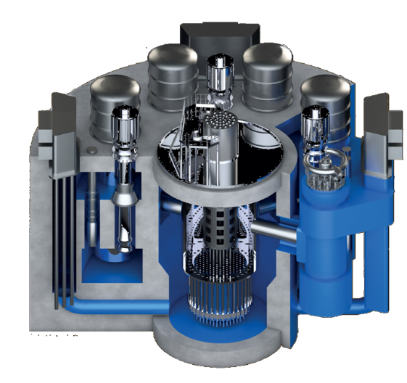
FIG.1. Overall view of BREST-OD-300.

TABLE 1. MAIN TECHNICAL CHARACTERISTIC OF THE BREST-OD-300 REACTOR

Parameters | Value
Thermal power, MW | 700
Steam-production capacity, t/h | At least 1500
Maximum neutron-flux density in the core, 10¹⁵∙cm⁻²∙s⁻¹ | 3.5
Fuel | (U−Pu)N
Fuel loading, t | 20.8
Number of FAs in the core | 169
Annual refuelings, t:  - for 6 % h.a. (~60 FAs), initial period of operation  - for 10 % h.a. (~35 FAs) | ~7.2  ~4.2
Maximum burnup, % h.a. | Up to 10
Maximum damaging dose on the fuel cladding at a maximum burnup of 10 % h.a., dpa. | Up to 140
Number of circulation circuits | 4
Maximum (hydrostatic) pressure of the secondary coolant, MPa | 1.17
Pressure of shielding gas (argon) above coolant level, MPa (abs.):  - during normal operation  - maximum during operational occurrences | ~0.104  0.2
Vessel diameter, m | 26
Vessel height, m | 17.5
Average mixed lead coolant temperature, °С:  - at core inlet  - at core outlet | 420  535
Secondary working medium | Water (steam)
Secondary coolant (water−steam):  - pressure at steam generator inlet, MPa  - pressure at steam generator outlet, MPa  - temperature at steam generator inlet, °С  - temperature at steam generator outlet, °С | 18.5  17  505  340
Efficiency coefficient, % | 43.5
Design service life, years | At least 30

main results of COMPUTATIONAL and EXPERIMENTAL justification of the BREST-OD-300 design
The core design uses mixed uranium-plutonium nitride fuel and low-swelling ferritic-martensitic steel for the claddings of fuel elements; the fuel elements are arranged in shroudless FAs. At present, for the manufacture of fuel for the BREST-OD-300 reactor facility, a technology of dense nitride fuel is implemented in experimental processing lines, technological processes are improved, industrial production of fuel is arranged (a fabrication-refabrication module is built).
The fuel performance at design burnup in the initial period of operation is confirmed by the results of studies of the BREST fuel element mock-ups, which were tested in the BN-600 power reactor and the BOR-60 research reactor [2]. In total, more than 1500 fuel elements were irradiated, of which 534 had standard EP823-Sh steel claddings. In the ETVS-11 experimental assembly with 61 BREST fuel elements with mixed nitride fuel and EP823-Sh steel cladding, burnup of 9% h.a. was achieved at a damaging dose of 107 dpa; all ETVS-11 fuel elements preserved their integrity according to the results of in-reactor control; post-reactor studies are underway.
Based on computational and experimental justification of the core using the FACT-BR and MCU-BR certified software tools, feasibility of low reactivity margin during reactor operation at the rated power (~0.54 β_{eff}) was confirmed even for the initial period of operation taking into account compensation of the method, constant and manufacturing uncertainties of 1.4 % δk/k by technical measures taken at the first criticality stage. The experimental justification of neutronic characteristics is based on the line of assemblies, created in the experimental facility “Big physical stand” (BFS): BFS-61, -64, -77, -88, -87, -95 with lead coolant, and simulation of nitride fuel (BFS -113); a full-scale simulation of the BREST-OD-300 nitride core using the BFS-2 test bench is scheduled.
The computational justification of thermohydraulic characteristics of the core was carried out using the validated PUCHOK-ZhMT and FLUENT computer codes. The peak temperature of fuel cladding and fuel during normal operation does not exceed 667 °C and 1353 °C, respectively (taking into account the uncertainties). The experimental justification of hydraulic characteristics of FAs and reflector blocks was carried out for all designs on full-scale mock-ups (Fig. 2) in water and lead flows and showed the possibility of performing hydraulic calculations both for liquid lead and water. For the used semi-finished products and materials, properties including those in short-term, long-term, under irradiation, and in lead coolant flow environment conditions, which ensure operability of fuel elements up to maximum burnup of 6 % h.a. corresponding to the initial period of operation were determined. Fretting corrosion of corrosion mockups with few rods was substantiated in the tests in liquid lead for 2500 and 5000 h with temperature up to 650 °C and velocity about 2 m/s, showed cladding abrasion of less than 0.5 micron, which is significantly less than the initial indexing grooves with a depth of up to 15 micron on the surface of the claddings. The total thinning of the fuel element claddings adopted in the calculation was 60 microns.

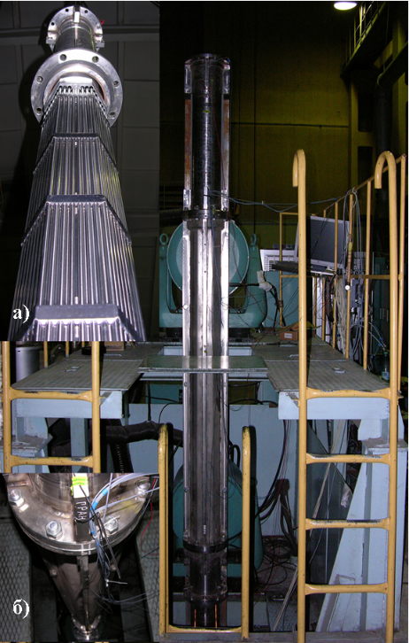  a) vibration hydro-testing in water | 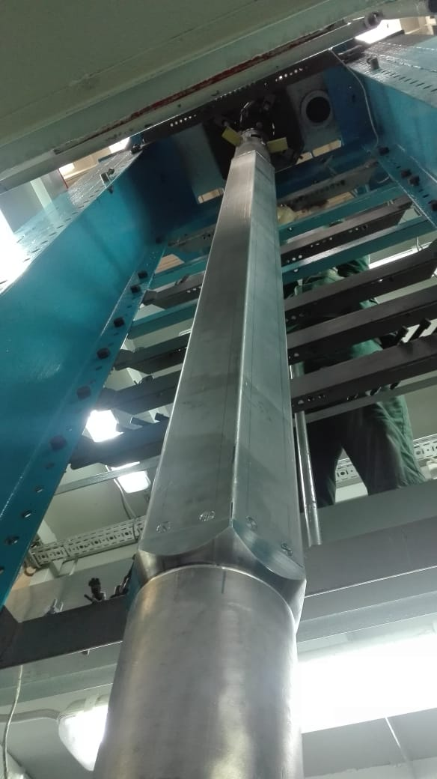  b) vibration testing in air | c) check of entry into the slipway
FIG. 2. Preparation for vibration and mechanical tests.
To exclude coolant loss, an integral reactor layout was used. The reactor facility vessel accommodating the lead coolant and the primary equipment is metal-and-concrete. Justification of operability of this vessel type, which is new for the Russian nuclear power industry, required a wide range of computational and experimental efforts. High-temperature concrete grades were selected, their properties were studied, simulation models were developed. Using the full-scale mock-up of the vessel bottom, the possibility of ensuring the required temperature of building structures was confirmed, and joint thermal displacements of elements were determined. Using the developed full-scale mock-up of the central part of the vessel, heating modes were tried out, parameters of gas release were determined. On the medium-scale model 1:5, a full cycle of work on the creation of the vessel was completed (Fig. 3). The absence of radiation impact on concrete samples was confirmed by reactor tests at a damaging dose of 0.181 dpa and a maximum design does of 0.111 dpa. Studies using a full-scale model showed that lead and lead oxide interaction with concrete at a temperature of 400 - 700 °C is negligible. The calculation justification confirmed that probability of leakage with partial coolant loss in the selected vessel design does not exceed 9.7∙10⁻¹⁰ 1/year.
The integral layout with steam generator accommodation in the vessel of the reactor block imposes heavy demands on justification of its operability and safety. In this respect, comprehensive justification of the elements and processes occurring in the steam generator was carried out. The required thermohydraulic parameters and the boundary of thermohydraulic stability limit of 18.6% in terms of water flow were justified using the validated HYDRA-IBRAE/LM/V1 code. The strength of the steam generator elements in all operating conditions was justified using the certified ANSYS software. The fulfillment of the conditions of thermal cyclic strength of the heat-exchanger tubes and tube-to-tube plate weld seams was confirmed over 5000 cycles. A test bench for experimental justification of vibration characteristics is being created for a tube bundle similar to the standard. Lead has high specific gravity; therefore, it is necessary to analyze the possibility of a secondary failure of the steam generator tubes in the event when one of them fails. Absence of a secondary failure in the event of one tube’s rupture was experimentally demonstrated [3]; the probability of a steam generator tube failure was 1.5∙10⁻⁵ 1/year with one tube failing and 4.3∙10⁻⁷ 1/year with two tubes failing.

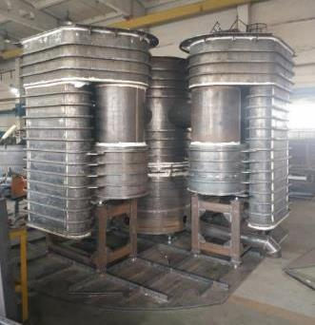
FIG.3. Metal part of the vessel layout.
The reactor coolant pump set (RCPS) is designed to create a pressure head of the lead coolant and ensure its circulation in the circuit. To substantiate its performance, several mock-ups of the pump and test sections for their validation were developed. The lead test bench was used to justify the choice of a blade system in the design of an impeller with a rim on the basis of 600 hours of testing at a scale of 1:2.5. Using the water test bench, the output performance of a model blade system was obtained at a scale of 1:2.8. It was demonstrated that the flow in RCPS can be calculated as for an ordinary Newtonian fluid. Endurance tests of the bearing in liquid lead in challenging conditions were completed, the hydrodynamic friction mode was confirmed. Tests of a full-scale sealing unit demonstrated that the data on the sealing liquid leakage does not exceed the values permitted by the reactor facility engineering design (Fig. 4). At the stand being created, a comprehensive functional test for the RCPS pilot model is scheduled.
The lead coolant technology for the power-generation class facilities has already demonstrated its sufficient degree of elaboration. Therefore, in the BREST project, the focus was on the development and testing of specific elements and technological systems. The procedure for lead oxygenation using oxide granules (PbO) and the process of lead sampling for analysis were tried out, measurement procedures were developed and certified, the type of measuring device for the oxygen activity sensor was approved with an error in determining the thermodynamic activity of oxygen in lead of 15%. Regulations for lead coolant including cleaning and decontamination were developed and confirmed by the experience in operating lead test benches. The absence of corrosion of materials in excess of the specified limits at a regulated oxygen concentration in lead of (1−4)∙10⁻⁶ was justified. Corrosion resistance of equipment steel was substantiated: for EP302-Sh steel, in the range between 420 and 540 °C over 53000 h, for EP302M-Sh steel, in the range between 450 and 550 °C over 28000 h.
a) shaft seal | 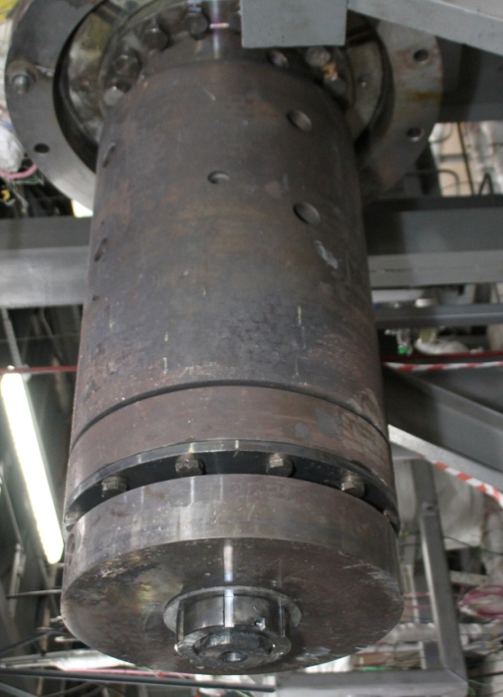  b) bottom bearing in housing
FIG. 4. Shaft seal and full-scale bottom bearing for RCPS.
The engineering design of the automated instrumentation and control system of the reactor facility (two-set, three-channel) including a diverse protection system was developed. Pilot models of primary transducers of the primary coolant system parameters (level gauges, thermocouples, etc.; Fig. 5) are manufactured and tested. For the automated instrumentation and control system test bench, a model of the primary and secondary coolant systems of the reactor facility was developed using the DINAR software system. Using this test bench, stable operation of the integrated control and protection system regulators in different transients was shown; the reliability was justified on the basis of the developed structures using analogs.

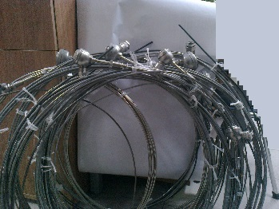  a) thermoelectric converter | 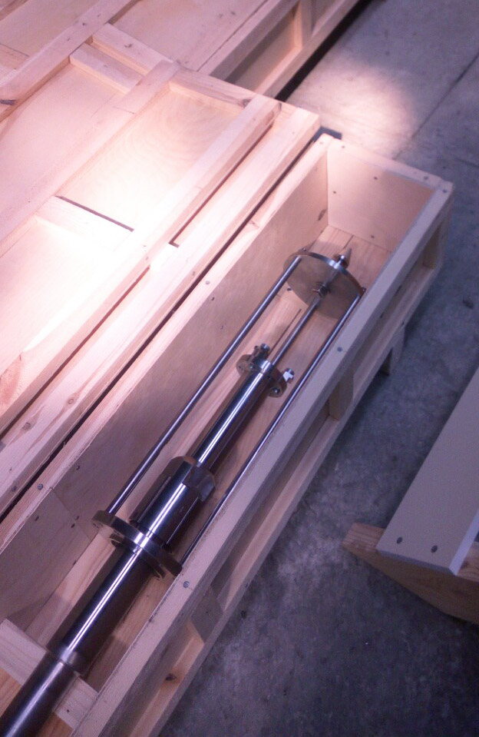  b) level gauge
FIG. 5. Primary converters

The performed safety analysis [4] showed that in the case of the most conservative scenario, which is the insertion of the full reactivity margin during power operation, the maximum temperature will reach 1640 °C for the fuel and 1260 °C for fuel element claddings, fuel melting does not occur, lead coolant does not boil, integrity of the primary coolant circuit is preserved (Fig. 6). The probability of such scenario is 2.9∙10⁻⁹ 1/year. For another conservative scenario, that is for power unit blackout with failure of mechanical shutdown systems (ATWS), the level of the attainable fuel-element cladding temperature turns out to be less than in the first scenario and does not exceed 903 °C. Power unit blackout also does not lead to melting of fuel element claddings and fuel and coolant boiling. Long-term cooldown is carried out using a passive emergency cooling system of the reactor with natural circulation in the primary lead coolant circuit.
Based on the results of the radiation safety analysis [5] when introducing the full positive reactivity margin by removing the CPS working members from the core with the maximum design speed when operating at power or at a shutdown state with a maximum reactivity margin, the total effective dose for adults at a distance of not more than 0.5 km from the source during the first 10 days does not exceed 1.8∙10⁻⁴ mSv, which is significantly less than the established evacuation criteria (50 mSv). Also, the release during depressurization of the steam generator tube with a postulated discharge into the atmosphere for the first 10 days does not exceed 8.0∙10⁻² mSv, which also does not exceed the established criteria.
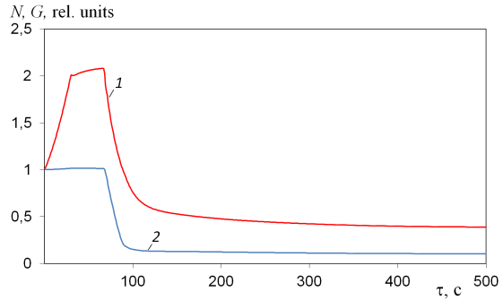  a) | 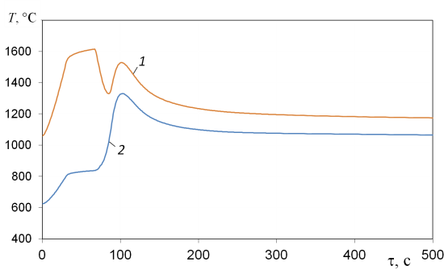  b)
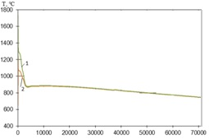  τ, с  c) | 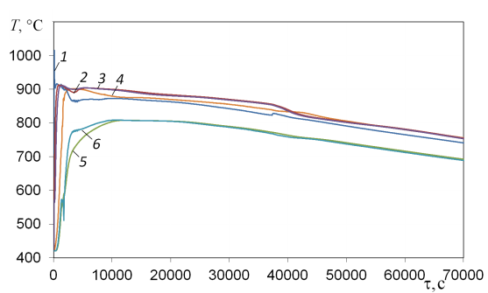  d)
FIG. 6. Parameters of the BREST-OD-300 reactor under the worst-case scenario with the introduction of the full reactivity margin: a) Change in power (1) and coolant flow through the reactor (2); b), c) Change in temperature of fuel (1) and fuel cladding (2); d) Coolant temperature at the core outlet (1), at the inlet (2) and outlet (3) of the steam generator, at the inlet to the cooldown heat exchanger (4), at the inlet to the core (5), at the outlet of the cooldown heat exchanger (6).

current status of the project, main conclusions and plans for the future
At the current stage, experimental justification of components, elements and equipment has been carried out using small- and middle-scale mockups, pilot models. For computational justification, the software tools that are certified and validated based on the available data were used. The reactor facility design is based on the requirements of current Federal norms and regulations for NPPs: OPB, PBYa, NRB, etc. To create innovative NPPs, new Federal rules and regulations as well as promising software tools are being developed almost concurrently. The rules for the arrangement and safe operation as well as related documents (welding, inspection rules), vessel strength calculation norms are specific. Appropriate norms and regulations have been developed for the implementation of the project. The safety analysis showed that the probability of severe accidents due to internal reasons without core destruction involving fuel and cladding melting, coolant boiling, disruption of circulation in the primary circuit does not exceed 6.48∙10⁻⁹ 1/year; the release of radionuclides per day under the conservative scenarios does not exceed the control value. The absence of the need for evacuation and resettlement of the population in severe accidents at the power unit is ensured with a probability of 3.2∙10⁻⁸ 1/year [1, 5].
Following the results of a long, detailed design review, in February 2021 Rostekhnadzor issued a license for the construction of a power unit with BREST-OD-300. A solemn ceremony was held on June 8, 2021, with pouring of the “first concrete” marking the beginning of the power unit construction (Fig. 7). The equipment fabrication and installation and construction of BREST-OD-300 is planned to be completed in 2026 and begin preparations for the reactor start-up. From 2024, the fabrication module shall begin mass production of FAs for the BREST reactor’s initial loading. In 2029, a spent fuel reprocessing module and a refabrication module are planned to be put into operation. Thus, at the PDEC site, the BREST-OD-300 reactor start-up and pilot operation in the closed nuclear fuel cycle will be carried out, life characteristics of the reactor facility and its equipment must be confirmed, and the extensive R&D program will be carried out, which is also relevant for the future lead-cooled commercial reactor facilities.
The obtained results made it possible to proceed to designing the BREST-type commercial mass-produced reactor facilities for the large-scale nuclear power industry. As part of the Proryv project, work has begun on the development of a commercial power unit with a lead-cooled fast reactor BR-1200 with an electric power of 1200 MW. For BR-1200 a design with an integral primary equipment layout has been selected, in which the core with reflectors and CPS members are located in the central cavity, steam generators, pumps and cooling heat-exchangers are located in peripheral cavities. In the primary circuit of the reactor block, forced circulation of a lead coolant is arranged, where it transfers thermal energy from the reactor core to the secondary working fluid in steam generators. In the reactor block, six circuits are arranged for lead coolant circulation between the cavities, in which the equipment is placed without any tubing and fittings. The reactor block layout ensures compactness and symmetry of equipment arrangement, as well as availability for monitoring and diagnostics of the equipment technical condition, repair operations and inspections.

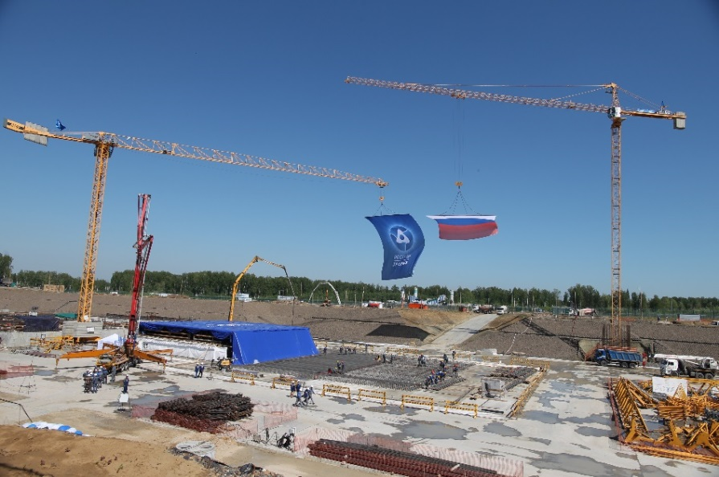
FIG. 7. Pouring the first concrete into the foundation of the power unit with the BREST-OD-300 reactor.

The BR-1200 core design, its geometry and composition ensure complete plutonium breeding in the core compensating for reactivity decrease during fuel burnup and accumulation of fission products. As a result, the reactor operates between regular refuelings at a power producing level with low reactivity margin ∼β_{eff} that excludes the possibility of uncontrolled core excursion caused by prompt neutrons due to equipment failures and personnel errors.
While many design solutions for BR-1200 were essentially borrowed from BREST-OD-300, direct use of the designed structures in a large reactor turned out to be not effective enough and required additional engineering. The engineering done at the current stage of the conceptual design points at the possibility of achieving competitive economic indicators for NPPs with BR-1200 while ensuring the high level of safety and target conceptual provisions of the BREST technology.

References
- ADAMOV YE.О., KAPLIENKO A.V., ORLOV V.V., SMIRNOV V.S., LOPATKIN A.V., LEMEKHOV V.V., MOISEEV A.V., “The BREST fast lead-cooled reactor: from concept to technology implementation”, Atomic energy (Atomnaya energiya). 2020. Vol. 129. Issue 4. P. 185-194.
- GRACHEV A.F., ZHEREBTSOV A.A., ZABUDKO L.M. et al., “Results of the study of BREST-type fuel elements with mixed nitride uranium-plutonium fuel irradiated in BOR-60 and BN-600”, Atomic energy (Atomnaya energiya). 2018. Vol. 125. Issue 5. P. 278-284.
- AFREMOV D.A., LEMEKHOV V.V., TUTUKIN A.V. et al., “Investigation of processes in a lead coolant in case of violation of the integrity of the heat exchange tube of the BREST-OD-300 steam generator” , Atomic energy (Atomnaya energiya). 2015. Vol. 119. Issue 3. P. 164-168.
- LEMEKHOV V.V., MOISEEV A.V., MURATOV A.G. et al., “Deterministic safety analyses of BREST-OD–300 reactor facility” International Conference on Fast Reactors and Related Fuel Cycles: Next Generation Nuclear Systems for Sustainable Development (FR17) Yekaterinburg, Russian Federation 26 – 29 June 2017.
- DUBENKOV N.E., V.P. VASYUKHNO, V.V. LEMEKHOV, A.V. MOISEEV et al., “Justification of radiation safety of the BREST-OD-300 reactor”, Atomic energy (Atomnaya energiya). 2021. Vol. 130. Issue 4. P. 223-228.

