# INTEGRATION OF SMALL MODULAR LEAD FAST REACTOR WITH ENERGY STORAGE FOR LOAD-FOLLOWING OPERATION IN HIGH V-RES PENETRATION ELECTRICITY MARKETS

M. PALMERO

Ansaldo Nucleare S.p.A

Genova, Italy

Email: [Marco.Palmero@ann.ansaldoenergia.com](mailto:Marco.Palmero@ann.ansaldoenergia.com)

M. FRIGNANI, M. CARAMELLO, A. ALEMBERTI

Ansaldo Nucleare S.p.A.

Genova, Italy

M. RODRÍGUEZ DE VICENTE, J, SORIANO GARCÍA, M. CELADOR LERA

Empresarios Agrupados Int.

Madrid, Spain

**Abstract**

Energy decarbonisation, through the transition from fossil fuels to V-RES electricity production and the electrification of transport & heating sectors, may jeopardise the electricity supply security on the long term, because of the growing power demand and the increased production volatility. While advanced and modular reactor designs can make nuclear an attractive low-carbon solution to diversify the energy mix and address the power demand increase, a paradigmatic change is required in both NPP design and operation to increase load-following mode attractiveness. Indeed, although the current nuclear Gen-III/III+ fleet provide good load following capabilities and some operators (especially in high nuclear share markets as France) find profitable operating NPP in load-following mode, most of nuclear generating units are operated in baseload mode. The paper investigates the feasibility and the potential of integrating a cost-effective Energy Storage system into a Small Modular Lead Fast Reactor, to achieve load-following performances while maintaining the reactor at high power levels minimizing power excursions. Indeed, the integration of Energy Storages in Gen-IV reactors may significantly boost nuclear competitiveness in high V-RES penetration electricity markets, by combining the economic benefits of running nuclear reactors at high power (i.e., efficient use of capital invested in plants, simplicity and reliability of the operations) with the plant load-following capacity, compensating V-RES volatility. The paper investigates the Energy Storage option under a wide and comprehensive perspective, from the description of the reference electricity market with the identification of specific national grid requirements down to the Energy Storage technology selection, integration with the balance-of-plant and preliminary sizing, to best-fit the load-following demand and LFR specificities. Romania has been selected as reference scenario for the investigation, due to the representative energy-mix with high RES penetration (42%), a large use of hydropower (27%) to compensate for wind and solar volatility as well as the consolidated use of nuclear power (18%) as baseload.

## INTRODUCTION

The word’s electricity market is widely changing in the recent decades. Two main factors are pushing this variation: the rise of the electricity demand and the high contribution of solar and wind energy to the electric systems, which increases considerably the electric production volatility. The first is a well-known factor, as the global primary energy consumption has been increasing continuously during the last century, pushed mainly by the planet population growth and the economic expansion of the developing countries. Besides, the electricity demand as a final form of energy consumption is getting importance due to the electrification of high consuming economic sectors such as the transport industry.

The second mentioned factor is caused by the rapid implementation of V-RES (Variable Renewable Energy Sources) in the electric systems during the las two decades looking to reduce carbon dioxide emissions to the atmosphere. Electricity production using renewable energy sources depends highly on the natural atmospheric conditions: sun, wind and rain. Whenever these plants are able to contribute to the electric system they are connected at low market prices and, as soon as their source of energy is not available, they have to stop producing and be replaced by other sources of energy in a short time period. The production of solar installations is highly predictable in day-to-day and hour-to-hour basis, which facilitates the offer-demand pairing. However, wind production cannot be easily foreseen. The other energy sources that complete the electric mixes are mainly thermal power plants using gas or coal to feed their boilers, with the consequent carbon dioxide emissions; hydroelectric power plants, which have also a strong dependence on the rainy seasons; and nuclear power plants.

Nuclear power is one of the least contaminant sources of energy in terms of carbon emissions per generated energy unit and can produce electricity with almost no dependence on external factors excluding extreme natural events [6]. Moreover, the latest nuclear reactor designs have load-following capacity that depends on the electric demand. Then, nuclear power is positioned as one of the key technologies to both, guarantee a continuous, autonomous and secure electricity supply, available in almost every part of the world, and contribute to the reduction of global carbon emissions as the best low-emission back-up technology to the V-RES production in the electric systems.

## NUCLEAR ENERGY LOAD-FOLLOWING CAPACITY STATUS AND FUTURE MARKET REQUIREMENTS

Nuclear technology has been diversifying along recent decades by adapting the power plant characteristics of the different electricity markets of the countries where they are installed [3], [4].

Modern Light Water Reactors design provides capability of daily power regulations in the range of 50-100% full power (FP) at a rate of 5% FP per minute, once or even twice per day.

Despite the modern fleet load-following capability, baseload supply is so far the most attractive and profitable exploitation mode of nuclear energy. The cost-effectiveness of high loads factor (i.e., low O&M / capital cost ratio), the operational simplicity and reliability of rated power operations make load-following unattractive for nuclear utilities. The average low nuclear share in the country energy mixes, the relatively low penetration of intermitting renewable sources (V-RES), the interconnected electricity markets and the cost-effectiveness of Combined Cycle Gas Turbine peaker plants make baseload operation the most attractive option for nuclear at national grids level. It follows that, to date, the electricity markets for which it turns to be cost-effective using part of the nuclear fleet for daily peak-demand are those with high nuclear share, such as France (70%) and Belgium (47%). Former German nuclear energy policy required enhanced built-in load-following capability to its PWR and BWR fleets since 1970s, achieving remarkable power ramp rates of 10% FP per minute.

Under a technical perspective, the current nuclear fleet is suited to daily duck-curve load-following (i.e., one or two power cycles per day). The future high V-RES penetration markets will ask for a significantly higher grid flexibility, on daily and hourly basis, the latter neither achievable nor profitable with current NPP design. The high penetration of V-RES will therefore require a paradigmatic change in nuclear power plants design, licensing and construction approach as well as deep investigation on economic sustainability and profitability of future nuclear load-following option. To date, there is a general consensus on the technical feasibility of designing new units for flexible, safe, reliable and efficient operations. However, under the economic perspective, the power flexibility will cause capital and O&M costs increase, requiring policy makers to leverage on financial incentive to attract future plant owners and designer to load-following option.

In this frame, the integration with Energy Storage Solution is raising interest in the development of advanced reactor design, as a potential solution that combines the full power operation technical and economic benefits with load-following capabilities. An Energy Storage will essentially decouple, to some extent, the plant electrical output from the reactor power, keeping the latter at rated values and modulating the first according to grid demand. This solution may be of particular interest in the case of Heavy Liquid Metal Fast reactors, where additional constraints – to be furtherly investigated - related to primary fluid inertia (for pool type reactor only), the thermal-fatigue due to the high temperature difference experienced by the in-vessel components as well as the lack of operational experience, might make steady-state operation on primary side preferable.

Based on the above considerations, this paper investigates the technical feasibility of integrating a Thermal Energy Storage in the Advanced Lead-cooled Fast Reactor European Demonstrator (ALFRED) and evaluating the hourly load-following performances against wind production variations, in a reference high-penetration V-RES market.

## CASE OF STUDY: ALFRED PLANT

ALFRED (Advanced Lead-cooled Fast Reactor European Demonstrator) is the name given to the project that develops the commercialization of a first of a kind LFR (Lead-cooled Fast Reactor) under the FALCON Consortium. This type of nuclear reactor forms part of the Generation IV International Forum (IV) that promote the innovative design of new safe, secure, sustainable, competitive and versatile nuclear reactors. This technology aims a better fuel cycle sustainability, maximum safety standards that exclude domino effects in case of incident or accident in the primary side, and economic competitiveness compared to current nuclear reactors, being optimum for multi-unit sites facilities.

To achieve these goals in the demonstrator facility, a staged approach will be implemented for the reactor by increasing progressively its thermal power, and consequently, the temperature and pressure of the generated steam. The Balance of Plant of the demonstrator should suit the needs of the mentioned stages without requiring major upgrade and maintaining high thermal efficiency objectives along all the process. Each stage shall be considered as a stationary condition for periods of the order of a few years, and power transients and partial load operation will be present in every stage. The investigation on Energy Storage integration is limited to the plant commercial exploitation.

One of the main requirements for the secondary side design is to keep the feedwater temperature at the steam generator inlet at 335ºC in order to ensure that the lead is always over its melting point. The reactor will produce high superheated steam (450ºC) at 180 bar,a. This high pressure is required at the reactor inlet to guarantee liquid conditions of the feedwater at the steam generators inlet. This will largely determine the overall performance of the plant as well as the operation and nature of the installed equipment.

The plant configuration as regards the heat removal system is impacted by the characteristics of the construction site; Given the fewer number of sites with large availability of sufficient water, a dry-cooled condenser configuration increases the number of sites available. The main objective of this project is to study the feasibility of integrating an Energy Storage System in the plant configuration by meeting as well the requirements described above. This system will allow modifying its electric output while keeping constant the power reactor, so that the exceeding heat produced is stored to be used afterwards when it is demanded. The following sections show the analysis done to meet a solution under a wide and comprehensive perspective, from the description of the reference electricity market with the identification of specific national grid requirements down to the Energy Storage technology selection, integration with the balance-of-plant and preliminary sizing.

### Reference electricity market

The selected site location for ALFRED plant is Mioveni, Romania. The project is included in Romania’s relevant strategies in matters of national research, development and innovation. This country has a consolidated nuclear industry with two nuclear reactors operating currently ([Cernavodă](https://en.wikipedia.org/wiki/Cernavod%C4%83)) that represent the 19.2% of the electricity production in 2019 [1], having two more units to be constructed that are under development for the same site. Moreover, the country counts on an internal infrastructure covering an open nuclear fuel cycle that grants the country’s independence in the production of nuclear energy.

The Romanian energy mix is balanced and diversified, with a high contribution of renewable sources of energy: 28.7% of Hydroelectric, 12.4% wind and a lower proportion of solar (3.3%). Fossil fuels complete the electric mix with a high contribution (36.4%), but the country is committed to continue reducing this percentage, in harmony with the European environmental policies [1]. Romania is representative of high penetration RES market with a renewable share of 41.7 %, that is significantly higher than the EU27 average (34.1 %).

The purpose of this report is to assess the technical feasibility of ALFRED hourly load-following to compensate, proportionally to the plant size, the wind power variation. Fig. 1 shows the wind power curve for the selected day in January of 2020, which has high power variations in short time periods making the load following of the plant challenging.

*FIG. 1. Wind production in Romania for different days*

### Secondary System Configuration

The reference balance-of-plant thermal-cycle conditions refers to stage 3, i.e., representative of the commercial fleet operations. The main steam produced in the Steam Generators (SG) located in the reactor vessel is superheated steam at 450ºC and 182 bar,a. A High Pressure Turbine (HPT) expands the steam up to slightly wet conditions, so it is then conducted to a moisture separator (see Fig. 2). Then the fluid is reheated in two different stages: 1st stage is fed with steam coming from the second HPT extraction and the 2nd stage with main steam. Afterwards the steam is expanded again in a Low Pressure Turbine (LPT) and is driven by backpressure from its exhaust to the condenser. The condenser will be a dry air-cooled condenser with precoolers in order to reduce drastically the makeup water needed to refrigerate the plant.

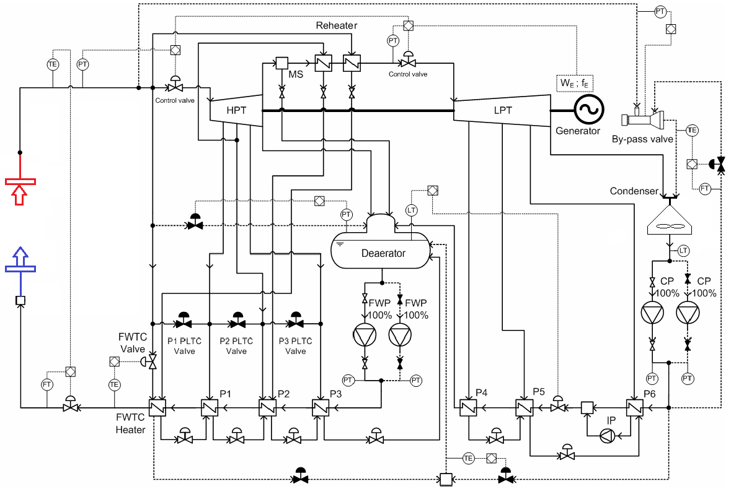

Fig. 2. Secondary System General Flow Diagram (adapted from [2])

Each turbine has three extractions that feed six preheaters used to increase the feedwater temperature. The three low pressure preheaters are located downstream the 2x100% condensate pumps that pump condensed water stored in the hot well of the condenser. The lowest pressure preheater is pump-forward as the steam stream is not subcooled.

An extra heater (Feedwater Temperature Control Heater – FWTCH) fed with main steam is located upstream the SG Feedwater inlets to maintain, during any transient or mode of operation, a feedwater temperature of 335ºC. In order to increase the control capacity on this parameter, three control valves regulate the main steam mass flow to each of the high pressure preheaters to have a higher heat exchanging capacity with the feedwater stream.

Between the low pressure and high pressure preheaters there is a deaerator that is fed with HPT exhaust steam, set at 12 bar, so that the 2x100% feedwater pumps supply the SG water with low oxygen and carbon dioxide concentrations to protect them against corrosion.

A 100% turbine bypass system is included, permitting direct transfer from the reactor to the condenser, giving the plant total power variability during possible thermal load transients. There is desuperheating feature in the bypass valves using cold water coming from a condensate pumps outlet connection (this solution is to be furtherly developed). The main control valves, which allow the correct functioning of the system during all modes of operation and partial loads, are included in this conceptual approach (see Fig. 2).

### Energy Storage technologies

Electricity markets are changing due to the VRES penetration increase such as wind and solar energy. These energy sources are non-dispatchable, what create volatile electricity prices. In order to adapt nuclear power plants to this new electricity market behavior, the feasibility of integrating an Energy Storage system in the Balance of Plant of ALFRED to vary the power plant production will be evaluated.

The goal is to keep the reactor at constant base load while the electric power given to the grid varies depending on the electricity market. When electricity prices are set low (or even negative), part of the produced steam will be used to store energy while the turbine will operate at minimum load. When electricity prices are set high, all the steam produced by the reactor will be used to produce electricity in the turbine, and also, an extra electric energy could be produced by using the energy from the ES System.

The main overall requirements that the Energy Storage System must fulfill are: thermodynamic compatibility with the main steam produced by the plant (superheated steam at 450ºC), daily basis storage time capacity, good thermal overall efficiency, and competitive economic costs. The feasibility of implementing different energy storage solutions that are being developed or investigated nowadays and their compatibility to ALFRED main requirements is analysed.

Currently, the two main alternatives for energy storing are thermal and electric forms of energy. According to the literature, the electric batteries are still highly expensive for large-scale utilities compared to the available heat storage solutions. However, the price is decreasing roughly in recent years, so a close tracking of the evolution of this technology during the following lustrums shall be considered. Given the demonstrator and innovative nature of ALFRED project, other solutions such as dams for storing water potential energy at certain elevation have been dismissed.

Related to the thermal storage solutions, there are plenty solutions that are being developed. However, most of them are not recommended either for not being suitable for ALFRED thermal conditions or for still being at laboratory stages. Table 1. shows a summary of the main characteristics of the analyzed energy storage solutions.

TABLE 1. ENERGY STORAGE TECHNOLOGIES

|  |  |  |  |  |  |
| --- | --- | --- | --- | --- | --- |
| Technology | Thermodynamic Conditions | Storage Time | Efficiency | Cost | Technology Status |
| Steam Accumulator | Main Steam Conditions | Hours | 95% (Thermal-to-Thermal) | Very High | Commercial for CSP |
| Molten Nitrate Salts | 290-565 ºC | Hours to Days | 98% (Thermal-to-Thermal) | High | Commercial for CSP |
| Hydrogen:  Electrolysis – Fuel Cells | - | Days | <80% (Electric-to-Thermal)  <60% (Thermal-to-Electric) | High | Few Utility-Scale Projects - Laboratory |
| Hydrogen:  NACC / NARC | 550-700 ºC | Hours to Days | 80% (Electric-to-Thermal)  30% (Thermal-to-Electric) | High | Laboratory |
| FIRES:  NACC / NARC | 550-700 ºC | Hours to Days | 98% (Electric-to-Thermal)  <40% (Thermal-to-Electric) | High | Laboratory |
| Concrete | 400ºC | Hours to Days | 98% (Thermal-to-Thermal) | Low | Laboratory |
| Cryogenic Systems | Variable | Hours to Days | 70% (Electric&Thermal-to-Electric) | High | Studies |
| Electric Batteries | - | Days | 90% (Electric-to-Electric) | Very High | Few Utility-Scale Projects |

* NACC: Nuclear Air-Brayton Combined Cycle // NARC: Nuclear Air-Brayton Recuperated Cycle

One of the promising technological solutions is the production of hydrogen [5] by means of electrolysis process, including high efficiency high-temperature steam (800-1000°C) and mid-temperature (400-500°C) processes. These latter, that are currently under investigation, are of great interested due to compatibility with current LFR temperature ranges. This gas is used as a thermal storage reservoir that can be later used to produce back electricity by means of fuel cells, either in separate devices, or in the same unified reversible equipment. Another possibility is to locate the nuclear plant close to an industry that uses hydrogen as a chemical reagent, such as a fertilizers plant. Although these technologies are young and still require development for large-scale facilities, there is a big interest on them and several projects are being developed around the world.

However, molten salt energy storage systems are the best positioned technology. This solution is compatible with the main steam characteristics of ALFRED as the salts can be in liquid state between 290ºC and 565ºC in secure conditions. Besides, this technology is already commercial for large scale CSP (Concentrating Solar Power) plants as thermal storage, and offers good performances and thermal efficiencies, as well as high load flexibility in an hour-to-hour basis.

## MOLTEN SALT STORAGE SYSTEM

The basis of this energy storage system applied to the ALFRED LFR would be to heat up molten salt with part of the main steam produced in the reactor, and store them in a hot salts storage tank so that when the plant load wants to be risen, they are used to produce back steam and obtain the extra electricity requested. During all time, the reactor power would remain constant at full load conditions, at least, while no partial loads are required from the primary side operating requirements.

The common heat transfer molten salt composition used in CSP facilities is a mixture of 60% weight of Sodium Nitrate (NaNO3) and 40% of Potassium Nitrate (KNO3). Some important advantages of these salts are their stability in contact with air and their low vapor pressure. The melting point is around 220ºC, but it can start crystalizing at 250ºC. Assuring that the molten salt are always over its melting temperature is one of the main concerns of this technology. For security reasons, the minimum operating temperature of the salts during all operation modes should be kept over 290ºC.

To accomplish this requirement, all molten salt piping and related equipment or devices should be designed to include a heat tracing system to keep the piping walls at the required temperature for all the operation modes of the plant, even when the plant is not under operation. Additionally the Cold and Hot Salts Tanks will be equipped with electric heaters in the bottom to assure the minimum operating temperature.

Auxiliary systems are needed for the molten salt melting, for the salts drainage system or for the tempering during transients and startups. The heat transfer fluid also requires high demanding design conditions for the piping and equipment due to the high levels of corrosion and the high operating temperatures.

### Integration with the secondary system

There are two main operating modes for the energy storage system: Loading and Unloading.

The loading mode consists on heating up molten salt with part of the main steam produced in the reactor, and store them in a hot salts storage tank. The condensed fluid would be discharged in the feedwater path towards the reactor, right before the last preheater (see Fig. 3). The steam-salts heat exchangers will have three different parts: de-superheating section, condensing section and drain cooler section

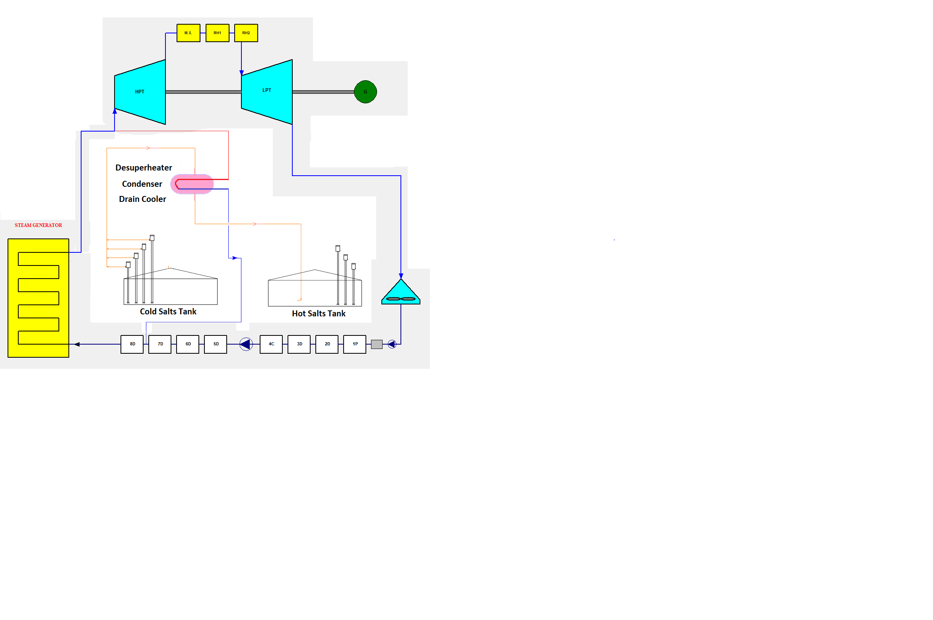

Fig. 3. Loading Operating Mode Schematic

The loading main steam will be de-superheated up to its saturation temperature, then condensed to saturated liquid, and afterwards subcooled. The limiting temperature for the cold side during *Loading Mode* will be the minimum operating temperature for the cold salts, that has been set to 290ºC, giving an operating margin. As this subcooled fluid is still at a high temperature and pressure, it can be returned into the feedwater system before the last high pressure feedwater preheater in base of the thermodynamic conditions of both flows.

The cold molten salt are pumped by means of several vertical pumps with variable speed installed inside the cold salts tank, from the atmospheric pressure of the cold salts storage tank to the cold side of the Loading Heat Exchangers. They are heated up to a maximum temperature limited by the steam inlet (450ºC) and moved into the hot salts storage tank, which operates also at atmospheric pressure, but has a higher design temperature.

During the unloading operation mode, the hot salts are used to generate steam that is sent as an addition to the reheated steam, into the Low Pressure Turbine (see Fig. 4). The hot salts are channeled to the Steam Generation System, which is formed by an economizer, an evaporator with steam drum, and a superheater. The live steam conditions cannot be achieved in this Steam Generation System if no external auxiliary heat sources are introduced.

As an assumption, it can be considered that the hot molten salt temperature when the power plant starts the unloading mode of operation will be 1ºC lower than their temperature when they were heated during the loading mode. This assumption is reasonable, as the thermal isolation materials commonly used for this kind of tanks is highly efficient, and also because it is considered that the hot salts will be used in a daily basis. Although these losses are very low, it is not feasible to produce a steam of the same (or close) thermodynamic conditions as the main steam.

Therefore, for a hot salts inlet temperature to the Steam Generator System of 395ºC, the conditions of the steam produced in the Unloading Heat Exchangers will be set at 342ºC and 12 bar,a, which are very close to the reheat steam coming from the reheaters between both turbines. For this thermal power, the feedwater conditions at the inlet of the SGS could be the ones of the deaerator outlet: 188ºC and 12 bar,a.

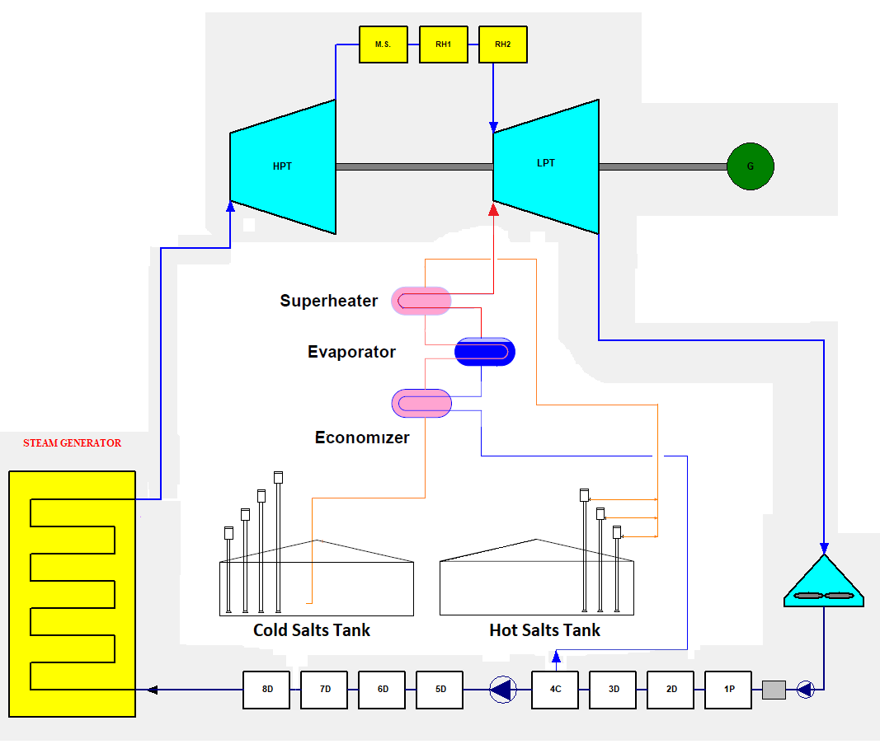

Fig. 4. Unloading Operating Mode Schematic

### Balance of the Plant and Performance

The balance of the plant calculations have been performed with the calculation software SteamPro, and is based on the secondary side configuration mentioned in Section 3.2, for the last stage of the project, in which the reactor thermal power is 300 MWth and its output main steam conditions are 450ºC and 180 bar,a. The ambient conditions considered are 12ºC, 0.964 bar of atmospheric pressure and 60% of Relative Humidity.

The balance of the plant for the nominal operation (no loading or unloading) is shown in Fig. 5. The nuclear reactor produces 191.8 kg/s of superheated steam. Part of this steam is used to feed the FWTCH and the second stage of the reheater, whereas the rest of the steam is introduced in the HPT. The plant produces a gross electric power of 135 MW (net power of 126 MW) with an overall thermal efficiency of 45%.

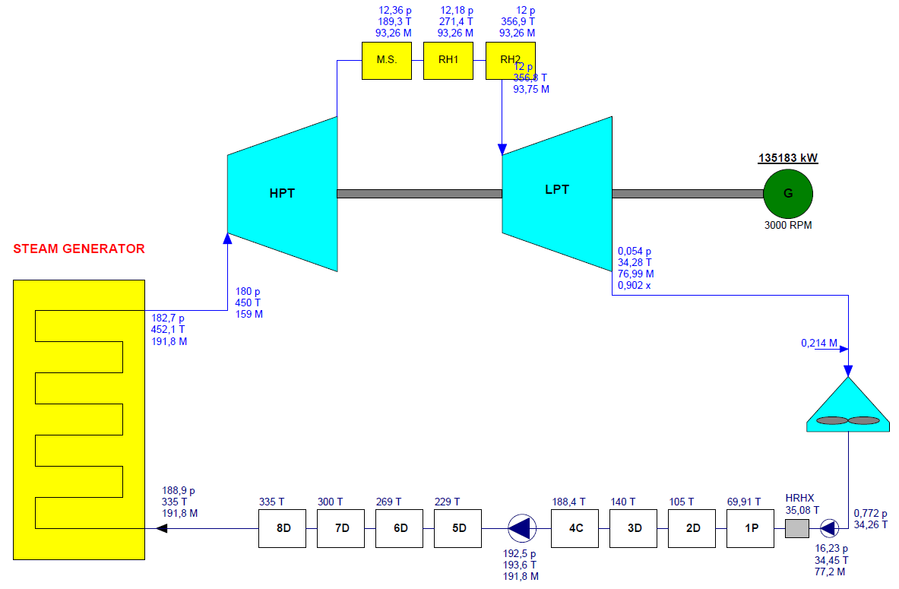

Fig. 5. Balance of Plant – Nominal Operation

The partial loads flexibility for loading and unloading modes is high for this technology, being able to work in a wide range of power loads by increasing or reducing the molten salt and steam / feedwater flow rates into the Loading and Unloading Heat Exchangers. The following table shows the main operation parameters for some loads of the Loading mode of operation and their correspondence with the extra power that the plant would be able to produce during Unloading mode for the same period of time, this is, for the stored energy during an hour.

TABLE 2. LOADING AND UNLOADING OPERATION EQUIVALENCE

|  |  |  |  |  |  |  |  |
| --- | --- | --- | --- | --- | --- | --- | --- |
| LOADING | | | | UNLOADING | | | |
| Steam Load [kg/s] | Salts Load [kg/s] | Net Electric Output [MWe] | % Full Power | Steam Unload [kg/s] | Salts Unload [kg/s] | Net Electric Output [MWe] | % Full Power |
| 80.7 | 630.3 | 56.4 | 44.8% | 59.9 | 630.3 | 160.1 | 127.1% |
| 65.3 | 510.2 | 67.8 | 53.8% | 48.5 | 510.2 | 153.7 | 122.0% |
| 49.9 | 390.2 | 81.1 | 64.4% | 37.1 | 390.2 | 147.2 | 116.9% |
| 34.6 | 270.1 | 94.7 | 75.2% | 25.7 | 270.1 | 140.8 | 111.8% |
| 19.2 | 150.1 | 108.6 | 86.2% | 14.3 | 150.1 | 134.4 | 106.7% |
| 11.5 | 90.0 | 115.4 | 91.6% | 8.6 | 90.0 | 131.1 | 104.1% |
| 3.8 | 30.0 | 122.4 | 97.2% | 2.9 | 30.0 | 127.9 | 101.5% |

In order to follow the wind power variation during the selected data shown in Section 4.1 in a proportional way, a simulation of the plant load during this day is performed, assuming an hour-to-hour load-following for the % of power variation with respect to the previous hour. The balance of plant calculations have been performed for a total of 27 different loads, from a minimum power of 56.4 MW, and a maximum of 154.1 MW.

A maximum molten salt storage capacity is set to 10000 Tn, which is a reasonable amount for a plant of this size, and the minimum amount of salts that could be stored in the tanks is set to 600 Tn due to operative reasons. An initial hot salts storage of 2500 Tn is assumed for the calculation.

Fig. 6 shows in the upper part the net power produced by ALFRED plant during the selected day in comparison with the wind power produced in Romania for that day (right axis), in MWe. In the lower part of the figure, it is shown in blue colour the amount of hot salts stored along the day and in orange line, the mass flow rates of salts from the tanks to the heat exchanger units, being positive during loading mode and negative during unloading mode.



Fig. 6. Load-Following example main parameters

It is shown how the ALFRED power changes when there are big variations of the wind power production, except when the power plant load limits or hot slats storage limits are reached. For instance, around 6 am, when wind power is slightly increasing, ALFRED however is forced to increase its power because the hot salts tank is almost full, and it would reach its maximum capacity in case the plant continues decreasing the electric power generated for the rest of that hour. Tanks volume or maximum and minimum power capacity could be increased to improve the load-following capacity of the plant, but this should be studied carefully along with all the design variables, under an economic study of the plant. Other important aspects to take into account when setting these limits, are the salts flow rates and the necessary equipment to move and control the fluid, as well as the turbine operable minimum main steam load.

## CONCLUSIONS

The paper investigated the feasibility and the potential of integrating a Molten-Salts based Thermal Energy Storage into a 300 MWth Small Modular Lead Fast Reactor (ALFRED). This solution aims at taking benefit of reactor full power steady-state operations but being able of even hourly load-following by decoupling reactor thermal power from the electric plant output through a molten-salt thermal buffer.

The reference case for the assessment is Romanian electricity market, a high RES penetration if compared with Europe average markets. The integrated system load-following capability has been checked again a strongly challenging scenario, that is to compensate – proportionally to plant size - for winter-day wind power variations, on hourly basis.

The results showed that given a high molten-salts inventory (i.e., 10000 Tn) the plant is able to deliver continuously up to +25% of full power to grid during peak demand of about 5-6 hours after an equivalent time of thermal storage charge off-peak, where plant electric output is lowered to the 65% of the reactor power.

Under a technical perspective, it can be concluded that ALFRED with molten-salt integrated TES solution has promising load-following capability that are however best suited to a quarter of a day basis variation, rather than hourly, as originally targeted, based on the dynamics obtained during the test case.

The cost-effectiveness of this solution needs to be assessed against the forecasted high penetration V-RES market demand and flexibility requirement as well as considering the increase of both capital and O&M plant cost, due to the molten-salt system, that is to be evaluated.

References

1. EUROSTATS, Electricity generation statistics – first results (2020)

https://ec.europa.eu/eurostat/statisticsexplained/index.php/Electricity_generation_statistics_%E2%80%93_first_results#Production_of_electricity

1. Pérez Pichel, G., Secondary Cooling Concepts & Feasibility Study of Heat Recovery of the ETDR, internal report, Empresarios Agrupados Internacional, Madrid, 2012
2. IAEA Nuclear Energy Series - No. NP-T-3.23 - Non-baseload Operation in Nuclear Power Plants: Load Following and Frequency Control Modes of Flexible Operation (April 2018)
3. OECD/NEA- Technical and Economic Aspects of Load Following with Nuclear Power Plants (June 2011)
4. IAEA Nuclear Energy Series – No. NP-T-4.2 - Technical Reports Hydrogen Production Using Nuclear Energy (March 2013)
5. de Coninck, H., A. Revi, M. Babiker, P. Bertoldi, M. Buckeridge, A. Cartwright, W. Dong, J. Ford, S. Fuss, J.-C. Hourcade, D. Ley, R. Mechler, P. Newman, A. Revokatova, S. Schultz, L. Steg, and T. Sugiyama, 2018: Strengthening and Implementing the Global Response. In: Global Warming of 1.5°C. An IPCC Special Report on the impacts of global warming of 1.5°C above pre-industrial levels and related global greenhouse gas emission pathways, in the context of strengthening the global response to the threat of climate change, sustainable development, and efforts to eradicate poverty [Masson Delmotte,V., P. Zhai, H.-O. Pörtner, D. Roberts, J. Skea, P.R. Shukla, A. Pirani, W. Moufouma-Okia, C. Péan, R. Pidcock, S. Connors, J.B.R. Matthews, Y. Chen, X. Zhou, M.I. Gomis, E. Lonnoy, T. Maycock, M. Tignor, and T. Waterfield (eds.)].