# CONCEPTUAL DESIGN OF ULTRA-LONG-LIFE HYBRID MICRO MODULAR REACTOR COOLED BY POTASSIUM HEAT PIPE

Seongdong Jang

Korea Advanced Institute of Science and Technology (KAIST)

291 Daehak-ro, Yuseong-gu, Daejeon, 34141, Republic of Korea

Email: seongdong@kaist.ac.kr

Kwangho Ju

Korea Advanced Institute of Science and Technology (KAIST)

291 Daehak-ro, Yuseong-gu, Daejeon, 34141, Republic of Korea

Email: ju2110@kaist.ac.kr

Yonghee Kim

Korea Advanced Institute of Science and Technology (KAIST)

291 Daehak-ro, Yuseong-gu, Daejeon, 34141, Republic of Korea

Email: yongheekim@kaist.ac.kr

**Abstract**

As part of achieving sustainable development, a concept of hybrid micro modular reactor (H-MMR) has been proposed by integrating the MMR design developed by KAIST with renewable energy and energy storage systems (ESS). The reactor power is designed to be 18 MWth, and it is aimed for an ultra-long core lifetime for more than 20 years without refueling. The H-MMR core consists of 18 hexagonal fuel assemblies (FAs) with a potassium heat pipe cooling system. The hexa-annulus types of UN fuel, including potassium heat pipes, are assembled into the oxide dispersion-strengthened steel (ODS) hexagonal duct. These heat pipes are connected to a sodium pool that is set up above the reactor core as an intermediate heat exchanger. The PbO and ODS reflectors are designed with a B4C shielding layer. The primary reactivity control (RC) system is placed in the radial-reflector as a drum-type, and a conventional secondary RC device is located in the center of the core. The neutronic analyses were performed by Monte Carlo code, Serpent 2, with ENDF/B-VII.1 data library. The results showed that the H-MMR achieves ultra-long life of 56 years without refueling and the discharge burnup is 37.12 MWD/kgHM, while the reactivity swing over the whole lifetime is less than 0.45 dollar.

## INTRODUCTION

According to the 2030 Agenda for sustainable development adopted by the United Nations member states in 2015, 17 goals and 169 targets are declared to improve human lives and protect the environment [1]. Some of the specific goals related to the energy resources are to take urgent action to combat climate change, which is mainly driven by increasing greenhouse gas emissions, and utilize affordable and clean energy by sharing renewable energy. As part of achieving sustainable development in nuclear fields, the concept of small and medium-sized or modular reactors (SMRs) have been highlighted due to its benefits such as inherent and passive safety, various applications, and reduced capital cost. Furthermore, the needs of SMRs are rapidly increased since a concept of the flexible energy mix system based on SMRs with renewable energy can be achieved via an energy storage system (ESS) [2].

Recently, a micro-modular reactor (MMR) was developed by KAIST, which is designed to be transported by a truck to the isolated sites [3, 4, 5 and 6]. The MMR is designed as a fast reactor type using uranium carbide (UC) fuel with supercritical CO2 gas cooled power conversion system. The specific reactor performances are 36 MWth power, 34% thermal efficiency, passive safety features, and over 20 years lifetime. The concept of the previous MMR design was expanded to the preliminary concept of the hybrid micro modular reactor (H-MMR), which is the flexible energy mix system based on nuclear and renewable energy through the ESS [7, 8, and 9]. An inverted uranium nitride (UN) fuel-assembly (FA) was introduced to utilize a passive heat transfer system through a sodium heat pipe. It has achieved around 100 years lifetime under the condition of less than 1$ excess reactivity, which can be controlled by the drum-type primary control system. The optimal conceptual reactor design has been frozen by introducing hexa-annulus design of the UN fuel with the potassium heat pipe since the performance of the potassium heat pipe is better than that of the sodium heat pipe under the condition of the operating temperature range of H-MMR [9]. The purpose of the present study was to assess the optimized H-MMR core performances and all neutronic analyses were carried out by Serpent 2 Monte Carlo code with the ENDF/B-VII.1 library [10].

## Conceptual design of h-mmr core

The conceptual design of H-MMR core comprises 18 FAs in the form of two rings without FA at the center as depicted in Fig. 1. A thick PbO radial-reflector and an oxide dispersion-strengthened steel (ODS) axial-reflector with a B4C shielding layer are surrounding the active core to improve the neutron economy, while the primary reactivity control (RC) system, control drums, are inserted in the radial reflector region. The main principle of the drum-type RC system is to insert reactivity worth by rotating control drums, which have asymmetric enriched B4C pad. A driving force of the control drum is an electric power, but it can be rotated by the resilience of the spring when the electric power is unavailable. The secondary RC device is located in the central non-fuel region operated by gravity as a conventional secondary shutdown system. The gas plenum region is designed above the active core.

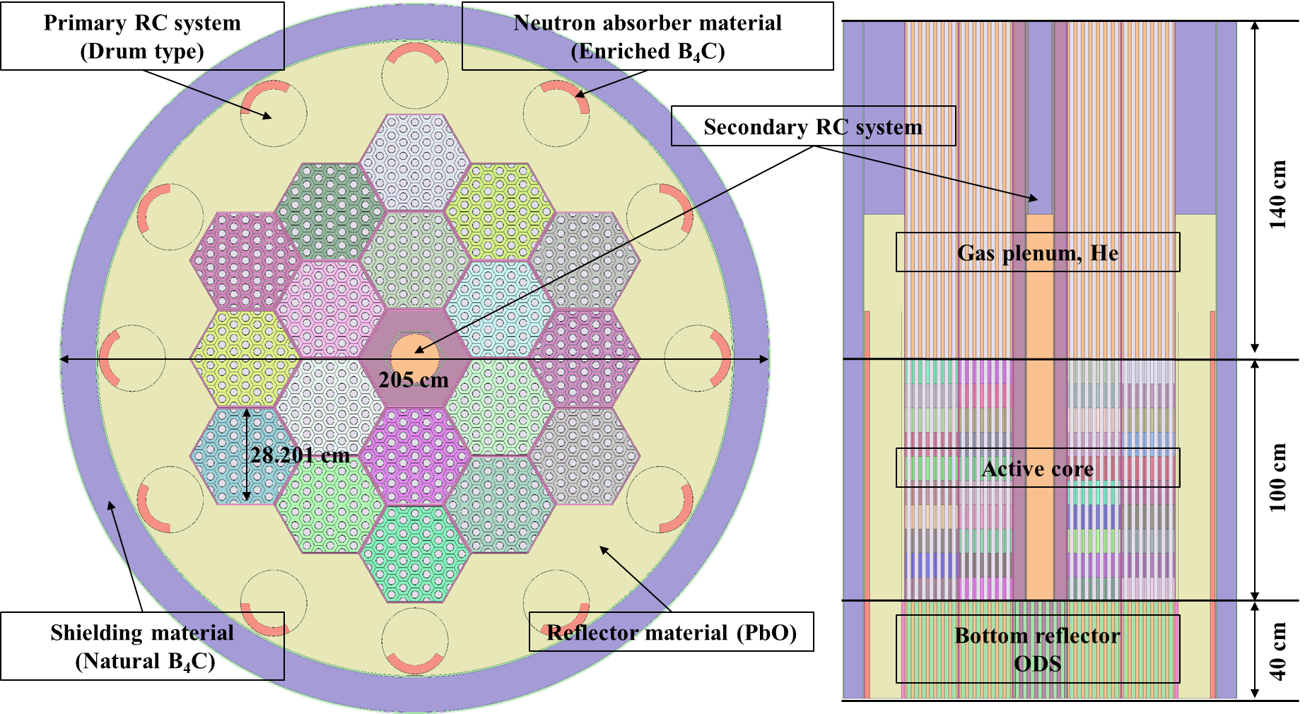

Fig. 1. Radial and axial configuration of H-MMR.

TABLE 1. DESIGN PARAMETERS OF H-MMR

|  |  |
| --- | --- |
| **Parameters** | **Values** |
| Reactor power | 18 MWth |
| Number of fuel assemblies | 18 |
| Active core equivalent radius | height | 64.54 cm | 100 cm |
| Whole core equivalent radius | height | 102.5 cm | 280 cm |
| Mass of U | 9.91 ton (550.65 kg/FA) |
| Operating temperature | 670 ~ 680 ℃ |
| Power density | 15.61 W/cc |

The specific design parameters are summarized in Table 1. The reactor power is 18 MWth and the power density is 15.61 W/cc. The nuclear fuel is UN, which uses 99.9 % N-15 enriched nitride to avoid the decrease of the neutron economy due to the neutron capture by N-14. The active core equivalent radius and height are 64.54 cm and 100 cm, respectively. The hexa-annulus type of UN fuel is introduced as shown in Fig. 2. In the interior region of FA, the O-shape potassium heat pipe is surrounded by hexagonal UN fuel within ODS cladding [11]. On the other hand, a D-shape heat pipe is introduced, which is surrounded by isosceles trapezoid UN fuel, to transfer the heat at the peripheral FA region. The ODS cladding is introduced for the manufacture point of view since a solid core block one has a challenging issue. In the neutronics point of view, the role of the ODS cladding within the FA is to mitigate excess reactivity that can be formed less than one dollar during the whole lifetime by adjusting the conversion ratio through the neutron spectrum softening. The auxiliary benefit of the hexagonal and isosceles trapezoid ODS cladding is to prevent the leakage of potassium from the failure of the hexa-annulus UN fuel.

The detailed design parameters of the hexa-annulus fuel assembly are summarized in Table 2. The UN fuel density is assumed to be 13.5 g/cc, which is 94.21 % of theoretical density. The 12.10 w/o fuel enrichment is optimized in terms of excess reactivity and reactor lifetime.

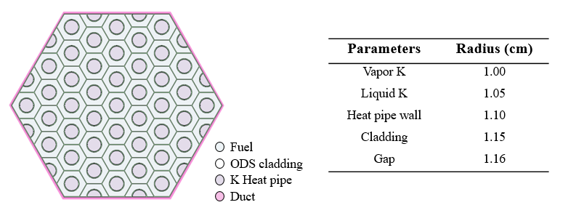

Fig. 2. Configuration of hexa-annulus fuel assembly cooled by potassium heat pipes.

TABLE 2. DESIGN PARAMETERS OF HEXA-ANNULUS FUEL ASSEMBLY

|  |  |
| --- | --- |
| **Parameters** | **Values** |
| Fuel material (density) | U15N (13.5 g/cc) |
| Fuel enrichment (235U) | 12.10 w/o |
| N-15 enrichment | 99.9 % |
| Cladding material (density) | ODS (7.2 g/cc) |
| Gap material | Helium |
| Number of heat pipes (O-shape | D-shape) | 43 | 12 |
| Heat pipe radius | 1.05 cm |
| Heat pipe wall thickness | 0.05 cm |
| Heap pipe cladding thickness | 0.05 cm |
| Heat pipe gap thickness | 0.1 cm |
| Fuel assembly pitch | 28.20 cm |
| Fuel assembly duct thickness | 0.3 cm |
| Inter-assembly gap | 0.2 cm |

## nUMERICAL RESULTS

In Monte Carlo analyses by Serpent 2 code, the condition of the calculation is as follows. The depletion calculation was conducted by 200 inactive and 300 active cycles with 1 M neutron histories per cycle using the predictor-corrector method. In the case of the steady-state calculation to obtain the reactivity feedback coefficient and reactivity worth of the control system, the same number of the inactive and active cycles were carried out with 10 M neutron histories.

The evolution of the multiplication factor and corresponding excess reactivity is depicted in Fig. 3. The excess reactivity in dollar was calculated by the evolution of effective beta value as shown in Fig. 4. Results show that the H-MMR core lifetime is around 56 years, while the excess reactivity is less than one dollar during the whole reactor core lifetime. The maximum excess reactivity is around 0.45 dollar in the middle of the lifetime (MOL). The discharge burnup is estimated as 37.12 GWd/MTU, which is around 3.96% fractional burnup. It is noticeable that the effective beta value is decreased during the lifetime from ~0.72 to ~0.59 since the Pu build-up by the conversion.

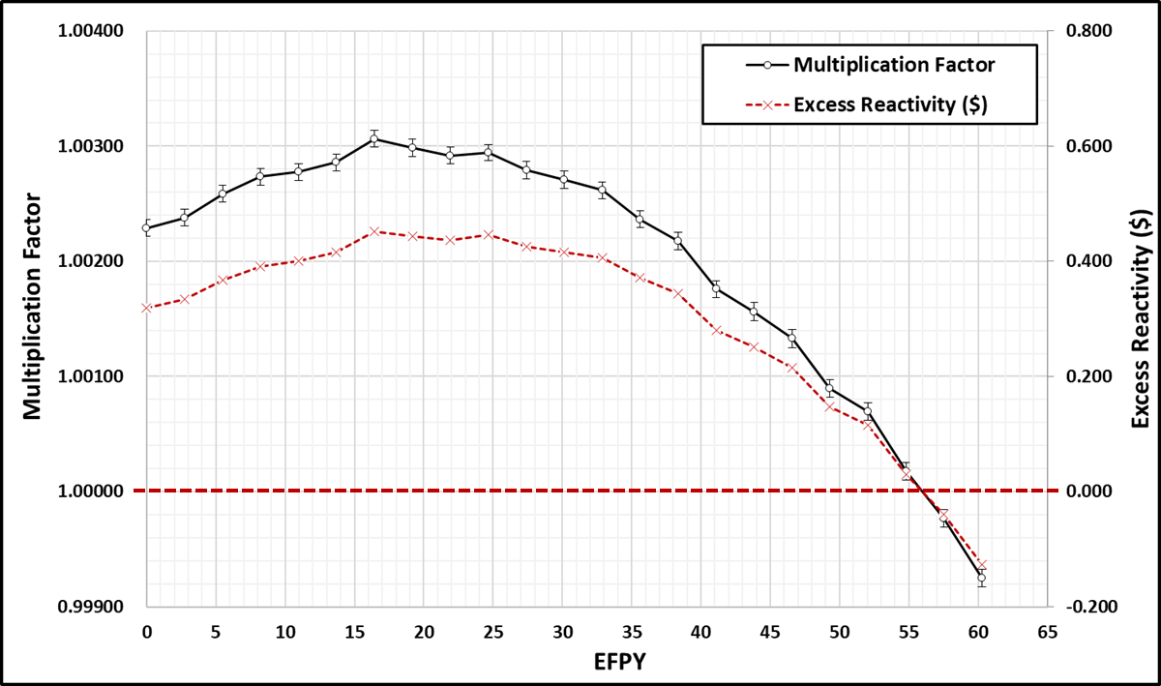

Fig. 3.Evolution of multiplication factor and excess reactivity.

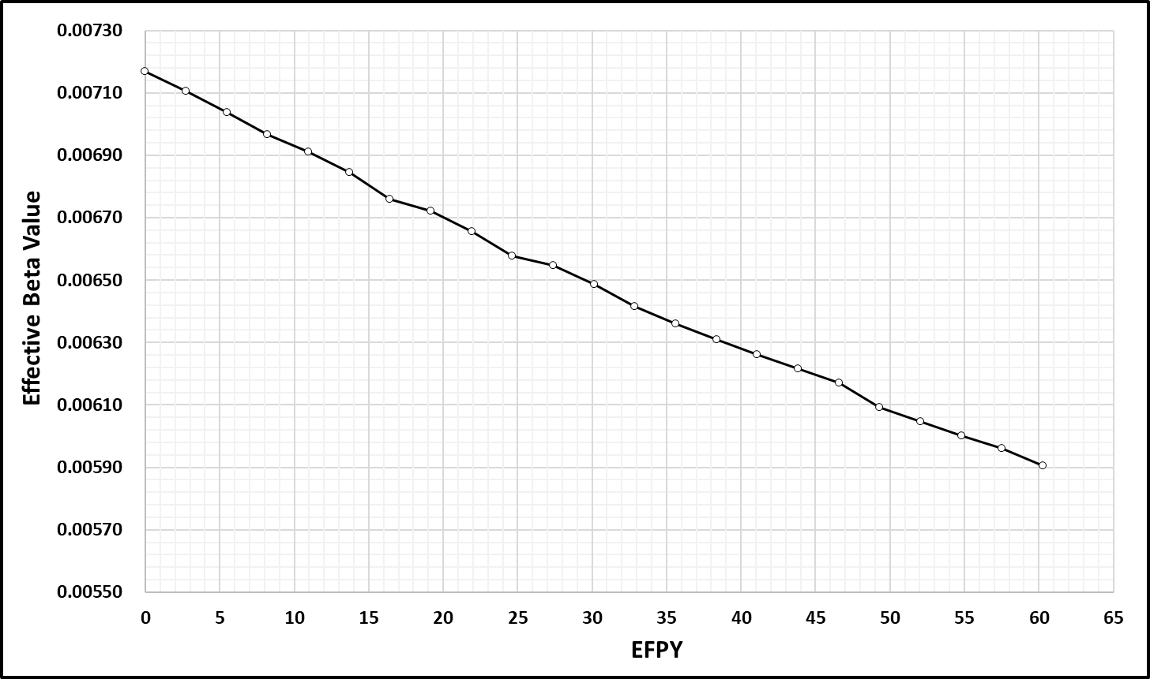

Fig. 4.Evolution of effective fraction of delayed neutrons (effective beta value).

The reactivity feedback coefficients at the beginning of lie (BOL) and end of life (EOL) are summarized in Table 3. The fuel temperature coefficient (FTC) and the coolant temperature coefficient (CTC) were estimated by ± 100 K of UN fuel and ± 50 K of potassium perturbed calculation, respectively. In the case of coolant void reactivity (CVR), the conservative assumption was considered that all of the potassium in the entire heat pipe in the core is removed. Results show that the FTC is dominant compared to CTC due to the characteristic of the hexa-annulus FA. Compared to the conventional pin-type FA in a fast reactor, the portion of the liquid potassium is relevantly small so that the impact of the spectrum softening by coolant material is relevantly minor in the H-MMR core. In this regard, CVR could be a negative value at the BOL since the neutron leakage effect is dominant compared to the spectrum softening effect when all of the potassium is removed. It is expected that some heat pipe failures would be neglected in terms of CVR since the current CVR is assumed based on the absence of potassium in 774 O-shape and 216 D-shape heat pipes. The group-wise kinetic parameters of H-MMR, a six-group fraction of delayed neutrons (βi), and decay constant of delayed neutron precursor (λi) are tabulated in Table 4 for the point-kinetic analysis of the load-follow operation.

TABLE 3. REACTIVITY FEEDBACK COEFFICIENTS

|  |  |  |  |
| --- | --- | --- | --- |
| **Burnup** | **FTC (pcm/K)** | **CTC (pcm/K)** | **CVR (pcm)** |
| BOL | -0.505 ± 0.023 | -0.022 ± 0.032 | -30.98 ± 3.24 |
| EOL | -0.481 ± 0.023 | -0.001 ± 0.034 | 1.07 ± 3.40 |

TABLE 4. KINETIC PARAMETRES OF H-MMR

|  |  |  |  |  |
| --- | --- | --- | --- | --- |
| **Energy group** | **BOL** | | **EOL** | |
| **Beta (βi)** | **Lambda (λi)** | **Beta (βi)** | **Lambda (λi)** |
| 1st | 1.955E-04 ± 1.324E-06 | 1.339E-02 ± 7.900E-07 | 1.556E-04 ± 1.298E-06 | 1.339E-02 ± 9.641E-07 |
| 2nd | 1.117E-03 ± 3.284E-06 | 3.238E-02 ± 1.716E-06 | 9.346E-04 ± 3.084E-06 | 3.211E-02 ± 2.505E-06 |
| 3rd | 1.125E-03 ± 3.285E-06 | 1.215E-01 ± 3.281E-06 | 9.214E-04 ± 3.087E-06 | 1.209E-01 ± 8.705E-06 |
| 4th | 2.773E-03 ± 5.019E-06 | 3.101E-01 ± 1.861E-05 | 2.281E-03 ± 4.699E-06 | 3.105E-01 ± 2.391E-05 |
| 5th | 1.377E-03 ± 3.553E-06 | 8.758E-01 ± 7.182E-05 | 1.176E-03 ± 3.187E-06 | 8.790E-01 ± 8.087E-05 |
| 6th | 5.729E-04 ± 2.229E-06 | 2.943E-00 ± 3.826E-04 | 4.817E-04 ± 2.177E-06 | 2.947E-00 ± 5.010E-04 |
| Effective | 7.161E-03 ± 8.235E-06 | 5.485E-01 ± 8.282E-04 | 5.951E-03 ± 7.617E-06 | 5.553E-01 ± 1.011E-03 |

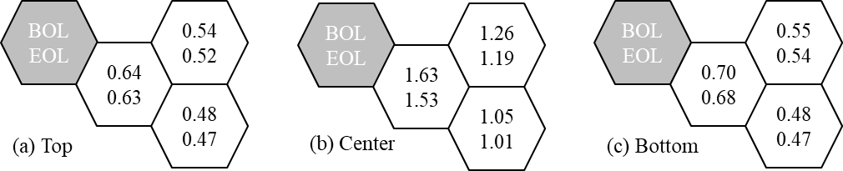

Fig. 5. Normalized radial power distribution of H-MMR

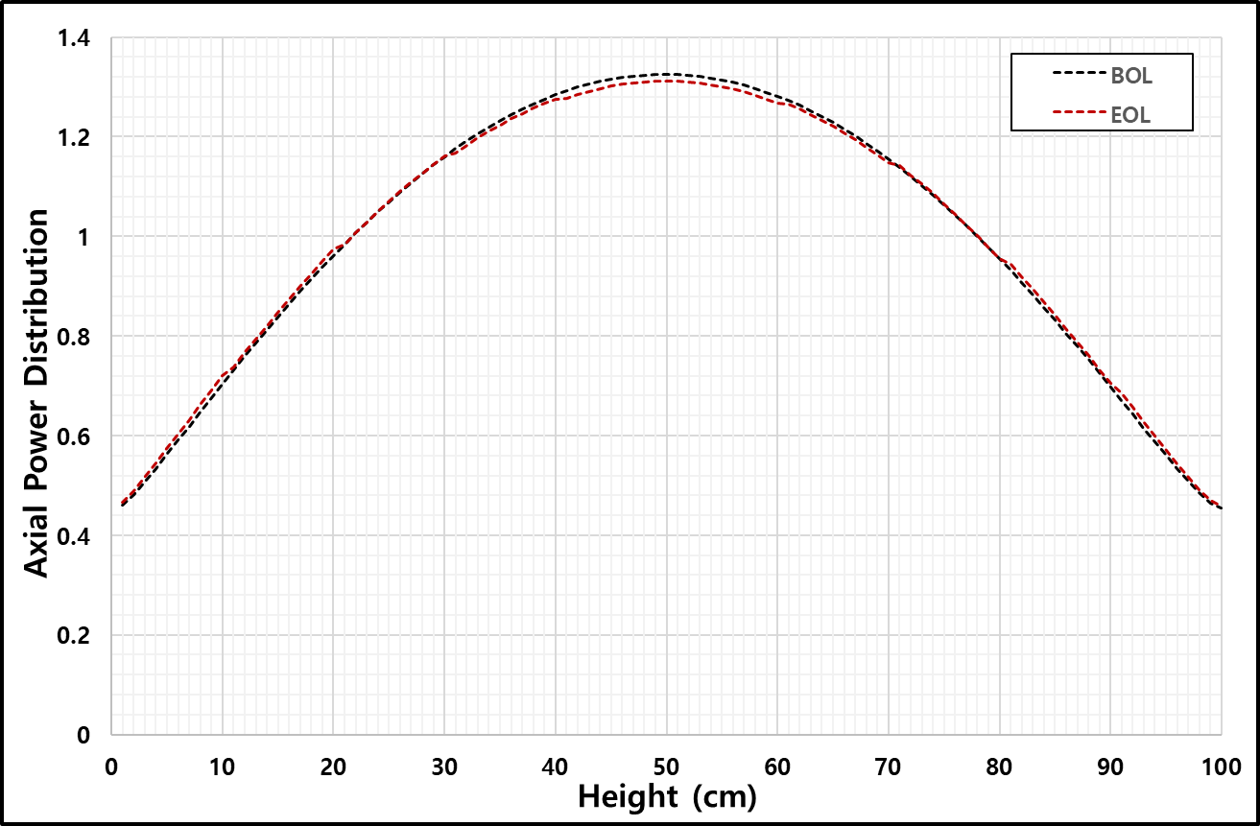

Fig. 6. Normalized axial power distribution of H-MMR

The normalized radial and axial power distribution were evaluated as shown in Fig. 5 and 6. The maximum normalized radial and axial power are around 1.6 and 1.3, respectively. In the case of the normalized radial power distribution, H-MMR has the characteristic of the radial power distribution in a conventional fast reactor due to the relatively long mean free path of the neutron under the fast spectrum. In Fig. 6, results show that the axial power distribution is symmetric and there are no differences between that at the BOL and EOL.

The primary RC system, in drum type form, consists of 98 % B-10 enriched B4C neutron absorber material with 98 % of theoretical density. On the other hand, the secondary RC system located in the central region above the active core consists of natural B4C neutron absorber material with 98 % of theoretical density. To assess the reactivity worth of the primary and secondary control system, there are three cases as shown in Fig. 7. The ‘Primary’ means that all control drums were inserted by rotating them. In the case of the stuck drum worth, the reactivity worth was estimated while one of the control drums is stuck as shown in the “Primary -1” case. In the case of the secondary control system, it was evaluated by inserting the control rod assembly into the non-fuel region at the center of the active reactor core. The “Total” indicates the evaluated reactivity worth when all primary and secondary RC systems are inserted into the active core. The evaluated reactivity worth is tabulated in Table 5. Results show that the primary and secondary RC systems have enough shutdown margins.

TABLE 5. REACTIVITY WORTH OF PRIMARY AND SECONDARY REACTIVITY CONTROL SYSTEM

|  |  |  |
| --- | --- | --- |
| **Worth** | **BOL (pcm)** | **EOL (pcm)** |
| Primary | 1956.43 ± 3.30 | 1803.94 ± 3.46 |
| Primary-1 | 1808.22 ± 3.37 | 1663.12 ± 3.38 |
| Secondary | 1978.17 ± 3.46 | 1888.65 ± 3.39 |
| Total | 4180.74 ± 3.46 | 3896.97 ± 3.54 |

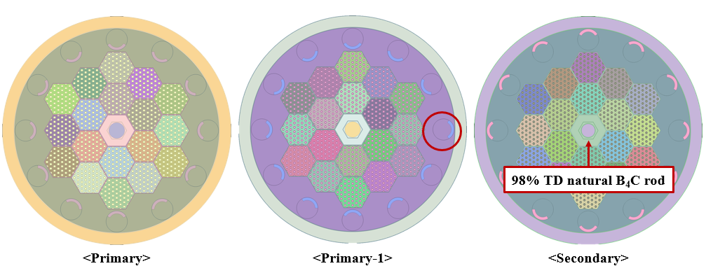

*FIG.7 Primary and secondary reactivity control system*

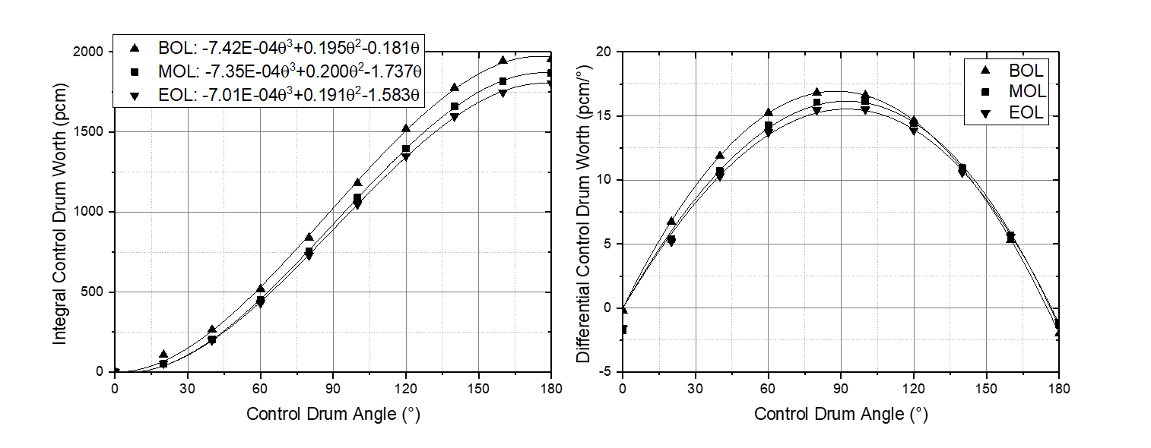

*FIG.8 Integral and differential control drum worth depending on control drum angle*

The strategy of the passive load-follow operation is based on the reactivity feedback effect by temperature change while excess reactivity is controlled by rotating the control drum. Therefore, the integral and differential control drum worth are needed to achieve the critical reactor in normal operation. The integral control drum worth was evaluated by rotating all control drums to clockwise direction as shown in Fig. 8. Depending on the rotating control drum angle, the integral control drum worth was obtained and it was approximated by the 3rd order polynomial function. Then, the differential control drum worth was obtained from the polynomial function.

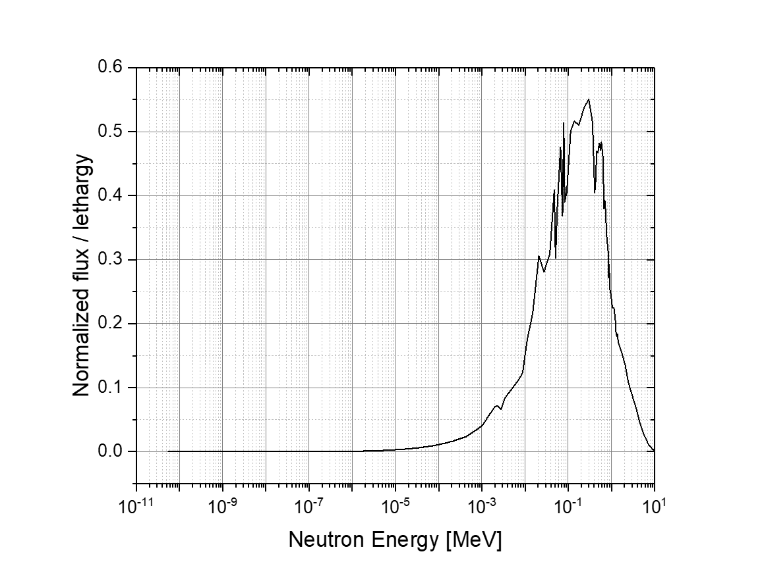

*FIG.9 Neutron spectrum in H-MMR active core*

The neutron spectrum in H-MMR active core was also evaluated as shown in Fig. 9 and the evolution of conversion ratio as shown in Fig. 10. In the fast neutron spectrum, the reproduction factor, so-called eta value, is an important factor in terms of the neutron economy. It should be mentioned that the neutron economy was mitigated in the current H-MMR design by softening the neutron spectrum through the ODS cladding material in the hexa-annulus fuel to maintain the flat excess reactivity in the whole lifetime. Otherwise, the H-MMR lifetime would be unrealistically determined like over 100 years mainly due to the efficient neutron economy. It is also noticeable that the conversion ratio is increased from around 0.755 to 0.800 due to Pu build-up even though the neutron spectrum was mitigated by ODS cladding in hexa-annulus FA.

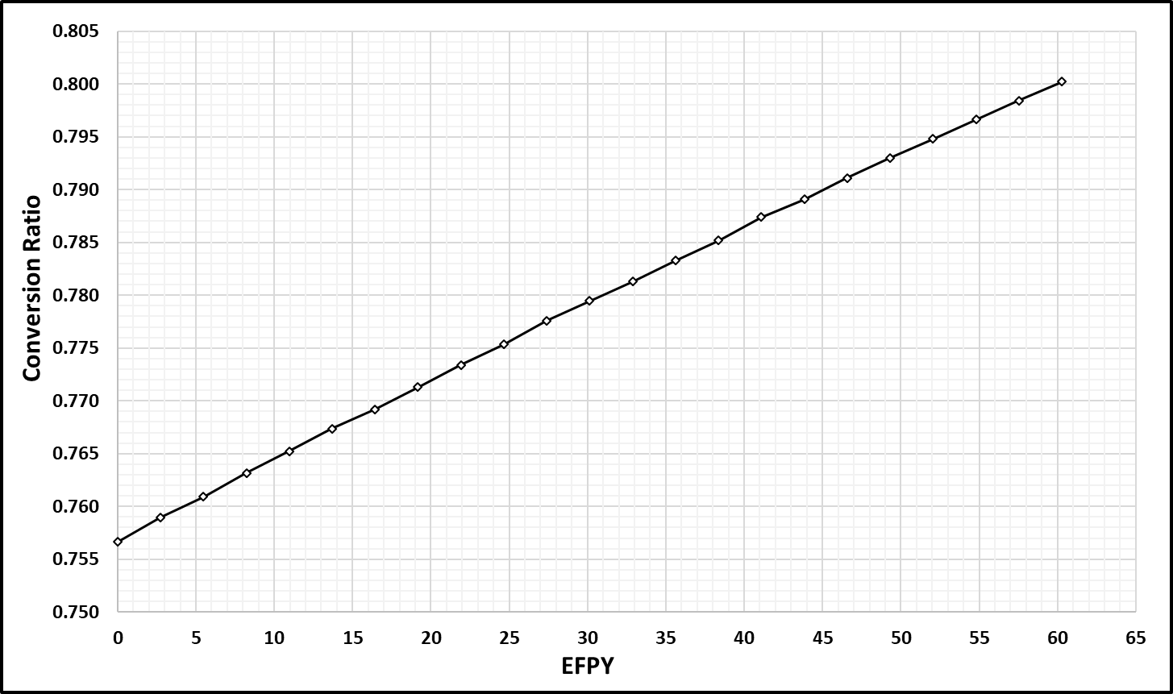

*FIG.10 Evolution of conversion ratio*

## CONCLUSIONS AND FUTUREWORKS

The conceptual design of a hybrid micro modular reactor (H-MMR) cooled by potassium heat pipe has been introduced, which aimed at the ultra-long reactor core lifetime and capability of the passively load-follow operation. The reactor power is 18 MWth and the power density is 15.61 W/cc. The unique fuel assembly (FA) design is adopted as hexa-annulus FA that the potassium heat pipe is surrounded by hexagonal uranium nitride (UN), which uses 99.9 % enriched N-15, fuel within oxide dispersion-strengthened steel (ODS) cladding. The fuel enrichment is 12.10 w/o, and the reactor core lifetime is around 56 years maintaining the excess reactivity of less than ~0.45 dollar. The discharge burnup is 37.12 GWd/MTU (3.96 %burnup). All point kinetic parameters and feedback coefficients were evaluated for the point kinetic analysis of the passively load-follow operation. In conclusion, the conceptual design of ultra-long-life H-MMR has been successfully introduced by an aspect of the neutronics optimization.

In future works, the point kinetic analysis would be performed by combining the heat pipe model for the evaluation of the passively load-follow operation aimed at the flexible energy mix system. Furthermore, the optimization of the shield is needed to reduce the total weight of the reactor module.

ACKNOWLEDGEMENTS

This work was supported by the National Research Foundation of Korea (NRF) grant funded by the Korean government (Ministry of Science and ICT) (No. NRF-2017M2B2B1071970)

References

1. General Assembly of the United Nations, “Resolution adopted by the General Assembly on 25 September 2015, Transforming our world: the 2030 Agenda for Sustainable Development”, A/RES/70/1, September, 2015.

https://sdgs.un.org/

1. S. M. Bragg-Sitton et al. “Nuclear-Renewable Hybrid Energy Systems: 2016 technology development program plan”, INL/EXT-16-38165,March, 2016.
2. Hwanyeal Yu, Donny Hartanto, Bong Seong Oh, Jeong Ik Lee, and Yonghee Kim, “Neutronics and Transient Analyses of a Supercritical CO2-Cooled Micro Modular Reactor (MMR)”, Energy Procedia, Vol. 131, pp. 21-28, December, 2017.
3. Hwanyeal Yu, Donny Hartanto, Jangsik Moon and Yonghee Kim, "A Conceptual Study of a Supercritical CO2-Cooled Micro Modular Reactor," Energies, Vol.8, Issue 12, p.13938-13952, 2015.
4. Donny Hartanto, Yonghee Kim, and Francesco Venneri, "Neutronics Evaluation of a Super-Deep-Burn with TRU Fully Ceramic Microencapsulated (FCM) Fuel in CANDU," Progress in Nuclear Energy, Vol. 83, p. 261-269, 2015.
5. Bong Seong Oh, Yoon Han Ahn, Hwanyeal Yu, Jangsik Moon, Seong Gu Kim, Seong Kuk Cho, Yonghee Kim, Yong Hoon Jeong, and Jeong Ik Lee, “Safety evaluation of supercritical CO2 cooled micro modular reactor”, Annals of Nuclear Energy, Vol. 110, pp. 1202-1216, December, 2017.
6. Seongdong Jang and Yonghee Kim, “Autonomous and Ultra-long Life Hybrid Micro-Modular Reactor Cooled by Heat Pipes,” Proceedings of the Vietnam Conference on Nuclear Science and Technology, Ha Noi, Vietnam, August 7-9, 2019.
7. Seongdong Jang and Yonghee Kim, “A Preliminary Study of Autonomous and Ultra-long Life Hybrid Micro-modular Reactor Coolded by Sodium Heat Pipe,” IAEA Technical Meeting on the Benefits and Challenges of Fast Reactors of the SMR Type, Milan, Italy, September 24, 2019.
8. Young Jae Choi, Seongmin Lee, Seongdong Jang, In Woo Son, Yonghee Kim, Jeong Ik Lee, and Yong Hoon Jeong, Conceptual design of reactor system for Hybrid Micro Modular Reactor (H-MMR) using potassium heat pipe, Nuclear Engineering and Design, Vol. 370, 110886, published online, 2020.
9. J. LEPPÄNEN, “Serpent–a continuous-energy Monte Carlo reactor physics burnup calculation code,” VTT Technical Research Centre of Finland, 4 (2013).
10. Young Jae Choi, “Optimal design of heat pipe cooling system of small modular reactor and experimental study of high temperature heat pipe, Ph.D. Thesis,” Korea Advanced Institute of Science and Technology, 2021.