OPTIMIZATION OF BUILT-IN PRIMARY SODIUM PURIFICATION SYSTEM FOR ADVANCED BN REACTOR PLANT

RUKHLIN S.V.
JSC “Afrikantov OKBM”,
Nizhny Novgorod, Russia
Email: rukhlin_sv@okbm.nnov.ru

SHEPELEV S.F.
GUSEV D.V.
SHUMSKII A.A.
JSC “Afrikantov OKBM”,
Nizhny Novgorod, Russia

Abstract

While developing an advanced BN reactor plant the tasks were put to reduce a reactor plant cost with obligate meeting of safety requirements and reliability increase of reactor plant equipment and systems. The subject of the present paper is optimization of a built-in primary sodium purification system for the advanced BN reactor plant.

Introduction
The sodium cooled reactor plants of high power were equipped with the purification system with cold traps for cooling of sodium, which were located in the reactor vessel (in-built purification system) [1].
During development of the design of the advanced fast sodium reactor plant, the tasks were assigned to reduce the cost of the reactor plant with implicit maintaining of the safety requirements and enhancing the reliability of the equipment and systems of the reactor plant.
The primary circuit purification system was subjected to modification.

WORKING OUT THE AREAS OF THE OPTIMIZATION OF THE PURIFICATION SYSTEM
The principle design of the preset in-built purification system [1], and namely of the in-built cold trap, is given in Fig. 1.

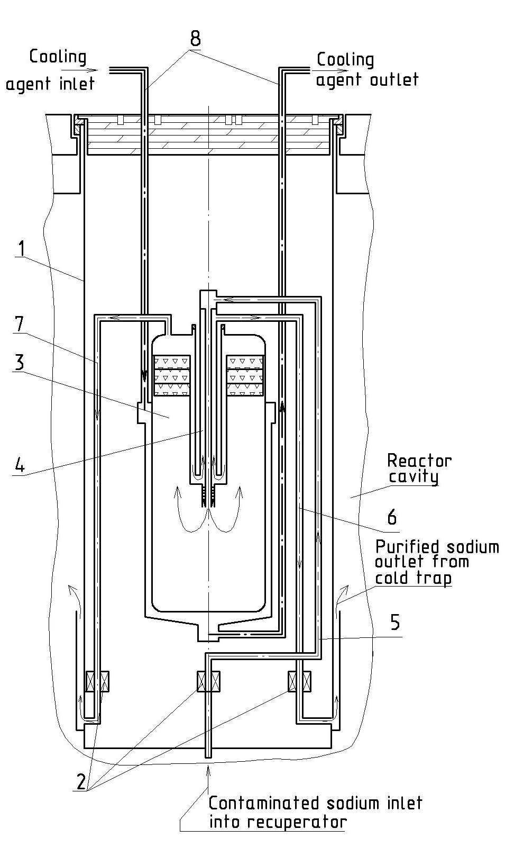
1 - casing of the in-built cold trap
2 – electromagnetic devices
3 - working cavity of the cold trap
4 - recuperator
5 - feed pipe of the contaminated sodium to the recuperator
6 - discharge pipe of the purified sodium from the recuperator
7 - bypass pipe of the purified sodium from the working cavity
8 - coolant inlet and outlet pipes
FIG. 1. Basic diagram of the cold trap

After analyzing this design of the cold trap there were found the possible areas of optimization from the point of view of reliability and economic efficiency.
The present design of the cold trap had electromagnetic devices to provide circulation of sodium through the cold trap.
As these devices are installed at the bottom part of the cold trap on the sodium feed and discharge pipes, the replacement of these devices is possible only with removal of the cold trap from the reactor, washing of the cold trap and its disassembly.
Considering low accessibility of the electromagnetic devices, complexity of the design, and additional requirements for equipping of the electromagnetic devices with auxiliary systems – power supply system, cooling system – the decision was taken to work out a cold trap design without electromagnetic devices.
So, the first area of optimization is exclusion of the non-interchangeable electromagnetic devices.
The design of the cold trap has a working cavity of a definite volume, which defines the capacity of the cold trap relatively to the impurities.
Approximately 18 cold traps are required to provide accumulation of impurities for the service life of the reactor plant (60 years). Meanwhile, some of them are installed in the reactor, and the balance ones are a part of spare parts. A cold trap is replaced after accumulation of a definite amount of impurities.
Considering that fact that significant costs are required to manufacture 18 cold traps, their periodical replacement, and decommissioning of the spent cold traps, the decision was taken to work on the increase of the impurity capacity of the cold traps.
So, the second optimization area is increase of the impurity capacity of the cold traps (increase of the volume of the working cavity).

Exclusion of the noninterchangeable electromagnetic devices
In case of absence of the electromagnetic devices it is necessary to solve a problem of providing circulation through a cold trap.
The decision was taken to connect the cold trap with the discharge chamber of the reactor.
But, considering different sodium pressure during operation of the reactor at power levels, and at the shut-down reactor, it is necessary to regulate sodium flow rate through the cold trap. And, respectively, it is necessary to equip the cold trap with mechanical valves. In this case it is necessary to ensure a possibility to replace the valves in case of their failure.
The basic diagram of the valves is given in Fig. 2.

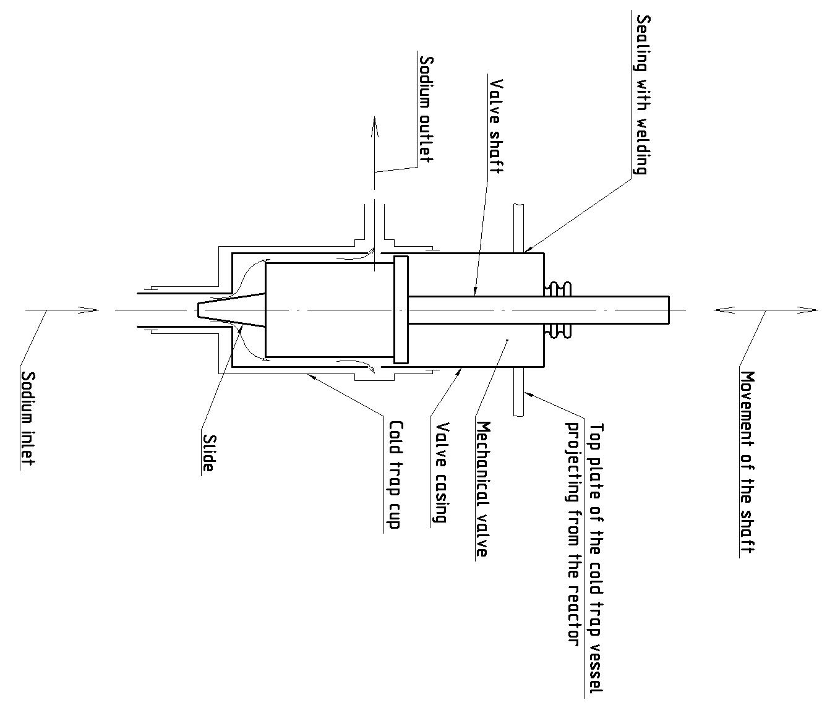
FIG. 2. Basic diagram of mechanical valves.

The developed design of the mechanical valves consists of a casing and a movable shaft with a slide.
While approaching of the slide or its distancing from the seat, the sodium flow rate is decreasing or increasing through the cold trap respectively.
The valves are installed in the panels of the cold trap through the top plate of the cold trap casing and sealed with a weld joint.
This ensures accessibility and changeability of the mechanical valves.
A model of the valve was manufactured and tested to validate the functionality of the mechanical valves and to choose the flow part of the slide. The model of the valve installed on the test facility is given in Fig. 3.

Manual drive
Test facility
Valve model

FIG. 3. The model of the valve on the test facility

During testing of the valve several slides were manufactured with different geometry of the flow part.
Hydraulic resistance, leaks through the valve (in closed position), variation of the flow by the position of the slide was defined for each modification of the slide.
Based on the test results the optimal shape of the slide was chosen for application in the valve.

Increase of impurity capacity of the cold trap
The capacity of the cold trap is defined with the volume of its working cavity. Diameter of the working cavity is limited with the diameter of the cold trap casing, which defined with a reactor layout.
Additionally, as it can be seen in Fig. 1, the coolant inlet and outlet pipes of 100 mm diameter are placed outside the working cavity.
The essence of the solution is application of eccentricity headers, which permit to avoid pipes passing along the working cavity.
The cooling system of the working cavity using eccentricity headers is given in Fig. 4.

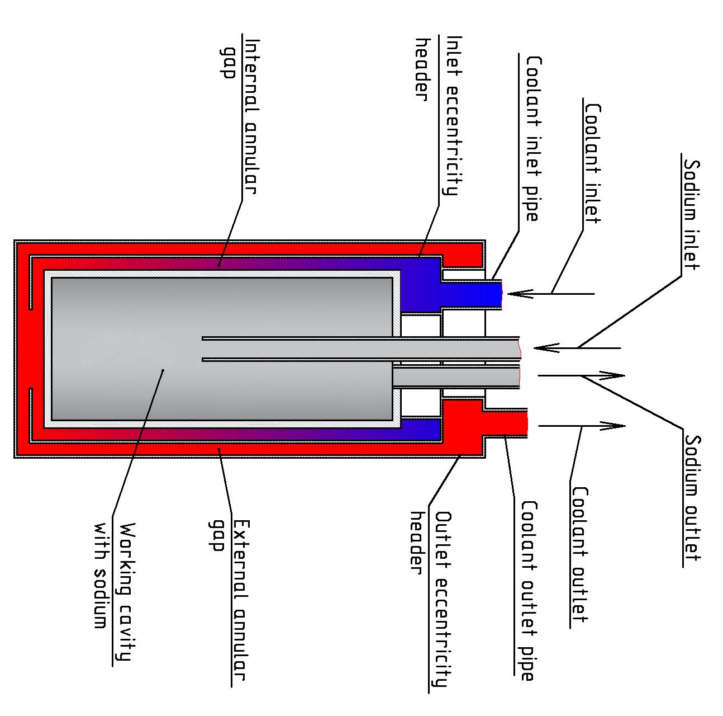

FIG. 4. Cooling system of the working cavity with eccentricity headers

This system works in the following manner.
The coolant goes from the coolant inlet pipe to the inlet eccentricity header, further goes through the internal annular gap and cools the working cavity. Further, in the bottom part of the working cavity the coolant comes to the outer annular gap and further flows to the outlet eccentricity header, and then to the coolant outlet pipe.
The implemented scheme excludes any necessity to place the coolant inlet and outlet pipes outside the working cavity, and this permits to increase the diameter of the working cavity and impunity capacity of the cold trap.

The optimized design of the cold trap
The basic diagram of the optimized design of the cold trap is given in Fig. 5.

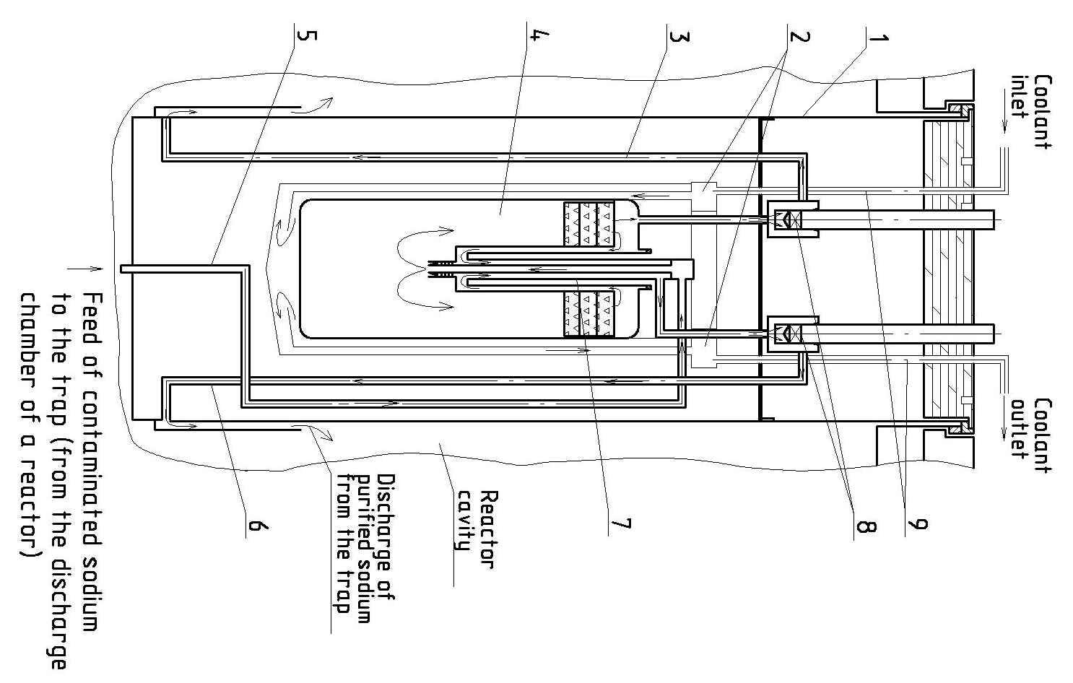
1 - casing of the in-built cold trap
2 - eccentricity headers
3 - bypass pipe of the purified sodium from the working cavity
4 - working cavity of the cold trap
5 - feed pipe of the contaminated sodium to the recuperator
6 - discharge pipe of the purified sodium from the recuperator
7 - recuperator
8 - interchangeable valves
9 - coolant inlet and outlet pipes

FIG. 5. Principal scheme of an optimized cold trap design

The optimized design of the cold trap is a vessel, where the working cavity with the recuperator and filter, sodium feed and discharge pipes, mechanical valves, coolant inlet and outlet pipes and eccentricity headers are located inside.
The cold trap works in the following manner. Contaminated sodium flows from the discharge chamber of a reactor to the working cavity of the cold trap pos. 4, and the sodium purified in the working cavity flows through the mechanical valves pos. 8. The sodium flow (through the recuperator of bypassing it depending on the sodium temperature at the cold trap inlet) is regulated and changed with the mechanical valves pos. 8.
It was possible to enhance significantly the main characteristics of the cold trap and maintain its main characteristics.
The comparison characteristic of the present cold trap and the optimized one is given in table 1.

TABLE 1. COMPARISON CHARACTERISTICS OF THE COLD TRAP

Cold trap | Flow rate, kg/s | Impurity capacity, kg | Number of cold traps for the service life of a reactor plant, pc.
Before optimization | 0.7 | 430 | 18
After optimization | 1.07 | 760 | 11

Conclusion
Application of some technical solutions in the design of the cold trap, like use of interchangeable valves located in the top part of cold trap and eccentricity headers, permitted to enhance reliability and serviceability of the cold trap, and reduce number of cold traps required for replacement during service life of a reactor plant, and that positively influenced the cost of construction of a reactor plant and costs for replacement of the cold trap and utilization of the spent cold traps.

References
- Rukhlin S., Berikbosinov V., Gusev D., Komarov A., Rogozhkin S., Shepelev S., Shumsky A., “Development of the built-in primary sodium purification system for the advanced BN-1200 reactor plant”, Fast Reactors and Related Fuel Cycles: Next Generation Nuclear Systems for Sustainable Development FR17 (Proc. Int. Conf., Yekaterinburg, 2017), IAEA, Paper CN245-404.

