Development of the Sodium-Cooled Fast Reactor Technology in Russia

Vasyaev A.V., Zverev D.L., Staroverov A.I., Shepelev S.F.
JSC “Afrikantov OKBM”, Nizhny Novgorod, 456612, Russian Federation

Gulevich A.V., Kamaev A.A., Klinov D.A.
JSC SSC RF-IPPE, Obninsk, Russian Federation

Yershov A.V., DYAGILEV A.M., PAVLYUKEVICH YE.YU., Yashkin A.V.
JSC ATOMPROEKT, St. Petersburg, Russian Federation

Abstract

The experience and competences obtained while establishing the BN reactor technology from BR-5/10 to BN-600 and BN-800 have provided an opportunity for commercial deployment of this technology in a two-component nuclear energy system.
The paper covers the operation results of the BN-600 and BN-800 commercial reactors, and describes the development and validation results of a commercial power unit with a next generation BN-1200 reactor. The large BN reactor design is based on the best possible combination of reference and innovative engineering solutions; and in this connection a representative scope of R&D activities is underway to support the validation of those solutions.

Introduction
The development of the first fast-neutron reactor (BR-5) in Russia more than 60 years ago paved the way for emerging of a two-component nuclear power industry with thermal and fast-neutron reactors and a closed nuclear fuel cycle (NFC) [1]. Such closed fuel cycle is underpinned by the physical features of fast neutron reactors, which, due to their neutron spectrum, ensure the U-238 involvement in the nuclear fuel cycle, fuel breeding with multiple uses of plutonium in a closed fuel cycle, efficient utilization of minor actinides (MA), and multiple reductions in natural uranium consumption; and what is more those features are fundamental for handling the challenges related to spent nuclear fuel (SNF) management in reactors of various types. This also allows for promoting a wide range of export services on the world fuel market.
The experience and competences obtained while establishing the sodium-cooled fast neutron reactor (BN) technology from the experimental BR-5/10 reactor to the commercial BN-600 and BN-800 reactors have enabled the transition to commercial development of the technology.
The BN-1200 design development is based on the best compromise between the reference and new engineering solutions aimed at achieving the safety level which eliminates the need for the population to be evacuated or resettled under severe beyond design-basis accident conditions; competitive technical and economic indicators of the power unit; and compliance of the design with the Generation IV requirements. To date, the step-by-step implementation of the R&D programme is underway aimed at justifying the safety and the new engineering solutions related to the reactor basic equipment; apart from that, engineering and economic solutions to architectural and construction issues of the power unit are being optimized.

Stages of Sodium-Cooled Fast Reactor Development in Russia
The programme of research, development and industrialization of fast reactor technologies is currently underway in Russia (Fig. 1) [2, 5].
The technologies associated with sodium coolant, structural materials, reactor equipment operation and repair were mastered as far back as at the experimental BR-5/10 reactor operation stage. In addition, the results of the first studies on performance validation of fuel rods with different types of fuel (uranium dioxide and plutonium, uranium carbide and nitride) under different operating conditions were obtained.
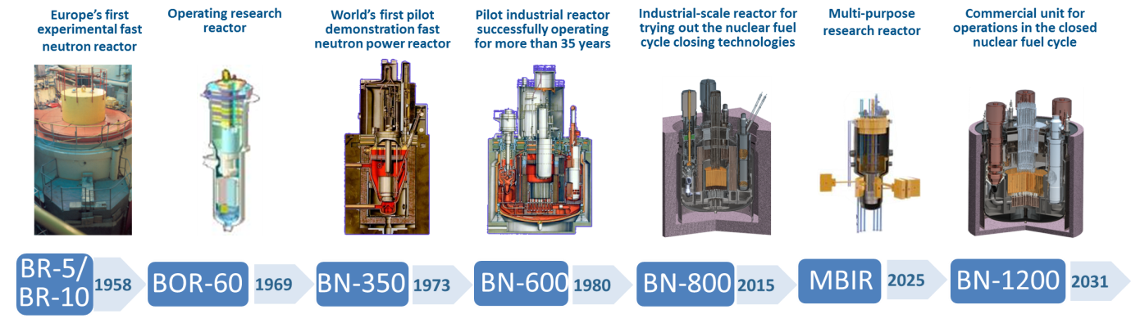Fig. 1. Evolution of the Sodium-Cooled Fast Reactors in Russia.

Sodium technology in terms of sodium contaminant monitoring and purification, development of sodium parameter monitoring instrumentation, including radiation monitoring was mastered based on the BOR-60 research reactor which is in operation up till now. The reactor provides for testing of fuel, main equipment, including SG.
The operation of the first power reactor BN-350 made it possible to gain experience in operation at a thermal capacity of up to 750 MW, study the behavior of structural materials under irradiation and verify the service life characteristics of the equipment. In addition, the plant was used to produce not only electricity, but also fresh water for enterprises and the population of the town of Shevchenko (present day Aktau, in Kazakhstan).
The use of sodium technology on an industrial scale began with the commissioning of the BN-600 reactor. The 40-year successful operation contributed to maturing the reactor equipment and implementing the reactor integrated layout, provided the possibility to validate various types of fuel (Mixed Oxide (MOX) and Mixed Nitride Uranium Plutonium (MNUP) fuel) and structural materials based on irradiation tests.
Participation in the CEFR project (China) determined the international cooperation experience related to the BN reactors, in particular, development and complete delivery of the main equipment (primary- and secondary-circuit pumps, reactor component parts, control rod drive mechanisms, heat exchangers, refueling equipment, sodium instrumentation, electromagnetic pumps), participation in on-site installation supervision and adjustment supervision, and in personnel training.
The BN-800 design development and implementation period is a significant stage in restoring the competences in equipment manufacturing, maintaining the competences in designing, manufacturing and delivery.
The BN-600 reactor development and operation experience and the BN-800 project implementation enabled sodium-cooled fast reactor technology development and ensured its readiness for commercial application in the two-component nuclear power industry.
Currently, the BN-1200 reactor project is being developed for a reference commercial power unit, and innovative design and engineering solutions are being developed and justified.
Over the years of BN technology formation there has been a stable cooperation of enterprises, which is based on the educational background and competences of specialists in various fields.
Reactor plant related activities are performed by the State Corporation Rosatom enterprises, the key ones include: JSC ATOMPROEKT (NPP General Designer), JSC “Afrikantov OKBM” (Reactor Plant Chief Designer), JSC SSC RF IPPE, (Scientific Coordinator), JSC OKB GIDROPRESS (Steam Generator Chief Designer), JSC VNIINM (Chief Designer – Process Engineer for Fuel Rods), CRISM "Prometey" (Head Materials Science Organization).
Design and engineering, scientific research, production and operational infrastructure had been created, which became the basis for stable development of the BN technology.

EVOLUTION OF ENGINEERING SOLUTIONS FOR COMMERCIAL REACTOR PLANTS
The key design criteria for BN reactor plants are nuclear and radiation safety, reliability, economic efficiency, environmental safety, and consumer appeal.
Development of the BN technical characteristics is shown in Table 1. A considerable growth in operational characteristics (power, service life, duration of operating cycles and FA residence time, fuel burnup level) did not impair the level of safety.

Table 1 Characteristics of the BN-600, BN-800 and BN-1200 reactor plants.
Characteristics | Reactor
 | BN-600 | BN-800 | BN-1200
Technical characteristics
Rated thermal (electric) capacity, gross, MW | 1,470 (600) | 2,100 (885) | 2,800 (1220)
NPP efficiency (gross/net) | 42.5 / 40.0 | 41.9 / 38.8 | 43.6 / 40.5
Capacity factor | 0.77–0.8 | 0.85 | 0.9
Service life, year | 30 (45) | 45 | 60
Operating cycle length, effective full power days (EFPD) | 120–170 | 155 | 330
Fuel | UO₂ | MOX | MOX/MNUP fuel
Fuel burnup, MW·day/kg | 74 | 66 | not less than 80 (MOX) / 51 (MNUP)
Specific metal content, t/MWe |  | 9.7 | not more than 5.7
Safety characteristics
Passive emergency protection (PEP) rods | ̶ | Passive Safety Rods - Hydraulically suspended | Passive Safety Rods - Hydraulically suspended,  Passive Safety Rods –  responding to sodium Temperature variations
Emergency heat removal system | As part of the  3rd circuit, as part of the 1st loop of the  2nd circuit | Connected to the 2nd circuit | Connected to the reactor tank
Probability of severe core damage | 10⁻⁵ | 1.2×10⁻⁶ | 5×10⁻⁷

The integrated primary circuit layout of the reactor was applied starting with BN-600. This solution not only increased the level of nuclear, radiation, fire and hydrogen safety, but also determined the changes in the design of basic equipment such as the intermediate heat exchanger (IHX), the primary main circulation pump (MCP-1) and the steam generator (SG).

During the project implementation and BN-600 operation the procedures of equipment commissioning, operation, replacement and repair have been mastered, the high reliability of SG protection system against sodium/water interaction, high efficiency of SG leak detection system and localization of its consequences have been demonstrated.
The BN-600 reactor is competitive with commercially available thermal reactors in terms of reliability and safety:
- approximately 81.5 % is the capacity factor over the last 10 years,
- the last outward sodium leakage, including SG leaks, occurred in 1994,
- 74 MW·day/kg is average fuel burnup (increased by a factor of 1.8),
- up to 592 effective full power days (EFPD) is the FA residence time (increased by more than twice),
- 0.2 is the average number of reactor shutdowns (it ranges 0.5–0.7 at NPPs worldwide).
The violations on the International Nuclear Event Scale (INES) are qualified as Level 1 (the lowest level of the seven considered). In general, the optimality of the adopted reactor plant scheme with an integral-type reactor was confirmed during the BN-600 reactor operation.
The reliable operation during the 30-year design service life (until 2010) has demonstrated the possibility of the step-by-step extension of the power unit service life until 2025, with the prospect of its further extension until 2040.
The BN-600 reactor is a unique site for experimental development of mixed uranium-plutonium fuel not only for sodium-cooled fast reactors, but also for those with other types of coolant. It is used to justify the performance of fuel elements of various designs with oxide and mixed uranium-plutonium fuel.
The operation of the BN-800 reactor located at the Beloyarsk NPP is aimed at using MOX fuel for fine-tuning the process components of the closed nuclear fuel cycle. In BN-800 the reactor capacity was increased by approximately 40%, the number of turbine units was reduced from three to one. To improve safety, an additional passive system of emergency shutdown using hydraulically suspended rods was introduced, the connection scheme of the emergency cooling system with air heat exchanger was changed, and a core catcher under the pressure chamber was introduced to confine the corium under severe beyond design-basis accident conditions. The refueling system specific features related to mixed uranium-plutonium fuel handling triggered changes involving elimination of manual operations when handling fresh FAs.
The significance of the BN-800 project is not so much due to the improvement of the power unit technical and economic performance, but rather due to the expansion and development of the BN technology in general and closing of the nuclear fuel cycle in particular.
The main results of the project are as follows:
- competences in the field of sodium-cooled fast reactors and reactor engineering have been fully preserved or restored, including the development of new unique technologies for manufacturing equipment and specific instrumentation and controls,
- a stable cooperation of Russian enterprises aimed at their production has been established;
- a unique complex of facilities has been created to develop and demonstrate the closed nuclear fuel cycle technologies, including:
- commercial production of mixed uranium plutonium oxide fuel for fast reactors was launched for the first time in Russia at FNO FSUE MCC.
The BN-600 reactor design development and operating experience jointly with the BN-800 design implementation contributed to advances in sodium-cooled fast reactor technology and ensured its readiness for commercial deployment in a two-component nuclear power system with the purpose of:
- creating a well-proven commercial power unit with a sodium-cooled fast reactor as a basic component intended for supplying fuel to the future nuclear industry, and designed to operate in the closed nuclear fuel cycle, inclusive of thermal reactors,
- achieving the technical and economic performance of a power unit with a BN reactor commensurate with the performance level of modern VVER reactors and conventional power units and alternative generation resources,
- demonstrating the safety which meets the requirements for Generation IV power units.
The BN-1200 project is based on the proven (BN-600 and BN-800) and new engineering solutions; first of all, on those related to the core, emergency heat removal system (EHRS), main circulation pump (MCP), cold trap, steam generator, refueling system, which contribute to the technical and economic performance improvement (Fig. 2). These are:
- primary circuit sodium systems fully integrated in the reactor vessel surrounded by a guard vessel,
- a core with an axial breeding interlayer made of depleted uranium, with a reduced power density, reduced burnup reactivity margin and increased in-vessel storage,
- mixed uranium plutonium (MOX and MNUP) fuel applied in combination with new radiation-resistant structural materials in fuel element cladding,
- a core which provides for any options of closed nuclear fuel cycle and the possibility to exclude accumulation of minor actinides,
- reactor passive emergency protection actuated when the in-core design temperatures are exceeded,
- emergency heat removal system with autonomous heat exchangers integrated into the reactor vessel,
- a vessel-type steam generator instead of the sectional-modular steam generator applied in the BN-600 and BN-800 reactors,
- a refueling system with a vertical elevator without a spent fuel sodium drum, and with combined transfer and washing cells,
- bellows expansion joints to compensate for thermal movements of the secondary circuit pipelines.
BN-800
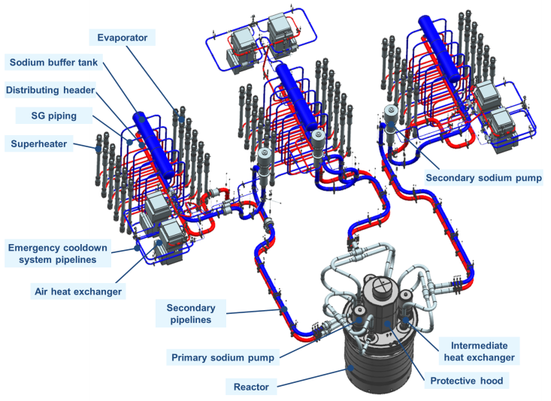 | 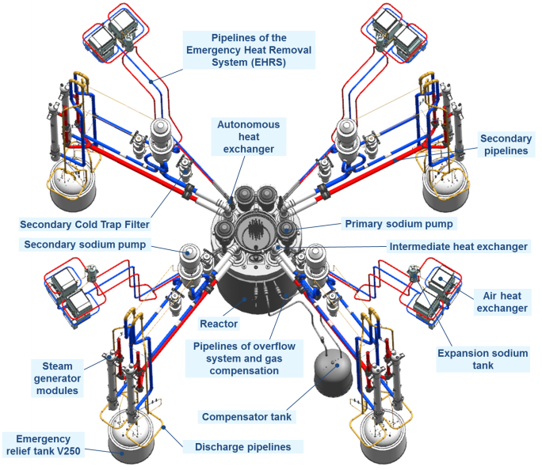  BN-1200

Fig. 2. Reactor Plant.

A large scope of calculation and experimental studies were performed for the design validation. The list and results of the studies comply with the R&D programme, as well as meet the whole range of the tasks set. The R&D activities aimed at verifying the new engineering solutions for the systems and equipment of the reactor and safety of the BN-1200 power unit (Fig. 3).
The calculations confirmed the target indicators – no need for the population living outside the NPP site to be evacuated or resettled under severe beyond design-basis accident conditions.
At the meeting held in September 2017, the Steering Committee for the GIF Agreement on SFR System Integration and Assessment adopted and approved the BN-1200 concept as a concept satisfying the GIF requirements for Generation IV fast neutron reactors.

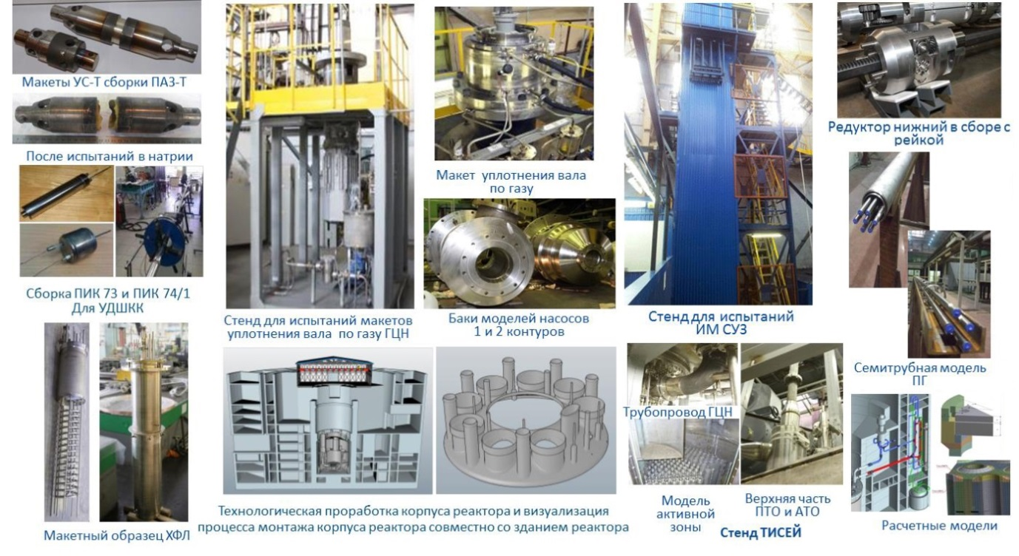
Tisey test facility
Assembly of ICS 73 and ICS 74/1 for
Detection device for wide-range neutron
flux monitoring channels
Mockups of self-triggering temperature device of PSR-H assembly
Reduction gear complete with rack
MCP piping
CRDM test facility
Computational models
Seven-tube SG model
IHX and AHX upper portion
Reactor core model
Technological analysis of the reactor vessel and visualization of reactor vessel installation process jointly with the reactor building
After tests in sodium
A mockup sample of
a cold trap filter
Test facility of the MPC gas-tight shaft seal mockup
Tanks of I and II circuit pump model
Gas-tight shaft seal mockup

Fig. 3. Illustration of the R&D results obtained within the BN-1200 project.

DEVELOPMENT OF POWER UNIT DESIGN SOLUTIONS
The proposals to change the reactor design directly determined the reduction of its mass (by 12.2 %) and made it possible to reduce the expected construction volumes of the reactor building (Fig. 4) [3, 4].

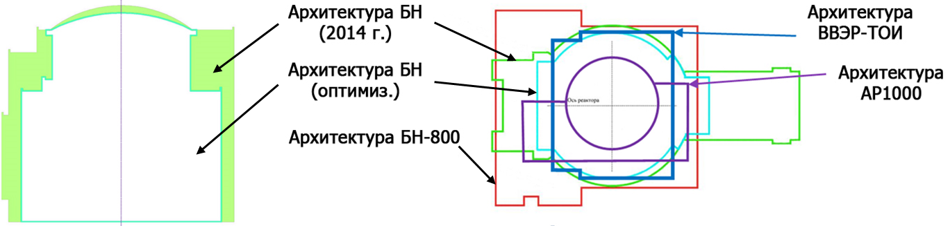
AP100
architecture
VVER-TOI architecture
BN architecture
2014
BN architecture
(optimized)
BN-800 architecture
Fig. 4. Footprint of the optimized reactor building

The power output system (turbine generator, etc.) was unified with the design of NPP-2006.
The detailed design of a turbine with a capacity of 1,221 MW in rated mode was developed, which contributed to improving technical and economic indicators of the turbine building (Table 2) [3].

TABLE 2 Comparative analysis of turbine building characteristics
Parameter | BN-800 | BN -1200 | VVER-1200
V_{total}, m³/MW | 283 | 225 | 222
Turbine heat rate, kCal/kW·h | 2,040.3 | 1,970.5 | 2,364
Overall turbine length, m | 42.07 | 42.16 | 52
Turbine weight, ton | 1,850 | 2,050 | 2,100

The optimization of architectural and planning solutions for the reactor building allowed for:
- reduction of construction volumes (by a factor of 1.5 or by 34%),
- reduction of construction area (by a factor of 1.6 or by 36%).
The achieved results ensure the competitive ability of the BN-1200 unit indicators and prospective power units.

Conclusion
To date Russia has demonstrated a successful many-years operation of existing BN-600 and BN-800 reactors and a high level of readiness to deploy the project of a commercial BN-1200 power unit with the aim of operating in the closed nuclear fuel cycle and forming the basis for fuel supply of the future two-component nuclear power industry.
The following has been done by now in the frame of R&D:
- methodological framework has been elaborated; computer codes have been developed to validate design characteristics and safety; the qualification of the computer codes is currently proceeding to completion;
- unique technologies for production of equipment and specific instrumentation and controls have been restored or newly developed; a stable cooperation of Russian enterprises aimed at their production has been established;
- work is underway to improve technical and economic performance of the power unit, and additional R&D work is underway to justify the new engineering solutions.
Thus, the BN-1200 reactor will ensure the U-238 involvement in the nuclear fuel cycle, fuel breeding with multiple use of plutonium in a single fuel cycle with the thermal reactors, efficient utilization of minor actinides, multiple reduction of natural uranium consumption, and promotion of a wide range of export services on the world market.
LIST OF REFERENCES
- Alekseev P.N., Alekseev S.V., Andrianova E.A. et al. Two-Component Nuclear Power System with Thermal and Fast Reactors in a Closed Nuclear Fuel Cycle, ed. Ponomarev-Stepnoy, M.; Technosphere, 160 p., 2016
- Shepelev S.F. BN Reactors in Russia: Innovations and Competences, 13th International Public Forum-Dialog and Exhibition ATOMECO 2019, Hungary, 2019
- Ershov V.N., Shepelev S.F. Power Unit with BN-1200M Reactor, Conference on Closed Nuclear Fuel Cycle on the Basis of Fast Neutron Reactors, Tomsk, 2018
- Lemekhov V.V. RBNs for Operation in Closed NFC, Branch Scientific Conference, Sochi, 2019
- Gulevich A.V., Dekusar V.M., Kamaev A.A. et al. The Role of Fast Sodium Reactors in Closing the Nuclear Fuel Cycle of Nuclear Power Industry, Conference on Closed Nuclear Fuel Cycle on the Basis of Fast Neutron Reactors, Tomsk, 2018

