iMAGINE –

a Breakthrough Technology for Closing the Fuel Cycle without Reprocessing

B. MERK, A. DETKINA, D. LITSKEVICH
School of Engineering, University of Liverpool
Liverpool, L69 3GH, United Kingdom
Email:b.merk@liverpool.ac.uk

Abstract

Nuclear technologies are one of the most promising approaches to deliver vast amounts of 24/7 available on demand energy to drive a future net-zero world. However, to be successful for the future, nuclear technologies have to be improved. One of the key steps promised already at the very beginning of the technological development is closing the fuel cycle to make better use out of the amount of energy stored in the nuclear fuel to improve sustainability while reducing the long-term waste problem in parallel.
The proposed iMAGINE technology is designed to provide the optimal approach to achieve closed fuel cycle operation while avoiding the most complex and costly components of the traditional fuel cycle – reprocessing and solid fuel production. The idea for iMAGINE was developed about 5 years ago based on developing a molten salt technology with will be able to work in closed fuel cycle mode based on spent nuclear fuel from light water reactors without prior reprocessing. The attractiveness of this approach is reflected by the quick uptake of the idea through several industrial developers. The opportunities and challenges of the project are described including the progress up to date. This state is used to describe the next steps required in a stepwise approach to develop an innovative nuclear reactor system in a structured development process characterized through Basic Studies, Advanced Studies, Experimental Reactor, and Full Scale Industrial System Demonstration. This process has already been taken up by ROSATOM for their molten salt reactor development.
iMAGINE has recently got a high recognition of the Royal Academy of Engineering through awarding a Chair in Emerging Technologies and has got funding for Defining a Draft for a Zero Power Reactor Experiment for Molten Salt Reactors. The Department for Business, Energy & Industrial Strategy has created supporting infrastructure with the Molten Salt Advisory Group and the Molten Salt Technology Platform.

INTRODUCTION
The energy trilemma [1] and UN SDG 7 "Ensure access to affordable, reliable, sustainable and modern energy for all." [2] are drivers for energy research to support the UK governments net-zero emissions law[3]. Nuclear is the most promising 24/7 on demand availably energy technology to provide large amounts of low carbon energy for the success of a Net-zero society. Besides this very acute role in the net-zero strategies, nuclear can significantly improve energy security and sustainability after leaving the hydrocarbon world – we need to develop new energy resources and new technologies to exploit other energy resources to avoid a breakdown in the opportunities for future generations. This unavoidable action, turning to a net-zero world, will significantly shrink the available amount of energy resources for future generation. Following the approach of the Brundtland commission on sustainability, we have caused a significant sustainability problem, since the energy resources for future generations have strongly deceased and will limit the development opportunities of future generations. In an ideal world, the current generation has to ‘repair’ this by developing new technologies which are able to extend the amount of energy resources for future generations – making all potential of every gram Uranium accessible. This is the only way to keep the level of sustainability following the Brundtland approach. A key will be, establishing cyclic economy.
The second problem to be solved to achieve a more sustainable nuclear technology has already been described in the IAEA Bulletin number 39 in 1997. Victor Arkhipov a consultant in the IAEA division of nuclear power and the fuel cycle, in the nuclear power technology development section gave there the following description “One of the greatest challenges in the use of nuclear energy is the highly radioactive waste which is generated during power production. It must be dealt with safely and effectively. While technical solutions exist, including deep geological repositories, progress in the disposal of radioactive waste has been influenced, and in many cases delayed, by public perceptions about the safety of the technology. One of the primary reasons for this is the long life of many of the radioisotopes generated from fission, with half-lives on the order of 100,000 to a million years. Problems of perception could be reduced to an essential degree if there were a way to burn or destroy the most toxic long-lived radioactive wastes during the production of energy.” The topic is currently discussed intensively in the United Kingdom in the frame of the restructuring of the Nuclear Decommissioning Agency of the country [5].
However, to deliver on both of these points nuclear strongly needs fresh thinking and breakthrough innovations to allow successful and economic application of closed fuel cycle technologies as well as partitioning and transmutation. This is of high importance since the current technology reactors and their related fuel cycles as well as partitioning and transmutation suffer from unreasonably high cost. For Light Water Reactor technologies, this is combined with a lack of sustainability due to the limited Uranium use, and a waste problem due to the absence of a long-term recycling strategy. Thus, in our view, fostering nuclear technology innovation acceptable to the society and supporting sustainable energy objectives will be a key step for the future success of nuclear to be able to deliver advanced nuclear systems and concepts, poised to provide the required effective solutions for a successful move into a net-zero society.

the iMAGINE project
The iMAGINE project is based on the idea of demand driven strategic development to answer on the demand described in the introduction. On the one hand, on the requirement of a variable and reliable 24/7 on demand low carbon energy for a Net-zero society, capable of providing readily available energy on demand and at scale. On the other hand, on started about five years ago with the proposed reactor operation based on spent nuclear fuel without prior reprocessing to deliver a much more efficient use of the resource Uranium [6] to make nuclear a successful promise for the future as well as to tackle the long term nuclear waste problem [7]. The described molten salt technologies will be a key step into the future of nuclear supporting a disruptive way of optimizing the whole nuclear system, instead of just developing a new reactor, to enhance sustainability and affordability. Main advantage, compared to existing closed fuel cycle technologies, is elimination of complex solid fuel production and other fuel cycle technologies like reprocessing.
Molten salt systems can deliver a breakthrough for most efficient fuel use, by operating on existing spent fuel while drastically reducing the cost of nuclear, its sustainability, and solving the long-term waste problem. However, developing a disruptive, highly sustainable and affordable fuel cycle – instead of just a reactor – requires a strong inter-disciplinary approach, linking physics, engineering, and chemistry.
The proposed iMAGINE approach pushes the breakthrough technology based on molten salt reactors and their related fuel cycle. This is a real net-zero technology, with significantly improved sustainability indices and economic performance, characterized by:
- avoiding mining (major source of eco-toxicity, carbon emissions, and cost);
- avoiding enrichment (major energy consumption, proliferation-risk, and cost);
- reducing waste production and storage by the reuse of existing spent fuel;
- eliminating highly-radiotoxic transuranium isotopes (reducing the long-term disposal challenge);
- eliminating the established reprocessing (energy requirement, proliferation risk, prohibitively expensive prior step into a closed fuel cycle);
- replacing traditional reprocessing with an optimized, strongly demand driven salt clean-up;
- applying low pressure technology (lower cost);
- avoiding solid fuel production (major cost driver and radiation source in closed fuel cycle).

The ultimate aim is to prepare the UK for a net-zero future using highly-innovative technologies. For this it is essential, to advance knowledge and capabilities in the technology to grow the skills base in the UK. Core activity is to assure a sufficiently educated nuclear community to allow a qualified response to regulatory requests and to support the formation of the required skilled workforce to support the BEIS (Department for Business, Energy & Industrial Strategy) nuclear innovation program (NIP). The aim of this structured long-term program of BEIS is to set out a vision for the energy system consistent with the government’s 2050 net-zero goals, with concrete actions that government will take up to 2030, which effectively illustrates the urgency of the initiative. The proposed work will support the UK in becoming the first major economy to legislate for net-zero, while assuring the 24/7 energy security offered by nuclear technologies. The work will be a key step to maintaining the UK’s position as a global leader in cutting emissions while growing the economy, and developing world-leading sectors to drive clean growth across the UK. [8].
The impact of the proposed iMAGINE technology developing a system able to operate on spent nuclear fuel and the attractiveness of the vision is evidenced by the rapid take-up through the major industrial technology developers, including Terrestrial Energy, Terrapower, Elysium Industries and others.

Progress to date
The demand for innovation, for the long-term success of nuclear as a reliable and sustainable large-scale energy source, has been identified by IAEA, which led to the formation of the Green Frontiers Initiative as a response to UN SDG7. Within this initiative, the disruptive innovation proposal iMAGINE – a Nuclear System Operating on Spent Fuel without Reprocessing has been chosen as the most promising large scale project and was honoured by an invitation to apply for an IAEA research collaboration centre. In addition, iMAGINE has received a very positive recognition of the technology, the disruptive approach and the high level of innovation in a letter of the BEIS chief scientific advisor. This recognition on the political level was accompanied through a series of scientific publications investigating different aspects of the required technologies required to be able to use molten salt reactors with the aim of leveraging the advantages closed fuel cycle operation without the massive upfront investment into reprocessing and MOX production required when solid fuels are used. The approach is to deliver on both challenges, massive sustainable energy production and reducing the long-term waste challenge in parallel to overcome the traditional separation of these two issues as it was one of the results of the EUROTRANS program to reduce the radiation exposure in the solid fuel production process. EUROTRANS was a European research Programme for the transmutation of high-level nuclear waste in an accelerator driven system run from 2005 to 2010 and coordinated by Karlsruhe Institute of Technology followed by several more detailed European research projects. Molten salt technologies will not face this problem thus this technology could allow to revise this decision.
To achieve these very attractive goals on energy production and waste management two basic challenges have to be solved:
- Achieving sufficient breeding in a molten salt system [9].
      - Identifying a molten salt system with high solubility for the fertile component, in our case, uranium
with sufficiently low melting point for reactor operation;
      - Evaluating the sensitivity of breeding performance of systems on the identified salts based on the sort of fissile material, the fissile material loading, and the core dimension.
- Creating a deeper understanding of the operational behaviour of the system and potential control strategies [10].
      - Investigating a possible control strategy for a molten salt system based on breeding and non-continuous feeding based on thermal feedback;
      - Drawing conclusions from the results on the operational behaviour of a continuous fed molten salt system.
- Creating the basis for developing of a demand driven salt clean up system [11].
      - Investing the elementary composition of the reactor operating and spent fuel;
      - Investigating the effect of different elements on the reactor operation;
      - Discussing potential optimization strategies for the salt-clean up system.

The modelling and simulation work has been supported by working out a process for the successful establishment of an innovative reactor system based on a stepwise approach [12] to make new nuclear happen until 2050 as planned and expected in the BEIS NIP. The proposed process is formed in 4 steps see Figure 1, which can be partly overlapping, see Figure 2.

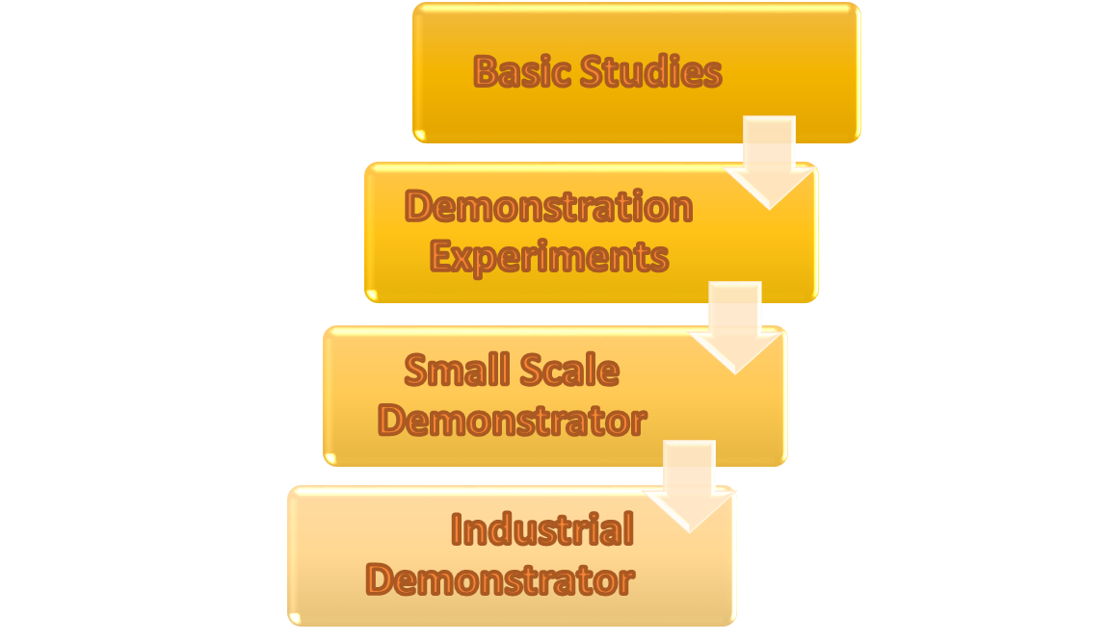
Figure 1: The 4 process steps proposed for the establishment of a new, innovative reactor technology

Basic Studies
The basic studies on a new nuclear technology is the time to form a first consortium with academic partners, national laboratories, and industrial players to exploit a new approach and demonstrate its feasibility. Ideally, it will provide attraction to the industry due to new long-term IP creation. It will provide first scientific underpinning and ideally create public believe and trust in the innovative capacities of nuclear research, ‘we are solving the problems of the future’. Necessary modern digital M&S tools will be created and a pool of experts will be formed as first step to be updated and improved later. Basic studies will make use of the traditional strength of the country to leverage from recent governmental investments and governmental funding streams to build new capabilities in subject areas where currently strength is missing by leveraging from international networking, working with supra national institutions.
First experiments can be used in order to establish fact (validation) or to understand the characteristics of critical components/processes to deliver a proof of principle. It involves small scale – separate effects –lower cost per experiments, mainly in existing facilities. Ideally, the basic studies will create the first interaction with the regulator to develop an understanding of a reasonable safety approach and the definition of supporting experiments required for licensing for the next step. It will lead to international recognition which can be supported by establishing additional international research collaborations.

Demonstration Experiments
In this stage new technology approaches (e. g. salt clean-up) have to be developed and demonstrated using existing infrastructure leveraging past investments as well as delivering new larger scale experimental infrastructure. Within this step, the development of a zero-power reactor will be a key stage, often recognized as the real start of a new nuclear program, since the first legacy is produced which requires a long-term investment plan and the related financial commitment. In addition, the zero-power facility will require to form a consortium to deliver the project while it will help to develop the skilled workers for the next step. The project will require to deliver of a supply chain to deliver first essential components which will be key for later steps, too, e. g. the production of the first significant amount of fuel of a completely new type. Ideally, the zero-power reactor can be based on refurbishment of a recently shutdown facility like it has been shown in the GUINEVERE experiments in Belgium which creates significant cost and time savings. In addition, the zero-power reactor will create international collaboration opportunities and can serve with experiments for money for industrial players in the later stage of the operation when the most urgent experiments for the new program have been delivered. A comparable approach is offered, e. g. by the IPPE in Russia using the BFS facility for fast reactor technology.

Experimental Reactor
The experimental reactor, often called the small-scale technology demonstrator is the first power producing unit. The system will be of small size with a power of 10 to 50 MW_{th} to demonstrate power production and to investigate/demonstrate the reactor behaviour under power conditions and the change in the fuel composition due to power production and irradiation. Close technological and financial collaboration with industrial partners will be a key to create innovative solutions in the supply chain as well as to identify a possible a system integrator for the next step. At this point two different approaches are conceivable, a collaboration driven approach for international innovative reactor development, or a more commercially driven approach. The historic boiling water reactor development shows that both approaches can even be followed in parallel [13].
In the molten salt reactor case, the experimental reactor will deliver the first operational experience with a liquid fuelled system since the molten salt reactor experiment at Oak Ridge National laboratory in 1956 [14]. A key point for a rapid delivery of the disruptive innovation will be starting with a conservative approach with reduced temperature level and low power density followed by a successive process of stretching the operational envelop. This will be essential to improve the longer term economy performance based on the operational experience and detailed observation of the material behaviour. The experimental reactor delivers the first opportunity for material testing under real operational conditions involving high temperature, corrosive environment and high radiation level. Taking the step into the small scale demostrator reactor early will provide the developer with very much accelerated learning in a new, innovative technology and thus an earlier success, but sure on the cost of taking a higher risk. Taking leadership will give the developers the early lead in an innovative technology resulting in excellent market opportunities.

Full Scale Industrial System Demonstration
In this stage industrial demonstration of economic, reliable, sustainable, and safe power production using a new technology for the national as well as the international market is the essential function. Key for this step is the demonstration of the functionality of the entire nuclear system from fuel production over reactor operation as well as salt clean-up and off-gas treatment as one unit, thus the application of a new highly sustainable low carbon technology. By providing the first industrial demonstrator since generations, the UK would demonstrate industrial leadership and create the related market opportunities required to achieve a significant market share. The industrial demonstrator should already be owned by a commercial operator, maybe supported by the government in critical components like the nuclear island and the fuel as well as in the licensing [13]. In the UK, this approach is consistent with current policy of supporting industry through the Advanced Modular Reactor programme and is in-line with recent NIRAB recommendations to the UK government.
The IP generated during the development and operation of an industrial scale demonstrator will serve the specific purpose of lowering the technical and commercial risk of licensing and operating a novel reactor technology. Commercial solutions will share some of the underlying, though with additional privately held IP in order to differentiate one commercial design from its competitor.
By no means, the industrial demonstrator needs to be a short-term operating prototype. Based on massive use of M&S it should be a well-developed, M&S supported, ideal demonstrator which will be a first of class and thus go into full production. There is history for this – the Calder Hall reactor, a demonstrator, operated for decades. It powered Sellafield site (a large town in scale) [[15]], and was comparable to EBR-II at the Argonne-West site in US [[16]].
The described stepwise development process has been meanwhile intensively discussed with BEIS after it was published in July 2019 [12]. The process is already applied internationally by ROSATOM for the Russian molten salt reactor (MSR) project in Zheleznogorsk in the frame of the Russian partitioning and transmutation program [17].
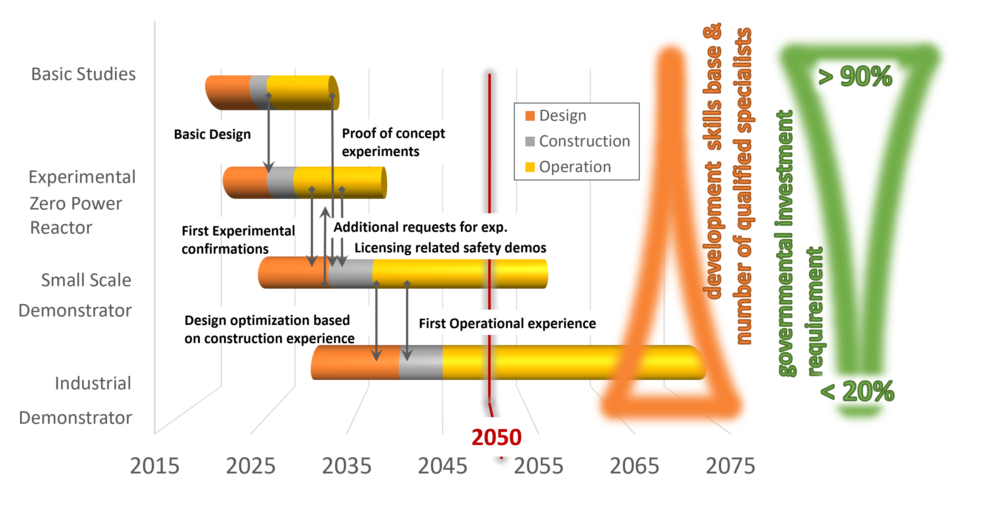
Figure 2: The 4 process steps proposed for the establishment of a new, innovative reactor technology until the delivery date 2050, the development of the skills base and the required governmental investment profile

Outlook to the future
The development of molten salt technologies in the UK is currently strongly supported through different funding streams. The iMAGINE has got a high recognition by the Royal academy of Engineering by awarding a Chair in emerging technology to the project. This position is funded for 10 years with £ 2.7m to allow a pure research Chair position freed of teaching obligations for the technical lead of the project and to provide finical independence to recruit PhD students.
The Department for Business, Energy & Industrial Strategy – BEIS has established a Molten Salt Advisory Group (MSAG) formed of independent academics with special capacities and capabilities to support molten salt technology development through the use of existing high quality facilities and to act as advisors for the government and interested industrial partners. In parallel to the MASG, BEIS formed the Molten Salt Technology Platform (MS-TP) to bring together industrial interests, capabilities and capacities required to push molten salt technologies in the UK.
The establishment of a zero-power facility to investigate molten salt reactor configurations in the UK has been recently funded through a governmental funding institution supporting a project on, Defining a Draft for a Zero Power Reactor Experiment for Molten Salt Reactors. The project has the objectives:
- Creating understanding of the importance of a zero-power experiment for future technologies;
- Creating a flexible multi-purpose core design and control/measurement strategy for a zero-power core for MSR studies based on applying advanced M&S techniques;
- Developing and evaluating the draft experimental programme to support regulatory requests and possible parasitic use for the zero-power facility based on advanced M&S techniques;
- Production of a relevant sample of a future fuel salt and experimental determination of the thermal-physical properties as basis for the advanced M&S;
- Identification and evaluation of refurbishing opportunities of existing UK facilities.

Besides this iMAGINE specific funding, the UK has funded and funds currently several projects using molten salt technologies for pyro reprocessing, e.g. through the REFINE project and through the Advanced Fuel Cycle Program (AFCP) within the BEIS NIP.
Core challenge for a successful development off the program will be to deliver sufficient spin-off in each of the development steps described in the last paragraph. Figure 3 give a first glance on the potential spin-offs delivered through the development of a highly innovative nuclear development program. It is essential to be able to deliver valuable outcomes through the whole program and not only concentrate on the final product in the form of the industrial demonstrator since n government will take such a long term investment on full risk in the modern world anymore. The potential spin-off plan delivers in the first step mainly education and skills development. However, this is important for a country like the UK which was suffering for years form very low investment volumes, especially in the reactor development research which has resulted in a massive degradation of the education in nuclear reactor topics. Thus, there is a strong demand for nuclear reactor specialists in industry, research, and academia. In the second stage the zero power reactor will play a major role in delivering spin-offs [18], [19] as a low cost, low risk, less complexity which delivers a quick response opportunity to learn in delivering a small scale nuclear facility. Core opportunities will be in manufacturing the facility including major components like the fuel, in doing the experiments to educate new experts, in delivering cutting edge scientist to get international recognition, and finally in providing a business opportunity through experiments for customers. In addition, heat transfer experiments can be used for another applications and code validation will support the modelling and simulation community. The small scale demonstrator in itself could be used later on as demonstrator for a small size reactor for remote siting and to support small modular reactor development and demonstration. This dual approach requires a disruptive development in the process of reactor development. In our case, the experimental reactor could be initially designed without salt clean-up, operating on enriched uranium (smaller and cheaper) serving a market niche like the Akademik Lomonosov for remote site electricity production or for propulsion, thus a new business opportunity can be developed. The final product will deliver at the end business opportunities for UK plc, thus jobs and tax income as reward for the investment into research and development. It will deliver a highly sustainable net-zero technology which will help the government to deliver on the promises of the net zero society.
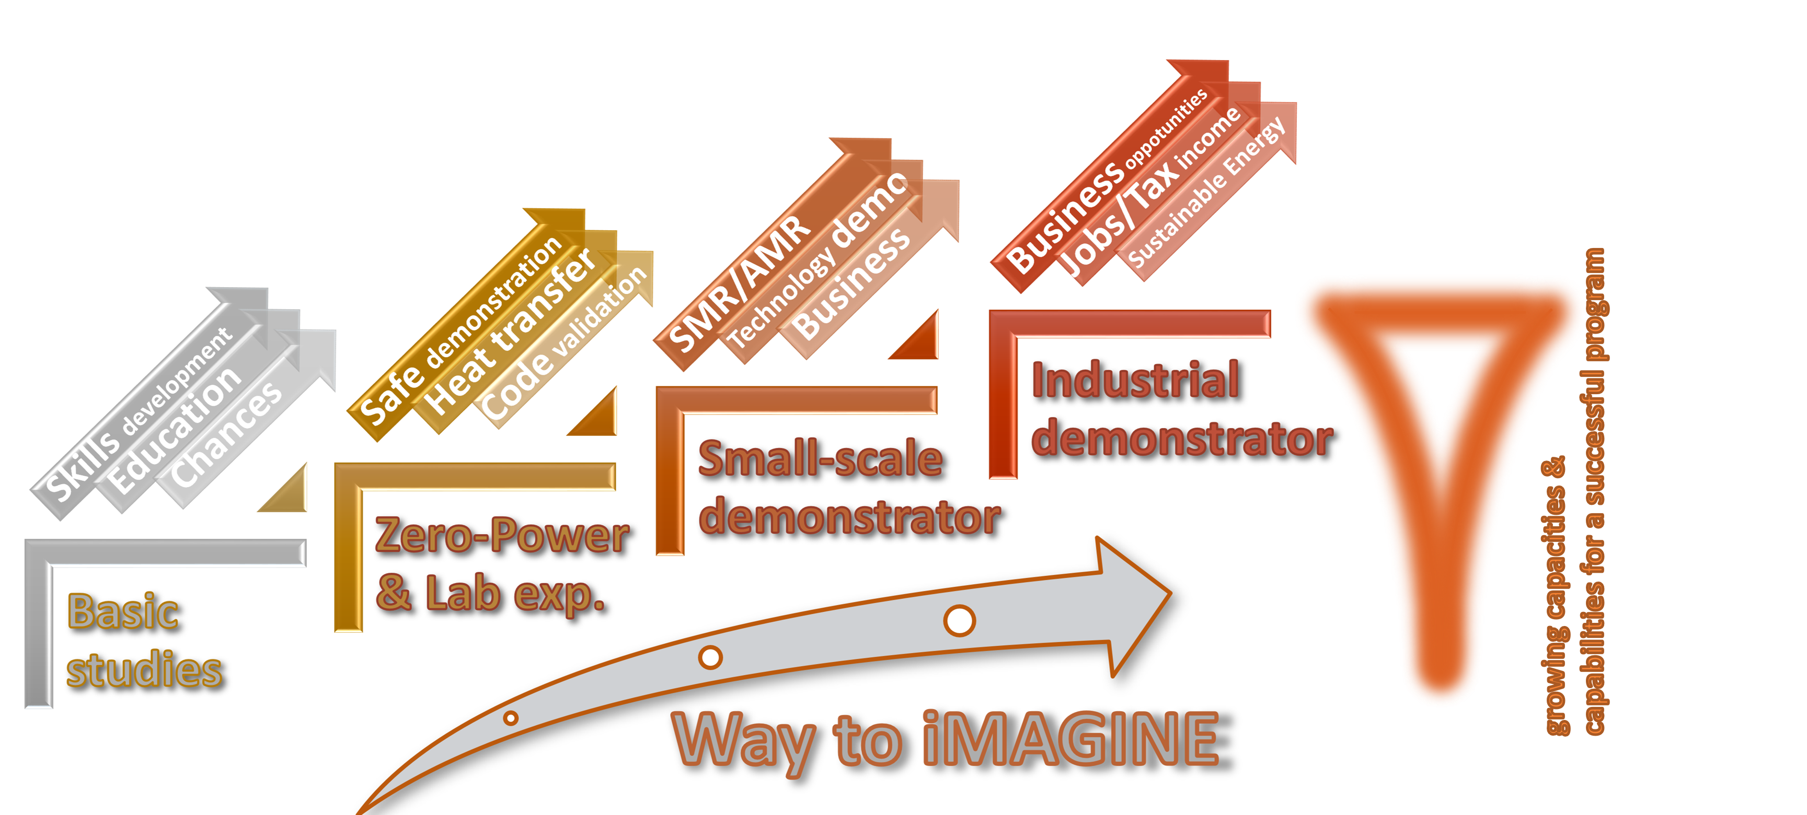
Figure 3: Potential spin-off in the different steps of the proposed process for the establishment of a new, innovative reactor technology

Conclusions
The world currently faces the big challenge of the transformation into a net-zero society. Nuclear has to potential to play a major role, but to be successful a long-term sustainable approach will be required which helps to deliver on the energy demand and solves in parallel the long-term nuclear waste issues.
The iMAGINE project is designed to deliver on both challenges through the operation on spent nuclear fuel without reprocessing aiming to significantly improve the sustainability indices and economic performance of a future nuclear system. The project has originally been developed within the IAEA green frontier initiative but is now followed up by the UK on different levels. On the academic level a series of publications have been delivered to demonstrate the feasibility of the approach, sufficient breeding in a molten salt system, creating a deeper understanding of the operational behaviour of the system and potential control strategies as well as creating the basis for the development of a strongly demand driven salt clean up system. The wider development of the technology has been supported through development and publication of a four step process designed to deliver an innovative reactor project with limited risks. The process is consisting of the steps Basic Studies, Advanced Studies, Experimental Reactor, and Full Scale Industrial System Demonstration. This process has already been taken up by ROSATOM for their molten salt reactor development.
iMAGINE has recently got a high recognition of the Royal Academy of Engineering through awarding a Chair in Emerging Technologies and has got funding for Defining a Draft for a Zero Power Reactor Experiment for Molten Salt Reactors. The Department for Business, Energy & Industrial Strategy has created supporting infrastructure with the Molten Salt Advisory Group and the Molten Salt Technology Platform.
However, for a successful innovative reactor program additional investment is required and the creation of early spin-offs seems to be a promising opportunity to find early investors.
References
- environmental Scientist, The Journal of the Institution of Environmental Sciences Volume 23 No 1, 2014, available: https://www.the-ies.org/sites/default/files/journals/env_sci_feb_14.pdf, accessed 07/03/2019
- https://unchronicle.un.org/article/goal-7-ensure-access-affordable-reliable-sustainable-and-modern-energy-all
- UK becomes first major economy to pass net zero emissions law, available: https://www.gov.uk/government/news/uk-becomes-first-major-economy-to-pass-net-zero-emissions-law, accessed 25/05/2021
- ARKHIPOV V., Future nuclear energy systems: Generating electricity, burning wastes. IAEA BULLETIN, 39/2/1997 (1997) https://www.iaea.org/sites/default/files/publications/magazines/bulletin/bull39-2/392047830,33.pdf, accessed 27.02.2015
- Radioactive Waste Strategy September 2019, available: https://www.gov.uk/government/consultations/nda-radioactive-waste-management-strategy/outcome/radioactive-waste-strategy-september-2019, accessed 25/05/2012
- MERK, B. et al: ”On a Long Term Strategy for the Success of Nuclear Power”, ENERGIES, 8(11), doi:10.3390/en81112328.
- MERK, B., LITSKEVICH, D., BANKHEAD, M., TAYLOR, R.J., An innovative way of thinking nuclear waste management – Neutron physics of a reactor directly operating on SNF. PLoS ONE 12(7): e0180703. https://doi.org/10.1371/journal.pone.0180703(2017)
- MERK, B. et al. The UK nuclear R&D programme on digital nuclear reactor design - modelling, simulation, and virtual engineering, ICAPP 2018 : Charlotte, NC, 8-11 April 2018
- MERK, B., DETKINA, A., ATKINSON, S., LITSKEVICH, D., CARTLAND-GLOVER G., Evaluation of the Breeding Performance of a NaCl-UCl-Based Reactor System, Energies 2019, 12(20), 3853; https://doi.org/10.3390/en12203853
- MERK, B., DETKINA, A., ATKINSON, S., LITSKEVICH, D., CARTLAND-GLOVER G., The Interplay between Breeding and Thermal Feedback in a Molten Chlorine Fast Reactor. Energies 2020, 13, 1609
- MERK, B., LITSKEVICH, D., GREGG, R., MOUNT, A.R. Demand driven salt clean-up in a molten salt fast reactor – Defining a priority list. PLoS ONE 13(3): e0192020. https://doi.org/10.1371/journal.pone.0192020(2018)
- MERK, B. et al., “iMAGINE - A disruptive change to nuclear or how can we make more out of the existing spent nuclear fuel and what has to be done to make it possible in the UK?”, atw 6/7 2019
- Program on Technology Innovation: Government and Industry Roles in the Research, Development, Demonstration, and Deployment of Commercial Nuclear Reactors: Historical Review and Analysis. EPRI, Palo Alto, CA: 2017. 3002010478
- MSRE's 50th - The short-lived Molten Salt Reactor Experiment is far from forgotten, https://www.ornl.gov/news/msres-50th
- First nuclear power plant to close, available: https://www.theguardian.com/uk/2003/mar/21/nuclear.world, accessed 28/03/2019
- EBR-II Sixteen Years of Operation, available: https://inldigitallibrary.inl.gov/Reports/ANL-0001.pdf, accessed 28/03/2019
- https://www.sibghk.ru/news/9068-na-gkhk-proshlo-rabochee-soveshchanie-po-voprosu-sozdaniya-zhidkosolevogo-reaktora.html
- MERK, B. et al., A zero-power facility as multi-fold opportunity to support quick progress in innovative reactor development, atw 66, Issue 3 (2021)
- MERK, B. et al., Supporting Quick Progress in Innovative Reactor Development Through the Multiple Opportunities in Developing a Zero-Power Facility, ICAPP 2021, October 16–20, 2021, Abu Dhabi, UAE.

