# Status of Generation-IV Lead Fast Reactor Activities

Alessandro Alemberti

Ansaldo Nucleare SpA

Genova, Italy Email: [alessandro.alemberti@gmail.com](mailto:alessandro.alemberti@gmail.com)

Kamil Tuček

European Commission, Joint Research Center (JRC)

Petten, Netherlands

Toru Obara

Tokyo Institute of Technology (Tokyo Tech)

Tokyo, Japan

Masatoshi Kondo

Tokyo Institute of Technology (Tokyo Tech)

Tokyo, Japan

Andrei Moiseev

Nauchno-issledovatelskiy i konstruktorskiy institut energotekhniki (NIKIET)

Moscow, Russian Federation

Il Soon Hwang

Ulsan National Institute of Science and Technology (UNIST)

Ulsan, Republic of Korea

Craig Smith

Naval Postgraduate School

Monterey, United States

Yican Wu

Institute of Nuclear Energy Safety Technology (INEST)

Hefei, People’s Republic of China

Ming Jin

International Academy of Neutron Science (IANS)

Qingdao, People’s Republic of China

Yuliya Kuzina

Institute of Physics and Power Engineering (IPPE)

Obninsk, Russian Federation

**Abstract**

The Lead-cooled Fast Reactor provisional System Steering Committee (LFR-pSSC) of the Generation IV International Forum (GIF) was initially organized in 2004 in a meeting between representatives from the EU and the USA. Shortly thereafter, representatives from KOREA and JAPAN agreed to participate, and the first meeting of the pSSC was held in October 2004. An official Memorandum of Understanding on LFR development (MoU) was then signed by EURATOM and the Tokyo Institute of Technology for JAPAN at the end of 2010 thereby formalizing the pSSC. Shortly thereafter, the signature of the RUSSIAN FEDERATION was added in 2011. The formalized committee started its official activities in early 2012. Gradually the list of official members was expanded through additional signatures of the MoU: the REPUBLIC OF KOREA in 2015, the UNITED STATES in 2018 and the PEOPLE’S REPUBLIC OF CHINA in 2019 (these additional countries had already been participating in the role of Observers). During the time span of its operation, the LFR-pSSC has developed a number of top level strategic activities with the aim to assist and support development of Lead-cooled Fast Reactor technology in member countries and entities. The paper highlights the status of some of the main collaborative achievements of the LFR-pSSC, including the development of the LFR System Research Plan, the LFR White Paper on Safety, the LFR System Safety Assessment paper, the LFR Proliferation Resistance and Physical Protection (PRPP) White Paper, as well as the LFR Safety Design Criteria paper. Finally, the status of the development of LFRs in the GIF member countries and entities is briefly presented together with a set of recent publications on LFR activities useful for interested readers. The strong and friendly collaboration among partners of the GIF-LFR-pSSC is considered a major factor in the effective support to the development of LFRs through an open, interactive and collegial environment, developing important synergies and exchange of both technical and strategic information.

## **INTRODUCTIO**N

Among the promising reactor technologies considered by the Generation IV International Forum (GIF), the Lead-cooled Fast Reactor (LFR) was identified as a technology with great potential to meet needs for both remote sites and central power stations, fulfilling the four main goals of GIF in terms of sustainability, safety, economics and proliferation resistance. In the technology evaluations of the Generation IV Technology Roadmap and the GIF Technology Roadmap Update [1], the LFR system was top-ranked in sustainability because a closed fuel cycle can be more easily achieved, and in proliferation resistance and physical protection. It was also assessed as good in safety and economics. Safety was considered to be enhanced by the choice of a relatively inert coolant. This paper highlights the main recent collaborative achievements of the LFR provisional System Steering Committee (pSSC), including the development of the LFR System Research Plan, the LFR White Paper on Safety, the LFR System Safety Assessment paper as well as the LFR Safety Design Criteria. The paper then presents the status of the development of LFRs in the GIF member countries and entities.

## **the GIF-LFR Reference Systems and update on the LFR-pSSC Activities**

The LFR concepts identified by GIF include three reference systems. The options considered are a large system rated at 600 MWe (ELFR EU), intended for central station power generation, a 300 MWe system of intermediate size (BREST-300 Russia), and a small transportable system of 10-100 MWe size (SSTAR US) that features a very long core life (Figure 1). The expected secondary cycle efficiency of each of the LFR reference systems is at or above 42%. It can be noted that the reference concepts for GIF-LFR systems cover the full range of power levels, including small, intermediate and large sizes. Important synergies exist among the different reference systems so that a coordination of the efforts carried out by participating countries has been one of the key points of LFR development.

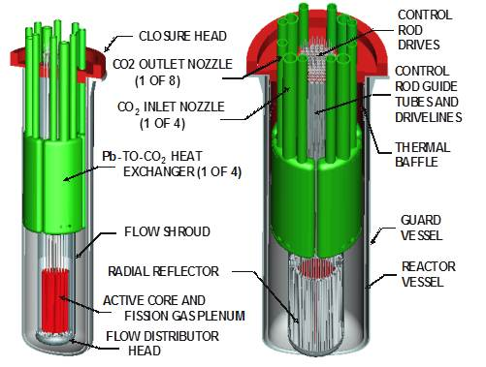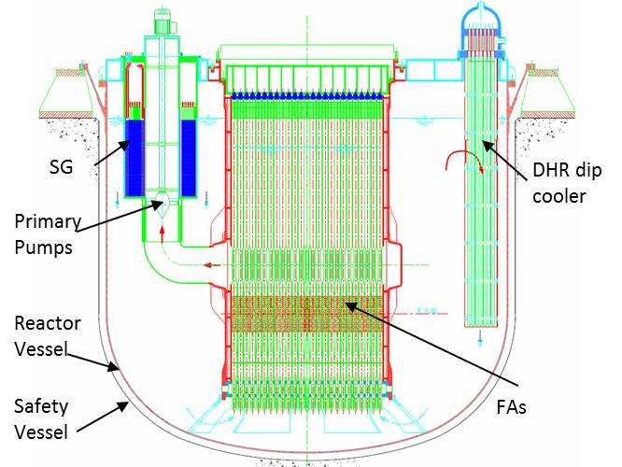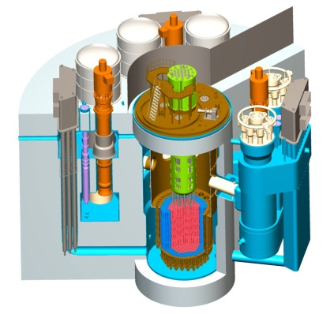

*FiGURE 1 Reference systems of GIF-LFR, from left to right: ELFR, BREST and SSTAR*

TABLE 1. Key design parameters of the GIF LFR concepts

|  |  |  |  |
| --- | --- | --- | --- |
| **Parameters** | **ELFR** | **BREST** | **SSTAR** |
| Core power (MWt) | 1 500 | 700 | 45 |
| Electrical power (MWe) | 600 | 300 | 20 |
| Primary system type | Pool | Pool | Pool |
| Core inlet T (°C) | 400 | 420 | 420 |
| Core outlet T (°C) | 480 | 540 | 567 |
| Secondary cycle | Superheated steam | Superheated steam | Supercritical CO2 |
| Net efficiency (%) | 42 | 42 | 44 |
| Turbine inlet pressure (bar) | 180 | 180 | 200 |
| Feed temperature (ºC) | 335 | 340 | 402 |
| Turbine inlet T (ºC) | 450 | 505 | 553 |

## **2.1. Lead Fast Reactor Research and Development Objectives**

The LFR System Research Plan (SRP) developed within GIF is based on the use of molten lead as the reference coolant and lead-bismuth eutectic (LBE) as the back-up option. The preliminary evaluation of the concepts included in the plan covers their performance in the areas of sustainability, economics, safety and reliability, proliferation resistance and physical protection. Given the R&D needs for fuel, materials, and corrosion-erosion control, the LFR system is expected to require a two-step industrial deployment: reactors operating at relatively modest primary coolant temperatures and power densities before 2030; and higher-performance reactors by 2040. Following the reformulation of GIF-LFR-pSSC in 2012, the SRP was completely revised. The report is intended presently for internal use of LFR-pSSC and will be used as a guideline for the definition of Project Arrangements once the decision of a transition from the present MoU status to a System Arrangement organization will be taken.

## **2.2. Main Activities of LFR-pSSC**

The collaborative activities of the LFR-pSSC during the last eight years were centered on top level reports for GIF. After the issuance of the LFR White Paper on Safety in collaboration with the GIF Risk and Safety Working Group (RSWG) in 2014 [2], the pSSC has been very active on the following main lines:

LFR System Safety Assessment: in 2014 the RSWG asked SSC chairs to develop a report on their systems to analyze them systematically, assess the safety level and identify further safety-related R&D needs. The LFR assessment report was prepared in collaboration with RSWG and the report was finally published in June 2020, presently available for the public [3].

LFR Proliferation Resistance and Physical Protection (PRPP) White Paper. In 2018 the Working Group on PRPP (PRPPWG) realized the need of a substantial revision of the White Paper on PRPP for the six GIF systems originally published in 2010. The modifications to the LFR paper were mainly related to the addition of the BREST system developed by Russian Federation and refinements of the information available for SSTAR (US) and ELFR (EURATOM) systems. The paper has been developed in strong collaboration with PRPPWG and the final version was sent to the GIF Experts Group (EG) for final approval at the end of 2020. The White Paper was uploaded on the GIF public website in October 2021 [4].

Recently, the LFR - pSSC has been also working actively with the GIF Task Force on Research Infrastructures and contributed inputs to the questionnaire provided by the Advanced Manufacturing Task Force (AMME). The activities resulted in the participation in a workshop organized in February 2020 at the OECD-NEA in Paris.

LFR Safety Design Criteria (SDC): development of the LFR SDC was based on the previously-developed SFR SDC report as a starting point. However, it was later realized that the IAEA SSR-2/1 (the guidance reference for SFR SDC development) did not require many of the features identified for the SFR to be adapted for the LFR (note that IAEA SSR-2/1 refers substantially to LWR technology). After a first set of comments, received at the end of 2016, the LFR pSSC updated the LFR-SDC report following the IAEA revision of SSR-2/1 and the document was then again circulated for comments within RSWG. The final comments from RSWG were received in December 2020. The report received EG approval in spring 2021 and is available on GIF public website [5]. The report was also officially sent to IAEA for external review. Comments received by IAEA are presently under consideration and discussion among LFR-pSSC members.

Interaction between LFR-pSSC and the Working Group on Safety of Advanced Reactors (WGSAR) started through the participation of LFR representatives to the October 2020 meeting of the WGSAR. The LFR-SDC and LFR-pSSC activities were briefly presented to WGSAR members and it was agreed to transmit the LFR-SDC report to the WGSAR following EG approval.

In December 2020 Alessandro Alemberti retired and Andrei Moiseev was unanimously elected in April 2021 as a Chair of the LFR-pSSC with Kamil Tucek taking the position of Co-Chair of the group. Two new members have been added to the group during 2021: Mariano Tarantino ENEA (Italy) as Euratom representative and Anton Moisseytsev (ANL), as the representative of US. Both Craig Smith and Alessandro Alemberti have been invited by the new Chair to participate future meetings of LFR-pSSC as observers.

## **Main Activities of GIF-LFR pSSC Member Countries**

In the following, the main achievements of the entities collaborating in GIF under the LFR-MoU are briefly highlighted. Due to the limitation on the number of pages the list of references has been shortened. A more complete list can be found in the GIF collection of Annual Reports [6].

### Russian Federation

The innovative fast reactor with lead coolant BREST-OD-300 is being developed as a pilot demonstration prototype of basic commercial reactors of the future nuclear power industry with a closed nuclear fuel cycle.

The lead coolant was chosen on the basis of the favourable characteristics of its properties, namely: 1) in combination with dense (U-Pu)N fuel, it allows for complete breeding of fissile materials in the reactor core, maintaining a constant small reactivity margin thus preventing any prompt-neutron excursion with an uncontrolled power increase because of equipment failures or personnel errors; 2) the possibility to avoid the void reactivity effect due to the high boiling point and high density of lead; 3) it prevents coolant losses from the circuit in the postulated event of vessel damage because of the high melting/solidification points of the coolant and the use of an integral layout of the reactor; 4) it provides for high heat capacity of the coolant circuit which decreases a possibility of fuel damage; 5) it capitalizes on its high density and albedo properties for flattening the Fuel Assembly (FA) power distribution; 6) it facilitates larger time lags of the transient processes in the circuit, which make it possible to lower the requirements for the safety systems’ rate of response.

Mixed uranium-plutonium nitride fuel is used in the core design and low-swelling ferritic-martensitic steel is used as the fuel cladding with fuel elements placed in shroudless hexagonal fuel assemblies. Currently the technology of dense nitride fuel is implemented on pilot production lines, technological processes are being improved, and industrial fuel production is being created for the fabrication of fuel for the BREST-OD-300 reactor. For the initial stage of BREST-OD-300 operation a reduced value of the maximum fuel burnout is provided (i.e., 6 % h.a.), then a gradual justified transition to the design target values of burnout (9-10 % h.a.) is envisaged. The performance of nitride fuel has been confirmed by the results of radiation tests in the BN-600 power reactor and the BOR-60 research reactor. In total, more than 1000 fuel elements were irradiated. For one experimental FA with fuel elements of the BREST type, burnout of more than 9 % h.a. and a damaging dose of more than 100 dpa were achieved. All semi-finished products from EP823 steel were put into production; all properties have been obtained that ensure the operability of the fuel elements up to 6% h.a. burnout: short-term, long-term, under irradiation, and in-lead coolant medium. FA mockups (all types) and reflector blocks were produced under industrial conditions, and the manufacturing technology is considered to be fully developed. All the necessary experimental studies were carried out for these mockups: spills in water and lead, vibration tests, and tests for bending stiffness and strength. Loading-unloading FA mockups from the core was experimentally tested, as shown in Figure 2.

|  |  |
| --- | --- |
|  |  |
| *Figure 2 (a) Experimental mockups of the dynamics of FA and Reactor Block* | *Figure 2* *(b) Testing of loading and unloading of FA mockup* |
|  |  |

The main objective of the reactor vessel, when performing safety functions, is to exclude the loss of coolant. The estimated probability of coolant leakage from the reactor circuit is about 9∙10-10 1/year. With this event, only a partial loss of the coolant is possible (i.e., presenting non-critical, acceptable outcomes); at the same time the primary circuit does not break, and the possibility of natural circulation of the coolant in the circuit remains. A wide range of experimental work was carried out on the metal-concrete vessel - on various concrete samples, mockups of the vessel itself and its elements. Experimentally determined properties of high-temperature concretes at temperatures of 400-700 °C and under irradiation were obtained. The chemical inertness of the lead coolant in relation to concrete was shown. Sufficient knowledge has been collected to start manufacturing the reactor vessel of BREST-OD-300 reactor.

The steam generators consist of monometallic tubes, corrosion resistant in water and lead, with no welds along the entire length. Each steam generator has a twisted heat exchange component design. To date, a comprehensive justification of the elements and processes occurring in the steam generator has been carried out. It can be especially noted that the absence of dependent failure in case of one tube rupture was experimentally demonstrated. Experiments have shown that neighboring tubes are not damaged – this is a very important achievement for safety. Another important point that has so far been confirmed only by calculations, but will be tested in an experiment at the BFS critical facility - with the postulated passage of steam bubbles through the core (when the tubes of the steam generator break) there is no burst of positive reactivity. The value of the void-vapor reactivity effect is close to zero. It should be noted that due to the presence of a free level in the reactor vessel, the probability of steam entering the core during depressurization of the steam generator tubes is extremely low.

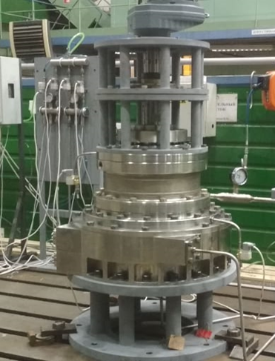To justify the pumps a wide range of studies was carried out. At the initial stages the flow parts were optimized, the shapes of the impeller blades were selected. By means of calculations and experiments on scale models, the head characteristics of the MCP were obtained, positive results of life tests of the bearing on lead were obtained (justification of the life of 100%); full-scale bench for MCP testing in lead is shown in Figure 3. As for other equipment and systems, the prototype of the CPS actuator passed acceptance and life tests; endurance testing of coolant quality system components are conducted; automated monitoring and control system has been developed, prototypes of equipment are undergoing final testing, so they are ready for implementation in the reactor during construction.

*Figure 3* *Testing of the friction pair of the MCP lower radial bearing as part of the model block*

A large set of experimental studies was carried out concerning the assessment of the yield of fission and activation products from a lead coolant. This knowledge is important when performing a radiation safety analysis for various temperature levels typical for normal operation (500 °C) and accidents with significant lead heating (680 °C). Based on the data obtained in the experiment, the requirements for the composition of the initial lead for the primary coolant are determined. In the course of the optimization performed, the composition of impurities was minimized while maintaining an acceptable cost of lead.

The safety analysis showed that under the most conservative scenario of introducing the full reactivity margin, the maximum fuel temperature will reach 1640 °C, fuel cladding 1260 °C (for a few seconds), there is no fuel melting, and the lead coolant does not boil. The implementation of such a scenario is feasible with a probability of 2.9∙10-9 1/year. For another conservative scenario, complete blackout of the power unit with failure of mechanical shutdown systems (ATWS), the level of the attainable fuel-element cladding temperature is lower than in the reactivity insertion case and does not exceed 903 °C. Long-term cooling is carried out using a passive emergency cooling system of the reactor with natural circulation of lead in the primary circuit. For both scenarios the main safety requirements are met and there is no need for evacuation or other population protection measures.

The BREST-OD-300 reactor is being created as one of the most important components of the pilot demonstration power complex operating in a closed fuel cycle, together with modules for fabrication, re-fabrication and reprocessing of spent fuel. In addition to operation (power generation), the most important task is the implementation of the R&D program at the reactor. It is planned to carry out various studies and life tests of components, equipment; irradiation experiments in a lead coolant in a fast neutron spectrum. This will form an essential scientific basis for research. The BREST-OD-300 unit design received a positive conclusion of the Glavgosexpertiza. Last year, the Russian Academy of Sciences examination was carried out, which gave a positive conclusion and recommended the construction of the power unit, confirmed that the design corresponds to the modern level of science and technology, scientific ideas about the problems of existing nuclear energy and ways to solve them. BREST-OD-300 received construction license from Rostekhnadzor in February of 2021 becoming the first Generation IV system presently in a construction phase. The construction of BRESTstarted in June 2021.

### Japan

Theoretical studies of fast reactors using lead-bismuth eutectic as a coolant have been performed in Japan since the beginning of LFR activities. One of the advantages of lead or lead-bismuth coolants is the better neutron economy in the core due to the hard neutron spectrum and the small neutron leakage. These features make it easier to realize the once-through fuel cycle fast reactor concepts. The concepts of the Breed-and-Burn reactors and CANDLE burning reactors with lead-bismuth coolant have been studied at the Tokyo Institute of Technology. One of the important issues in the concepts is to maintain the integrity of the fuel elements in very high burnup conditions. The research shows the possibility to solve the problem by the introduction of a melt-refining process based on metallic fuel. The study also considered the use of plutonium from LWR spent fuel for the start-up core to achieve effective utilization of the plutonium. A new fuel shuffling scheme was proposed as the output of the studies. It is shown is possible to achieve a stationary wave equilibrium condition by implementing a fuel shuffling scheme concept.

Chemical compatibility of Pb and its alloys with various materials in various situations is being studied at the Tokyo Institute of Technology. Figure 4 shows the various situations where chemical compatibility presents important issues to be addressed. The structural materials which reveal corrosion resistance are essential to expand the operating life and to improve the reliability of Pb coolant systems. The excellent corrosion resistance of FeCrAl alloys (APMT by Kanthal corp. and ODS FeCrAlZr alloy) in liquid Pb and Pb alloys were made clear. The FeCrAl alloys formed α-Al2O3 by the pre-oxidation treatment in air atmosphere at 1273K for 10 hours. This oxide layer works as a protective layer which can significantly improve the thermodynamic stability and the chemical compatibility of the alloys.

*Figure 4* *Corrosion issues in various situations*

The metallurgical analysis with a scanning transmission electron microscope (STEM) on the protective oxide layer after immersion in liquid Pb alloy was performed in a collaborative project for the development of oxide dispersion-strengthened ODS FeCrAlZr alloys. Experimental studies on the mass transfer of metal and non-metal impurities in a lead-bismuth coolant system have been performed. The diffusion behaviors of metal impurities such as Fe and Ni in lead-bismuth were investigated by means of long capillary experiment and Molecular Dynamic (MD) simulation. The diffusion coefficients of these elements were newly obtained for various temperatures. Refractory metals such as Mo and W are also corrosion resistance in liquid Pb alloys. Therefore, the insertion and the lamination of plate made of the refractory metals are proposed to suppress the corrosion of structural materials as shown in Figure 4 (b). Concrete materials must work as an important barrier which suppresses the Pb coolant leakage and the loss of coolant accident especially for the tank type Pb based reactors as shown in Figure 4 (c). The chemical compatibility of some cement and concrete materials having various water/cement (W/C) ratios is being investigated by means of their immersion in liquid Pb alloys. Corrosion resistant concrete materials are going to be developed. The thermodynamic behaviors of liquid Pb alloys in an air atmosphere (Figure 4 (d)) were investigated by means of the static oxidation experiments for Pb alloys with various chemical compositions. The results of the static oxidation tests for Pb-Bi alloys indicate that their chemical reactivity of Pb and Pb alloys in air at high temperature was rather mild. In the oxidation procedure of the Pb alloys, Pb was depleted from the alloys due to the preferential formation of PbO in air at 773K. Bi was not involved in this oxidation procedure. Pb-Bi oxide and Bi2O3 were formed only after enrichment of Bi in the alloys due to the Pb depletion.

The chemical control of liquid Pb alloy coolant was improved with high-performance solid electrolyte oxygen sensors, providing a better response in high temperature conditions. The high performance of the sensor with shorter stabilization time is achieved by reducing the gas volume in the compartment of the oxygen sensor.

### Republic of Korea

The Government of the Republic of Korea joined the GIF-LFR pSSC by signing the MoU at OECD-NEA in November 2015. LFR R&D progress has been made mainly by university programs during the past twenty years, since the first study in 1996 at Seoul National University (SNU). Since 2019, the primary momentum of LFR development has been transferred to Ulsan National Institute of Science and Technology (UNIST). The Korean LFR Program, however, remains unchanged with two main objectives:

* a new electricity generation and hydrogen production unit development requirement to match the needs of economically competitive distributed power and hydrogen sources for both developed countries and developing nations that need massive and inexpensive electric power with an adequate margin against worst case scenarios encompassing internal and external events.
* a technology development requirement for sustainable power generation using energy produced during nuclear waste transmutation.

To meet the first goal, the Korean Government has been funding international collaborative R&D to further upgrade the URANUS (Ubiquitous, Rugged, Accident-forgiving, Nonproliferating, and Ultra-lasting Sustainer) concept into a micro reactor design called MicroURANUS that can be applied for maritime applications with 40 year life without refueling. A pre-conceptual design has been completed with all the top-tier design requirements met, by following GIF LFR methodologies including LFR-SDC. The results of a PIRT analysis were reviewed by LFR-pSSC members through a video conference. Conceptual design development is in progress with foci on advanced materials development, core design optimization, shielding and containment design and mockup experiment for thermal-hydraulic code becnchmark.

Advanced alloys have been designed for improved corrosion and radiation resistance. Aluminum containing austenitic stainless steels are produced on lab-sclaes for the evaluation of microstructure and corrosion characteristics. Both static and dynamic corrosion tests are in progress in order to down select best candidates that can be produced in larger scale for detailed evaluations. Both neutron and heavy ion irradiation tests are planned. Limited testings will be made for corrosion characterization under proton irradiation.

For the second goal, the Korean first LFR-based burner PEACER (Proliferation-resistant Environment-friendly Accident-tolerant Continual-energy Economical Reactor) has been developed to transmute long-lived wastes in spent nuclear fuel into short-lived low-intermediate level wastes, since 1996. In 2008, the Korean Ministry of Science and ICT selected the sodium fast reactor (SFR) as the technology for long-lived waste transmutation. Since then, LFR R&D for transmutation in Korea has turned its direction towards an Accelerator Driven System (ADS) Th-based transmutation system designated as TORIA (Thorium Optimized Radioisotope Incineration Arena) with the leadership of Sung Kyun Kwan University and Seoul National University as well as UNIST.

### EURATOM

The main activities in Europe on heavy liquid metal technologies are centered on two main projects: (i) the development of the MYRRHA research infrastructure carried out by SCK•CEN in Mol, Belgium, aiming at the demonstration of Accelerator Driven System (ADS) technology and supporting the development of Gen-IV systems; and (ii) preliminary activities for the construction of an LFR demonstrator in Romania, the so-called ALFRED project. These two main projects are also supported by dedicated EURATOM initiatives.

Concerning the development of MYRRHA, the project roadmap for the implementation of LBE technology for an ADS system was defined at the end of 2018. In September 2018, the Belgium Federal government also decided to allocate 558 M€ to the implementation of MYRRHA in the period 2019 - 2038 as follows:

• 287 M€ for Phase 1: building of MINERVA (linear accelerator up to 100 MeV, 4 mA + Proton Target Facility [PTF]) in the period of 2019-2026;

• 115 M€ for Phases 2 and 3: Phase 2 involves the design and R&D of the second section of accelerator up to 600 MeV, while Phase 3 further design and licensing activities related to LBE-cooled sub-critical reactor, both to be carried out in the period of 2019-2026; and

• 156 M€ for operating expenses of the MINERVA for the period of 2027-2038.

The MYRRHA project is currently being implemented, supported also by numerous EURATOM projects.

Regarding the ALFRED project, the main development activities are being conducted by Ansaldo, ENEA (Italy) and the Institute for Nuclear Research (RATEN ICN, Romania), which are the signatories of the FALCON (Fostering ALfred CONstruction) Consortium Agreement. The FALCON Consortium Agreement was renewed at the end of 2018 for an additional phase of activities. One of the main aims of the Consortium is to also involve a number of additional European partners in the ALFRED project through the signature of a number of Memoranda of Agreement (MoA) expanding throughout Europe as much as possible the interest in the development of lead coolant technology. By the end of 2020, the FALCON Consortium enlarged the community and extended the ALFRED project with the signature of several Memoranda of Agreement with partners willing to support in-kind the technical activities related to ALFRED development.

A main event took place in June 2019 in Pitesti (Romania), where the European Commission (EC) co-organized the FISA 2019 and EURADWASTE’19 conferences with the Ministry of Research and Innovation of Romania and the RATEN ICN, under the auspices of the Romanian Presidency of the EU and in collaboration with IAEA. The conference gathered some 500 stakeholders, presenting progress and key achievements of around 90 projects which are or have been carried out as part of the 7th and Horizon 2020 Euratom Research and Training Framework Programmes (FP). In that frame, a side workshop organized by the FALCON Consortium on ALFRED infrastructure attracted a very large number of participants stimulating the discussion on the status of heavy liquid metal technology R&D activities and roadmap for the LFR demonstrator in Europe.

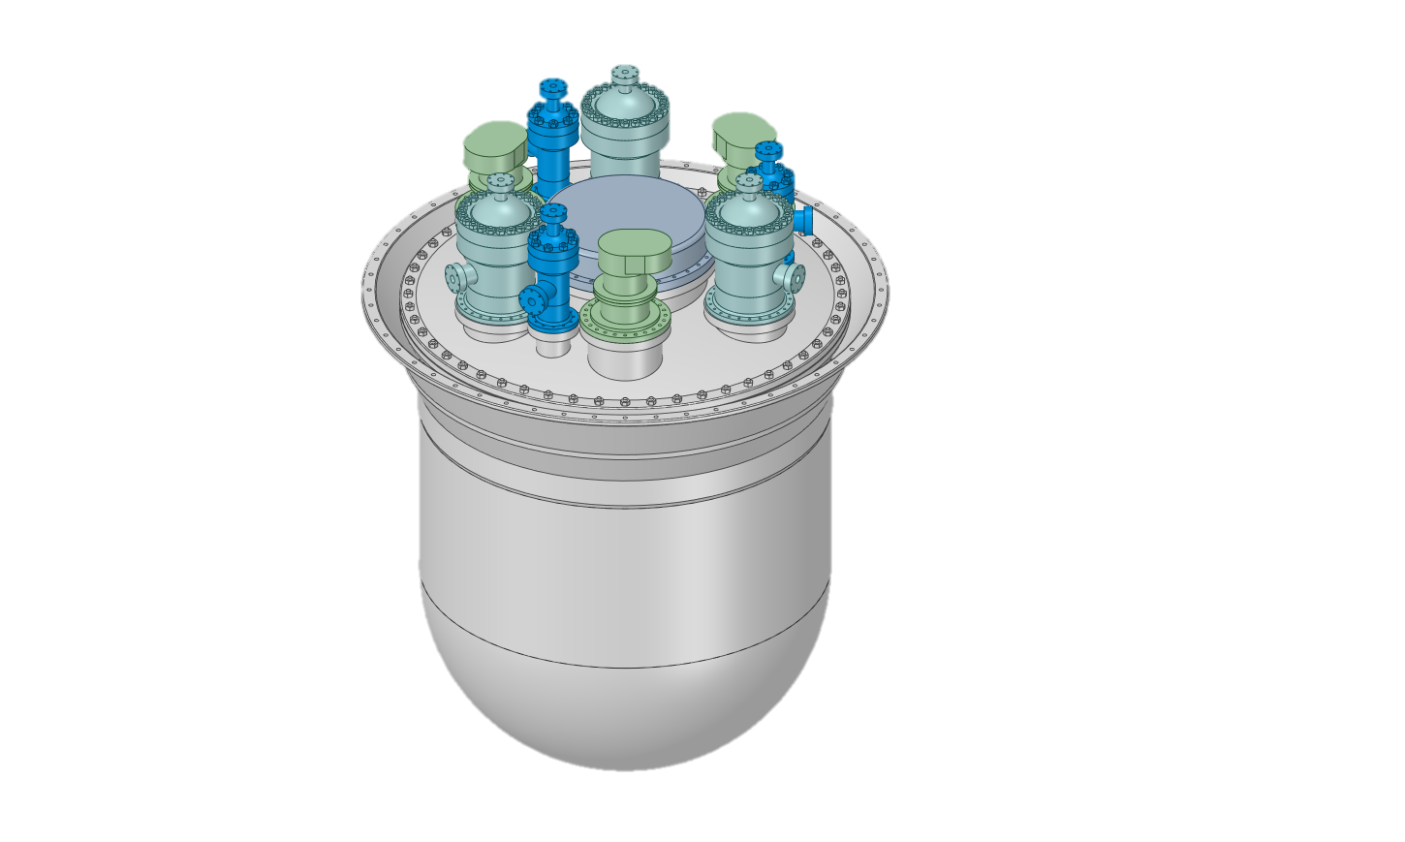The FALCON Consortium took important steps during the period of 2018-2020. First, a main step of the design review was completed, and a new system configuration was defined, consisting of three Steam Generators [SG] (using, benefitting from the new configuration, single wall bayonet tubes), three dedicated dip coolers for the second decay heat removal (DHR) system, and three primary pumps (PP). Definition of the placement of other dedicated systems and components on the reactor roof is presently under way. Additional design changes have been done in the primary system configuration. This involves an improved definition of hot and cold pools and a special arrangement of the primary flow path to completely eliminate the thermal stratification on the vessel for both forced and natural circulation conditions. The new configuration is presented in Figure 5:

*Figure 5* *ALFRED primary system flow-path configuration (left) and external view (right)*

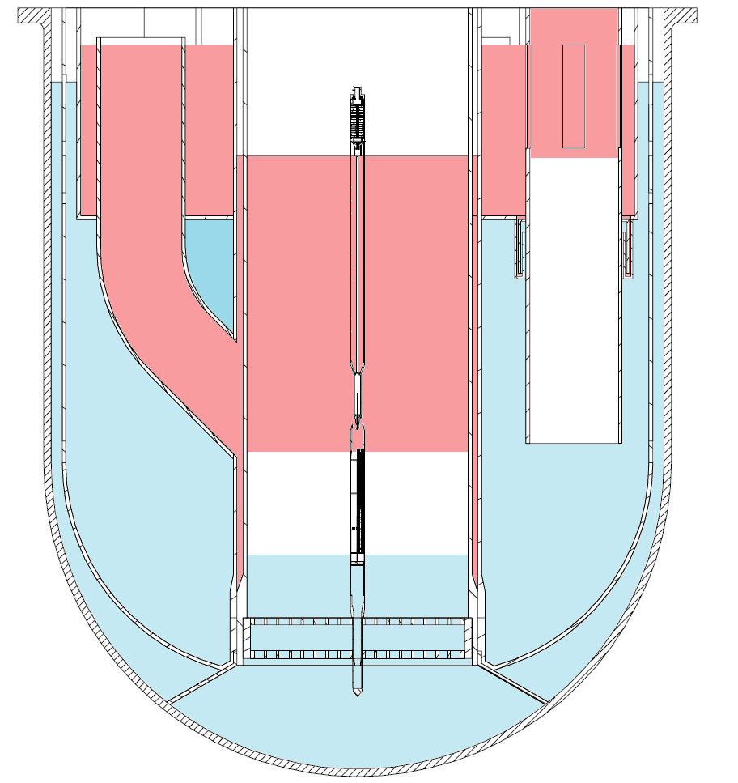

The DHR-1 system is comprised of Isolation Condensers connected to steam generators (three units) and equipped with an anti-freezing system which is being investigated in the PIACE EURATOM collaborative project. A similar system is used for the DHR-2 connected to a dip cooler, using double wall bayonet tubes.

In 2019, FALCON Consortium also took an important decision regarding ALFRED operation and licensing. Namely, it was decided to approach both the operation and licensing using a stepwise approach to better face the known limits concerning materials corrosion and consequent qualification in a representative environment. The idea is to follow a staged approach in principle characterized by a constant primary mass flow and increasing power levels resulting in an increase of the maximum lead coolant temperature as follows:

1st stage: low temperature Proven technology, proven materials, oxygen control, low temperatures

Hot fuel assembly (FA) for in-core qualification of coating for cladding

2nd stage: medium temperature Need for FA replacement, same SGs and PPs

Hot FA for in-core qualification at higher temperatures

3rd stage: high temperature Replacement of main components for improved performances

Representative of first-of-a-kind (FOAK) conditions for LFR deployment

In this way, each stage is used to qualify (through the hot fuel assembly conditions) the operation that will be carried out in the following stage. Each stage of the operation will need to be separately licensed but, using the confidence gained in the previous stage(s), the licensing process is expected to be a continuous process able to bring the technological solutions to the higher temperatures needed for the industrial deployment. The following table (Table 2) provides the main parameters of the envisaged staged approach:

TABLE 2: ALFRED staged approach - main parameters

|  |  |  |  |  |
| --- | --- | --- | --- | --- |
| Normal operation - full power | Units | Stage 1 | Stage 2 | Stage 3 |
| Thermal power | (MW) | 100 | 200 | 300 |
| Core inlet temperature | (°C) | 390 | 400 | 400 |
| Core outlet temperature | (°C) | 430 | 480 | 520 |
| Pump head | (MPa) | 0.15 | 0.15 | 0.15 |

Further information on ALFRED design and staged approach are presented in other papers of this Conference.

During 2019, the Romanian government also awarded RATEN ICN (the Romanian research lab) funding of 2.5 M€ for a project dedicated to “Preparatory activities for ALFRED infrastructure development in Romania”. The project ended successfully in November 2020 with a final public workshop organized by RATEN ICN.

RATEN ICN also responded to a call for proposals from Romanian government with the project “ALFRED - Step 1, experimental research support infrastructure: ATHENA (Lead pool type facility) and ChemLab (Lead chemistry laboratory)”. The project proposal was awarded funding in June 2020 and the competitive bids for design and construction of related facilities are to be published in the beginning of 2021 for a budget of 20 M€.

Finally, with regard to EURATOM R&D projects, the main already running collaborative projects related to LFR technology and Gen IV fuels are: (i) GEMMA, dedicated to material R&D and qualification for Gen IV / LFRs; (ii) M4F, covering material R&D for Gen IV and fusion applications; (iii) INSPYRE, dedicated to fuel R&D for fast reactors; and (iv) the LFR SMR INERI project, the latter involving European Commission / JRC and US DOE. This EURATOM project portfolio has recently been complemented by three new projects: PIACE (started in 2019) , and PATRICIA as well as PASCAL (both commenced in 2020). The PIACE project is dedicated to demonstrating prevention of lead freezing in LFRs through passive safety provisions. The project had its kickoff meeting at the ENEA research lab in Brasimone, Italy and is presently under execution, with some experimental results expected to be available in the beginning of 2021.

The PATRICIA project provides further supporting R&D for the implementation of MYRRHA and related pre-licensing efforts, while the PASCAL project involves R&D on selected safety aspects for heavy liquid metal systems, specifically focusing on the extension of experimental evidence to demonstrate the increased resilience of MYRRHA and ALFRED to severe accidents.

Lastly, the SESAME Euratom collaborative project was concluded in 2019 with the final workshop and the issue of a book dedicated to thermal hydraulic aspects of liquid metals.

### People’s Republic of China

The Chinese government has provided continuous national support to develop lead-based reactors technology since 1986, by the Chinese Academy of Sciences (CAS), the Minister of Science and Technology (MOST), the National Science Foundation (NSF), the 13th Five-Year plans, etc. Following more than 30 years of research on lead-based reactors, the China LEAd-based Reactor (CLEAR), proposed by the INEST(Institute of Nuclear Energy Safety Technology)/FDS Team, was selected as the reference reactor for ADS project, as well as for the technology development of the Generation IV lead-cooled fast reactor. Activities on the CLEAR reactor design, reactor safety assessment, design and analysis software development, lead-bismuth experiment loop, key technologies and components R&D activities are being carried out.

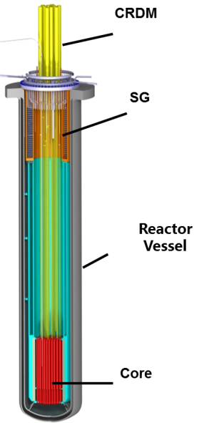The CLEAR-M project has been launched, with a reference 10MW power rating (i.e., the CLEAR-M10), aiming at construction of a small modular energy supply system. The main purpose of the project is to provide electricity as a flexible power system for wide application such as island, remote districts, industrial parks etc. Additionally, two small LFR projects have been supported by MOST aiming at exploring innovation in LFR concept designs.

For ADS systems, several concepts and related technologies are under assessment. For example, the detailed conceptual design of CLEAR-I with the final goal of MA transmutation, which has operational capabilities of subcritical and critical dual-mode has been finished. An innovative ADS concept system using an advanced external neutron source to drive the traveling-wave reactor CLEAR-A for energy production was proposed. The CiADS project conducted by collaboration of Chinese research institutes and industrial organizations aiming at building a 10MWth subcritical experimental LBE cooled reactor coupled with accelerator was approved, and the preliminary engineering design is underway.

In order to support the CLEAR projects as well as validate and test the key components and integrated operating technology of lead-based reactors, a multi-functional lead-bismuth experiment loop platform known as KYLIN-II was built and has been operated for more than 30,000 h.

*FIGURE 6* *Overall view of CLEAR-M reactor*

Various tests have been conducted, including corrosion tests, LBE thermal-hydraulic experiments, component prototype proof tests, etc. In addition, three integrated test facilities have been built and commissioned since 2017, including the lead-based engineering validation reactor CLEAR-S (Figure 7), the lead-based zero power critical/subcritical reactor CLEAR-0 coupled with HINEG neutron generator for reactor nuclear design validation, and the lead-based virtual reactor CLEAR-V.

A loss of flow benchmarking test based on the pool-type CLEAR-S facility is being prepared.

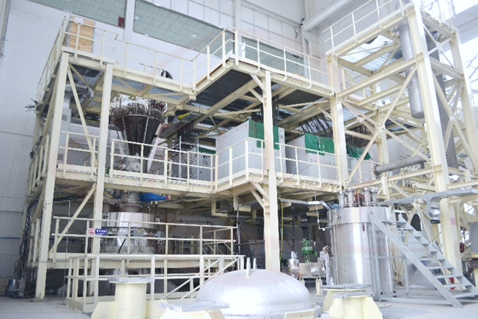

*Figure 7* *Lead-based Engineering Validation Reactor CLEAR-S*

In recent years, some other organizations started paying attention to LFR development. For example, China General Nuclear Power Group (CGN), China National Nuclear Corporation (CNNC), State Power Investment Corporation (SPIC), International Academy of Neutron Science(IANS) and several universities such as Xi’an Jiaotong University (XJUT), University of Sciences and Technology of China (USTC), etc. carried out LFR conceptual design and related R&D, like materials test, thermal-hydraulic analysis, safety analysis and so on. INEST was appointed by MOST as the lead organization to coordinate the paticipation of domestic organizations in GIF activities. The domestic LFR joint working group will be established.

To promote the engineering and commercial application of China lead-based reactor projects, the China Industry Innovation Alliance of Lead-based Reactor (CIIALER) and the International Co-operative Alliance for Small Lead-based Fast Reactors (CASLER), both led by INEST/FDS Team, were established and supported by over 100 enterprises, and a related industrial park began to be built.

### United States

Work on LFR concepts and technology in the U.S. has been carried out since 1997. In addition to reactor design efforts, these activities have included work on lead corrosion/material compatibility and thermal-hydraulic testing at a number of organizations and laboratories, and the development and testing of advanced materials suitable for use in lead or LBE environments. While current LFR activities in the US are limited, past and ongoing efforts at national laboratories, universities and the industrial sector demonstrate continued interest in LFR technology.

*FIGURE 8 Sketch of SSTAR Concept*

With regard to design concepts, of particular relevance is the past development of the Small, Secure Transportable Autonomous Reactor (SSTAR), carried out by Argonne National Laboratory (ANL), Lawrence Livermore National Laboratory (LLNL) and other organizations over an extended period of time. SSTAR is a SMR that can supply 20 MWe/45 MWth with a reactor system that is transportable. Although work on SSTAR is no longer active, SSTAR continues to be represented as one of the reference designs of the GIF-LFR pSSC. Some notable features of SSTAR include reliance on natural circulation for both operational and shutdown heat removal; a very long core life (15-30 years) with cassette refueling; and an innovative supercritical CO2 (S-CO2) Brayton cycle power conversion system. Figure 8 provides a sketch of the SSTAR concept.

Additional university-related design activities include past work at the University of California on the Encapsulated Nuclear Heat Source (ENHS) and more recently in several projects sponsored by the US Department of Energy under Nuclear Energy University Project (NEUP) funding. These include the following ongoing efforts: An effort led by the Massachusetts Institute of Technology in the area of corrosion/irradiation testing in Lead and Lead-Bismuth Eutectic. The project seeks to investigate the “Radiation Decelerated Corrosion Hypothesis” relying on simultaneous exposure tests (rather than separate long-term corrosion and neutron irradiation) followed by microstructural characterization, mechanical testing, and comparison to enable rapid down selection of potential alloy candidates and directly assess how irradiation affects corrosion. An effort at the University of Pittsburgh to develop a versatile liquid lead testing facility and test material corrosion behavior and ultrasound imaging technology in liquid lead.

In the industrial sector, ongoing LFR reactor initiatives include the continuing initiative by Westinghouse Corporation to develop a new advanced LFR system (Westinghouse-LFR) and the efforts of Hydromine, Inc. to continue development of the 200 MWe LFR identified as LFR-AS-200 (Amphora Shaped) as well as several micro-reactor spinoff concepts identified as the LFR-TX series (where T refers to Transportable, and X is a variable identifying power options ranging from 5 to 60 MWe). It should be noted that Westinghouse is engaged with several universities and national laboratories to pursue technology developments related to the LFR including an experimental investigation of radioisotope retention capability of liquid lead as well as efforts to utilize the Versatile Test Reactor for LFR-related investigations. Additionally, Westinghouse is currently engaged in the Phase 2 effort of the UK Government's Department for Business, Energy and Industrial Strategy's (BEIS) Advanced Modular Reactor (AMR) Feasibility and Development project to demonstrate LFR components and accelerate the development of high-temperature materials, advanced manufacturing technologies and modular construction strategies for the LFR.

## **Conclusion**

The paper briefly outlines the present activities of the LFR-pSSC in the frame of GIF. Details have been presented about the status of developments in the individual signatories of GIF-LFR-MoU. The scope of these activities and the breadth of international involvement demonstrates that the LFR should be considered as a promising technology for future nuclear development in the world.

References

1. Generation IV Technology Roadmap, Report GIF-002-00, Dec. 2002, and GIF Technology Roadmap Update – 2014 – <https://www.gen-4.org/gif/jcms/c_40473/a-technology-roadmap-for-generation-iv-nuclear-energy-systems>
2. A. Alemberti et al., Lead-cooled Fast Reactor Risk and Safety Assessment White Paper, <https://www.gen-4.org/gif/upload/docs/application/pdf/2014-11/rswg_lfr_white_paper_final_8.0.pdf>, GIF, 2014.
3. A. Alemberti et al. “Lead-cooled Fast Reactor (LFR) System Safety Assessment,” Generation IV Int. Report - June 3, 2020, <https://www.gen-4.org/gif/upload/docs/application/pdf/2020-06/gif_lfr_ssa_june_2020_2020-06-09_17-26-41_202.pdf>
4. “GIF Lead Cooled Fast Reactor Proliferation Resistance and Physical Protection White Paper” GIF web site October 2021 <https://www.gen-4.org/gif/jcms/c_196726/lfr-prpp-white-paper-2021-final-22102021-clean2?details=true>
5. A.Alemberti et al. “Lead-cooled Fast Reactor (LFR) Safety Design Criteria” Generation IV Int. Report - March, 2021 <https://www.gen-4.org/gif/jcms/c_176110/lfr-sdc-report-rev-1-march-2021>
6. GIF Web site collection of GIF Annual reports: <https://www.gen-4.org/gif/jcms/c_44720/annual-reports>