# The Status of the ALFRED Project

A. Alemberti

Ansaldo Nucleare SpA

Genova, Italy

Email: [Alessandro.Alemberti@gmail.com](mailto:Alessandro.Alemberti@gmail.com)

M. Frignani, M. Caramello, F. Merli

Ansaldo Nucleare SpA

Genova, Italy

M. Tarantino

ENEA C. R. BRASIMONE

Camugnano (Bologna), Italy

G. Grasso

ENEA C.R. BOLOGNA

Bologna, Italy

v. Moreau, m. profir

CRS4, Science and Technology Park Polaris

Pula, Italy

I. turcu, m. constantin, d. diaconu

RATEN/ICN

Mioveni, Romania

**Abstract**

The Lead cooled Fast Reactor (LFR) has been selected by the Generation IV International Forum (GIF) as one of the most promising nuclear technologies able to meet the GIF goals and playing an increasingly important role in the international context. The ALFRED (Advanced Lead-cooled Fast Reactor European Demonstrator) project aims to bridge the gap between the research and development effort and the commercial application. The ALFRED project is internationally supported by FALCON (Fostering ALFRED Construction), a consortium under the leadership of Ansaldo Nucleare with ENEA (IT) and RATEN-ICN (RO) which is presently pursuing the design review and optimization of the reactor system arrangement, an integration of the safety demonstration plan within the R&D roadmap as well as the pre-licensing process. In addition to the three full members, FALCON gathers many European organizations willing to contribute to ALFRED development not only in its role of LFR technology demonstrator but also as a prototype of a viable competitive LFR commercial unit in the Small Modular Reactors (SMRs) segment, by 2035-2040. The FALCON consortium recently completed a design review of ALFRED (based on the design developed and defined in the frame of the EC FP7 LEADER project) and, on the basis of the review, agreed to proceed to an optimized configuration able to solve all the specific issues of the previous configuration introducing innovative aspects not only related to improvements but also envisaged to increase the economic attractiveness for a potential deployment of the ALFRED follow-up unit as a first Small Modular Fast Reactor (SMFR). In parallel to such important developments the FALCON consortium is already developing a licensing strategy able to cope with the shortage of irradiation facilities (worldwide but especially European) through a staged approach providing the necessary qualification steps for this new technology, and pursuing the activities associated with the pre-licensing phase. The paper presents the main design developments, the new primary system arrangement and the strategy in terms of both R&D efforts as well as the envisaged licensing approach.

## INTRODUCTION

Lead cooled Fast Reactors (LFR) are increasingly gaining attention at worldwide level [1], as one of the most promising nuclear technologies, able to meet the goals set forth by the Generation IV International Forum (GIF). Molten lead as a coolant is recognized to offer multiple advantages to increase the safety, sustainability and economic aspects of the plant thanks to design simplifications and advantages inherent to the use of lead as a coolant. In Europe, the interest for the LFR technology is demonstrated by several dedicated supported collaborative research and innovation actions, with a total funding of about 150 M€ from the European Commission in the period 2005-2020 [2]. The support by the Commission reflects the interest of the member states whose research organizations and industry invested government or private funding to complement the European grants. The first pioneering studies on HLM-cooled systems started 20 years ago under the 5th EURATOM Framework Program (FP5), and immediately gathered increasing momentum. More than 30 collaborative actions involving an enlarged scientific community distributed over 15 European countries were proposed in the course of the years. These projects provided the first vision for pursuing the deployment of a fleet of European LFRs, along with the necessary framework in terms of harmonized safety and licensing approach, Research and Development (R&D) roadmap, suitable Education and Training (E&T) scheme. Since the proposal of the 3-years long LEADER (namely, Lead-cooled European Advanced Demonstration Reactor) FP7 project [3], launched in March 2010 and devoted to conceptual design activities, ALFRED was considered as a necessary undertaking to go for industrial deployment, addressing licensing challenges and lack of operational experience.

At the conclusion of the LEADER project, the strong commitment of Ansaldo Nucleare, ENEA and RATEN-ICN was confirmed and formalized through the signature of the FALCON international Consortium [1], created to manage the R&D strategic needs and securing the necessary funding for siting, licensing and construction of ALFRED. FALCON was conceived as an incubator and a pole of attraction for partners interested in the LFR technology, paving the way for the construction in Romania of the first Gen-IV LFR demonstrator with SMR-oriented features. The ALFRED roadmap was structured into four main Phases (Viability, Preparation, Construction and Operation) and further detailed into five areas of intervention (Management, RD&Q, Licensing, Engineering and Human Resources) [4]. Of course, the very first step of the activities was the undertaking of a technical review based on the design and information developed during the LEADER project. The main aspects of the technical review focused on three main sources of concerns, generally considered as top-priority issues in HLM pool-type reactors from a thermal-hydraulic point of view: (i) thermal stratification in the upper part of the pool, where the lead coolant results almost stagnant, being not involved in the primary circuit flow-path neither in forced nor in natural circulation; (ii) gas entrainment in case of Steam Generator (SG) Tube Rupture (SGTR), and direct transport of voids through the core, potentially causing positive reactivity insertion; (iii) lead freezing in long-term accident conditions, where control logic cannot be credited to regulate the power removed by the Decay Heat Removal (DHR) systems working in passive mode (while decay heat decreases exponentially).

|  |  |
| --- | --- |
|  | (01) Fuel Assembly  (02) Inner Vessel  (03) Lower core plate  (04) Upper core plate  (05) Reactor Vessel  (06) Reactor cover  (07) Steam Generator  (08) Vessel support  (09) Reactor Coolant pump  (10) Reactor cover  (11) Safety Vessel |
| *Fig. 1. ALFRED conceptual configuration and main flow path based on LEADER project.* | |

Multiple options were investigated to address the above issues and other aspects of reactor coolant system (RCS) arrangement through mechanical considerations (space allocation, interfaces, loads), inspection and maintenance strategy as well as economic aspects. The final design choices are described in the following together with the main justifications and reasons behind the proposed solutions, starting from an analysis of the issues of the previous configuration shown in Fig. 1. The analysis has been supported by extended numerical simulation, also taking profit of the work performed under the SESAME H2020 European project [5] with particular emphasis on the CFD pool modeling [6]. The illustrations from CFD simulations shown in the following have been performed by means of the STAR-CCM+ software by Siemens.

## ALFRED DESIGN REVIEW

## Several aspects have been considered thanks to the previous experience in system arrangement, components design and layout options. For each of the items that have been revised by the new design, rationales and main motivations are provided.

## **2.1. Reactor coolant system arrangement and main flow path**

The RCS arrangement developed in the LEADER project excelled in simplicity, thanks to the adopted coolant flow-path: in normal operation, the hot coolant is pumped from the core upper plenum directly into the SG units through the axial pumps; the cold lead at the outlet of the SGs is collected in a common volume (cold pool), having a free level on the top of the reactor (no pressurized volume), but also directly serving the core inlet. As shown in the right picture of Fig. 1 presenting a CFD simulation of 1/4 of the primary system, the upper part of the cold pool is not involved directly in the coolant circulation and consequently it will be progressively heated up by conduction from the hotter regions. As a result of the coolant thermal stratification, the reactor vessel wall would be exposed to progressively higher temperature and may experience a non-negligible creep regime.

In the LEADER project, a pre-conceptual design option consisting of an array of cooling tubes on the outer shell of the SGs was intended to reduce the thermal stratification. However, the solution adds some design and operational complications and would have been ineffective in accident conditions, where the component cooling system could not be credited while the coolant flow-path is practically unchanged with respect to the forced circulation scenario.

Finally, some CFD calculations indicated that the distribution of lead within the SG bundle would not have been uniform. Although gas entrainment in lead coolant is a controversial subject [5], the absence of an intermediate circuit makes the LFR subject to direct injection of steam into the pool should a SG tube rupture or leakage take place. The reference configuration of Fig. 1 is characterized by a direct connection from the outlet of the SG to the core inlet, thus making it potentially prone to transport the steam phase towards the core. Commonly to other Fast Reactor concepts, the passage of voids below-through-above the core is typically associated to reactivity oscillations.

Preliminary calculations performed in the LEADER project through simplified models and computational tools [8] showed some potential for steam entrainment and transportation into the core in the postulated enveloping event of double guillotine break of 7 SG tubes, under the hypothetical scenario in which the rupture of a central tube would have damaged also the six surrounding ones.

The RCS main flow path was thus revised to address, at once, both sources of concern. Multiple options for the location and type of the Reactor Coolant Pump (RCP) were considered, to screen those not able to meet the following main design criteria: (i) the lead free level in the SG unit shall be the highest, in order to maximize the heat exchange surface when PPs are on (normal operation); (ii) the lead free level in the core shall be the minimum, in order to reduce the risk of reverse flow through the core in the natural circulation transition following pump trip; (iii) any pressurization in closed regions inside the pool shall be avoided, in order to eliminate risks of partial loss of flow due to the failure of the mechanical structures; (iv) the volume of hot lead (hot pool) shall be minimized, in order to maximize the overall heat capacity of the reactor coolant in transient condition involving the loss of heat sink.

|  |  |
| --- | --- |
|  |  |
| *Fig. 2. Lead coolant flow-path in reference ALFRED configuration (left) and revised one (right).* | |

Fig. 2 synthetically describes the new conceptual primary system flow path where the introduction of an internal structure (IS) is shown to address the issues related to both thermal stratification and gas entrainment while at the same time maintaining a maximum level in the SGs during normal operation and minimizing the lead level on the core side. The main idea is to guide the flow at SG outlet to move upwards towards the cold pool free level.

|  |  |
| --- | --- |
| DHR |  |

*Fig. 3. ALFRED new configuration (left) and streamlines (right).*

The introduction of an IS has the main drawback of forcing a slight overall increase of the vessel diameter, which is however considered still acceptable. A flow-path involving also the upper part of the cold pool, as shown in Fig. 3, is intended to: (i) avoid stagnation of the coolant as main cause of the thermal stratification; (ii) bring any entrained steam close to the free level, where it will be released, thanks to the huge density difference with respect to the molten lead and to the absence of hydrostatic pressure; (iii) the primary system flow path is unchanged in case of natural circulation in the primary side so that thermal stratification does not develop during accidental conditions. This is illustrated in Fig. 3 and 4.

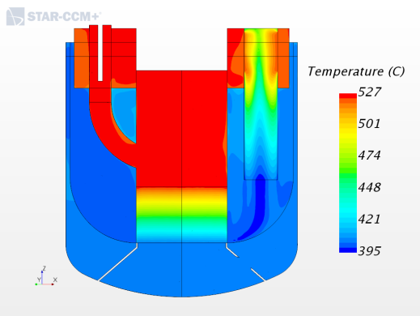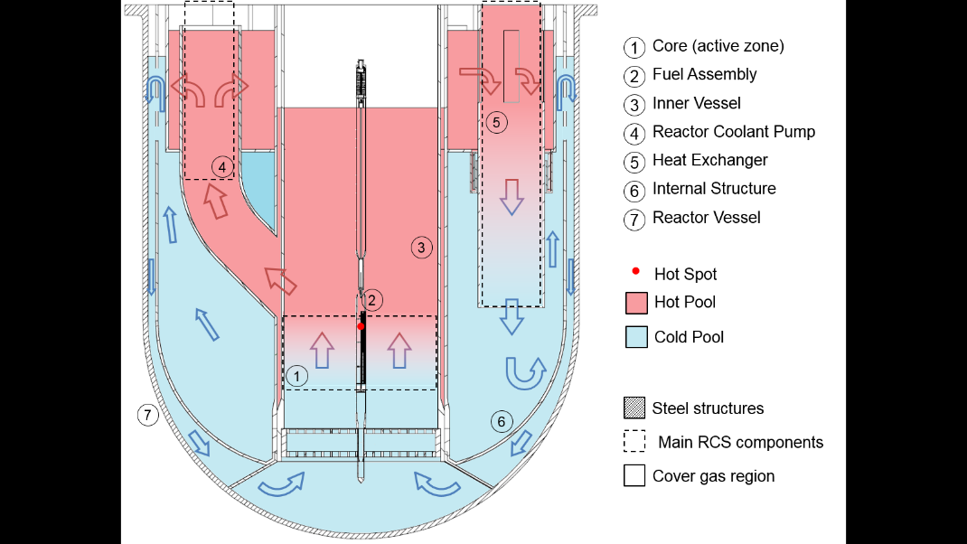To better highlight the characteristics of the new configuration, the primary flow path, hot and cold pool are schematically presented in Fig. 4, which well summarizes also the temperature distribution and level conditions in the primary system during normal operation.

*Fig. 4. ALFRED new RCS arrangement, main regions, coolant flow path (left) and temperature distribution (right).*

## P:\ENTI\RSC-CSA\ALFRED Project\003_Primary\Primary System\LAYOUT\Top_view.png**2.2. The new primary system configuration**

Following the new RCS arrangement, the main design solutions for the components and structures as well as new operational conditions of the primary system are highlighted. In fact, additional considerations about components removability, improvement of SG inlet distribution, separation of RCP and SGs unit, allocation of additional dip-coolers for decay heat removal and overall reduction of the number of components (3 RCPs, 3 SGs, 3 dip-coolers) lead to the configuration of Fig. 4 showing a buffer hot pool receiving the outlet flow from the pump and providing the inlet to SGs or dip-coolers. A top view of the new configuration is provided in Fig. 5. Additional space in the reactor cover is provisionally allocated for connections of auxiliary systems (e.g., cover gas purification, coolant conditioning, over-pressure protection, instrumentation etc.).

*Fig. 5.**Reactor top view.*

Thanks to the new primary system configuration and to the absence of a direct flow path from SG outlet to core inlet, the new design features single wall bayonet tubes (to increase the heat transfer efficiency and reduce the size of the tube bundle), thus facilitating the introduction of dip coolers directly immersed in the primary pool in the same functional position of the SG to preserve the main flow path also in accident conditions.

To improve performance and economic attractiveness of the system (in a short-term SMR deployment perspective), 520°C is considered as reference core outlet coolant (average) temperature. This fact not only improves the efficiency of the system, but also decreases the challenges in terms of requested RCP performance, being the overall thermal power still 300 MW(th). Concerning the safety systems, the LEADER project strategy has been not only confirmed but also improved. The first line of defense to remove the decay heat is still constituted by the active auxiliary feedwater system to the SGs (a non-safety grade system). The second level of defense is still through the 3 SGs connected to 3 Isolation Condensers (ICs), able to remove (2 loops out of 3) the full decay power in a passive mode after containment isolation. In order to cope with potential postulated scenarios where the DHR system would not be available, an E-DHR (Emergency) system has been conceived; the system is based on 3 independent loops respectively connected to 3 dip coolers and to 3 ICs. Both DHRs can be equipped with an anti-freezing system that is able to extend the grace time to freezing up to one week, a time which is considered enough to allow operator actions. The system and on-going validation activity are described in a companion paper and in further references [9,10]. The side view of the reactor is provided in Fig. 6.

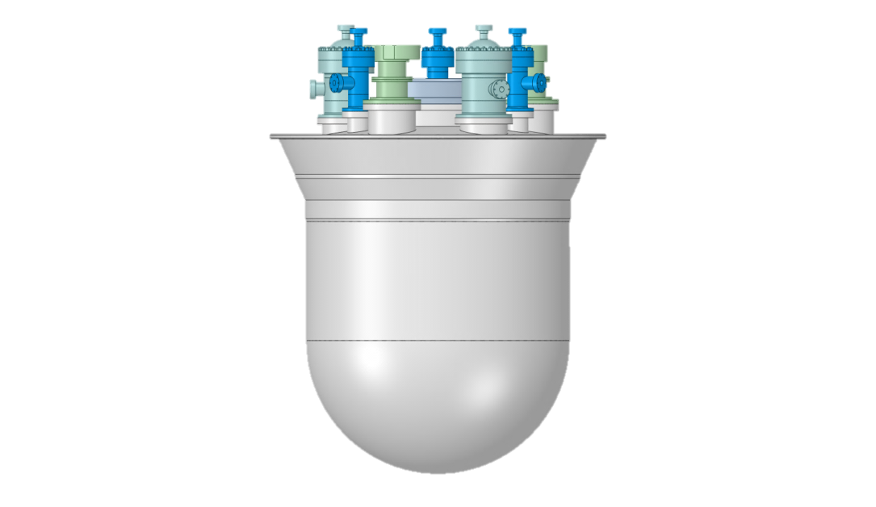

**Reactor Vessel**

**Steam Generator**

**Reactor Coolant Pump**

**Dip Cooler**

**Reactor cover**

*Fig. 7.**Reactor internals view.*

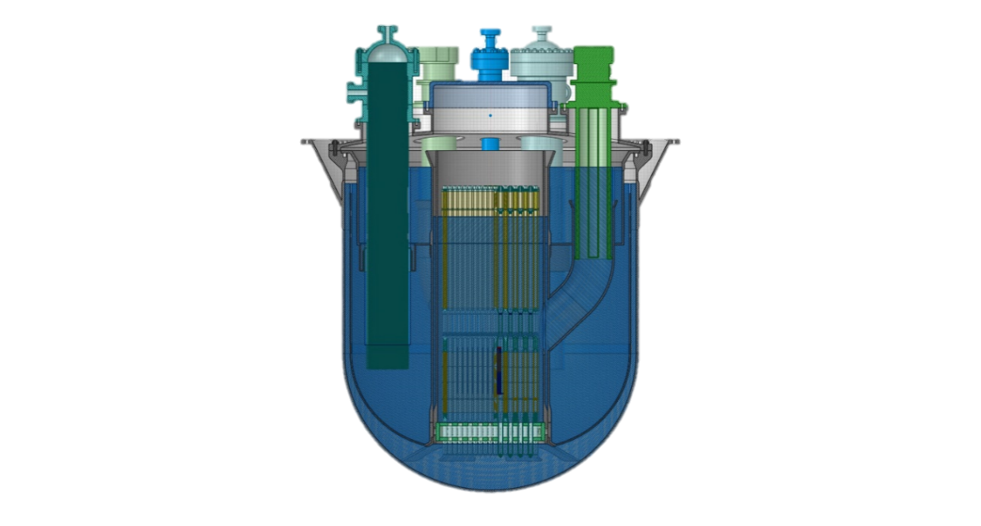

**Internal Structure**

**Inner Vessel**

Cold Level

Hot Level

Core Level

**Fuel assemblies**

**Reactivity control**

*Fig. 6. Reactor side view.*

Many options of the previous LEADER configuration have been confirmed: two different reactivity control and shut-down systems, hexagonal fuel assemblies (large p/d and pins supported by grids) extended to the cover gas region, MOX fuel, Inner Vessel (the main core support) laterally constrained by a lower cone frustrum and now completely removable for inspection/maintenance (due to its core support and restraint functions) because independent from the IS. The IS, used as guide for the primary coolant flow path, is also removable but requires the complete extraction of the components, which is however not foreseen for routine inspection, as it is a non-safety-classified component.

The result is illustrated in Fig. 7 where the main elements are highlighted.

The review has also provided indications on the need of isolating the reactor pit structural concrete through a layer of refractory material aimed at reducing the heat losses while keeping the structural concrete below the 60°C limit. The multi-layer structure is served by a dedicated heat removal passive system based on natural circulation of air (continuously in operation).

## LICENSING STRATEGY AND STAGED APPROACH

ALFRED, conceived initially to be the European Demonstrator of the LFR technology, is also trying to fill the gap between the research endeavor and the commercial application, assuming at the same time the role of a prototypic small modular lead fast reactor. However, such an ambitious goal is suffering the absence of previous operating experience, particularly regarding the qualification under irradiation of materials and coatings withstanding high temperatures in lead coolant. To reach such goal in a time frame compatible with a market perspective projected to 2035-2040, a strategy involving the licensing approach has been identified.

The main idea is to segment ALFRED operation in stages, starting from low temperature conditions and progressively increasing the core outlet temperature to close the gap between currently available technology (as irradiation-qualified materials withstanding low temperatures exist) and desired commercial performances (disclosed once high-temperature materials and coatings will have been qualified). While the demonstration program will provide operational experience and will address safety concerns thanks to enhanced margins, an R&D program will advance in parallel, feeding the demonstration program with the bases for advanced technological and design options, required for increased competitiveness of the commercial fleet. The demonstrator itself will contribute to complement the parallel R&D program, by qualifying technological solutions intended to be used in the following stages, thereby providing the evidences for its own licensing uprate, as being discussed with the Romanian safety authority.

Summarizing, the ALFRED first stage of operation addresses the two main areas of concern for the LFR technology:

* compatibility of lead with structural materials
* lead chemistry control.

Indeed, ALFRED will leverage on a combination of oxygen concentration control in liquid lead (10‑6 to 10-8 wt.%) and nuclear grade structural materials (notably, austenitic steels of 316 and 15-15Ti types), which have been shown to be compatible in the selected temperatures [11].

In practice each of the stages will be used to qualify the conditions of the following stage, anticipating such condition in the central hot channel fuel assembly. This strategy permits to the reactor to qualify its own operating conditions of the following stage, providing the needed experience presently lacking. The following Table 1 provides details of the envisaged stages for ALFRED operation:

TABLE 1. ALFRED MAIN PARAMETERS IN THE STAGES OF OPERATION

|  |  |  |  |  |
| --- | --- | --- | --- | --- |
|  | Stage 0  (Commissioning) | Stage 1  (Low Temp.) | Stage 2  (Medium Temp.) | Stage 3  (High Temp.) |
| Core inlet temperature (°C) | 390 | 390 | 400 | 400 |
| Core outlet temperature (°C) | 390 | 430 | 480 | 520 |
| Core thermal power (MW) | ≈ 0 | 100 | 200 | 300 |

This approach was selected also to minimize the risks posed by the current shortage of irradiation facilities, and especially of facilities where irradiation can be performed in lead coolant relevant conditions and fast neutron flux. While proceeding to the construction and first stage operation, the planned research program will produce the necessary out-of-pile evidences on the advanced materials and protection means (i.e., coatings) so to allow the irradiation qualification to be carried out at the right time.

## Conclusion

The paper is an overview of the present status of the activities carried out by the FALCON consortium on the ALFRED design. Starting from the issues identified in the previous configuration, an optimized design with several modifications and improvements has been defined and is going to be further developed through the detailed design phase.

The design review also accounted for the needs introduced by the identified licensing strategy, based on the concept of a staged approach able to provide an adequate response to the lack of operating experience and providing a way to bring progressively ALFRED to the operational conditions of an industrially deployable small modular lead fast reactor, envisaged around the year 2035-2040.

**ACKNOWLEDGEMENTS**

The CRS4 contribution to the work described in this paper for the FALCON consortium has been funded by the Autonomous Region of Sardinia.

References

1. Alemberti A. et al. (2014), “Overview of lead-cooled fast reactor activities”, Progress in Nuclear Energy, V. 77, Pages 300-307 https://www.sciencedirect.com/science/article/pii/S0149197013002357?via%3Dihub
2. Euratom Contribution to the Generation IV Int. Forum Systems in the period 2005-2014 and future outlook https://op.europa.eu/en/publication-detail/-/publication/77dd098e-1877-11e9-8d04-01aa75ed71a1/language-en
3. LEADER. (2010). https://cordis.europa.eu/project/id/249668/it
4. Frignani, M., & al. (2017). FALCON advancements towards the implementation of the ALFRED Project. IAEA FR17, (p. Paper 485). Yekaterinburg. https://www.iaea.org/publications/13414/fast-reactors-and-related-fuel-cycles-next-generation-nuclear-systems-for-sustainable-development-fr17
5. Tarantino M. et al. (2020), SESAME project: advancements in liquid metal thermal hydraulics experiments and simulations. EPJ Nuclear Sci. Tech. 6, 18 (2020) doi: 10.1051/epjn/2019046
6. Moreau V. et al.(2029) Pool CFD modelling: Lessons from the sesame project. Nuclear Engineering and Design. doi: 10.1016/j.nucengdes.2019.110343
7. Dinh, N. T. (2007). Multiphase flow phenomena of steam generator tube rupture in a lead-cooled reactor system: A scoping analysis. ICAPP 2007, (p. Paper 7497). Nice, France
8. Jeltsov, M., & al. (2018). Steam generator leakage in lead cooled fast reactors: modeling of void transport to the core. Nuclear Engineering Design, 328, 255-265
9. Caramello, M., & al. (2013). Thermal hydraulic analysis of a passively controlled DHR system. Progress in Nuclear Energy, 99, 127-139
10. Marinari, R., & al. (2019). SIRIO: An Experimental Facility for a New Heat Removal System Passively Controlled by Non-Condensable Gases. 26th International Conference on Nuclear Engineering (ICONE 26), 6B
11. Ejenstam J., Szakalos P., “Long term corrosion resistance of alumina forming austenitic stainless steels in liquid lead”, J ournal of Nuclear Materials, 461, 164–170, (2015).