Modelling of radionuclide release from primary system during a hypothetical severe accident in an SFR
Parthkumar Rajendrabhai Patel^{a,b}
Homi Bhabha National Institute and,
ªIndira Gandhi Centre for Atomic Research, Kalpakkam 603102, Tamilnadu, India
^{b}Homi Bhabha National Institute, Training School Complex, Anushaktinagar, Mumbai 400094, India Email: parthpdpu@gmail.com

A. John Arul^{a,b}
ªIndira Gandhi Centre for Atomic Research, Kalpakkam 603102, Tamilnadu, India
^{b}Homi Bhabha National Institute, Training School Complex, Anushaktinagar, Mumbai 400094, India

S. Raghupathy
RDTG, Indira Gandhi Centre for Atomic Research
Kalpakkam, Tamilnadu, India

Abstract
The determination of the radionuclide (RN) release from the primary system is a challenging task, as there is significant uncertainty involved in the modelling of RN transport owing to the complex physio-chemical process following a core melt. The RN release and transport is mainly controlled by their diffusion characteristics in the fuel, chemical interactions between RNs and coolant, their physical form, to mention a few phenomena. In the present work, a thermo-chemical equilibrium approach is adopted to study the release behaviour of RN from the core & coolant to the cover gas and containment volume. We would consider this approach as the first step towards mechanistic model development for oxide fueled Sodium cooled Fast Reactors (SFRs). To study the release behavior of RN, a medium-sized oxide fueled, pool type SFR (1250 MWt) is chosen as a reference design. For the analysis, unprotected loss of flow accident (ULOFA) initiated by tripping of both the coolant pumps without reactor shutdown, resulting in whole core melt is considered. The analysis is performed for different temperatures with two mixing assumptions, i.e., ideal mixture assumption and real mixture assumption and the results are compared using previously calculated released value for no mixture. The ideal mixture follows Raoult's law. Whereas in the real mixture assumption, the excess functions and solubility are considered. With the help of equilibrium species distribution, the release fractions (RFs) are evaluated. From the calculations, we observe that the amount of oxygen available for the reaction affects the release of lanthanides and the barium-strontium group (For example, Eu and Sr). Additionally, various mixture assumptions have an impact on the release estimate of the RN. Finally, a sensitivity study is performed for the release control volume to include containment volume.

INTRODUCTION
The radioactive source term estimation is concerned with the analysis of the evolution and release of the RN from the reactor vessel to the environment post severe accident. Since the inception of nuclear reactors, the determination of the source term for nuclear reactors has been a central interest for regulators as well as reactor designers. Sufficient tools and experimental databases are available for the mechanistic estimation of source term for the Light Water Reactor (LWR). For SFRs, though advanced code systems can predict the neutronic and thermal-hydraulic evolution with confidence, there is still considerable uncertainty in terms of accident initiating events, accident progression, evolution and transport of the RN in the reactor vessel as well as in the containment [1]. These necessitate the development of a relatively accident path independent code system.
The present manuscript studies the RN release from the primary sodium system (core and coolant) for the medium-sized oxide fuelled fast reactor. In a recent article, P R Patel and John Arul [2] have analysed the RN release from primary sodium using the chemical equilibrium approach [3] with no mixture assumption. The present article extends the analysis to include analysis for the ideal mixture and real mixture cases. The detailed information regarding the reference reactor and the initiating ULOF event can be found in P R Patel and John Arul [2]. The ideal mixture follows Raoult's law. Whereas the behaviour of real mixtures depends on the excess functions. The real mixture provides a comparatively realistic estimate for the RN release, provided correct estimates of the excess functions are available. With this assumption, the RN released to the cover gas are estimated. Additionally, RN release from the reactor vessel is estimated by changing the release control volume to containment volume.
The article is structured as follows: Section 1 briefly describes the methodology used for the analysis. Section 2 discusses calculation results and assumptions considered for the analysis. Section 3 describes the results of the sensitivity study. Section 4 concludes our findings.

Calculation methodology
The thermochemical equilibrium can be determined by two methods: i) using rate kinetics ii) using free energy minimization. The equilibrium using the kinetic rates gives the time information of the species formation. For the determination of the equilibrium using kinetics for the reactor systems, a large database of reaction rates is required. For nuclear materials, these reaction rates are scarce. Thermochemical equilibrium using free energy minimization provides an efficient way to determine the equilibrium species for a large system with thousands of possible chemical species.
Additionally, the free energy minimization method does not require knowledge of the resultant species beforehand [4]. For the current analysis, thermochemical equilibrium is determined using free energy minimisation. Since the reactor temperatures are high, the rates of the reactions are expected to be rapid; the equilibrium approximations will not result in a significant error [2,5]. The present section discusses the methodology used to determine the source term.

Free energy minimisation
Free energy minimisation can be achieved by minimizing either Gibb's or Helmholtz's free energy function following [6]. The choice of the minimisation function depends on the system description, i.e., whether the system is defined at the constant volume or at the constant pressure. For a multiphase system with $\left(x_{1},x_{2},…,x_{N_{g}},…,x_{N_{g}+N_{l}},…,x_{N_{g}+N_{l}+N_{c}}\right)$ moles of $\left(N_{g}+N_{l}+N_{c}\right)$ species containing $N_{e}$ elements at constant T & V, the Helmholz free energy minimisation can be formulated as below:

$$A\left(T,V\right)=G-PV$$
$$\begin{aligned}=\sum_{i=0}^{N_{g}+N_{l}+N_{c}}{μ_{i}x_{i}}-PV \#(1)\end{aligned}$$
Dividing Eq. 1 by RT,
$$\begin{aligned}\tilde{A}\left(T, V\right)=\sum_{i=0}^{N_{g}+N_{l}+N_{c}}{\tilde{μ_{i}}x_{i}- \overline{x^{g}}} \#\left(2\right)\end{aligned}$$
Where, G is the Gibb's function. $\overline{x^{g}}$ is the total moles of gaseous species in the system. $\tilde{μ_{i}}$ is the reduced (dimensionless) chemical potential, which can be expressed in terms of their standard chemical potentials as,
$$\begin{aligned}\tilde{μ_{i}}=\left\{\begin{aligned}{\left(\tilde{μ^{o}}\right)}_{i}^{g}+\ln{\frac{γRT}{V}+lnx_{i}^{g},\text{ for} i=1, 2,…,N_{g}} \\ {\left(\tilde{μ^{o}}\right)}_{i}^{l}+\ln{\frac{γx_{i}^{l}}{\overline{x}}} ,\text{ for} i=1, 2,…,N_{l} \\ {\left(\tilde{μ^{o}}\right)}_{i}^{c} ,\text{ for} i=1, 2,…,N_{c}\end{aligned}\right.\#\left(3\right)\end{aligned}$$
The superscripts' g', 'l' and 'c' are for the gas phase, liquid phase, and condensed phase, respectively. $γ$ is the activity coefficient. For the ideal solution, the activity coefficient is one, where for the nonideal solution, the activity coefficient is nonzero.
The above function is minimised with the mass constraint, given as below,
$$\begin{aligned}\sum_{i=1}^{N_{g}}{a_{ij}^{g}x_{i}^{g}+ }\sum_{i=1}^{N_{l}}{a_{ij}^{l}x_{i}^{l}+ }\sum_{i=1}^{N_{c}}{a_{ij}^{c}x_{i}^{c}=b_{j} , j=1, 2, 3…, N_{e}} \#\left(4\right)\end{aligned}$$

xi≥ 0, is the positivity constraint#5

Here, $a_{ij}^{g}$ is the number of atoms of j^{th} element in the i^{th} gaseous species. Similarly, $a_{ij}^{l}$ and $a_{ij}^{c}$ are the number of atoms of j^{th} element in the i^{th} liquid and condensed species, respectively. b_{j} is the total number of moles of the element j, originally present in the system mixture [2]. The above Helmholtz function (Eq. 2) is minimized with the specified constraints (Eq. 4). From the obtained equilibrium species at particular temperature and pressure, released RN to the cover gas were determined using the following relation [2]:

$$\text{Elemental release fraction}= RF(e_{j})=\frac{\sum_{\text{i}}{\text{Number of moles of }{\text{j}}^{\text{th}}\text{element in }{\text{i}}^{\text{th}}\text{gaseous species}}}{\text{Total mole inventory of }{\text{j}}^{\text{th}}\text{element}}$$

$$\text{Isotropic release fraction}=RF{\left(iso\right)}_{k}=RF{\left(e\right)}_{j}×\text{isotopic fraction of }{\text{k}}^{\text{th}}\text{ isotope}$$

A python program named MINICHEM (MINImization of CHEMical potentials) [2,7] was extended to solve the above equations for the real mixture and ideal mixture assumptions. MINICHEM is an open-source code and the MINICHEM with no mix case is available at GitHub [7].

Calculation, results and discussion
For the analysis, similar assumptions as in P R Patel and John Arul [2]are considered as follows,
(a) All RNs are homogeneously mixed in the sodium pool at a uniform temperature.
(b) The considered species are at the thermochemical equilibrium.
(c) The elements having inventory less than 0.1 moles were not taken into consideration.
During the disassembly phase, the sodium pool temperatures will not be at the uniform temperature. However, the thermal equilibrium of the core will be reached within ~0.7 seconds [8]. Additionally, during the disassembly phase, the homogeneous mixture is not valid; however, the fuel sodium reactions are expected and will lead to fragmentation of the fuel as well RN. These fragments will be in intimate contact with sodium. To address the uncertainty in the sodium pool temperature, we have analysed the release behaviour of the RN at different temperatures.
For the detailed thermochemical analysis, a comprehensive chemical potential database of all RN is needed for a wide range of temperatures. For the current analysis, NASA CEA code's thermochemical database [9,10] was used. However, we found that thermochemical data for the lanthanides and actinides were not available in the NASA thermochemical database. Hence, the thermochemical database is compiled from the open literature [11–15] as well as from the FASTSAGE thermochemical database [16]. For the thermochemical analysis, about 37 elements and about 2300 species were considered. For the oxygen inventory, oxygen in the sodium as an impurity was also considered apart from the oxygen in the fuel. The RN selection was made based on their radiological importance, provided their inventory is greater than 0.1 mole [17]. In the current analysis, the contribution of structural material to the source term is not considered [2]. Two calculations were performed, i) by assuming all RN and sodium as an ideal mixture, which follows Raoult's principle ii) by assuming all RN and sodium as real mixture, where the excess functions were incorporated. For the simulation, the excess functions for the Cs, NaI, Rb, Ba, Te, UO₂, PuO₂, and Ce₂O₃ were used. The RFs for the ideal mix assumption as well for the real mix analysed at different temperatures are shown in Table 1 and Table 2.

Table 1 In-vessel source term RF with the ideal mixture assumption, the cover gas volume for the reference reactor was considered as 100 m³. The thermochemical equilibrium was analysed at the constant temperature and constant reactor vessel volume
Element | 873 K | 900 K | 950 K | 1000 K | 1156 K
Ag | 5.70E-16 | 1.89E-15 | 1.45E-14 | 9.16E-14 | 1.05E-11
Am | 2.13E-21 | 2.21E-20 | 1.18E-18 | 4.85E-17 | 4.01E-13
Ar | 1.00E+00 | 1.00E+00 | 1.00E+00 | 1.00E+00 | 1.00E+00
Ba | 3.97E-12 | 1.03E-11 | 5.27E-11 | 2.32E-10 | 1.02E-08
Br | 1.01E-07 | 5.86E-08 | 2.71E-08 | 1.23E-08 | 8.76E-08
Cd | 3.21E-06 | 4.73E-06 | 9.10E-06 | 1.63E-05 | 7.07E-05
Ce | 4.81E-25 | 4.65E-24 | 2.33E-22 | 9.14E-21 | 1.11E-16
Cm | 1.42E-22 | 5.95E-22 | 2.44E-20 | 8.00E-19 | 6.01E-15
Cs | 1.39E-05 | 1.81E-05 | 2.80E-05 | 4.14E-05 | 1.11E-04
Eu | 1.31E-16 | 2.62E-16 | 8.43E-16 | 2.47E-15 | 3.16E-12
Gd | 4.48E-18 | 9.08E-18 | 2.99E-17 | 8.66E-17 | 1.24E-15
Ge | 6.00E-20 | 3.33E-19 | 6.39E-18 | 9.43E-17 | 1.05E-13
H | 1.77E-09 | 3.23E-09 | 9.19E-09 | 2.35E-08 | 2.51E-07
He | 1.00E+00 | 1.00E+00 | 1.00E+00 | 1.00E+00 | 1.00E+00
I | 1.06E-08 | 7.69E-09 | 7.54E-09 | 1.98E-08 | 2.22E-07
Kr | 1.00E+00 | 1.00E+00 | 1.00E+00 | 1.00E+00 | 1.00E+00
La | 1.03E-25 | 1.22E-24 | 9.24E-23 | 4.53E-21 | 8.85E-17
Mo | 2.55E-32 | 2.55E-32 | 2.55E-32 | 2.77E-32 | 1.78E-28
Na | 1.01E-06 | 1.50E-06 | 2.92E-06 | 5.29E-06 | 2.40E-05
Nb | 1.91E-31 | 1.91E-31 | 1.91E-31 | 4.08E-30 | 5.14E-25
Nd | 3.31E-26 | 2.51E-25 | 7.87E-24 | 1.75E-22 | 5.25E-19
Np | 2.51E-22 | 3.57E-22 | 6.06E-22 | 2.59E-21 | 3.14E-17
O | 9.37E-19 | 3.43E-18 | 3.43E-17 | 3.13E-16 | 1.64E-13
Pm | 1.25E-16 | 2.44E-16 | 7.58E-16 | 2.07E-15 | 2.62E-14
Pr | 1.52E-14 | 2.97E-14 | 9.17E-14 | 2.49E-13 | 3.00E-12
Pu | 5.61E-17 | 7.81E-17 | 1.35E-16 | 2.19E-16 | 7.02E-16
Rb | 1.12E-05 | 1.47E-05 | 2.34E-05 | 3.53E-05 | 9.99E-05
Ru | 4.42E-31 | 6.27E-30 | 5.71E-28 | 3.30E-26 | 1.08E-21
Sb | 1.00E+00 | 1.00E+00 | 1.00E+00 | 1.00E+00 | 1.00E+00
Sm | 1.38E-18 | 2.76E-18 | 8.92E-18 | 2.53E-17 | 3.40E-16
Sn | 1.44E-17 | 4.69E-17 | 3.50E-16 | 2.14E-15 | 2.19E-13
Sr | 2.72E-12 | 7.53E-12 | 4.32E-11 | 2.12E-10 | 1.30E-08
Tb | 6.19E-20 | 7.65E-20 | 5.31E-19 | 8.52E-18 | 1.29E-14
Te | 6.12E-28 | 5.77E-27 | 2.61E-25 | 8.01E-24 | 4.99E-20
U | 1.22E-28 | 1.40E-27 | 8.78E-26 | 3.63E-24 | 4.89E-20
Xe | 1.00E+00 | 1.00E+00 | 1.00E+00 | 1.00E+00 | 1.00E+00
Zr | 1.85E-32 | 1.85E-32 | 1.30E-31 | 1.09E-29 | 1.57E-24

Table 2 In-vessel source term RF with the real mixture assumption, the cover gas volume for the reference reactor was considered as 100 m³. The thermochemical equilibrium was analyzed at the constant temperature and constant reactor vessel volume
Element | 873 K | 900 K | 950 K | 1000 K | 1156 K
Ag | 5.70E-16 | 1.89E-15 | 1.45E-14 | 9.16E-14 | 1.05E-11
Am | 2.14E-21 | 2.22E-20 | 1.19E-18 | 4.86E-17 | 4.02E-13
Ar | 1.00E+00 | 1.00E+00 | 1.00E+00 | 1.00E+00 | 1.00E+00
Ba | 3.98E-12 | 1.03E-11 | 5.28E-11 | 2.32E-10 | 1.02E-08
Br | 2.30E-07 | 1.36E-07 | 3.18E-07 | 4.30E-07 | 1.63E-06
Cd | 3.21E-06 | 4.73E-06 | 9.10E-06 | 1.63E-05 | 7.07E-05
Ce | 2.06E-25 | 2.03E-24 | 1.06E-22 | 4.33E-21 | 5.81E-17
Cm | 1.45E-22 | 6.05E-22 | 2.49E-20 | 8.13E-19 | 6.08E-15
Cs | 3.81E-05 | 4.77E-05 | 7.14E-05 | 1.02E-04 | 2.46E-04
Eu | 1.32E-16 | 2.63E-16 | 8.44E-16 | 2.47E-15 | 3.16E-12
Gd | 4.49E-18 | 9.10E-18 | 3.00E-17 | 8.67E-17 | 1.24E-15
Ge | 6.00E-20 | 3.33E-19 | 6.38E-18 | 9.42E-17 | 1.05E-13
H | 1.77E-09 | 3.23E-09 | 9.19E-09 | 2.36E-08 | 2.51E-07
He | 1.00E+00 | 1.00E+00 | 1.00E+00 | 1.00E+00 | 1.00E+00
I | 1.48E-07 | 1.07E-07 | 2.65E-07 | 7.09E-07 | 4.82E-06
Kr | 1.00E+00 | 1.00E+00 | 1.00E+00 | 1.00E+00 | 1.00E+00
La | 1.03E-25 | 1.22E-24 | 9.25E-23 | 4.54E-21 | 8.86E-17
Mo | 2.55E-32 | 2.55E-32 | 2.55E-32 | 2.77E-32 | 1.78E-28
Na | 1.01E-06 | 1.50E-06 | 2.92E-06 | 5.29E-06 | 2.40E-05
Nb | 1.91E-31 | 1.91E-31 | 1.91E-31 | 4.08E-30 | 5.14E-25
Nd | 3.31E-26 | 2.51E-25 | 7.88E-24 | 1.75E-22 | 5.25E-19
Np | 2.65E-22 | 3.77E-22 | 6.24E-22 | 2.65E-21 | 3.19E-17
O | 9.93E-19 | 3.57E-18 | 3.50E-17 | 3.15E-16 | 1.64E-13
Pm | 1.25E-16 | 2.45E-16 | 7.59E-16 | 2.07E-15 | 2.62E-14
Pr | 1.53E-14 | 2.98E-14 | 9.18E-14 | 2.50E-13 | 3.00E-12
Pu | 5.63E-17 | 7.82E-17 | 1.36E-16 | 2.20E-16 | 7.02E-16
Rb | 2.72E-05 | 3.48E-05 | 5.22E-05 | 7.56E-05 | 1.92E-04
Ru | 4.42E-31 | 6.27E-30 | 5.71E-28 | 3.30E-26 | 1.08E-21
Sb | 1.00E+00 | 1.00E+00 | 1.00E+00 | 1.00E+00 | 1.00E+00
Sm | 1.38E-18 | 2.77E-18 | 8.94E-18 | 2.53E-17 | 3.40E-16
Sn | 1.44E-17 | 4.69E-17 | 3.50E-16 | 2.14E-15 | 2.19E-13
Sr | 3.06E-12 | 8.34E-12 | 4.68E-11 | 2.26E-10 | 1.36E-08
Tb | 6.19E-20 | 7.65E-20 | 5.31E-19 | 8.51E-18 | 1.29E-14
Te | 6.12E-28 | 5.77E-27 | 2.61E-25 | 8.01E-24 | 4.99E-20
U | 1.23E-28 | 1.40E-27 | 8.80E-26 | 3.64E-24 | 4.89E-20
Xe | 1.00E+00 | 1.00E+00 | 1.00E+00 | 1.00E+00 | 1.00E+00
Zr | 1.85E-32 | 1.85E-32 | 1.32E-31 | 1.11E-29 | 1.58E-24
The interpretation of the calculated RFs is discussed in terms of the approximate chemical group to which the RN belong (as per NUREG-1465 grouping). Here, the no mix case is discussed for comparison with real/ideal mix. Since the release fractions for the real and ideal mixtures assumptions have not much difference for most of the species, the release behaviour is discussed for No mixture and Ideal/real mixture.

Noble gases:
Irrespective of the mixture assumption, most of He, Xe, Kr gets released from the fuel as the solubility of the noble gases is negligible in the sodium. However, as it is seen from past experiences [18], the initial release will be from the gap inventory. The gap inventory is mainly from the diffusional release during the steady-state operation. The remaining noble gas RNs are released during the melt phase of the accident.

Halogens:
Iodine has strong chemical affinity to both cesium and sodium. The core inventory of iodine is several times less than the cesium and sodium inventory. It is important to determine whether iodine will bind with cesium or sodium. Though the formation of the cesium iodide or sodium iodide will not have effect on the release behaviour of the iodine, it will affect the release behaviour of the cesium. The NaI compound formation leads to higher retention of iodine compared to its elemental forms from the primary system. The release behaviour of the sodium iodide or cesium iodide is dependent on the mixing property and excess functions.
(a) No mix: For no mix assumption, most of the iodine reacts with the available cesium [2]. The formation of sodium iodide is in trace amount.
(b) Real/ideal mix: For calculations with real/ideal mixture, it is found that NaI_{(l)} is the predominant chemical species in the primary sodium with a fraction of I reacting with Cs and Rb. This confirms the observation by Castleman et al. [19]. Though species formation for halides in both mixture assumption is identical, the real mixture does result in one order higher release compared to ideal mixture case. This might be due to the contribution of excess function for the sodium iodide to the Gibbs potentials.

Additionally, it is found that unlike uranium halide compounds observed for the metal fuelled reactor by Schram et al.[3], for the oxide fuelled fast reactor, the uranium halide compound formation is not found either in the coolant or cover gas. This might be due to the stronger affinity of uranium towards oxygen. The chemical affinity of cesium to bromine is similar to the affinity of cesium to iodine. With consideration of the mixture properties, most of bromine reacts with sodium and forms sodium bromide. However, this compound formation will lead to a lower release of the bromine compared to its elemental form.
Alkali metals:
This group consists of Cs, Rb, and Na. The release behaviour of the alkali metals changes with the solubility assumptions.
(a) No mix: With no mixture assumption, about 10% of total Cs was bound with iodine [2], formation of the elemental Cs without consideration of solubility leads to a higher release of the Cs. Similar observations are seen for the rubidium. At 873 K and above temperatures, complete rubidium inventory was released [2]
(b) Real/Ideal mix: With mixture properties, the cesium is found mostly in the solute form in the sodium as in elemental form. The rubidium is soluble in sodium. Most of the rubidium is retained in liquid sodium in the elemental form. Sodium mostly binds with uranium, iodine and rubidium. The rest of sodium remains in Na_{(l)} form.

Tellurium group:
The tellurium group consisting of Te, Sb, and Se. With consideration of the mixture property, most of tellurium reacts with sodium and forms Na₂Te_{(l)}. Antimony is found to be released 100% at all temperatures. Since, in this calculation, the excess functions for antimony are not considered, the higher RFs are reported. However, with (real or ideal) mixture assumption, only trace amounts of antimony are expected to be released [3].

Barium, Strontium group:
This group consists of barium and strontium.
(a) No mix: For the no mix assumption, most of the barium and strontium was in sodium in condensed form. Where, almost 70% of the barium was in the oxide form, and rest of barium binds with the tellurium [2]. For no mixture metal fuelled reactor case, Schram et al. [3] observed higher RF of the strontium (0.077) since, for the metal reactor, the available oxygen for the reaction is less compared to the oxide fuelled fast reactor, and metallic strontium is more volatile compared to its oxide forms.
(b) Real/Ideal mix: With (real or ideal) mixture assumption, about 60% of the barium is retained as Ba_{(l)} in the sodium and the rest of the barium forms oxide condensates (BaO_{(cr)}). Similar to the no mix case, we observe the formation of strontium oxide condensate in the sodium for the current reference reactor (oxide fuelled reactor).

Noble Metals:
The noble metal group consists of Ru, Rh, Pd, Mo, Tc, Co. All ruthenium stays in condensed form for both ideal as well as real mix cases. Molybdenum is found in Mo_{(l)} form in the sodium.

Lanthanides:
The lanthanide group consists of La, Zr, Y, Cm, Am, Nd, Eu, Nb, Pm, Pr, Sm. The volatility of these elements is dependent on the availability of oxygen [2,20]. For example, for metal reactors [3], It is observed that Eu has volatile behaviour (RF: 0.133); this is due to the less available oxygen for reaction in the metal fuelled fast reactor.
In the oxide core with no mix case, Eu was in stable condensate form (Eu₂O₃) [2]. Ideal and real mixture cases also follow the same trend as the no mixture case. Hence, it is concluded that the availability of oxygen for reactions is an important parameter to the RFs.

Cerium group:
The cerium group mainly consist of Ce, Pu and Np. For all mixture (no, real and ideal mix) assumptions, all three elements form stable oxide condensates in the sodium with negligible RFs.

Sensitivity Study
In this section, the sensitivity of the release of RN with respect to different release control volumes is studied. Two release control volumes are considered for the analysis, viz. i) cover gas volume ii) containment volume. The RFs from the constant temperature and cover gas volume can be considered as an instantaneous source to be released to the containment. Whereas RF from the constant temperature and containment volume can be considered as the long term RN source to the containment. Since, prior to roof-slab failure, the cover gas volume will be available for RN release and similarly post roof-slab failure, the containment volume will be available for the release of the RNs. The analysis is performed at 873 K and 1156 K with both no-mix and real mix assumptions. The results are shown in Fig. 1. As shown in Fig. 1, as control volume size increases, higher release fractions are observed. This may be due to the larger release volume available to RN for the release. The difference in the release of RN for different mixture cases may be due to the solubility of RN. For example, as shown in Fig. 1 (b, d), no mix assumption for the containment volume leads to release of all volatile RNs in the containment volume. Whereas lower release fractions are observed for the real mixture. For Sr, Ba, La, Np, U Pu, Cm, the release fractions have negligible change with the mixture assumption irrespective of the release control volumes.

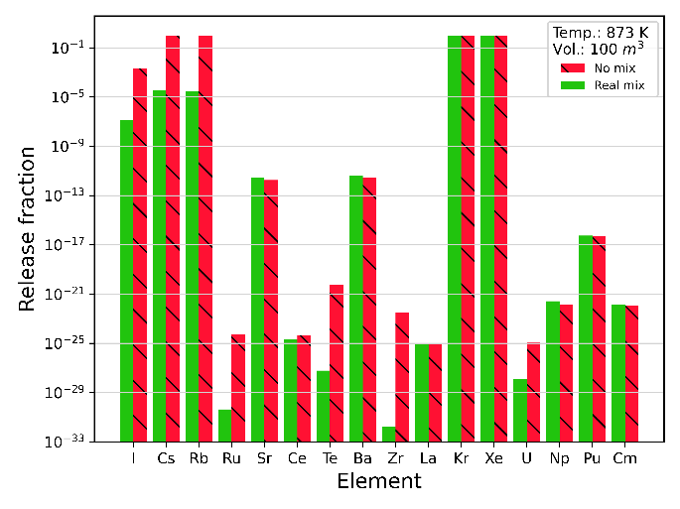  (a) | 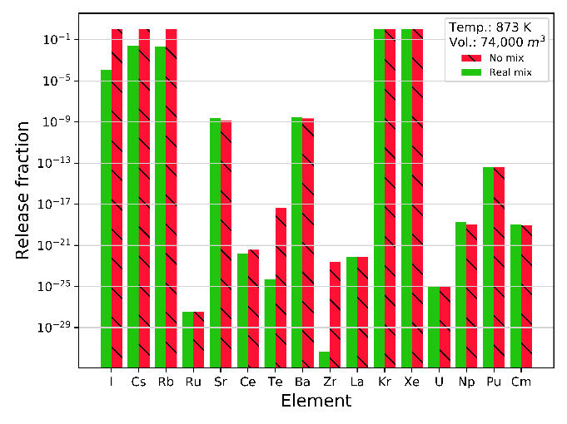  (b)
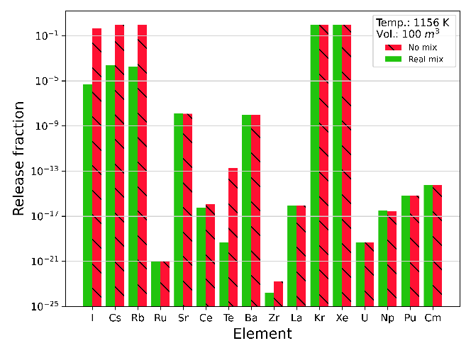  (c) | 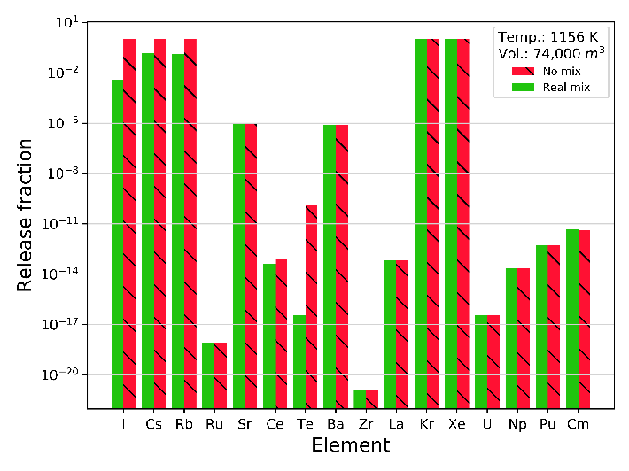  (d)
FIG. 1 (a) RFs in the cover gas calculated for the constant temperature (873 K) and cover gas volume (100 m3) (b) RFs in the containment calculated for the constant temperature (873 K) and containment volume (74000 m³) (c) RFs in the cover gas calculated for the constant temperature (1156 K) and cover gas volume (100 m³) (d) RFs in the containment claculated for the constant temperature (1156 K) and containment volume (74000 m³)
The calculated RFs are compared with the Fukushima accident release. Here, calculation performed for the containment release volume with real mixture assumption at 873 K and 1156 K is considered for the comparison (Fig. 1b). For example, the calculated iodine release value is about 1E-04 and 4E-03 for 873 K and 1156 K, respectively, whereas the RF for the Fukushima accident was observed were around 0.01 to 0.07 [21]. The lower values for the fast reactor case may be due to higher retention by sodium. For Cs, the calculated release is about 0.2 to 0.2, whereas the RF for the Fukushima accident was observed around 0.1-0.2 [21]. The higher cesium release is due to consideration of the containment as the release control volume. The similarity, despite wide difference in the accident condition, may be arrived from the formation of chemical species having similar volatility. It may be noted that, for the detailed comparison of RF with Fukushima accident, the aerosol dynamics aspect of the release needs to be considered. Since the present analysis only considers chemical interactions, the RF may be over predicted.

conclusion
The source term for a medium-sized FBR is evaluated using the thermo-chemical equilibrium approach under ideal and real mix assumptions. For the current analysis, an extended version of in-house developed code MINICHEM is used, which is validated with the ALMR source term problem. It is found that the amount of oxygen available for the reaction strongly determines the release behaviour of the lanthanides and barium-strontium groups. For example, Eu and Sr are more volatile in the metal fuelled reactor, whereas in oxide fuelled reactors, they form stable oxides, which eventually lead to lower RFs of Eu and Sr. Further, we observed that different mixture assumptions do affect the formation of chemical species. For example, with no mix assumption, iodine has more affinity toward Cs [2], whereas, with real mixture assumption, almost all iodine reacts with Na.
Additionally, it is found that the solubility of the RN has greater impact on the release of RNs. For example, in the no mixture case, the RF for Cs is about 0.9 [2]; when mixing is considered, the RFs are of the order of 1E-04 – 1E-05 for cover gas as release control volume. The sensitivity study for different release control volumes shows that the released fractions for the containment as release control volume are higher compared to cover gas as release control volume. This is expected as higher volume is available for the release. This case can also be applicable for the long term source term, where the reactor vessel may be in contact with the containment volume. It should be noted that the present analysis is performed with respect to the thermochemical aspect only. In future, it would be interesting to see coupled analysis incorporating diffusion and aerosol aspects of the release.
ACKNOWLEDGEMENTS
The assistance provided by the Department of Atomic Energy (DAE), for this project is gratefully acknowledged. The authors acknowledge the contribution from Dr. Suddhasattwa Ghosh, who provided valuable comments for this work and provided us thermochemical data for actinides and lanthanides

References
[1] M.P. Kissane, M. García-Martin, L.E. Herranz-Puebla, Major Remaining Uncertainties Associated with Source-Term Evaluation for SFR Severe Accidents, Proc. FR13 IAEA. (2013) 4–7.
[2] P.R. Patel, A. John Arul, In-vessel source term calculation using chemical equilibrium approach for a medium sized sodium cooled fast reactor, Nucl. Eng. Des. 362 (2020) 110583. https://doi.org/10.1016/j.nucengdes.2020.110583.
[3] R.P.C. Schram, E.H.P. Cordfunke, M.E. Huntelaar, Source term calculations of the ALMR, Netherlands Energy Research Foundation (ECN), 1995. http://inis.iaea.org/Search/search.aspx?orig_q=RN:27032052.
[4] J. Blecic, J. Harrington, M.O. Bowman, TEA: A code calculating thermochemical equilibiurm abundances, Astrophys. J. Suppl. Ser. 225 (2016) 4. https://doi.org/10.3847/0067-0049/225/1/4.
[5] U.S. NRC, Technical Bases for Estimating Fission Product Behavior During LWR Accidents. Technical Report, Nuclear Regulatory Commission, Washington, DC (USA), 1981. https://www.osti.gov/scitech/biblio/5743397 (accessed August 30, 2017).
[6] Kenneth Denbigh, The Principles of Chemical Equilibrium, with Applications in Chemistry and Chemical Engineering, Cambridge University Press, Cambridge, 1956.
[7] parthigcar, parthigcar/MINICHEM, 2020. https://github.com/parthigcar/MINICHEM (accessed April 19, 2021).
[8] O.P. Singh, R. Harish, Energetics of core disruptive accident for different fuels for a medium sized fast reactor, Ann. Nucl. Energy. 29 (2002) 673–683. https://doi.org/10.1016/S0306-4549(01)00070-6.
[9] B.J. McBride, S. Gordon, Computer Program for Calculation of Complex Chemical Equilibrium Compositions and Applications-I: Analysis, National Aeronautics and Space Administration, Office of Management, Scientific and Technical Information Program, Cleveland, Ohio, 44135, 1996.
[10] B.J. McBride, S. Gordon, Computer Program for Calculation of Complex Chemical Equilibrium Compositions and Applications-II: User manual and program description, National Aeronautics and Space Administration, Office of Management, Scientific and Technical Information Program, Cleveland, Ohio, 44135, 1996.
[11] M.G.M. van der Vis, E.H.P. Cordfunke, R.J.M. Konings, Thermochemical properties of zirconium halides: a review, Thermochim. Acta. 302 (1997) 93–108. https://doi.org/10.1016/S0040-6031(97)00193-7.
[12] R.J.M. Konings, O. Beneš, A. Kovács, D. Manara, D. Sedmidubský, L. Gorokhov, V.S. Iorish, V. Yungman, E. Shenyavskaya, E. Osina, The Thermodynamic Properties of the f-Elements and their Compounds. Part 2. The Lanthanide and Actinide Oxides, J. Phys. Chem. Ref. Data. 43 (2014) 013101.
[13] R.J.M. Konings, O. Beneš, The Thermodynamic Properties of the f-Elements and Their Compounds. I. The Lanthanide and Actinide Metals, J. Phys. Chem. Ref. Data. 39 (2010) 043102. https://doi.org/10.1063/1.3474238.
[14] R. Guillaumont, F.J. Mompean, others, Update on the chemical thermodynamics of uranium, neptunium, plutonium, americium and technetium, Elsevier Amsterdam, 2003.
[15] G. Chattopadhyay, J.M. Juneja, A thermodynamic database for tellurium-bearing systems relevant to nuclear technology, J. Nucl. Mater. 202 (1993) 10–28. https://doi.org/10.1016/0022-3115(93)90024-S.
[16] C.W. Bale, E. Bélisle, P. Chartrand, S.A. Decterov, G. Eriksson, A.E. Gheribi, K. Hack, I.-H. Jung, Y.-B. Kang, J. Melançon, A.D. Pelton, S. Petersen, C. Robelin, J. Sangster, P. Spencer, M.-A. Van Ende, Reprint of: FactSage thermochemical software and databases, 2010–2016, Calphad. 55 (2016) 1–19. https://doi.org/10.1016/j.calphad.2016.07.004.
[17] B.D. Middleton, J.L. LaChance, J. Phillips, E.J. Parma, T.J. Olivier, The Development of a Realistic Source Term for Sodium-Cooled Fast Reactors: Assessment of Current Status and Future Needs., Sandia National Laboratories, 2011. https://doi.org/10.2172/1018468.
[18] H.A. Morewitz, Fission Product and Aerosol Behavior Following Degraded Core Accidents, Nucl. Technol. 53 (1981) 120–134. https://doi.org/10.13182/NT81-A32616.
[19] A.W.J. Castleman, I.N. Tang, R.A. Mackay, Fission Product Behavior in Sodium Systems, Brookhaven National Lab., Upton, N. Y., 1966. https://doi.org/10.2172/4474975.
[20] R.P. Wichner, R L Jolley, Uri Gat, B R Rodgers, Chemical factors affecting fission product transport in severe LMFBR accidents, Oak Ridge National Lab., Oak Ridge, Tennessee, 1984.
[21] Y.-H. Koo, Y.-S. Yang, K.-W. Song, Radioactivity release from the Fukushima accident and its consequences: A review, Prog. Nucl. Energy. 74 (2014) 61–70. https://doi.org/10.1016/j.pnucene.2014.02.013.

