Development of submerged
electromagnetic pump for liquid lead

D.M. Obukhov, P.Yu. Chaika, M.M. Golovanov, I.R. Kirillov, S.A. Krizhanovsky, K.A. Komov, A.N. Labusov, G.V. Preslitsky, P.A. Tukeev, V.S. Federyaeva

Joint stock company “D.V. Efremov Institute of Electrophysical Apparatus”, St. Petersburg, Russian Federation

obukhov@sintez.niiefa.spb.su

Abstract

Development results of submerged electromagnetic pump (EMP) for liquid lead in reactor BREST-OD-300 are presented. EMP is planned to use for liquid lead level regulation in the reactor during putting it into exploitation under partial or full EMP submerging in lead. Main EMP parameters: pressure head 1.0 MPa, nominal flow rate 2.0 m³/hr, lead temperature 390-420 °С. Required service life time under nominal conditions is 1000 hours. EMP optimum design was chosen – annular linear induction pump (ALIP), calculations supporting its main characteristics were done, list of necessary tests for supporting design and main parameters was estimated.
- INTRODUCTION
Electromagnetic pump (EMP) is developed for liquid lead level regulation in reactor BREST-OD-300 [1] during putting it into exploitation. The EMP is submerged fully or partially into liquid lead with temperature 390-420 °С.
- WORKING PARAMETERS AND SPECIFICATIONS
The EMP working position is vertical. To provide for leak tightness it is placed in hermetic containment that separates the pump from environment (lead and argon-nitrogen mixture above lead surface).
The EMP winding does not have forced cooling and is cooled by heat exchange with surrounding liquid lead.
Working regimes of the EMP are the following: preliminary warm up to 420 °С; placement in liquid lead; preparations for switching on (outer pipe welding, feeding and instrumentation cables connection); liquid lead level regulation with lead temperature 390-420 °C, nominal flow rate 2 m³/hr and pressure head 1.0 MPa.
The EMP specified life time – not less than 1 year, time to failure – not less than 1000 hrs.
- DESIGN DESCRIPTION
Typical design of the annular linear induction pump [2] was chosen as an optimum variant with identification ALIP 10/2. Its operating principle is based on interaction of travelling magnetic field created by inductor winding with currents generated in liquid lead in an annular duct. Electromagnetic force is generated as a result of this interaction that provides for liquid metal motion in upward direction.
EMP design scheme is shown in Fig. 1. The EMP consists of transporting element, case, EMP flange, outlet pipe, inductor and duct. The duct consists of two shells (inner and outer) that provides for annular gap where lead is flowing. Inner magnetic structure made of electrotechnical steel is placed inside the inner shell. The inductor consists of magnetic structure and winding coils, connected in three phase system. The magnetic structure has batches from electrotechnical steel with slots for coils.
The inductor, duct and outlet pipe are placed in hermetic case. The case preserves these elements from contact with lead and takes stretching forces from pump weight during its lifting and compression forces from floating during pump immersion in lead. The transporting element for pump movement is attached to the pump flange.

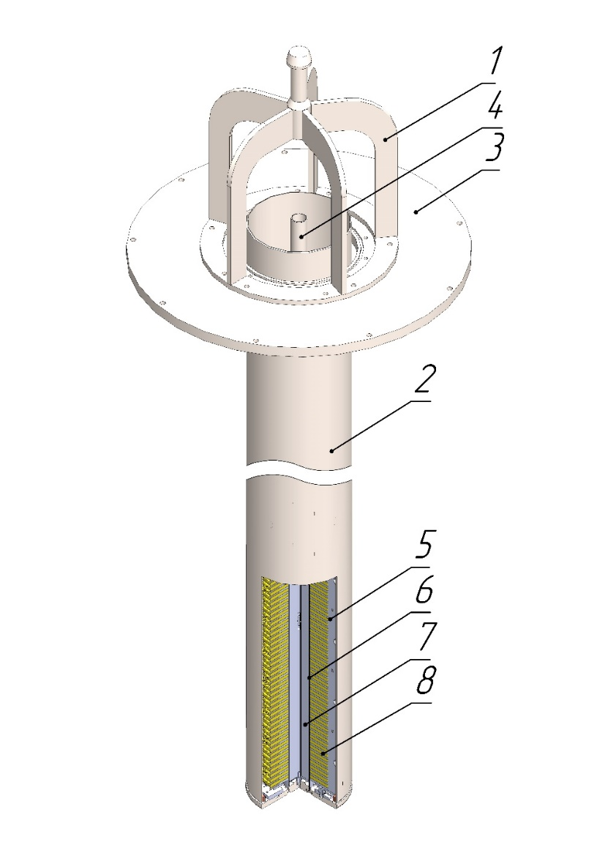
Fig. 1. EMP design scheme: 1 - transporting element (lifting device), 2 - case, 3-EMP flange, 4 - outlet pipe, 5 - inductor, 6 - duct, 7 - inner magnetic structure, 8 – coil.

- RESULTS OF ANALYSIS
The following analysis was made to support the design: electromagnetic, thermal, strength analysis and reliability evaluation.
4.1. Electromagnetic analysis results
Engineering approach is used for electromagnetic analysis based on the use of corrective coefficients in the relations for “ideal” EMP taking account of “real” peculiarities, like:
- different materials in the air gap between the magnetic structures;
- electromagnetic field attenuation over the gap;
- magnetic system finite length;
- moving media velocity profile.
Corrective coefficients are obtained from MHD specific tasks and proved with experiments and EMP design and exploitation experience. Engineering approach detailed description may be found in [2].
As a result of this analysis the EMP optimum design, inductor and duct main dimensions and power supply parameters were chosen (Table 1). Nonstandard frequency will require a frequency convertor. Low efficiency 1.1% is not an important parameter for this pump that works short time (1000 hrs. for its life time), and is the result of large slip s~0.97 (low lead velocity) and lead properties – relatively low electrical conductivity and large density.

Table 1. Electromagnetic analysis results

Parameter | Symbol | Value
Pressure head, kg/cm² | р | 10.2
Flow rate, m³/hr | Q | 2
Frequency, Hz | f | 80
Power consumed, kW | Р₁ | 51.1
Efficiency, % | η | 1.1
  - Thermal analysis results
Thermal analysis was made in code ANSYS. Liquid metal flow in the duct was modeled with program feature “Thermal Fluid и Mass Flow Rate” allowing taking care of temperature gradient along the flow and internal heat generated in liquid metal by induced currents.
Winding maximum temperature was obtained that determines the pump life time and its reliability. Electric power needed to heat up the outlet pipe to prevent lead solidification was determined as well. Analysis was done for EMP different height of submerging in lead.
The following results were obtained. Maximum winding temperature at pump submerging on 2 m and nominal parameters is 471 ºС that gives time to failure – 4200 hrs. and this is more than required.
Winding maximum temperature at pump submerging on 2.5 m and switching off the power (pre-starting procedure) is 420 ºС and 23300 hrs. time to failure.
Power for heating up the outlet pipe is 332 W that gives led temperature 372 ºС.
  - Structural analysis results
Stress analysis and strength estimation were made according to rules [3]:
- strength estimation of the duct shell at hydraulic tests, vacuum tests and working operation;
- buckling analysis of the pump case during pump immersion into lead;
- strength estimation of screwed joints at working operation and during transportation;
- strength estimation of the pump lifting device.
The 1-st buckling mode at working operation under lead outer pressure is shown in Fig. 2. Equivalent stress distribution in the pump lifting device is shown in Fig. 3.

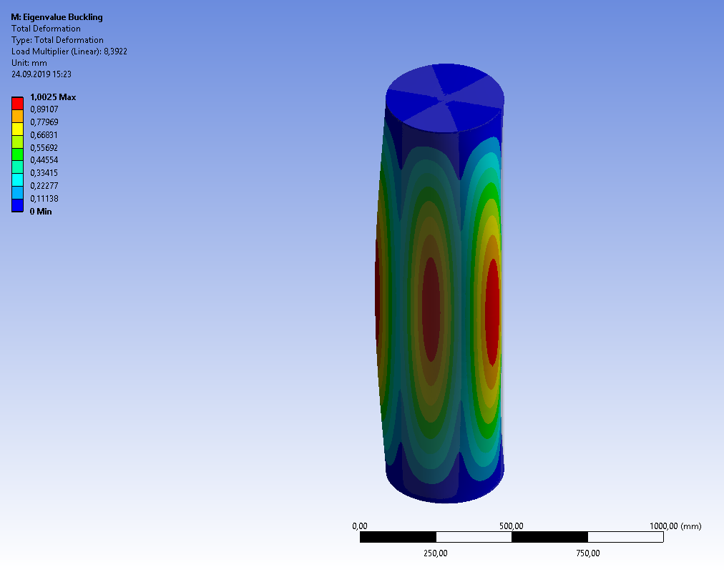
Fig. 2. The 1-st buckling mode at working operation under lead outer pressure.

Fig. 3. Equivalent stress distribution (MPa) in the pump lifting device
Analysis has shown that stresses in considered elements do not exceed allowable limits at operating conditions and at hydraulic tests. Pump design satisfies structural design criteria.
- PLANNED WORK AND TESTS PRIOR TO PUMP MANUFACTURING
The following works are planned to confirm the pump design and its parameters:
- long run tests of winding mock-ups to prove its reliability;
- the pump shortened length mock-up manufacturing and testing in lead facility to prove nominal parameters (pressure head 1.0 MPa, flow rate 2 m³/hr at lead temperature 390-420 °С.
After successful completion of these works the EMP ALIP 10/2 manufacturing and shipment to reactor BREST-OD-300 is planned.
- CONCLUSION
The immersed EMP ALIP 10/2 for liquid lead level regulation in the reactor BREST-OD-300 was developed. Supporting analyses of the design confirm its characteristics and working ability. The necessary tests are defined for validation of technical decisions and characteristics.

References

[1] Yu.G. Dragunov, V.V. Lemekhov, A.V. Moiseyev, V.S. Smirnov, O.A. Yarmolenko, V.P. Vasyukhno, Yu.S. Cherepnin, D.A. Afremov, Yu.V. Lemekhov. BREST-OD-300 Reactor Facility: Development Stages And Justification. FR17: International Conference on Fast Reactors and Related Fuel Cycles: Next Generation Nuclear Systems for Sustainable Development; Yekaterinburg (Russian Federation); 26-29 Jun 2017.
[2] G.A. Baranov, V.A. Glukhih, I.R. Kirillov. Calculation and design of induction MHD machines with a liquid metal working fluid, Atomizdat, Moscow, 1978 (in Russian)

[3] Rules of strength calculation for equipment and pipelines of nuclear power plants PNAE G-7-002-86, Energoatomizdat, Moscow, 1989 (in Russian).

