**AN EXPERIMENTAL STUDY ON SECONDARY SODIUM SYSTEM**

**BASED DECAY HEAT REMOVAL CIRCUIT OF A SODIUM**

**COOLED FAST REACTOR**

S.P. Pathak, K. Natesan, V.A. Suresh Kumar, B.K. Nashine, S. Raghupathy

Reactor Design and Technology Group

Indira Gandhi Centre for Atomic Research, Kalpakkam, India

Email: [sppathak@igcar.gov.in](mailto:sppathak@igcar.gov.in)

**Abstract**

Decay heat removal is an important safety function of a nuclear power plant and failure of the same needs to be practically eliminated. Some of the pool type designs adopt safety grade decay heat removal system (SGDHRS) which consists of three coupled natural circulation loops. SGDHRS removes decay heat through immersed decay heat exchangers in the hot sodium pool and sodium to air heat exchanger kept at a higher elevation at the bottom of a tall stack. In order to improve reliability of the decay heat removal function, an additional decay heat removal system capable of functioning under emergency conditions which is connected to secondary sodium system may be considered. One typical design configuration for this system adopts a forced cooling type of sodium to air heat exchanger, operating in parallel to steam generators in the secondary sodium circuit of the reactor. The secondary sodium system based decay heat removal circuit could also be considered to function as a normal shutdown cooling system if its controllability under various operational conditions is established. Accordingly, the controllability of the system under varying decay power scenario and utilization of this system for long term maintenance of cold shutdown condition in the plant are some of the important aspects to be established. Towards this, experiments are conducted with model AHX to ensure controllability and operability of the system at desired operating conditions respecting various thermal hydraulic design constraints under various transient conditions.

1. INTRODUCTION

The decay heat released immediately after shutting down of reactor is approximately 6 % of the nominal power, 1 % after one hour and even after 100 h, 2 % per thousand of reactor power [1]. This decay heat needs to be removed positively, to maintain the fuel, clad, coolant and structural temperatures below their admissible design safety limits. Diverse systems are adopted for the removal of decay heat from the reactor core to an ultimate heat sink in all the states of the reactor including accidents with the core in a degraded state. The reliability for the system shall be defined in measure with the probability target of a hypothetical core accident [2] [3]. Normally, two diverse and independent paths are used for decay heat removal in sodium cooled fast reactors. The first path is through the normal heat transport circuit comprising of steam generators (SG) called Operation Grade Decay Heat Removal (OGDHR) system. This system also meets the requirement of bringing down the sodium system temperature at a controlled rate, maintaining the plant in hot shutdown condition for up to 8 hours and maintaining the plant at cold condition at 200 ˚C for longer period to carry out maintenance / fuel handling operations [4]. In pool type sodium cooled fast reactors (SFR), a separate dedicated safety grade decay heat removal system bypassing the normal intermediate heat transfer system and power conversion systems is required to meet the safety requirement. Due to the high power density of SFR, decay heat removal is required to take care of any unexpected events. Hence, the presence of a passive decay heat removal system is critical to meet the reliability and safety requirements.

The second path considers all these safety aspects and it relies completely on natural circulation of sodium as well as air. The second path is known as Safety Grade Decay Heat Removal System (SGDHRS) which is always in poised condition and it is used whenever off-site power supply is not available. This system consists of (i) a sodium-sodium decay heat exchanger (DHX) dipped in sodium pool, (ii) a sodium-to- air heat exchanger (AHX) located at the bottom of a tall stack and (iii) associated sodium piping. The SGDHR system can satisfy all the requirements with respect to those specified in the safety criteria for defence in depth system credited to multiple levels and systems intended for Design Extended Condition (DEC). If SGDHR system is envisaged for all situations, demand on this system will be very high. Such a high demand on SGDHR may make it difficult to demonstrate that the failure of decay heat removal function is highly unlikely to be regarded as Practically Eliminated. In keeping view of these safety and reliability aspects, it is envisaged to adopt an additional decay heat removal system which is based on secondary circuit of SFR. The additional system is called as Secondary Sodium based Decay Heat Removal System (SSDHRS). A similar theoretical study has been reported for an emergency heat removal system that removes heat from the secondary loop of a fast reactor by air cooling the surfaces of the piping and equipment of the heat –sink loops of secondary loop [5].

The present system is planned as a forced cooling type of sodium to air heat exchanger (AHX), operating in parallel to steam generators in the secondary sodium main circuit of the reactor. In case of operation of this system without isolating of steam generators, it would require a thermal mixer to be incorporated at the common junction where the sodium flow from SG and AHX join. In such a case, operation of the system without exceeding the thermal constraints of the mixer is important. Since, sodium has very high thermal conductance as compared to air, extended surfaces (fins) are used for balancing the low thermal conductance of air side. AHX consists of a few hundred serpentine type tubes connecting the inlet and outlet headers wherein sodium flows from the top to the bottom. The tubes are provided with tightly packed cylindrical fins. Ambient air flowing across the finned tubes pick up heat from the finned tube surfaces and get heated up while flowing from bottom to the top of the AHX. The heat transfer from the sodium to air involves multiple resistances, viz., from tube to fin and fin to air and directly from tube to air [6]. Due to complex nature of heat transfer mechanism in AHX, it is essential to check the controllability of this system under varying decay power scenario and utilization of this system for long term maintenance of cold shutdown conditions before adopting in the reactor. Successful demonstration of the operability of the system can help in elimination of the presently adopted operation grade decay heat removal (OGDHR) system from the design. Towards this, experimental investigations have been carried out on a 2 MWt capacity AHX in steam generator test facility (SGTF) at Indira Gandhi Centre for Atomic Research, Kalpakkam, India by simulating the decay heat removal operating conditions in the reactor. The present paper discusses the details for experimental simulation and studies carried out on model AHX.

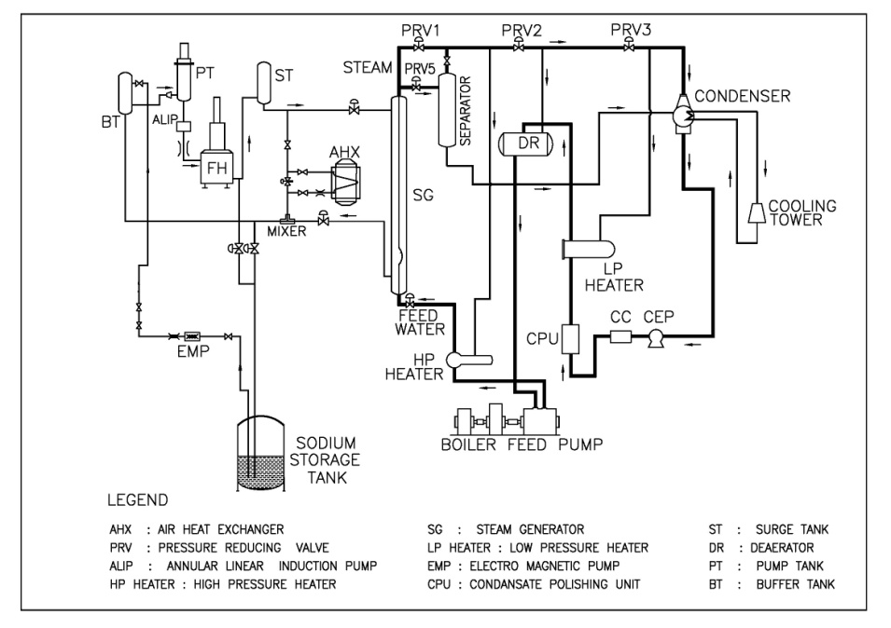

*FIG.1: Schematic of steam generator test facility (SGTF)*

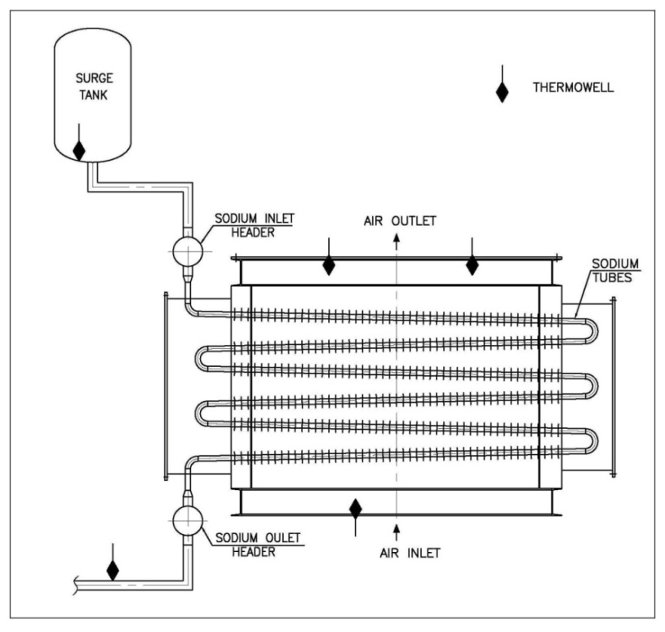

*FIG 2: Schematic of sodium to air heat exchanger (AHX)*

2. TEST SET UP

Steam generator test facility (SGTF) (Fig. 1) has a model sodium to air heat exchanger (AHX) with a heat removal capacity of 2 MWt connected in parallel to the steam generator [7]. The heat source of the facility is furnace oil fired heater where sodium is heated to the desired temperature. The thermal power of the experimental loop is regulated by controlling the furnace oil pressure to fired heater. The model AHX (Fig.2) is a finned tube air cooled sodium heat exchanger with 6 passes of 22 parallel tubes [6]. The tubes are made of stainless steel. The circular fins are welded around the tubes throughout the length. The finned tubes are supported at three places by end support plates, at the two ends and at the middle. This arrangement ensures that air flows fully over the finned tubes thereby leading to better heat transfer performance. The desired sodium flow through the model AHX is maintained by means of an Annular linear induction pump (ALIP) and air flow through the AHX shell is supplied by a centrifugal blower. Since the prime mover is variable frequency drive motor, the required air flow to AHX is regulated by varying motor speed. The maximum operating temperature of ALIP is limited to 400 °C due to winding temperature limitation and the nominal flow rate through AHX is 35 m3 / h. The maximum temperature differential of 25 °C is allowed through the thermal mixer (joining point of sodium flows through AHX and SG) provided in the experimental loop. The hot air, after picking up the heat, is vented to the atmosphere through a chimney that houses the AHX. The four sides of the AHX are sealed by plates with asbestos gaskets.

The AHX temperatures across its length are monitored by the surface type 3 mm diameter Chromel/Alumel thermocouples, brazed in between the fins. Sodium inlet and outlet temperatures of model AHX are measured by 3 mm diameter Chromel/Alumel thermocouples inserted in thermo wells. Sodium flow through model AHX is measured by a permanent magnet flow meter with an accuracy of 1.5%. A Pitot tube type probe provided at the inlet duct of the model AHX measures the airflow rate through the model AHX, with an accuracy of 1%.

3. EXPERIMENTS

The main purpose of the experiment is to ensure the operability and controllability of parallel operation of AHX and SG (without water flow) under varying heat source conditions (simulating the decay power evolution in the reactor core). The core decay heat is simulated by adjusting the furnace oil pressure to fired heater. The thermal constraints on the mixer are respected by adjusting the air flow rate through AHX. Thus, the possibility of controlling the performance of the system meeting the decay heat removal requirements is established through experimental studies by controlling the fired heater power and air flow rate. Considering all the constraints, the maximum heat removal capacity is calculated as 264 kW (t) for simulating SSDHRS operating conditions in experimental loop. The tests are planned in three steps viz; (i) maintaining hot shutdown condition at various temperatures and (ii) maintaining cold shutdown condition and (iii) cool down phase following SCRAM replicating the operation grade decay heat removal (OGDHR) deployment. The data for decay heat simulation study is taken from a 500 MW (e) pool type prototype fast breeder reactor (PFBR) which is being commissioned at Kalpakkam, India [8]. The estimated decay power after half an hour is 26 MWt and it reduces to 14 MWt in 4.5 hours i, e the decay power reduces to 53.8% in 4.5 hours. To simulate the cool down phase following SCRAM, the fired heater power was adjusted in such a way that heat removed by AHX shall reduce from 264 kWt to 142 kWt (53.8%) in four and half hours. Decay power evolution in the core has been simulated by varying the power of oil-fired heater in the facility and controlled cooling of the system was established by varying the heat removed by adjusting the airflow rate through AHX. To simulate SSDHRS operating conditions in experimental loop, the operating data were calculated using a porous body based CFD model [6]. During experiments, sodium flow through AHX as well as SG has been maintained at 35 m3 /h and 70 m3/h respectively. Steam generator is kept in dried condition, i.e., no feed water flow is supplied through the steam generator.

4. RESULTS AND DISCUSSION

**4.1 Hot shutdown condition at various temperatures**

The experiments were carried out for three different hot leg sodium temperatures, viz; 350 ˚C, 325 ˚C and 300 ˚C representing three different hot shutdown conditions. Figure 3 shows the evolution of important parameters of the facility for the case of hot leg sodium temperature at 350 °C. With constant AHX inlet sodium temperature of 350 ˚C, AHX outlet sodium temperature is changed in steps to 325 ˚C, 327 ˚C, 330 ˚C, 334 ˚C and 335 ˚C at an interval of about ½ h duration by adjusting the air flow rate through AHX. Subsequently, heat source is varied by adjusting furnace oil pressure to fired heater so that the hot leg temperature is maintained constant at 350 ˚C. In the similar way, the experiment was carried out for hot leg sodium temperature of 325 and 300 ˚C. Figure 4 & 5 depict the evolution of important parameters of the facility for the case of hot leg sodium temperature at 325 and 300 °C. It can be inferred from the plots that the hot leg sodium temperature at the desired level can be maintained without exceeding the differential temperature limit across thermal mixer. It is established from the test that hot shutdown condition at any desired temperature can be maintained under varying heat source condition by manually adjusting the air flow rate through the AHX. Thus, by having control logic in the plant to control the sodium outlet temperature of AHX at a desired value by adjusting the air flow rate through AHX, maintaining the hot shutdown condition in the plant at any desired temperature is possible.



*FIG.3: Parameters recorded in the facility during the test on maintaining hot shutdown temperature of 350 °C in the hot leg*



*FIG.4: Parameters recorded in the facility during the test on maintaining hot shutdown temperature of 325 °C in the hot leg*



*FIG.5: Parameters recorded in the facility during the test on maintaining hot shutdown temperature of 300 °C in the hot leg*

**4.2 Cold shutdown condition**

Cold shutdown condition in the reactor corresponds to maintain the temperature of loop sodium at ~ 200 ˚C, while the decay power produced in the core undergoes a natural reduction. During this test, fired heater power was reduced to bring down the sodium system temperature to 200 ˚C and the loop was operated steadily at this condition for ½ h before the start of experiment. At a constant AHX inlet sodium temperature of 200 ˚C, air flow rate was varied in multiple steps to achieve desired AHX outlet sodium temperatures of 192 ˚C, 195 ˚C and 198 ˚C respectively. At each specified value of AHX outlet sodium temperature, a steady state operation was continued for ½ h and the stabilized readings were recorded. Figure 6 shows the evolution of important parameters recorded in the facility. When the AHX outlet sodium temperature is 192 ˚C, the power supplied by the fired heater is 88 kW and when the differential temperature between AHX inlet/outlet sodium temperature decreased to 5 ˚C (at AHX outlet sodium temperature of 195 ˚C), heater power was reduced to 56 kW whereas air flow rate had to decrease from 3200 to 1800 m3/h. Thus, it is established that cold shutdown condition can be maintained under varying heat source condition by manually adjusting the air flow rate through the AHX.



*FIG.6: Parameters recorded in the facility during the test on maintaining cold shutdown temperature of 200 °C in the hot leg*

**4.3 Cool down phase following SCRAM replicating the operation grade decay heat removal (OGDHR) deployment**

During this phase of experiment, fired heater power and heat removal through AHX were adjusted simultaneously to simulate the decay heat removal condition along with cool down of the system at a desired rate. The heater power was reduced from 264 kW (t) to 142 kW (t) (53.8 %) within four and half hours. Air flow rate through AHX was kept constant throughout the test. Figure 7 shows the evolution of important parameters in the facility recorded during the test. While decreasing AHX inlet sodium temperature from 355 ˚C to 208 ˚C, there is a decrease in AHX outlet sodium temperature from 331 ˚C to 202 ˚C and AHX outlet air temperature drops from 286 ˚C to 183 ˚C. It is seen that the differential temperature across thermal mixer is always less than the limiting value of 25 ˚C during the entire duration of the test. The expected temperature variation at the hot leg of secondary sodium circuit of OGDHR in the plant and corresponding simulated temperature during the experiment is shown in the Figure 7. Thus, the feasibility of cooling down the reactor system at a desired rate without violating the thermal constraints is established through this test. The important aspect to be noted is that the cool down at a desired rate could be achieved without even adjusting the air flow rate through the AHX. There is additional flexibility of varying the air flow rate through AHX in order to avoid exceeding of thermal constraint of mixer.



*FIG.7: Parameters recorded in the facility during the simulation of cool down transient in the reactor post shutdown condition*

5. SUMMARY

Preliminary experimental studies have been carried out to ensure the controllability and operability of secondary circuit based decay heat removal system before adopting in reactor. The tests were performed by simulating the three operating phases of SSDHRS, viz; (i) maintaining hot shutdown condition at various temperatures (ii) maintaining cold shutdown condition (iii) cool down phase following SCRAM replicating the OGDHR deployment. Decay heat power evolution in the core was simulated by varying the heater power of oil fired heater in the facility (representing the decay power evolution in core) and controlled cooling of the system was established by varying the heat removed by adjusting the air flow rate through AHX. The cool down transient as envisaged could be achieved respecting the thermal constraint on the mixer without even varying the air flow rate through the AHX. It is also established from the tests that hot shutdown and cold shutdown conditions can be maintained by manually adjusting the air flow rate through the AHX. Thus, it is possible to maintain of hot/cold shutdown conditions in the plant at any desired temperature by having control logic which control the AHX outlet sodium temperature at a desired value by adjusting the air flow rate through AHX. Moreover, a variable frequency drive motor for AHX fans is found to be very useful in controlling the heat removal performance of the system in a very effective manner.

**REFERENCES**

[1] Kugeler, K. 1992. Principles of decay heat removal in reactor technology- Present status and Future prospects, IAEA-TECDOC-757, Proceedings of a specialists meeting held in Jolich, Germany, 6-8 July.

[2] Chetal, S.C., 2015. Safety aspects of Intermediate heat transport and decay heat removal systems of sodium-cooled fast reactors, Nucl. Eng Techno (47), 260-266.

[3] Pathak, S.P. et al., “Experimental investigation of transients in SFR steam generators   during decay heat removal condition”, Proceedings of the 25thNational and      3rdInternationalISHMT-ASTFE Heat and Mass Transfer Conference (IHMTC-2019),   December 28-31, 2019, IIT    Roorkee, Roorkee, India.

[4] Somavathi et al., Control of decay heat removal through alternate system in PFBR, Nuclear Engineering and Design 259 (2013), 8-13.

[5] Ashurko, I. Decay heat removal system in the secondary circuit of the sodium cooled fast reactor and evaluation of its capacity, IAEA-CN245-161.

[6] Satya P. Pathak, et al. 2014. “Numerical and Experimental Investigations of Heat Removal Performance of Sodium to Air Heat Exchanger used in Fast Reactors”, Heat Transfer Engineering, 36:5, 439-451.

[7] Vinod, V.et al., 2013. Experimental evaluation of sodium to air heat exchanger performance, Annals of Nuclear Energy 58, pp.6-11.

[8] Chetal, S.C. and Chellapandi, P., 2013. Indian fast reactor technology: Current status and future programme, Indian Academy of Sciences Vol (38) part 5, pp.795-815.