FAST REACTOR SOURCE TERM MODELING AND SIMULATION FUNCTIONAL REQUIREMENTS AND GAP ASSESSMENT

S. SHAHBAZI
Argonne National Laboratory
Lemont, Illinois, United States of America
Email: sshahbazi@anl.gov

The submitted manuscript has been created by UChicago Argonne, LLC, Operator of Argonne National Laboratory (“Argonne”). Argonne, a U.S. Department of Energy Office of Science laboratory, is operated under Contract No. DE-AC02-06CH11357. The U.S. Government retains for itself, and others acting on its behalf, a paid-up nonexclusive, irrevocable worldwide license in said article to reproduce, prepare derivative works, distribute copies to the public, and perform publicly and display publicly, by or on behalf of the Government. The Department of Energy will provide public access to these results of federally sponsored research in accordance with the DOE Public Access Plan. http://energy.gov/downloads/doe-public-access-plan.

2022 International Conference on Fast Reactors and Related Fuel Cycles
Beijing, China
April 25- 28, 2022

Fast Reactor Source Term Modeling and Simulation Functional Requirements and Gap Assessment

S. SHAHBAZI, D.S. GRABASKAS, S.A. THOMAS
Argonne National Laboratory
Lemont, USA
Email: sshahbazi@anl.gov

N.A. ANDREWS, D.L. LUXAT, A.J. CLARK
Sandia National Laboratories
Albuquerque, USA

Abstract

A vital part of the licensing process for advanced (non-LWR) nuclear reactor developers in the United States is the assessment of the reactor’s source term. The source term represents the potential release of radionuclides from the reactor system to the environment during normal operations or accident sequences. A mechanistic approach (based on realistic phenomena, models, and data) to assessing the reactor’s source term is expected for advanced reactor licensing applications. Development of such mechanistic source term tools should occur in parallel with the development of reactor technologies to aid in the design process as well as the licensing process. A brief summary is provided of the important phenomena and functional requirements in modeling the source term of fast spectrum molten salt reactors and liquid metal-cooled fast reactors. A brief description of potential licensing basis events for both reactor classes is provided, as it aids in establishing the spectrum of scenarios possibly requiring source term assessment. In the U.S., the NRC is supporting the development of SCALE for reactor physics analyses along with the development of MELCOR for advanced reactor accident and source term analyses within the reactor system. Therefore, the paper provides a brief survey of the current state of computational capabilities in the modeling and simulation of the source term within the reactor system, including MELCOR as well as other potential tools. This includes both system-level modeling and source term analysis tools which cover radionuclide transport inside the reactor system. Some gaps are discussed as current capabilities for each reactor class are assessed. Finally, some considerations are introduced regarding potential differences between the source term for fast and thermal spectrum advanced reactors.

INTRODUCTION
A vital part of the licensing process for advanced (non-LWR) nuclear reactor developers in the United States (U.S.) is the assessment of the reactor’s source term. The source term represents the potential release of radionuclides from the reactor system to the environment during normal operations or accident sequences. Initially, source term assessments for LWRs followed a bounding approach with conservative assumptions, but within the last few decades a more mechanistic, or realistic, approach to modeling LWR radionuclide transport has become the standard, and this mechanistic approach is also being proposed for advanced reactor systems. As the designs of advanced reactors increase in maturity and progress towards licensing, there is a need to develop modeling and simulation capabilities in analyzing the source term of a prospective reactor concept.
Two types of fast spectrum advanced reactors currently being pursued are liquid metal-cooled fast reactors and molten salt fast reactors. The sodium fast reactor (SFR) is the most pursued variant of the liquid-metal cooled reactors, while there is also interest in lead-cooled fast reactors (LFR), which share much of the same general source term modeling phenomena. Among salt-fueled molten salt reactors (MSR), there is interest in both chloride salt (Molten Chloride Fast Reactor, MCFR) or fluoride salt (Molten Salt Fast Reactor, MSFR) as the fuel-bearing salt system. While there has been much work in developing the mechanistic source term for SFRs, due to the extensive operational experience in the U.S., MSR technology is generally less mature and there is more diversity in the designs being pursued. Therefore, the development of source term modeling strategies for MSRs is largely incomplete at present. Because of this, a roadmap or pathway is needed to assist in the development of source term modeling tools for both salt-fueled MSRs and SFRs.
The following is a summary of: the phenomena important to modeling the mechanistic source term of SFRs and fast-spectrum MSRs; the functional requirements needed to model those phenomena; and the current state of computational capabilities available to fulfill those requirements. In completing a survey of the current landscape of modeling capabilities, resulting in a gap analysis, this work aims to identify the future modeling and simulation development needs.

source term modeling
The current work is part of a larger collaboration between Argonne National Laboratory (Argonne) and Sandia National Laboratories (SNL) to assist in the development of modern mechanistic source term modeling and simulation tools, as part of the U.S. Department of Energy (DOE) Nuclear Energy Advanced Modeling and Simulation (NEAMS) program. Mechanistic source term (MST) analysis entails the modeling and simulation of potential radionuclide releases from the reactor system to the environment under normal or accident scenarios using realistic phenomena, models, and data. This includes identifying the radionuclide sources, characterizing the potential pathways to release, modeling those pathways based on underlying physical and chemical phenomena, and applying those models to specific scenarios which need to be evaluated, including both normal operation and accident scenarios. An outline of the development pathway for analyzing the source term mechanistically is shown in Fig. 1.

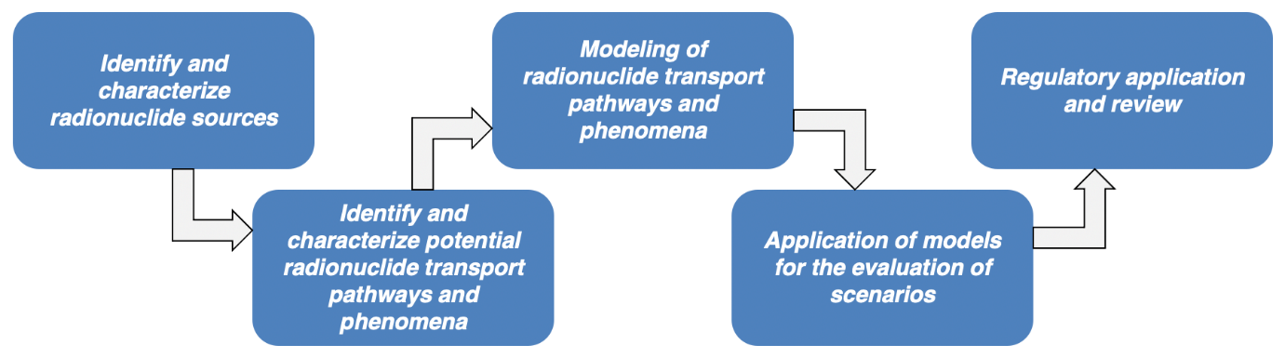
Fig. 1. Outline of MST development pathway

Due to the relative immaturity of advanced (non-LWR) reactor technology compared to that of LWRs, the modeling tools that are currently available to simulate many necessary source term phenomena are similarly immature. Additionally, the experimental data needed to validate those modeling tools may be lacking in certain areas and could be addressed in tandem as these tools are developed. Examples of experimental data that may be needed include but are not limited to the speciation, vaporization, transport, and leakage of the various chemical classes of radionuclides that may exist at one point in non-aqueous coolants.
Despite these potential gaps, preliminary source term analyses can be completed utilizing the current landscape of modeling tools. Previous reports have outlined the important phenomena and corresponding functional requirements [1], and a survey was completed of the current computational capabilities that are available in modeling these phenomena [2]. Relevant phenomena for each reactor type (e.g., radionuclide formation, chemical speciation, aerosol transport, etc.), as well as reactor-agnostic dose consequence modeling, are discussed in terms of the tools that are currently available, and corresponding modeling gaps are summarized.

Regulatory considerations
Source term considerations are a primary focus of the reactor licensing process, as the protection of the public and environment against accidental releases of radionuclides is central to the mission of the U.S. Nuclear Regulatory Commission (NRC). Historically, early source term evaluations for light water reactors (LWRs) were developed based on prescribed core melt scenarios, with conservative, non-mechanistic assumptions regarding the release of radionuclides [3]. With the publication of NUREG-1465 in 1995 [4], the NRC began a shift towards accounting for specific radionuclide transport and retention phenomena in LWR accident scenarios based on insights gained from experimentation and modeling. This was followed by Regulatory Guide 1.183 [5], which provided guidance on the development of an alternative source term for LWRs following the initial mechanistic guidance utilized in NUREG-1465. For advanced non-LWRs, the NRC has long stated an expectation of the use of MST analyses as part of the reactor licensing process [6, 7]. Therefore, recent developments in the establishment of a licensing pathway for advanced reactors has brought additional focus to MST development.
The ASME/ANS PRA Standard for Advanced Non-LWR Nuclear Power Plants (PRA) establishes the technical requirements for PRAs used in supporting risk-informed decisions. A trial use version of the standard was first published in 2013 [8]. Based on pilot user feedback, a revised version of the standard has been prepared [9]. The non-LWR PRA standard includes separate technical elements for MST assessments and radiological consequence analyses, with both high-level and support requirements. These requirements are utilized by the current work for guidance on the necessary capabilities of MST modeling and simulation tools.
Finally, central to MST considerations for advanced reactor licensing is the recent approval of the Licensing Modernization Project (LMP) process by the NRC [10]. The LMP approach [11] provides guidance on a technology-inclusive, risk-informed, performance-based process for advanced reactor licensing. Specifically, risk information derived from the PRA standard is utilized to guide the identification and categorization of LBEs, the classification of structures, systems, and components (SSCs), and the evaluation of the adequacy of defense-in-depth.

molten salt reactors

Molten salt reactors are liquid-fueled advanced reactor designs which contain the fissile isotope dissolved in the fuel salt (typically either a fluoride or chloride salt) and most commonly involve the circulation of the radionuclide-containing fuel salt through the primary loop to allow heat exchange with a secondary loop of a coolant, often also a molten salt. Due to their design diversity, it can be difficult to develop a standard source term modeling strategy applicable to all MSRs, even for seemingly similar fast spectrum MSRs. Nonetheless, a survey of computational capabilities in modeling and simulation is described. While a detailed MST analysis has not yet been completed for an MSR, much work has been published regarding system modeling, transient analysis, and multiscale modeling, which has previously been reviewed [2]. Knowledge of these capabilities can assist in the development of a robust source term modeling approach. These tools provide a starting point for understanding radionuclide transport in MSRs but have yet to be utilized specifically for source term modeling. Therefore, a summary of MST phenomena and functional requirements is provided, followed by a description of potential licensing basis events, and finally source term modeling capabilities are summarized based on the specific underlying phenomena along with the perceived modeling gaps.

Phenomena and Functional Requirements
The first analysis phase of evaluating the source term of MSRs involves breaking down the mechanisms with which radionuclides are formed. This includes not only fission product formation which occurs in the liquid fuel salt, but also if a blanket or breeder salt is used where a small portion of fissions may happen on the newly formed fissile isotopes which were activated from the fertile precursors. Neutron activation may occur anywhere in the flux of neutrons which is derived from a flowing liquid, and so advanced modeling methods for neutronics, fuel depletion, and activation analysis may be needed beyond what is normally encountered with solid-fueled systems. The next analysis phase involves the chemical speciation of the radionuclides, and, similar to solid fuels, this involves a thermodynamic modeling of the system. This involves knowledge of the constantly changing list of possible elements (radionuclide formation), as well as the basic thermodynamic data for the possible compounds. Analysis of the transport of the various chemical classes of radionuclides is one of the biggest focuses of MSR MST. Generally speaking, radionuclides can be salt-soluble, salt-insoluble, or elemental (e.g., metallic), and can be solids, liquids, or gases, and each of these chemical classes can often exist as each of these phases. Relevant phenomena related to the transport behavior of radionuclides inside the MSR system include vaporization, corrosion/deposition, transport of gaseous species through the salt, aerosol formation and transport, and phase stability of species initially soluble in the salt, especially as a function of the changing redox potential. An overview of radionuclide transport phenomena in a generic MSR is provided in Fig. 2.
It may be desirable to model tritium separately from other radionuclides as dedicated tritium modeling codes have been developed due to the large amounts of tritium produced in certain systems, especially those containing lighter nuclei and fluoride salts. Therefore, it may be important to have a separate code to model tritium formation, speciation, transport, and sorption, with the hopes of modeling tritium release, mitigation, and capture.
The phenomena relevant to modeling a few example accident scenarios have also been briefly summarized [1]. The first of these accident sequences is a generic spill of molten salt from somewhere in the reactor system into a reactor building or core cell. The second accident sequence is a generic rupture in the primary heat exchanger, where the primary fuel salt will likely mix with the primary coolant salt. Phenomena worth considering may include a pressure gradient between the two salt flows which will have an impact on the ensuing mass transfer, any chemical reactions that may occur between the salts and components, and the ingress of air to the interior of the reactor system/core given a breach in the structural component.
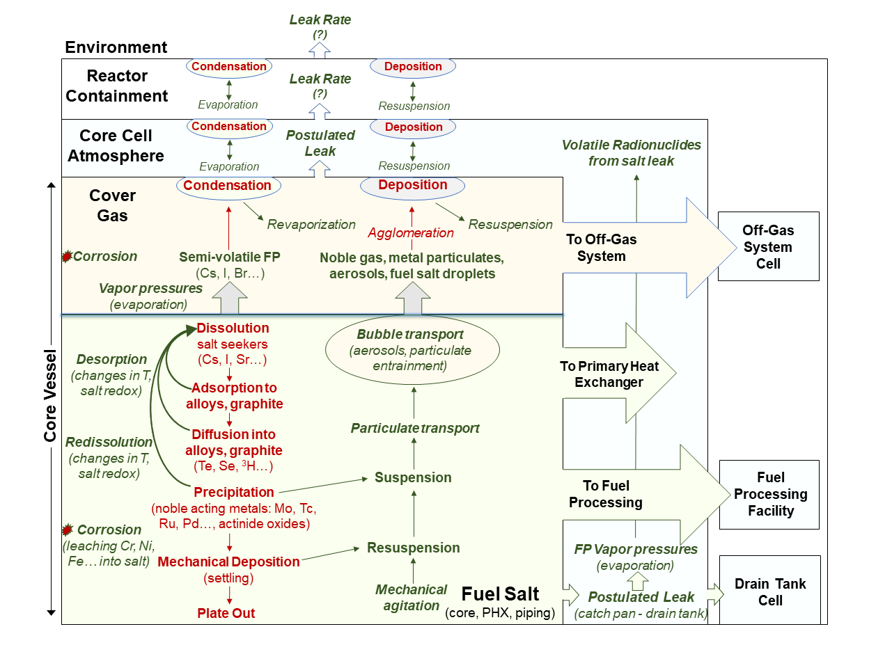
Fig. 2. Overview of MSR radionuclide transport phenomena [12]

Licensing Basis Events
Oak Ridge National Laboratory (ORNL) hosted a workshop of subject matter experts with the goal of identifying initiating events (IE) as precursors to licensing basis events for MSRs [10]. They noted 140 different IEs that warranted further investigation. Some of these high-level events selected for extended discussion include primary heat exchanger failures, primary boundary breaches, primary fuel salt composition changes, primary fuel salt void fraction changes, drain tank heat removal failure, drain tank breaches, and off-gas system breaches/failures. Many of these IEs may ultimately result in a broadly defined salt spill or release outside the primary reactor system, and so a salt spill scenario should be considered at carefully chosen points in the reactor design to assure adequate protection to the public and environment. As a whole, these IEs provide a starting point for event types and failure modes to consider when analyzing radionuclide transport phenomenon, but this should not be considered an exhaustive list.

Source Term Modeling Capabilities
MST assessment will require a deeper understanding of IEs as well as event sequence development. Therefore, certain aspects of MST will depend directly on the system modeling code results. For example, during a reactivity insertion accident, the temperature of the fuel salt will theoretically increase up to a limit based on various neutronics, flow, and salt-related properties. Because temperature has arguably the biggest impact on physicochemical properties (i.e., transport), this time- and event-dependent information is necessary to accurately model radionuclide transport for that specific time and event considered. Many nuclear systems codes have been developed for modeling liquid-fueled molten salt reactors. A summary of recent advances in some of these codes was provided [2], including system-level analysis, thermal hydraulics, coupled multiphysics, and general neutronics analysis codes.
In the U.S., the integral severe accident analysis code MELCOR has been outlined for regulatory use in the assessment of MSR source terms [13]. The models within MELCOR are generic and can be adapted to different reactor designs by implementing corresponding thermal fluid properties and other physical models. Recently MELCOR was assessed for use in modeling molten salt systems by contracted experts and the NRC. These reviews highlighted a pathway forward for the MELCOR program to accurately capture behavior in such systems. Of particular importance is a better experimental database of chemical and thermal fluid behavior of the molten salt itself as well as the entrained radionuclides in vapor or aerosol forms.
There are several important MST phenomenon areas to consider, including but not limited to:
- Radionuclide inventory;
- Salt thermochemistry;
- Bubble transport;
- Corrosion and deposition modeling;
- Salt release;
- Aerosol modeling;
- Tritium modeling;
- Salt processing or off-gas systems.

Capability Assessment
Considerable reactor physics and system modeling capabilities have been developed for MSRs, including high fidelity neutronics, computational fluid dynamics, and system-level thermal hydraulics. Dedicated MSR source term modeling tools are largely immature, but development is ongoing. Based on the NRC development pathway, the reactor physics suite of codes SCALE is planned to be utilized for MSR radionuclide inventory estimation with the integral accident analysis code MELCOR being further developed for MSR source term modeling.
Nonetheless, several key gaps still remain regarding the current capabilities for some individual MSR source term modeling phenomena. Salt thermochemistry is very important to MSR source term modeling; computational tools exist, but much of the experimental thermodynamic data necessary as input for the tools is lacking. Important chemical and physical phenomena in MSRs include, but are not limited to, bubble transport, aerosols, corrosion, and deposition. A salt spill scenario is potentially a high-priority LBE that will require modeling capabilities for the prospective design. Finally, successful MST strategies will likely also need to assess radionuclide transport throughout all auxiliary systems such as off-gas and salt processing systems.

sodium fast reactors
Relatively extensive work has been performed for SFRs concerning the development of MST assessments [14-16]. This is partly a result of the seminal sodium-cooled reactor development and testing in the U.S. in the mid 20th century, as well as recent research motivated by multiple U.S. reactor developers interested in the technology. The focus of the following assessment is for metal fuel pool-type SFR designs, which is the generic design proposed by such vendors in the U.S. industry. From a source term modeling perspective, lead-cooled fast reactors (LFR) share many of the same phenomena and may use many of the same tools, and so MST analysis of LFRs is covered in this section as well, with considerations provided at the end of the section.

Phenomena and Functional Requirements
The first analysis phase includes the production and release of radionuclides from the metal fuel pin, and the second analysis phase includes the production of radionuclides outside of the fuel. Both of these important analysis phases constitute the starting point for an MST analysis for almost any solid-fueled reactor, including SFRs. Radionuclide transport behavior in metal fuel is complex, with a high retention of certain elements and a high mobility of others. Therefore, it is very important to understand these phenomena which represent radionuclide interactions in the fuel pin, fuel cladding, bond sodium, as well as the fission gas plenum above. Both chemical and physical interactions of the radionuclide in the fuel materials need to be accounted for, as well as the interactions between these different elements at varying temperatures and compositions. Increasing gas pressures in the fuel subassembly must also be considered if not vented.
The third analysis phase involves radionuclide interactions in the core and primary coolant system. These core interactions are taken to mean those that occur outside the fuel cladding, or as the radionuclide has already escaped the fuel pin. After release from the fuel, the radionuclides will interact with the significant sodium inventory within the reactor vessel. The design dependent auxiliary systems that may be used in the reactor will need to be accounted for (e.g., cover gas cleanup system (CGCS) or a primary sodium purification system (PSPS)). These could be important to the source term as they remove radionuclides as they travel through the core, coolant circuit, or cover gas.
The next analysis phase covers radionuclide interactions in the reactor building or the next level of containment of the reactor system. The leakage of aerosols from the cover gas of the reactor system to the reactor building is an important phenomenon. This is somewhat unique for SFRs due to the possibility of the leakage path becoming plugged with sodium oxide species formed by sodium reacting with surrounding materials and air to precipitate as a solid. All of these analysis phases are just examples of how the important phenomena for radionuclide transport pathways can be broken up into analysis phases, each with functional requirements for modeling and simulation. A summary of the radionuclide transport phenomena relevant to pool-type SFRs and LFRs is seen in Fig. 3.

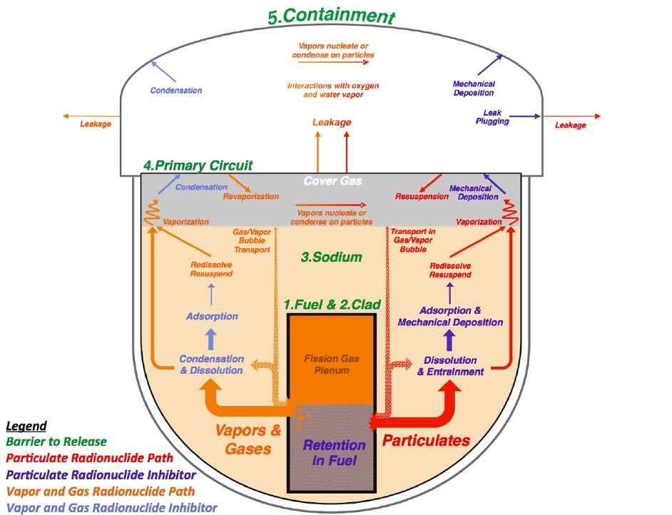
Fig. 3. Overview of SFR radionuclide transport phenomena [14]

Licensing Basis Events
There are generally two major sources of radionuclides in a generic pool-type SFR design: the fuel, and the auxiliary systems, such as primary sodium or cover gas clean-up systems. Therefore, the central LBEs of interest for MST analysis can also be segregated similarly.
Progress in inherent and passive safety measures has generally resulted in the practical elimination of hypothetical core disruptive accidents (HCDAs) concerning potential fuel damage sequences. Historically, these HCDAs have included phenomena such as fuel melting, re-criticality, and subsequent core energetics. Such events were thought to result in large-scale fuel vaporization, extreme vessel loading, and sodium fires. Now, the current focus is typically on low-frequency LBEs involving limited core damage, which could involve partial fuel damage due to localized core blockages, overpower events, or loss of long-term decay heat removal [16]. These events generally do not result in energetic consequences or core relocation, and therefore do not challenge vessel integrity.
For LBEs associated with auxiliary systems, the main focus is on potential releases of radionuclides contained within filtration systems, decay beds, or accompanying piping. For primary sodium clean-up systems, this could include leaks which may ultimately result in sodium fires and the volatilization of any contained radionuclides. Similar to the reactor core itself, such systems are often contained within structures with their own containment-like properties to limit the release that may be associated with such potential events.

Source Term Modeling Capabilities
Modeling of reactor transients, as well as the evaluation of potential fuel damage, has historically been performed in the U.S. using the SAS4A/SASSYS-1 code [17]. Developed by Argonne for thermal, hydraulic, and neutronic analysis of power and flow transients in SFRs and LFRs, the code also includes severe accident models for both oxide and metal fuel. SAS4A/SASSYS-1 simulations have been used as input (i.e., as a basis) for source term modeling codes for both SFR and LFR MST analyses, which are briefly discussed below. The recently released NRC code development vision and strategy has proposed the SAM code as the system analysis tool for SFR DBEs [18]. SAM has been assessed for modeling behavior during both steady-state operation and transients, including validation utilizing tests from EBR-II and FFTF [19-21].
The actual transport of radionuclides within the reactor system and beyond can be accomplished with several different codes, each offering many of the same phenomena modeling capabilities. Recently at Argonne, the Simplified Radionuclide Transport (SRT) has been developed to model radionuclide release and transport within the reactor system [22]. It takes user-developed reactor conditions as input, or as mentioned previously, it can take output from the above safety analysis code SAS4A/SASSYS-1 because SRT itself does not perform reactor transient analyses. SRT tracks radionuclide releases from the fuel, the transport through the sodium pool, behavior in the cover gas and containment regions, and offsite dispersion, which is summarized in Fig. 4 below. Currently, SRT requires user modification in order to evaluate non-core releases, such as those from auxiliary systems.

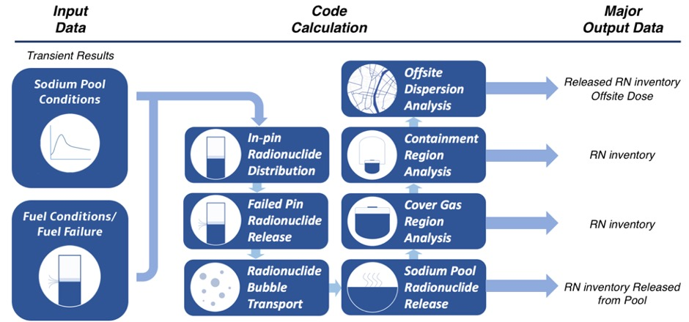
Fig. 4. SRT SFR model code overview [22]
DOE has funded efforts to enhance MELCOR’s ability to model sodium reactors by incorporating models previously developed for the CONTAIN/LMR code into MELCOR. Some key SFR accident progression phenomena that may be leveraged with existing models in MELCOR include bubble transport, reactor kinetics, and fission product release and speciation. Overall, the proposed NRC evaluation model for SFRs includes utilizing SCALE for reactor physics calculations, MELCOR for system behavior and fission product transport, and MACCS for dose consequence analysis beyond the reactor system [13].
Internationally, the Transport Phenomena of Radionuclides for Accident Consequence Evaluation of Reactor (TRACER) code was developed in Japan to evaluate in-vessel radionuclide transport during fuel pin failure transients [23]. This code contains models for radionuclide release from the fuel, transport through the sodium, and release to the cover gas region via bubbles or vaporization and focuses on oxide fuel loop-type SFR designs. Additionally, a sodium-specific version of the ASTEC source term code (ASTEC-Na) was developed in Europe for the analysis of SFR severe accidents [24]. Point kinetic models have been added for the assessment of unprotected transients in addition to sodium fire models for the evaluation of volume temperature and pressure loading.
Finally, much of the previous discussion for SFRs covers phenomena and systems that are also applicable to lead-cooled fast reactors (LFR). Some of the phenomenological differences which may appear in LFR designs compared to those being considered by current SFR developers will be briefly discussed here, but additional discussion can be found elsewhere [2]. Differences include the use of a bond material other than sodium, as well as fuels other than a metal fuel, such as oxide, nitride, or other types. Naturally, these will result in differing release fractions and failure modes than those previously modeled in some of the codes mentioned above. The production of ²¹⁰Po from ²⁰⁹Bi in the coolant is another source of radionuclides which must be considered, not just from lead-bismuth eutectic coolants, but also as an impurity in lead or from activation of ²⁰⁸Pb. The chemical reactions between radionuclides and the lead coolant will need to be assessed separately from those that may occur in liquid sodium, and, finally, energetic reactions between lead and oxygen are not a concern at the normal operating temperatures of LFRs. A facility analysis code called Facility flow, Aerosol, Thermal, and Explosion (FATE) is currently being developed for source term analysis of LFRs and tracks transport through the coolant pool, cover gas region, and the containment system [25]. It couples to the SAS4A-SASSYS-1 code mentioned previously and takes radionuclide inventory input from the SCALE code ORIGEN.

Capability Assessment
Several key gaps were identified regarding current modeling and simulation capabilities for metal fuel pool-type SFRs. The existence of mechanistic modeling tools specifically for simulating in-pin migration and the release of radionuclides from the fuel is the first key gap identified. Existing MST tools utilize data-driven correlations therefore a more mechanistic approach may be warranted depending on the fuel types, materials, and temperature conditions. Second, ongoing experimentation on bubble transport through liquid sodium or lead will be utilized to confirm transport models and better understand the retention of certain classes of radionuclides. Third, additional aerosol behavior model development may be necessary to account for sodium-specific aerosol phenomena such as the possible dissociation of chemical species or the potential for sodium oxide plugging of leakage pathways. Finally, current analysis tools regarding sodium fires do not assess the release of radionuclides entrained within the burning sodium, although some experimental data regarding the phenomenon is available.

fast reactor considerations
A comparison has not been made of the source term for advanced reactors in the fast spectrum versus thermal spectrum. It is believed that any such differences would have more to do with the type of fuel, the design-specific choices in the reactor system, and the reactor technology class as a whole. Because some fast reactor concepts may intend on utilizing used nuclear fuel (potentially with either minimal or no reprocessing) as fuel, it can be assumed the reactor will start with a larger source term. Although varying fuel utilization of the higher (bred) actinides as well as varying activations of fission products may also change the radionuclide inventory in the solid- or liquid-fueled system. The fission product yields of different fissile isotopes should also be accounted for when considering the fuel type used. Therefore, a proper neutronics analysis (e.g., fuel depletion and activation analysis) should be completed for each considered reactor type and design. This would be needed to confirm a supposed reduction in transuranic quantities in the fuel.
Other than fuel type, an additional factor which may influence the equilibrium radionuclide inventory in the reactor system includes potential differences in material activations due to core design differences owing to both differences in the mean free path of fast neutrons and the reflector thickness. Similarly, each reactor may use different material types and therefore the activation of the material should be always considered, along with the potential for release of that activated radionuclide from the material via leaching or corrosion. Additionally, the lack of moderator materials in fast spectrum MSRs provide less potential hold-up materials for radionuclides in the core (e.g., radionuclide retention in graphite). Finally, the use of a fuel processing system will affect the equilibrium circulating inventory of MSRs, as will the type of off-gas system used, although many of these auxiliary systems are not necessarily exclusive to fast or thermal spectrum reactors.

summary
A brief review of the current state of computational capabilities for mechanistic source term modelling of fast-spectrum molten salt reactors and sodium fast reactors is provided. MSR technology is less mature compared to SFRs, therefore source term modeling tools are still under development. Considerable work has been done in thermal hydraulic and system-analysis codes which may be used for MSR systems, but the ability to model reactor-specific source term phenomena is still being developed. Such phenomena include radionuclide transport in the salt and vapor (salt chemistry, bubble transport, aerosol behavior, corrosion and deposition, etc.) as well as the modeling of transport in design-specific auxiliary systems such as the off-gas or fuel processing systems. Tritium modeling is also especially important for MSRs, especially those salt systems based on fluorides and/or lighter nuclei.
The development of source term modeling tools specifically catered to certain SFR designs has occurred in multiple countries due to considerably more operational experience compared to MSRs. The major phenomena which must be considered in SFR MST includes radionuclide in-pin migration and release from the fuel, bubble transport through the sodium coolant pool, vapor interactions and aerosol formation in the cover gas region, and modeling leakage pathways (with potential oxide formation and plugging) leading to the containment building.
ACKNOWLEDGEMENTS
The submitted document has been created by UChicago Argonne, LLC, Operator of Argonne National Laboratory (“Argonne”). Argonne National Laboratory’s work was supported by the U.S. Department of Energy, Office of Nuclear Energy under contract DE-AC02-06CH11357.
This report is part of a larger collaboration between Argonne National Laboratory and Sandia National Laboratories to assist in the development of modern mechanistic source term modeling and simulation tools, as part of the U.S. Department of Energy (DOE) Nuclear Energy Advanced Modeling and Simulation (NEAMS) program. The authors would like to thank Nathan Bixler, Brad Beeny, Daniel Clayton, Jennifer Leute, Raymond Fasano, Andrew Hahn, and Tina Nenoff from Sandia and Bo Feng, Tanju Sofu, Tom Fanning, Jim Jerden, Nathan Hoyt, Adam Nelson, Micheal Smith, Alisha Kasam-Griffith, and Scott Richards from Argonne for their support in this effort.
References
[1] SHAHBAZI, S., GRABASKAS, D., Functional Requirements for the Modeling and Simulation of Advanced (Non-LWR) Reactor Mechanistic Source Term, Argonne National Laboratory, ANL/NSE-20/17, June 2020.
[2] SHAHBAZI, S. et al., Survey and Assessment of Computational Capabilities for Advanced (Non-LWR) Reactor Mechanistic Source Term Analysis, Argonne National Laboratory and Sandia National Laboratories, ANL/NSE-20/39, SAND2021-3250R, September 2020.
[3] DINUNNO, J. J., BAKER, R. E., ANDERSON, F. D., WATERFIELD, R. L., Calculation of Distance Factors for Power and Test Reactors, Atomic Energy Commission, Division of Licensing and Regulation, TID-14844, March 23 1962.
[4] SOFFER, L., BURSON, S. B., FERRELL, C. M., LEE, R. Y., RIDGELY, J. N., Accident Source Terms for Light-Water Nuclear Power Plants, U.S. Nuclear Regulatory Commission, NUREG-1465, February 1995.
[5] U.S. NUCLEAR REGULATORY COMMISSION. OFFICE OF NUCLEAR REGULATORY RESEARCH., Regulatory guide 1.183 alternative radiological source terms for evaluating design basis accidents at nuclear power reactors, [Washington, D.C.]: U.S. Nuclear Regulatory Commission, Office of Nuclear Regulatory Research, (2000), p. [62] p. [Online]. Available: http://purl.access.gpo.gov/GPO/LPS107166.
[6] TAYLOR, J., Issues Pertaining to the Advanced Reactor (PRISM, MHTGR, and PIUS) and CANDU 3 Designs and their Relationship to Current Regulatory Requirements, U.S. Nuclear Regulatory Commission, SECY-93-092, April 8 1993.
[7] TRAVERS, W. D., Policy Issues Related to Licensing Non-Water Reactor Designs, U.S. Nuclear Regulatory Commission, SECY-03-0047, March 28 2003.
[8] Probabilistic Risk Assessment Standard for Advanced Non-LWR Nuclear Power Plants, ASME/ANS RA-S-1.4-2013, (2013).
[9] Probabilistic Risk Assessment Standard for Advanced Non-Light Water Reactor Nuclear Power Plants, ANSI/ASME/ANS RA-S-1.4-2021, (2021).
[10] Memorandum: Staff Requirements - SECY-19-0117 - Technology-Inclusive, Risk-Informed, and Performance-Based Methodology to Inform the Licensing Basis and Content of Applications for Licenses, Certifications, and Approvals for Non-LWRs, U.S. Nuclear Regulatory Commission, SRM-19-0117, May 26 2020.
[11] Risk-Informed Performance-Based Technology Inclusive Guidance for non-LWR Licensing Basis Development, Revision 1, Nuclear Energy Institute, 18-04, August 2019.
[12] JERDEN, J., Personal Communication, Argonne National Laboratory, 2020.
[13] NRC Non-Light Water Reactor (Non-LWR) Vision and Strategy, Volume 3 - Computer Code Development Plans for Severe Accident Progression, Source Term, and Consequence Analysis, Draft Rev.1, U.S. Nuclear Regulatory Commission, ML20030A178, January 31 2020.
[14] GRABASKAS, D., BRUNETT, A. J., BUCKNOR, M. D., SIENICKI, J. J., SOFU, T., Regulatory Technology Development Plan - SFR Mechanistic Source Term Development, Argonne National Laboratory, ANL-ART-3, February 2015.
[15] GRABASKAS, D., BUCKNOR, M. D., JERDEN, J. L., Regulatory Technology Development Plan - SFR Mechanistic Source Term Metal Fuel Radionuclide Release, Argonne National Laboratory, ANL-ART-38, February 2016.
[16] GRABASKAS, D. et al., Regulatory Technology Development Plan - SFR Mechanistic Source Term Trial Calculation, Argonne National Laboratory, ANL-ART-49, October 2016.
[17] T. H. FANNING, A. J. BRUNETT, T. SUMNER, EDS., The SAS4A/SASSYS-1 Safety Analysis Code System: User's Guide, Argonne National Laboratory, ANL/NE-16/19, 2017.
[18] U.S. NUCLEAR REGULATORY COMMISSION, NRC Non-Light Water Reactor (Non-LWR) Vision and Strategy, Volume 1 – Computer Code Suite for Non-LWR Plant Systems Analysis, Rev 1, 2020.
[19] TRAVIS, M., HU, R., ZHANG, G., Uncertainty Quantification on SAM Simulations of EBR-II Loss-of-Flow Tests, Proceedings of NURETH-18 (2019)
[20] HU, R., SUMNER, T., Benchmark Simulations of the Thermal-Hydraulic Response during EBR-II Inherent Safety Tests using SAM, Proceedings of ICAPP 16 (2016)
[21] YANG, L., HU, R., Benchmark Modeling and Simulation of the FFTF LOFWOS Test #13 using SAM, ANL/NSE-20/8, 2020.
[22] GRABASKAS, D., BUCKNOR, M., JERDEN, J., Simplified Radionuclide Transport (SRT) Code: Users Manual, ANL-SRT-4, Rev 2.0, 2020.
[23] TOYOHARA, D., OHNO, S., MATSUKI, T., HAMADA, H., MIYAHARA, S., In-Vessel Source Term Analysis Code TRACER Version 2.3, User’s Manual, JNC TN9520 2004-004, 2005.
[24] HERRANZ, L. E., LEBEL, L., MASCARI, F., SPENGLER, C., Progress in Modeling In-containment Source Term with ASTEC-Na, Annals of Nuclear Energy 112 (2018) 84-93.
[25] HUA, T. Q. et al., Development of Mechanistic Source Term Analysis Tool SAS4A-FATE for Lead- and Sodium-Cooled Fast Reactors, Nuclear Technology 206 2 (2020) 206-217.

