The SAIGA in-pile experimental program to qualify the SIMMER calculation tool in SFR Severe Accident Conditions

F. Payot¹, R. Clavier², F. Charollais², D. Cambet², E. Martin-Lopez², L. Trotignon², E. Dufour²
and F. Serre¹
Commissariat à l’Energie Atomique et aux Energies Alternatives
¹CEA Cadarache - CEA/DES/IRESNE/DER, 13108 St Paul lez Durance - FRANCE
²CEA Cadarache - CEA/DES/IRESNE/DTN, 13108 St Paul lez Durance - FRANCE

E. Batyrbekov, A. Vurim, A. Pakhnits, V. Baklanov, V. Vityuk
National Nuclear Center of the Republic of Kazakhstan, 2B, Beibyt atom St., 071100, Kurchatov, VKO, KAZAKHSTAN
E-mail contact of main author: frederic.payot@cea.fr

Abstract

The CEA, together with the NNC-RK, has carried out a feasibility study with regard to conducting an in-pile test program - the SAIGA program (Severe Accident In-pile experiments for Gen-IV reactors and the ASTRID prototype) - on the degradation of a SFR fuel bundle with molten fuel discharge device which are planned to be housed in the IGR reactor (Impulse Graphite Reactor operated by NNC-RK). The purpose of the SAIGA program is to qualify the SIMMER computer code based on one in-pile test conducted with two fuel sub-assemblies and one discharge tube representative for an in-core mitigation device dedicated to severe accident situations. This test should be representative, as much as possible, for the phenomena encountered during Unprotected Loss-Of-Flow Total (ULOF) severe accident sequences.
A sodium loop will be built and connected to the in-pile experimental device to drive the sodium flow inside the fuel pin bundle with experimental conditions close to the SFR nominal conditions before triggering of the Na Loss-Of-Flow sequence. Over accidental transient period with sodium flow reduction, the constant neutron heating from IGR reactor will lead to degrade a first sub-assembly (16 homogeneous fuel pins by sub-assembly) to produce some molten fuel material and the propagation of this degraded fuel will be followed by fine instrumentation towards both a second sub-assembly and a discharge tube.
For this scenario, the feasibility study defined the main characteristics of the experimental device and the operating conditions for the test to be conducted in the IGR reactor. The purpose of this study was to assess the capacity of the IGR reactor to provide the necessary neutron flux during the transient, to demonstrate the capacity to carry out on-line or post-test measurements of the variables of interest, and to assess the schedule of one test incorporating the safety issues. Also, the sodium loop feeding the test device and its instrumentation were studied and their feasibility demonstrated.

Context
The CEA conducted the ASTRID programme from 2010 to 2019, supported by the French Investments Programme (PIA1 and PIA2). The programme had various objectives, including demonstration of nuclear safety improvements and progress in the availability, operability and economy of sodium-cooled fast reactor (SFR) technology [1].
After this period, the French ministerial authorities decided to postpone the SFR construction and in the meantime a R&D programme was initiated by CEA in 2019 to preserve its capacity to support the development of this technology and its fuel cycle. So, the CEA reviewed its R&D strategy and submitted new proposals:
• Taking into account the current prospects of deployment
• Seeking to maintain the technical and scientific skills
• Aiming to make progress on the identified technological obstacles using knowledge acquired from the ASTRID programme

The main challenges involved in controlling the safety associated with this reactor technology are exposed on severe accidents under the SFR development programme [2]. This programme provides a roadmap for meeting the requirements for calculation and simulation tools supporting the safety case and the design of a demonstration reactor for the technology in the medium term and then a Generation IV SFR technology reactor in the longer term.
This CEA roadmap is based on three main programmes:
• A study programme for improving knowledge of the phenomena and equations governing the sequence of events occurring during a severe accident.
• A numerical simulation programme to capitalise on this knowledge in existing or future calculation codes and develop numerical platforms focusing specifically on severe accidents in order to sequence and couple these codes, and to carry out analyses of uncertainties in order to control them.
• An experimental programme, which aims to:
o Extend the experimental database needed to validate the calculation and simulation tools to cover the ranges of the parameters expected in future reactors incorporating advanced design options.
o Qualify innovative systems for mitigating the consequences of radioactive emissions in severe accident conditions proposed for future reactors, for which the objective is also to reduce the mechanical loads on the reactor’s structures during high-energy events.

The SAIGA (Severe Accident In-pile experiments for Generation IV reactors and the ASTRID prototype) programme, which started early in the ASTRID programme, still remains one of the experimental parts of the SFR severe accident development plan [2]. As early as 2014-2015, an initial feasibility study for in-pile tests with the National Nuclear Centre in Kazakhstan (NNC-RK) concerning ‘loss of sodium flow’ and/or ‘reactivity insertion transient’ type scenarios led to a favourable assessment of the Impulse Graphite Reactor (IGR) [3, 4, 5]. Following analysis of the requirements for the safety case, three types of test were proposed to supplement our experimental knowledge on the degradation of axially heterogeneous fuel during accident sequences:
• Flow reduction test in a pin bundle
• Power excursion test in a pin bundle
• Multi-sector test with two fuel sub-assemblies and one sector filled with sodium (no fuel) corresponding to a corium transfer tube
The possible use of a homogeneous fuel for the future French SFR demonstrator, whose behaviour has already been studied in the CABRI and SCARABEE experimental programmes, means that the CEA does not have to carry out the first two types of tests. Only the multi-sector test remains. This SAIGA test must remove (or help to do so) what is still a scientific and technical obstacle, i.e. to provide robust validation of the effectiveness of a passive in-core mitigation device (In-core Transfer Tube) that will enable the reactor to reach a safe state, even in the event of a control rod drop failure. In the architecture of the ASTRID reactor, this was called the complementary safety device for severe accident mitigation via transfer tubes (DCS-M-TT) [6-7].

SAIGA in-pile experimental test
As part of the CEA’s development of the sodium-cooled fast reactor (SFR) technology, innovative options are being integrated to improve the technology’s safety response in advanced fuel degradation conditions or even severe accident conditions. These options include an additional in-core safety system, called a mitigation device (Transfer Tube), which is designed to transfer a large fraction of the molten fuel into a core catcher and thus avoid prompt criticality, as illustrated in FIG 1. This mitigation device is designed to help return the reactor to a safe state after a severe accident.
The aim of the SAIGA programme is to subject an experimental device consisting of three parts (two bundles of 16 fuel pins and a third sector filled with sodium simulating the mitigation device) to neutron irradiation conditions in order to reproduce a severe accident sequence. To do this, the experimental device will be placed in the core of the IGR used for research at the NNC-RK. The experimental conditions (physical, neutronic, chemical, sodium loop, etc.) of an SFR operating at nominal conditions will be recreated before initiating a Na loss-of-flow severe accident.
The SAIGA experimental programme must meet the following technological and scientific objectives, which are:
• Study the degradation of two bundles of fuel pins and then the propagation of degraded material called corium (molten fuel and cladding steel) from one fuel sub-assembly to the neighbouring sub-assembly in the presence of a sodium channel representing the corium transfer tube in a Na Loss-Of-Flow transient.
• Improve our understanding of mitigation and enhance the database needed to validate scientific calculation tools for severe accidents (e.g. SIMMER), with the aim of reducing the uncertainties in the modelling of fast reactor core degradation, in order to improve margins in nuclear safety studies.
Following a brief overview of the IGR characteristics, the specifications for the SAIGA programme and the expected results are reported hereafter. This paper then gives some important results on a feasibility study, as first phase to ensure that this SAIGA experimental test is possible. The aim of the first phase is to demonstrate the technical and scientific feasibility of the SAIGA programme, while the second phase involves conduction the experimental test. The main results of this feasibility study carried out by the NNC-RK teams in Kazakhstan and by the CEA teams are reported in various scientific fields: sodium thermohydraulics and neutronic behaviours, sodium loop and test section design, modelling of the behaviour of SFR fuels in steady-state conditions and in advanced degradation conditions.
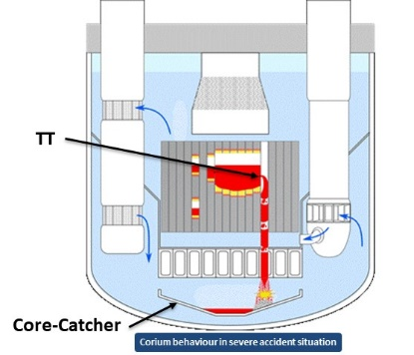

FIG. 1. In-core SFR mitigation devices and molten fuel relocation in a severe accident sequence

Relevance of the SAIGA programme with regard to the design of the ‘transfer tube’ mitigation device
The French mitigation strategy for severe accidents is based on the core of an SFR technology reactor containing innovative transfer tube type devices allowing the corium to flow away from the core towards a core catcher.
These mitigation devices generally comprise:
• A hexagonal tube (HT) containing no fuel pins combined with specific upper neutron shielding
• A specific base with an opening allowing the corium to flow out in the secondary severe accident phase
Transfer Tube mitigation devices are integrated in the core, pass through the diagrid and the core support structure (strongback) and open into the low-pressure cold plenum. It is designed to mitigate generalised core melting accidents. Their role is to reduce the effects of a severe accident by routing the molten fuel (corium) out of the neutron flux area (short-term action), then to the core catcher located beneath the core in the vessel bottom head (long-term action).
Its effectiveness still remains to be demonstrated. Removing the corium from the core area limits the neutron power generated in the reactor core and therefore ensures controlled management of the reactivity of the core during compaction and then its degradation and radiological releases in severe accident conditions. The main parameters influencing the speed of corium transfer into the core catcher, and more generally the success of mitigation, are: the speed of opening of these transfer tubes, the potentially high-energy interaction between the hot corium and the sodium, and solidification of corium particles in these tubes.

The available models for simulating these phenomena are not adequately qualified through lack of experimental tests and materials representative of the conditions that may be encountered in a SFR. This is a key factor in the safety case for SFRs. There is not enough experimental data on these transfer tubes (although some is available through the EAGLE tests operated by Japan [8, 9, 10]) and the tests have been conducted in conditions fairly different from in-vessel conditions (geometric scale, geometry of the transfer tubes with cross-section restrictions, mass and composition of the corium to be removed, etc.).

In the corium relocation sequence during the SFR severe accident, the corium flow is driven by the pressure generated by the sodium vapour produced during the corium-sodium interaction in the transfer tube and by gravity. These phenomena are simulated by CEA using the SIMMER code, in which the corium transfer qualification is partly based on the EAGLE programme tests.
The SAIGA multi-assembly in-pile test in the IGR in Kazakhstan meets the qualification requirements for the SIMMER-V tool and the mitigation device on the large domain. It will be used to study and, if possible, demonstrate that corium generated during the degradation of fuel sub-assemblies is discharged into the transfer tube, limiting propagation of the accident to the neighbouring sub-assemblies. The experimental measurements and the lessons learned from such a SIAGA integral in-pile test, at a scale representative of this reactor technology, will be used in the SIMMER-V calculation code.

Impulse Graphite Reactor (IGR)
The Impulse Graphite Reactor (IGR) produces a thermal neutron flux and is used for experimental purposes. It is owned by the NNC-RK and is located 600 km east of Nur-Sultan in Kazakhstan. By design, it is authorised to create significant neutron pulses which are “self-quenching” due to the intrinsic negative temperature reactivity coefficient of the reactor.
The IGR core (see Fig. 2.) consists of a stack of graphite blocks (in red colour), which are saturated with fuel (uranyl nitrate 90% enriched with U235), surrounded by the graphite reflector: all assembled to a height of 4.4 m, placed in a 3.1 m diameter leaktight cylindrical steel vessel [11].
For the SAIGA experimental test, the operating modes will be based on a controlled mode which is achieved by moving the control rods which compensate for the negative temperature reactivity effect. The form, amplitude and duration of controlled mode must be determined based on experience without exceeding a critical in-core temperature threshold of 1400 K (operating limit). Consequently, the maximum energy production delivered by the reactor is 5.2 GJ. This mode therefore enables a short power history, but with the possibility of producing, for example, a high power peak lasting a few seconds before a lower power plateau of a few tens of seconds.
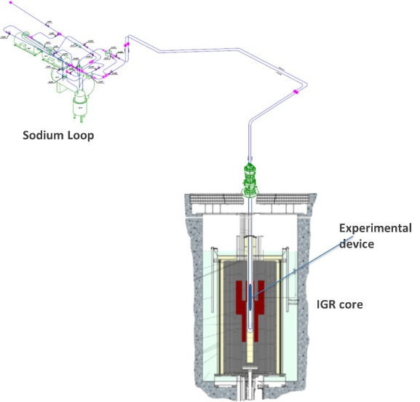

FIG. 2. IGR facility with sodium loop and experimental test

SAIGA objectives and specifications
The main objective of the SAIGA experimental test is to study the degradation of the SFR fuel during a Na Loss-Of-Flow phase, its progress from one sub-assembly to another in the presence of a sodium channel representing the mitigation device (transfer tube) by perforation of the steel walls between the sub-assemblies, then the relocation of the corium to the bottom of the SAIGA test device.

The SAIGA experiment aims to reproduce the physical conditions of a Na Loss-Of-Flow accident. This leads to an experiment divided into two phases:
• Starting from a “cold” state (400°C) with sodium circulating in the test section, the IGR reactor starts to deliver power in order to reach a stabilised “hot” state representing the steady state of an SFR reactor under nominal conditions, referred to in the remainder of this paper as "steady state".
• After reaching steady state and stabilising in this state, and maintaining the reactor's power at a constant level, the sodium flow rate is reduced linearly, leading to a considerable temperature rise in the test section, and finally to its degradation. This phase is referred to as “degradation phase” in the remainder of this document.

The specifications for the SAIGA multi-assembly test defining the experimental conditions and the required objectives for conducting the feasibility study are as follows:
• A test device comprising three Sub-Assemblies (SA) in a hexagonal tube (see Fig. 3.). Two fuel sub-assemblies consisting of a bundle of 16 homogeneous fuel pins (each pin contains a single 800 mm high fissile column) with BN350 annular fuel pellets (UO₂ enriched with U-235 - Φ_{ext} = 5.9 mm).
• The U-235 enrichment level of the pellets making up the fissile columns in each fuel sub-assembly was determined and adjusted to obtain the required axial and radial power profiles.
• The axial power profile of the fuel bundles, in steady state, is close to that of the SFR technology reactor with a cosine shape centred on the middle of the profile, whereas the flattest possible radial profiles are sought. A 25% power difference between the two fuel sub-assemblies is aimed for to be representative of the operation of a reactor with two different burn-up rates. The target maximum mass power the “hot” sub-assembly is ~118 W/g. This of the “cold” sub-assembly is ~88 W/g. These mass power values are representative for the SFR conditions.
• A 1 mm-diameter spacer wire is wound round each fuel pin.
• An identical sodium flow rate in both sub-assemblies is sought in the steady state phase. The third sub-assembly, which does not contain any fuel, simulating the mitigation device (corium transfer tube to the core catcher) will be filled with quasi-static sodium.
• The sodium circulation conditions in the test section prior to the transient (Na Loss-Of-Flow) are defined as followed : sodium inlet temperature 400°C, sodium ΔT(outlet-inlet) = 150°C, sodium flow rate per sub-assembly approximately = 1.8 kg/s. This initial thermohydraulic conditions comparable to the steady-state conditions of a reference SFR.
• To initiate the degradation phase, a controlled linear reduction of the sodium flow rate will be applied over 5 seconds to simulate the loss-of-flow transient.

The feasibility of such a multi-assembly test in the IGR needs to be investigated. Hence specific studies were carried out at the beginning of the SAIGA programme to specify the experimental conditions, the constraints and limits in terms of instrumentation, and/or check that the whole test can be completed before the IGR reaches its operating limit, which is dependent, in particular, on the maximum energy deposition of 5.2 GJ permitted in the reactor without thermal degradation of the core elements. In the following of the paper, these specific studies are presented.

Main results obtained with SAIGA feasibility study
This section gives the main results of the feasibility studies for the SAIGA experimental test in IGR reactor:
- Design studies of the experimental test device (including neutron modelling) and the sodium loop.
- Modelling of the thermohydraulic behaviour of the sodium in the loop and the SAIGA pin bundle in nominal conditions.
- Modelling of the SFR pin bundle degradation using the SIMMER-V computer code for fuel behaviour in severe accident conditions.

Design of the SAIGA experimental test device connected with Na loop
To meet the test requirements, the design of the test section was studied as displayed in Figure 3. A hexagonal tube, containing three trapezoid-shaped cross-section tubes, is inserted in the test section. Inside these three tubes, there are two sub-assemblies, each containing a bundle of 16 fuel pins, and the transfer tube (sub-assembly containing no fuel and filled with sodium).
Fig. 3 on the right shows an axial cross-section of the experimental device which will be inserted in the central channel of the IGR. An important point to underline is that a fine instrumentation is planned to measure the physical parameter during the experimental test i.e. thermocouples, pressure sensors, fission chambers, etc.
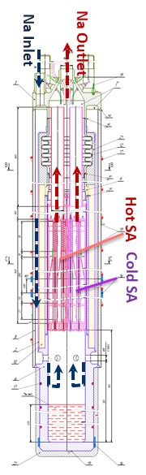
The two sodium inlet and outlet tubes, at the top of the experimental device, provide the connection with the sodium loop. The sodium circulation can be observed in Fig. 3. The liquid sodium enters via the top of the experimental device in a 20 mm diameter pipe, travels down in an annular space (the downcomer) positioned around the sub-assemblies and the transfer tube and arrives in the lower plenum at the bottom of the bundles. The sodium then rises through the two sub-assemblies and the transfer tube.
The sodium loop, the main function of which is to supply the test section with liquid sodium, must be able to operate as a closed system for the SAIGA test preparation stages. A 3D representation of the sodium loop is given in Fig. 2. This sodium loop is connected to the SAIGA test devices housed in the central part of the IGR reactor. The upstream and downstream Na circulation was designed to meet the Na inlet data specified above.
Two pumps are connected in series (4 bar each) to provide a higher pumping capacity, as specified by thermohydraulic pre-calculations which concluded that a minimum pumping capacity of 7 bar is required.

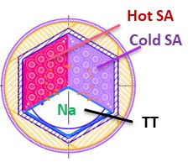

FIG. 3. Cross-sectional schematic view of the SAIGA multi-assembly test: radial (on the left) and axial (on the right)

Neutron study
Neutron calculations were performed using the MCNP v5 code and the ENDF/B-VI library by modelling the SAIGA experimental device positioned in the central channel of the IGR. The fuel pins were modelled as simple rods. All calculations were based on the assumption that the reactor was “cold” in critical conditions, which resulted in a coupling factor (ratio between the energy deposited in the fuel and the energy provided by the IGR core) with a margin of error around 10%.
To produce a radial power profile that is as flat as possible in each of the two fuel sub-assemblies, neutron calculations were performed to validate a specific layout for the SAIGA pins based on various enrichment pin levels (see Fig. 4 (on the left)). From this fuel pin specific distribution, the radial power profile per sub-assembly was reduced to 10%.

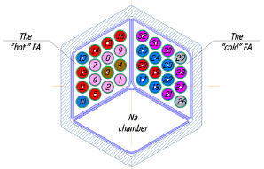
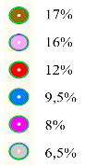
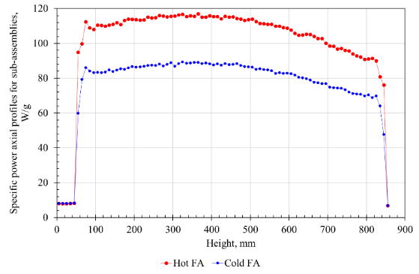
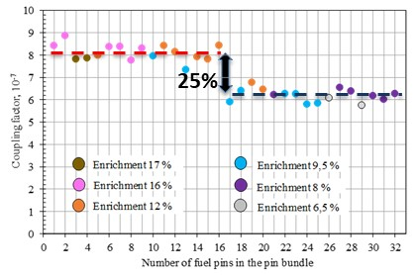

FIG. 4 : Fuel pin configuration according to their enrichment in 235U% in the two Fuel sub-Assemblies (FA) : pin to pin (on the left) and axial profile (on the right)

Based on the mean power calculated per sub-assembly, it was possible to calculate the power that IGR core needed to provide via the coupling factors. In SAIGA conditions, the IGR power was evaluated to be 137.5MW. To note that the power levels of the hot and cold sub-assemblies were ~ 347.2 kW and 267.3 kW respectively.

To approach the cosine-shaped axial power profile, the middle of the fissile columns is positioned in the axial centre of the IGR core. This requirement combined with the inherent neutron properties of the IGR core resulted in an axial power profile reported in Fig. 4 (on the right) for the cold and hot sub-assemblies.

Estimating the maximum duration of the SAIGA test and scenario

From neutron study results, the duration of the IGR reactor operating time can be evaluated on the entire SAIGA test sequence, i.e. reach a steady-state before provoking a rapid reduction in the sodium flow that must cause the corium to perforate the transfer tube wall.
Two possible reactor control scenarios (see Fig. 5) were proposed to successfully complete the SAIGA test. The first power history (trapezoidal in shape) increases linearly for 2 seconds to reach a plateau of 137.5 MW (1) that lasts 35.8 seconds before the reactor is progressively shut down.
The second power history has an overpower peak up to 275 MW for ~ 4 seconds before stabilising at 137.5 MW for 31.8 seconds, the duration required in order to comply with the maximum power deposit of 5.2 GJ.

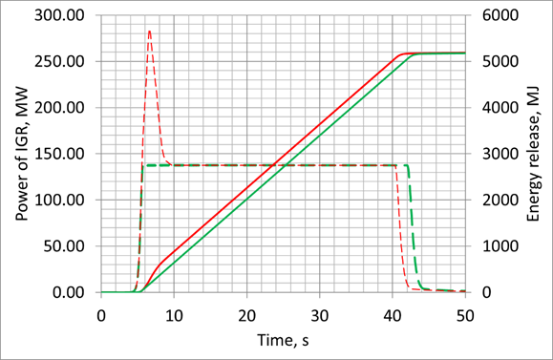

FIG. 5. Possible power scenarios of the SAIGA test together with control rod movements

Thermo-hydraulic study in the SAIGA test section

Within the scope of the sodium thermohydraulic and pin thermal study, the test section was modelled in 3D using GAMBIT and the calculations were performed in the ANSYS environment.

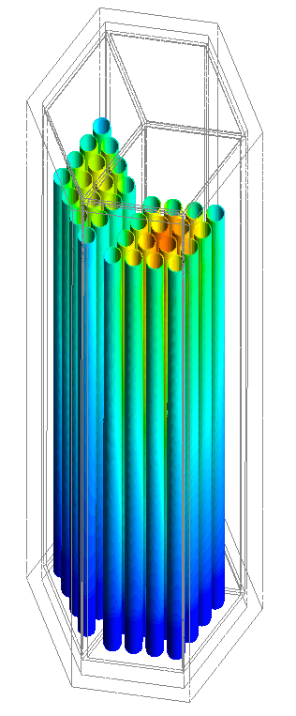  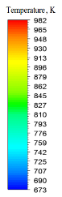 | 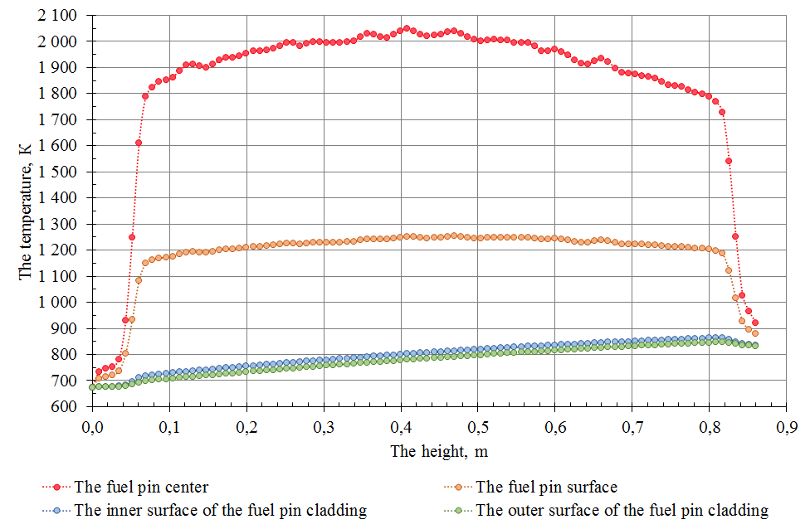
FIG. 6. 3D distribution of the cladding surface temperature | FIG. 7. Axial temperature profiles of the hottest fuel pin at different radii i.e. pellet centre and surface, cladding depth and surface
The main results calculated with respect to the steady-state conditions in thermal equilibrium are:
• Fig. 6 shows the 3D distribution of the cladding surface temperature in the sub-assemblies.
• The maximum temperature reached in the fuel pellets is estimated at 2075 K (see Fig. 7.).
• In the case where the power history is trapezoidal in shape (power ramp-up to a plateau of 137.5 MW), the steady-state conditions are reached after ~15 seconds, i.e. the heat exchanges between the fuel and sodium stabilize for an outlet sodium temperature of ~823 K.
• In the case of a reactor start-up with an overpower peak at 275 MW before decreasing to a plateau of 137.5 MW, the heat exchanges between the fuel and sodium stabilize after 5 seconds.

The key information to draw from these calculations is that it is possible to trigger a Na Loss-Of-Flow transient about five seconds after having started up the IGR with a pulse two times more powerful than its nominal power, before maintaining a power plateau. With these conditions, the reactor’s maximum operating time is limited to about 36 seconds, which means the remaining ~31 seconds can be used to study the fuel degradation phase up to perforation of the transfer tube wall.

Modelling the Na Loss-Of-Flow degradation behaviour of the SAIGA test section
The SIMMER-V code is the CEA’s reference computer code for safety studies investigating severe SFR accident conditions [12]. SAIGA fuel behaviour was modelled using SIMMER-V for the full duration of the experiment in the IGR reactor and particularly during the loss of sodium coolant flow phase to validate the feasibility of the SAIGA programme.
Only one SIMMER-V reference calculation is presented here which is based on a rather crude modelling of the entire system in which all 16 fuel pins were grouped as a single element. Another calculation type was done (but not presented here) using a meshing configuration considerably more refined. It is worth noting that the results of two calculations are quite close.

Fig. 8 shows the time sequence of the main events calculated by SIMMER (configuration with initial power peak) from the start of the degradation phase (where t₀ corresponds to the point at which the loss of sodium flow starts). The mains events are as followed:
- Sodium boiling in the Hot sub-assembly: t₀ + 6.8 s
- Cladding melting for Hot sub-assembly: t₀ + 13 s
- Rupture of the wall between the hot and cold sub-assemblies: t₀ + 15.6 s
- Rupture of the wall between the hot sub-assembly and the transfer tube: t₀ + 18.2 s
- Transfer of fuel in the TT: t₀ + 20.5 s

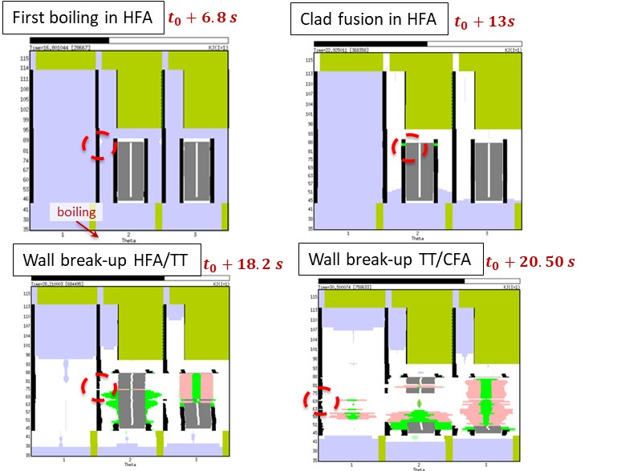

FIG. 8. Illustrations of the pin bundle degradation by using the SIMMER-V code. The calculation architecture is based on a TT on the left, the Hot sub-assembly at the center and the Cold-subassembly on the right (one fuel object in each sector corresponds to 16 fuel pins) ; Color code: liquid Na in blue, vapor Na in blank, wall (and intact cladding) in black, intact fuel in grey, molten cladding in light green, degraded particle fuel in pink and virtual walls in dark green.

Regardless of which configurations were modelled (with or without power peak), the result of the SIMMER simulation shows that the wall ruptures were caused by melting of the steel; the degraded fuel particles only appears later, around 5s + 20.5 s (steady state + Na Loss-Of-Flow degradation phases). As a conclusion, IGR has enough power to produce severe accident sequence.

7. Conclusion and future prospects
The purpose of this programme is to use the experimental Impulse Graphite Reactor (IGR) to reproduce the conditions needed to simulate a severe accident involving a Na Loss-Of-Flow (conditions as close as possible to a ULOF scenario) in the two fuel assemblies in the presence of Transfer Tube. It would therefore be possible to study the propagation of a degraded fuel from one fuel sub-assembly to a neighbouring sub-assembly and/or eventually into a mitigation device (transfer tube) whose main function is to transfer the corium into the core catcher in the event of a severe accident in a sodium-cooled fast reactor.
Relying on the results of neutronic and thermos-hydraulic calculations, as well as on the results of the SIMMER-V severe accident studies, it was possible to demonstrate the feasibility of the SAIGA programme, i.e. that the IGR can be operated (in compliance with the safety regulations) in such a way as to provoke the degradation of SFR fuel up to failure of the wall between the fuel sub-assemblies and the transfer tube before reaching the reactor’s operating limit.
Currently, the second part of the SAIGA program was engaged with the SAIGA test realization in 2025, it will involve:
• Fabrication of the sodium loop, followed by its commissioning
• Fabrication of the experimental device, the test section, the fuel sub-assemblies and mock-ups
• Fabrication of the fuel pellets for the mock-up and the SAIGA test by the Ulba Metallurgical Plant (UMP, Kazakhstan)
• Detailed definition of the test, supported by SIMMER-V code calculations
• Performance of the test in the IGR pile with online measurements
• Post-test analysis

In the end, the SAIGA in-pile integral test, to be performed under the most representative conditions of a severe accident in an SFR, will provide key information that is needed to qualify the SIMMER-V calculation tool. It will also expand our knowledge and experimental database essential for designing the mitigation device needed to transfer corium into the core catcher.
References
- CHENAUD, MS et al., STATUS OF THE ASTRID CORE AT THE END OF THE PRE-CONCEPTUAL DESIGN PHASE 1, Nuclear Engineering and Technology, Volume 45, Issue 6, 2013, Pages 721-730,
- GARNIER and al., Fast reactor development program in France, N° 183, paper presented in FR22 conference, Session on “Overviews and Fundamentals of Fast Reactors”, Beijing, China, 25–28 April 2022
- PAYOT, F., SERRE, F., BASSI, A.,SUTEAU, C., BATYRBEKOV, E., VURIM, A., PAKHNITS, A., VITYUK, V., Fast reactor conference (FR21), The SAIGA experimental program to support the ASTRID Core Assessment in Severe Accident Conditions, 26–29 June 2017, Yekaterinburg, Russian Federation
- SERRE, F., et. al., R&D and experimental programs for mitigating severe accidents consequences in GENIV SFRs and the ASTRID technology demonstrator. – NNC Bulletin, Volume 1, 2016, Pages. 25-30,
- SERRE, F., PAYOT, F., SUTEAU, C., TROTIGNON, L., BATYRBEKOV, E., VURIM, A., PAKHNITS, A., VITYUK, V., KUBO, S., KATOH, A., TOBITA, Y., KAMIYAMA, K., MATSUBA, K., TOYOOKA, J. R&D and Experimental Programs to support the ASTRID Core Assessment in Severe Accidents Conditions. – Proceedings of International Congress on Advances in Nuclear Power Plants (ICAPP), 2016, San Francisco (CA, USA), April 17-20, 2016 – San Francisco (CA, USA), Vol. 3, 2016, pp. 2173-2182,
- BERTRAND, F., MARIE, M., BACHRATA, A., BRUN-MAGAUD, V., DROIN, J.B., MANCHON X., HERBRETEAU, K., FARGES, B., CARLUEC, B., POUMEROULY, S., LEMASSON, D., Status of severe accident studies at the end of the conceptual design of ASTRID: Feedback on mitigation features, Nuclear Engineering and Design, Volume 326, 2018, Pages 55-64,
- BERTRAND, F., et al. Mitigation of severe accidents for SFR and associated event sequence assessment, Nuclear Engineering and Design, Volume 372, 2021,
- KONISHI, K.,et al., The result of a wall failure in-pile experiment under the EAGLE project, Nuclear Engineering and Design, Volume 237, Issue 22, 2007, Pages 2165-2174,
- KAMIYAMA, K. et al., Experimental studies on the upward fuel-discharge for elimination of severe recriticality during core-disruptive accidents in sodium-cooled fast reactors / Journal of Nuclear Science and Technology, Volume 51(9), 2014, Pages 1114-1124,
- BATYRBEKOV, E. et al., Experimental studies in substantiation of sodium cooled fast reactors safety / NNC Bulletin, Volume 3, 2018, Pages 117-121,
- NAZARBAYEV, N.A., SHKOLNIK, V.S., BATYRBEKOV, E.G., BEREZIN, S.A., LUKASHENKO, S.N., SKAKOV M.K., scientific, Technical and engineering work to ensure the safety of the former Semipalatinsk test site, London, Volume 3, 2017, 548 pages,
- BACHRATA, A., and al., Severe accident studies on the efficiency of mitigation devices in a SFR core with SIMMER code, Nuclear Engineering and Design, Volume 373, 2021.

The degraded fuel appears more widely in the cold sub-assembly compared with hot sub-assembly because of a calculation artefact. Indeed, in the calculation parameters, these degraded particles form when the wall (on the left side) is failed together with temperature threshold is reached. So, the TT rupture occurs after wall failure between two fuel sub-assemblies what explains this difference.

