Hybrid high power fast breeder reactor with metallic fuel and additives consisting with lightweight atoms

I.I.DROBYSHEV
JSC “VNIIAES”
Moscow, Russian Federation
Email: dr.yuri92@yandex.ru

E.F. SELEZNEV
JSC “VNIIAES”
Moscow, Russian Federation

Abstract

There are a huge data volume based upon theoretical and experimental metallic fuel studies in the fast spectrum nuclear installations. A higher density of such fuel allowed to get a high BR (breeding ratio) has a considerable research interest. But there are number of restrictions not allowed the practical implementation of the high power reactor projects with such fuel at that moment. Additional materials are included into the light water reactor fuel assembly to improve the core neutronic characteristics. In this study similar approaches for a fast breeder reactor core are considered by using metallic fuel containing additive materials of relatively lightweight nuclei in the composition.
Analysis of the neutron-physical characteristics of reactor core load with metallic fuel demonstrate three main problems with which heterogeneous (hybrid) layout should handle with:
- increasing a feedback level expressed both in relatively low affecting power reactivity coefficient and mainly affecting Doppler coefficient;
- decreasing a hypothetical whole core sodium void worth;
- proposed construction should respond to an operation limits of the fuel and fuel cladding materials.
To meet condition described above a lot of multivariate calculations on the three geometric scale have been conducted: homogeneous medium, fuel assembly and reactor core. Calculations were performed using Monte-Carlo code with depletion simulation OpenMC to thorough considering a neutron spectra effect on sodium void worth and Doppler effect .
A result of multicriteria optimization of the composition and geometry of hybrid cores with different additives layout in the metallic fuel assembly is studied in this paper.

INTRODUCTION
Contemporary fast reactors and experimental facilities use uranium oxide as a fuel due to the large experience with MOX and the available infrastructure. At the same time, to achieve a number of goals facing the fuel loading the use of oxide is limited due to its low breeding ability. Metallic fuel can overcome these problems, but its operation in high power reactors is difficult due to a number of its safety characteristics.
As a result of the neutron-physical characteristics analysis of core with MOX and metallic fuel, one can come to three main problems of the metal with which a heterogeneous (hybrid) layout core should handle with:
- increase feedback level expressed in a low value of the reactivity power coefficient and as its main component of the Doppler effect;
- reduction of the possible value of the SVW (Sodium Void Worth);
- the proposed configuration should ensure with according to the material operational limits for the fuel and the fuel cladding, by reducing both the average linear temperature stress and the unevenness of energy release over the load volume.
There are two potentially main solutions:
- adding the y fraction of the metallic fuel to the x fraction of the MOX fuel with an increase in the fertile potential while maintaining the levels of feedback for the oxide;
- adding a certain amount of a moderator the type and composition of which must be preliminarily assessed to the assembly with metal fuel, which will allow while maintaining the reproduction ability of the metal fuel to reduce the SVW value and increase the Doppler effect.

The first option with an axial arrangement of oxide fuel in the upper region of the assembly where the fuel temperature is maximum and metallic fuel in the previous study [1]. The presented work discusses the second approach to solving the problem.

NEUTRON PHYSICS MODEL AND METHOD DESCRIPTION
This article suggests including of an additional moderator material into the fuel assembly which would allow:
- increasing a feedback level expressed both in relatively low value of the power reactivity coefficient and main component of this one - Doppler-effect;
- decreasing a possibly maximum core sodium void worth value;
- a construction should respond to an operation limits of the fuel and fuel cladding materials.
In the process of searching for the most suitable options for the layout of the reactor core from the point of view of the constraints set it is necessary to enumerate a large number of options. The most accurate results are obtained by the Monte Carlo method which use relatively large amounts of data and, as a result, consumes significant computing resources. In order to reduce the resources and time of calculations, the computational analysis of the core loading is performed on a certain set of levels of reactor core models.
The first level is a homogenization by a fuel assembly volume in a model of an infinite homogeneous medium. The second level is a fuel assembly that is part of an infinity hexagonal lattice with a profile of the composition in height. The third level is already a full-scale loading of a fast reactor core with fuel at various burnups, steel shielding and reactivity controlling devices (see FIG 1).

a | 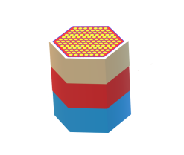  b
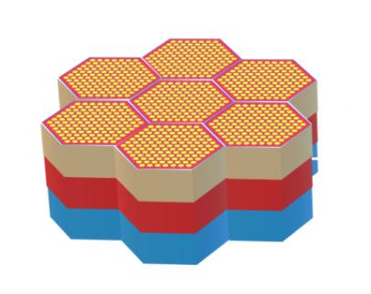  c | 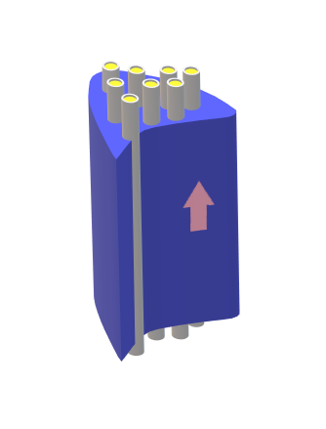  d

FIG 1. Level of core modeling: a. continuous medium; b. fuel assembly with reflection boundary condition; c.fuel load of the core; d.coupled calculation with thermo-hydraulics
Core assemblies based on the designs of developed and existing reactors can be described with several basic types:
- fuel assemblies with different enrichment and reloading rates (see FIG 2a.);
- blanket fuel-breeding area (see FIG 2a.);
- bundle assembly of regulation / compensation of reactivity in a submerged state and a sodium channel with a sleeve in a withdrawn one (see FIG 2b., FIG 2c.);
- bundle assembly of emergency protection in a submerged state and a sodium channel with a sleeve removed (see FIG 2b., FIG 2c.);
- steel / boron shielding assemblies to reduce radiation exposure on non-reactor devices and instrument channels (see FIG 2d.).
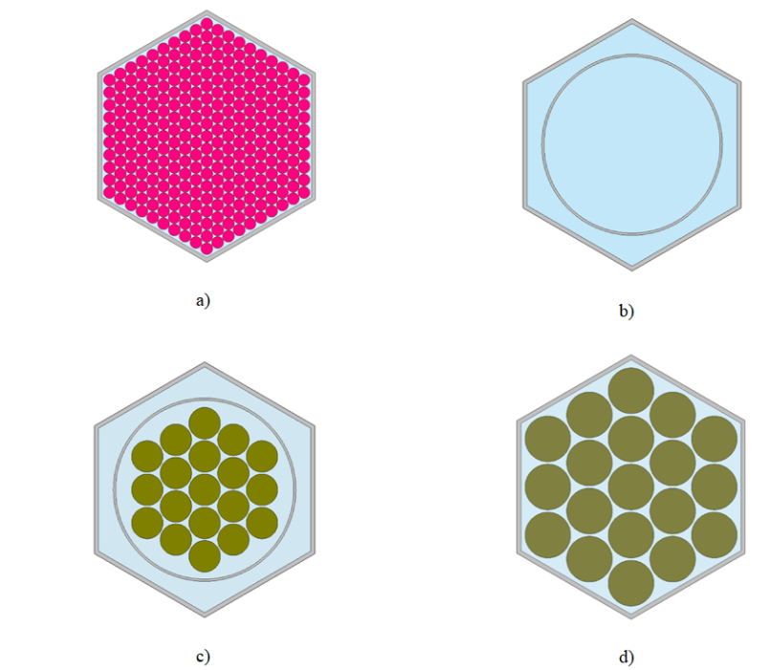
FIG 2. Radial cross section of the assembly a) fuel assembly/top blanket 10 pins per assembly grain; b) rod’s channel with sodium; c) control rod/scram; d) shielding assembly.

As a result of the calculation preformed on different simulation levels, one can come to the following conclusions:
- from the point of view of limiting the linear power heat the best option is core with a longest assemblies;
- from the point of view of obtaining the minimum SVW, the linear sizes of the assembly should be minimal, i.e. the large value of neutrons core leakage is assumed;.
- to provide the criticality of the core load it is necessary either to have the smallest leakage which followed by the largest core sizes or with the smaller sizes of the core to have the predominantly fraction of fissile nuclides;
- to achieve high BR (Breeding Ratio) the smallest leakage is required in order to use neutrons as efficiently as possible with the largest fraction of fertile nuclides.
The above considerations show that to obtaining the best parameters of geometry and nuclide composition are in conflict with each other. Therefore the result of research will only be a compromise option for these neutron-physical characteristics. With searching for optimal parameters to optimization problem [3] it becomes necessary to narrow the set of possible solutions using an iterative process both within one level and cycles involving two or more levels (SEE FIG 3).
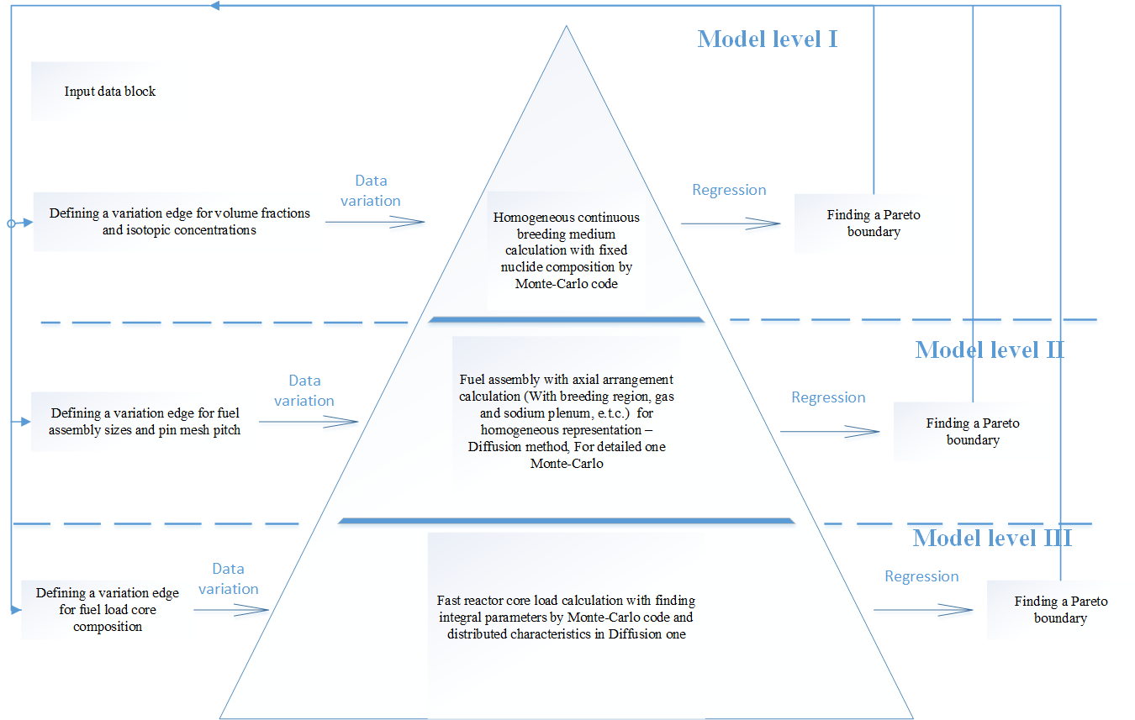
FIG 3. An iterative scheme of sequential three-level (three-stage) solutions to optimization problems using GDE3 algorithm [4]

The main purpose of the performed variant optimization calculations in this article is to find such a ratios for fuel and moderator compound to meet all safety and efficiency requirements.

NEUTRON PHYSICS ANALYSIS OF MODERATOR MATERIAL CHARACTERITICS IN THE FAST NEUTRON SPECTRUM
If we consider an oxygen influence on core with MOX fuel neutronics compare with metal fuel core we can see that the introduction of relatively light moderator nuclei into the medium of a fast reactor leads to decrease in the "hardness" of the neutron spectrum. On the one hand, this followed by to increase in temperature feedback and decrease in the magnitude of the SVW. On another hand, despite the breeding ability is higher on the softer spectrum increase in parasitic capture leads to the need to increase the enrichment in fissile isotopes which followed by to a greater extent reduces in the BR.
To determine the best moderator element based on model of a breeding medium with a metallic fuel, we will carry out a number of calculations with the addition of relatively light nuclei with an atomic weight of no more than for Zr and a concentration of 1: 1 with respect to U238.
In the practice of calculating thermal reactors is accepted the value ξϭs - the product of the mean logarithmic energy loss per collision on the scattering cross section, which is directly proportional to the moderating ability of the element [11].
Using Monte Carlo code in a model of an infinite homogeneous medium we defined for each of the light nuclei introduced into the composition of the breeding medium two analogous values: $R_{s}^{1→2}$ is the rate of the reaction of neutron withdrawal from the boundary ~ 1 MeV and $R_{с}^{}$ is the integral by energy rate of the reaction of neutron absorption on a given nuclide (see Table 1) per nucleus.
TABLE 1. Reaction-rate of interaction neutrons with additives nucleus in the breeding medium
№ | Nucleus | $$R_{s}^{1→2}$$ | $$R_{с}^{}$$ | № | Nucleus | $$R_{s}^{1→2}$$ | $$R_{с}^{}$$
1 | H | 4.3363(++) | 6.00E-03(--) | 12 | Si | 0.2843 | 6.17E-05
2 | O | 0.7143(+) | 6.95E-05(+) | 13 | P | 0.3373 | 2.49E-04
3 | Li | 0.5696 | 9.19E-03 | 14 | Cl | 0.2837 | 6.02E-04
4 | Be | 1.1218(+) | 6.49E-04(+-) | 15 | K | 0.1466 | 6.53E-04
5 | C | 0.6914(+-) | 1.21E-05(++) | 16 | Ca | 0.1413 | 5.11E-04
6 | B | 0.6127 | 4.63E-02 | 17 | Sc | 0.6266 | 6.59E-04
7 | N | 0.5440 | 1.66E-03 | 18 | Ti | 0.6284(+-) | 1.26E-05(+)
8 | F | 0.9959(+) | 1.34E-04(+) | 19 | Fe | 0.5793 | 1.03E-04
9 | Na | 0.5789 | 2.40E-04 | 20 | Cr | 0.6165 | 5.68E-05
10 | Mg | 0.5778(+-) | 4.60E-05(+) | 21 | Ni | 0.3932 | 4.40E-04
11 | Al | 0.4909 | 4.82E-05 | 22 | Zr | 0.5699 | 1.47E-04

Records in the table are marked with the symbols ++, +, + -, - depending on the quality of each element as a moderator in descending order. The quality depends, firstly, on how efficiently neutrons are removed beyond the 1 MeV threshold, since it was found that the largest contribution to the void effect is made by the reaction of neutron generation on fertile nuclides, secondly, from a smaller contribution to parasitic absorption. For example, as expected, the most effective moderator is hydrogen; however, significant absorption on this nuclide will lead to a critical decreasing in the breeding ability. The most appropriate values for such a consideration are for the elements O, F, Be, Mg, Ti, which is proved by the example of MOX fuel in comparison with metal.
The above considerations are qualitative assessment of element nuclei and do not take into account a very important quantitative one. For the MOX fuel the oxygen atoms content is 2 to 1 to fuel isotopes (UO₂). Therefore, when looking for a specific material as such a moderator it should meet a number of condition for a fast reactor:
- to have an acceptable melting point in order to work in the temperature ranges of sodium reactor;
- to have the highest density at minimum total molar mass, i.e. ensure the maximum nuclear concentration for the moderator element;
- (preferably) to have operating experience in reactor tests in general and in fast reactor installations in particular
In Table 2 is provides a list of such materials. BeO has the best performance in terms of nuclear concentration and this material also has the most experience in post-reactor testing [7].
TABLE 2. Physical properties of possibly moderator additive materials for fast reactor with metallic fuel
№ | Name | Density, g/cm3 | Molar mass, a.e.m | Thermal conductivity  Wt /(m*K) at 25°C | Melting point, °C | In reactor experience
1 | Berillium oxide/BeO | 3.01 | 25.01 | 285.0 | 2530 | presented
2 | Magnesium oxide/MgO | 3.58 | 40.30 | 42.0 | 2850 | presented
3 | Magnesium fluoride /MgF₂ | 3.13 | 62.31 | 11.6 | 1263 | no information is found
4 | Titanium oxide/TiO₂ | 4.05 | 79.87 | 5.0 | 1843 | no information is found

It should be noted that the materials mentioned have already been considered as a potential additive to the fuel assembly in other works [8,9], however, more qualitative characteristics were given in them. This paper provides quantitative estimates of the core loading parametres.

MULTIVARIATE OPTIMIZATION PROBLEM
Multivariate calculations were carried out for three materials of the moderator, for three types of heterogeneous arrangement (see FIG.4-FIG.6) of the moderator in the assembly, and for two compositions of plutonium - refined plutonium from thermal and fast reactors.
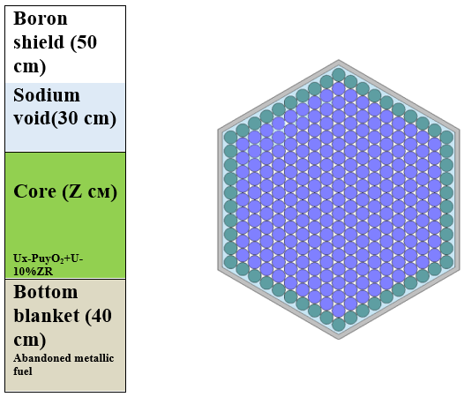
FIG 4. Heterogeneous layout of moderator in the peripheral pins of fuel assembly core
The moderator additives material is accepted based on the considerations of Table 2:
- beryllium oxide (BeO);
- magnesium oxide (MgO).

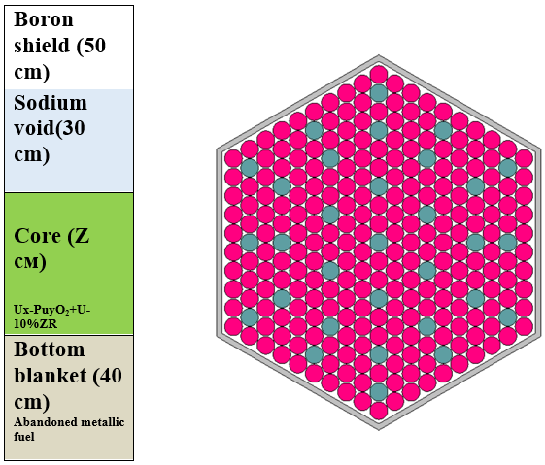
FIG 5. Hybrid layout of moderator symmetrically distributed in fuel assembly core cross-section

In addition to the searching of the moderator and the variant of its placement solutions are found for two types of the isotopic composition of plutonium: corresponding to the reprocessed fuel of thermal reactors separated from the one developed at facilities with a fast energy spectrum [10].
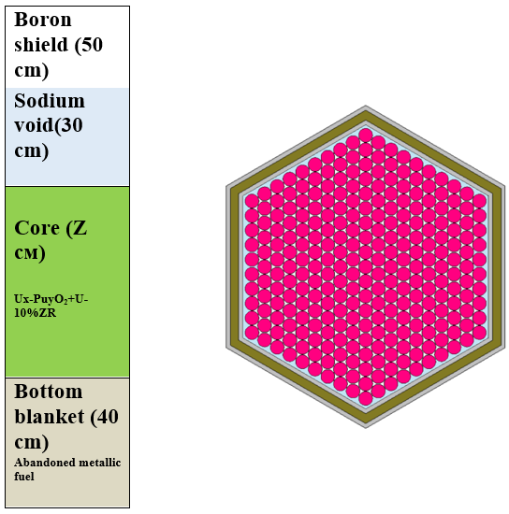
FIG 6. Hybrid layout of moderator placed in double steel case of fuel assembly
TABLE 4. List of input data for providing variant calculations with a hybrid core of a fuel assembly.
Name | Value
Power thermal /el. | 3000/1200
Fuel type | Ux-Puy-10%ZrМе;
Smear density, g/cm3 | 11.8
Core lifetime , duration in eff.days* frequency of reloads | 330*4/330*6
Inlet sodium temperature, С | 360
Temperature drop in core, С | 150

Calculation results discussion
To assess the neutronics characteristic obtained during the search for solutions comparison is made with the same results for a reference core loads [2] with MOX fuel and a similar loading with a metallic fuel, the characteristics of which are presented in Table 4. In the course of the solution the following optimal configurations of core loads with metallic fuel and a moderator were found (see Table 5).
TABLE 5. The optimized parameters of hybrid metallic core with moderator.
Name | №1(FIG 4) | №2(FIG 5) | №3(FIG 4) | №4(FIG 5)
Moderator/plutonium types | BeO/therm. | BeO/ therm. | BeO/fast | BeO/ fast
Number of fuel assemblies | 492 | 540 | 492 | 492
Assembly face-to-face width, cm | 19.4 | 19.4 | 19.4 | 19.4
Pins per assembly | 214 | 189 | 227 | 226
Height of fuel core part , cm | 100.0 | 110.0 | 100.0 | 90.0
Plutonium fraction ,wt % | 13.2 | 15.1 | 9.8 | 10.5
Fuel volume fraction | 0.389 | 0.334 | 0.414 | 0.412
Moderator volume fraction | 0.105 | 0.160 | 0.080 | 0.082
Name | №5(FIG 6) | №6(FIG 4) | №7(FIG 4)
Moderator/plutonium types | BeO/therm. | MgO/ therm. | MgO/fast
Number of fuel assemblies | 504 | 540 | 540
Assembly size, cm | external. 18.0  internal. 16.52 | 19.4 | 19.4
Pins per assembly | 217 | 190 | 200
Height of fuel core part , cm | 90.0 | 100.0 | 98.0
Plutonium fraction ,wt % | 10.2 | 14.6 | 12.0
Fuel volume fraction | 0.437 | 0.346 | 0.336
Moderator volume fraction | 0.03 | 0.148 | 0.140

At the same time for the parameters given in Table 5 the following values of the neutron-physical characteristics were obtained which are significant from the point of view of the possibility of implementing such a project (see Table 6).

TABLE 6. Neutron-physics characteristics for optimal parameters of the fuel core loading with metallic fuel and a moderator.

Name | Unit. | Reference | №1 | №2 | №3 | №4 | №5 | №6 | №7
BR |  | 1.50 | 1.30 | 1.21 | 1.34 | 1.34 | 1.42 | 1.29 | 1.2
Temperature reactivity effect(Doppler broad) | % ΔК/К | 2.03 | 3.60 | 5.50 | 2.30 | 3.00 | 3.60 | 5.50 | 3.30
Sodium void worth maximum value | % ΔК/К | 2.30 | 0.67 | 0.54 | 0.86 | 0.73 | 0.64 | 0.90 | 0.74
Reactivity burnup swing | % ΔК/К | 0.42 | 0.35 | 1.00 | 0.30 | 0.33 | 0.30 | 0.50 | 0.70
Linear heat power | kWt/m | 42.40 | 42.00 | 35.10 | 37.60 | 48.80 | 47.60 | 37.50 | 36.80

Analysis of the result of carried out optimization calculation parameters for a set of hybrid loads of metallic fuel with a moderator suggests the following:
- the introduction of a moderator into a fuel assembly makes it possible to improve the feedback indicators expressed in the Doppler effect by more than 50% in comparison with a homogeneous metal load, at the same time, to reduce almost 3 times compared to a metal load and by more than 70% the maximum SVW in comparison with homogeneous MOX core load;
- the introduction of a moderator makes it possible to reduce the reactivity swing to the same level comparable to the effective fraction of delayed neutrons;
- the introduction of a moderator reduces the breeding ratio of the core to the level of 1.0 ± 0.1, which, without additional breeding zones, allows the installation to operate within the fuel cycle in a self-sustaining mode or utilization of nuclear materials;
- the using of BeO as a moderator with different layouts and types of fuel in the assembly, on average, gives better results in terms of the above criteria, since less material is required to achieve the desired values;
- the using of magnesium compounds (MgO) as a moderator makes it possible to achieve acceptable results from the point of view of the criteria of optimization problems, their combination with plutonium refined product of thermal reactors, makes it possible to obtain the highest Doppler effect;
- no fundamental difference from the point of view of neutronic characteristics from the type of plutonium is revealed, the feedback indicators for the refurbished product of thermal reactors are better expressed in the magnitude of the Doppler effect;
- installations with fuel assemblies with all types of hybrid fuel can operate in the expanded breeding mode using a radial and bottom blanket.

Conclusion
The calculation results showed that the introduction of a moderator into the core with metallic fuel can improve the reactivity feedbacks while maintaining the advantages of loading with a high BR, such as a low value reactivity loss during fuel burnup. However, it should be noted that such an approach for implementation requires consideration of the following issues:
- handling with the irradiated moderator after its using in the reactor;
- full-fledged analysis requires dynamic, thermal-hydraulic and material science studies of presented core.
References
- Drobyshev I.I., Seleznev E.F. «Analysis of the Characteristics of the Fast Breeder Reactor with Metallic Fuel» Proceeding of International Conference on Fast Reactors and Related Fuel Cycles: Next Generation Nuclear Systems for Sustainable Development FR17 (Proc. Int. Conf., Yekaterinburg, 2017), IAEA, Vienna (2018),
- Kuznetsov A.E., Vasiliev B.A., Farakshin M.R. and etc. Selecting the layout for the hybrid core of the BN-800 reactor. Proceeding of International Conference on Fast Reactors and Related Fuel Cycles: Next Generation Nuclear Systems for Sustainable Development FR17 (Proc. Int. Conf., Yekaterinburg, 2017), IAEA, Vienna (2018), Paper CN245-406
- Boyd Stephen and Vandenberghe Lieven, “Convex Optimization”, Cambridge University Press, 2009, pp 716.
- Kukkonen and Lampinen J., “GDE3: The third evolution step ofgeneralized differential evolution,” inProc. IEEE Congress on Evol.Comput., (CEC 2005), 2005, vol. 1, pp. 443–450.
- Bell G. I. and Glasstone S., “Nuclear Reactor Theory,” Van Nostrand Reinhold Co., New York (1970).
- Romano Paul K. and Forget Benoit, “The OpenMC Monte Carlo Particle Transport Code”, Ann. Nucl. Energy, 51, 2013,pp. 274–281.
- Snead L. L. and Zinkle S. J. “Use of Beryllium and Beryllium Oxide in Space Reactors” Volume 746, Issue 1, AIP Conference Proceedings 746, 768 (2005)
- Waltar Alan E.,Todd Donald R., Tsvetkov Pavel V. FAST SPECTRUM REACTORS, Springer.2012, 720 p.
- Kim T.K., Yang W.S., Grandy C., Hill R.N. “Core design studies for a 1000 MWth advanced burner reactor”, Annals of Nuclear Energy, 2009, 8p.
- Troyanov M.F., Ilyunin V.G, Matveev V.I., Shmelev A.N. Fast reactors with axial position of oxide and metal fuels in the core//SovietAtomicEnergy 49(5), 1980.

