# An e-learning tool on Fast Reactors and their

# Fuel Cycles

N. J. BARRON

National Nuclear Laboratory Limited,

Central Laboratory, Sellafield, UK

Email: nicholas.barron@uknnl.com

A. González-Espartero

International Atomic Energy Agency

Vienna, Austria

V. Kriventsev

International Atomic Energy Agency

Vienna, Austria

R. LINDSEY-HALLS

Nucleargraduates,

Lillyhall, Cumbria, UK

A. AHMED

National Nuclear Laboratory Limited,

Central Laboratory, Sellafield, Cumbria, UK

M. MOORE

National Nuclear Laboratory Limited,

Central Laboratory, Sellafield, Cumbria, UK

A. CONSTANTIN

International Atomic Energy Agency

Vienna, Austria

J. MAHANES

International Atomic Energy Agency

Vienna, Austria

M. Zeman

International Atomic Energy Agency

Vienna, Austria

**Abstract**

The United Kingdom (UK) was one of the countries that pioneered fast reactor development and demonstration with the construction and operation of two fast neutron spectrum reactors; these demonstrated sustainable fuel cycles and were supported by multiple co-located facilities that included zero-power and thermal hydraulic facilities. Since the end of the UK Fast Reactor Programme in 1994, much of the knowledge acquired has not been passed onto the next generation. To address this, the National Nuclear Laboratory (NNL), are leading on the Advanced Fuel Cycle Programme, which aims to support the development of the next generation of technical experts. One approach to enable this, is the development of modern and interactive e-learning modules. These resources are being developed as part of the NNL-IAEA Collaborating Centre on the Advanced Fuel Cycle. Through the Centre, the IAEA, NNL and partners will collaborate on several topics relating to the development of advanced fuels and fuel cycles required for the reactors of the future. The collaboration will place particular emphasis on the exchange of technical expertise between the UK, IAEA and Member State representatives. To benefit the global nuclear sector in developing the next generation of experts the modules developed will be hosted by IAEA and freely available to all member states. The paper details the proposed approach to develop the e-learning modules, focusing on the modular nature to enable the incorporation of further topics as they are produced. This is followed by an overview of the content, and the interactive nature. In summary, this paper provides an overview as to the need for training material to support the development of the next generation of fast reactor experts, utilizing advances in online learning to deliver a shared resource that supports the global development of future fast reactor experts in a timely and costly endeavor.

## INTRODUCTION

One of the most significant challenges of our lifetime is mitigating the worst impacts of climate change which will require rapid and global decarbonisation of all forms of energy. This will require an international response that builds upon past endeavours, such as the 2016 Paris Agreement [1], to the recent national commitments to reach Net Zero greenhouse gas emissions that are either being considered or implemented by more than 130 countries globally [2]. The decarbonisation challenge is further complicated by the more than 1 billion individuals worldwide that are thought to not currently have access to electricity. Access to clean and affordable energy is highlighted in the UN Sustainable Development Goals [2]. To avert a climate crisis will require a diverse energy mix and nuclear power is the only mature and proven low carbon technology that can be deployed at scale to deliver access to clean energy. This assertion is based on the ability of nuclear power to avoid the release of carbon emissions, for example, between 1970 and 2015 electricity produced using the global reactor fleet prevented more than 60 billion tonnes of emissions that would otherwise have been released [3]. Independently, the need for, and the fundamental role nuclear is expected to play during a transition to Net Zero was noted through modelling by the International Energy Agency (IEA) [4].

Historically, nuclear reactors have primarily provided access to low-carbon baseload electricity. Advanced reactors with high (i.e. >500°C) coolant outlet temperatures have a greater potential to decarbonise hard to abate sectors through the provision of process heat across industrial and domestic applications; while those with the ability to load follow offer greater integration with renewables. The IEA modelling notes nuclear playing a potential role in co-generation to support the transition to a Net Zero energy system with an increase in reactor deployment. Such an increase will lead to additional challenges being placed on the supply of uranium, essential for their operation. Based on current projections, reactor-related uranium requirements are projected to almost double between 2018 and 2040 and while sufficient uranium resources are currently thought to exist to support continued use and growth of nuclear power, for this to continue into the long-term it will require “*considerable exploration, innovative techniques and timely investment will be required to turn these resources into refined uranium ready for nuclear fuel production and to facilitate the deployment of promising nuclear technologies*” [5]. An increase in reactor deployment will also place additional demands on the back-end of the fuel cycle, with increasing volumes of spent fuel to store and ultimately dispose of in a suitable facility, which has yet to begin operating anyway in the world. As such, fast neutron spectrum reactors that utilise sustainable fuel cycles offer an opportunity to decarbonise power generation, through (traditional) electricity production or the provision of process heat as well as a route to reduce the demands on the environment through mining of new fuel and minimising the volume of spent nuclear fuel. To realise these opportunities will require a significant increase in infrastructure including reactors and fuel cycle facilities, but equally important the availability of a highly skilled, knowledge and capable workforce to initially design and build, prior to operating these facilities.

### Global skills shortage

A survey conducted by the Global Energy Talent Index (GETI) in 2019 found that 37% of nuclear professionals believe that a ‘talent crisis’ has already hit the sector [6]. The survey reported that (nuclear) engineers whilst having transferrable skills are missing the direct nuclear knowledge that is hindering their recruitment. A similar need has been noted at national levels, for example, the (UK) Nuclear Skills Strategy Group’s 2019 Nuclear Workforce Assessment estimated that the UK nuclear sector requires at least 35,000 to 40,000 full time employees by 2030 [7]. The challenge of recruitment is further compounded by a lack of awareness of the low carbon nature of nuclear. This is exemplified by a 2019 poll by the UK Institution of Mechanical Engineers that found that only 26% of 18 to 24 year old understand that nuclear energy is low carbon, compared with 76% who are aware that wind and solar are [8]. In comparison 61% of those aged between 65 and 74 years old knew that nuclear power was low carbon.

### Impact of Fast Reactor development

The hey-day of fast reactor research could be considered to have been the period between the mid-1950s and mid-1990s with significant nationally funded fast reactor R&D programmes that led to their development and deployment across the globe. The primary focus of the research was light metals fast reactors, i.e. sodium or sodium-potassium cooled systems, culminating in the operation of experimental, prototype and commercial-scale systems across the globe, including the UK [9]. However, of the multiple fast reactors that were built, the majority have now been closed down and are undergoing decommissioning (Figure 1) leading to a loss of the skills and knowledge associated with their design and operation. This also includes the support facilities necessary to operate such reactors. Notable exceptions to this are China, India and Russia.

Figure 1: Summary of selected Fast Reactor Operations (grouped into 5-year periods) based on [10]

The UK experience is a perfect example of this, with the (UK) Fast Reactor Programme running between the 1950s and 1994 and involving the construction and operation of the Dounreay Fast Reactor (DFR) 1955-1977 and the Prototype Fast Reactor (PFR) 1974-1994 [11], [12]. Throughout the UK Fast Reactor Programme a significant amount of ground-breaking research and skills development took place that was shared with international partners. Yet the near-generational gap since the Programme closed down, and the speed at which it was ended meant that recent efforts to capture this potentially globally unique repository of knowledge, experience and skills has been challenging. The UK is unlikely to be the only nation facing these challenges as the gap since the construction or operation of a fast reactor grows in many nations.

### 1.3 E-learning

One way to help meet the skills gap and preserve existing knowledge, whilst fostering an interest in nuclear as a future career in younger generations is through the provision of suitable educational resources. Alternatives include summer placements, vocational training, and short research opportunities however these might not necessarily be widely accessible, or convenient for those with existing commitments, so will not contribute greatly to increasing diversity within the sector. Therefore, it is essential that accessible, free, and comprehensive online learning resources are developed to begin to increase the interest of early career professionals in nuclear energy.

At the time of writing, very little, if any, online content exists that explain Fast Reactors and that is aimed at early career professionals, or those new to the topic. The information that is available is either inaccessible or difficult to find. In contrast, a significant volume of research exists on Fast Reactors, however it is aimed at those who already understand the fundamentals of the technology and are developing into subject matter experts. In comparison, various online resources exist for those across the career and knowledge level that provide information on thermal reactors, and such systems are the primary focus in most educational institutions.

## 2. Developing a Fast Reactor e-learning

### 2.1 Existing IAEA e-learning resources

To support member states with the retention and development of domestic skills, the International Atomic Energy Agency (IAEA) hosts a range of electronic-learning (e-learning) modules freely accessible for registered users in Member States. A recent example of this is the ‘Spent Fuel and Radioactive Waste Management, Decommissioning and Environmental Remediation’ e-learning on the Nucleus website (Figure 2) [13]. These are the culmination of years of work by the IAEA and associated nuclear specialists. The target audience for the modules are students, early career professionals or governmental advisors who require a working knowledge of the topic. The website reinforces these aims, stating that ‘*both newcomers and those expanding their nuclear power programmes may benefit from the e-learning series*’ [13]. The e-learning modules developed to date are interactive in nature and involve assessments as part of the course to benefit from the developing “gamification” drive, as well as meet the needs of individuals to demonstrate continued professional/personal development.

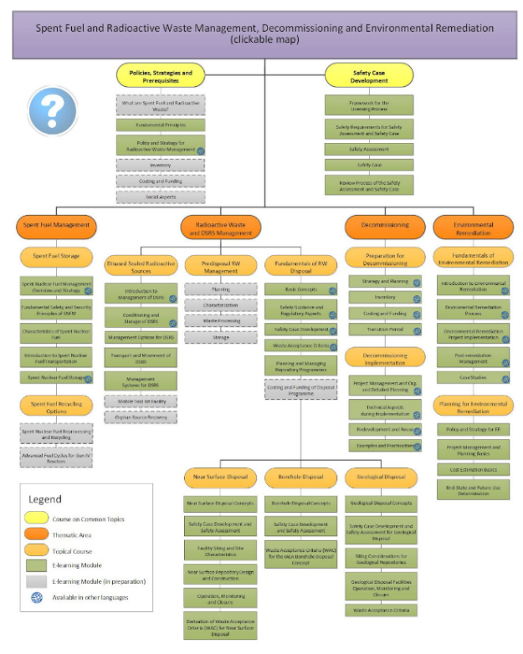To best explain the structure of the wider ‘Spent Fuel and Radioactive Waste Management, Decommissioning and Environmental Remediation’ e-learning it is best focus down onto one of the 4 main topic areas of: Spent Fuel Management, Radioactive Waste Management, Decommissioning and Environmental Remediation. This paper will briefly focus in on the ‘Spent Fuel Management’ topic which consists of seven modules of which five have been finalised. These five modules formed the IAEA on-Line Course on Spent Fuel Storage (Figure 2). The first of which contains a general overview of the fuel cycle and the main factors that drive its selection by a given country. The general overview creates significant value by enabling those who are new to the sector to complete the e-learning gaining a fundamental baseline understanding. For those with some experience or familiarity with spent fuel management, it provides a refresher of the key terminology and the basic knowledge. The subsequent four modules cover different aspects of spent fuel management such as fundamentals of safety and security that is fully covered by the IAEA Nuclear Safety and Security Department e-Learning materials, spent fuel characteristics, how to establish a spent fuel transportation system, and what are the options for storing spent fuel and how a spent fuel storage facility is designed and maintained to meet the fundamental safety objective. Each on-line lecture takes approximately 60 minutes to listen to the full narration, with the lectures being interactive, with animations and small activities throughout and self-assessment quizzes at the end of each lecture. Upon completion of the five modules, one can go through the Quizzes to get the IAEA Certificate of Completion where the e-Learning Objectives are indicated to give an idea of the scope of the course and the covered topics.

Figure 2: Topic map of the Spent Fuel and Radioactive Waste Management, Decommissioning and Environmental Remediation e-learning [13].

To complement this material, the IAEA through its direct work and with partners, such as through Collaborating Centres, are covering the development of additional topics that will be converted into e-learning modules. This resonates with the UK National Nuclear Laboratory (NNL) aspiration to develop content to support the next generation of Fast Reactor research scientists and engineers to avert the looming skills crisis. Development of suitable content, with the involvement of current subject matter experts can preserve and disseminate existing knowledge and in the UK’s case, provide an output for the Fast Reactor Knowledge Capture activities that began in 2019 [14].

### 2.2 Fast Reactor e-learning approach

The strategy followed for the development of fast reactor e-learning modules was based on the IAEAs previous experience of developing e-learning content. First and foremost, amongst this is that the e-learning modules must be modular in nature. This enables the future addition of further content or updating of information based on developments over time, without the need to replace or review all the information in one go. The modular approach also supports the convenient linking to additional modules as they are either developed and allows the “ad-hoc” design for specific courses. Finally, it enables the individuals completing the course to be able to fit the course in around existing work-based commitments, as each lecture should take no more than one hour to complete, including the self-assessments.

The relatively complex features of fast reactors and their related fuel cycles necessitates that the e-learning modules must address a number of key learning objectives, these include:

* **What is a Fast Reactor?** Discussing key features of fast reactors in common terms, and the key differences with thermal reactors. It was realised that without an understanding of what a fast reactor is, it would not be possible to discuss fast reactor fuel cycles and the potential benefits such systems offer.
* **History of Fast Reactor Development.** An overview of the global development history of fast reactors.
* **Fast Reactor Fuel Cycles.** An explanation of fuel cycles and what is meant by closed, sustainable fuel cycles and how they compare to open fuel cycles. The summary includes an overview of what has previously been demonstrated and future options under consideration.
* **Benefits and Challenges of Fast Reactors Use.** How and why fast reactors might feature in a future energy system as well as key remaining obstacles to their deployment.

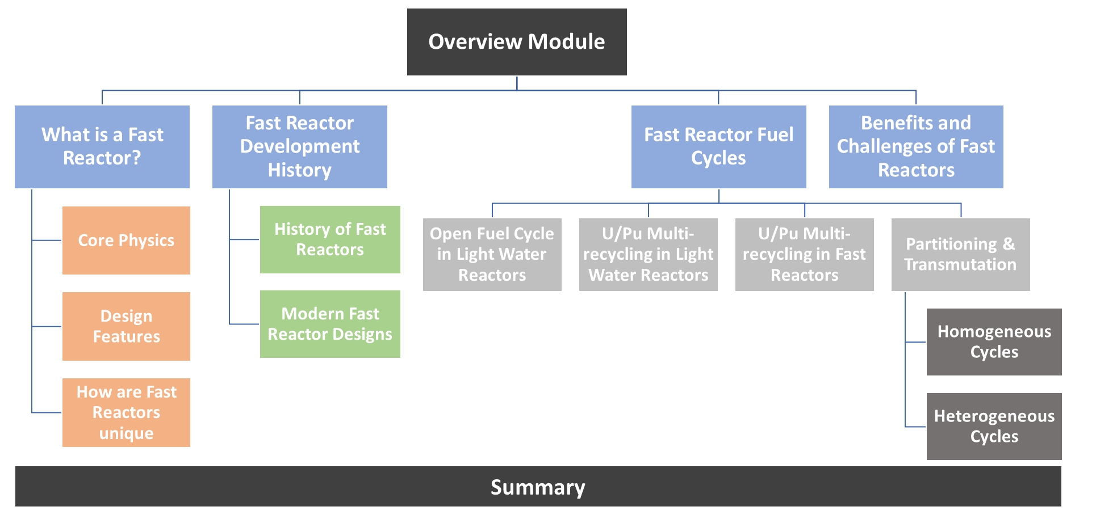The Fast Reactor and their Fuel Cycle learning map has three tiers of modules (Figure 3). Featuring an overview module that is the focus of the work discussed in this paper. Implementing the learning from experience from the IAEA, the overview module provides a high-level summary of the four key learning objects previously introduced and will be further discussed shortly. The tier one modules are focused overviews that provide an explanation at a greater level of detail of the key learning objectives. For example, this includes discussing in-reactor features and the impacts of coolant on fast reactor technology and how this compares with thermal reactors, as well as doppler broadening (in What is a Fast Reactor). The other tier one modules follow a similar approach of explaining key concepts and for the Fuel Cycle topic, linking out to other IAEA modules.

Figure 3. *The potential ‘Map’ for the Fast Reactor e-learning module, depicting the four main topics covered (blue) and key aspects within these (orange, green, and shades of grey)*

### 2.3 Overview module features in detail

As previously mentioned, the overview module will act as a refresher for those with some familiarity to the topic, as well as provide a fundamental understanding of the topic for those new to the area. Its production has been the focus of the work to-date. This module provides an overview of the key aspects of fast reactors and their fuel cycles, whilst giving a baseline of knowledge that is essential in understanding this and subsequent modules. Such advanced and sustainable fuel cycles are the focus of the IAEA-NNL Collaborating Centre on Advanced Fuel Cycles (reference the NNL-IAEA announcement) which led to the joint project to develop the e-learning.

A key source of information for the Fast Reactor and their Fuel Cycles overview module was developed and delivered by Professor Massimo Salvatores at the Joint ICTP-IAEA Workshop on Physics and Technology, specifically the ‘Global Scenario for Nuclear Energy and Future of Innovative Nuclear Energy Systems’ [15] and ‘Fuel Cycle Options for Innovative Nuclear Energy Systems’ workshops [16]. It is important to highlight at this point that this module has been developed in recognition of the contribution he made to and is dedication in his memory to continue to inspire future generations of nuclear researchers.

The overview module contains four sections. The first, having the working title of ‘What is a Fast Reactor?’ aims to provide a comprehensive background covering the differences between a thermal and a fast reactor (including the advantages and disadvantages), the features of a fast reactor (core neutronics, capture cross-sections, fissile material of fuel required, coolant characteristics, safety features, reactor concepts (breeder and burner reactors) and proliferation), and an explanation of common terms – this also ensures that any misunderstandings due to different educational backgrounds will be minimised. This introductory section provides an unexperienced user with a solid foundation, enabling them to complete the rest of the module, whereas more experienced individuals can pass through the overview at a quicker pace. It includes an optional summary and quiz at the end, if a score above a threshold is achieved then a certificate will be issued that can be used for either continuing professional development (CPD) or to contribute to an individual’s personal development record (PDR).

The second section of the overview module provides a short development history of fast reactors worldwide. The primary feature is an interactive historic timeline detailing operational fast reactors worldwide. For each fast reactor included in this timeline, a pop-up has been developed that contains a brief overview and key facility milestones. This section also links out to external resources that provide additional information on current and future fast reactor designs, including the Advanced Reactor Information System (ARIS), a database maintained by the IAEA, that contains information about advanced fast reactors [17].

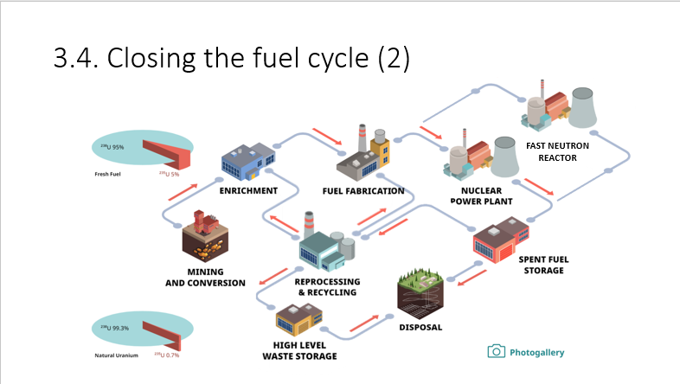The third section of the Fast Reactor and their Fuel Cycles module encompasses approximately half to two thirds of the total time of the module content due to the significant role of the module. The content starts by explaining what is a fuel cycle, and what the key differences are between open and closed fuel cycles and how certain features (reactors) are needed to realise. This is explained as an overview of the key steps that are required to realise Fast Reactor Fuel Cycles across fuel manufacture and opportunities for the reprocessing of spent nuclear fuel to minimise waste. The interactive nature of the e-learning is exemplified for the nuclear fuel cycle with pop ups that provide an introduction to all aspects of the fuel cycle, and the links to a more detailed explanation on each stage.

Figure 4: An overview of the nuclear fuel cycle. Advanced steps of the fuel cycle are shown in green. Adapted from [18]

This module also covers reasons why fast reactors may be deployed, including the sustainable fuel cycle and waste managements (through the use of ‘burner reactors’) opportunities as well as the benefits offered by the high coolant outlet temperatures (relative to water-cooled reactors) and the decarbonisation benefits this provides. A key component of this section will be the availability and managing of nuclear resources, through the development of future waste management processes such as partitioning and transmutation. Links to other IAEA publications, such as the ‘Red Book’ also provide content for fast reactor deployment, identifying the amount of conventional and unconventional uranium resources to 2040 [19]. This is a key and challenging topic as the fast reactors can operate in breeders modes to either produce the amount of fissile material that they use, or depending on core design to start more reactors. This will delay the exhaustion of accessible uranium resources, but does raise potential proliferation concerns that are highlighted in a factual manner. This module will then end with an optional quiz, upon achieving a threshold score a certificate is awarded.

The development of the module content was primarily conducted by early careers at the NNL and by individuals from IAEA member states that were on secondment at the IAEA, in the Fast Reactors and Fuel Cycle areas. This provided an up-skilling and development opportunity for the early-career individuals, providing an opportunity to engage with colleagues at a similar stage in their careers. Following compilation of the module content, the material was initially reviewed by more experience technical experts in the IAEA and NNL. A final technical review process has been undertaken which involved an assessment and comments being sought from individuals previously involved in the UK Fast Reactor Programme, and who have taught lecture courses on nuclear technology. Following this review, an external multimedia company was contracted to convert the developed material from images and text on PowerPoint slides into a draft e-learning format prior to a final review and module launch.

## Future modules

Beyond the initial e-learning module on ‘Fast Reactors and their Fuel Cycles’, future e-learning modules are planned, as part of a structured and tiered approach that was previously introduced in this paper (Figure 3). This includes following a “top-down approach” where the complexity of the content will increase over time and with each module. This also supports the development of priority topics to meet the development needs of users as they develop over time.

Future modules under consideration are those to explain and contextualise what fast reactors are, detailed sections explaining fast reactor core physics, reactor features and technology, challenges of fast reactor coolants (compared to water-coolants) including thermal hydraulics and fast reactor safety are under consideration. The fast reactor development module will cover the history, and the current national programmes, where it has resulted in a reactor being built, up to the year 2020. The different advanced fuels’ manufacture will be covered in a separate IAEA project under development and will be linked here as needed. An opportunity exists to incorporate information ARIS on advanced reactors under development, potential offering an engagement mechanism to incorporate R&D updates from commercial organisations developing concepts or multinational organisations.

## Conclusion

This Fast Reactor module, alongside the existing and planned modules available on the IAEA website provides an invaluable resource for early career professionals and those new to the nuclear sector or concept of fast reactors. In addition, provides an excellent high-level introduction to government individuals who lack a technical background, and for anyone who wants to learn more about the nuclear industry and role it can play in the decarbonisation agenda. The ‘Fast Reactor and their Fuel Cycle’ module, and the others planned to follow, provide a comprehensive and easily accessible bank of information that is currently missing. Free access to individuals in IAEA members states, across academia, national laboratories, government or the general public will support the development of future generations of students, researchers, operators, and policy makers worldwide.

Providing accessible, free information in a flexible learning format will also increase the diversity of those who can utilise this resource, and the inclusivity of the sector. Enabling individuals to study and complete the modules when it is convenient to them. Enabling easier access to knowledge about Fast Reactors and their Fuel Cycles, supports the development and maintenance of a positive global attitude towards nuclear energy and the role advanced nuclear, in particular fast reactors, can play. Having access to a highly skilled and knowledgeable workforce will support the development and deployment of such advanced systems, through delivery to time and cost - key barriers to nuclear deployment in nations.

ACKNOWLEDGEMENTS

This research was funded under the £46m Advanced Fuel Cycle Programme as part of the Department for Business, Energy and Industrial Strategy’s (BEIS) £505m Energy Innovation Programme.

References

[1] United Nations Climate Change, The Paris Agreement, <https://unfccc.int/process-and-meetings/the-paris-agreement/the-paris-agreement>

[2] Nuclear Power for Sustainable Development, 19913IAEA Brochure, IAEA, Austria, Vienna (2017), <https://sustainabledevelopment.un.org/content/documents/19913IAEA_Brochure_NP_for_Sustainable_Development.pdf>

[3] Nuclear Power and the Paris Agreement, Brochure, IAEA, Austria, Vienna (2016), <https://www.iaea.org/sites/default/files/16/11/np-parisagreement.pdf>

[4] World Nuclear News, Nuclear 'vital' to Sustainable Development Goals (2016), <https://world-nuclear-news.org/Articles/Nuclear-vital-to-Sustainable-Development-Goals>

[5] Uranium 2020: Resources, Production and Demand, NEA No. 7551, NEA, IAEA, France (2020).

[6] The Global Energy Talent Index Report 2019, <https://www.getireport.com/reports/2019/>

[7] Nuclear Workforce Assessment 2019, Nuclear Skills Strategy Group, UK (2019), <https://www.niauk.org/wp-content/uploads/2019/12/nssg-nuclear-workforce-assessment-summary19_web.pdf>

[8] Murray J, Young people have a low understanding of nuclear power, poll finds (2020), <https://www.nsenergybusiness.com/news/nuclear-power-young-people/>

[9] Kittel, J.H., Frost, B. R. T., Mustelier, J. P., Bagley, K. Q., Crittenden, G. C., and van Dievoet, J., “History of fast reactor fuel development,” Journal of Nuclear Materials, **vol. 204**, (1993) pp. 1-13.

[10] IAEA, Status of Fast Reactor Research and Technology Development, IAEA-TECDOC-1691, Austria, Vienna (2012).

[11] Pioro, I.L, Handbook of Generation IV Nuclear Reactors, Woodhead Publishing, Duxford, UK (2016).

[12] World Nuclear Association, Nuclear Development in the United Kingdom (2016), <https://www.world-nuclear.org/information-library/country-profiles/countries-t-z/appendices/nuclear-development-in-the-united-kingdom.aspx>

[13] IAEA Learning Management System, Spent Fuel and Radioactive Waste Management, Decommissioning and Environmental Remediation (clickable map), <https://elearning.iaea.org/m2/course/index.php?categoryid=60>

[14] Barron, N.J., ‘Fast Reactor Knowledge Capture’, in Nuclear Innovation UK Conference, Sheffield, UK (2019).

[15] SALVATORES M, Global Scenario for Nuclear Energy and Future of Innovative NES (2018), <https://www.youtube.com/watch?v=B8blOrYA1PM&list=PL6S8U84PCLB3z6ai_39pgjqQF17OP3Ujq&index=3>

[16] SALVATORES M, Fuel Cycle options for Innovative Nuclear Energy Systems (2018), <https://www.youtube.com/watch?v=WixJ7hpKMk&list=PL6S8U84PCLB3z6ai_39pgjqQF17OP3Ujq&index=7>

[17] IAEA, ARIS Advanced Reactors Information System, <https://aris.iaea.org/>

[18] IAEA Learning Management System, Spent Nuclear Fuel Management Overview and Strategy, <https://elearning.iaea.org/m2/mod/scorm/view.php?id=11131>

[19] Nuclear Engineering International, Red Book says identified uranium resources are enough for 135 years (2021), <https://www.neimagazine.com/news/newsred-book-says-identified-uranium-resources-are-enough-for-135-years-8442410/>