TECHNICAL AND ECONOMICAL FEATURES OF
COMMERCIAL SODIUM FAST REACTOR IN FRANCE

David SETTIMO
Electricité de France (EDF) - FRANCE
Email: david.settimo@edf.fr

Rémy DUPRAZ
Framatome - FRANCE
Email: remy.dupraz@framatome.com

Nicole FORTUNET
Commissariat à l’Energie Atomique et aux Energies Alternatives (CEA) - FRANCE
Email: nicole.fortunet@cea.fr

Abstract

The paper aims to present a study conducted by the engineering departments of EDF, Framatome and CEA in order to define a functional description and a sketch of the commercial industrial French Sodium Fast Reactor 1000 eMW.
This pre-conceptual design study has been carried out with the benefits of ASTRID project, which conducted the basic design of an industrial Generation IV Sodium Fast Reactor (SFR) demonstrator.
The presentation includes:
- Technical requirements of Commercial SFR 1000 eMW.
- Plant description, technical features with an underlining of what is transposed (or not) from ASTRID design.
In a second part of the paper, we present an economical comparison of a commercial SFR in France and an equivalent PWR, based on the evaluation of investment cost of the SFR 1000 and of a commercial European Pressurized Reactor (EPR).
Finally, we examine some technical proposals to reduce the cost of the commercial SFR, given with the needs of R&D or design assessment to be performed.

INTRODUCTION
The French nuclear policy for closed fuel cycle provides the deployment of Sodium Fast Reactors (SFRs) at the end of the 21st century. The deployment of this technology aims to balance the spent PWR MOX fuel inventory and to use the recycled Uranium reprocessed from UOX or MOX spent fuel. Fast reactors can use the plutonium produced by Light Water Reactor (or by themselves) indefinitely, so they represent a key link in the closed-cycle strategy.
For the balancing of the PWR MOX inventory in France, around 2000 eMW of SFRs are necessary, in a predominantly PWR fleet, with a total nuclear power (PWR + SFR) of 50 to 60 GW in the energy mix. So, two 1000 eMW SFR reactors would constitute a first step towards the closed fuel cycle (ref. [8]).
The paper aims to present a study conducted by the engineering departments of Electricité de France (EDF), of Commissariat à l’Energie Atomique et aux Energies Alternatives (CEA) and Framatome to define a functional description and a sketch of the commercial French SFR 1000. This pre-conceptual design study has been carried out with the benefits of ASTRID project, which conducted the basic design of an industrial Generation IV SFR demonstrator in France between 2009 and 2019 (ref. [3]). ASTRID is a 600 eMW Generation IV SFR designed by CEA and its industrial partners (among them, EDF and Framatome).
The presentation includes:
- Technical requirements of Commercial SFR 1000.
- Plant description, technical features with an underlining of what is transposed (or not) from ASTRID design.
In a second part of the paper, we present an economical comparison of a commercial SFR in France and an equivalent PWR, based on the evaluation of investment cost of the SFR 1000 and of a commercial European Pressurized Reactor (EPR).
Finally, we examine some technical proposals to reduce the cost of the commercial SFR, given with the needs of R&D or design assessment to be performed.

DEFINITION OF A FRENCH INDUSTRIAL SODIUM FAST REACTOR
From 2017 to 2018, a French working group composed by EDF, CEA and Framatome has produced an expression of needs in R&D necessary for the design and operation of future commercial SFR. The group has produced both a specification and a first sketch of the SFR reactor to be introduced into the French nuclear fleet in the second half of the 21st century, the power of 1000 eMW had been determined by industrial scenario studies for the closure of the French fuel cycle (ref.[8]).
This working group mobilized some 30 engineers from EDF, CEA and Framatome, all involved in the CEA's ASTRID program, who brought their expertise in the search for a reactor optimized in terms of compactness, cost and responding to objectives for industrial implementation of the recycling of valuable materials from the MOX PWR fuel cycle.

Fuel cycle requirements
Recycling plutonium and uranium from spent fuel both saves natural uranium and produces less bulky and less toxic ultimate waste. The multi-recycling of Pu in PWR is difficult, due to the degradation of its isotopic quality. With fast neutrons allowing better use of Pu, the introduction of SFR in the nuclear fleet is the preferred way to use the Pu contained in MOX fuels and to multi-recycle valuable materials.
Before reaching a state of independence from natural uranium and a complete closed fuel, it has been chosen to go through intermediate levels, each of which met a particular technical objective.
- Stage A corresponds to the current French situation and the continuation of single-recycling in PWR (MOX and ERU); inventory of PWR MOX and stored Pu spent fuel is increasing,
- Stage B is the implementation of the recycling of used MOX in a few SFRs, allowing the stabilization of the storage of used PWR MOX fuel,
- Stage C sees the implementation of the multi-recycling of Pu from spent fuels PWR and SFR, resulting in the stabilization of the inventory in Pu,
- Finally, the final Stage D corresponds to the energy independence from natural uranium, thanks to a 100% SFR or symbiotic fleet between SFR and PWR using MOX.

Safety requirements
Since their first unit, the commercial SFRs will be reactors complying the Generation IV (GEN IV) targets. These objectives defined by the GEN IV Forum (GIF) lead to the search for systems concepts (reactor - associated fuel cycle):
- Sustainable,
- Economical performant,
- Safe and reliable,
- Proliferation-resistant and protected from malevolence.

For the design of the commercial SFR to be classified as "safe and reliable", it will have to include:
- A very low probability of generalized core melting and the elimination of the use of emergency countermeasures outside the site not limited in space and time,
- Considering the lessons of Fukushima accident.
Targets (radiological releases, probability of core melting) for GEN III reactors are already ambitious and can be considered as benchmarks in terms of nuclear safety. The safety gain provided by the GEN IV will be an improvement in the robustness of the safety demonstration. For example, greater diversification of safety provisions (with the implementation of passive systems) improves this robustness, in return for a less operating experience feedback from the SFR than from the PWR GEN II and III.
The GIF has issued the Safety Design Criteria, which is currently being available in Safety Design Guidelines (ref. [1]).
The safety level of the different types of reactors commissioned in the 21st century should be considered equivalent between technologies. However, comparing the safety level of two types of reactors as different as the SFR and the GEN III PWR (EPR for example) is difficult. The ambitious objectives of safety that meet the best standards are therefore considered at the reactor sketch stage:
- Probabilistic targets: the estimated frequency of generalized core melting should be less than 10⁻⁵ per year per reactor considering internal hazards and internal and external aggressions (excluding acts of malevolence).
- Limitation of releases in case of severe accident: releases will have to be very low, no need for off-site emergency measures.
- In response to extreme natural aggressions, the design of the plant will incorporate sufficient margins beyond the reference design to prevent cliff edge effects in terms of off-site radiological consequences.
- Considering feedback experience is essential, particularly in terms of major incidents and accidents, in terms of lessons learned by the nuclear industry or more specifically the SFR sector. It includes especially:
  - Fukushima accident,
  - Extreme natural external hazards,
  - Situations resulting from prolonged loss of external electrical supply and heat sink which must not lead to any risk of early or massive radioactive release,
  - Risk of reactivity transients.

As the core of a SFR is not always in its maximum reactive configuration, it is necessary to analyze the risk of variations in reactivity on the international and French operating experience and to integrate lessons learned from the incidents. Particularly, Phenix automatic shutdowns due to negative reactivity transients.
Scenarios leading to generalized core melting will be prevented, using and strengthening the characteristics of SFR that are favorable, such as some neutron reaction effects, the margin of sodium from boiling and the ability to remove the decay heat and cool the reactor in natural convection. In particular, the void effect must be compensated naturally by the other favorable effects occurring within the same time frame in order to avoid a power excursion (primary excursion) in a severe accident.
The conservation of the primary fluid inventory should be guaranteed in all circumstances, with prevention means (independent primary and safety vessels, leak tightness of the reactor pit...) and mitigation means.
The justification for the practical elimination of severe events will use a deterministic approach, supported by probabilistic assessments, and will be analyzed on a case-by-case basis.
However, the concept of Defense in Depth (DiD) used in nuclear safety requires to consider the generalized core melting in the design of the reactor (fourth level of DiD). For SFR, this implies to take provisions to control the consequences of the core melting, based on a better knowledge and understanding of physical phenomena, in particular the risks of re-criticality and high-energy sodium-molten fuel interaction.

Concerning the reactivity control, prevention of risk of generalized core melting necessitates the application of the following principles:
- Redundancy and diversification of control rods, their mechanisms, and the reactor automatic shutdown systems.
- Control rods should be insensitive to the risk of jamming due to sodium oxides or aerosols (at the mechanism level) or to deformations of nearby assemblies, especially at high irradiation rates.
- If necessary, in addition to the two diversified shutdown systems, a third provision will be targeted: natural behavior of the core or addition of a passive system (third automatic shutdown level based on passive rods, for example), to be analyzed on a case-by-case basis.

The decay heat removal must be based on the optimized use of diversified circuits, on the use of natural convection and forced convection, and on the choice of efficient fluids (sodium, water, air, and other fluids).
- In situations of prevention of the core melting, the decay heat removal function should be based on the use of reliable, efficient, and independent systems, with a probabilistic goal of non-loss of function. The characteristics to consider are: a sufficient number of systems, the location of the systems, the enhancement of the grace delay, the operation in natural convection, and the possibility of repairing easily.
- In core melting situations (DEC-B - Design Extension Conditions), cooling will be provided by a means not damaged by the severe accident or sequence of events that caused the accident. Radiative cooling from outside the reactor vessel has been considered as one of the means of delayed cooling of the molten core for ASTRID, it will be necessary to find an equivalent or a complementary means if the power level of the commercial SFR (1000 eMW) does not allow the cooling from outside the vessel after the accident, at a reasonable cost.

The confinement in all circumstances must delay and limit the possible radiological release that may be rejected outside. The containment of the various parts of the plant will have to be adapted to the risk of releasing the radioactive products they contain, fission or activation products, and sodium, particularly in terms of the number and independence of the barriers.
Structures, including buildings, participating in the containment function will need to be designed, sized or protected to ensure their function in the event of hazards that could involve a radiological source, including the seismic hazards, specifically important for the SFR technology.

TECHNICAL FEATURES OF FRENCH 1000 EMW COMMERCIAL SFR
On a technical point of view, experts have been asked to try to integrate more power capacity into the SFR plant infrastructure, which is generally heavier than its PWR equivalent in terms of dimensions (reactor building, vessel, Steam Generators buildings, auxiliaries, etc....). Similar approaches have been followed for SFR design by the most advanced countries (notably Russia between BN 600 and BN 800, which are operating reactors, and after with BN 1200 on design phase).
The working group’s objective was not to move away from the size of the ASTRID reactor (600 eMW) to house the 1000 eMW reactor. The favorable characteristics of ASTRID have been reused or extrapolated as much as possible.
Another structuring hypothesis, as an economy focused one, is the choice to study a plant consisting of two twinned reactors on the same site, sharing their auxiliary facilities, including their fuel facilities and buildings for maintenance.

Core
The main objective to define the elements of the 1000 eMW core, was to benefit from the positive feedback of the design of the ASTRID core with low void effect (CFV Core), considering certain criteria:
- No simple extrapolation of ASTRID 600 to 1000 eMW,
- Bring an optimization of the core design in terms of compactness and size (to limit costs).
It is well known that the diameter of the core is a critical parameter that has a predominant influence on the size of the reactor vessel. This vessel size is an essential driver of the cost of the reactor, as it determines the size of the reactor building as well as that of certain primary components (Above Core Structure for example), it can also impact the size of the auxiliaries and the maintenance building.
The Oxide Dispersed Strengthened cladding (ODS) used as a hypothesis allows a burn-up performance corresponding to 150 dpa. The average fissile burn-up is in the order of 120 GWd/tHM for an irradiation of 1900 Equivalent Full Power Days (EFPD). With a load factor of 0.8, this gives cycle durations:
- Four cycles with each cycle lasting for 1.6 years and having 475 EFPD,
- Five cycles with each cycle lasting for 1.3 years and having 380 EFPD.

Reactor Block
The main design options are:
- Above Core cover plug can be replaced.
- By-air cooled alveolar upper slab.
- Two rotating plugs for fuel handling.
- Single inner vessel, conical or ogive shaped.
- Melted core catcher inside Main Vessel.
- Reactor pit consisting in a steel-concrete structure with a Safety Vessel (except if the remote Safety Vessel becomes a robust solution, see paragraph 5.9). In the Remote Safety Vessel design, the reactor pit structure plays the Safety retention role, so there is no second vessel between Main Vessel and reactor pit.

Primary and secondary systems
The main features of the primary and secondary circuits are:
- Four Primary Pumps
- Four Intermediate Heat Exchangers, namely one per secondary loop
- Two in-reactor Decay Heat Removal (DHR) exchangers able to operate in passive mode
- Two solutions for DHR systems arrangement:
  - Two in-reactor DHR exchangers (passive mode) + two exchangers able to remove the decay heat through the vessels, by thermal radiation.
  - Alternative solution: DHR arrangement based on two in reactor exchangers in passive mode + two in reactor exchangers in active mode.
- The four secondary loops are equipped with mechanical secondary pumps, as the electromagnetic pumps do not fulfill the requirements in term of flow rate capacity (more than 3m³/s).

Tertiary systems and fuel management
The power conversion system is based on a Rankine cycle with water and steam, including:
- Four helical Steam Generators (SG), improved from Superphenix design, with unit power 625 thMW,
- Around the SG, bunkers made of a steel-concrete structure offer shielding for the rest of the nuclear island to prevent the Na-water-air reaction risk and protect the SG from other external hazards,
- 1000 MW turbine generator set, the turbine of which is similar to the one of fired coal power plants.
Concerning the fuel management, spent fuel handling does not use any external buffer storage. The spent sub-assemblies are cooled before removal in an internal storage. All the fuel subassemblies handling is carried out with an in-gas cask.

General Layout
The general lay-out for the nuclear island contains:
- A rectangular reactor building,
- Two Steam generator buildings, including the DHR circuits,
- A Fuel Handling Building, for the spent fuel facilities, the storage pool for fresh and spent fuel,
- A Maintenance Building for large components washing and repair,
- The Fuel Handling and Maintenance Building are shared by two 1000 eMW reactors units,
- Main buildings of the Nuclear Island are on an anti-seismic double foundation-raft.
See figure 3 at the end of paragraph 4.3.

ECONOMIC STUDIES
This chapter presents the approach and assumptions of comparison of capital costs (CAPEX) between two twinned commercial SFR 1000 eMW and two EPR 1650 eMW.
During the European Fast Reactor project phase (EFR), according to a study in 1994 issued by EFRUG (European Fast Reactor Utilities Group), a cost transfer coefficient of 1.33 was determined for the comparison between the investment of an N4 French PWR and the EFR [9]. The aim of the 2018 study was to update this coefficient based on the latest economic knowledge.
The cost comparison is carried out on EPR and SFR twinned reactors, which provide the best cost ratio in installed eMW. It covers the entire perimeter of a nuclear power plant, namely:
- The Nuclear Islands (NI) including the « Nuclear Steam Supply System » (NSSS) and the « Balance of Nuclear Island » (BNI);
- The « Conventionnel Island » (CI) :
  - The electricity generation facility and its cooling source,
  - Means support systems.
- The site facilities, roads, galleries, and networks.

Figure 1 shows the full costs of a nuclear power plant, the CAPEX portion of which is entitled « Hard plant investment Cost ».
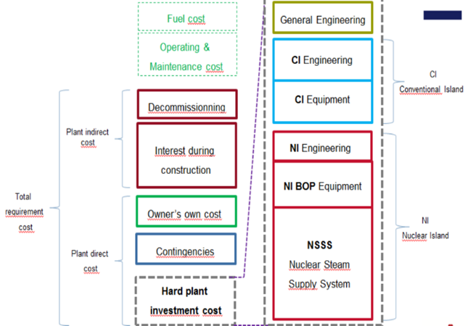
Fig. 1. Decomposition of costs of a NPP

Four areas with homogeneous cost drivers are identified for the study:
- The part of the conventional island consisting of the electricity generation facility and its cooling source. We assume in this study that the two SFR and EPR plants have a similar cooling source, namely, a seaside facility.
- The site portion of the conventional island and its facilities and roads and networks (excluding NI): we consider these elements to be equivalent between the SFR and EPR.
- Similar nuclear island systems in terms of design and manufacturing. Only Bills of Quantities (BoQs) differ between SFR and EPR. Examples include HVAC and cranes.
- Specific nuclear island systems with different technology and a differentiated industrial manufacturing. One example is the primary circuits.
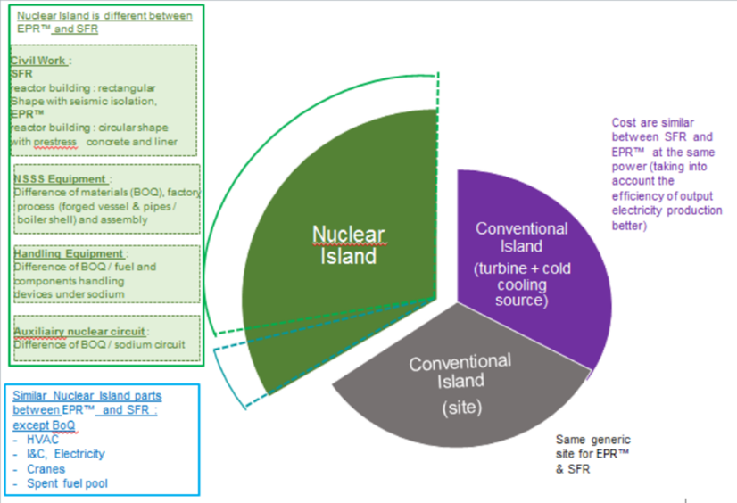
Fig. 2. Comparison of costs for EPR and SFR NPP

The Cost Transfer Coefficient (CTC) deducts the cost of SFRs from the PWR under the following formula:
Cost SFR 1000 = CTC x Cost EPR 1000
It implies to calculate a cost of a 1000 eMW EPR, by a Chilton method (ref. [7]), transforming the 1650 eMW EPR cost to an equivalent 1000 eMW EPR (which does not actually exist).
The methodology used for comparing costs between SFR and EPR is based on costs derived from the current achievements of the EPR. This cost base is broken down into homogeneous subsets that extrapolate SFR costs based on accessible and relevant cost drivers.
For the nuclear island, CTC cost transfer coefficients between the EPR and the SFR are developed based on BoQ and unit costs per equipment. For non-nuclear island subsets, the methodology is based on a comprehensive approach using Chilton's law and overall cost drivers.

SFR specific areas of the nuclear island
The following subsets are:
- The civil works of the NI,
- The Nuclear Steam Supply System (NSSS) consisting of the primary circuit for the EPR and SFR reactors and the secondary circuit for the SFR,
- Fuel handling,
- Specialized maintenance.

For the civil works, the methodology is based on a comparison of the costs of civil works on the NI of the EPR and the SFR. The cost of civil works for the SFR is calculated based on unit costs from the EPR and BoQ sets of the SFR structure. The difference in concrete volume of twinned SFR compared to twinned EPRs represents 16%, due to the additional buildings for secondary circuits of SFR and the higher reactor building of SFR.

For the NSSS, the methodology is based on a comparison of the costs and masses of the components of the primary and secondary circuits of the EPR and the components of the primary, secondary, and tertiary circuits of the SFR.
The primary heat production function includes for each reactor:
- EPR: the primary circuit consists of the vessel, the lid, the lower and upper internals, studs, the control rods mechanisms, the vessel support and the external core catcher,
- SFR: the Reactor Block consists of: main and safety vessels, slab and support pit, rotating plugs, Above Core Structure, control rods, internal structures, internal core catcher, primary pumps and intermediate exchangers.
The heat transport function includes:
- EPR: primary piping, primary pumps, pressurizer, and steam generators (SG),
- SFR: secondary loops including secondary piping, secondary pumps, SG, and sodium storage tanks.
The steam transport function to the turbine hall includes:
- EPR: water steam pipes, valves, isolation valves,
- SFR: water steam pipes, valves, isolation and decompression valves, decompression circuits.

For fuel handling, the methodology is based on a comparison of the masses (excluding biological protection) and the costs of the components of the fuel handling subset of the twinned EPR and the twinned SFR.
Primary fuel handling includes:
- EPR, the following equipment:
  - Refueling Machine,
  - Fuel Transfer Facility,
  - Reactor Operating Platform.
- SFR, the following equipment:
  - Fueling/defueling Gas Cask,
  - Transfer Arm,
  - Handling machine.
Secondary fuel handling includes:
- EPR, the following equipment:
  - Spent Fuel Mast Bridge,
  - Fuel Elevator,
  - Spent Fuel Cask,
  - Transfer Facility,
  - Fuel handling tools.
- SFR, the following equipment:
  - Conditioning and washing pit,
  - Fresh fuel handling cask,
  - Shuttles in air and water,
  - Crane for spent and fuel,
  - Control room.
Fuel storage, includes:
- EPR, the following equipment:
  - Underwater Fuel Storage Racks,
  - New Fuel Storage Rack,
  - Underwater lighting,
  - Vacuum Cleaner.
- SFR, the following equipment:
  - Under water fuel storage racks.
The specialized maintenance subset includes materials associated with component handling functions
- EPR, the following equipment:
  - The vessel lid removing machine,
  - The material buffer,
  - The outdoor handling.
- SFR, the following equipment:
  - The special handling casks,
  - special handling slots,
  - Equipment of large components maintenance,
  - The polar table.

NI systems similar for EPR and SFR in terms of technologies and industrial manufacturing
The following subsets are:
- Ventilation,
- Nuclear auxiliary circuits,
- Handling cranes,
- Electricity,
- Instrumentation and control (I&C).
For the ventilation, the methodology is based on a comparison of the ground surfaces and ventilated volumes of the nuclear island of the twinned EPR and SFR configurations.
For nuclear auxiliary circuits and handling cranes, the methodology is based on a comparison of the BoQ of the steel masses and the unit costs of the subset of twinned EPRs and SFRs.
For electricity and I&C, the methodology is based on a comparison of BoQ by equipment type (length of wiring and power balance, number of inputs/exits) and unit costs by type of equipment in the twinned EPR and SFR.

Site equipment, road, galleries and networks
The EPR and SFR reactors are installed at the seaside and are a generic site. The occupied surfaces in both configurations are similar.
For the EPR, the site under consideration is Taïshan.
For the SFR, it comes from the CAD model.
The surfaces are in the order of 175,000 m2 each.

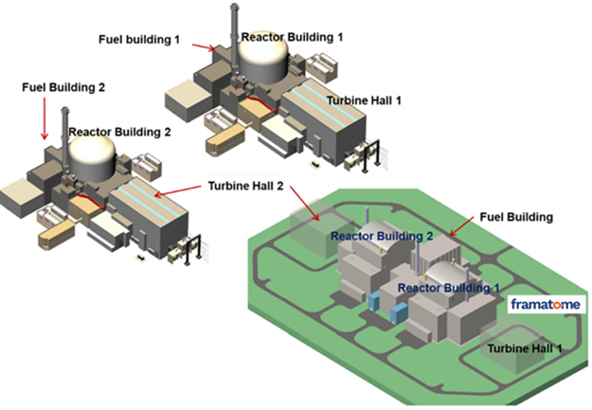
Fig. 3. Comparison of layout of 2 twinned EPR (above) and 2 twinned SFR (under).

Conventional Island
The perimeter of the conventional island subset of twinned EPRs and twinned SFRs includes:
- The civil works of the turbine hall,
- The turbine generator,
- The alternator,
- The mechanical equipment in the turbine hall,
- The fluid circuits of the turbine hall,
- The electrical installation of the turbine hall,
- I&C of CI,
- The pumping station,
- Raw water supply pipes,
- The Electric auxiliary station.

Two cost drivers are identified for the conventional island subset:
- Electrical power: 1650 eMW for EPR and 1000 eMW for SFR,
- Thermodynamic efficiency: 36% for EPR and 42% for SFR (calculation for ASTRID).

Intermediate conclusion
On the complete perimeter of systems, structures and components, the ratio of costs between two 1000 eMW SFR and two 1650 eMW EPR is 1.19.
For 2 SFR and 2 EPR transposed to the same power of1000 eMW, this ratio is 1.61.
The cost of an EPR equivalent 1000 eMW has been calculated from the EPR 1650 with a Chilton formula with an exponent 0.6.
This result should not be considered as a definitive conclusion, because the exercise conducted in this study is based on the extrapolation of the ASTRID 600 eMW configuration conducted over 2016 and 2017.
The continuation of ASTRID studies beyond 2017 which led to the New Configuration ASTRID 150 eMW, focused on cost-cutting, highlighted technical solutions that it will be useful to instruct for the SFR 1000 twinned reactors.
Some technical and economic optimizations of the SFR1000 sketch are presented in chapter 5.
The current state of the studies shows that a target of 1.45 for the cost ratio is achievable.

TECHNO-ECONOMIC OPTIMIZATIONS

Increase of thermal power by 10% at constant core size
The architecture chosen for the 1000 eMW SFR consists of four secondary loops with one Intermediate Heat Exchanger (IHX) and one SG by secondary loop. This architecture structure could be maintained while increasing the power of the reactor. This would give economic interest because the production capacity of the reactor would be increased. It is envisaged to study the impact of a 10% increase in power on the sizing and lifetime of the main components.
From a reactor physics point of view, one must verify that such a core power increase keeps the properties of CFV cores in terms of safety as outlined in paragraph 3.1. In particular, one has to verify with the detailed design [6] that a modest increase in the average power density (W/cm3) in the core maintains the limited mechanical energy release in case of an Unprotected Loss of Flow (ULOF) accident.
From a technology point of view, the limit could be reached for the IHX (unit power of 625 thMW, much higher than what was done in past projects like Phenix or Superphenix).

Reduction of the primary circuit diameter
The diameter of the primary circuit is imposed by the critical path on the slab. This critical path is conditioned by:
- The diameter of the Above Core Structure,
- The architecture chosen for in vessel fuel handling. As a reminder, the solution adopted on the 1000 eMW SFR consists of 2 rotating plugs, 1 transfer machine with a fixed offset transfer arm,
- The number and diameter of large components IHX and Primary Pumps,
- The distance between the components, necessary to be able to carry out their handling.

To reduce the vessel diameter, the following work axes are proposed:
- Interest in switching to a conical Above Core Structure to reduce the size of small rotating plug,
- Reduce the distance of isthmus between components, which implies an increased complexity of on-slab operations,
- Reduce the primary pump diameter using an innovative hypercritical shaft solution.

Optimization of maintenance facilities for large components
The large components maintenance building is an important investment because of the height, the volumes involved and the complexity of the maintenance and examination cells. It is proposed to study the modes of economic optimization of this facility:
- Reduction of the number of component storage pits,
- Optimization of the examination cell in terms of volume through a reduction of its functionalities, cumulated with a delayed investment of certain equipment of this cell,
- Removal of auxiliary handling equipment.

Suppression of the anti-seismic foundation raft
The SFR design integrates an anti-seismic raft under main buildings of the nuclear island. This option is expensive and conditions some choices of architectures / locations of buildings.
Nevertheless, some French nuclear sites may have more favourable spectra that could allow the deletion of this anti-seismic raft.

Extension of containment to the reactor building without polar table
The SFR design integrates a concept of remote containment compartmented with a polar table which ensures the following functions:
- Protection of the reactor block against heavy load drop,
- Reduction of pressure loads on the containment enclosure; thanks to this, the reactor building is rectangular.
The evolution of computer tools for calculating sodium sprayed fires based on a CFD approach allows significant gains on pressure loads.
In addition, it is envisaged to design the containment of the SFR in mixed steel concrete structures. This type of option inherently has better resistance to pressure than standard reinforced concrete (withstand limit> 1 bar).
The removal of the polar table could allow a simplification of the design of the confinement, as well as a reduction of the height of the reactor building by several meters.

Steam generators buildings optimization
The SFR design integrates SG buildings with:
- Bunkers of protection around the SGs to ensure that a sodium-water-air reaction (SWAR) does not lead to damage to the buildings important for safety and the reactor building in particular,
- A significant number of compartments of the rooms with sodium risk, with the aim of greatly reducing any aerosol release to the outside.

The following concept is proposed:
- Remove the bunkers around the SGs by seeking to erase the walls of the upper part of the SG building in the event of SWAR (to avoid a confined explosion). The upper part of the building is made of metallic construction,
- Reduce the parceling of sodium rooms by using the new CFD calculation tool for sprayed sodium fire.

New concept of « short secondary loops »
The design of the SFR secondary loops do not incorporate bellows. The general layout therefore includes expansion bends to compensate the dilatations.
There is no qualified bellows in France for sodium temperature and nuclear operation according to nuclear standards. To avoid large bellows size, it is necessary to consider very short loops (reduction of displacements) and adapted layout accordingly, like the concept proposed by the Russian designers of BN1200.
This concept requires a major overhaul of the general layout of buildings but allows significant savings in civil engineering and pipe dimensions.

Optimization of reactor auxiliary systems
The SFR design follows the principles of design of ASTRID 600 reactor auxiliary systems:
- Warm, gas-cooled slab,
- Cover argon gas circuit with tanks of significant capacity,
- External primary purification with cold traps with extractable cartridges.
These options lead to significantly increase the dimensions of the reactor building.
It is proposed to look at the economic interest of cooling the slab with an organic fluid, which reduces the volumes involved.
As regards the argon gas circuit, volumes could be reduced voluntarily.
Finally, it is proposed to analyse the interest of an external purification with a single large cold trap.

Remote Safety Vessel concept
The reactor block of the SFR integrates a suspended safety vessel, completed by reactor pit also ensuring a function of sodium retention. An alternative would be to have a remote safety vessel that can be assimilated to an anchored safety vessel concept as considered on EFR. The idea would be to valorise the steel concrete structure of the reactor pit to make ensure the role of safety vessel by the internal liner.

CONCLUSION – SYNTHESIS OF COSTS
Throughout the perimeter of the facilities of the NPP, and by integrating the potential economic improvements presented in chapter 5, the CTC ratio of the costs between the twinned 1,000 eMW SFRs and the twinned EPRs whose unit power has been reduced to 1,000 eMW can be evaluated at 1.45. This ratio is higher than the 1994 evaluation between the PWR N4 of the French fleet and the EFR project, which gave a ratio of 1.33.
The time frame available before the development of industrial SFRs must be used to achieve the R & D necessary to improve the economic performance of these reactors.
However, SFRs must not be compared with LWRs only on the cost of eMW produced, as these reactors could find a place alongside GEN III reactors, with a view to optimizing management of nuclear materials.
In all cases, construction of industrial SFRs will depend on the capacity of R&D agencies, designers, manufacturers and operators to make safe and long-lasting SFRs that produce competitive MWh, comply the GENIV objectives and offer the service expected for a closed fuel cycle.

REFERENCES
- Sodium-Cooled Fast Reactor (SFR) System Safety Assessment, GEN IV International Forum, (2017).
- Economics of Nuclear Energy (in French). Appendix B. compared economics of PWR’s and SFR’s. E. Bertel and G. Naudet, EDP Sciences (2004).
- ASTRID reactor Design overview and main innovative options for Basic Design, F. Chanteclair et al, IAEA FR17 Conference (2017).
- Prototype and Industrial SFRs - Yesterday, Today and Tomorrow, JF Sauvage, IAEA FR13 Conference (2013).
- Superphenix Technical and Scientific achievements, J Guidez, G Prele, Atlantis Press (2017).
- Design optimization of the core of a Fast Neutron Reactor of commercial size. (In French). S Poumerouly, Internal EDF/R&D Report June 2018, (unpublished).
- Cost Engineering in the Process industries, C. H. Chilton Mc Graw Hill (1960)
- Prospective inventory of radioactive materials and waste produced by the French nuclear fleet according to various options. C Chabert et al. Global Conference (2019).
- European Fast Reactor design, J.C. Lefèvre, C.H. Mitchell, G. Hubert (1994).

