Analysis of the natural circulation

capacity of decay heat removal system in

pool-type sodium-cooled fast reactor

Yapeng Liu¹, Dalin zhang¹, Lei Zhou¹, Chenglong Wang¹, Wenxi Tian¹, Suizheng Qiu¹, G.H. Su¹

¹State Key Laboratory of Multiphase Flow in Power Engineering, Shaanxi Key Lab. of Advanced Nuclear Energy and Technology, School of Nuclear Science and Technology, Xi’an Jiaotong University, Xi’an 710049, China

Yapeng Liu: liuyp@stu.xjtu.edu.cn

Abstract

The structure of pool-type sodium-cooled fast reactor (SFR) is complex, which leads to the complicated thermal-hydraulic phenomena in the process of natural circulation for decay heat removal. The determination of the natural circulation flow path and the decay heat removal capacity of the natural circulation of each flow path are issues to be considered in the design of SFR. Core flow distribution, flow and heat transfer of inter-wrapper flow, thermal stratification of the sodium pool, thermal-hydraulic interaction between the core and the sodium pool, and arrangement of the decay heat removal system are factors that affect the decay heat removal capacity in the reactor. Therefore, the paper analyzes the influence of the arrangement scheme of the decay heat removal system on the removal of decay heat. Firstly, the system program THACS is used to establish the decay heat removal system of coupling primary circuit and external circuit of SFR, and the analysis is carried out for the condition of station blackout (SBO). Secondly, sensitivity analysis is conducted for the arrangement scheme of the decay heat removal system, so as to evaluate the decay heat removal capacity of the reactor. In the paper, two schemes of placing the direct heat exchanger (DHX) in the hot pool and placing the direct heat exchanger (DHX) in the cold pool are calculated, and the effects of the two schemes on decay heat removal using natural circulation are analyzed. The results indicate that both decay heat removal system arrangements can effectively remove decay heat from the reactor. Placing DHX in the cold pool can increase the natural circulating flow inside the assembly, which facilitates decay heat removal in the assembly. However, placing DHX in a hot pool can increase the natural circulating flow in the inter-wrapper region, thereby increasing the decay heat carried away by the inter-wrapper flow.

INTRODUCTION
Sodium-cooled fast reactor (SFR) is one of the fastest developing reactors in the Generation IV reactors. The pool-type fast reactor has become the main type in the construction of SFR, because of its compact structure, large thermal inertia, and good inherent safety. The operating pressure of the sodium-cooled fast reactor is atmospheric, and the coolant temperature is generally well below its boiling point. Accidents such as loss of flow or rupture of the main pipe do not cause pressure drop, coolant boiling, and loss of cooling capacity. Therefore, the key to the safety of sodium-cooled fast reactors is to keep the sodium above the core and to continuously remove the decay heat of the core. As long as these two requirements are met, core damage can be prevented [5].
For sodium-cooled fast reactors, since the density of sodium changes significantly with temperature, natural circulation driven by density differences can be used to remove decay heat. Under the accident condition of the sodium-cooled fast reactor, it is necessary to take into consideration in the design of decay heat removal system to remove the decay heat from the core in time and transport the heat to the final heat sink through the decay heat removal system. Decay heat removal systems can be divided into the following four types [2]:
- IRACS: Intermediate Reactor Auxiliary Cooling System.
For IRACS, the air heat exchanger (AHX) is connected by a branch line between the intermediate heat exchanger (IHX) and the steam heat exchanger (SG) in the secondary loop. In this design, the integrity of the secondary loop is necessary for the decay heat removal system to work properly.
- PRACS: Primary Reactor Auxiliary Cooling System.
In this design, the direct heat exchanger is set in the main cooling system. The intermediate heat exchanger (IHX) is connected with the air heat exchanger (AHX). In contrast to IRACS, no secondary cooling system is required in this design.
- DRACS: Direct Reactor Auxiliary Cooling System,
The most common decay heat removal method is to place a direct heat exchanger (DHX) in a sodium pool. A direct heat exchanger (DHX) is connected to an air heat exchanger (AHX) through an intermediate pipe to transport decay heat to the atmosphere through natural circulation. Moreover, natural circulation can be enhanced by increasing the height difference between cold and heat sources.
- RVACS: Reactor Vessel Auxiliary Cooling System,
There is no sodium-sodium heat exchanger in this design. It mainly depends on the natural convection of air between the reactor vessel and concrete. The decay heat in the vessel is continuously discharged out of the reactor through the natural convection of air. However, this design has limited heat removal capacity and is widely used in small or medium-sized reactors with electrical power less than 50 MW.
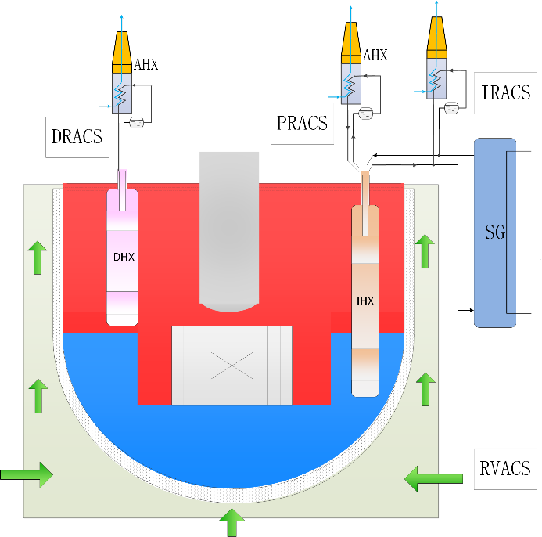
FIG. 1. Schematic of a typical decay heat removal system
EBR-II is a pool-type experimental reactor in the United States. The decay heat removal heat exchanger of EBR-II is connected to the sodium-sodium heat exchanger, which is immersed in the cold pool of the reactor vessel [8]. In the French sodium-cooled fast reactor, the decay heat removal of the Superphenix reactor is mainly dependent on the air heat exchanger connected to the secondary circuit, and the sodium-sodium heat exchanger placed in the hot pool can directly cool the primary circuit [9]. In the European EFR project, decay heat removal is still based on the direct reactor cooling (DRC) system, with direct heat exchangers primarily located in the hot pool. Three DRC systems in EFR use forced cycles and the other three DRC systems use natural cycles. The decay heat removal system for Japan's JSFR, which is being designed, consists of two Intermediate Reactor Auxiliary Cooling Systems (IRACSs) and one Direct Reactor Auxiliary Cooling System (DRACS) [1]. The decay heat removal system (DHRS) of the Korean Prototype Gen IV sodium-cooled fast reactor (PGSFR) is composed of four loops, two active DHRSs (ADHRS) and two passive DHRSs (PDHRS), the direct heat exchanger (DHX) of PDHRS is placed in the cold pool [11].
The decay heat removal system is the main challenge for the design of all sodium-cooled fast reactors, and it is also the safety guarantee for the operation of the sodium-cooled fast reactor. Whether each design scheme can effectively discharge the decay heat requires in-depth experimental and theoretical research. In the study of decay heat removal efficiency of DHRS layout scheme, THACS program is applied to the analysis of three schemes, which are DRACS, IRACS, and PRACS with check valve. The results showed that the cooling efficiency of IRACS and PRACS was higher [6]. For direct reactor auxiliary cooling systems (DRACS), it has been shown that the immersed DHX in the hot pool mainly cools the bottom of the hot pool and takes away the core heat by promoting the flow in the inter-wrapper region. Therefore, the design and the position of the immersed coolers are key parameters affecting the efficiency of the decay heat removal system [9]. Placing the DHX in a cold pool provides long-term cooling for the reactor, especially in the event of a core disruptive accident (CDA), the DHX in the cold pool can provide long-term cooling for the debris bed. Therefore, it is necessary to analyze the two schemes of placing DHX in the cold pool and placing DHX in the hot pool, and make clear the impact of placing DHX in the cold pool on the efficiency of the decay heat removal system, so as to design a scheme that comprehensively considers the long-term decay heat removal capability and the efficiency of the DHRS.
In this paper, the model of system analysis program THACS is briefly introduced, and then the unprotected loss of flow (ULOF) of the sodium-cooled fast reactor and the corresponding modeling method are introduced. In the end, two schemes in which the direct heat exchanger is placed in the hot pool and the cold pool in the decay heat removal system are studied. Through the analysis of two decay heat removal systems, the influence of the arrangement of decay heat removal systems on the key parameters of the reactor is obtained. The decay heat removal ability, advantages, and disadvantages of the two decay heat removal system arrangements are evaluated, which can provide a reference for the design optimization of sodium cold fast reactor.

Code Model
THACS program is a one-dimensional system analysis program developed by Xi'an Jiaotong University for the sodium-cooled fast reactor. The program can model the primary system and decay heat removal system of sodium-cooled fast reactor. The components included in the program are core, inter-wrapper flow, sodium pool, heat exchanger, reactor vessel cooling system, pump, and pipe. The parallel multi-channel model is used in the core. The inter-wrapper flow is solved by radial stratification model, which considers the inter-wrapper channel between two adjacent loops of subassemblies as a layer, and divides several nodes in the axial direction [12]. There are three solution methods for sodium pool: uniform mixing model, three-layer model, and 2-D junction-cell model. Heat exchangers in the program include sodium-sodium heat exchangers and sodium-air heat exchangers. A model for the reactor vessel cooling system of sodium-cooled fast reactor is developed to calculate the flow and heat transfer of the outer and inner channels of the reactor vessel cooling system [7]. The reactor vessel cooling system considers the heat transfer between the inside of the reactor vessel and the sodium pool, and the outside of the reactor vessel and the air. The pump model in the program is centrifugal pump, the relationships among pump head, hydraulic torque, volume flow rate, and speed are summarized by four-quadrant curves.
The ability of the program to analyze natural cycle decay heat removal in sodium-cooled fast reactors has been verified by a set of benchmark problems. The unprotected loss of flow (ULOF) benchmark problem of BN-800 type LMFR is analyzed by the program, and the calculated results are in good agreement with the benchmark results [4]. The program was used to analyze the benchmark of EBR-II shutdown heat removal tests (SHRT-17 and SHRT-45R), and the simulation results verified the capability of the inter-wrapper flow model and the capability of analyzing the natural circulation of SFR [12]. The natural circulation test of Phenix is analyzed, which further verifies the capability of the program to analyze the natural cycle of the sodium-cooled fast reactor, and also demonstrates the importance of the flow and heat transfer through the inter-wrapper tubes of the subassemblies to remove decay heat from the core [3]. VECAS is coupled with THACS to calculate the station blackout accident of CEFR, which verified the RVCS model of VECAS [7]. Through the calculation and analysis of the natural circulation experiment carried out on a scaled water experiment platform, the prediction ability of the program for the flow rate of natural circulation in different natural circulation flow paths was verified, and the prediction ability for the cooling power of DRACS was verified [10].

THACS modeling
The program was used to model the sodium cold fast reactor with a power of 1538MWth, and the schematic diagram of the model is shown in Fig. 2. The program models the core, the inter-wrapper flow, the cold pool, the hot pool, the main pump, the intermediate heat exchanger, the direct heat exchanger, the air heat exchanger, and the pipes in the reactor. To analyze the effect of the direct heat exchanger placed in the cold pool and hot pool on the removal of natural cycle decay heat, the DHX placed in the cold pool and hot pool was modeled respectively. The core is modeled by five channels, which are Core 1, Core 2, control rod, blanket, and shield zone.
For the steady-state condition of the SFR, the results of program calculation are shown in Table 1. The total power of the reactor is 1538MW, the mass flow rate of the reactor core is 6495 kg/s, and the mass flow rate of IHX is 1635 kg/s. The average temperature of the cold pool is 628.6 K, and the average temperature of the hot pool is 808.3 K.

TABLE 1. RESULTS OF STEADY-STATE

Parameters | THACS
Power of core/MW | 1538
Core flow rate/kg∙s-1 | 6495
Primary flow rate in IHX/kg∙s-1 | 1635
Temperature of cold pool/K | 628.6
Temperature of hot pool/K | 808.3
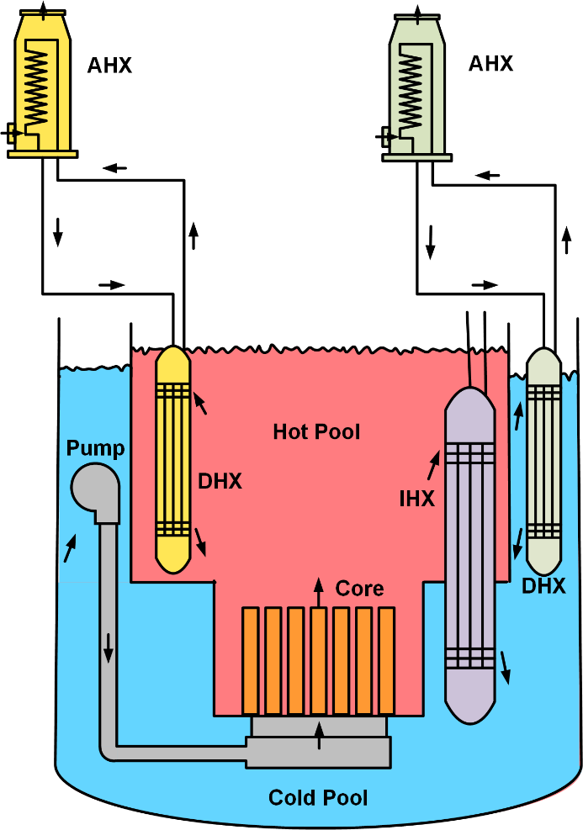
Fig. 2. Schematic of the decay heat removal system layout

Accident sequence and transient result analysis
The station blackout (SBO) accident is an important condition in the analysis of sodium-cooled fast reactor accidents, in which the reactor will lose flow and heat sink. If the decay heat in the reactor is not removed in time, the core temperature of the reactor will continue to rise, which could lead to a meltdown of the reactor core, and eventually lead to a severe accident. The program is used to analyze the station blackout accident, and the main sequence of the accident is shown in Table 2. At 0 s, the reactor loses external power and the primary and secondary pumps begin to idle. Scram is triggered 0.5 s after the whole plant power failure, and the safety rod is fully inserted into the core within 4 s, to realize the reactor shutdown. The speed of the main pump reduced to 0 rpm in 74 s, and the speed of the secondary pumps reduced to 0 rpm in 120 s. At 600 s, the AHXs are put into operation.
The layout of DHX first affects the temperature of the cold and hot sodium pools, so the average temperature of the cold and hot sodium pools under the two schemes is analyzed, as shown in Figure 2. Since DHX was put into operation at 600 s, there was little difference between the two schemes in the early stage of the establishment of natural circulation due to the thermal inertia of sodium in the sodium pool. As can be seen from, when DHX is placed in the hot pool, it takes away more heat from the hot pool, so the temperature of the hot pool is lower. Correspondingly, the temperature of the hot pool is higher when DHX is placed in the cold pool. At 36000 s, the temperature of the scheme in which DHX is placed in the hot pool is about 60 K lower than that in the cold pool. On the one hand, the temperature of the cold pool is affected by the DHX placed in it, and on the other hand, it is affected by the inflow of fluid from the primary side of IHX. There is little difference between the two schemes, but the cold pool temperature is slightly lower when DHX is placed in the cold pool.

TABLE 2. MAIN ACCIDENT SEQUENCE OF SBO

Time | Events
0 s | Loss of external power, the primary pumps, and the secondary pumps began to idle
0.5 s | Scram, the safety rod begins to fall and is fully inserted after 4 s
74 s | Primary pumps speed reduced to 0 rpm
120 s | Secondary pumps speed reduced to 0 rpm
600 s | The AHXs are put into operation

Fig. 3. Average temperature of hot pool
Fig. 4. Average temperature of the cold pool
Fig. 5 shows the comparison of the average core outlet temperature under the two schemes. According to the figure, the difference between the two cases is very small before the 1200s, which is caused by the thermal inertia of the cold and hot sodium pools. Then, with the temperature difference between the cold and hot sodium pools, the core outlet temperature decreased a little faster when DHX was placed in the hot pool. At 36000s, the scheme of DHX in HP had a lower average core outlet temperature, about 38 K lower than the scheme of DHX in CP.
Fig. 6 compares the core flow changes under two decay heat removal system arrangements. As can be seen from, when DHX is placed in the cold pool, the core flow rate is higher, which is about 20 kg/s higher than that in the hot pool, reaching about 60 kg/s. This shows that the DHX in the cold pool scheme is more conducive to the primary natural circulation.
(a) 0-4000 s (b) 0-36000 s
Fig. 5. Average core outlet temperature
Fig. 6. Core mass flow rate
Fig. 7 compares the change of inter-wrapper mass flow rate under the two DHX layout schemes. It can be seen that when DHX is placed in the hot pool, the natural circulation flow rate in the inter-box area is higher. This is because when DHX is placed in the hot pool, the temperature of the hot pool is lower, the density difference between the inter-wrapper area and the hot pool is greater, and the natural circulation capacity is stronger. Therefore, the scheme of DHX in the hot pool can be more conducive to the natural circulation of inter-wrapper. Fig. 8 shows the change of heat carried out by the inter-wrapper flow (IWF). It can be seen that because the inter-wrapper mass flow rate is larger when DHX is placed in the hot pool, the heat carried out by the inter-wrapper flow is greater.
Fig. 7. Mass flow of inter-wrapper
Fig. 9 shows the variation of total DHX heat dissipation under two DHX layout schemes. When all DHXS are in the hot pool, the total DHX heat dissipation power is higher than that in the cold pool. When DHX is placed in the hot pool, the temperature of the hot pool decreases significantly. With the decrease of the temperature of the hot pool, the natural circulation capacity of the decay heat removal loop decreases, and the heat dissipation of DHX decreases.
Fig. 8. Heat dissipation power of inter-wrapper flow
Fig. 9 Heat dissipation power of DHX

Conclusion
Through the comparative analysis of the two schemes of placing DHX in the hot pool and placing DHX in the cold pool, the following conclusions can be drawn. When the DHX is placed in the cold pool, the hot pool temperature is higher, the cold pool temperature is slightly lower, and the core outlet temperature is lower before 10000 s, and then higher than that in the hot pool. For the natural circulation flow, the natural circulation flow inside the core subassemblies is higher, but the natural circulation flow of the inter-wrapper region is relatively low, and the decay heat of the core is mainly carried out by the flow inside the subassemblies. When the DHX is placed in the cold pool, the total heat dissipation of DHX is relatively low. Therefore, considering that placing DHX in a cold pool has little effect on the efficiency of the decay heat removal system, and that placing DHX in a cold pool can provide long-term cooling for the reactor, it is possible to place DHX in a cold pool in the design of the pool-type sodium-cooled fast reactor.

References
- Hishida, M., Kubo, S., Konomura, M., & Toda, M. (2007). Progress on the Plant Design Concept of Sodium-Cooled Fast Reactor. Journal of Nuclear Science and Technology, 44(3), 303-308.
- Kamide, H. (2010). Investigation on thermal hydraulics phenomena in a sodium-cooled fast reactor core during natural circulation decay heat removals
- Liu, Y., Zhang, D., Song, P., Wang, S., Liang, Y., Zhou, L., . . . Su, G. H. (2021). Analysis of the natural circulation test of PHENIX reactor by the THACS code. Annals of Nuclear Energy, 152.
- Ma, Z., Yue, N., Zheng, M., Hu, B., Su, G., & Qiu, S. (2015). Basic verification of THACS for sodium-cooled fast reactor system analysis. Annals of Nuclear Energy, 76, 1-11.
- Nakai, R. (2017). The Safety Design Guideline Development for Generation-IV SFR Systems FR 17, Russia.
- Nina Yue, R. C. (2018). THE CHOOSE OF DECAY HEAT REMOVAL SYSTEMS OF SFR. ICONE26, 81563.
- Song, P., Zhang, D., Feng, T., Wang, S., Chen, J., Wang, X. a., . . . Su, G. H. (2019). Numerical approach to study the thermal-hydraulic characteristics of Reactor Vessel Cooling system in sodium-cooled fast reactors. Progress in Nuclear Energy, 110, 213-223.
- Sumner, T. S., & Wei, T. Y. C. (2012). Benchmark specifications and data requirements for EBR-II shutdown heat removal tests SHRT-17 and SHRT-45R (ANL-ARC-226 Rev. 1; Other: 73647 United States 10.2172/1432465 Other: 73647 ANL English).
- Tenchine, D. (2010). Some thermal hydraulic challenges in sodium cooled fast reactors. Nuclear Engineering and Design, 240(5), 1195-1217.
- Wang, S., Zhang, D., Liu, Y., Wang, C., Qiu, S., Su, G., & Tian, W. (2020). An experiment‐based validation of a system code for prediction of passive natural circulation in sodium‐cooled fast reactor. International Journal of Energy Research.
- Yoo, J., Chang, J., Lim, J.-Y., Cheon, J.-S., Lee, T.-H., Kim, S. K., . . . Joo, H.-K. (2016). Overall System Description and Safety Characteristics of Prototype Gen IV Sodium Cooled Fast Reactor in Korea. Nuclear Engineering and Technology, 48(5), 1059-1070.
- Yue, N., Zhang, D., Chen, J., Song, P., Wang, X. a., Wang, S., . . . Zhang, Y. (2018). The development and validation of the inter-wrapper flow model in sodium-cooled fast reactors. Progress in Nuclear Energy, 108, 54-65.

