Aerosol module for modeling of the fission product behavior in FR cooling circuits and NPP compartments
Sorokin A.A., Tarasov O.V., Nazarov D.A., Mosunova N.A., Strizhov V.F.
Nuclear Safety Institute of the Russian Academy of Sciences (IBRAE RAN)
52, B.Tulskaya st., Moscow 115191, Russia

Abstract. This contribution presents an overview of models of an aerosol module designated to simulate the behavior of fission products in the circuits and compartments of nuclear power units with fast reactors with sodium and lead coolants. Aerosol module AEROSOL/LM is integrated with the thermal-hydraulic code HYDRA-IBRAE/LM. Together they have a common user interface to set the input data, calculate the processes of thermal-hydraulics and the fission products transport in both gaseous and aerosol forms and view the results obtained. The AEROSOL/LM module allows calculating the relevant processes of aerosol dynamics: nucleation, coagulation, condensation and sedimentation. A specific feature of the module is the simulation of multicomponent and polydisperse aerosols.
In particular, for sodium reactors the behavior of sodium combustion aerosols in nuclear power plant compartments is simulated. For fast reactors with lead coolant the lead and lead oxide aerosols are considered. The aerosols formation and transport between compartments of the NPP are also modeled by the aerosol module. Some results of the module validation are also briefly presented in the contribution.

Key Words: fast reactor, liquid-metal coolant, aerosol module, multicomponent aerosols, sodium combustion.

Introduction
Fast reactors with liquid metal coolant are commonly viewed as prospective ones for the further development of nuclear energy, including as the most promising sodium, lead and lead–bismuth coolants [IRSN, 2015; Alemberti et al., 2019; Mosunova et al., 2020]. Present paper deals with the simulation of the behavior of fission products and the formation of particles and aerosols in the circuits and compartments of nuclear power plants (NPP) with fast reactors with sodium and lead coolants.
Aerosol module AEROSOL/LM is designated to simulate the behavior of fission products in coolant loops and compartments of nuclear power plants (NPP) with fast reactors with sodium and lead coolants [Filippov et al., 2018; Kolobaeva et al., 2020]. For sodium reactors it simulates also the formation and behavior of sodium aerosols and sodium combustion aerosols in reactor compartments. For fast reactors with lead coolant, it includes models of the formation and transport of lead and lead oxide aerosols and their interaction with fission products. Also, tritium transport in the coolant loops is considered (in sub-module called TRITIUM). Specific features of the module are the simulation of multicomponent and polydisperse aerosols and accounting for radionuclides decay in the bulk of aerosol matter with the possible following phase change of decay products.
Aerosol module is integrated with the thermal-hydraulic HYDRA-IBRAE/LM code [Alipchenkov et al., 2016]. Together they have a common user interface to set the input data, calculate the processes of thermal-hydraulics and the fission products transport in both gaseous and aerosol forms and view the results obtained. Also, they use the same nodalization scheme. Code HYDRA-IBRAE/LM with the module AEROSOL/LM have been developed in the “Proryv” project, specifically in its subproject – Codes of New Generation [Mosunova et al., 2020]. HYDRA-IBRAE/LM code is intended for computational analysis of nonstationary thermohydraulic processes. It allows to model flow of two-phase medium (coolant in vapor and liquid form) with an admixture of noncondensing gases. Heat transfer in solid structures is described in two-dimensional approximation. It can model both the flow of coolant in circuits and dynamics of gas in NPP compartments.

Models in the module AEROSOL/LM
The module consists of several blocks for calculating physicochemical phenomena. Each of them considers its own set of key phenomena. Fission products are considered in the form of volatile and semi-volatile components and aerosol particles. However, the method for calculating the dynamics of aerosols in the gas phase or solid particles in a liquid metal coolant is the same and based on the method of fractions for the mass of particles.

Models for phenomena in sodium and lead coolants
For fast reactors with sodium and lead coolants, the module is designed to calculate the transfer and behavior of fission products in the coolant circuits and in the shielding gas in all regimes of NPP operation. The module is based on models of the transfer of impurities in the liquid and gaseous phases of the coolant, the deposition on the surface and re-washout of dissolved fission products, interphase mass transfer, behavior of vapors and multicomponent aerosols in a vapor-gas medium [Filippov et al., 2018]. It is assumed that all impurities do not affect the thermal-hydraulic characteristics of the coolant.
A distinctive feature of the model for the transfer of radionuclides in AEROSOL/LM module is the ability to simulate the dynamics of radionuclides as a part of various chemical compounds in circuits or in compartments, taking into account their individual properties, that is, without combining radionuclides into a small number of representative groups with some common properties for all components in a group. This makes it possible to simulate the evolution in the circuit of each radionuclide significant from the point of view of radiation safety. In turn, this makes it possible accurately calculate the accumulation of activity on the surfaces of the circuit elements, in the volume of the coolant and shielding gas during normal operation, as well as reliably determine the composition of radionuclides and their activity during possible accidents with a coolant leak or when a leak appears in the gas system.
Among the promising reactor technologies considered by the Generation IV international Forum, the lead-cooled fast reactor was identified as a technology with great potential [Dragunov et al., 2015; IRSN, 2015; Alemberti et al., 2019]. One of the main safety advantages of such reactors is the choice of an inert coolant. From the point of view of fission products (FP) modeling, the calculation of FP in a sodium or lead coolant differs only in the coefficients of the equations, the properties of the coolant and the composition of chemical compounds.
The presence of a shielding gas in the reactor design determines the transfer of some of the radionuclides dissolved in the coolant into the gas and then through the leaks in atmosphere of the NPP compartments. The possibility and intensity of aerosol formation in the gas volume above the coolant and then in the gas circuit depends on the rate of evaporation of coolant vapor from the melt surface. In the module, the evaporation of a coolant from a free melt surface into a volume of protective gas is considered in the diffusion approximation based on the analogy of heat and mass transfer processes [Eckert, 1972]. The model makes it possible to simulate the formation of aerosols mixed in composition in an inert (argon) and oxidizing gas medium (a mixture of argon with air) with components of coolants, its oxides and fission products.
The AEROSOL/LM module includes a model for the formation and behavior of aerosols of evaporation products from the surface of lead melt, including aerosols of lead-iodide. For example, it is possible to simulate the formation of aerosols mixed in composition, consisting of aerosols of lead and lead oxides, as well as different radionuclides and molecular fission products.
The formation and transfer of tritium in circuits of fast reactors leads to an increase in the dose load of the operating personnel. Therefore, it is important to have estimations of the distribution of tritium in the circuits and its release through the walls of circuits into the air and the steam-water circuit, as well as its accumulation in cold traps.
The specially developed module TRITIUM was designed and integrate into the AEROSOL/LM module to simulate the behavior of tritium in the circuits of the reactor [Ilyasova et al., 2018]. The module allows calculating the intensity of the tritium source in compartments of the NPP and its release into the environment. The behavior of tritium in circuits is determined by the source from the core into the coolant in the primary circuit, the transfer of dissolved tritium and hydrogen with the coolant, permeability through the metal walls of the channels, the accumulation of tritium and hydrogen in cold traps, isotopic exchange in cold traps and in the steam-water mixture of the steam generator, the sink from circuits and with water from the steam generator circuit into the storage pool. Models developed in IPPE (Russia) [Kozlov, 2005] and ENEA (Italy) [Franza, 2011] are considered as basic in the module.

Models for phenomena in NPP compartments
The main source of aerosols in compartments of NPP with sodium coolant is the nucleation of sodium vapors and various sodium oxides when they are cooled in a mixture of sodium combustion products and humid air. The second source of aerosols in NPP compartments is the nucleation of different FP vapors. Subsequent intensive coagulation of primary aerosol particles leads to the formation of multicomponent aerosols with different radionuclides in their composition.
As expected relatively fewer radionuclides get into the atmosphere of NPP compartments in case of the accident for reactors with lead and lead-bismuth coolants. The most important components in the composition of aerosols should be particles containing toxic lead oxides, activated products of corrosion, polonium isotopes (mostly for reactors with PbBi coolant), elements of nuclear fuel and actinides released through leaks in the cladding of fuel elements. Among FPs, the large dose of activity is connected with particles with iodine and cesium.
The module of fission products behavior in the gaseous atmosphere of NPP compartments of a fast neutron reactor makes it possible to calculate the main processes of aerosol dynamics. The module allows simulating the following processes:
- vapor phase aerosol nucleation (classical nucleation theory approach);
- coagulation of multicomponent polydisperse aerosol particles (sectional approach);
- condensation of vapors on aerosol particles taking into account their composition;
- condensation and sorption of vapors on surfaces;
- deposition of aerosols on surfaces due to different mechanisms (diffusion, gravity, thermophoresis);
- formation of multicomponent deposits on surfaces including different radionuclides;
- absorption of water vapor by hygroscopic aerosols;
- transfer of aerosols and various vapors through the compartments.
An important feature of the model is accounting for the aerosol composition. The aerosol dynamics simulation approach is based on the method of fractions for the mass of particles (mass-bins similar to the size-bin approximation, [Kumar et al., 2006]), modified to take into account the multicomponent composition of aerosols, as well as the condensation of various vapors on particles. In this approach modeled variables are masses of the component i in the vapor phase , in deposits on walls and in aerosol particles from the section j with the mass of the particle . Here and – the total number of components that can be in the composition of aerosol particles and in deposits, and – the number of mass fractions considered. For convenience, the index of the spatial computational cell corresponding to the nodalization scheme of the simulated installation is omitted here.
The volume of particles in j^{th} mode is defined as , where – an aerosol bulk density. An assumption, that independently on the composition of the particle (an input parameter given by user), is the weakest point in this approach. In particularly, for mixed particles composed of components with bulk densities that are essentially different. Nevertheless, this assumption is frequently used in the aerosol codes.
The mass ratio defines the structure of mass bins. An algorithm with an arbitrary value of (e.g., ) is implemented in the module. As a result, the total number of differential equations for each spatial cell of the nodalization scheme is defined as

, (1)

where – the number of simulated surfaces for the given spatial cell, for example, in the case of the cylindrical compartment (floor, walls and ceiling).
Another feature of the aerosol model is accounting for the decay of radionuclides in the bulk of aerosol particles. This phenomenon is important for the correct calculation of the iodine isotopes behavior, the lifetime of aerosols containing short-lived radionuclides and the formation of radioactive deposits on various surfaces that allows calculating the residual heat generation.
The SOPHAEROS module in the ASTEC-Na code [Lebel and Girault, 2018; Lebel et al, 2018] and the CONTAIN-LMR code [Murata et al., 1993; Louie et al., 2017] are the closest analogue of the AEROSOL/LM module in terms of modeling the behavior of aerosols in NPP compartments with SFR. The structure of the sodium jet combustion model in the AEROSOL/LM module generally corresponds to the model from the FEUMIX module [Rigollet-Pichon and Malet, 1986]. The sodium source in the NPP compartments is calculated either in the thermohydraulic module of the integral code, or is set by the user. The model of the sodium pool combustion is similar to the model from the SOFIRE-II code [Beiriger et al., 1973], which is also the part of ASTEC-Na and CONTAIN-LMR codes. Currently, the AEROSOL/LM module does not include a model of the interaction of Na-oxide aerosols with CO₂ and sodium carbonate formation. However, it has the capability of aerosol ageing modelling through the chemical reactions of Na-oxide aerosols with steam to form NaOH aerosols.
The AEROSOL/LM module includes models for calculation of the yield and behavior in the atmosphere of NPP compartments of sodium and lead aerosols, aerosols of sodium combustion products and aerosols of fission products, which makes it possible to consider the behavior of all possible types of aerosols in NPP compartments for FR with sodium and lead coolants. One of the main distinctive features of the module is the ability to calculate the kinetics of formation (nucleation) of multicomponent aerosols, taking into account the action of sources of different physics. For example, the formation of aerosols mixed in composition, consisting of the products of combustion and evaporation of sodium and fission products.
It is possible to take into account the presence of up to one hundred different radionuclides in the composition of vapors and aerosol particles, both in the form of molecular compounds and isotopes. This, in turn, makes it possible to simulate more reliably the radiation situation in the compartments in the event of a severe accident and to carry out a related calculation of the accident dynamics from the initial event to the spread of activity in the environment, including the assessment of the consequences for staff and the population (using separate code).
Moreover, a distinctive feature of the AEROSOL/LM module is the simulation of the multicomponent composition of aerosols depending on the size of aerosol particles with any degree of detalization (decomposition) for the sizes of aerosol fractions. According to [Cousin, 2009], the SOPHAEROS module of the ASTEC-Na code used a simplified approximation of the average composition for all aerosols, regardless of their size, and there was an upper limit on the number of fractions when calculating the polydisperse distribution of aerosols.
To date, the model of the behavior of multicomponent aerosols has been modified to take into account the change in the density of the particle material depending on the change in their composition. To take into account the influence of the composition of components on the density of the material of mixed aerosols, the approximation of an ideal solution is considered. The test calculations performed showed that the use of the conventional approach with the assumption of a constant density of multicomponent aerosols, regardless of their composition, can lead to a difference with the results for a model with a variable density of aerosol material by several times for such parameters as the mass of multicomponent aerosols in the indoor atmosphere and the mass of radionuclides in deposits on surfaces. These parameters are decisive for a reliable assessment of the change in radiation activity over time in the containment rooms.
The module of melt-concrete interactions CORCONIT in combination with the AEROSOL/LM module calculates the source of fission products in the event of their release from the melt. The main mechanism for the release of FPs from the melt into the NPP compartments is associated with the release of gas bubbles from the free surface of the melt. It is assumed that the chemical reactions of lead with gas bubbles do not take place in the considered temperature ranges, which are associated with the low chemical activity of lead.
Verification and validation of models for FPs behavior in NPP compartments was carried out on the basis of analytical tests and the results of separate phenomena evaluation experiments. Further, the code was validated by comparison of the simulated results with the data of integral experiments. For each series of calculations, the sensitivity and uncertainty analysis was carried out.
Further work on the development of the aerosol part of the code should mainly be related to the validation of the developed models on the results of experiments.

Examples of validation results
Experiments AB1 and AB2 within the ABCOVE (Aerosol Behavior Code Validation and Evaluation) program at the Containment System Test Facility (CSTF) were devoted to the study of sodium combustion in a puddle with the formation of aerosols of combustion products and their behavior in the air atmosphere of the facility [Hillard et al., 1979]. The AB1 test was dry with a very low relative humidity. Test AB2 was specially created wet with the supply of water vapor after the start of the fire. The supply of steam simulated the release of steam from the heated concrete when it interacted with burning sodium. A significant increase in atmospheric humidity following by steam interaction with hygroscopic aerosols affects the intensity of their deposition.
To assess the degree of uncertainty in calculation results due to the presence of uncertainties in experimental data and parameters of the model, multivariate calculations were carried out taking into account the range of their variation obtained as a result of an expert assessment. In result of calculations, it was found that the combustion model reproduces the experimental sodium burnup rate quite accurately. The amount of Na burned differs from that measured by 13% for the AB1 test and by 3% for the AB2 test. As an example, in Fig. 1 the results for the time variation of the mass of aerosols suspended in the atmosphere for tests AB1 and AB2 are shown.
The main parameters influencing the concentration of aerosol particles suspended in the atmosphere are the phase density of aerosols (unknown in the case of coagulation of mixed particles) and the amount of water vapor absorbed on the particles. These values determine a fairly wide range of uncertainty for the calculated concentration, which in the experiment was also measured with a large uncertainty. The average deviations from the experimental data obtained in the calculations were 30% for the AB1 test and 40% for AB2 test, which can be considered as a good result demonstrating the correct operation of the models in the aerosol module.

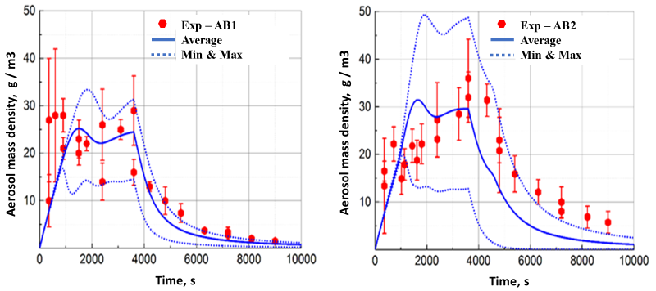
a) b)
- AB1; b) AB2
Fig. 1 Time change in the mass of suspended aerosols for tests AB1 and AB2

The purpose of the SOLFA (Sodium Leak, Fire and Aerosol) experiment was to recreate the conditions of the accident that led to the sodium fire at the Monju reactor in April 1996 [JAEA, 2011]. The experiment was carried out just a few months after the accident with the rupture of the sodium pipeline and its subsequent ignition. The leak parameters on the experimental setup were made closest to those that happened at the NPP at the time of the accident: a freely falling sodium jet (flow rate of about 44 g/s and a temperature of 480⁰C), a long time of leakage, the formation of a sodium pool on the floor and sodium burning both in jet and pool. The SOLFA unit is a vertical sealed steel vessel. It is equipped with a sodium jet injection system, a steel sump in the lower part of the vessel to ensure sodium pool combustion and a ventilation system for oxygen supply.
Fig. 2 shows the results of calculations for the total rate of sodium burning in a pool taking into account variations in the input parameters.
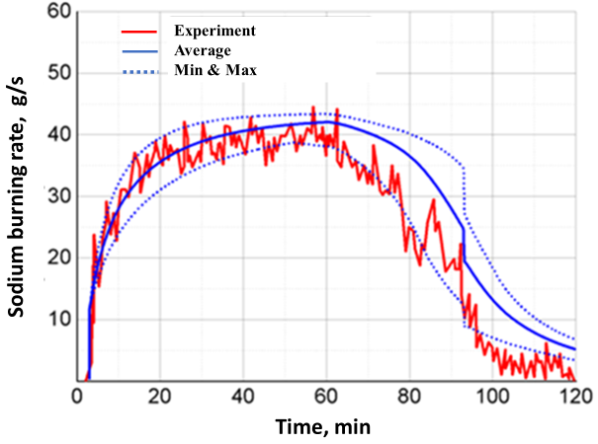
Fig. 2 Calculated total rate of sodium burning in comparison with experimental data

It follows that during the first 20 minutes the combustion rate is lower than the sodium injection rate of 44 g/s, since about a quarter of the incoming sodium burns in the jet, and there is still too little sodium in the sodium pool, and hence the combustion area is small. Due to the increase in the mass of sodium in the pool, the rate of sodium burning in the pool increases with its area. In 20-60 minutes, a state close to stationary occurs, when the burning rate in the pool is approximately equal to the rate of sodium injection. The range of 63-93 minutes corresponds to a decrease in ventilation rate with continued sodium supply. Due to oxygen starvation, the rate of combustion in the jet and in the pool becomes less than the rate of sodium injection. At 93 minutes, the sodium feed stops. Thereafter, increasing oxygen starvation is combined with the effect of slowing down the combustion in the jet and reducing the burning area of the sodium pool.
It is seen, that the computational model qualitatively well reproduces the experimental results. Some differences from the experimental data appear after the stopping of the normal operation of ventilation in the experiment. The resulting difference between the calculations and the experimental data for the sodium pool burning rate reaches 23%. A similar result was obtained for modeling the change in the mole fraction of oxygen. The calculations are in good agreement with the measurement data for the time interval as long as the ventilation normally operates in the experiment. The calculation error in comparison with experimental data in this interval is less than 5%.
Fig. 3 shows simulation results for the time variation of the concentration of sodium combustion aerosols, suspended in the atmosphere of the vessel. It can be seen that in the time interval with ventilation normally operating in the experiment (up to about 63 minutes), the aerosol concentration initially increases rapidly and then remains close to stationary value. This is due to the competition between the rate of aerosol generation during sodium combustion and the rate of aerosol removal by gas due to air ventilation. After a decrease in the intensity of air ventilation, the concentration of aerosols firstly increases, since their removal from the vessel decreases, and then begins to decrease, since the sodium burning in the pool stops. After stopping the normal operation of ventilation, deposition becomes the only mechanism that determines the decrease in the concentration of aerosols in the volume of the installation.
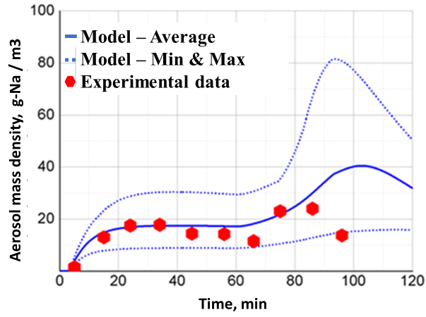
Fig. 3 Calculated time change of the mass of sodium combustion aerosols, suspended in the vessel atmosphere in comparison with experimental data

Conclusions
The paper briefly outlines the present activities in the development of the module AEROSOL/LM designed to simulate the behavior of fission products in the circuits and compartments of nuclear power plants with fast reactors with sodium and lead coolants.
Details have been presented about the developed models. Models describe the fission products transport in gaseous and aerosol forms, multicomponent aerosol formation, sodium combustion and sodium oxide aerosol formation, evaporation of a lead from a free melt surface into a volume of protective and the lead and lead oxide aerosols formation.
Presented results of the validation of the AEROSOL/LM module in combination with the system thermal-hydraulic code HYDRA-IBRAE/LM have shown the ability to simulate processes with sodium combustion in a jet and a pool, followed by the formation and transport of aerosols of sodium combustion products in NPP compartments, including their interaction with aerosols of fission products and deposition on the surface of walls and floor.
Acknowledgments
The module AEROSOL/LM as a part of the EUCLID/V2 code has been developed within the “Codes of a new generation” subproject of the "Proryv" project.
References
- Alemberti A., Tucek K., Obara T., et al., 2019. Status of Generation-IV Lead Fast Reactor Activities. IAEA-CN245-065, 1–10.
- Alipchenkov, V.M., Anfimov, A.M., Afremov, D.A., Gorbunov, V.S., Zeigarnik, Y.A., Kudryavtsev, A.V., Osipov, S.L., Mosunova, N.A., Strizhov, V.F., Usov, E.V., 2016. Fundamentals, current state of the development of, and prospects for further improvement of the new-generation thermal-hydraulic computational HYDRA-IBRAE/LM code for simulation of fast reactor systems. Thermal Eng. 63 (2), 130–139.
- Beiriger P., Hopenfeld J., Silberberg M., Johnson R. P., Baurmash L., Koontz R. L., 1973. SOFIRE II user report. / United States, 1973. Web. doi:10.2172/4490831.
- Cousin F., 2009. ASTEC V2 SOPHAEROS module. Theoretical manual. DPAM-SEMIC-181.
- Dragunov Yu.G., Lemekhov V.V., Moiseyev A.V., Smirnov V.S., 2015. Lead-cooled fast-neutron reactor (BREST). INPRO Dialog-Forum. IAEA HQ. Vienna. Austria, May 26-29, 32.
- Eckert E.R.G., Drake R.M. Analysis of heat and mass transfer. McGraw-Hill, New York, 1972.
- Franza F., 2011. Tritium Transport Analysis in Advanced Sodium Fast Reactors: Thesis for Master Deg. in Nucl. Eng., Politecnico di Torino, Italy.
- Filippov, M.F., Kolobaeva, P.V., Mosunova, N.A., Sorokin, A.A., 2018. Aerosol-LM/Na aided simulation of fission product production and transport in the first loop of a fast reactor. Atomic Energy 124 (4), 266–271.
- Hilliard R.K., MCcormack J.D., Postma A.K., 1979. Aerosol behavior during sodium pool fires in a large vessel - CSTF tests AB1 and AB2. Report No. HEDL-TME 79-28 UC-79, 79p, Hanford Engineering Development Laboratory.
- Ilyasova O., Nazarova S., SorokinA., 2018. Tritium module for calculating the behavior of tritium in a loop of a reactor installation with sodium coolant. Atomic Energy 124 (4), 272 – 278.
- IRSN, 2015. Review of Generation IV Nuclear Energy Systems.
- JAEA, 2011. Sodium Fire Test at Broad Ranges of Temperature and Oxygen Concentrations (IV) – Low Temperature Sodium Spray Tests. JAEA – Review – 046.
- Kolobaeva, P.V., Mosunova, N.A., Sorokin, A.A., 2020. Verification of module AEROSOL/LM on experiments with sodium combustion aerosols in air at various humidity. Atomic Energy 127 (6), 352–355.
- Kozlov F.A., V. M. Poplavskii V.M., Alekseev V.V., 2005. Simulation of tritium mass transfer in a three-loop sodium – cooled NPP. Atomic Energy 98 (3), 175–182.
- Kumar J., Peglow M., Warnecke G., et al., 2006. Improved accuracy and convergence of discretized population balance for aggregation: The cell average technique. Chem. Eng. Science 61, 3327–3342.
- Lebel L., Girault N., 2018. New developments in modeling sodium spray fires with ASTEC-Na. Annals of Nuclear Energy 119, 23 – 35.
- Lebel L., Cousin F., Girault N., 2018. New developments in sodium pool fire and SFR containment aerosol modeling with ASTEC-Na. Annals of Nuclear Energy 119, 229 – 239.
- Louie D.L.Y., Humphries L.L., Denman M.R. Implementation Status of CONTAIN-LMR Sodium Chemistry Models into MELCOR 2.1. / In: proceeding of International Conference on Fast Reactors and Related Fuel Cycles: Next Generation Nuclear Systems for Sustainable Development, Ekaterinburg, Russia, 2017.
- Mosunova N.A., Alipchenkov V.M., Pribaturin N.A., et al., 2020. Lead coolant modeling in system thermal-hydraulic code HYDRA-IBRAE/LM and some validation results. Nucl. Eng. Design 359, 110453, 1–11.
- Murata K.K., Carroll D.E., Bergeron K.D., Valdez G.D. CONTAIN LMR/ 1BMod. 1, A Computer Code for Containment Analysis of Accidents in Liquid-Metal-Cooled Nuclear Reactors / Sandia National Laboratories Report SAND-91-1490, 1993.
- Rigollet-Pichon L., Malet J.C., 1996. The modelling of sodium jet fires in a global computer code – FEUMIX 3. In: IAEA Technical Committee Meeting on Evaluation of Radioactive Materials Release and Sodium Fires in Fast Reactors, O-arai, Japan.

