IAEA-CN-291-382
Perspectives and Discussions on the Modes and Development Path of China's Commercial Closed Nuclear Fuel Cycle
Min XIAO
China Nuclear Power Technology Research Institute
Shenzhen, China
francisa@126.com
XIAOJUN XIAO
The Chinese University of Hong Kong, Shenzhen
Shenzhen, China
Abstract
China implements the established policy of closed nuclear fuel cycle for the sustainable development of nuclear power. However, there seems no feasible development plan and roadmap to initiate and deploy a commercial closed fuel cycle in China up to now.
The industrialization of the nuclear fuel cycle requires gradual and phased progresses. Since most of the operating nuclear power plants in China are PWR units, and China implements and promotes a commercial closed nuclear fuel cycle, how to initiate a closed nuclear fuel cycle from the mature commercial pressurized water reactors is an unavoidable reality.
Different from the implementation of closed nuclear fuel cycle reactors in countries such as France and Russia, the operating status and modes of PWRs in China are varied significantly. Most PWRs in China have implemented different plant modifications such as reactor power upgrading, core design and fuel management improvements with different new fuel types, different burnups and different cycle lengths, which have consumed certain degree of safety margins. These characteristics and differences bring challenges and difficulties to the implementation of a closed nuclear fuel cycle in China.
Based on international experiences and China’s situation, this paper discusses the necessity of initiating a closed nuclear fuel cycle from mature commercial nuclear power plants in China as the initial stage of the closed fuel cycle to lay the foundation for the future advanced nuclear fuel cycle, analyze and discuss the initiating mode of China's commercial closed nuclear fuel cycle, review the nuclear fuel types to be utilized in the closed nuclear fuel cycle, and discuss the possible configuration and development path of China's closed fuel cycle in the future.
Key words：fuel cycle，PWR，fast reactor, hybrid, MOX.
- Introduction
Since 2012, China has been the country with the largest installed power capacity, and it has increased this by 85% since then to reach 2011 GWe in 2019, about a quarter of global capacity, in which nuclear power capacity being about 5%.
China has 48 nuclear power reactors in operation, 12 under construction, and more about to start construction in 2020s and beyond. UO₂ fuel is used currently for all commercial reactors in China. The accumulated spent nuclear fuel has exceeded 8500 tons. It estimated that 23,500 tons of used fuel will have been discharged from reactors by 2030.
China adopts a closed nuclear fuel cycle policy. A small scale test MOX fabrication facilities has been in operation since about 2018 mainly for fast reactors. A pilot reprocessing plant was constructed from 2006, which completed hot commissioning in 2010 to reprocess about 50 tons of used fuel. A demonstration used fuel treatment plant, with capacity of 200 tons of used fuel per year, is being built in March 2015. A large (800t/y) commercial reprocessing plant based on international cooperation has been negotiated for long time and still going on.
However, how to initiate and implement the closed fuel cycle, and how to use MOX fuel, does not seem to be clearly defined yet: initiate the closed fuel cycle directly from fast reactors or from mature PWRs ? China has large scale mature PWR nuclear power plants and implements commercial closed fuel cycle policy, and there are mature PWR fuel cycle experiences in the world, therefore, China's commercial closed fuel cycle initiation should take both international experiences and the actual scenarios of China's PWRs into consideration.
Different from the implementation of closed nuclear fuel cycle reactors in countries such as France and Russia, the operating status and modes of PWRs in China are varied significantly. Fuel management in China’s PWRs experienced a lot of modifications and improvements includes power upgrade of M310 reactors, 18 fuel cycle fuel cycle with cycle length 17~19 months or 16~18 months for Daya Bay, Ling Ao II, and nearly all CPR1000 and CPR1000+ reactors using fuel with gadolinium burnable poison. The average burn-up is about 43 GWd/t, with maximum around 50 GWd/t. An Advanced Fuel Management (AFM project) cycle is implemented at Ling Ao, with quarter core refueling giving higher average burn-up of 50 GWd/t and maximum 57 GWd/t. UO2 fuel is used for all commercial PWRs in China up to now. These diversiform modifications and improvements have consumed certain amount of safety margins (including DNBR margin) due to higher enrichment, higher Bu and low leakage core loading pattern, and would make the potential closed fuel cycle transition more complicated.
2. Initiation of commercial closed fuel cycle from LWR or FR IN CHINA?
For decades, discussions on the future nuclear fuel cycle have been dominated by the anticipated final deployment of a closed fuel cycle based on fast reactor plutonium. So far, the maturity of fast reactors is still low in general. People's continuous research on the fuel cycle shows that there are multiple fuel cycle options, and these options are facing huge uncertainties, including technical, economic and other factors. At least until the second half of this century, fast reactor technology and its fuel cycle would gradually mature and be deployed on a large scale.
The development of fuel cycle technology and the establishment of industrial systems are very complicated, including spent fuel reprocessing, MOX fuel manufacturing, and waste disposal facilities. It would take a long time to accumulate related technologies and establish the facilities.
MOX fuel assemblies are licensed today for a substantial number of commercially operated PWRs and BWRs in Belgium, France, Germany, India, Switzerland, Sweden, etc. Additionally, Japan has more than 10 reactors currently licensed for MOX usage. USA introduced MOX fuels in PWR as Lead Test Assemblies (LTAs) in early new century. The MOX fuel operation experiences and the large number of MOX fuel assemblies used in LWRs for more than half century have demonstrated that plutonium recycling in LWRs has reached industrial maturity. More than 7500 MOX fuel assemblies have been used in LWRs worldwide [1][2].
France is the most successful country in commercializing a closed nuclear fuel cycle in PWRs. As the first step, the French implemented the MOX fuel cycle in the PWR to build the fuel cycle infrastructure, capable of saving uranium resources and reducing the amount of nuclear waste by a factor of four. The French 24 PWR unit uses MOX fuel assemblies for routine power generation.
The successful implementation of the commercial nuclear fuel cycle in PWRs in France has laid a solid foundation for the nuclear fuel cycle industry, which is self-evident for the significance of the establishment of advanced fuel cycle dominated by fast reactors in the future [3][4].
Russia focused mainly on closed fuel cycle and MOX application in fast reactor for quite a long time in the past. Recently, however, Russia has adjusted its fuel cycle strategy and has taken a two-pronged approach: while maintaining the development of the fast reactor fuel cycle, Russia had launched the closed fuel cycle for VVER using REMIX fuel [16], to work along both lines in parallel. This two-pronged approach would be more effective and have lower risk because VVERs (LWRs) are more mature than fast reactors from commercial application point. REMIX fuel Lead Test Rods (LTRs) and LTAs have introduced in test reactor and commercial VVER since 2016 and their progresses seem smoothly.
Among the countries that adopt a closed fuel cycle strategy, no country does not use MOX fuel in mature LWRs, such as France, Russia, and Japan, etc. Even some countries that do not have a closed fuel cycle policy have already implemented the MOX LTAs program in commercial PWRs (like USA).
It can be seen from international experiences that if the MOX fuel cycles would not be initiated from the mature LWRs to accumulate experiences, it is almost impossible or would have huge risks to realize commercial closed nuclear fuel cycle. So far, China has not implemented any nuclear fuel cycle including MOX fuel LTA program in mature LWRs, therefore China's closed nuclear fuel cycle initiation and implementation seem still far away.
3. International Nuclear fuel cycle experiences
- French mode
MOX fuel cycle in PWR units. France has implemented the MOX fuel cycle in PWR for about 40 years. It has established a complete fuel cycle industrialization system and laid a solid foundation for the fast reactor fuel cycle in the future. France specifically assigned 24 (900MWe) PWR units to use MOX fuel assemblies for power generation. Over 4000 MOX fuel assemblies are delivered for power generation. France considers the closed fuel cycle in PWRs has strong significance of transition of closed fuel cycle from PWRs to fast reactors [3].
The French 900MWe reactors have 30% of MOX fuel in the core with the Pu content of about 8.65%, and with the MOX Parity (equivalence of Bu) being achieved with 1/4 refueling for both UO₂ fuel and MOX fuel. About 1000 tons of used UO2 fuel assembly from PWRs go through reprocessing to get 100 tons of Pu to be used in the MOX fuels for the 24 900MWe units each year.
The MOX fuel core has higher energy spectrum and different reactivity characteristics. For this reason, more RCCAs are introduced in reactors and high boron concentration is added in the boron make-up system and safety injection system in these units.
- Russia Mode
REMIX fuel in VVER reactors. REMIX (from Regenerated Mixture) fuel is made from uranium and plutonium recovered as an unseparated mixture from previously used fuel（by different reprocessing technology）, with a low-enriched uranium (up to 17% U-235) make-up comprising about 20% of the mixture, which gives fuel equivalent about 1% Pu-239 and 4% U-235 which can sustain burn-up of 50 GWd/t over four years. They are topped up with low-enriched uranium to give a fuel that performs within the same parameters as fuel made only from fresh low-enriched uranium. This means a reactor would not need any modification to start using REMIX.
Different from spent MOX fuel in LWRs in which the spent MOX fuel are not reprocessed (like in France), the spent REMIX fuel can be reprocessed and recycled in VVERs (LWRs) with addition of some fresh LEU. The cycle of reprocessing, recycling and top-up can be repeated as many as five times, with waste fission products removed each time and vitrified in glass ready for permanent geological disposal. In theory, a new reactor could operate for its whole design life of 60 years on just three REMIX fuel loads, circulating them continuously. A batch of six REMIX fuel assemblies are planned to undergo a full operation cycle in one of Russia's VVER-1000 reactors in 2022.
Dual-component power system. This system needs about twice the capacity of thermal reactors to fast reactors, depending on the FR breeding ratio, MOX fuel proportion and fuel management in LWRs. The system would be self-sufficient to some extent, in which the Pu and most of the U do not leave the system, but are recycled as much as possible and there is little accumulation of used fuel [16]. Minor actinides are burned in the fast reactors.
4. Perspectives on China's commercial closed nuclear fuel cycle
4.1. Necessity and advantages to accumulate nuclear fuel cycle experiences from mature PWRs
China adopts closed fuel cycle policy and launched a large commercial reprocessing plant and a closed fuel cycle program more than 10 years ago，which plans to build an 800-ton/y reprocessing plant and supporting facilities.
However, so far, there seems no viable feasibility study (including economic analysis), no implementable top-level design and roadmap plan for the commercial closed fuel cycle, which makes the implementation of the commercial closed nuclear fuel cycle face huge difficulties.
By 2035, there may be more than 100 nuclear power units with an installed capacity of more than 100 GWe in China. By mid-to-late this century, light water reactors (PWRs) are still main-stream nuclear power plants. The implementation of closed fuel cycles in mature LWRs (PWRs) would be completely feasible with low risk, which could lay an industrial foundation for the advanced fuel cycle in the future.
In view of international experience, no matter what kind of fuel cycle China would expect to implement in the future, it is necessary to initiate a closed fuel cycle from mature PWRs in order to accumulate experiences in design, development, engineering, operation and maintenance, and lay industrial foundation for more advanced fast reactor closed fuel cycle in the future.
4.2. Initiation of closed fuel cycle in PWRs (Stage 1)
The establishment of a closed fuel cycle is a long-term process that requires the accumulation of industrial and operational experiences. Therefore, it is necessary to initiate and establish nuclear fuel cycle system from mature pressurized water reactors.
LWR (PWR) is a mature technology with extensive and mature international experiences including the use of MOX fuel. Therefore, the feasibility of implementing a closed fuel cycle in PWR is certain. These experiences and practices are the valuable references to establish a closed nuclear fuel cycle industrial system for those countries (including China) with closed fuel cycle policy but without implementation yet.
The establishment of closed nuclear fuel cycle in LWRs is the initial stage of the closed nuclear fuel cycle, and it would be also an insurmountable stage. The establishment of a closed nuclear fuel cycle from LWRs would also help establish the PWR-FR hybrid power and fuel cycle system, and transition to fast reactors and other advanced fuel cycle systems.
For countries that have commercial nuclear power and adopt a closed fuel cycle policy, it would be wise to initiate and gradually establish closed fuel cycle systems based on mature LWR before the fast reactor and its fuel cycle are deployed.
The core physical properties of MOX fuel assemblies are significantly different from those of UO₂ fuel assemblies, including Moderator Temperature Coefficient (MTC), void reactivity coefficient, fuel temperature coefficient (Doppler coefficient), boron reactivity coefficient, neutron spectrum, etc. As the Pu content increases, the energy spectrum becomes harder, the MTC contribution decreases. The void coefficient tends to become positive with the increase of Pu content. The fuel temperature coefficient (Doppler coefficient) decreases in absolute value with increasing Pu content. The overall reactivity of the LWR MOX core with burnup curve is more gentle than that of UO2 fuel, mainly due to the breeding effect of Pu-239. The characteristics of these parameters are related to the design of MOX fuel and the proportion of MOX fuel in the core. Therefore, reactors using MOX fuel need to take special and targeted measures in reactor design and operation.
The absolute value of the boron coefficient of the MOX core is very small, only about 20% of the UOX core. This is one of the main reasons why some generation II PWRs could not accept 100% MOX loading because of the requirements of the boron concentration during normal operation and emergency shutdown would be too high.
Therefore, the reactors using MOX fuel have higher requirements for the MOX fuel design, the ratio of MOX fuel in the core, the fuel management and core safety margins (including DNBR margin).
Due to the relatively low safety margin of the generation II PWR, the core MOX ratio should not be too high (such as up to 30%), and there are special requirements for the fuel management and the boron concentration of safety injection in the primary loop.
Besides, different from the situation of closed nuclear fuel cycle in countries such as France and Russia, the operating status and modes as well as the fuel management of PWRs in China are of a wide variety. Most PWRs have implemented different plant modifications such as reactor power upgrade, core design and fuel improvements with 18-month refueling, different fuel types, different burnups, which consumed a lot of safety margins. These characteristics and differences bring some challenges and difficulties to the implementation of closed nuclear fuel cycle in China.
If it would be to implement MOX fuel application in PWR in China, special arrangements need to be made, such as designating some PWR units dedicated to MOX operation with special consideration of safety related parameters such as boron concentration for safety injection, RCCA pattern, cycle length, MOX fuel ratio, etc., in order to ensure sufficient safety margin.
In order to avoid uneven safety margins caused by the diverse core designs and various modifications of each PWR unit, it would be quite necessary to select certain types of PWR units to implement a unified MOX fuel cycle. These selected units should have basically the same or similar reactor design, and implement unified core design and fuel management with the same fuel type. First it is necessary to introduce MOX LTAs into the selected PWRs to establish the technical and licensing experiences as well as operation experiences of MOX fuel in PWRs. Only on the basis of MOX LTAs, the batch MOX refueling (30% of core) can be considered, and then the MOX parity to increase MOX fuel burnup to the UO₂ fuel level could be gradually realized.
As an alternative, the optimized MOX fuel (similar to the REMIX fuel) can also be used in the PWR to make full use of the separated mixture of Pu and U from the spent fuel reprocessing with adding a certain amount of new enriched uranium. The process of this fuel is more complicated than MOX, but its utilization of uranium resources is more sufficient than that of MOX fuel, and the overall resource utilization efficiency and final hi-level radioactive waste reduction are better.
4.3. Distributed FR-PWR hybrid power and fuel cycle system (Stage 2)
Fast reactors are far from large scale deployment, and the implementation of fast reactor closed fuel cycle is still far away. Based on the mature PWR nuclear fuel cycle experiences，it is necessary to further explore and expand the fuel cycle to the local distributed FR-PWR hybrid and fuel cycle system, which will better promote the future transition, development and deployment of advanced fast reactor fuel cycles.
The distributed FR-PWR hybrid power and fuel cycle system could make full use of the mature experience and industrial foundation of LWRs and its MOX fuel cycle, combined with the advantages of fast reactor (breeding, high neutron efficiency), avoiding the risk of immature deployment of large-scale fast reactor fuel cycle. In the system, the characteristics of fast reactors and LWRs can complement each other. Fast reactors can make full use of the low-quality recovered plutonium from LWR spent nuclear fuel reprocessing, and the high-quality fissionable plutonium extracted from fast reactor spent fuel can be well used by MOX fuel in LWRs.
● In addition, the system could be a small-scale distributed structure with wide adaptability, easier system development, demonstration and deployment. Before the large scale deployment of fast reactor would mature, the distributed FR-PWR hybrid power and fuel cycle system could be a more feasible way to achieve the advanced closed nuclear fuel cycle expansion and transition. The scale of this distributed fuel cycle system could be small and flexible，and can be regarded as a transition mode between the LWR closed fuel cycle and the fast reactor closed fuel cycle.
The typical and local distributed FR-PWR hybrid power and fuel cycle system include 1FR+1LWR, or 1FR+2LWRs. The specific configurations of the system depend on the reactor design and power capacity, Pu contents, MOX fuel proportion, and loading scheme, which are discussed below.
5. Typical CONFIGURATIONs of distributed FR-LWR hybrid power and fuel cycle systems
(a) 1FR+2PWR (CPR1000, 30% MOX), shown in Fig. 1
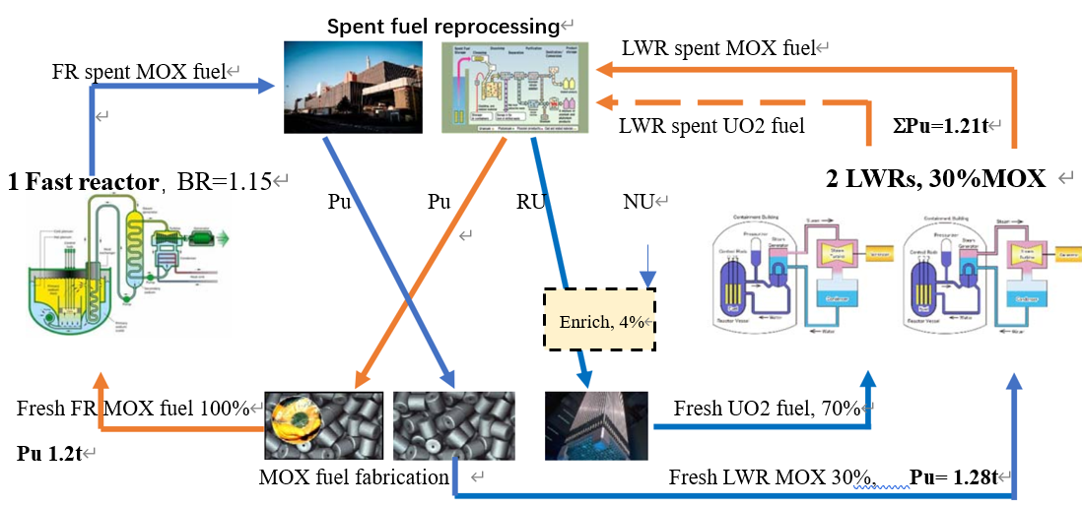
FIG.1. Distributed hybrid nuclear power and fuel cycle system (1 FR+2 LWR with 30% MOX)
RU：RepU, NU: Natural Uranium

100% MOX fuel in FR (typical 600MWe SFR), 30% of MOX fuel (16 MOX FAs each LWR) in 2 LWRs (CPR1000). There are 104 spent fuel assemblies discharged every year for 1/3 refueling mode, including 32 MOX spent fuel assemblies and 72 UO₂ spent fuel assemblies with the total Pu of 1.21 tons from all spent fuel per refueling. The plutonium from the reprocessing of all LWR spent fuel is used for fast reactor MOX fuel fabrication.
Each LWR uses 16 fresh MOX fuel assemblies for LWR are MOX fuel (Pu 8.65%), two LWRs require 1.28 tons of Pu. The CPR1000 Pu breeding ratio is about 0.95 (1.21/1.28). If the FR breeding ratio is about 1.15~1.2, the Pu produced by FR can meet the needs of Pu for the sustained operation of the hybrid system in FIG 1.

(b) 1FR+1LWR (CRP1000, 23% MOX), shown in Fig.2.
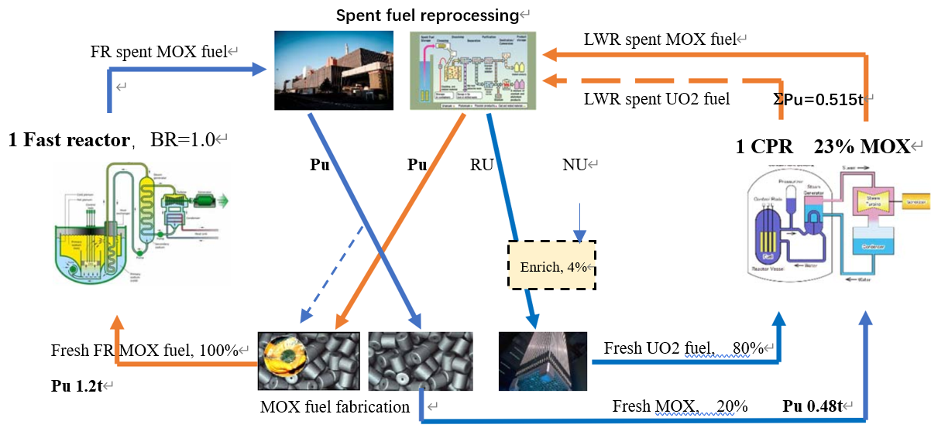
FIG. 2. Distributed hybrid nuclear power and fuel cycle system (1FR+1LWR with 23% MOX)
RU：RepU, NU: Natural Uranium

100% MOX fuel in FR, 23% of MOX fuel (12 MOX FAs) in 1 LWR (CPR1000). There are 52 spent fuel assemblies discharged each refueling for 1/3 refueling mode, including 12 MOX spent fuel assemblies and 40 UO₂ spent fuel assemblies with the total Pu of 0.515 tons from all spent fuel per refueling. The Pu from CPR1000 spent fuel reprocessing is used for fast reactor MOX fuel fabrication.
The LWR using 12 fresh MOX fuel assemblies for LWR are MOX fuel (Pu 8.65%) require 0.477 tons of Pu. The CPR1000 Pu breeding ratio is about 1.08 (0.515/0.477). If the breeding ratio is about 1.0~1.05, the Pu produced by FR can meet the needs of Pu for the sustained operation of the hybrid system in FIG 2.

(c) 1FR+1LWR (EPR, 30% MOX), shown in Fig.3
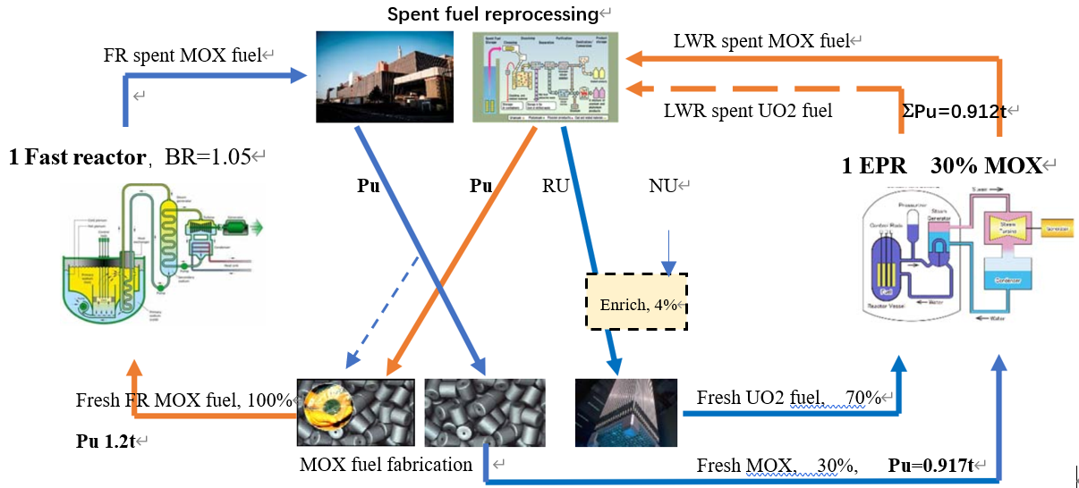
FIG. 3, Distributed hybrid nuclear power and fuel cycle system (1FR+1EPR with 30% MOX)
RU：RepU, NU: Natural Uranium

100% MOX fuel in FR, 30% of MOX fuel (20 MOX FAs) in 1 EPR. There are 72 spent fuel assemblies discharged each refueling for 1/3 refueling mode, including 20 MOX spent fuel assemblies and 52 UO₂ spent fuel assemblies with the total reprocessed Pu of 0.912 tons from all spent fuel per refueling. The Pu from EPR spent fuel reprocessing is used for FR MOX fuel fabrication. The EPR using 20 fresh MOX fuel assemblies (Pu 8.65%) requires 0.917 tons of Pu. The EPR Pu breeding ratio is about 0.99 (0.912/0.917). If the FR breeding ratio is about 1.05~1.1, the Pu produced by FR can meet the needs of Pu to be used by 1 EPR and FR.
If the MOX fuel percentage in EPR is 20%, then fast reactor BR=1.0 is enough for the sustained operation of the hybrid system in FIG 3.

(d) 1 FR + 1 LWR（HPR1000，20%MOX）, Shown in Fig.4
100% MOX fuel in FR. 20% of MOX fuel (12 MOX FAs) in 1 HPR (Hualong One). There are 60 spent fuel assemblies discharged each refueling for 1/3 refueling mode, including 12 MOX spent fuel assemblies and 48 UO₂ spent fuel assemblies with the total reprocessed Pu of 0.552 tons from spent fuel per refueling. The Pu from HPR spent fuel reprocessing is used for FR MOX fuel fabrication.
The HPR using 12 fresh MOX fuel assemblies (Pu 8.65%) requires 0.477 tons of Pu. The HPR Pu breeding ratio is about 1.16 (0.552/0.477). If the FR breeding ratio is about 1.0, the Pu produced by FR can meet the needs of Pu to be used by 1 HWR and FR.
If the MOX fuel proportion in HPR is 30%, then the FR breeding ratio needs to be 1.1 for the sustained operation of the hybrid system in FIG 4.
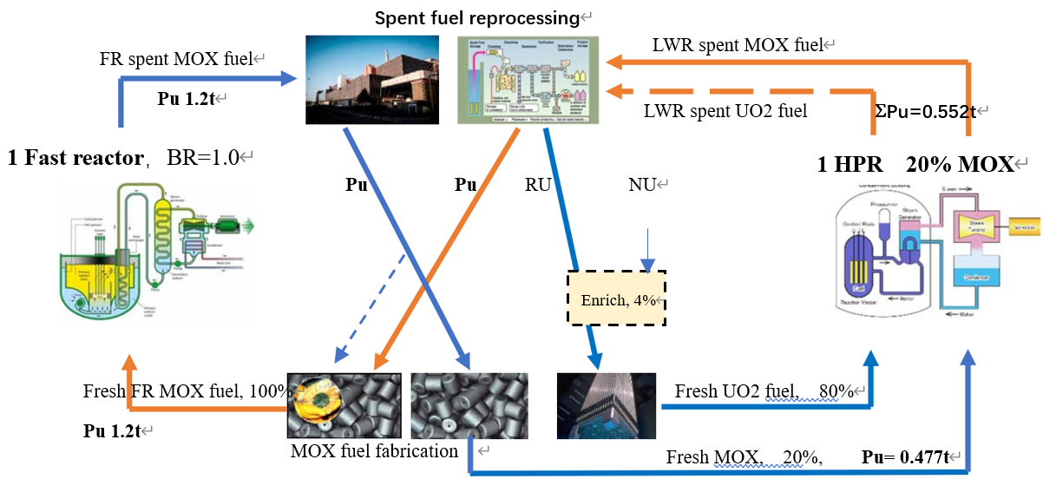
FIG.4, Distributed hybrid nuclear power and fuel cycle system (1FR+1HPR with 20% MOX)
RU：RepU, NU: Natural Uranium

The FR breeding ratio (for a given typical FR, 600MWe) versus LWR MOX fuel percentage in the distributed hybrid nuclear power and fuel cycle system is illustrated in the Fig.5, where the required FR BRs depend on the percentage of MOX fuel in LWRs as well as the LWR capacity and numbers. For the given hybrid power and fuel cycle system configuration, the larger the proportion of MOX fuel in LWR, the higher requirement for the fast reactor BR. For the variation of configuration of the system with the same proportion of MOX fuel in LWRs, the larger the LWR design capacity (e.g., EPR vs. CPR1000; or LWR quantity increase, such as 1FR+2LWRs vs. 1FR+1LWR), the higher requirement for the fast reactor BR.
If the LWR MOX fuel percentage is around 20%, the required FR BR around 1.0 is enough to main the Pu balance in the distributed hybrid nuclear power and fuel cycle system thank to the LWR Pu breeding ratio is obviously greater than one (net Pu generation in LWR).
If the capacity and design characteristics of the fast reactor are different, the required BR of the fast reactor in the hybrid power system discussed in the paper is subject to change accordingly.

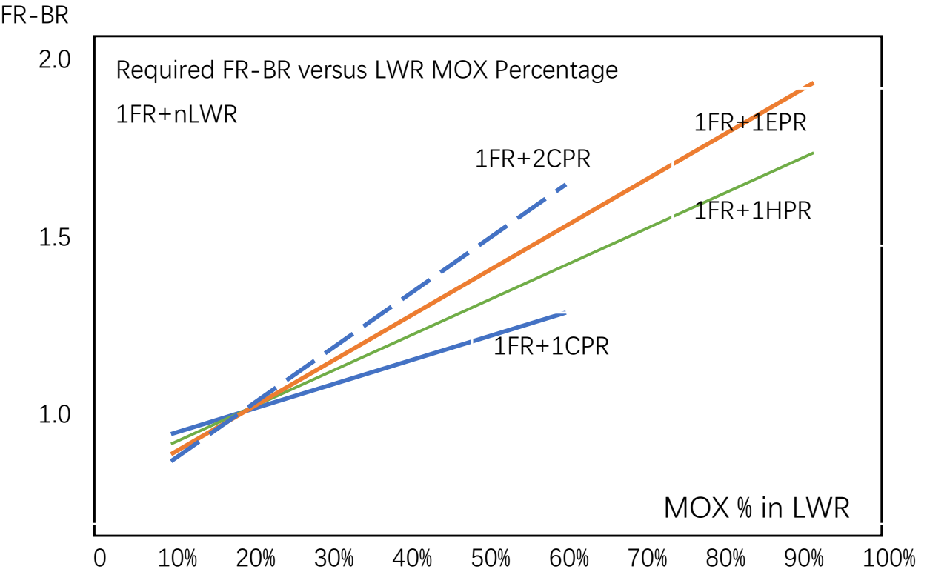
FIG.5. Required FR Breeding ratio versus LWR MOX fuel percentage in hybrid nuclear power system

6. Longer-term transition - modular distributed fuel cycle systems
Today, people do not have enough knowledge to make a reasonable and clear choice for the best (fast reactor) fuel cycle implementation and related technical routes in the future. Based on the mature LWR fuel cycle, and the distributed LWR and FR hybrid power and fuel cycle system, the commercial fuel cycle would go through very long transitional stages, which needs and is worth log-term exploring.
A closed nuclear fuel cycle is essential for the sustainable development of nuclear energy. People should continue to explore and develop more advanced closed fuels cycle based on the mature LWR fuel cycle and distributed LWR and FR hybrid power and fuel cycle systems.
With the gradual maturity of fast reactors and distributed fuel cycle systems, modular (combined) distributed fuel cycle systems could be developed to gradually expand the scale of the hybrid FR-LWR fuel cycle. This process could be maintained at least until the end of 21st century. The fast reactors can be sodium-cooled fast reactor, lead-cooled fast reactor, or other fast reactors.
7. Future advanced nuclear fuel cycle
A technology roadmap issued by GIF and DOE in 2002 identified six Generation IV nuclear technologies to pursue: fast neutron gas-cooled, lead-cooled, sodium-cooled, molten salt, supercritical water-cooled, and very high temperature reactors. Some of these reactor concepts have been demonstrated at the commercial scale, but none has been sufficiently developed for successful commercialization [14].
It has been widely believed that fast breeder reactors would be necessary for providing sufficient fuel for a commercial nuclear power industry. Researches were also conducted on a wide variety of other advanced power reactor concepts. The research effort on various advanced nuclear concepts has made some achievements but the progress was not smooth or even waxed and waned in some countries due to technical, economic and political challenges and difficulties during past decades. Technical and engineering advances have appeared to move some of the technologies closer to commercial viability, but significantly greater effort would be necessary to move them beyond the indefinite research and development stage [4] [10].
Some typical advanced reactors have some active progress in the past 10 years. Demonstration sodium fast reactors have been developed, constructed or operated in some countries in the world such as recent BN-800, ASTRID, CDF-600 , PRISM which could use MOX or other advanced fuel [9] [11] [12] [13] [15]. Lead (Lead-Bismuth) Fast reactor development progress looks constructive, such as ELFR, MYRRHA, Breast-300 with the design features of integrated fuel cycle, and have been developed in some countries [7].
As fast reactors gradually mature and expand their deployment scale, the FR-LWR hybrid power and fuel cycle system can gradually transition to the fast reactor fuel cycle.
8. Conclusion
Based on the international experience and the China's reality，the paper investigates and discusses the initiation strategy of China's commercial closed nuclear fuel cycle, explores the nuclear fuel technology adopted by the closed nuclear fuel cycle, and discusses the possible configurations and development path of China's closed fuel cycle in the future.
China adopts a closed fuel cycle policy. However, the commercialization of fast reactor and its fast fuel cycle is still far away. The industrialization of the fuel cycle requires gradual and phased progresses. For a long period of time, most of the nuclear power plants operated in China are PWR units. The PWRs are mature technology and have formed a large scale. From the industrialization point of view, it would be inevitable to initiate nuclear fuel cycle from mature PWRs.
Since China insists on the policy of implementing and promoting the commercial closed nuclear fuel cycle, it is no doubt that it worth seriously considering to initiate nuclear fuel cycle in the mature commercial PWRs，thus could gradually establish the infrastructure of commercial closed fuel cycle industrial system, which is the foundation for the more advanced fuel cycle systems in future.
It is recommended that some suitable PWR units in operation be selected at the appropriate time, be loaded with MOX fuel or optimized MOX fuel (LTAs) operation, so that the experiences of MOX design, MOX operation, commercial spent fuel reprocessing and MOX fabrication can be accumulated, in order to gradually establish the infrastructure of commercial fuel cycle industrial system.
On the basis of PWR MOX fuel cycle and fast reactor MOX operating experience, develop and deploy PWR-FR hybrid power and fuel cycle systems at an appropriate time to give full play to the respective advantages of PWR maturity and FR fuel breeding, gradually expand the scope of the distributed hybrid power and fuel cycle system, and then promote the transition process of the fuel cycle, and so as to lay a relatively solid foundation for the future advanced fuel cycle.
REFERENCES
[1] World Nuclear Association, Mixed Oxide (MOX) Fuel, https://www.world-nuclear.org/information-library/nuclear-fuel-cycle/fuel-recycling/mixed-oxide-fuel-mox.aspx.
[2] IAEA, Fast Reactors And Related Fuel Cycles: Next Generation Nuclear Systems For Sustainable Development (FR17), STI/PUB/1836, Yekaterinburg, Russian Federation, 26–29 June 2017.
[3] FRANK CARRÉ (CEA), “The Nuclear Fuel Cycle: Key To Generation IV Nuclear Energy Systems’ Sustainability and Transition From LWRs”, ANS Annual Meeting, Boston, Massachusetts, 2007.
[4] JIN WHAN BAE, KATHRYN HU, CLIORD, SINGER, “Synergistic Spent Nuclear Fuel Dynamics Within the European Union, French Transition into SFRs”, University of Illinois at Urbana-Champaign, 2017.
[5] V.M. POPLAVSKY, A.M. TSIBOULIA, YU.S. KHOMYAKOV, “Core Design and Fuel Cycle of Advanced Fast Reactor with Sodium Coolant”, International Conference on Fast Reactors and Related Fuel Cycles - Challenges and Opportunities (FR09), Kyoto, Japan, 2009.
[6] MORITZ KUTT, FRIEDERIKE FRIEß, AND MATTHIAS ENGLERT, “Plutonium Disposition in the BN-800 Fast Reactor: An Assessment of Plutonium Isotopics and Breeding, Science & Global Security”, Taylor & Francis Group, LLC, ISSN: 0892-9882 print/1547-7800 online, 2014.
[7] INTERNATIONAL ATOMIC ENERGY AGENCY, Fast Reactor Data Base 2006 Update, IAEA-TECDOC-1531, IAEA, 2006.
[8] V.M. POPLAVSKY, et al., “Advanced Sodium Fast Reactor Power Unit Concept”, International Conference on Fast Reactors and Related Fuel Cycles: Challenges and Opportunities (FR 09), Kyoto, Japan, 2009.
[9] E. MAROVA, et al., “Results Of BN-1200 Design Assessment For The Compliance With The Requirements Of Generation IV and INPRO”, International Conference on Fast Reactors and Related Fuel Cycles: Next Generation Nuclear Systems for Sustainable Development FR17 (Proc. Int. Conf., Yekaterinburg, 2017), CN245-399, IAEA, Vienna, 2018.
[10] Bernard BOULLIS，“The French Nuclear Fuel Cycle: Current Status And Possible Future Options”, International Conference On The Management Of Spent Fuels From Nuclear Power Reactors: An Integrated Approach To The Back-End Of The Nuclear Fuel Cycle, Vienna, 2015.
[11] Overview of Fast Reactors in Russia and the Former Soviet Union, International Nuclear Safety Center Database, ANL(2006).
[12] ILIA PAKHOMOV, “BN-600 and BN-800 Operating Experience”, Generation IV International Forum, 2018.
[13] ZHANG DONGHUI, “Fast reactor technology facing nuclear energy technology development in China”, 12th International Group on Research Reactors (12th IGORR), Beijing (2009).
[14] DOE Nuclear Energy Research Advisory Committee And Generation IV International Forum, A Technology Roadmap for Generation IV Nuclear Energy Systems, GIF-002-00, 2002.
[15] Nuclear Engineering International, “MOX Plant at Russia’s MCC Manufactures First Full MOX Core for BN-800”, https://www.neimagazine.com/news/newsmox-plant-at-russias-mcc-manufactures-first-full-mox-core-for-bn-800-8047443, 2020.
[16] LIUDMILA ZALIMSKAYA, Making The New Nuclear Fuel Cycle, WNA Symposium, London, 2017.

