# ­­­­DESIGN OF SECONDARY SODIUM SYSTEM BASED DECAY HEAT REMOVAL SYSTEM FOR FUTURE FAST BREEDER REACTOR

Pritam Kumar Patel, R Nandakumar, Amzad Pasha, Partha Sarathy Uppala*

Indira Gandhi Centre for Atomic Research (IGCAR)

Kalpakkam, India

*Email contact of corresponding author: [ups@igcar.gov.in](mailto:ups@igcar.gov.in)

**Abstract**

Fast Breeder Reactor 1&2 (FBR 1&2) are the sodium-cooled, pool type, Mixed Oxide (MOX) fuelled twin reactors each planned to operate on two sodium loops (primary and secondary) in series. This reactor is designed based on experiences from Fast Breeder Test Reactor (FBTR) and Prototype Fast Breeder Reactor (PFBR). Decay Heat Removal (DHR) system removes decay heat from the reactor after shutdown to ensure proper cooling of core sub-assemblies. PFBR has two diverse paths for decay heat removal: Safety Grade Decay Heat Removal System (SGDHRS) and Operation Grade Decay Heat Removal System (OGDHRS). OGDHR system requires at least one secondary loop, steam-water system, and off-site power supply. SGDHR system is operated when the OGDHR system is not available. To improve the reliability of the DHR system, it is planned to have another DHR system using secondary sodium, thus reducing the dependency on the SGDHR system. The design of Secondary Sodium based Decay Heat Removal System (SSDHRS) for FBR-1&2 was carried out after reviewing the design and operational experiences of BN 800, SUPERPHENIX, and MONJU available in various forums. SSDHRS is a part of the Secondary Sodium Main Circuit (SSMC). It operates only during shutdown conditions for decay heat removal. The system is designed for a heat removal capacity of 15MW. It is provided with an Air Heat Exchanger (AHX) with sodium flow through the tube side forced by a Secondary Sodium Pump (SSP) and airflow over the tubes forced by the blower. The system's heat removal capacity with passive operational mode was also studied and seen as about half of the active capacity. System optimization was carried out to arrive at the sizing of various equipment of SSDHRS like the size of AHX, blower capacity, the height of the stack, and circuit design. Parametric studies have been carried out to find the effects of primary sodium temperature and its flow rate on heat removal capacity.

## INTRODUCTION

The Decay Heat Removal (DHR) system removes the decay heat generated (by radioactive decay of fission products) in the core after reactor shutdown, thereby ensuring proper cooling of core subassemblies and limiting the primary sodium and structural temperatures within safe limits. In PFBR, there are two diverse paths for DHR operation, namely Safety Grade Decay Heat Removal System (SGDHRS) and Operation Grade Decay Heat Removal System (OGDHRS).

The SGDHR circuit (shown in figure 1) removes the decay heat of the core after reactor shutdown to the atmosphere with required reliability for safety viz. when the secondary sodium and steam water circuit is not available. Each SGDHR loop has one Na-Na Heat Exchanger (DHX) immersed in the hot pool of the main reactor vessel. The hot intermediate sodium coming out of this DHX is taken to a Na-Air Heat Exchanger (AHX) located at a sufficient elevation. The stack height provided above the AHX induces the air to pass through AHX. The heat transfer from DHX to AHX and from AHX to the atmosphere is only by natural convection.

OGDHR (shown in figure 1) circuits ride on the main steam-water system. It can be used only when at least one secondary loop is available. The decay heat is transferred to Steam Generator (SG) from the reactor core through Intermediate Heat Exchanger (IHX). The steam from the Steam Generator (SG) modules enters the Steam Water Separator (SWS) prior to deployment of OGDHR. The wet steam that enters the SWS is of very low quality and is separated into water and steam. The separated steam is vented to multiple decay heat removal condensers (ACC) and the condensate flows back to the separator. The water collected in the separator is circulated back to the SG by pumps.

SGDHR system circuit is deployed when the OGDHR system is unavailable or when both the secondary loops are unavailable for DHR.

For Fast Breeder Reactor 1&2, which is planned adjacent to PFBR, to improve the reliability of the DHR system compared to PFBR, it is planned to have an additional DHR system riding on secondary sodium circuits (SSDHRS), which reduces the number of demands on SGDHRS (shown in figure 1) . The main use of SSDHRS is to cater to fuel handling and other maintenance conditions when the OGDHR system is not available.

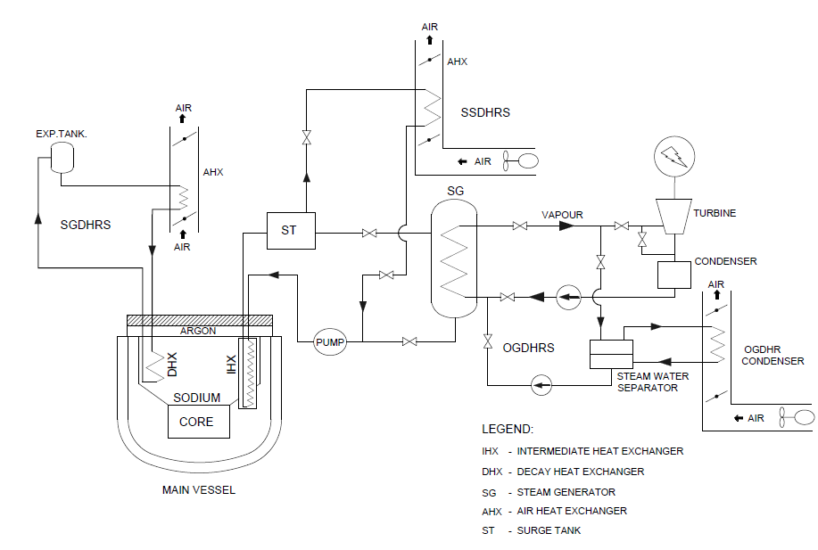

FIG. 1. Decay heat removal systems for FBR 1&2

## LITERATURE REVIEW

LMFBRs utilizing secondary sodium systems for decay heat removal requirements are studied based on the available literature, about the size of the reactor, details of decay heat removal path & type of flow (natural or forced), and consolidated based on literature review.

### BN 800

BN800 is a pool-type reactor with an 800MW electrical power rating. In BN800 SFR, Decay Heat Removal (DHR) system, which can operate in both active and passive mode, is being used to remove the residual heat through Air Heat Exchanger (AHX) connected to every loop of the Secondary Sodium System (SSS) [1, 2]. The process path is shown in figure 2.

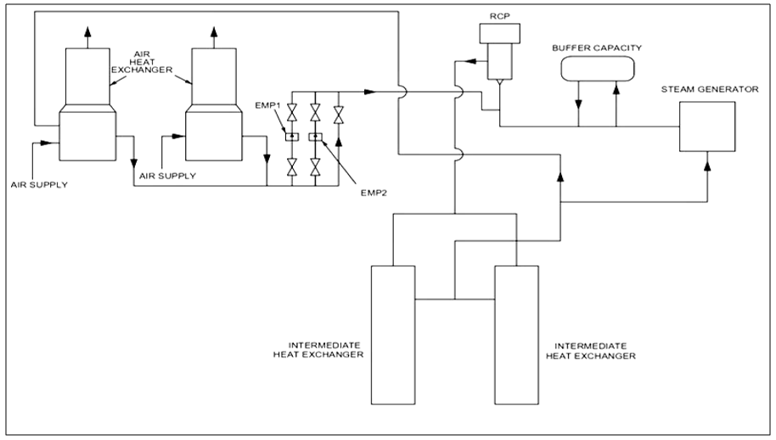

FIG. 2. Emergency reactor cooling system used in secondary sodium system of BN 800 (Adopted from [1])

### Superphenix

In super Phenix, SSS is designed to take part in the residual decay heat removal [3] (known as BPR) by both passive and active means, and a sodium air exchanger is placed for this purpose [3]. The heat removal capacity is 4 x 12.5 MWt = 50 MWt by forced circulation and 4 x 5.4 MWt = 21.6 MWt (i.e., 43% of forced circulation rating) by natural circulation for 550˚C average temp of reactor block. The process path is shown in figure 3.

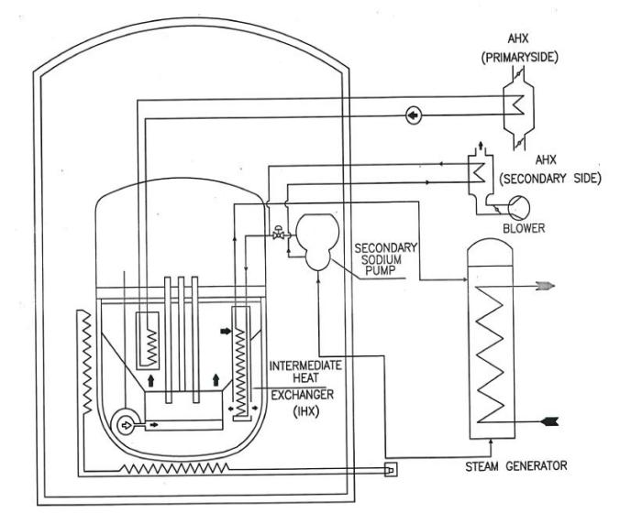

FIG. 3. Process flow chart of Decay heat removal circuit used in SSS of Super Phenix (adopted from [3])

Experiences:

1. The AHX performance was lower than expected on the secondary side during the trial.
2. Due to excitation of the blade at the natural frequency, blade breaks occur on a BPR fan.
3. To avoid the chance of sodium freezing at the AHX tube outlet, an anti-freezing system is used.

### Monju

It is a loop-type reactor with a capacity of 280 MWe. It has three loops. This reactor has a DHR system in the SSS [4]. The process path is shown in figure 4. The heat from the main loop to the DHR system was transferred via heat transfer coils placed within the IHX shells. Though EMPs drove the secondary coolant of the DHR system in SSS, elevation in piping and equipment are so chosen that they will enforce natural circulation. The thermal center difference of nearly 9 m between core and IHX and nearly 25 m between IHX and air cooler was provided to ensure adequate flows.

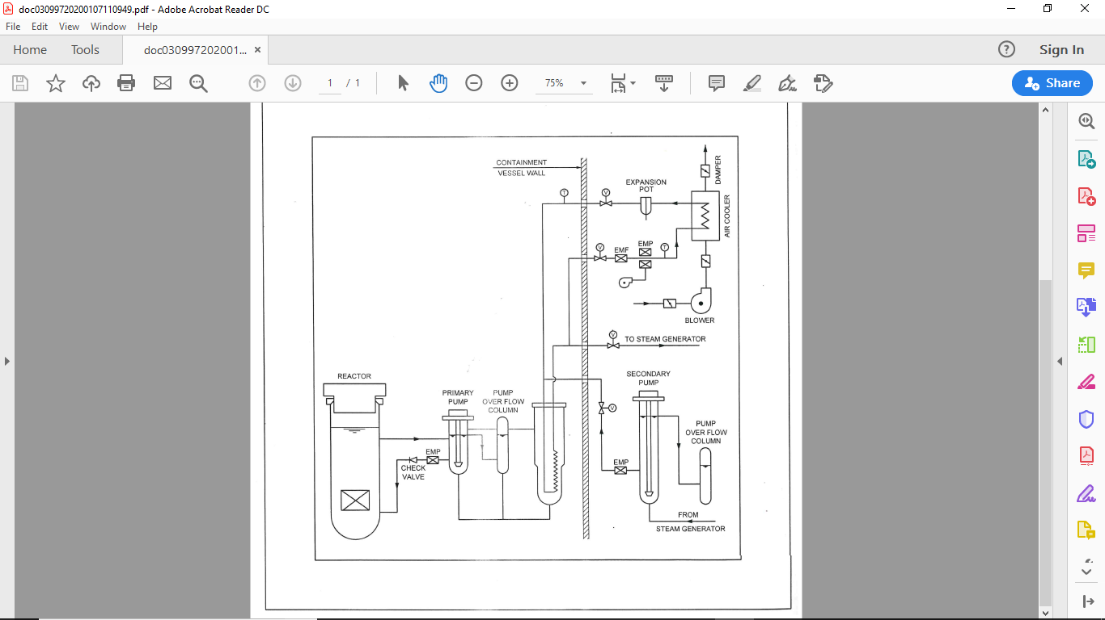

FIG. 4. The process flow path of secondary sodium cooling system in MONJU (adopted from [4])

## Decay HEAT removal capacity

In PFBR, SGDHR is designed to remove 24 MWth, with 3 out of 4 circuits available (i.e., n-1 criteria). This heat removal capacity is ~1.92% of the total thermal power of 1250 MWth of the reactor. For FBR 1&2, in addition to SGDHR and OGDHR systems similar to that in PFBR, a new DHR system known as SSDHRS is planned. When deciding the heat removal capacity of SSDHRS for FBR 1&2 (2×600MWe), a proportional value is considered abeit not with n-1 criteria. Considering the 1500 MWth rated capacity of FBR 1&2, the minimum decay heat removal capacity required is ~28.8 MW. Considering the space constraints and optimization of the overall cost, one DHR circuit of 15 MW is planned to be riding on both the secondary sodium circuit.

## SSDHRS SYSTEM DESCRIPTION

SSDHRS loops are integrated into the Secondary Sodium Main Circuit (SSMC). It is planned to have two secondary circuits in each FBR. Each SSMC is provided with one SSDHR circuit, as shown in (Figure 5). This is an active system with forced circulation on both sodium and airside. There also exists a provision to remove heat with a reduced capacity using natural circulation. Each SSMC consists of Intermediate Heat Exchangers (IHX), Surge Tank (ST), Steam Generators (SGs), and Secondary Sodium Pump (SSP). Each SSDHR system is provided with one AHX of rated capacity. The inlet to the AHXs is taken from the ST located in the hot leg of SSMC. The discharge line of the AHX is joined to the inlet header of SSP. The airside, bird screen, louver, inlet damper, blower, expansion bellow at the exit of AHX, outlet damper, stack, and hood are provided in each loop, similar to the SGDHR system.

* 1. **Air heat exchanger (AHX)**

It is a cross-flow type shell and tube Heat Exchanger (HX) with finned tubes for airflow on the shell side. The HX has inlet and outlet headers. The inlet and outlet header are connected by a serpentine finned tube bundle having three-row arranged in four banks with three U bends. The Schematic of AHX is shown in figure 6. The AHX is placed inside the Steam Generators Building (SGB) at 52 m elevation, just below ST, to facilitate gravity flow to AHX. Ambient air is induced through the AHX tube bank by a blower. The AHX casing is leak-tight to avoid hot air entry into SGB.

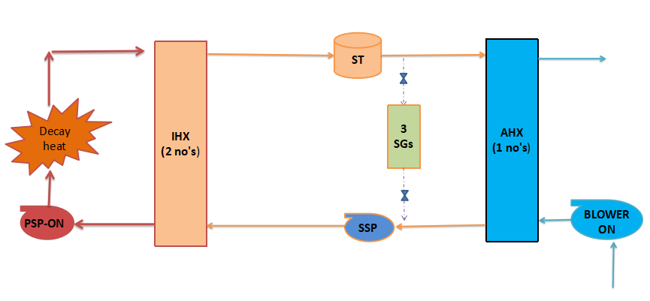

To atmosphere

FIG. 5. Schematic of secondary sodium-based decay heat removal system



FIG. 6. The sectional view of the air heat exchanger

* 1. **Blower**

The blower is used to supply air from the atmosphere to AHX and exhaust it back to the atmosphere. One blower of total capacity is recommended for the SSDHR system. The blower is also provided with a diesel power supply to increase the availability. The blower is placed on the inlet side of the AHX at a 45 m elevation. After heat exchange in AHX, the hot air is exhausted to the atmosphere through the stack.

## Requirements, advantages & drawbacks of SSDHR system

The major considerations for the requirements of the SSDHR system are discussed below.

1. In the SSDHR system, the airside flow is maintained by the blower to take care of severe cyclonic conditions.
2. The SSDHR system is provided with a diesel generator power supply, and it is independent of the steam-water system. Hence, it can cater to fuel handling and other maintenance conditions instead of the OGDHR system, which requires an off-site power supply, recirculation pumps, condenser cooling fans, steam generators, etc.
3. SSDHR system can be seismically qualified compared with the OGDHR system, which depends on the steam water system located away from the nuclear island and is not qualified for SSE events. Hence the reliability of the SSDHR system improves the reliability of the overall DHR system significantly.
4. Eliminates loss of complete DHR systems when there is a common cause failure leading to loss of all SGDHR circuits

The advantages and disadvantages of SSDHRS are discussed below.

Advantages:

1. This system could be brought into operation with minimal time delay.
2. This system's reliability is higher than OGDHRs due to its independent off-site power supply and steam water system components.
3. The Air Heat Exchangers (AHX) for SSDHRS can be placed inside Steam Generator Building (SGB), below surge tank, which allows gravity flow of sodium from the surge tank to AHX and hence, there is no need for an extra tank for expansion of sodium as surge tank is a part of this system.
4. Since AHX is placed inside SGB and the blower is provided with DG power, this system is available during severe cyclone events.
5. This system can be designed for a specified heat transfer capacity through natural circulation.

Drawbacks:

1. More floor space in SGB is required to accommodate AHX, blower, etc.
2. To increase the availability of SSDHRS, secondary sodium systems may be designed for a higher safety class, or diesel generator power supply to SSP, blower, etc., needs to be provided.

## Process design for forced circulation flow

The SSDHRS process path consists of 2 IHXs, a surge tank, AHX, SSP, associated piping, and one blower on the airside. The process design of AHX, associated piping is carried out with design data of IHXs (designed based on heat removal capacity of SSMC). The SSDHRS process design is carried out by considering the 20% of the nominal flow on the primary sodium pump (PSP), Secondary Sodium Pump (SSP) with a reduced flow, and blower on the airside. The process design is carried out using the visual basic code.

To design the AHX, all four inlet and outlet temperatures are estimated. The airside inlet temperature (TAi) is taken as atmospheric. The outlet temperature (TAo) is limited to 287 °C, similar to SGDHR in PFBR. The blower capacity required for the airside is estimated from using equation-1.

$$Q=m_{a}C_{pa}\left({TA}_{o}-{TA}_{i}\right) (1)$$

To estimate the sodium inlet and outlet temperatures to AHX, primary side sodium temperature to the inlet (TPi) and outlet (TPo) to IHX are estimated. The hot pool temperature of 544 °C is taken as the inlet to both the IHX, and the flow on the primary side (mp) is assumed to be maintained as 20 % of the nominal of each PSP. The outlet temperature from IHX on the primary side is 531.5 °C, as estimated using equation-2.

$$Q=m_{p}C_{pn}\left({TP}_{i}-{TP}_{o}\right) (2)$$

The secondary inlet temperature to IHX (TSi), secondary outlet temperature from IHX (TSo), the number of tubes required for AHX (n) are estimated using equation 3-5 by assuming a secondary side flow (ms). A similar design of AHX is being used in PFBR. Hence other dimensions except for the number of tubes of AHX are taken as constant. $$Q=m_{s}C_{pn}\left({TS}_{o}-{TS}_{i}\right) (3)$$

$$Q={(UAθ_{LMTD }) }_{IHX } \left(4\right)$$

$$Q={(UAθ_{LMTD }) }_{AHX } \left(5\right)$$

As the other parameter is constant, the heat transfer through AHX is dependent on the area of the heat exchanger and velocity inside the tube. The tube diameter and length are adopted similar to the PFBR. nceHenHENHEHE Hence, the heat transfer depends on the number of tubes on AHX and the velocity inside the tube. The following studies are carried out to arrive at the optimal number of tube and mass flow rate. The graph (shown in figure 7) is plotted between velocity in AHX, percentage flow of secondary sodium pump, and the number of tubes. As the secondary sodium flow increases, the number of tubes decreases, the rate of decrease is very high up to 10 %, and tube velocity increases linearly. The ideal flow percentage is around 6 % of secondary sodium full flow. However, to limit the sodium velocity below 2 m/s, the secondary sodium flow rate is kept as 4 % of the nominal flow rate. For the 4 % flow, the secondary inlet temperature to IHX, secondary outlet temperature from IHX, no of tubes required for AHX (n) are 454 °C, 544 °C, and 129 tubes, respectively.

Studies are also carried out to find the air velocity in the shell side of AHX with respect to airflow rate and respective air outlet temperature. The results are plotted in figure 8. Figure 8 also depicts the number of tubes required to meet the given heat removal rate with respect to the airflow rate in the shell side of AHX. From the study, the optimal number of tubes is 120. The chosen 129 tubes are very close to the optimal value. The respective chosen air flow rate is 52 m3/s, and velocity in the shell side is ~5 m/s which is to be considered for FIV studies for tube bundle supporting requirements.

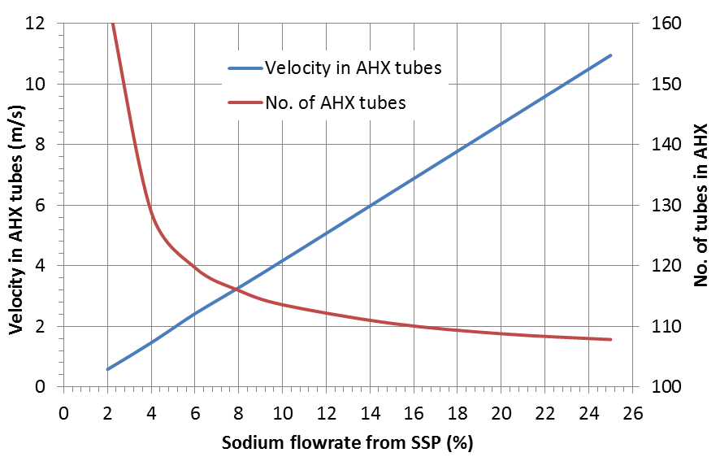

FIG. 7. Sodium velocity in AHX tubes and number of tubes with respect to % flow from secondary sodium pump

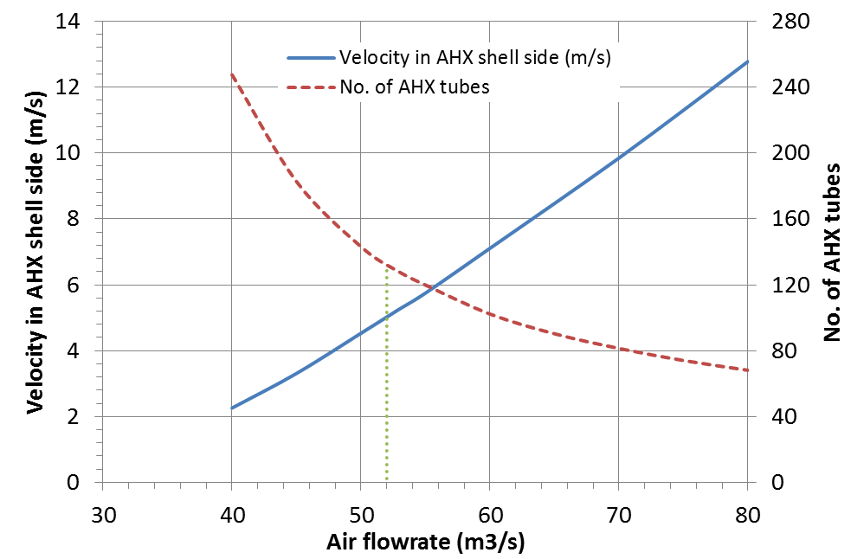

FIG.8 Air velocity in AHX shell side and no. of tubes required with respect to air flow rate from blower operation

**6.1 Sodium pump selection**

The flow rate required to meet the DHR requirement is 569 m3/h for FBR 1&2. The EM pumps are not capable of meeting such flow rates. Hence secondary sodium pump with the reduced flow is used in the SSDHRS for FBR 1&2.

The typical pump system characteristic curve for SSDHRS and SSMC is shown in figure 9 below. The pressure head generated by SSP for 4 % flow of rated capacity is not adequate for the SSDHRS circuit.

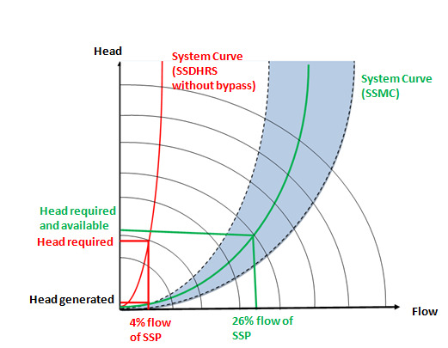

FIG. 9. Typical pump system characteristic curve for SSDHRS and SSMC

Hence, a bypass line is provided from the SSP outlet to the SSP inlet line (or AHX outlet line) with a control valve. The total pressure drop of the SSDHR line together with the bypass ­line is matched with the pressure drop of the SSMC system curve to enable the SSP to operate near to the best efficiency point.

After implementing the bypass line, the flow through the SSP is estimated as 26 % of rated capacity (863 kg/sec), of which 4% flow is sent through AHX of SSDHRS. The remaining flow is bypassed through the bypass line.

## Process design for natural circulation flow

The SSDHRS is primarily designed for forced circulation. However, provision is also made to cater for natural circulation without aiding active components such as pumps and blowers. The process path is shown in figure 9. The provision includes elevation in piping and equipment chosen to enforce natural circulation. Also thermal center differences of nearly 33 m between IHX and AHX and 30 m tall chimney for the air side were provided to ensure adequate flows.

The process design calculation is carried out using an in-house developed code. The flow chart of the code for natural circulation is given in figure 11. The primary side is assumed to be forced circulation using primary pumps with constant 20 % flow (477 Kg/sec) of IHX rated capacity.

For natural circulation flow in both secondary sodium and airside, heat removal capacity for each SSDHR system is estimated with respect to reactor sodium temperature and plotted in figure 12. The heat removal capacity is compared with forced convection flow using a secondary sodium pump. For a nominal reactor temperature of 550 °C, the heat removal capacity is 8.6 MWt for natural circulation flow which is 57% of the heat removal capacity during forced circulation flow. Natural circulation mode of heat transfer through SSDHRS will avoid loss of complete DHR systems when there is a common cause failure of all SGDHR circuits.

The evolution of secondary sodium flow rate and airflow rate with natural circulation flow for various reactor sodium temperatures are predicted and plotted in figure 13.

The effect of chimney height on heat removal capacity during the natural circulation flow in the airside of AHX is studied for the nominal sodium temperature of 550 °C and plotted in figure 14. Chimney height of 30 m is considered optimum for natural circulation flow in the air exit of AHX, and the same is proposed for FBR 1&2.

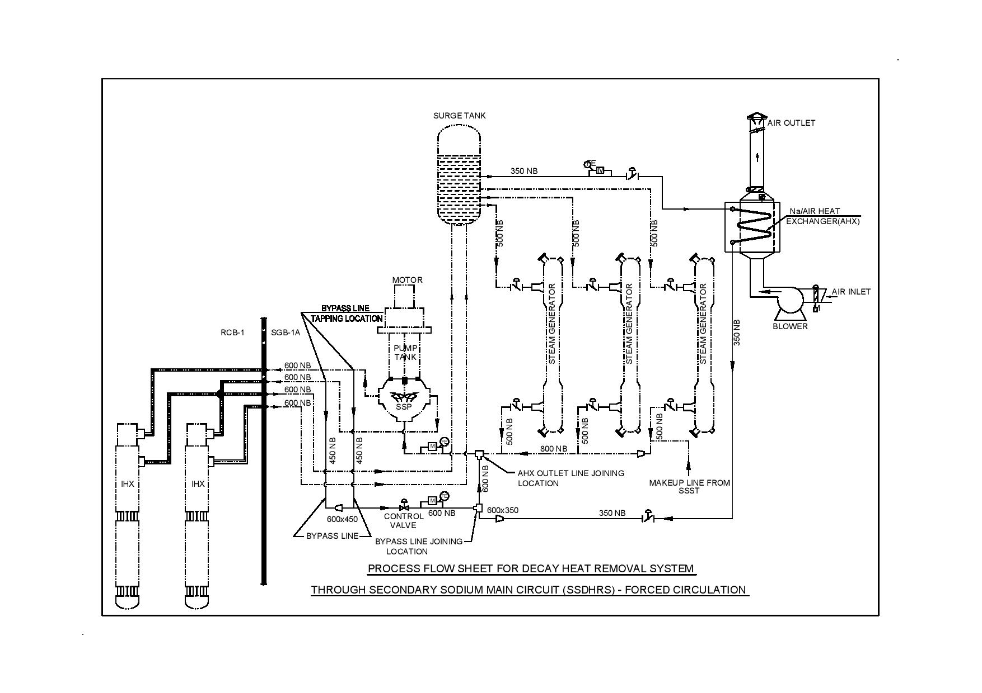

FIG.10. Schematic of secondary sodium based decay heat removal system (forced circulation)

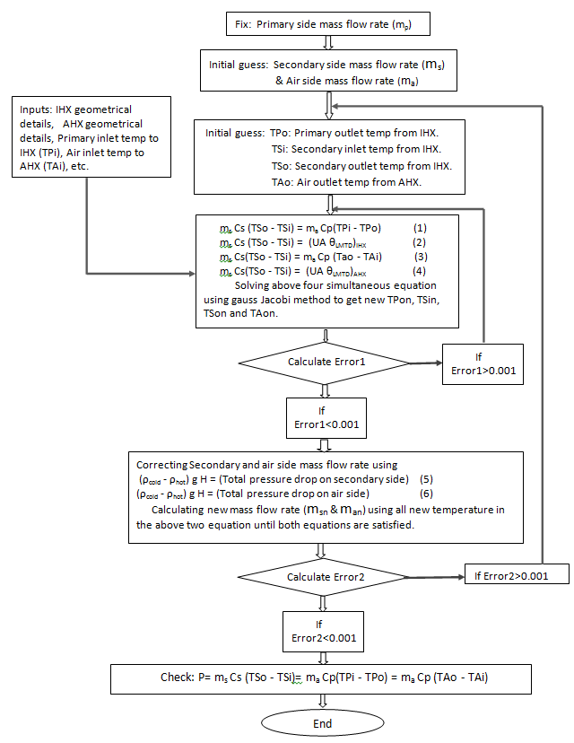

FIG.11. Flowchart for process design calculations for natural circulation flow in SSDHR system

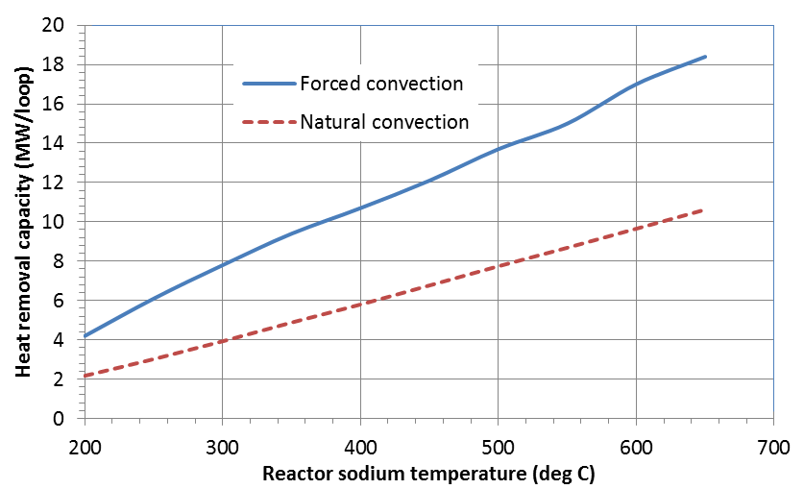

FIG. 12. Heat removal capacity between forced and natural convection

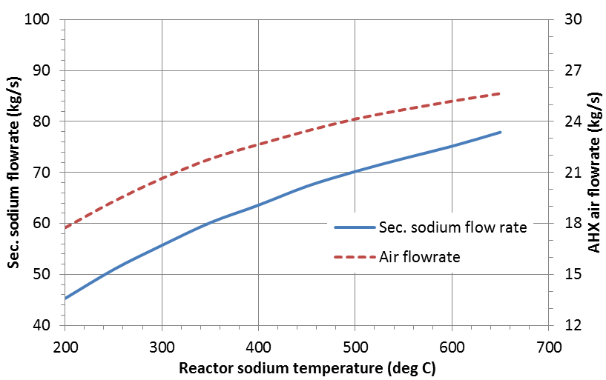

FIG. 13. Evolution of secondary Sodium and air flow rate during natural convection

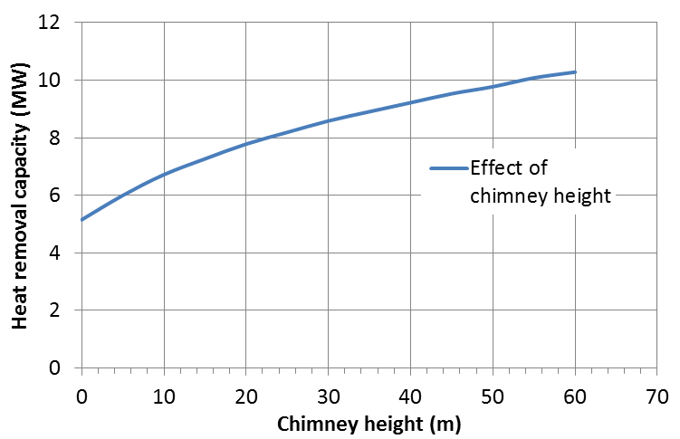

FIG.14. Effect of chimney height on heat removal capacity by natural circulation

## COnclusion

The process design of SSDHRS is carried out for both forced circulation and natural circulation modes of flow through both secondary sodium and airside. The heat removal capacity for forced circulation mode is 15MWth per secondary sodium loop (SSP). For forced circulation flow, secondary sodium main pump is used for secondary sodium flow, and a blower is used for the airside flow. One AHX of 15MWt rating is considered in these studies.

Studies are carried out for natural circulation capacity considering SSP and blower in OFF condition. The heat removal capacity is estimated as 8.6 MWth per SSDHR loop, about 57% of capacity achieved during forced circulation flow. With two secondary sodium loops available, the SSDHR system alone would also satisfy the DHR requirements as a diverse DHR system. The process path, piping layout, and component locations are finalized considering the proposed layout of FBR 1&2 (2×600MWe).

References

1. Y. M. ASHURKO, A presentation on sodium cooled Fast Reactors: Current status and proposal for the second workshop, 5th GIF/INPRO interface meeting, IAEA HQs, Austria, (2011).
2. Joint stock Company St. Petersburg Research and Design institute, BN-800 NPP, (2011).
3. Joel Guidez, Gerard Prele, Superphenix Technical and Scientific Achievements, (2017).
4. Nuclear Engineering International, (June 1975).