Integrated assessment of high-performance scenarios for HL-2M

L. Xue
Southwestern Institute of Physics (SWIP)
Chengdu, China
Email: xuelei@swip.ac.cn

J. Garcia², G.Y. Zheng¹, X.R. Duan¹, G.T. Hoang², J.F. Artaud², J.X. Li¹, H.L. Du, X. Song¹, S. Wang¹, M. Xue¹, F. Liu^{1,2}, G. Giruzzi², X.L. Zou², W. Pan¹

¹ Southwestern Institute of Physics, Chengdu, China
² CEA, IRFM, F-13108 Saint-Paul-lez-Durance, France

Abstract
HL-2M is the new tokamak of SWIP, generating the first plasma in 2020. It is dedicated to support the critical physics and engineering issues of ITER and future fusion reactors. As one of the major missions of the machine, exploring key physics for the high-performance plasma is emphasized. This paper will firstly introduce the assessment of high-performance scenarios analyzed by Integrated modeling. Simulation results show that The high-performance operation can be realized at plasma current as high as 2.5 mega-ampere. In such regime, the normalized beta can reach 3, the triple-product can reach about 10²⁰. In a moderate Greenwald density fraction, the central ion temperature can reach 10keV. These allows HL-2M to own the capability to carry out ITER relevant plasma physics. In support of ITER pre-fusion phase operation (Hybrid and Steady State), the advanced scenarios, such as the hybrid and the steady state regimes can be achieved. For the non-inductive regime, the normalized beta can reach 3.4, and the confinement enhancement factor can exceed 1.3.

INTRODUCTION
For supporting the critical physics and technique research of ITER and future fusion reactors, the new medium-sized tokamak HL-2M has been built at Southwestern Institute of Physics (SWIP) [1,2]. It aims to address key physics and technology issues, e.g. (1) tests and qualification of various advanced divertor concepts, such as Snow Flake (SF) and Tripod, on both physics and technological aspects; 2) Tests and validation of high heat flux plasma-facing components; 3) Investigation of advanced plasma physics with high performance, and design of scenarios compatible with advanced divertor configurations. The main parameters anticipated of the machine: plasma current I_{p}=2.5~3MA, toroidal field B_{T}=2.2~3T, major radius R = 1.78 m, minor radius a = 0.65 m, elongation $≥$1.8, triangularity ~ 0.5. It was designed to have flexible configuration in order to explore various divertor configurations [3]. For realizing high-performance operation, three Heating & Current Drive (H/CD) systems, with maximum power of 27MW, were designed for HL-2M. 15MW of the neutral beam injections (NBI) provided by three heating windows (2 co-current tangent injection (angle: 42º-45º) and one counter-current tangent injection based on four sets of 80 kV/45A bucket deuterium ion sources) [4]; The ECRF system on HL-2M is constituted of eight gyrotrons, each of which has a nominal power of 1 MW. Two of those ECRF gyrotrons can be operated with a dual-frequency, i.e. 140 GHz and 105 GHz，and are connected with the upper launcher. The other six gyrotrons can only be working at the single frequency of 105 GHz, and are connected with the equatorial launcher. This allows the heating and current drive to be located in a large range of the radial coordinate. Toroidal injection angles of equatorial launcher and upper launchers are respectively in the range of -20 to 20 degrees and -25 to 25 degrees. Poloidal injection angles of the equatorial launcher and the upper launchers can be respectively varied from -20 to +15 degrees, -80 to -15 degrees and -90 to -30 degrees (For the poloidal angle, along the horizontal direction of the injection, the degree obtained by the counter-clockwise rotation is the minus. For the toroidal angle, the injection degree with the same direction (clockwise) as the magnetic field is minus). Furthermore, all the launchers can perform real-time feedback control scheme in the poloidal direction, used to control the transient plasma MHD events such as the neoclassical tearing modes (NTM). The lower hybrid current drive (LHCD) has 4MW at the 3.7GHz frequency [5]. The LHCD antenna is a full active multi-junction (FAM) with a peak parallel refractive index n//0 of 2.25. Such auxiliary heating system allows the machine to heat and control high performance plasmas, as well as a variety of advanced scenarios. This paper will introduce the high-performance scenarios with mega-ampere level discharges, including the conventional and advanced regimes.

capability assessment
In this section, we use METIS [6] to assess the operation capabilities (such as the inductive, hybrid and full non-inductive regimes) for HL-2M, based on the double-null configuration with elongation of 1.8. During the simulation, the engineering limits, of the auxiliary heating duration and of the heating loads in the coils, are assumed to be free. Thus, performing H-mode plasmas at these conditions is limited by the available poloidal flux of 14Wb.

2.1. Conventional inductive operation
From a set of METIS simulations, foreseen in HL-2M when we operate ECRF in the current drive scheme. Note that the ITPA2008 scaling of L-H transition threshold predicts a total power of about 10 MW to access H-mode at nominal condition, i.e., Ip = 2.5 MA, B_{T} = 2.2 T and line averaged density N_{bar} ~1.9×10²⁰ m-3 (Greenwald fraction f_{G}=1). Thus, performing H-mode plasmas in HL-2M in these conditions is possible with NBI alone (15 MW available), or with a combination of NBI and ECRF (8 MW available). When using only NBI, the current flat-top phase lasts about 1.5s, which is limited by the available poloidal flux of 14 Wb. However, operating at such high-density regimes could lead to a significant loss of NBI power (up to ~20%), mainly from first orbit losses due to high edge density. At this high density, the LH wave propagation and the power absorption should be an issue.
In Table 1, for the case Ip = 2.5 MA, B_{T} = 2.2T and N_{bar} = 1.1x10²⁰m⁻³ corresponding to f_{G} = 0.6, in the regime of 15MW NBI heating alone, the thermal stored energy reaches 2.6 MJ. The values of central electron and ion temperatures reach respectively 6.1 keV and 8.1 keV. β_{N} could reach 2.2 with f_{BS}=0.18 and f_{NI}=0.22. It allows the plasma flat top to be maintained more than 7s, when the 14Vs restriction of the poloidal flux consumption is considered. When adding 8 MW of on-axis ECCD (15MW NBI + 8MW ECRF), the central electron and ion temperatures can be increased to 8.3keV and 9.0keV. The thermal stored energy reaches 3.2 with β_{N} =2.7. Meanwhile, the f_{BS} and the f_{NI} could achieve to 0.25 and 0.29, respectively. The triple product can reach 2.0×10²⁰m⁻³skeV with G factor of 0.26. In case of further implementing 4MW LH wave (15MW NBI + 8MW ECRF + 4MW LHW), deposition peak of which is around ρ=0.7 assessed by C3PO/LUKE, The thermal stored energy reaches 3.5 with β_{N} =2.9. Meanwhile, the f_{BS} and the f_{NI} could increase to 0.28 and 0.35, respectively. In this case, the fusion triple product can achieve to 1.8×10²⁰m⁻³skeV, which is a little bit lower than that of C1 due to the decrease of the energy confinement. The central electron and ion temperatures can reach 8.7keV and 9.4keV. In the case with lower density (C5 in Table 1) with the same heating combination as C4, the central electron and ion temperatures can respectively be increased to 9.2 keV and 11 keV. Time evolution of the main parameters of C5 is shown in Fig. 1.

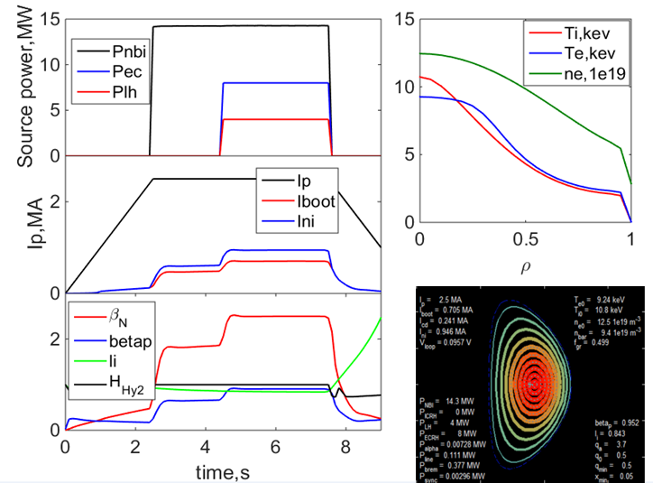
Fig. 1. Waveform and profiles of plasma parameters in the regime of Ip=2.5MA / B_{t}=2.2T with P_{heat}=27MW and f_{G}=0.5

Table 1. Main plasma parameter in the flat top of conventional inductive regimes
Parameters | Conventional inductive
 | C1 | C2 | C3 | C4 | C5
I_{p} (MA) / B_{T} (T) | 2.5 / 2.2 | 2.5 / 2.2 | 2.5 / 2.2 | 2.5 / 2.2 | 2.5 / 2.2
κ / δ | 1.8 / 0.5 | 1.8 / 0.5 | 1.8 / 0.5 | 1.8/ 0.5 | 1.8 / 0.5
a / R (m) | 0.65 / 1.78 | 0.65 / 1.78 | 0.65 / 1.78 | 0.65 / 1.78 | 0.65 / 1.78
f_{G} | 0.6 | 0.6 | 0.6 | 0.6 | 0.5
P_{NBI} / P_{EC} / P_{LH} (MW) | 15 / 0 / 0 | 15 / 8 / 0 | 15 / 8 / 2 | 15 / 8 / 4 | - / 8 / 4
X_{EC} / X_{LH} | -/ - | 0.3 / - | 0.3 / 0.7 | 0.3 / 0.7 | 0.3 / 0.7
q₉₅ | 3 | 3 | 3 | 3 | 3
β_{p} | 0.7 | 0.9 | 1 | 1 | 1
β_{N} | 2.2 | 2.7 | 2.8 | 2.9 | 2.8
f_{BS} / f_{ni} | 0.18 / 0.22 | 0.25 / 0.29 | 0.26 / 0.32 | 0.28 / 0.35 | 0.28 / 0.37
T_{e}(0) / T_{i}(0) (keV) | 6.1 / 8.1 | 8.3 / 9.0 | 8.5 / 9.2 | 8.7 / 9.4 | 9.2 / 11
W_{th} (J) | 2.6 | 3.2 | 3.3 | 3.5 | 3.3
H_{98(y,2)} | 1 | 1 | 1 | 1 | 1
G | 0.26 | 0.31 | 0.32 | 0.33 | 0.31
n(0)τT_{i}(0) (1e¹⁹m⁻³skeV) | 2.0 | 1.9 | 1.8 | 1.8 | 1.7

2.2. Advanced scenario
Development of Advanced Tokamak scenarios has also been investigated. By tuning the off-axis ECCD power deposition, the negative magnetic shear can be controlled in the core region, triggering an internal transport barrier (ITB), which leads to enhancement of the core confinement. It is worth noting that LHCD alone is not efficient for controlling the current density profile due to its broad power deposition. But LHCD helps ECCD for alignment of non-inductive driven current with the bootstrap current which is a well-known issue in AT operation. A main finding from our simulations is that large fractions of non-inductive current - with moderate bootstrap fraction - can be obtained when operating HL-2M at plasma currents below 1.5 MA even at high density f_{G} > 0.7. Achievement of fully non-inductive AT plasmas is possible when operating at Ip below 1.2 MA and f_{G} > 0.7. Five cases are summarized in Table 2, including three hybrid regime and two full-non-inductive regimes. Hybrid scenario can be realized with Ip=1.0~1.4MA, f_{G}~0.5 by combining NBCD with ECCD or ECCD+LHCD In Hybrid regimes, the fractions of bootstrap current f_{BS} and total non-inductive current fni are between 30%~45% and 70%~90%, respectively; β_{N} could reach around 2.5 with H_{98(y,2)}~1.1(H1,H2 and H3 in Table 2 ). Full non-inductuve regimes, such as the hybrid steady state regime and the regime with a reversed magnetic shear, could be reached around 1MA of plasma current with the bootstrap current fraction exceeding 50%. Simulation of fully non-inductive AT case with Ip = 1MA shown in Table 2 is illustrated in Fig. 2. H&CD powers (10 MW NBI, 5.5 MW ECCD) are applied at the early phase of current flat-top. ECCD power depositions are centered at the normalized radius r/a ~ 0.42. Hollow profile of safety factor q occurs that leads to the enhancement of the core confinement, due to negative magnetic shear, with β_{N} = 3.4 being below the no-wall β limit (4× li = 4.0), Te(0) = 7.5 keV, and Ti(0) = 12 keV. Thus, HL-2M can provide experiments for physics issues in the condition where Ti >Te, vanishing loop voltage and high β_{N} simultaneously. This is not only necessary for modeling activity, but also relevant for the preparation of operations foreseen on ITER, and reactor-grade facilities.
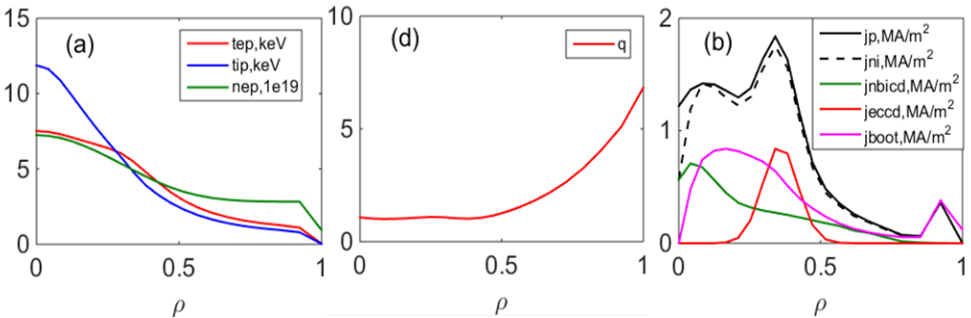
Fig. 2. Parameter profiles of the full non-inductive regime with Ip=1.2MA (F1): temperature and density profiles (a), q profile(b), current profile(c)

Table 2. Main plasma parameter in the flat top of hybrid and full non-inductive regimes
Parameters | Hybrid |  |  | Full non-inductive
 | H1 | H2 | H3 | F1 | F2
I_{p} (MA) / B_{T} (T) | 1.4 / 2.2 | 1.0 / 2.0 | 1.0 / 2.0 | 1.2 / 1.7 | 1.0 / 1.85
κ / δ | 1.8 / 0.5 | 1.8/ 0.5 | 1.8 / 0.5 | 1.8 / 0.5 | 1.8 0,5
a / R (m) | 0.65 / 1.78 | 0.65 / 1.78 | 0.65 / 1.78 | 0.65 / 1.78 | 0.65 / 1.78
f_{G} | 0.47 | 0.5 | 0.5 | 0.5 | 0.73
P_{NBI}/ P_{EC}/ P_{LH} (P_{EC2}) (MW) | 10 / 5 / (2) | 6 / 7 / (1) | 6 / 6 / 3 | 10 / 5.5 / - | 1.5 / 3.5 / 4
X_{EC} / X_{LH} | 0.34 / (0.28) | 0.4 / (0.2) | 0.3 / 0.7 | 0.42 / - | 0.45 / 0.6
q₉₅ | 5.5 | 4.8 | 4.7 | 5.1 | 4.8
β_{p} | 1.3 | 1.7 | 1.6 | 1.8 | 1.9
β_{N} | 2.3 | 2.5 | 2.4 | 3.4 | 2.3
f_{BS} / f_{ni} | 0.33 / 0.76 | 0.40 / 0.86 | 0.41 / 0.89 | 0.55 / 1.00 | 0.63 / 1.00
T_{e}(0) / T_{i}(0) (keV) | 8.4 / 9.2 | 6.7 / 6.1 | 6.5 / 5.8 | 7.5 / 12.0 | 4.0 / 4.0
W_{th} (J) | 1.3 | 0.85 | 0.82 | 1.3 | 0.95
H_{98(y,2)} | 1.05 | 1.1 | 1.03 | 1.29 | 1.32

preliminary analysis of sn plasma
In this section, the performance of the standard single-null plasma with elongation of 1.5 and triangularity of 0.43 is further analyzed by the integrated modelling suite—CRONOS. Two kinds of expected high-performance D-D scenarios (including the conventional inductive regime of Ip=1.8MA and the hybrid regime of Ip=1.4MA) are investigated. As shown in Fig. 3., the initial equilibrium boundary is provided by EFIT/FEEQS. Other initial guess provided for CRONOS [7-11] is provided by METIS and EPED-NN / Scaling law. In CRONOS, the NBIH&CD is calculated by NEMO+SPOT, while ECCD is calculated by REMA. NCLASS and Qualikiz modules are implemented for the neoclassical transport and the anomalous transport, respectively. For maintaining the target density of the core, the electron density profile (versus the normalized magnetic flux radius) of the puffing is assumed as a Gaussian distribution function around the edge. Zeff is assumed as 2 with the core impurity of Carbon. Considering the fixed-boundary equilibrium module HELENA integrated in CRONOS is difficult to describe the magnetic structure of the divertor leg, in order to verify the output divertor configuration from CRONOS, a free-boundary code–FEEQS is implemented to check the reasonable PF coil voltage keeping the target divertor leg.

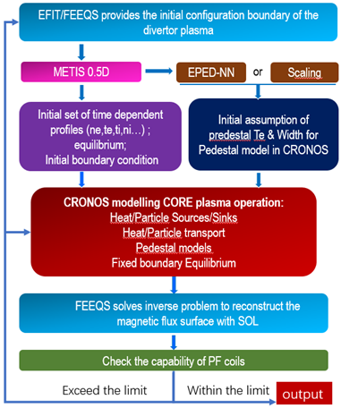
Fig. 3 Workflow of the integrated analysis

For the conventional inductive H-mode regime of Ip=1.8MA / B_{T}=2.2T with the line-averaged density N_{bar} of 9.0×10¹⁹m⁻³ (Greenwald density fraction f_{G}=0.69), NBI of 15MW combining with ECW of 8MW are implemented. In such condition, the O-mode with the frequency of 105/140 GHz allows the EC wave propagates deeper than the X-mode in the plasma, obtaining the deposition peak around ρ=0.4-0.5. Meanwhile, the NBI deposition power on ions is around 4 times of that on electrons in the core, and the total NBI deposition power profile is flat within ρ=0.65, shown as Fig. 4. The non-inductive current fraction is 0.34 with the bootstrap current fraction of 0.29. The low pedestal pressure causes the low bootstrap current at the pedestal, corresponding to the potential favorable ELM stability. Due to the very low off-axis additional current drive, the current profile gets peaked in the center with β_{p}=1.2. The thermal energy of the plasma reaches 2.0MJ with the high β_{N} of 3.0 which is seemed to be compatible with li(3)=0.9 of the peaked current profile for avoiding the resistive wall mode (RWM) instability. Similar to ITER baseline, the q₉₅ can reach 3.0. Both the ion and the electron temperature of the center can reach around 5keV, shown in Fig. 5.

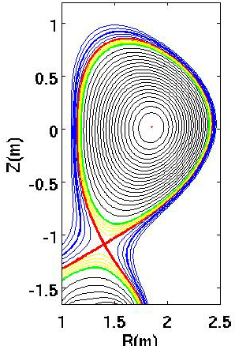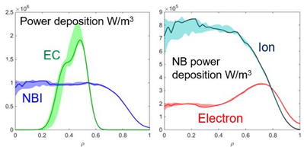
Fig. 4. Single-null standard configuration(left), total power deposition profile of NBI and EC (middle), NBI power deposition on ions and electrons (right)

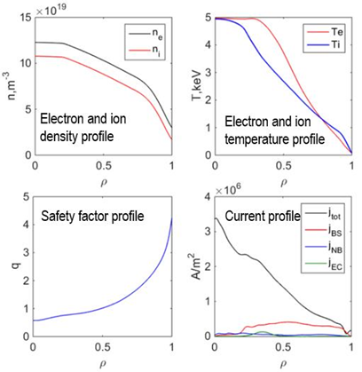
Fig. 5. Parameter profiles of the conventional inductive regime of Ip=1.8MA

For the hybrid regime of Ip=1.4MA / B_{T}=2.2T with Nbar=4.9×10¹⁹m⁻³, NBI of 8MW combine with the equatorial ECW (X-mode + 105GHz) of 6MW and upper ECW (X-mode + 140GHz) of 2MW are implemented shown in Fig. 6. In this case, power the deposition peak of NBI is on-axis, while the ECW deposition peak is off-axis. Comparing to the conventional inductive regime, both the bootstrap current fraction and the additional drive current fraction increase. The total non-inductive drive current fraction reaches 0.6. As shown in Fig. 7, the substantial increased off-axis drive current allows the magnetic shear to get flat around the center. The center safety factor q₀ increases to 1.2 and the minimum safety factor q_{min} increases to 0.94 with the location of ρ=0.35. Such weak reversed shear is seemed to lead to the internal transport barrier ITB generating around the center, allowing the energy confinement to increase obviously. The H_{98(y,2)} reaches 1.3. Similar to the ITER hybrid scenario, q₉₅ in this regime reaches 3.9. The ion and the electron temperature of the center can reach 6.4keV and 8.5keV, respectively. The thermal energy of the plasma reaches 1.4MJ with the high β_{N} of 3.1.

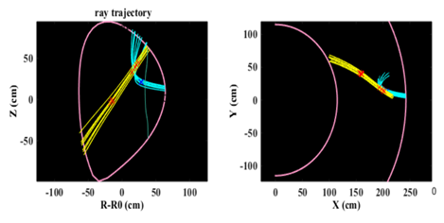
Fig. 6. Trajectory of the two ECWs

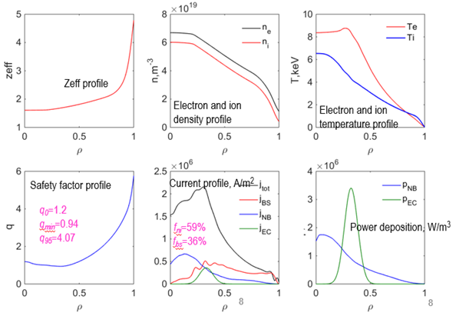
Fig. 7. Parameter profiles of the hybrid regime of Ip=1.4MA

Summary

The results obtained in this paper show that HL-2M is a flexible tokamak able to obtain a broad variety of plasmas due to the different combinations of heating and current drive systems, in particular a significant electron heating. This is especially important for the correct assessment of future tokamak devices which, unlike most of the present-day high-performance plasmas, will be dominated by the electron heating due to the alpha power generated by fusion reactions. Therefore, in HL-2M, topics as turbulence or power exhaust in steady-state scenarios at high β_{N} could be studied in conditions closer to those expected in tokamak reactors. These allows HL-2M to have the capability to carry out ITER relevant plasma physics, supporting ITER pre-fusion phase operation.

ACKNOWLEDGEMENTS
This work is implemented in the framework of SIFFER. This work was supported by the CNNC Elite Project under grant nos. 2019JZYF-01 and the National MCF Energy R&D Program under grant nos. 2019YFE0340002, 2018YFE0301101.

References
- Duan X. R. et al 2017 1st Asia-Pacific Conference on Plasma Physic (Chengdu, China, 18-23 Sep. 2017) P29
- Li Q. et al 2015 Fusion Engineering and Design 96-97 338
- Zheng G.Y. et al 2016 Nucl.Fusion 56 126013
- Cao J.Y. et al 2013 Fusion Engineering and Design 88 872
- Huang M. et al, 17th Joint Workshop on Electron Cyclotron Emission and Electron Cyclotron Resonance Heating, EPJ Web of Conferences 147, 04006 (2017).
- Artaud J.F et al 2018 Nucl.Fusion 58 105001
- Artaud J.F. et al 2010 Nucl. Fusion 50 043001
- Garcia J. et al 2008 Physical Review Letters 100 255004
- Garcia J. and Giruzzi G. 2010 Physical Review Letters 104 205003
- Garcia J. and Giruzzi G. 2012 Plasma Phys. Control. Fusion 54 015009
- Garcia J. et al 2013 Plasma Phys. Control. Fusion 55 085006

