- Background

The paper summarizes the work conducted by the authors working on the International Atomic Energy Agency (IAEA) Coordinated Research Project (CRP) on “Improved Assessment of Initial Alarms for Radiation Detection Instruments – J02005” and more specifically, Ghana carried out its project on “Investigation of Initial Alarms from Radiation Detection Instruments”. The goal of the CRP is to developing a composed tool for Front Line Officers (FLOs) to aid them in their analyses of cargo containing characters of radioactive materials at border post. Ghana was tasked to gather enough data on alarming containers at selected border post in Ghana to aid in the development of a composed tool for FLOs. Per the deliverables in the detailed programme, data collection has been carried out on 700 conveyances/containers covering all kind of commodities passing through the three selected borders using the Identifinder which is a hand held tool. Sixty-two (62) containers identified radioisotopes indicating the presences of Naturally Occurring Radioactive materials (NORMs). Data collected was inputted into a computer tool called ICAAD which was transferred onto the IAEA data sheet to aid in the development and implementation of the Tool for Radiation Alarm and Commodity Evaluation (TRACE) application and associated algorithms. Commodity type, Container information, Dose rate reading from the RHDs, and Identified radioisotope (NORMs) were recorded. This provided detailed information for various cargo commodities. Apart from the project helping to develop the TRACE, it also revealed interesting outcomes which will be of significant help to the FLOs and the state in the provision of RPMs at its border posts.

- Facilities
Facilities which were used for the research were;
- Kotoka International Airport
- Sea port (Tema and Takoradi Harbour)
The Kotoka International Airport (KIA) is the only international airport in the country. It is also a destination for the import and export of commodities. The cargo section of the port has a scanning department which scans the containers and only determines the type of commodity in the container. There is no RPM at the airport to detect the presence of radioactive materials transported in and out of the port. There are two major sea ports in Ghana, these are the Tema harbour and the Takoradi harbour. The Tema port is located on the eastern coast of Ghana and the Takoradi port is located on the western coast of Ghana. These are the ports where large quantities of containers of commodities are imported and exported on daily bases. Commodities at these ports are transported in 20 and 40 footer containers.

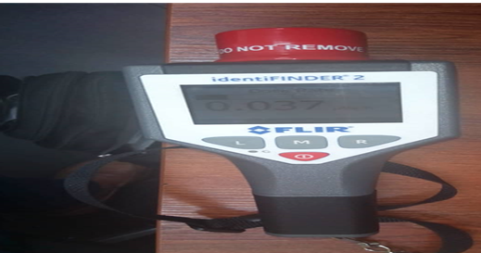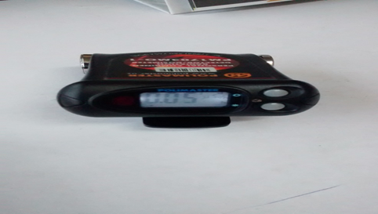
Fig 1. Detection Instruments used (Identifinder and Pager)

- Overall Program of Work

Officers for the project made a familiarization tour to the facilities listed above to get a firsthand information of activities carried out there;
- The two parties engaged in an agreement (MOU) with the scanning companies which permitted us to carry out the research project and also develop a time table for visits;
- A data collection sheet was developed by the project officers;
- Project officers had a thorough study of a computer tool called ICAAD;
- Data of containers measured were collected and later recorded in the ICAAD.

3.1 Data Collection Process
- The identifinder is first callibrated and a background reading is taken in identifing mode and recorded at a location far from the operational area;
- Measurement is then taken on containers by move the device very close to the container for a period of two (2) minutes on one side of the container.
- Container numbers, dose rate and container type were recorded on a data sheet. This activity continued on all containers identified to be going through the scanner;
- Details of the containers (HS Code, Commodity type, Weight and Origin) of which measurements were taken were entered in the data sheet the following day.
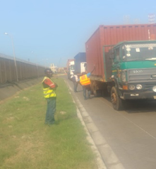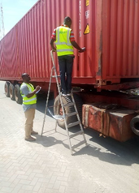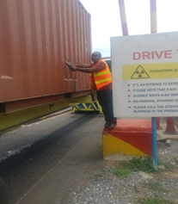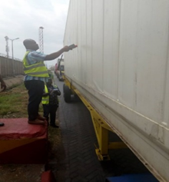
FIG. 2. Project officers taking measurements of containers
- Results
Measurement of 700 containers were recorded and analyzed. It comprises of sixty-two (62) commodities identified with radioisotopes, two hundred and fifteen (215) indicating ‘unknown’ radioisotopes and four hundred and twenty-three (423) indicating ‘insufficient counts’ of isotopes in the commodities when the Identifinder was used. Below is a chat representing the data collected.
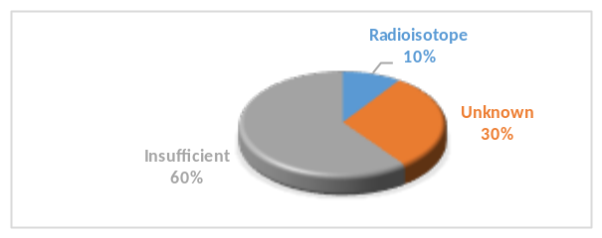
FIG.3. Percentage of data collected for 700 containers

  - Radioisotopes Commodities
Dark gray reflective glass, Blue Reflective glass, Bronze tinted glass, Floor Tiles, Ceremic floor tiles, Luminar Flat Plates, Chemical (DV), Sanitary ware, Kitchen ware goods, Plastic bags, Alumina ceramics, Used bicyle, Caustic soda flakes, Aluminium cans, Rubber slippers, Iron chips sheets, Pallet of uncoated paper, Fertilizer, Cotton bud, Aluminium profile, Plastic products, Alumina ceramics, Rubber slippers, Iron chips sheets, Pallet of uncoated paper, Cotton bud.

Table 1: Radioisotopes identified and Corresponding Frequencies
Radioisotopes | Frequency
I-131 | 2
Th-232/U-232 | 9
Cs-134 | 8
K-40 | 30
Ra-226 | 7
Mn-54 | 3
Eu-152 | 5
Co-60 | 1
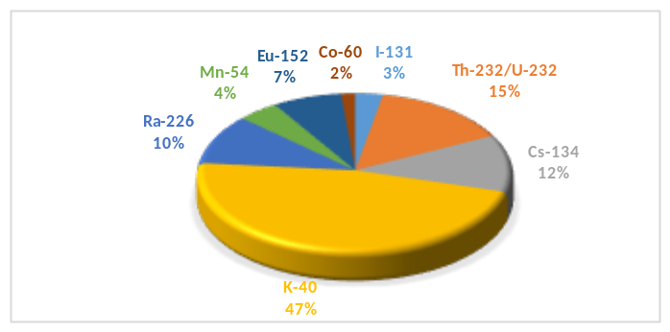 Fig 4. Percentages of alarmed radionuclides

- Interesting Case
Measurement was taken on a cargo at the Airport cargo section and the reading was 4.0 mSv/hr using the pager, a secondary inspection was done with the Identifinder and it alarmed as Thorium (Th-232). The commodity was documented as silver cups but physical examination showed that it was Quantum Pendant and flask.

- Conclusion
- The targeted number of data on containers was not realized but the results gave a fair idea of the outcome if enough containers were measured.
- The dose rates of the radioisotopes identified were higher than the background dose rates.
- For 100% data collection of cargoes the use of handheld is not preferred.

The project was very interesting and insightful for the project staff, an awareness on activities concerning movement of cargoes at the port was known. There is the possibility of illicit trafficking of radioactive materials since detection capabilities of the Frontline Officers (FLOs) are very low.
Moving forward, the project officers suggest considering the following steps:
- FLOs should be provided with enough RHDs to carry out detection activities at the port.
- It is prudent that portal monitor be situated at major border points to boast detection abilities, thus the IAEA could assist member states in acqiuring RPMs.

- References
[1] “Shipping and World Trade - Overview,” International Chamber of Shipping, (2020).
www.ics-shipping.org/shipping-facts/shipping-and-world-trade
[2] “How Many Shipping Containers Are There in the World?” Budget Shipping Containers, www.budgetshippingcontainers.co.uk/info/how-many-shipping-containers-are-there-in-the world/.

