# Spatial Variations in the Physicochemical Parameters, Trace Metal Concentration AND radon level in Groundwater of Qatar- A Comparative View between the Past and Present

Y. MANAWI

Qatar Environment and Energy Research Institute (QEERI), Hamad bin Khalifa University (HBKU), Qatar Foundation,

Doha, Qatar

Email: [ymanawi@hbku.edu.qa](mailto:ymanawi@hbku.edu.qa)

H. AL-SULAITI

Qatar Environment and Energy Research Institute (QEERI), Hamad bin Khalifa University (HBKU), Qatar Foundation,

Doha, Qatar

Email: [halsulaiti@hbku.edu.qa](mailto:halsulaiti@hbku.edu.qa)

**Abstract**

The study presents a recent overview of the status of Qatari groundwater in terms of its physicochemical parameters, trace elements and radon content. This study was necessitated because the last comprehensive study on groundwater characteristics of Qatar was carried out and presented by Schlumberger Water Services (SWS) in 2009 and since then there has not been a study conducted to give a holistic study of the groundwater covering the entire State of Qatar. Hence the present study, is a way, is a follow-up to the SWS findings, 10 years apart. The study will report on spatial variations in some of the most important physicochemical parameters in addition to trace metals content. The trace elements concentrations in the groundwater were evaluated using ICP-MS and ion chromatography. Radon concentrations in the groundwater were determined using radon detector (RAD7). The analysis of the Qatari groundwater has shown some alarming results. Out of the 80 groundwater wells studied, 42, 29 and 46 wells exceeded Qatar guidelines for drinking water, Qatar guidelines for irrigation and USEPA, respectively. The level of Boron, Molybdenum and Lithium were significantly higher than the Qatar Guidelines, WHO and USEPA for drinking water and irrigation. The radon level measurements of the Qatari groundwater were between 2.71 and 330 Bq/L with a mean value at about 20.6 Bq/L which is greater than the US EPA’s maximum contamination level of 11 Bq/L. Similarly, a total of 32 and 33 exceedances to the US EPA’s maximum contamination level (MCL) of 11 Bq/L and EPA’s drinking water guidelines, respectively were observed. The comparison of the results from the present work to Schlumberger’s results showed that quality of Qatari groundwater is deteriorating due to the extreme over pumping and the low recharge rate. The results from this work can help manage groundwater resources in Qatar.

## INTRODUCTION

Qatar is an arid country with no surface water resources. The only source for aquifer recharge is rainfall. The annual average rainfall falls between 10 and 200 mm. The long-term average is 76 mm per year [1]. On the other hand, the natural evaporation rate of Qatar is estimated at about 2000 mm/year [2]. In Qatar, there are two main aquifers; namely: Rus and Abu Samra. Rus aquifer, also known as Dammam and Umm er Radhuma, lies in the northern part of the country and is composed of chalky limestone. On the other hand, Abu Samra aquifer lies in the south-western part and is mainly granular limestone rocks. The salinity of the two aquifers varies; Rus aquifer has salinity level between 500-3000 mg/L of total dissolved solids whereas that of Abu Samra aquifer is between 4000 to 6000 mg/L. [3]. Fig. 1 shows the main aquifers across the map of Qatar. In general, Qatar’s aquifers are composed of carbonate and are characterized with larger number of cavities, fractures and depressions [1]. Unfortunately, this is the reason why Qatar’s aquifers are very vulnerable to contamination by anthropogenic sources, which can easily infiltrate and spread to larger area.

Before 1960, the water demand for municipal applications were met by groundwater resources. Nowadays, all freshwater demand comes from the desalination plants whereas the water demand for agriculture comes from groundwater. As a result of the boom in the economic and industrial sectors, Qatar’s annual water demand has reached 766 million cubic meter in 2012 compared to 218 million cubic meter in 1990. This water demand is now met by desalination, groundwater abstraction and reuse of treated sewage effluents [4]. Nowadays, about 36% of the water demand in Qatar is supplied by groundwater which is mainly used for agriculture [4]. The increase in the agricultural activity has been found to be proportional to the population growth in Qatar in order to meet their supply. Groundwater is the only feasible option to support agriculture keeping in mind that desalination process is costly. This can be seen by comparing the current agricultural water consumption to that earlier. In 1974, the water demand for agricultural purposes was estimated at 44 million cubic meter compared to 238 million cubic meter in 2013 [5]. According to Schlumberger Water Services report in 2009, the number of wells used in Qatar was estimated to be more than 8500 [6]. Around seventy percent of the groundwater abstraction in Qatar occur in the northern part (the wells penetrate Rus formation with average depths estimated between 60 and 70 meters). The extraction rate of groundwater in Qatar has reached unprecedented levels resulting in severe water table drop. For instance, the annual groundwater extraction rate is around 250 million cubic meters; this figure is about five times the estimated annual natural freshwater recharge which is about 50 million cubic meters. The annual groundwater pumping rate was estimated at 400 million cubic meter accounting for about seven times of the renewal rate of the same year [7]. The annual groundwater extraction rate, which is estimated at about 800% of the available renewable water resources, has resulted in the reduction of the groundwater reserves and hence reduction of their quality. The amount of renewable freshwater resources in Qatar in 2006 was estimated at 47 cubic meter per capita per year whereas in 2015 it was estimated at 27 cubic meter per capita per year [8]. The effect of extensive water pumping and its consequent seawater intrusion in Qatar has been widely reported in literature. For instance, Schlumberger water services (SWS), has published a study to characterize the quantity and quality of Qatari groundwater and aquifers. In their report, they discussed the increase in the salinity of the groundwater over time in Qatar. Fig. 2 shows the increase in the salinity level between 1971 and 2009 across the map of Qatar. Moreover, SWS described the change in the freshwater area in Qatar with time. The estimated freshwater lens in 2009 was about 11% of its size in 1971. The freshwater lens area in 1971 was estimated at about 15% of Qatar’s area whereas in 2009, the area has declined to 2% only. Out of the total number of wells surveyed in 2009, which were estimated at 8509, 4304 wells were either: non-pumping, dry or cancelled. This constituted more than 50% of the total number of wells in Qatar [6].

In 2014, Shomar et al [9] conducted a similar work to analyse the Qatari groundwater by collecting 205 samples from different wells across Qatar. The study reported on the physicochemical parameters, trace element, anions and cations content of the sampled groundwater. It would be worth investigating to have an update on the wells status now and in order to have a more accurate idea about the groundwater quality in Qatar. In the work reported by SWS in 2009, the main recommendation in the report was to monitor future salinity changes and water quality to ensure water is safe for use. This work aims to carry on the monitoring of the Qatari groundwater in order to fully describe the status of the groundwater resources, which will help in managing and extending the lifetime of such resources.

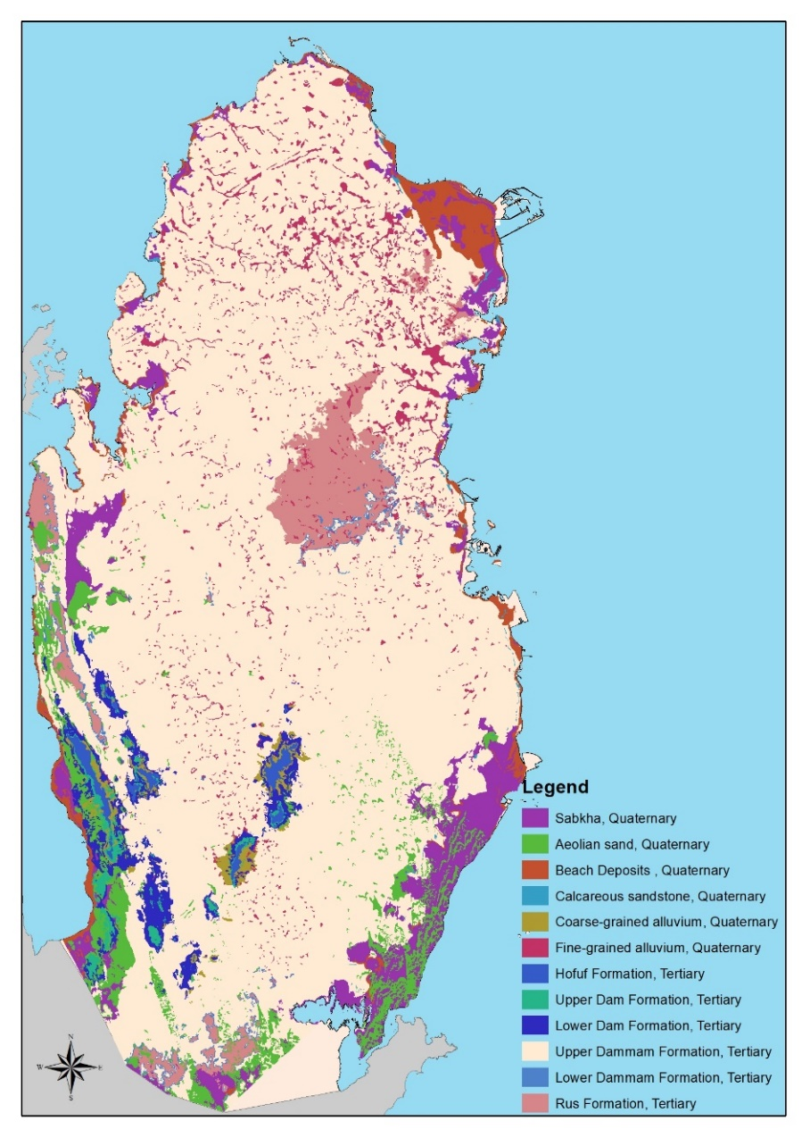

*FIG. 1. Qatar’s surface geological map [1]*

## Materials and Methods

## **2.1 Materials**

For sample preservation, nitric acid (ACS reagent) was purchased from Sigma Aldrich (Missouri, United States). Nalgene high-density polyethylene sampling bottles with closure (2 and 4-liter size) were acquired from Thermo Fisher Scientific (Massachusetts, United States).

## **2.2 Methods**

## *2.2.1 Sampling locations selection*

In this work, 80 groundwater wells were selected for sampling such that the well sites represented influencing factors like different groundwater basins lithology and sampling location end-use like industrial, domestic and agricultural. Fig. 2 shows the selected groundwater wells across the map of Qatar. For crosschecking of the analysis results, sample duplication was conducted by sampling groundwater from another well in the same well location.

These well sites were chosen from the list of wells which were sampled earlier by SWS. However, at places where a well was found dry, perhaps due to overexploitation, well in close proximity was selected (within 5 km distance).

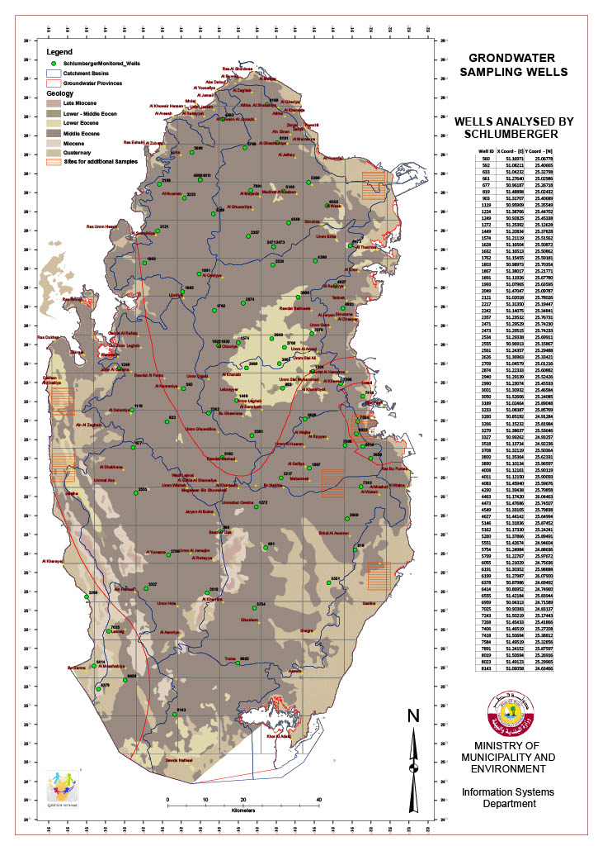

*FIG. 2. Sample locations of groundwater wells across the map of Qatar*

## *2.2.2 Sampling procedure*

* The sampling procedure was developed and followed to ensure the collection of groundwater that describes the real groundwater conditions and not the stagnant water in the well. Hence, before the sample collection the groundwater from well was pumped for at least 30 minutes.
* On-field (in situ) measurement of water quality parameters (such as pH, temperature and SEC) for every well was performed before collecting sample.
* The sampling bottles were thoroughly rinsed with water from the well for 3-4 times before being fully filled, capped and were then labelled with sample number, date and time using permanent markers.
* For sample preservation, acidification of some of the samples was performed using nitric acid-HNO3 (up to HNO3 concentration of 2%) for heavy metals characterization using the ICP-MS.
* On-site addition of HNO3 to samples was performed to reach pH values between 1.5 and 2.
* All sample bottles were kept in cold room which is maintained at 4 0C before their analysis.

## *2.2.3 Physico-chemical analysis*

The physicochemical parameters of the groundwater such as EC, temperature and pH were determined on field using portable multi-parameter from Hanna (Rhode Island, USA). Prior to measurement, the multi-parameter was calibrated, and the probe was rinsed with deionized water first followed by the groundwater sample.

Secondary electrical conductivity (SEC) of the groundwater samples were determined using the total dissolved solids (TDS). The secondary electrical conductivity and TDS are well-correlated in literature. In this work, equations (1 & 2) were used to determine the TDS of the groundwater in Qatar which were used by SWS in their report. The correlation coefficients of these equations were developed by SWS based on the historical data of Qatari groundwater (between 1971 and 2003) and was also verified in 2009 with a correlation coefficient of 0.99 [6].

TDS = 0.65 X SEC ---------------------------- for SEC values below 5,000 µS/cm (1)

TDS = 0.70 X SEC --------------------------- for SEC values above 5,000 µS/cm (2)

## *2.2.4 Characterization*

The chemical analysis of the groundwater samples was conducted using inductively-coupled plasma (ICP) mass spectrometry (MS) from PerkinElmer, model NexION 300D The reference calibration standards were acquired from Fluka (New Jersey, USA) and AccuStandard (Connecticut, USA). In this work, the water analysis of the groundwater samples included 21 chemical elements, which are Lithium, Beryllium, Aluminum, Vanadium, Chromium, Iron, Manganese, Copper, Nickel, Cobalt, Zinc, Strontium, Molybdenum, Silver, Cadmium, Barium, Lead, Boron, Arsenic, Uranium-238 and Potassium.

The statistical analyses were performed using the statistical package for the social sciences (SPSS) software.

## *2.2.5 RADON MEASUREMENT*

Radon in ground water samples was measured by a radon detector RAD7 (Durridge Co. Ltd) applying RAD-H2O method to detect alpha radiation. The samples were analyzed on-field at the sampling location in order to avoid any decay taking place hence it was only a few minutes between taking the sample and its analysis. DURRIDGE’s RAD7 has a solid state alpha detector which is a semiconductor material (silicon) that translated alpha particles into an electrical signal allowing its energy to be detected. The sample air is pumped and reaches the detector chamber or internal cell with a volume of 0.7 liters.

## Results and discussions

## **3.1 Physico-chemical parameters (pH, SEC)**

Table 1 lists the pH and SEC of the studied wells across the map of Qatar. Fig. 3 depicts the interpolated maps of TDS, pH and turbidity which were plotted using the IDW method. As seen in the iso-concentration maps (Fig. 3), the highest electrical conductivity values were observed in the coastal areas whereas the lowest were in the north-central part of Qatar.

The 2961 wells surveyed by SWS in 2009 showed some quite high physicochemical parameters such as SEC and pH. The maximum SEC value was 57.6 mS/cm whereas the mean value was 6,402 mS/cm.

Table 2 lists the exceedances of the general water quality statistics and standards/guidelines as found in this study.

**Table** 1. Physico-chemical parameters of the wells analyzed

|  |  |  |  |  |
| --- | --- | --- | --- | --- |
| **well code** | **PH** | **Conductivity (mS/cm)** | **TDS (PPM)** | **Turbidity (NTU)** |
| 592 | 7.37 | 3.45 | 2242.5 | 0.28 |
| 661 | 7.85 | 6.58 | 4606 | 0.19 |
| 677 | 7.4 | 5.36 | 3752 | 0.38 |
| 819 | 7.38 | 7.8 | 5460 | 0.55 |
| 903 | 7.32 | 3.41 | 2216.5 | 0.15 |
| 1224 | 7.41 | 41700 | 29190 | 0.21 |
| 1272 | 7.46 | 40.8 | 28560 | 0.48 |
| 1449 | 7.39 | 2.78 | 1807 | 0.36 |
| 1574 | 7.25 | 2.45 | 1592.5 | 0.43 |
| 1762 | 7.48 | 1.345 | 874.25 | 0.16 |
| 1803 | 6.5 | 22.3 | 15610 | 16.5 |
| 1891 | 7.66 | 1.086 | 705.9 | 0.58 |
| 1993 | 7.45 | 1.693 | 1100.45 | 0.17 |
| 2049 | 1.4 | 36 | 25200 | 0.42 |
| 2121 | 7.48 | 17.98 | 12586 | 0.81 |
| 2217 | 6.28 | 5.35 | 3745 | 1.1 |
| 2242 | 7.23 | 3.19 | 2073.5 | 0.77 |
| 2357 | 7.47 | 2.49 | 1618.5 | 0.25 |
| 2534 | 7.51 | 1.294 | 841.1 | 0.44 |
| 2626 | 7.09 | 40.18 | 28126 | 0.45 |
| 2709 | 6.88 | 24.3 | 17010 | 0.26 |
| 2874 | 7.24 | 17.4 | 12180 | 0.23 |
| 2940 | 7.49 | 3.96 | 2574 | 0.17 |
| 2990 | 7.79 | 4390 | 3073 | 0.16 |
| 3001 | 7.11 | 40.38 | 28266 | 0.58 |
| 3189 | 7.8 | 12.15 | 8505 | 0.18 |
| 3233 | 7.22 | 9.81 | 6867 | 0.71 |
| 3266 | 7.15 | 2.21 | 1436.5 | 0.26 |
| 3279 | 6.41 | 4350 | 3045 | 0.17 |
| 3327 | 7.23 | 10.84 | 7588 | 0.51 |
| 3518 | 7.17 | 3.37 | 2190.5 | 0.62 |
| 3800 | 7.19 | 2.44 | 1586 | 0.31 |
| 3890 | 6.09 | 8.18 | 5726 | 0.38 |
| 4083 | 7.14 | 4.5 | 2925 | 0.89 |
| 4290 | 7.15 | 2.46 | 1599 | 0.62 |
| 4473 | 7.24 | 12.3 | 8610 | 0.3 |
| 4549 | 5.3 | 2.45 | 1592.5 | 1.03 |
| 5146 | 7.24 | 3.02 | 1963 | 0.18 |
| 5162 | 7.75 | 6.24 | 4368 | 0.24 |
| 5551 | 7.38 | 8.14 | 5698 | 0.25 |
| 5754 | 6.97 | 4.78 | 3107 | 0.58 |
| 5799 | 7.53 | 8.34 | 5838 | 0.28 |
| 6055 | 7.06 | 17.16 | 12012 | 0.51 |
| 6191 | 7.8 | 7840 | 5488 | 0.12 |
| 6199 | 7.39 | 6.39 | 4473 | 0.16 |
| 6555 | 7.3 | 10.51 | 7357 | 0.47 |
| 7418 | 6 | 42.7 | 29890 | 0.46 |
| 7584 | 7.2 | 7.02 | 4914 | 0.2 |
| 8019 | 7.17 | 4.28 | 2782 | 0.29 |

|  |  |  |
| --- | --- | --- |
|  |  |  |

*FIG. 3. Spatial variation in TDS, pH and turbidity in groundwater*

Table 2. General Water Quality Statistic and Guideline/Standards Exceedances

|  |  |  |  |  |  |  |  |  |  |  |  |  |  |  |  |
| --- | --- | --- | --- | --- | --- | --- | --- | --- | --- | --- | --- | --- | --- | --- | --- |
| Parameter | Units | Number of Samples | Min | Max | Mean | Qatar Drinking Water Guidelines | Number of Exceedances | Qatar Crop Irrigation Guidelines | Number of Exceedances | Qatar Grass Irrigation Guidelines | Number of Exceedances | WHO  Guidelines | Number of Exceedances | EPA MCL | Number of Exceedances |
| PH |  | 45 | 6.77 | 7.88 | 7.207 | 6.5-8.5 | - | 6-9 | - | 6-9 | - | 6.5-8.5 | - | 6.5-8.5 | - |
| SEC | $μ$ S/cm | 46 | 1112 | 14690 | 4387 |  | - |  | - |  | - | 1200 | 44 |  |  |
| TDS | mg/L | 46 | 722.8 | 10283 | 2972 | 1000 | 42 | 2000 | 29 | 2000 | 29 |  |  | 500 | 46 |

## **3.2 Hydrochemistry (metals, trace elements, anions, cations)**

Table 3 lists the concentration of the chemical elements present in the water samples taken from groundwater wells in Qatar in µg/L (or parts per billion). In Table 3, the water analysis of the groundwater included 21 chemical elements, which are Lithium, Beryllium, Aluminum, Vanadium, Chromium, Iron, Manganese, Copper, Nickel, Cobalt, Zinc, Strontium, Molybdenum, Silver, Cadmium, Barium, Lead, Boron, Arsenic, Uranium238 and Potassium. The concentration of the Table 4 tabulates the exceedances of the general water quality statistics and standards/guidelines as observed in this study. Figs.4-7 show the interpolated maps of Uranium, Boron, Lithium and Molybdenum which were created using the geo-statistics method which investigated spatial variability using Arc-GIS software. Spatial interpolation technique is used by applying inverse distance weighted (IDW) which interpolates on un-sampled locations and converts these samples points to a continuous water quality surface (grid raster).

In 2009, SWS conducted a more thorough investigation of Qatari groundwater by analyzing the water quality and hydrochemistry of 80 wells across the map of Qatar. Out of the surveyed wells, 73 wells exceeded Qatar drinking water guidelines and 62 wells exceeded Qatar crop and grass irrigation guidelines whereas all wells exceeded EPA’s maximum contaminant level (MCL). The concentration of the toxic element Boron in Qatari groundwater was significantly prominent and exceeded WHO guidelines with 75 exceedances out of 80 samples analyzed. The WHO guidelines of boron in drinking water is 0.5 ppm; however, boron concentrations above 5 ppm were observed in Qatari groundwater wells which are used for crop irrigation. A total of 71 samples exceeded Qatar crop and grass irrigation guidelines for Sulfate (SO4). Similarly, chloride and fluoride levels in the groundwater were quite high; 69 wells exceeded Qatar drinking water guidelines and EPA’S MCL. Sixty-nine wells exceeded Qatar grass irrigation guidelines in terms of sodium concentration.

In the work reported by Shomar et al [9] in 2015, groundwater in Qatar contained high levels of molybdenum, lead, arsenic, cadmium and selenium in addition to elevated TDS levels which clearly point out that care must be taken when using groundwater for irrigation. The constant use of groundwater in irrigation will drastically reduce its quality and risk its presence as a source of water for the country.

The current practice of direct land irrigation with highly saline groundwater without pretreatment or desalination has been reported to have detrimental effect on the humans and the environment. The continuous irrigation of contaminated Qatari groundwater without treatment can potentially lead to the chemical loading of several environmental media such as soils, animals, crops by trace elements contaminants. This will eventually increase the risk to humans due to the persistence nature of trace elements [9-12]. Moreover, the continuous use of saline groundwater for irrigation in Qatar will seriously reduce the crop yields and considerably lower the productivity of the farms [13].

Table 3. concentration of elements analyzed in the water samples taken from groundwater wells in Qatar

|  |  |  |  |  |  |  |  |  |  |  |  |  |  |  |  |  |  |  |  |  |  |
| --- | --- | --- | --- | --- | --- | --- | --- | --- | --- | --- | --- | --- | --- | --- | --- | --- | --- | --- | --- | --- | --- |
| **Well Code** | **Li** | **Be** | **Al** | **V** | **Cr** | **Fe** | **Mn** | **Co** | **Ni** | **Cu** | **Zn** | **Sr** | **Mo** | **Ag** | **Cd** | **Ba** | **Pb** | **B** | **As** | **\*U238** | **\*K** |
| **(ppb)** | **(ppb)** | **(ppb)** | **(ppb)** | **(ppb)** | **(ppb)** | **(ppb)** | **(ppb)** | **(ppb)** | **(ppb)** | **(ppb)** | **(ppb)** | **(ppb)** | **(ppb)** | **(ppb)** | **(ppb)** | **(ppb)** | **(ppb)** | **(ppb)** | **(ppb)** | **(ppb)** |
| 592 | 57.7 | <0.01 | <3.39 | 23.2 | 0.724 | <4.02 | 3.7 | <0.02 | 1.8 | 113.29 | 35.73 | 9051 | 3.85 | 1.79 | <0.01 | <0.54 | 9.05 | 1036 | 1.8 | 5.9 | 45454 |
| 661 | 95.6 | <0.01 | <3.39 | 27.3 | 4.35 | <4.02 | 1.8 | <0.02 | 0.14 | 15.43 | 17.12 | 9857 | <3.31 | 0.48 | <0.01 | <0.54 | <0.38 | 1060 | 1.5 | 9.8 | 31604 |
| 677 | 83.6 | <0.01 | <3.39 | 33.5 | 7.24 | <4.02 | 1.6 | <0.02 | 0.9 | <3.42 | 29.73 | 8878 | <3.31 | 0.18 | <0.01 | <0.54 | <0.38 | 1521 | 0.3 | 9.9 | 29374 |
| 819 | 94.5 | <0.01 | <3.39 | 24.1 | 8.7 | <4.02 | 1.8 | <0.02 | <0.35 | <3.42 | 11.41 | 6140 | 8.21 | 0.36 | <0.01 | <0.54 | <0.38 | 1239 | <0.24 | 4.1 | 54937 |
| 903 | 45.5 | 0.35 | <3.39 | 3.91 | 0.36 | <4.02 | 1.14 | <0.02 | 0.57 | <3.42 | 3.6 | 6943 | 73 | <0.31 | <0.01 | <0.54 | <0.38 | 1042 | <0.24 | 0.1 | 44942 |
| 1224 | 107.8 | <0.01 | <3.39 | 12.5 | 0.36 | <4.02 | 3 | <0.02 | 0.66 | <3.42 | <2.44 | 8567 | 79.85 | <0.31 | <0.01 | <0.54 | <0.38 | 2039 | 0.3 | 1.5 | 67999 |
| 1272 | 59.2 | <0.01 | <3.39 | 21.7 | 5.43 | <4.02 | 2.4 | <0.02 | 0.8 | 41.85 | 35.13 | 7129 | <3.31 | <0.31 | <0.01 | <0.54 | <0.38 | 791 | <0.24 | 5.4 | 27131 |
| 1574 | 35.7 | <0.01 | <3.39 | 17.5 | <0.05 | <4.02 | 1.9 | <0.02 | 0.52 | <3.42 | 16.22 | 5468 | <3.31 | <0.31 | <0.01 | <0.54 | <0.38 | 511 | 1.2 | 4.1 | 19989 |
| 1762 | 27 | <0.01 | <3.39 | 17.4 | 0.36 | <4.02 | 1.1 | <0.02 | <0.35 | <3.42 | 34.23 | 2120 | <3.31 | <0.31 | <0.01 | 48.75 | <0.38 | 273 | 0.3 | 3.2 | 8178 |
| 1803 | 220.8 | <0.01 | <3.39 | 20.2 | 1.45 | <4.02 | 1.4 | <0.02 | 0.38 | <3.42 | <2.44 | 17715 | 17.4 | 1.62 | <0.01 | <0.54 | <0.38 | 1808 | 1.8 | 7.3 | 156872 |
| 1891 | 24.8 | <0.01 | <3.39 | 22.2 | 1.09 | <4.02 | 2.4 | <0.02 | <0.35 | 3.98 | 13.81 | 2577 | <3.31 | <0.31 | <0.01 | 15.06 | <0.38 | 469 | 0.6 | 14.5 | 18576 |
| 1993 | 50.3 | <0.01 | <3.39 | 20.3 | 5.43 | <4.02 | 3.2 | <0.02 | 0.99 | 24.99 | 31.23 | 9435 | 6.89 | <0.31 | <0.01 | <0.54 | <0.38 | 1357 | 3.8 | 4.3 | 50692 |
| 2049 | 183.8 | <0.01 | <3.39 | 27.8 | 1.09 | <4.02 | 1 | <0.02 | <0.35 | <3.42 | <2.44 | 14316 | 48.35 | <0.31 | <0.01 | <0.54 | <0.38 | 2534 | 2.3 | 1.5 | 67954 |
| 2121 | 241.5 | <0.01 | <3.39 | 23.8 | 1.09 | <4.02 | 1.8 | <0.02 | 1.85 | 2.19 | 7.81 | 17423 | <3.31 | <0.31 | <0.01 | <0.54 | <0.38 | 2846 | 1.8 | 20.3 | 112410 |
| 2217 | 106.2 | <0.01 | <3.39 | 29 | 2.54 | <4.02 | 2.9 | <0.02 | 2.32 | 27.46 | 33.33 | 10373 | <3.31 | <0.31 | <0.01 | <0.54 | <0.38 | 1377 | 1.2 | 12.1 | 36959 |
| 2242 | 33.1 | <0.01 | <3.39 | 9.5 | 0.36 | 58 | 3.3 | <0.02 | 4.07 | 26.11 | 40.54 | 5945 | <3.31 | <0.31 | <0.01 | <0.54 | <0.38 | 541 | <0.24 | 4.3 | 24978 |
| 2357 | 43.8 | <0.01 | <3.39 | 21.55 | 1.09 | <4.02 | 1.37 | <0.02 | <0.35 | 16.48 | 15.31 | 3618 | <3.31 | <0.31 | <0.01 | <0.54 | <0.38 | 820 | 2.6 | 2.2 | 28570 |
| 2534 | 29.6 | <0.01 | <3.39 | 41.06 | 5.07 | 105.63 | 4.46 | <0.02 | 0.38 | 26.34 | 54.35 | 3083 | <3.31 | <0.31 | <0.01 | 8.77 | <0.38 | 370 | 0.9 | 0.7 | 19384 |
| 2626 | 86.9 | <0.01 | <3.39 | 19.63 | 5.43 | <4.02 | 2.63 | <0.02 | 0.35 | 30.4 | 18.32 | 8025 | <3.31 | <0.31 | <0.01 | <0.54 | <0.38 | 1406 | 1.2 | 11 | 36564 |
| 2709 | 316.4 | <0.01 | <3.39 | 33.96 | 2.9 | <4.02 | 0.57 | <0.02 | 1.51 | <3.42 | <2.44 | 24122 | <3.31 | 0.44 | <0.01 | <0.54 | <0.38 | 3591 | 2 | 32.5 | 130481 |
| 2874 | 23.5 | <0.01 | 66.7 | 30.95 | 2.53 | <4.02 | 2.97 | <0.02 | <0.35 | 29.62 | 41.74 | 3296 | <3.31 | <0.31 | <0.01 | <0.54 | <0.38 | 373 | <0.24 | 3.4 | 19412 |
| 2940 | 55.1 | <0.01 | <3.39 | 8.13 | 0.36 | <4.02 | 3.09 | <0.02 | 1.56 | 43.77 | 42.64 | 6852 | 99.2 | <0.31 | <0.01 | <0.54 | <0.38 | 1482 | 0.6 | 9.6 | 52335 |
| 2990 | 56.8 | <0.01 | <3.39 | 19.75 | 0.72 | <4.02 | 3.77 | <0.02 | 2.22 | 22.96 | 41.74 | 3892 | 5.65 | <0.31 | <0.01 | <0.54 | <0.38 | 1487 | <0.24 | 3.5 | 52452 |
| 3001 | 58.1 | <0.01 | <3.39 | 11.32 | 1.45 | <4.02 | 4.69 | <0.02 | 2.32 | 25.84 | 1048 | 7883 | 20.63 | <0.31 | <0.01 | <0.54 | <0.38 | 1081 | <0.24 | 5.6 | 39584 |
| 3189 | 134.3 | <0.01 | <3.39 | 17.4 | 1.45 | <4.02 | 15.77 | <0.02 | 1.94 | 23.13 | 20.12 | 11483 | 9.8 | <0.31 | <0.01 | <0.54 | <0.38 | 1279 | 1.2 | 5.8 | 67654 |
| 3233 | 77.9 | <0.01 | <3.39 | 33.9 | 1.09 | 48.89 | 2.86 | <0.02 | 0.99 | 20.47 | 9.61 | 12255 | 6.11 | <0.31 | <0.01 | <0.54 | <0.38 | 1510 | 4.4 | 4.7 | 62586 |
| 3266 | 23.9 | <0.01 | <3.39 | 23.3 | 2.17 | <4.02 | 7.32 | <0.02 | 2.56 | 25.6 | 39.94 | 5343 | <3.31 | <0.31 | <0.01 | <0.54 | <0.38 | 635 | 0.3 | 3.2 | 16961 |
| 3279 | 54.4 | <0.01 | <3.39 | 5.48 | 0.72 | 27.63 | 1.94 | 0.15 | 2.65 | <3.42 | 12.91 | 7231 | 12.04 | <0.31 | <0.01 | <0.54 | <0.38 | 1334 | <0.24 | 5.1 | 45976 |
| 3327 | 110.8 | <0.01 | <3.39 | 25.83 | 6.16 | 39.79 | 2.51 | <0.02 | 1.75 | 29.85 | 24.02 | 9065 | 2.1 | <0.31 | <0.01 | <0.54 | <0.38 | 2425 | 0.9 | 12.6 | 70549 |
| 3518 | 58.6 | 0.35 | <3.39 | 19.15 | 2.53 | <4.02 | 2.29 | <0.02 | <0.35 | 26.38 | 24.32 | 5629 | <3.31 | <0.31 | <0.01 | <0.54 | <0.38 | 315 | <0.24 | 3.8 | 11338 |
| 3800 | 25.5 | <0.01 | <3.39 | 9.63 | 1.09 | <4.02 | 4.12 | <0.02 | <0.35 | 29.38 | 31.53 | 2844 | <3.31 | <0.31 | <0.01 | <0.54 | <0.38 | 427 | 0.6 | 3 | 18395 |
| 3890 | 65.1 | <0.01 | <3.39 | 35.71 | 6.52 | 161.82 | 3.54 | <0.02 | 0.19 | 19.99 | 18.02 | 7857 | 2.94 | <0.31 | <0.01 | <0.54 | <0.38 | 1677 | 1.5 | 6.6 | 54836 |
| 4083 | 63.4 | <0.01 | <3.39 | 1.44 | <0.05 | <4.02 | 2.86 | <0.02 | 2.18 | 18.68 | 28.83 | 4979 | 1.03 | <0.31 | <0.01 | <0.54 | <0.38 | 1427 | <0.24 | 5.2 | 54793 |
| 4290 | 24.4 | <0.01 | <3.39 | 14.03 | 1.09 | 4.42 | 17.6 | <0.02 | 0.57 | 40.23 | 57.06 | 2050 | <3.31 | <0.31 | <0.01 | <0.54 | <0.38 | 495 | 0.3 | 3 | 15873 |
| 4473 | 94.1 | <0.01 | <3.39 | 36.19 | 4.71 | <4.02 | 0.46 | <0.02 | -0.47 | <3.42 | 45.34 | 11216 | 20.44 | 1.92 | <0.01 | <0.54 | <0.38 | 2484 | 0.3 | 6.1 | 78534 |
| 4549 | 22 | <0.01 | <3.39 | 19.93 | 2.53 | <4.02 | 2.29 | <0.02 | -0.85 | 22.63 | 19.52 | 3394 | <3.31 | <0.31 | <0.01 | <0.54 | <0.38 | 993 | 0.9 | 2.3 | 21338 |
| 5146 | 28.7 | <0.01 | <3.39 | 24.81 | 7.24 | <4.02 | 1.14 | <0.02 | -0.38 | 13.71 | 22.82 | 3239 | <3.31 | <0.31 | <0.01 | <0.54 | <0.38 | 620 | 3.5 | 2.2 | 16136 |
| 5162 | 81.4 | <0.01 | <3.39 | 6.14 | 1.07 | <4.02 | 1.49 | <0.02 | 1.67 | <3.42 | 15.01 | 7074 | 13.86 | <0.31 | <0.01 | <0.54 | <0.38 | 1529 | <0.24 | 8.1 | 40666 |
| 5551 | 71 | <0.01 | <3.39 | 31.19 | 11.59 | <4.02 | 2.97 | <0.02 | -0.38 | 15.74 | 26.13 | 6877 | 11.95 | <0.31 | <0.01 | <0.54 | <0.38 | 1472 | 1.5 | 4.4 | 58451 |
| 5754 | 94.9 | <0.01 | <3.39 | 24.57 | 1.07 | <4.02 | 2.17 | <0.02 | 0.52 | 21.65 | 18.32 | 6935 | 3.59 | <0.31 | <0.01 | <0.54 | <0.38 | 774 | <0.24 | 9.9 | 23330 |
| 5799 | 52.3 | <0.01 | <3.39 | 20.35 | 7.49 | <4.02 | 2.74 | <0.02 | 0.43 | 17.97 | 10.81 | 5991 | <3.31 | <0.31 | <0.01 | <0.54 | <0.38 | 2760 | 0.9 | 6.5 | 37856 |
| 6055 | 270.9 | <0.01 | <3.39 | 7.1 | 0.71 | 69.48 | 14.06 | <0.02 | -0.67 | <3.42 | 0 | 11241 | 9.89 | <0.31 | <0.01 | <0.54 | <0.38 | 1580 | 0.3 | 4.1 | 69747 |
| 6191 | 44.2 | <0.01 | <3.39 | 19.45 | 3.21 | <4.02 | 0.23 | <0.02 | -1 | <3.42 | <2.44 | 4546 | 0.19 | <0.31 | <0.01 | <0.54 | <0.38 | 1370 | 2.9 | 3.8 | 36095 |
| 6199 | 54.2 | <0.01 | <3.39 | 18.48 | 2.85 | <4.02 | 2.17 | <0.02 | -0.67 | 17.32 | 8.71 | 6584 | <3.31 | <0.31 | <0.01 | <0.54 | <0.38 | 1221 | 3.2 | 3.8 | 41701 |
| 6555 | 74.7 | <0.01 | <3.39 | 19.51 | 1.78 | <4.02 | 2.86 | <0.02 | 1.33 | 19.42 | 14.41 | 7574 | <3.31 | <0.31 | <0.01 | <0.54 | <0.38 | 1609 | 0.3 | 3 | 61416 |
| 7418 | 97.8 | <0.01 | <3.39 | 5.9 | 0 | <4.02 | 6.06 | <0.02 | 1.67 | 15.64 | 11.71 | 7161 | 4.62 | <0.31 | <0.01 | <0.54 | <0.38 | 1622 | 2.3 | 1.6 | 151069 |
| 7584 | 43.1 | <0.01 | <3.39 | 10.78 | 0.71 | <4.02 | 2.17 | <0.02 | 0.62 | 20.77 | 17.72 | 4650 | <3.31 | <0.31 | <0.01 | <0.54 | <0.38 | 576 | <0.24 | 2.5 | 34165 |
| 8019 | 27.4 | <0.01 | <3.39 | 19.15 | 0.71 | <4.02 | 2.4 | <0.02 | 0.81 | 14.32 | 12.91 | 3268 | <3.31 | <0.31 | <0.01 | <0.54 | <0.38 | 518 | 1.5 | 4 | 28409 |

Table 4. The exceedances of the general water quality statistics and standards/guidelines as observed in this study

|  |  |  |  |  |  |  |  |  |  |  |  |  |  |  |  |  |  |  |  |  |
| --- | --- | --- | --- | --- | --- | --- | --- | --- | --- | --- | --- | --- | --- | --- | --- | --- | --- | --- | --- | --- |
| **Parameter** | **Units** | **Number of Detection** | **Min** | **Max** | **Median** | **Mean** | **Qatar Drinking Water Guidelines** | **Number of Exceedances** | **Qatar Crop Irrigation Guidelines** | **Number of Exceedances** | **Qatar Grass Irrigation Guidelines** | **Number of Exceedances** | **WHO**  **Drinking Water Guidelines** | **Number of Exceedances** | **WHO**  **Irrigation Guidelines** | **Number of Exceedances** | **USEPA**  **MCL Drinking Water Guidelines** | **Number of Exceedances** | **USEPA Irrigation Guidelines** | **Number of Exceedances** |
| U-238 | mg/L | 48 | 0.001 | .0325 | .0043 | .006085 | .03 | 1 | - | - | - | - | .03 | 1 | - | - | .02 | 1 | - | - |
| K | mg/L | 48 | 156.872 | 8.178 | 40.125 | 47.806 | - | - | - | - | - | - | - | - | - | - | - | - | - | - |
| Al | mg/L | 1 | <0.00339 | .0667 | .0667 | .0667 | 0.2 | - | 15 | - | 15 | - | - | - | 5 | - | 0.2 | - | 5 | - |
| Ag | mg/L | 7 | <0.000331 | .0192 | .0048 | .0097 | 0.1 | - | - | - | - | - | - | - | - | - | .1 | - | - | - |
| As | $μ$ g/L | 35 | <0.24 | 4.4 | 1.2 | 1.457 | 10 | - | 100 | - | 100 | - | 10 | - | 50 | - | 10 | - | 100 | - |
| Ba | mg/L | 3 | <0.00054 | .04875 | 0.01506 | .024193 | 0.7 | - | 2 | - | 2 | - | 0.7 | - | - | - | 2 | - | - | - |
| Be | mg/L | 2 | <0.00001 | 0.00035 | 0.00035 | 0.00035 | 0.001 | - | - | - | - | - | - | - | - | - | .004 | - | .1 | - |
| B | mg/L | 48 | 0.273 | 3.591 | 1.3065 | 1.28554 | 0.5 | 42 | 1.5 | 35 | 1.5 | 35 | 0.5 | 42 | - | - | - | - | 3 | 1 |
| Cd | $μ$ g/L | 0 | < 0.00001 | < 0.00001 | < 0.00001 | < 0.00001 | 3 | - | 50 | - | 50 | - | 3 | - | - | - | 5 | - | 10 | - |
| Co | mg/L | 1 | <0.00002 | 0.00015 | 0.00015 | 0.00015 | 0.002 | - | 0.2 | - | 0.2 | - | - | - | - | - | - | - | .05 | - |
| Cr | mg/L | 46 | <0.00005 | .01159 | .00145 | 0.002796 | 0.05 | - | 0.01 | 1 | 0.2 | - | 0.05 | - | - | - | .1 | - | .1 | - |
| Cu | mg/L | 34 | <0.00342 | 0.11329 | .022795 | 0.0254 | 2 | - | 0.2 | - | 0.5 | - | 2 | - | - | - | 1.3 | - | .2 | - |
| Fe | mg/L | 8 | <0.00402 | 0.16182 | 0.053445 | 0.003375 | 0.3 | - | 1 | - | 1 | - | - | - | - | - | .3 | - | 5 | - |
| Li | mg/L | 48 | .022 | .3164 | .05835 | .07984 | .05 | 31 | - | - | - | - | - | - | - | - | - | - | 2.5 |  |
| Mn | mg/L | 48 | .00023 | .0176 | .002455 | .003375 | 0.1 | - | 0.05 | - | 0.05 | - | 0.4 | - | - | - | .03 | - | .2 | - |
| Mo | mg/L | 23 | .00331 | .0992 | 0.0098 | .020069 | 0.07 | 3 | - | - | - | - | 0.07 | 3 | - | - | - | - | .01 | 10 |
| Pb | $μ$ g/L | 1 | <0.00038 | 9.05 | 9.05 | 9.05 | 10 | - | 100 | - | 100 | - | 10 | - | - | - | 15 | - | 500 | - |
| V | mg/L | 48 | .00144 | .041 | .020 | .0202 | - | - | - | - | - | - | - | - | - | - | 0.2 | - | - | - |
| Zn | mg/L | 43 | <.00244 | 1.048 | .02012 | .0479 | 3 | - | 0.5 | 1 | 0.5 | 1 | - | - | - | - | 5 | - | - | - |



*FIG. 4. Spatial variation in U-238 Concentrations in Groundwater Created by IDW method.*



*FIG. 5. Spatial variation in Boron Concentrations in Groundwater Created by IDW method.*



*FIG. 6. Spatial variation in Lithium Concentrations in Groundwater Created by IDW method.*



*FIG. 7. Spatial variation in molybdenum concentrations in Groundwater Created by IDW method.*

## **3.3 RADON MEASUREMNT**

As seen in Table 5, the radon levels of the studied wells were tabulated in in Bq/L. The radon concentration values ranged between 2.71 and 330 Bq/L with a mean value of 20.6 Bq/L. Due to the scarcity of rainfall in Qatar, which tends to decrease the radon level in groundwater, radon levels in Qatari groundwater were quite high with a total of 32 exceedances of the US EPA’s maximum contamination level (MCL) of 11 Bq/L and 8 exceedances of the UNSCEAR guidelines. The highest radon level was observed at Dukhan area which is characterized by intensive agricultural activity (eastern part). FIG. 8 shows the Radon levels across the map of Qatar using the least RMSE of IDW method.

Table 5. The radon levels of the groundwater wells analyzed in the present work

|  |  |  |  |  |
| --- | --- | --- | --- | --- |
| Well Code | Radon Bq/L | Erning (µSv/y) | Ernih(µSv/y) | Total dose (µSv/y) |
| 592 | 5.570 | 1.16413 | 14.02526 | 15.18939 |
| 661 | 16.500 | 3.4485 | 41.547 | 44.9955 |
| 677 | 5.160 | 1.07844 | 12.99288 | 14.07132 |
| 819 | 41.900 | 8.7571 | 105.5042 | 114.2613 |
| 903 | 2.710 | 0.56639 | 6.82378 | 7.39017 |
| 1224 | 51.400 | 10.7426 | 129.4252 | 140.1678 |
| 1272 | 12.400 | 2.5916 | 31.2232 | 33.8148 |
| 1574 | 28.900 | 6.0401 | 72.7702 | 78.8103 |
| 1762 | 45.300 | 9.4677 | 114.0654 | 123.5331 |
| 1803 | 11.900 | 2.4871 | 29.9642 | 32.4513 |
| 1891 | 58.800 | 12.2892 | 148.0584 | 160.3476 |
| 1993 | 49.400 | 10.3246 | 124.3892 | 134.7138 |
| 2049 | 60.700 | 12.6863 | 152.8426 | 165.5289 |
| 2121 | 9.870 | 2.06283 | 24.85266 | 26.91549 |
| 2217 | 6.900 | 1.4421 | 17.3742 | 18.8163 |
| 2242 | 14.400 | 3.0096 | 36.2592 | 39.2688 |
| 2357 | 10.500 | 2.1945 | 26.439 | 28.6335 |
| 2534 | 11.000 | 2.299 | 27.698 | 29.997 |
| 2626 | 4.870 | 1.01783 | 12.26266 | 13.28049 |
| 2709 | 10.800 | 2.2572 | 27.1944 | 29.4516 |
| 2874 | 37.200 | 7.7748 | 92.6696 | 100.4444 |
| 2940 | 44.000 | 9.196 | 110.792 | 119.988 |
| 2990 | 27.200 | 5.6848 | 68.4896 | 74.1744 |
| 3001 | 55.500 | 11.5995 | 139.749 | 151.3485 |
| 3189 | 7.550 | 1.57795 | 19.0109 | 20.58885 |
| 3233 | 11.000 | 2.299 | 27.698 | 29.997 |
| 3266 | 21.200 | 4.4308 | 53.3816 | 57.8124 |
| 3279 | 20.900 | 4.3681 | 52.6262 | 56.9943 |
| 3327 | 8.550 | 1.78695 | 21.5289 | 23.31585 |
| 3518 | 12.600 | 2.6334 | 31.7268 | 34.3602 |
| 3800 | 14.500 | 3.0305 | 36.511 | 39.5415 |
| 3890 | 16.100 | 3.3649 | 40.5398 | 43.9047 |
| 4083 | 18.300 | 3.8247 | 46.0794 | 49.9041 |
| 4290 | 17.400 | 3.6366 | 43.8132 | 47.4498 |
| 4473 | 330.200 | 3.8664 | 46.583 | 50.4494 |
| 4549 | 9.000 | 1.881 | 22.662 | 24.543 |
| 5146 | 17.700 | 3.6993 | 44.5686 | 48.2679 |
| 5162 | 15.600 | 3.2604 | 39.2808 | 42.5412 |
| 5551 | 39.100 | 8.1719 | 98.4538 | 106.6257 |
| 5754 | 15.300 | 3.1977 | 38.5254 | 41.7231 |
| 5799 | 14.500 | 3.0305 | 36.511 | 39.5415 |
| 6055 | 15.600 | 3.2604 | 39.2808 | 42.5412 |
| 6191 | 18.900 | 3.9501 | 47.5902 | 51.5403 |
| 6199 | 17.200 | 3.5948 | 43.3096 | 46.9044 |
| 6555 | 7.500 | 1.5675 | 18.885 | 20.4525 |
| 7418 | 8.590 | 1.79531 | 21.62962 | 23.42493 |
| 7584 | 11.100 | 2.3199 | 27.9498 | 30.2697 |
| 8019 | 9.910 | 2.07199 | 24.95338 | 27.02537 |

Table 4: Radon Statistic and Guideline/Standards Exceedances

|  |  |  |  |  |  |  |  |  |  |  |  |  |  |  |  |
| --- | --- | --- | --- | --- | --- | --- | --- | --- | --- | --- | --- | --- | --- | --- | --- |
| # | Unit | Number of Detection | Min | Max | Median | Mean | Geom.  Mean | US EPA’s MCL | Number of Exceedances | UNSCEAR  (UNSCEAR, 2000; UNSCEAR, 2008) | Number of Exceedances | WHO  Drinking Water  Guidelines  (WHO, 2004) | Number of Exceedances | EPA Drinking Water  Guidlines (EPA,  2000) | Number of Exceedances |
| Rn | Bq/L | 48 | 2.71 | 330.20 | 15.450 | 20.614 | 15.977 | 11 | 32 | 40 | 8 | 100 | - | 11.1 | 33 |

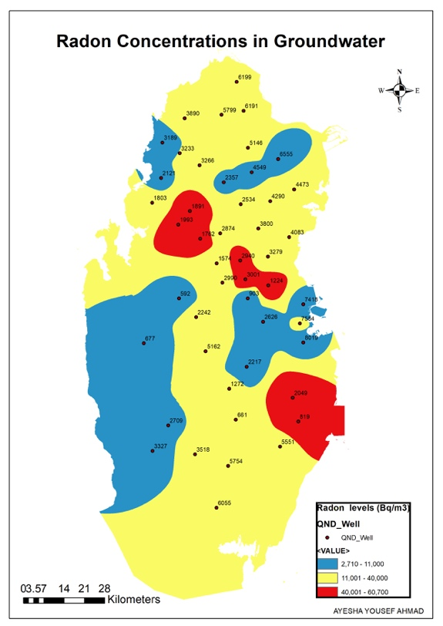

*Fig. 8. Interpolated Maps of Radon Concentrations in Groundwater Created by IDW method.*

## CONCLUSIONS

The results of physiochemical characterization in groundwater samples taken from 48 locations showed that pH values were within the recommended values by WHO and USEPA and Qatar Guidelines for drinking water. However, SEC and corresponding TDS exceeded the recommended values. The highest TDS value was 29,890 mg/l whereas the lowest and the mean values were 705.9 mg/l and 7,481 mg/l, respectively. A total of 42 samples exceeded TDS values of Qatar Guidelines for drinking water and 29 exceeded Qatar guidelines for irrigation whereas 46 values exceeded USEPA. This can be attributed due to high groundwater extraction combined with lower aquifer recharge from rain. Almost all heavy metals values were within the recommended values by WHO and USEPA and Qatar Guidelines for drinking water, except one sample of Uranium (0.0325 mg/l) which exceeded the WHO and USEPA. The concentrations of boron in five samples exceeded Qatar and WHO drinking water guideline of 2.4 mg/L (WHO, 2011; KAHRAMAA, 2014). Forty-two samples exceeded Qatar guidelines for lithium level. Likewise, three samples exceeded Qatar and WHO drinking water recommended values for Molybdenum level whereas ten wells exceeded the irrigation level recommended by USEPA. The radon level measurements of the Qatari groundwater were between 2.71 and 330 Bq/L with a mean value at about 20.6 Bq/L which is greater than the US EPA’s maximum contamination level of 11 Bq/L. Similarly, a total of 32 and 33 exceedances to the US EPA’s maximum contamination level (MCL) of 11 Bq/L and EPA’s drinking water guidelines, respectively were observed. The results from this work can help in better understanding and managing the groundwater resource in Qatar, which is extensively used in agriculture, in order to extend its presence as a strategic, clean and vibrant resource for water for the country.

## REFERENCES

1. BAALOUSHA, H.M., Groundwater vulnerability mapping of Qatar aquifers. Journal of African Earth Sciences, 2016. **124**: p. 75-93.

2. Aquastat-Qatar (2009). 2009, Food and Agricutlrue Organization of the United Nations (FAO-UN).

3. ALHAJ, M., S. Mohammed, M. Darwish, A. Hassan, and S.G. Al-Ghamdi, A review of Qatar’s water resources, consumption and virtual water trade. Desal. Wat. Treat., 2017. **70**: p. 70-85.

4. QNDS, Qatar National Development Strategy (2011~2016). 2011, Qatar General Secretariat for Development Planning, Washington, DC, . p. 1-270.

5. KIMREY, J., Proposerd articficial recharge studies in northern Qatar 1985, UNITED STATES DEPARTMENT OF THE INTERIOR GEOLOGICAL SURVEY. p. 1-33.

6. (DAWR), D.o.a.a.w.r., studying and developing the natural and artificial recharge of the groundwater aquifer in the state of Qatar. 2009, schlumberger water services: Doha. p. 1-132.

7. DARWISH, M.A., H.K. Abdulrahim, and Y. Mohieldeen, Qatar and GCC water security. Desalination and Water Treatment, 2015. **55**(9): p. 2302-2325.

8. Renewable internal freshwater resources per capita (cubic meters). 2019, world bank group.

9. SHOMR, B., Geochemistry of soil and groundwater in arid regions: Qatar as a case study. Groundwater for Sustainable Development, 2015. **1**(1): p. 33-40.

10. MEHRAG, A.A. and M.M. Rahman, Arsenic Contamination of Bangladesh Paddy Field Soils:  Implications for Rice Contribution to Arsenic Consumption. Environmental Science & Technology, 2003. **37**(2): p. 229-234.

11. RAHMAN, M.A., H. Hasegawa, and R.P. Lim, Bioaccumulation, biotransformation and trophic transfer of arsenic in the aquatic food chain. Environmental research, 2012. **116**: p. 118-135.

12. FIROUZI, A., A. Eshraghi, F. Shakerian, H.R. Sanati, N. Salehi, A. Zahedmehr, R. Kiani, M. Madani, and A. Pedarzadeh, Efficacy of pentoxifylline in prevention of contrast-induced nephropathy in angioplasty patients. International urology and nephrology, 2012. **44**(4): p. 1145-1149.

13. MAAS, E.V. and S. Grattan, Crop yields as affected by salinity. Agronomy, 1999. **38**: p. 55-110.

ACKNOWLEDGEMENTS

The authors would like to acknowledge Qatar Environment and Energy Research Institute (QEERI) and the Ministry of Municipality and Environment (MME) at Qatar for their outstanding support.