Security of Radioactive Material and Metal Recycling in the Netherlands

Nico van Xanten, Martijn de Meulmeester

Authority for Nuclear Safety and Radioprotection (ANVS), the Netherlands

Abstract

In the Netherlands, the regulatory framework for oversight of scrap metal recycling is based on radiation risk analysis, and a graded approach. Scrap metal recycling in the Netherlands is a voluminous affair. After some serious incidents around the turn of the century, new radiation safety regulations were developed. Security and detection of illicit trafficking benefit from the radiation regulations.

Companies can apply for a license issued by the Dutch nuclear regulator ANVS to handle radioactive contamination in scrap metal under pre-agreed conditions. This license aims at the correct handling of any such contamination (both in respect to radioprotection as to security) by the company, and reporting to the ANVS. The ANVS can impose additional measures.

Since most of the scrap metal trade is increasingly international, especially in the high-end stainless steel market, the origin of the metal and the quality of radiation management in the sector become more important. In this paper, the metal recycling sector and detection of radioactive material are addressed; also some recent incidents involving serious radioactive contamination are presented.

Radioactive contamination in scrap metal

The chances that scrap metal is radioactively contaminated vary from one type to the other. The equivalent quantities are 20,000 tons of ferrous material, 1,000 tons of aluminum, and 500 tons of stainless steel. In the Dutch risk based approach, the focus is more on aluminum and on stainless steel than on ferrous materials in general. Scrap trade companies are responsible for the first step in proper handling: detection. For radiation protection reasons, elimination of radioactive contamination is performed by experts. Companies that have the capabilities to properly handle, separate and dispose of radioactive contamination may apply for a license.

The major types of radioactive contamination found in stainless steel are naturally occurring radioactive materials (NORM), source holders, (aviation) instruments and flow meters. Occasionally, sources themselves are found, as well as lightning conductors (Ra-226, Am-241). Sources and radioactive material are disposed of in a controlled manner: these are either shipped to the national radioactive waste depository (COVRA) or to a licensed smelter for metal recycling and separation of radioactive contamination. Under certain conditions, contaminated cargo is returned; then acceptance by the originator and by their government is required.

Metal recycling in The Netherlands

At the lower end of the trade pyramid, there are some 100 small and medium-sized businesses in the Netherlands that collect scrap metal. Many of these are involved in cross-border trade. Cross-border trade is monitored by Customs with around 80 portal detectors. The metal collectors themselves are also obliged to have radiation detectors (portal detectors, crane detectors). When radioactive contamination is detected in the scrap metal, this must be immediately reported to the ANVS. In general, these operators have limited knowledge about radiation safety, and are therefore only allowed to localize – from the outside of the cargo – the contamination, but are not allowed to separate it from the cargo. The report should include the results of the portal or crane measurements, and – if available – the results from handheld detection on the outside of the cargo. Also, the details of the origin and the type of cargo must be reported. The ANVS interprets the report and may conduct an investigation or issue instructions, i.a. on the disposition of radioactive material. Yearly, some 200 reports are received from small and medium-sized scrap collectors.

At the top end of the trade pyramid, there are two international traders in the port of Rotterdam. They specialize in stainless steel, a high value commodity, and have a turn-over higher than 250,000 tons stainless steel per year. Both are in the top-ten of stainless steel traders in the world. Their suppliers are located in Africa, South America, and Eastern Europe (Russia and neighboring states). They supply their sorted stainless steel to smelters mainly in Europe, China and India. Many melting companies demand metal that is guaranteed free from contamination. The two companies use large portal detectors (8 plates each) for container scanning, and crane detectors for bulk material handling. For the case that radioactive contamination is found, these big traders hold an ANVS license to separate the contamination and to check that the remaining stainless steel is free of contamination. The two traders have built in financial drivers in contracts with their suppliers, stipulating cost recovery for remediation and disposal at COVRA in case the supplied stainless steel scrap is radioactively contaminated. Over the past few years, this has resulted in awareness in the supply chain and in cleaner scrap supplies. The two stainless steel traders issue annually some 150 – 200 reports to the regulator.

Recent incidents with orphan radioactive sources

Over a period of several months, on three separate occasions, nine highly active Cobalt-60 (Co-60) sealed sources were found in scrap metal containers, shipped from a country in Africa (five sources in November 2018, three in January and one in March 2019). A similar incident took place in the port of Hamburg in January (one Co-60 source). The sources have the shape of small bars; the dimensions and the total activity of the sources found in Germany and the Netherlands were similar. Both Germany and the Netherlands reported the incidents to USIE, ECURIE, ITDB and INES in order to alert the IAEA, the European Union and its member states. The IAEA has no further information on these sources, and over the past ten years, no similar sources have been reported found or missing to the ITDB. Investigations are still ongoing to establish the origin and use of the sources. The source geometry matches irradiator geometry, which may have held several dozens, up to 100 – 200 source bars. There are concerns that other sources from the same origin may still circulate in the metal recycling industry.

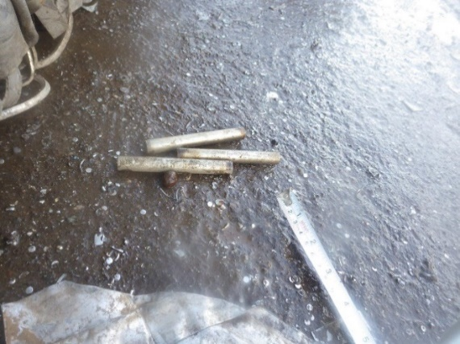
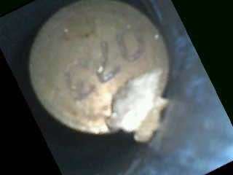

Figure 1. Sources found in Rotterdam, January 28, 2019. The sources are numbered on the end cap (three digits).

Germany and the Netherlands have worked in close cooperation with the IAEA and the country of shipment in order to establish where the sources originated, and in order to bring potential other sources under regulatory control. The country of shipment requested the IAEA to conduct an assistance mission for review of the regulatory framework and detection capabilities, and to provide advice on strategies to prevent further occurrence of radioactive contamination of scrap metal.

Conclusion

Metal can be recycled many times. Therefore, it is important to prevent any contamination, including radioactive contamination. Detecting and sorting out radioactive material when possible in the metal recycling business is of great importance. The scrap metal trade is increasingly international and vast volumes are circulating the globe. This is especially the case in high-end markets, such as the stainless steel market, as was illustrated (vide supra). The demand of melting companies that metal is guaranteed free from contamination – which is reinforced by financial penalties – is affecting the quality of radiation management in the entire sector, from the big metal trading companies in the top of the pyramid, down to the smaller scrap collectors. In addition, regulatory measures, timely detection and early reporting help minimizing the risk of exposure of workers – both in the metal recycling industry and in the related transportation sector – and contamination of (consumer) goods and the environment.

There is a requirement for further international cooperation on a technical level. The IAEA could conduct a network analysis of the world wide metal scrap trade. A voluntary “coalition of willing member states” consisting of relevant states within such networks could be created for exchange of good practices on regulatory framework, radiological and illicit trafficking detection technologies and procedures, inspection strategies, and international reporting. The IAEA could conduct advisory missions to member states in order to review regulatory systems and regulatory control. In the 2019 Nuclear and Radiation Safety Resolution, member states were encouraged to make use of the Agency’s services regarding orphan sources and the Secretariat was encouraged to advise member states on how to formulate such assistance requests. In addition, national authorities may use the information that is available to them through the IAEA to actively inform their industries about potential contamination risks.

It is important that a level playing field exists in the international scrap metal recycling. If trade shifts from places where regulatory oversight is adequate and cost for remediation and disposal is recovered to less stringent places, then safety and security are at risk.

In 2013 IAEA organized a technical meeting on a concept for a Code of Conduct on “Transboundary movement of radioactive material inadvertently incorporated into scrap metal and semi-finished products of the metal recycling industries” (Metal Recycling Code of Conduct). It would be beneficial to both radiation safety and security to renew the discussion on this subject.

In Dutch: Centraal Opvangorgaan voor Radioactief Afval. It is policy in the Netherlands to collect all radioactive waste and unused sources and store these under regulatory control at COVRA. The repository is foreseen to be in operation (at least) until 2130. Disposal sites are allowed to receive naturally occurring radioactive materials.
Dimensions: 10 cm long and diameter approximately 1.5 cm, and total activity ~25 GBq per source. If the sources stem from an irradiator, normally a higher activity would be expected; the rather low activity per source indicates that they probably are some decades old.
The IAEA Unified System for Information Exchange in Incidents and Emergencies. The system was set up in 2011 to enable member states to exchange urgent notifications and follow-up information during an emergency.
The European Community Urgent Radiological Information Exchange System. This system is the technical implementation of a 1987 Council decision on Community arrangements for early notification and exchange of information in the event of a radiological or nuclear emergency.
The IAEA Incident and Trafficking Data Base. In 1995, this database has been established for timely sharing of trusted information on (attempts of) unauthorized acquisition, supply, possession, use, transfer or disposal of nuclear and radioactive material. Both Germany and the Netherlands reported their incidents as Unauthorized Shipments. There is no suspicion of illicit trafficking or malicious use.
International Nuclear and Radiological Event Scale. This scale has been introduced in 1990 by IAEA for communication with the public on incidents in the nuclear sector. Germany reported an INES-1 level (anomaly), and the Netherlands an INES-2 level (incident that could have had an impact on people and the environment).
A match for the sources could not be found in the IAEA’s International Catalogue of Sealed Radioactive Sources (ICSRS), nor in the ITDB. Also, the International Source Suppliers and Producers Association was unable to identify the origin of the sources.

