RADIOLOGICAL RISK REDUCTION IN URUGUAY: AN INTERNATIONAL ALTERNATIVE TECHNOLOGY PILOT
W. CABRAL
National Regulatory Authority on Radio Protection
Ministry of Industry, Energy and Mining (MIEM-ARNR)
Montevideo, Uruguay
Email: Walter.Cabral@miem.gub.uy
B. FALLER
National Regulatory Authority on Radio Protection
Ministry of Industry, Energy and Mining (MIEM-ARNR)
Montevideo, Uruguay
Email: blanca.faller@miem.gub.uy
J. LIEBERMAN
Sandia National Laboratories
Albuquerque, New Mexico, USA
Email: Jbliebe@sandia.gov
Abstract
Radioactive materials play an important role in commercial, medical, and research facilities across the world. However, the benefits of these sources must be balanced with sufficient security to prevent radiological materials from falling into the wrong hands and used as a radioactive dispersal device or a radioactive exposure device. In its efforts to reduce the risks of using high-activity radiological materials, the Department of Energy’s (DOE) National Nuclear Security Administration (NNSA) Office of Radiological Security (ORS) helps reduce the global reliance on high-activity radioactive sources by leading efforts to support the adoption and development of non-radioisotopic alternative technologies. ORS engages in efforts internationally to exchange technology information with users of cesium-137 based irradiators who are interested in converting to viable non-radioisotopic alternatives and to understand and reduce obstacles preventing the transition to such technologies.
As the maturation of technology has led to the availability of non-radioisotopic alternative technologies, many countries are exploring the transition from cesium-based blood irradiators to x-ray-based blood irradiators. Today, there are six x-ray irradiator models for sale that have been approved for use in this application in the U.S. and European Union facilitating this transition.
This paper will describe the first international alternative technology project implemented under the NNSA ORS risk reduction program in which a hospital in Montevideo, Uruguay, switched from Cs-137-based to x-ray-based blood irradiation.

INTRODUCTION
NNSA Office of Radiological Security Risk Reduction: The International Reduce Program
The Office of Radiological Security (ORS) within the United States Department of Energy’s National Nuclear Security Administration (NNSA), enhances global security by preventing high activity radioactive materials from use in acts of terrorism. The ORS mission employs a holistic approach to radiological security, including protecting sources, removing and disposing of disused sources, and reducing the global reliance on radioactive sources through replacement with viable non-radioisotopic alternative technologies.
In order to reduce global reliance on radioactive sources, ORS works with international, federal and state government, industry and other partners to achieve permanent risk reduction by leading efforts to support the adoption and development of alternative technologies. To accomplish this goal, ORS engages in efforts both domestically and internationally to exchange technology information, invest in and encourage improvement of non-radioisotopic technologies, understand and reduce obstacles preventing radioisotopic device replacement, and promote the transition to alternative technologies where feasible. In so doing, the result is permanent risk reduction through downsizing the footprint of high activity radioactive sources. The program is currently focused on replacement options for civilian-use cesium-137, cobalt-60, americium-241, and iridium-192 due to the higher risk associated with these materials as well as the number of sources in use. In it important to note that these programs are voluntary and aimed at finding win-win solutions that maintain if not improve the intended result, while also achieving permanent risk reduction.

Alternatives to High Risk Radiological Sources
Commercially available, non-radioisotopic alternatives exist for most major applications of high activity radioactive materials. For example, in industrial sterilization, a Co-60 based irradiator can be replaced by x-ray, electron beam or linear accelerator technology. For radiography, x-ray technology has been proven to be an effective replacement for Ir-92 based irradiators. Finally, for blood irradiation, x-ray technology has long been used as an effective replacement for Cs-137 based irradiators; Japan has led the way in using x-ray irradiation exclusively to eliminate the risk of Transfusion Associated Graft versus Host Disease (TA-GvHD) for almost a decade. Other countries, including Norway, instituted a national plan to replace all Cs-137 based irradiators. While both technologies are capable of delivering 25 Gy of ionizing radiation to containers filled with blood or blood products, x-ray technology does not present the same security risks as does Cs-137 irradiators. The costs associated with additional security to protect the radioisotopic source from theft or misuse would be eliminated by switching to x-ray. Sites would have to balance the increased cost of maintaining the x-ray irradiator with savings from decreased security costs as well as decreased liability should a facility’s device be used as a RED/RDD. Finally, there is increasing recognition of alternative technologies as part of a comprehensive approach to radiological security.

The Project at Asociación Española Primera de Socorros Mutuos in Montevideo, Uruguay
The first international alternative technology project under the ORS program was the replacement of a Cs-137-based blood irradiator at the Asociación Española Primera de Socorros Mutuos (La Española) in Montevideo, Uruguay. In this case, both because it was a project implemented outside the U. S. and because of circumstances unique to Uruguay, implementation of the project presented a unique set of challenges. Those challenges, and how the site and the relevant Uruguayan regulatory agencies addressed those challenges, have provided policymakers, regulators, and site operators with lessons learned and tools to assist in implementation of future international alternative technology projects.

Why Alt Tech?
At the start of the project, there were two Cs-137 blood irradiators in Montevideo, Uruguay; one was at the La Española and one at the Pereira Rossell Children’s Hospital. Both sites had received security upgrades through the ORS program. After initial discussions with the National Regulatory Authority on Radio Protection (ARNR), the decision was made to approach La Española first because, as a private hospital, it would be easier and less time consuming to move forward with a project to replace their Cs-137 blood irradiator. Implementation of an alternative technology project at Pereira Rossell hospital would likely have been more time consuming because, as a public hospital, additional approvals, including from the Ministry of Health, would have been required. In addition, contracting through a public acquisition system would have added other delays. It was therefore determined that La Española would serve as a good “demonstration project” in the region to demonstrate the efficacy of x-ray technology for blood irradiation.
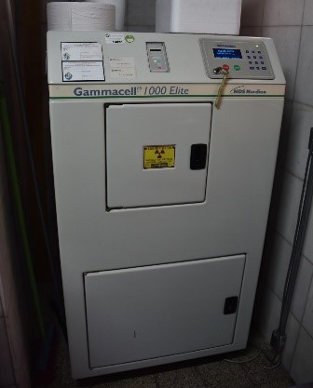
Fig 1. Cs-137 based Gammacell 1000 irradiator at Primera Asociación Española de Ayuda Mutua

X-ray Replacement
La Española selected the Best Theratronics Raycell Mk2 x-ray-based machine (Fig. 2) to replace their existing Cs-137 Gammacell 1000 irradiator (Fig 1). This new machine has a mass of 1000 kg (2200 lbs) and is 1.53 meters high, 1.45 meters wide, and 1 meter in depth. There is a 2.0 liter and a 3.5 liter irradiation canister option, and the hospital selected the smaller canister. With this configuration, the machine is capable of irradiating four 300ml bags or two 600 ml bags during each four-minute irradiation cycle, which was greater than the most extreme daily needs for the hospital. In contrast, the Gammacell 1000 has a mass of 1150kg (2535 lbs), is 1.55 meters high, 0.8 meters wide and 0.98 meters in depth. It can only irradiate one unit at a time. In addition, irradiation time increases as the cesium source decays. This is not a problem for the x-ray-based irradiator; irradiation time remains consistent. The Mk2 uses two opposing x-ray tubes that allow delivery of a uniform dose to the blood products in a short amount of time and requires a heat exchanger to dissipate the waste heat generated by the x-ray tubes (Fig. 3). The Raycell Mk2 was approved by the United States Federal Drug Administration (FDA) in August 2016 to irradiate blood to prevent Transmission Associated Graft Versus Host disease (TA-GvHD) and is approved for use in other countries, including Uruguay and throughout the European Union.
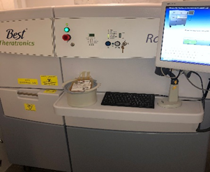
Fig. 2 – MK2 in operation at Primera Asociación Española de Ayuda Mutua irradiating 2.0 L blood bag
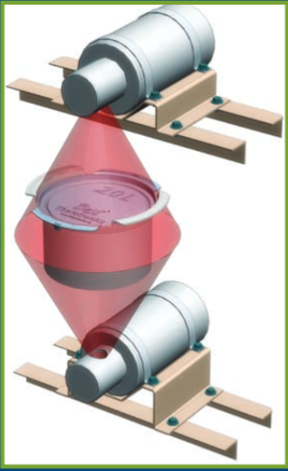
Fig. 3 – Best Theratronics Raycell Mk2 opposing x-ray tubes

Infrastructure Modifications
Because the La Española blood irradiation department moved into a new part of the hospital building during the irradiator replacement project, the entire section of the building that would house the irradiator underwent a complete renovation in the spring before the new irradiator was installed. Sliding doors had to be installed to permit movement of the new unit into the irradiator room, and new porcelain floor tiles, electrical work, lighting, plumbing, and a chiller were installed to prepare the room for the installation of the new machine.

Licensing, Validation, Commissioning and Training
Before the new blood irradiator machine could be imported and used in Uruguay, Best Theratronics had to obtain a Company Qualification Certificate from the Ministry of Public Health (MSP) and an approval of radioactive equipment and prior import authorization from the National Directorate of Nuclear Technology, Ministry of Industry, Energy and Mining (MIEM) to bring the irradiator into the country. In addition, the hospital had to obtain a Certificate of Registration and Authorization of Sale of Medical Products license from the MSP to operate the device.
La Española began using the Mk2 for blood irradiation in December 2018, upon obtaining MIEM certification on November 20, 2018. The hospital followed the validation protocols recommended by Best Theratronics. Specific color-changing labels were used to validate the irradiation process. Staff were able to examine those labels both before (Fig. 4) and after irradiation (Fig. 5) to ensure proper irradiation. Other validation procedures included running functional checks on the equipment, checking the function of the chiller and heat exchanger, checking dose distribution to confirm the adjustment and performance of the x-ray tubes using ion chamber measurements, and confirming doses, including the maximum dose to the whole canister holding the blood bag.
Staff from La Española were trained on how to use and operate the machine by the engineers from Best Theratronics who came to Uruguay to install the machine. This training involved instructing the staff on how to prepare the machine for operation as well as how to interpret error codes that may be produced by the machine. The local company that imported the equipment into Uruguay also imports other medical equipment into the country. One of their technicians was trained by Best Theratronics in Canada to perform basic troubleshooting as well as to perform basic repairs on the machine. This will allow La Española to get needed repairs done more quickly than if someone had to fly from Best Theratronics in Canada to repair the machine. The reliability of this equipment is critical to enable operations to continue; it is therefore important that any problems with the equipment be resolved quickly. In addition, there is only one other blood irradiator machine in Uruguay with the next closest machine located in Buenos Aires, Argentina. Backup capacity is therefore limited should the La Española irradiator be shut down.
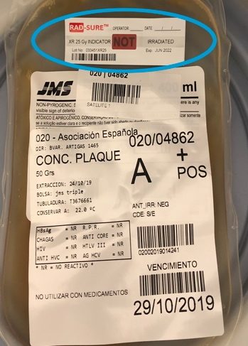
Fig. 4 – Unirradiated Blood Bag with “Not Irradiated” on Label
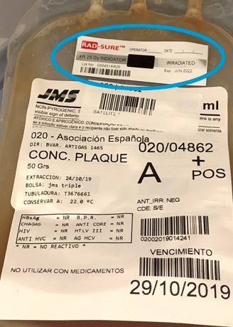
Fig. 5 – Irradiated Blood Bag with “Irradiated” Label
3. Unexpected Issues
Because the renovation work took several months longer than expected, installation of the Raycell was delayed, causing technical problems for the x-ray machine. Specifically, there was a risk of arcing between the anode and cathode within either one or both of the two vacuum tubes in the machine. This, in turn, could cause the cathode to burn up resulting in lower than expected doses to the blood products.
Because each of the x-ray tubes has a high vacuum, gases can accumulate in the tube if not used for a period of time or stored on a shelf for an extended period of time. Oxygen can slowly leak into the tubes; if oxygen accumulates inside of the tube, the anode and cathode can arc, reducing the number of x-rays that are generated. It therefore needs to be burned off if the tubes have been left inactive for long times. The tubes might need to be warmed up by running the machine for one cycle if not used for several days. Running the x-ray tube for a longer period to prevent arcing during irradiation of blood products may be needed to season the tubes if inactive for longer periods of time, including during the shipment and delivery. Some systems have external vacuum pumps to remove any oxygen that may have leaked into the tube. However, most industrial X-ray tubes simply require a warm-up procedure to be followed. This warm-up procedure carefully raises the tube current and voltage to slowly burn any of the available oxygen before the tube is operated at high power. Because the Raycell spent several extra months in storage at the hospital due to the ongoing construction, it required some seasoning runs when it was installed before it was ready to irradiate product.
Another complication arose when it was discovered that the machine’s heat exchanger was likely damaged during shipping and was not working properly following installation. A work-around was created in which the machine was connected directly to the chiller, allowing for machine cooling during operation. This was possible because the weather outside was cool enough to permit this temporary solution to work until the new heat exchanger was installed.
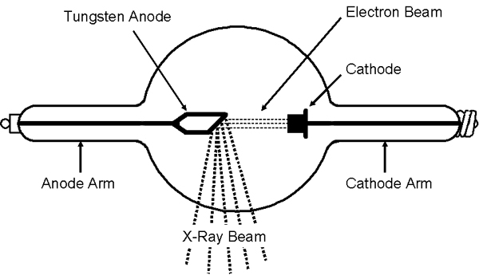
Fig. 6 – x-ray tube

Results of using the Raycell Mk2
Despite initial technical issues related to installation, the irradiator has been working well; throughput is higher for the MK2 than it was for the Gammacell 1000. In addition, the Raycell Mk2 provides state-of-the-art technology and allows Española to be at the forefront of blood irradiation due both to its advanced technology and its safety features as compared to the Cs-137 Gammacell 1000 irradiator, which had a radioisotopic source. In addition, the Raycell offers a very user-friendly operating system so that once hospital personnel were trained on its use, machine operation was simple.
Blood irradiation is generally carried out at the hospital from 8 am to 8 pm, but in necessary cases also outside these hours. The staff only irradiate blood needed at La Española and do not irradiate blood for other hospitals or facilities. The number of weekly irradiations is approximately 10-14. La Española staff are now assessing the possibility of an interface with the irradiator and the blood bank computer system to optimize and improve the information entered.

Lessons Learned
In addition to some of the unexpected technical difficulties, this project provided some important "lessons learned" which have helped inform implementation of future international alternative technology projects.
During implementation of the project, we learned that it was important to ensure the participation and agreement of the relevant in-country regulatory agencies and the need to satisfy regulatory requirements for licensing and operation of a new medical device.
There was also the need to work with the site facilities personnel, in addition to the medical personnel, to establish clear requirements for infrastructure modifications required to install the x-ray device, including electrical and cooling requirements. Each x-ray manufacturer maintains a “site preparation” or facility requirements document which lists all the requirements needed to accommodate their device. This often includes the required air conditioning to ensure appropriate room temperature, electric power, space around the machine for exhaust heat ventilation, distilled water for the cooling system and a load bearing floor to accommodate the weight of the machine. In the case of the Mk2 installation, the hospital conducted the site survey according to the manufacturer requirements to assess needed infrastructure modifications to the room in which the device was to be installed. Once those modifications were made, the device was able to be installed.
We also had to ensure the proper pathway and paperwork necessary to have the x-ray device clear Customs once it arrived in country. It was important to ensuring the availability of timely local technical support in case problems should arise with the replacement device either before or following delivery and for follow-on preventive maintenance. In some cases, this may involve factory authorized training for a local or regional service provider.
And finally, a safe and secure disposition pathway for the existing cesium unit must be determined early in the project to ensure that, once the new machine was validated, the old one could be removed and properly disposed. This includes having a licensed company remove the old device from the site, dismantle the machine, remove the sources safely and securely and dispose of them according to relevant regulations. It is important to note that a key requirement in this project, because it was funded by ORS, was to ensure that the old Cs-137 sources were not recycled but permanently stored in a secure facility.
Beyond all of these issues is the concern regarding the availability of a backup irradiator should the x-ray device be out of service for repairs. As with all technology, there are pluses and minuses for each. Clearly, the need to reduce the security risks and costs associated with a Cs-137 based irradiator is a critical element in considering the move to x-ray-based technology. However, Cs-137 irradiators are believed to be more robust, while x-ray irradiators tend to break down more often. This is an important consideration when selecting an alternative technology replacement device. For La Española, the only back up irradiator in the country is located at Hospital Pereira Rossell, across the street from them. That hospital has not yet switched over to x-ray irradiation; it is hoped that once there is a good amount of operating data that indicates the MK2 machine is adequately reliable, Pereira Rossell will consider switching to an x-ray irradiator. Doing so will not only reduce the risk of using Cs-137, but also enable Pereira Rossell hospital to continue to provide a back up to the machine located at La Española.
Sandia National Laboratories is a multi-mission laboratory managed and operated by National Technology & Engineering Solutions of Sandia, LLC, a wholly owned subsidiary of Honeywell International Inc., for the U.S. Department of Energy’s National Nuclear Security Administration under contract DE-NA0003525. SAND2019-14668 O

