SIGNIFICANCE AND CHALLENGES OF PHYSICAL PROTECTION SYSTEMS EFFECTIVENESS EVALUATION FOR NUCLEAR MATERIAL AND NUCLEAR FACILITIES
ALEXANDER IZMAYLOV
Federal Center of Science and High Technologies “SSPA “Eleron”
Moscow, Russian Federation
E-mail: a.izmaylov@eleron.org

Abstract

Provision of nuclear materials and nuclear facilities physical protection is an essential part of nuclear activity. This statement mentioned in many IAEA International Documents. In particular those documents also mentioned that physical protection systems (PPS) creation (updating) should be based on their effectiveness evaluation. It is necessary to understand how nuclear materials and nuclear facilities protection have been enhanced for some financial and human resources investment into PP provision. The paper analyzes IAEA Nuclear Security Series (NSS) documents (NSS 13 “Nuclear security recommendations on physical protection of nuclear material and facilities (INFCIRC/225/Rev.5)”, NSS 14 “Nuclear security recommendations on radioactive material and associated facilities”, NSS 27 “Physical Protection of Nuclear Material and Nuclear Facilities (implementation of INFCIRC/225/Revi.5)”) requirements concerning physical protection systems effectiveness evaluation. The paper views methods that were developed under Coordination Research Project (CRP)“Nuclear Security Assessment Methodology (NUSAM)” (2014-2016). Russian theoretical and practical experience in this area viewed as an example. It’s also mentioned evaluation methods were developed only in relation to physical protection systems but similar methods for following nuclear security subsystems (information security etc.) are absent. Besides progress in this area here viewed other perspective research trends. In particular here proposed to consider modern threats in detail (for example, unmanned airborne vehicles, divers, modern software/hardware used by intruder etc.) and their influence on nuclear facilities physical protection effectiveness. Furthermore the paper encourages other perspective research trends in this area: distribution of developed effectiveness evaluation methods to radioactive materials and associated facilities, human factors taking into account in physical protection systems effectiveness evaluation, optimization methods development for PPS design process (for example, by “cost-effectiveness” criteria), risk assessment methods development etc.
1. INTRODUCTION
Nuclear materials (NM) and nuclear facilities (NF) physical protection (PP) against different malicious acts is one of the main elements in nuclear technologies and activities. This is reflected in different international documents, particularly in IAEA Nuclear Security Series (NSS) related to physical protection systems (PPS) [1-4].
IAEA makes significant efforts to help Member States in education and human resource development, national PP legal and regulatory framework development, and PPS enhancement for specific nuclear facilities. Some funds for Member States national physical protection regime enhancement are designated (i.e. from IAEA Nuclear Security Fund).
Anyway it is needed to evaluate how a protection of nuclear material and nuclear facilities has been improved due to financial and human resources were spent for these purposes. Otherwise, we would not know how effective those resources were spent. In other words, the methodology of PPS effectiveness evaluation should be developed and used. Different PPS versions can be compared in a base of PPS effectiveness evaluation methodology. Then it can be used to develop PPS optimization methods by “cost-effectiveness” criteria.
The paper is dedicated to PPS effectiveness evaluation importance and relevance. Analysis of progress that been reached in this area at international (IAEA) level during past years is outlined. Also Russian national experience is described here as an example of best practices.
2. PPS EFFECTIVENESS EVALUATION SIGNIFICANCE AND CHALLENGES
An PPS effectiveness means an ability to resist potential adversary actions concerning NM and NF taking into account Design Basis Threat (DBT) accepted for the specific nuclear site. In other words, it is PPS ability to protect Physical Protection Items (PPI) that include nuclear materials and nuclear facility critical elements against adopted threats.
PPS Effectiveness Evaluation necessity underlined in some IAEA documents [2, 4]. Particularly the IAEA document [2] mentioned that:
“5.15. The operator should evaluate and the competent authority should validate the design of physical protection system effectiveness to verify that it complies with the required level of protection for the nuclear facility and nuclear material.”
“5.16. If the evaluation of the design of physical protection system indicates that it is ineffective, then the operator should redesign the physical protection system and re-evaluate its effectiveness.”
In Effectiveness Evaluation two different approaches can be applied:
- Prescriptive approach – definition of PPS requirements specification in regulatory documents and PPS compliance assessment to these requirements
- Performance-based approach – PPS evaluation using quantitative effectiveness index.
In present paper second approach mentioned as most progressive that allows to evaluate PPI protection index.
Probability of adversary actions suppression by response forces that followed by alarms has been chosen as effectiveness index.
Effectiveness Index should take into account:
- accepted design basis threats (DBT);
- nuclear site structure and characteristics;
- technical security means and systems structure;
- physical barriers;
- response forces features (tactics, weapons etc.).
The PPS effectiveness evaluation should be conducted at every stage of PPS lifecycle (see fig.1).

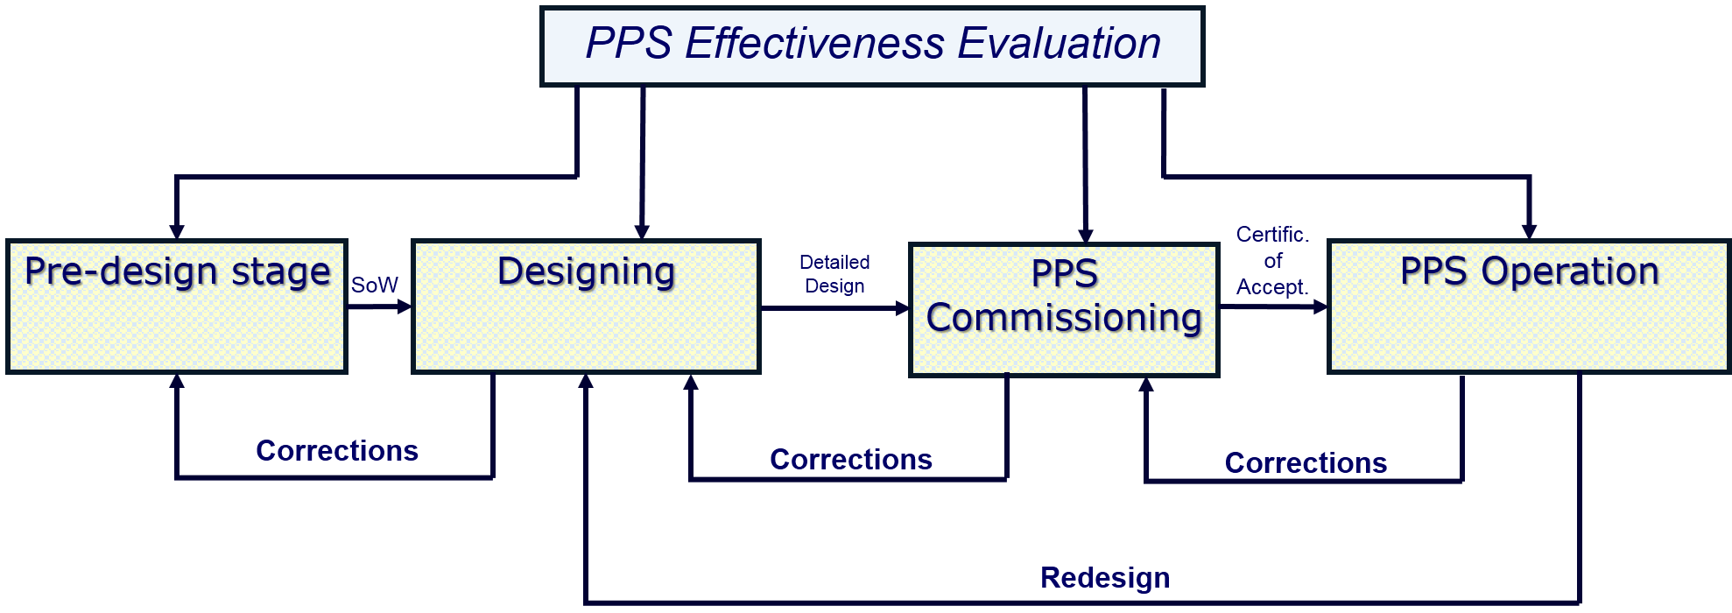

Fig.1 PPS Lifecycle

Likewise, in decommissioning stage effectiveness evaluation should be conducted in accordance with adopted threats to be specific for this stage.
It should be mentioned that adequate intruder profile choice for specific nuclear facilities is one of the most important topics [2]. Possible adversary types are presented in fig.2.

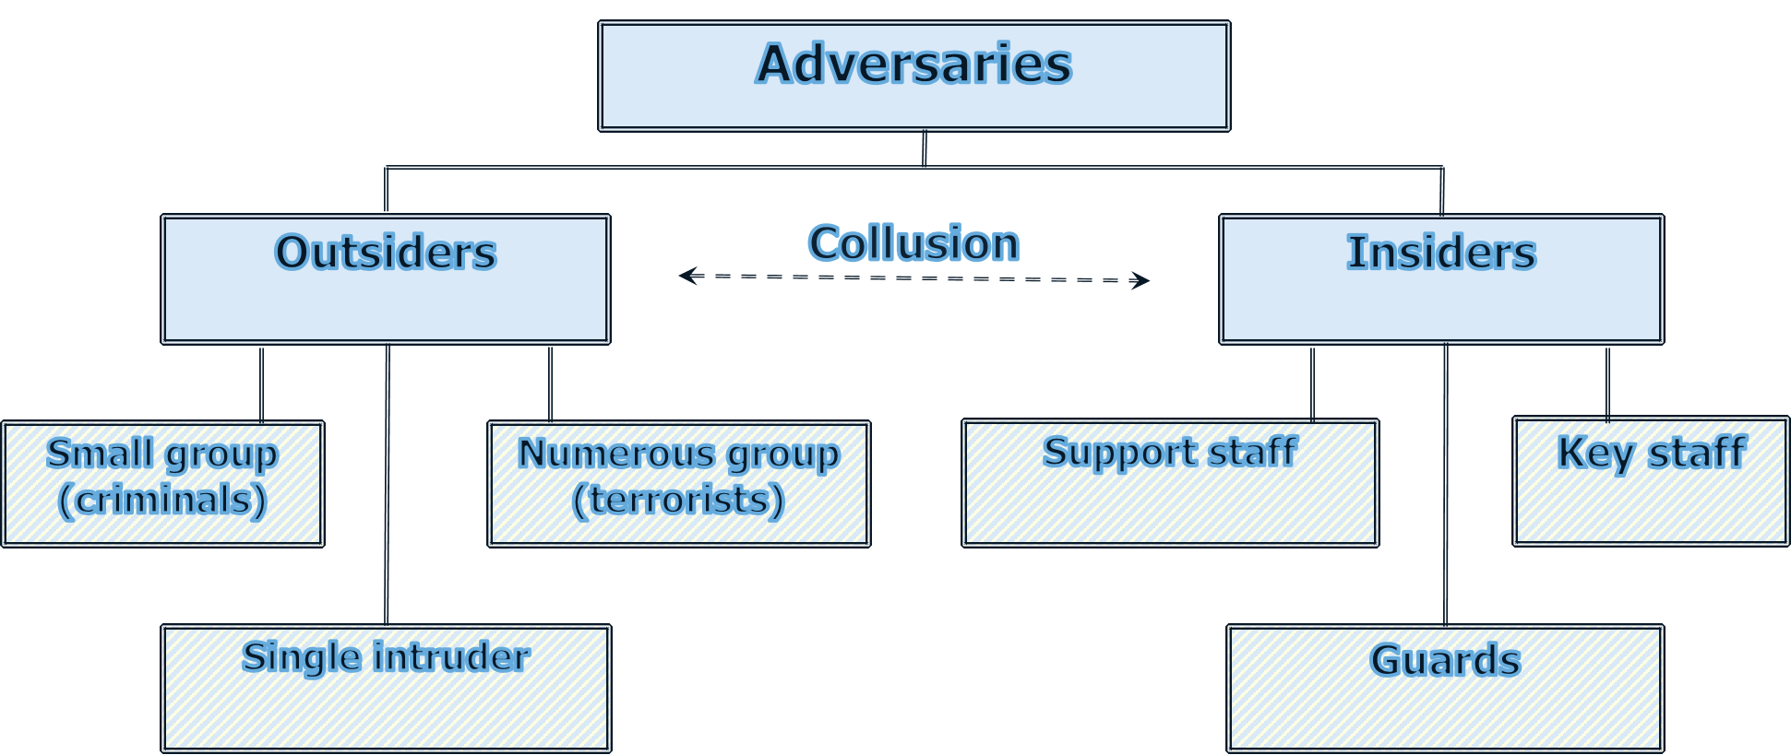

Fig.2 Adversary classification

Effectiveness evaluation methods including their mathematical basis are presented in [5].
Therefore, we come to conclusion that PPS effectiveness index has to be an “indicator” that allows to evaluate reached NF protection level at all PSS lifecycle stages including designing, commissioning and operation stages and allows to upgrade PPS structure and composition.
3. STATE OF AFFAIRS IN THE AREA OF PPS EFFECTIVENESS EVALUATION METHODOLOGY DESIGN AND IMPLEMENTATION
IAEA undertook significant efforts in this area in recent years.
Particularly in 2014-2016 IAEA performed Coordinated Research Project (CRP) on Nuclear Security Assessment Methodology (NUSAM) [6].
CRP NUSAM final documents consist of effectiveness evaluation methodology and examples of its application for different types of nuclear facilities (NPP, radiation hazardous facilities etc).
On a basis of CRP NUSAM results, IAEA developed the document TECDOC – 1868 in 2019.
Now development of new NSS document on PPS effectiveness evaluation methodology has begun (NST029).
IAEA organized special Training Course (TC) on the topic in Member States. Particularly first version of these TC materials was developed in 2011. Pilot TC was conducted in South Africa in 2011 and TC materials were upgraded based on results. Than TC were conducted in India (2013), South Korea (2017) and Pakistan (2015, 2018, 2019).
4. RUSSIAN EXPERIENCE ON PPS EFFECTIVENESS EVALUATION METHODS DEVELOPMENT AND APPLICATION
The State Corporation “Rosatom” dedicated sufficient attention to this area.
The State Corporation “Rosatom” developed methods and first computer programs on PPS effectiveness evaluation in 90-s. They were applied and still are applying in all the State Corporation “Rosatom” facilities at all PPS lifecycle stages [7].
Modern computer programs “Vega-2” and “Polygon” developed by Federal Centre of Science and High Technologies “Eleron” (“Rosatom”) are certified that provides adequacy of evaluation. These programs are applied in practice during PPS analyzing, designing and implementation. Also they were transferred to lead the State Corporation “Rosatom” facilities for operation by themselves.
Vega-2 program allows performing the PP effectiveness evaluation of a determined target (probability of its protection) for a given PPS structure, DBT, various response force tactics etc. (see fig.3) [7]. The program is based on the use of Monte Carlo mathematical method.

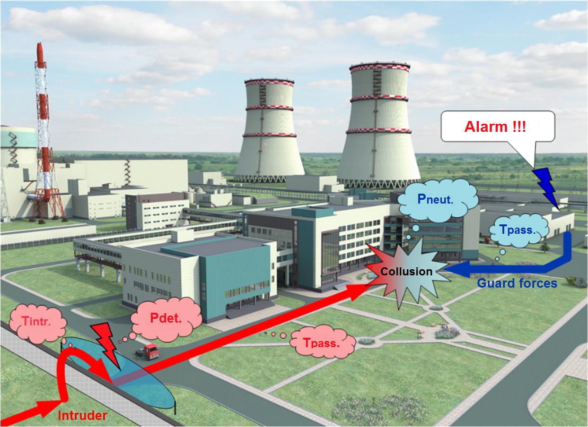
Fig. 3 “Vega-2” modeling and simulation
Another “tool” is the Polygon computer program which allows simulation of local battles between protection forces and intruders, including similar situations during nuclear material transportation [7]. The simulation is performed in a game mode. The participants are at their work stations, in various places (see Fig 4).
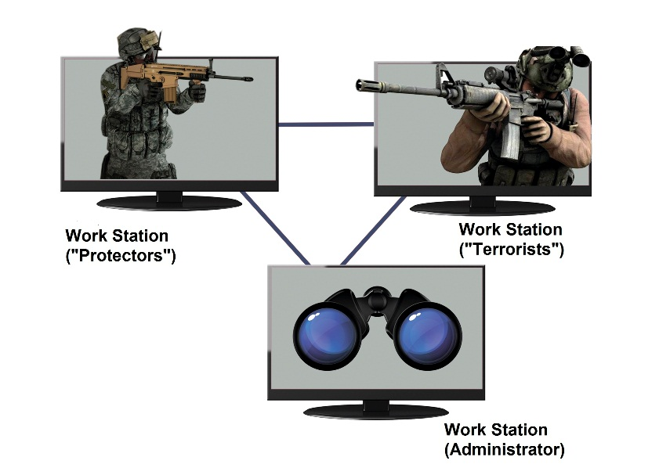
Fig. 4 “Polygon” hardware
5. FUTURE PERSPECTIVES INTHE PPS EVALUATION AREA
Along with mentioned above results reached in PPS effectiveness evaluation methodology and “tools” development some perspective tasks could be proposed in the area (see table 1).

TABLE 1. PPS EFFECTIVENESS EVALUATION PERSPECTIVES
Task | How to solve? | Comments
PPS effectiveness evaluation methods expansion to Radioactive Material (RM) and associated facilities. | Analysis of adequacy to IAEA documents concerning RM nuclear security. Initial data should be defined more precisely. | Now prescriptive approach is applied for RM protection.
Consideration of new threats (UAV, divers, special tools and software etc.). | PPS effectiveness evaluation methods and computer programs have to be modified. Initial data should be defined more precisely. | According to accepted new DBT.
Consideration of PPS connections with safety system and other protection systems. | Analysis of the interconnections (interfaces) to provide “equal protection”. | NSS-27G, paragraph «Safety-Security Interface» et al.
Human factor should be taken into account (guards, security operators, etc.) in PPS effectiveness evaluation methodology. | Analysis how human factor influences to effectiveness evaluation. Existing methods and computer programs should be modified. | Now only “ideal” PPS is evaluated without human factor consideration.
Optimization of PPS structure and composition using “cost-effectiveness” criteria. | Optimization methods [8] should be development. | Provision of rational resources usage for PPS development and operation.
Comprehensive use of different effectiveness evaluation approaches (analytical, experimental, simulations,). | Labor costs optimization due to different effectiveness evaluation approaches. | Promotion of evaluation reliability, labor cost reduction.
Risk evaluation:  R=P_{А}* (1-P_{eff})*С, where  R – risk,  Р_{А}–probability of attack,  P_{eff} – PPS effectiveness index,  С – coefficient, reflecting consequences of adversary actions. | Development ofР_{А} and С assessment methods. | This topic is a subject for a special paper.
6. CONCLUSION
- Physical protection systems effectiveness evaluation is significant and relevant topic as it allows to assess the level of nuclear material and nuclear facility protection and to justify financial and human resources have been spent.
- Significance of this area is reflected in a number of IAEA documents (Nuclear Security Series).
- Many events in this area has been performed and are performing now: IAEA CRP “NUSAM” (2016), training courses in IAEA Member States (South Africa, India, South Korea, Pakistan), start of development of special IAEA NSS document NST029 on PPS effectiveness evaluation.
- Russian Federation has big theoretical and practical experience in this area. An appropriative mathematical method, regulatory documents and computer programs has been developed. All “tools” are put into practice at dozens nuclear facilities in the State Corporation “Rosatom”.
REFERENCES
- Objective and essential elements of a state's nuclear security regime. IAEA Nuclear Security Series, №20
- Nuclear security recommendations on physical protection of nuclear material and facilities (INFCIRC-225-Revisions) IAEA Nuclear Security Series, №13
- Nuclear security recommendations on radioactive material and associated facilities. IAEA Nuclear Security Series, №14
- Physical Protection of Nuclear Material and Nuclear Facilities (Implementation of INFCIRC/225/Revision 5) IAEA Nuclear Security Series, №27-G
- Izmaylov A., et al, Fundamentals of Nuclear Materials Physical Protection, Control and Accountability. National Research Nuclear University “MEPHI”, Moscow, Russian Federation, 2011
- Nuclear Security Assessment Methodology for Regulated Facilities. Coordinated research project NUSAM. International Atomic Energy Agency (IAEA), Vienna, 2016
- Izmaylov A., Computer programs for effectiveness evaluation of Russian nuclear sites physical protection systems, Workshop materials under IAEA NUSAM project, IEAE, Vienna (2015).
- Podinovsky V., Gavrilov V., Optimization under consistently applied criteria, Soviet Radio, Moscow (1975) (in Russian).

