INCIDENTS OF RADIOACTIVE MATERIAL OUT OF REGULATORY CONTROL IN VIETNAM
NGUYEN Dinh Giap,
Vietnam Agency for Radiation and Nuclear Safety
Hanoi, Vietnam
Email: nguyengiap23@gmail.com

Abstract
In recent years, there were some incidents of radioactive material out of regulatory control in Vietnam. These incidents show that: management system at facilities still has loopholes; responsibility of facility for ensuring radiation safety and security of radioactive sources is still low; process of managing radioactive sources is loose; emergency response to incident of loss radioactive sources is still slow and no close combination between the facilities and the regulatory agencies.
1. INTRODUCTION
Vietnam Agency for Radiation and Nuclear Safety (VARANS) is under the Ministry of Science and Technology (MOST) and has the responsibility to assist the Minister in performing the duties and authorities in radiation and nuclear safety; security of radioactive sources, nuclear materials, nuclear facilities; international safeguards; emergency response to radiation and nuclear incidents within its competency.
In database of radioactive sources in 2017, Vietnam has approximately 650 radioactive sources facilities with 5300 sealed radioactive sources, including about 2450 sources are in use and 2850 sources are in temporary storage. These sources are being applied in industrial, medical, research, education, and other purposes. Besides the benefits, radioactive sources also bring potential risks if not managed well. Currently, Vietnam does not have a national long-term storage of disused radioactive sources with sufficient capacity to manage a large number of radioactive sources, ensuring safety and security. The mainly disused radioactive sources are still stored in facilities and some units of the Vietnam Atomic Energy Institute are allowed supporting temporary storage. This has negatively affected the management of safety and security of radioactive sources, potentially high risk of loss, or theft of sources that can occur as incidents occur during the time recently.
This paper gives an overview of those aspects of Vietnam’s Regulatory Body relevant to control and strengthen of management in order to detect and prevent the insecurity of radioactive sources.
This paper will present some typical incidents of loss radioactive source in Vietnam in recent years. From there, give lessons learned, remedial measures, tasks to be implemented for the management agencies, the facilities and the public.
2. REGULATORY CONTROL IN VIETNAM
- System of legal documents

FIG 1: National Legal System
- Legal documents on radioactive source security and incident response
- Atomic Energy Law (Law No. 18/2008/QH12 dated June 3, 2008)
- Decree of the Government detailing and guiding the implementation of a number of articles of the Atomic Energy Law (Decree No. 07/2010/ND-CP dated January 25, 2010)
- Decision of the Prime Minister promulgating the National Plan on responding to radiation incidents and nuclear incidents (Decision No. 884/QD-TTg dated June 16, 2017)
- Prime Minister's Decision approving the National Plan of Action on Prevention, Detection and Preparation of Risks, Chemical, Biological, Radiation and Nuclear incidents in the Period of 2019-2025 (Decision No. 104/QD-TTg dated January 22, 2019)
- The Circular of the Minister of Science and Technology stipulating the preparation and response to radiation and nuclear incidents, developing and approving the radiation and nuclear incident response plan (Circular No. 25/2014/TT-BKHCN dated October 8, 2014)
- Circular of the Minister of Science and Technology providing for security of radioactive sources (Circular No. 01/2019/TT-BKHCN dated May 30, 2019)
- Atomic Energy Law
Article 8. Duties and authorities of the Agency for Radiation and Nuclear Safety
The agency for radiation and nuclear safety is under the Ministry of Science and Technology and has the responsibility to assist the Minister in performing the following duties and authorities:
6. To take part in emergency response to radiation and nuclear incidents within its competency;
Article 84: Responsibilities of related organisations, individuals in case of incidents:
1. Responsibilities of organisations, individuals conducting radiation practices:
a) Identifying location of the incident, premilinarily determining causes, nature of the incident, and potential development of the incident for apprpopriate emmergency response measures corresponding to incident groups specified in Article 82 of this Law;
c) Reporting the incident and the incident place to the superior agencies, organisations, the local People’s Committee, local police, the agency for radiation and nuclear safety, and the Ministry of Science and Technology, initial assesment on the cause and impact of the incident to humans and environment;
3. Responsibles of Provincial People’s Committees:
d) Reporting promptly to the Ministry of Science and Technology of the incidents in the local area;
đ) Informing to the local media on the incident in the local area..
4. Responsibilities of the Ministry of Science and Technology:
d) Investigating the causes and level of the incident as prescribed in paragraph 3 Article 82 of this Law, making announcement to the mass media,;
đ) Informing on the incident to the related countries and international organisations; requesting for foreign assistance in accordance with international conventions and agreements on incident notification and assistance that Vietnam has acceded to, in case of no transboundary harm caused by the incident.
5. Responsibilities of the National Committee for Search and Rescue:
a) Organising the execution of, and directing related organisations to excute the national response plans for incidents in group 5 as prescribed in paragraph 2 Article 82 of this Law.
b) Promptly supporting the response plan for incidents in group 4 as prescribed in paragraph 2 Article 82 of this Law in case the incident proceeds the local capacity.
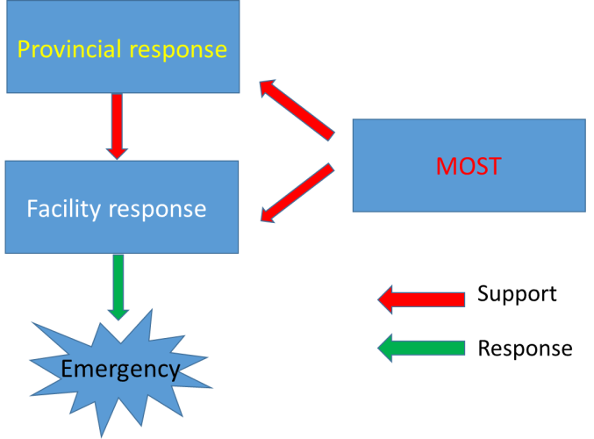
FIG 2. Schema of emergency response – provincial level
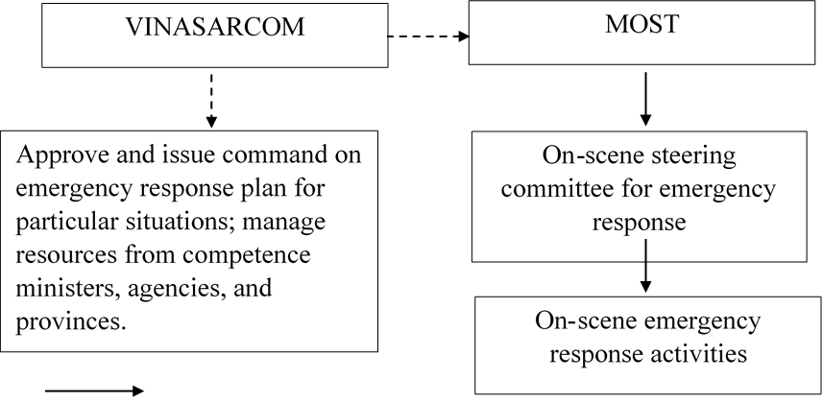

FIG 3. Schema of Emergency response – National level

3. SOME INCIDENTS OF RADIOACTIVE MATERIAL IN VIETNAM
3.1. Incidents of loss radioactive sources have not been found
- Cs-137 radioactive source was lost to measure the automatic discharge of clinker at Viet Trung Cement Joint Stock Company, Ha Nam province, in 2003;
- Cs-137 radioactive source was lost at Song Da Cement Joint Stock Company, Hoa Binh province, in 2006;
- Co-60 radioactive source was lost at Pomina Steel Plant, Ba Ria - Vung Tau province, in 2014;
- Cs-137 radioactive source was lost to measure the automatic discharge of clinker at Bac Kan Cement Joint Stock Company, Bac Kan province, in December 2016.
3.2. Some incidents of detection of radioactive material out of control and in steel scrap
- In May 2006, the source of Eu-152 was lost (in powder form, activity 14 mCi with the size of 54.8 mg) at the Institute of Rare Radiation Technology. It was sold scrap.
During 7 days: collecting contaminated materials, furniture, lead containers used to store radioactive materials, peeling soil from the ground, contaminated soil in front of the door of the house land. This collection material was transferred to the radiation facilities of the Institute of Rare Radiation Technology for further treatment. Cost: a tens of thousands USD and take people around to the clinic;
- In September 2017: detected poor uranium material at the scrap purchasing facility in Hung Yen provinve;
- April, May and December 2018: detected radioactive sources during domestic procurement and scrap import at Vina Kyoei Steel Co., Ltd. (Ba Ria - Vung Tau province);
- April 2018: Detected Ra-226 radioactive source during domestic procurement (using handheld measuring device);
- May 2018: Detected NDT radiography equipment (using RPM port, unidentified domestic or imported origin);
- December 2018: Detected radiactive source Ra-226 (using RPM port, unidentified domestic or imported).
- In April 2019, radioactive contamination was detected at 11/95 containers of metal scrap, and in June 2019, 01 container of contaminated radioactive products was imported into Hai Phong Port.
3.3. Some typical incidents of radioactive source
i. Incident 1: Level gauges
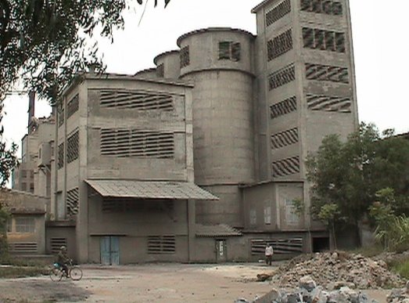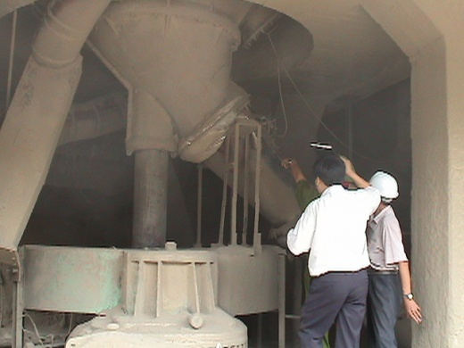
FIG 4. Loss of Cs-137 of Viet Trung Cement Joint Stock Company, Ha Nam province, in 2003
- Events:
Be in used: Sept-1999 without licensing from authority. Loss of regulatory control
Incident time: Dec-2003, report to local police but no information for VARANS. Loss of physical control
Inspection time: May- 2004. No accident report
- Response: Come to Hospital and collect patients data; Cooperate with police search source at scrap metal store; Enlarge for searching to adjacent provinces. No result.
- Lesson learn:
Loss of control in declaring and licensing
Lack of nesscesary informations for facility
Lack of information exchange between organization, Police and VARANS.
ii. Incident 2: Industry Radiography
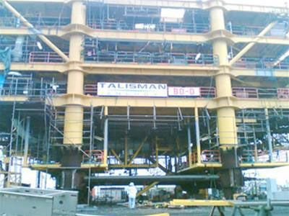
FIG 5. Incident of RT source in Onshore oil-rig at Ba Ria - Vung Tau province, 2007
- Events: Onshore oil-rig at Ba Ria - Vung Tau province. Accident time: 11.30am-0.30pm 28 Dec-2007. RT team’s lost RT source on the rig but they only detected this accident at their own container. RT team report to contractor about the incident
- Response:Evacuate workers out of rig from 1.55pm to 2.15pm. RT team search and recover source from 3.00pm to 3.40 pm
- Lesson learn:
RT team did not follow the RT procedure.
Hundreds worker’s been stress because of fear of their health.
Small source but big effect
After response, maximum effective dose of one member equal to 34 mSv.
Roles of regulatory body
Some news paper provides incorrect informations.
iii. Incident III: Loss Eu-152 isotope

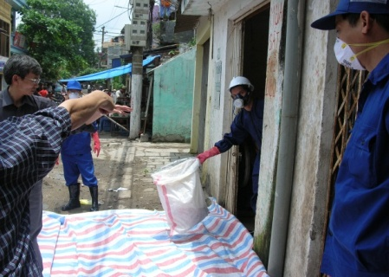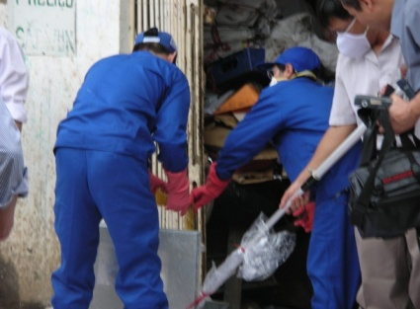
FIG 6. Incident of loss Eu-152 isotope of ITRRE, 2006
- Events: 10 AM, May 31,2006: MOST & VARANS inspected Institute for Technology of Radioactive and Rare Elements (ITRRE). Facility reported Eu-152 (25 mCi at Oct.1995) had lost.
10.30 AM, May 31.2006, the isotope had found at 628 Bach Dang st. Ha Noi – a scrap metal facility.
- Response: VARANS cooperate with ITERR, and VAEI decontaminated the contamination zone from May 31.2006 to June 5.2006.
People in this facility had been transferred to hospital to monitor their health.
The maximum effective dose absorption by people in this facility is 5 mSv.
- Lesson learn:
Cause: ITRRE repaired facility at May.2006. ITRRE did not have sufficient control to store radioactive source at this time. Srcap metal facility had bought and broken this source.
ITRRE had not: Followed the radiation control and safety rules during the facility repaired time. Controled stranger come inside radioactive source store zone. Reported timely to authority after lossing radioactive source.
People did not have knowledge to identify the radioactive source.
4. LESSON LEARNED AND IMPLEMENTATION SOLUTIONS
Reconsider the above-mentioned loss of radioactive sources, lessons learned after the incidents, as well as making corrective measures to enhance the work of ensuring radiation safety and radioactive source security, the Regulatory Agency in Vietnam has focused on the following issues:
- Enhance inspection, verification to ensure the security of radioactive in Vietnam. When conducting inspections, there must be contents on security of radioactive sources, in which the existence of radioactive sources must be verified. Establish a national database of radioactive sources. Strengthening coordination between relevant ministries, branches, People's Committees of provinces and cities in radioactive sources security.
- Strengthening the capacity of VARANS and local Agency to well perform the function of managing radiation safety and security of radioactive sources, ensuring human resources, infrastructure and equipment for inspection activities and management, focusing on staff training.
- Strengthening propaganda, dissemination and guidance on the implementation of legal regulations, training and awareness rising on radiation safety and security of radioactive sources for organizations and individuals in the local area.
- Raising awareness among leaders and employees of the facility about responsibility for ensuring radiation safety and security of radioactive sources, building safety and security culture, focusing on training employees on radiation safety and security of radioactive sources.
- Need to build a national storage facility to meet the requirements of safety and security management of disused radioactive sources.
5. CONCLUSIONS AND ACKNOWLEDGEMENTS
The state management of radiation safety and security of radiation sources should be further improved. It is necessary to consider and complete the system of legal documents and guidelines to improve the management of radiation courts and security of radioactive sources.
It is necessary to strengthen measures (administrative and technical) to control and detect radioactive materials at import border gates, at steel production and processing factories as well as at domestic purchasing establishments.Communication and awareness raising (to understand risks and benefits) plays a very important role.
The risk of radioactive materials appearing in both domestic and imported iron and steel scraps is not small. The consequences of radiation incidents may cause severe impacts on society, economy, human health and the environment.
I would like to extend my appreciation to Inspectorate of VARANS and my colleagues who supported me to complete this paper.
REFERENCES
[1] Vietnam Atomic Energy Law (2008).
[2] Directive No. 17 / CT-TTg dated July 10, 2015 on enhancing the assurance of radiation safety and security of radioactive sources.
[3] Assoc.Prof.Dr. Vuong Huu Tan, Vietnam Agency for Radiation and Nuclear Safety, "Assessing the dangers of the lost Co-60 radioactive source at Pomina 3 Steel Factory in Ba Ria - Vung Tau province".
[4] Inspection and incident response records of VARANS.

