- Background and Purposes of This Work
The problem of radioisotope supply is not only about production, but also about radioisotope transportation from the fabrication plant to the end user. One of the impacts of the current transportation scheme is if the delivery route of radioisotope going through the densely populated areas. The radiological and non-radiological will impact on truck crews, road users and people around it. This work will discuss the ideas, advantages, and challenges of implementing radioisotope transportation using drones especially for short half-life medical radioisotopes. In addition, this work also explains the progress of the implementation and future challenges of drones for transportation in various countries.

- Radioisotope Supply and Transportation

The Mo-99 isotope has a half-life of 2.75 days, making it possible to transport Mo-99 / Tc-99m generators from production facilities to any place in the world. In addition, when a Mo-99 / Tc-99m generator is transported to a hospital, the Tc-99m can be produced fresh up to 2 weeks by daily milking / elution from this Mo-99 / Tc-99m generator. Whereas Xe-133 (half-life of 5.27 days) Gas is for diagnostic inhalation use only. Tl-201 (half-life of 3.04 days) has been mainly used in the manufacturing of thallium-201 injections which are widely used in nuclear medicine for cardiac perfusion studies.
The transportation process is mostly carried out using land and air routes. For example, the production process at Los Alamos has a total distance of radioisotope transportation during the production process until the distribution to generator distributors and suppliers in Boston is 200 km by land and 3200 km by air.

- Type of Drone Based on Design and Construction

3.1. Fixed Wing Drone
Drones with fixed wing type use two wings such as airplanes to generate lifts when flying in the air. An example of this type can be seen in the figure, which has advantages in terms of speeds and also cruising power. This makes this type of drone widely used in a number of tasks. Although the implementation is more widely used for monitoring, a start-up called “Zipline” is able to modify this type of drone to be able to send drugs to areas with a considerable distance in Africa.

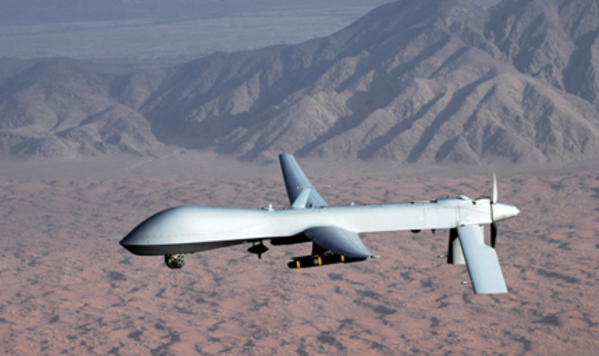 | Fixed wing drone example : GAAS MQ-1
  - Rotary Wing Drone
Rotary wing type drone is not like the previous type which uses wing. This type has several frame construction designs, and can be seen in the figure. The more rotary wings that are used, the more rotary motor installed on the drones. A lot of rotary motor makes the lifting power greater, but the battery power needed is also higher. So that further research is needed to determine the optimal point of weight, battery power and the rotary motor used.

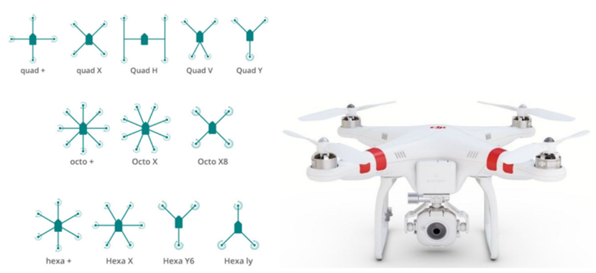 | Rotary wing drone illustration and construction design

- The Progress of Material Transportation using Drone in Different Countries

In the past few years the use of drones has increased and has received high attention. In the United States, world leader companies in the technology industry such as Amazon, DHL and Google have begun developing developments in the implementation of drones for their freight systems.
European countries such as France through France’s General Directorate for Civil Aviation (DGAC) have begun authorizing DPD group companies to operate drones in the company's freight and logistics delivery process. In addition the use of drones in countries such as Croatia has also been rife. Around 130 companies are already using drones in their business.
In Asia, countries like Japan have started implementing drone technology in the industry starting from the end of 2015. Some testing to implement parcel delivery in the shipping industry has been carried out in the Chiba area, outside of Tokyo. They also have some test-condominiums built for providing off-loading places for parcel drones.

- The Example Scenario of Drone Usage in Medical Isotopes

5.1. Delivery of radioisotopes from airport to Tc-99m generator supplier or vice versa for efficiency in supply and minimalize radiology and non-radiology impact
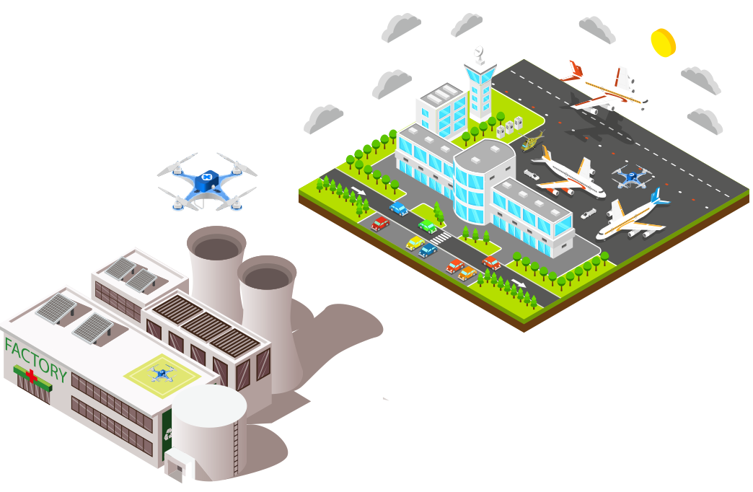 | Hypothetical Illustration of Scenario for radioisotopes delivery from airport to Tc-99m generator supplier

5.2. Delivery of radioisotopes generator and other radioisotopes supply in island nations or area for medical imaging and diagnosis
 | Hypothetical Illustration of scenario for radioisotopes delivery of the generator and other radioisotopes supply in island nations or area for medical imaging and diagnosis
5.3. Delivery of radioisotopes generator and other radioisotopes supply efficiency inside the city for medical imaging and diagnosis
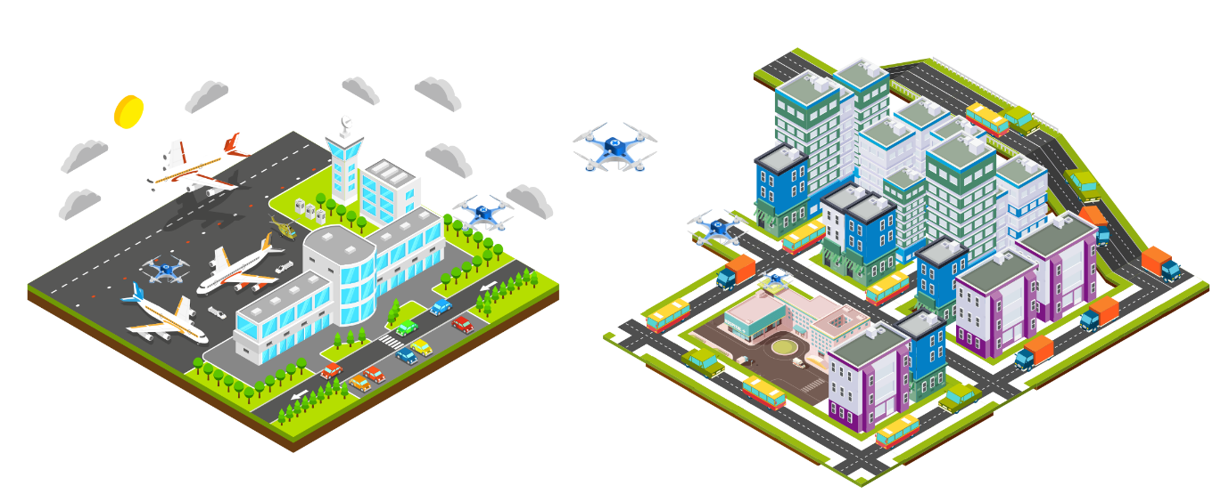 | Hypothetical Illustration of scenario for radioisotopes delivery of the generator and other radioisotopes supply inside the city for medical imaging and diagnosis
- Future Challenges
6.1. Safety: Dose Limitation and Material Packaging
In IAEA Safety Standard Regulations for the Safe Transport of Radioactive Material 2018 edition the surface dose rate is greater than 2 mSv / h and 10 mSv / h for the package under exclusive use. In general, packages of radioactive material to be transported must be able to withstand shocks and vibrations during acceleration. Especially for the transportation of these materials by air, the package must be able to withstand a temperature range and pressure. The development of a Tc-99m generator to be transported using drones needs to consider these standards in terms of both dose limitation and physical endurance.

6.2. Regulation: Drone Usage and Material Transport using Drones
Countries such as Poland and the UK have regulations to legalize the use of drones for both commercial flights and BVLOS (Beyond Visual line of sight) flights. Meanwhile Indonesia and Australia allow only VLOS. This makes the use of drones by commercial has a limit on the range. Whereas countries such as Argentina and Russia do not allow drones to be flown commercially in their territory. Although not all countries allow the operation of drones in their territories, the development of regulations regarding transportation using drones, especially in the transport of radioactive material, needs to be done. This is considering that the use of drones can save the cost of transporting material through the air because it can work autonomously.
6.3. Security: Drones Hijacking, Hacking and Electronic Attacks
The case of drone exploitation in a modern way has occurred in 2011 in Iran. With cases of exploitation of drones both directly and by cyberattack, it is necessary to develop regulations regarding this security problem. Although in 2015 the FAA issued regulations regarding the use and registration of small drones, this was not enough to regulate cases of technical exploitation of drones. Ways to find out if a drone is working improperly have been developed, one of which is to look at variations of the flying drone's statistical data.

- Conclusions
  - Transportation radioactive material using drone has not yet been regulated, but the transportation of short half-life radioisotope has a couple advantages scenario that can be used in the future. However, a few challenges like safety, security and regulation of this idea need to be considered and need to solve at first in the future.

