THE DESKTOP RADIATION PORTAL MONITOR
The ultimate training aid for developing maintenance providers

S. PEPER
PACIFIC NORTHWEST NATIONAL LABORATORY
Richland, Washington, USA
Email: Shane.Peper@pnnl.gov

C.L. STINSON
OAK RIDGE NATIONAL LABORATORY
Oak Ridge, Tennessee, USA
Email: Craig.Stinson@IB3Global.com

Abstract

Radiation detection systems and measures are key components of a State’s nuclear detection architecture and its nuclear security regime. The sustained operation of these radiation detection systems to detect nuclear and other radioactive material out of regulatory control requires trained personnel to operate and properly maintain them. Practical considerations and implementing guidance related to the sustained operation of radiation detection systems has recently been published in the International Atomic Energy Agency serial publication NSS-30G, ‘Sustaining a Nuclear Security Regime’. Whether conducted at an operational level or at a national level (e.g., via a Nuclear Security Support Centre) the maintenance of a qualified cadre of technicians to maintain radiation detection systems has historically presented challenges to States for various reasons, including the need to access a functioning detection system for significant time periods and the small number of staff that can be trained at one time. One solution that has been developed to mitigate these training obstacles involves the use of a portable desktop-sized radiation portal monitor, complete with a functional gross counting gamma detector. This paper will include an overview of this novel maintenance training aid, as well as provide numerous examples of how this tool can be configured to meet the myriad training needs of maintenance staff, including routine maintenance, troubleshooting and corrective maintenance, and equipment familiarization.

INTRODUCTION
This paper will present an overview of the desktop radiation portal monitor (RPM) concept starting with a treatment of the unique challenges of developing and sustaining a qualified cadre of maintenance technicians, various possible applications of the desktop RPM to address many of these challenges, and recommendations and considerations for organizations developing their own maintenance training tools.
Developing and sustaining a qualified cadre of technicians to maintain radiation detection systems (RDS) has historically presented challenges to States for various reasons, including:

- training to specific maintenance tasks requires significant hands-on training;
- system operational needs tend to restrict time available for training on the equipment;
- configuration of RPM cabinets limits the number of staff that can be trained at one time.

The design and configuration of desktop RPMs are driven by the specific training needs of maintenance personnel and limited only by the imagination of the developer. Note, simple portable systems support training at any location, whereas more sophisticated versions sacrifice mobility for an expanded scope of functionality. Properly configured, the desktop RPM can be used to provide RDS/RPM familiarization training to other key personnel, such as RDS system operators, RDS system managers, and relevant competent authorities.

Maintenance-SPECIFIC TRAINING CHALLENGES
Developing and sustaining a qualified cadre of technicians to maintain radiation detection systems has historically presented the challenges described below to States .

Hand-on training
Training for specific maintenance tasks requires significant hands-on training, which requires access a functioning detection system for significant time periods ranging from several days to a week. Further, RPM maintenance training can be complex and demanding. To be successful, each technician should be allowed to perform each task multiple times. Multiple iterations are necessary to walk the trainee through the levels of awareness, practice, and mastery of each task they are required to perform.Trainees are often hesitant to adjust operational equipment for fear of breaking something. The desktop RPM frees them from the concerns of damaging operational equipment and allows them to learn from their mistakes in a no-fault training environment.
Radiation portal monitors are typically installed outdoors in high traffic areas of busy seaports and border crossings, yielding both safety and logistical challenges for maintenance personnel in training. A desktop RPM such as the one shown in Figure 1 allows for performance of maintenance training activities in a safe and controlled environment. Trainees can focus on the assigned task without distractions from moving vehicles, weather, or other safety concerns.
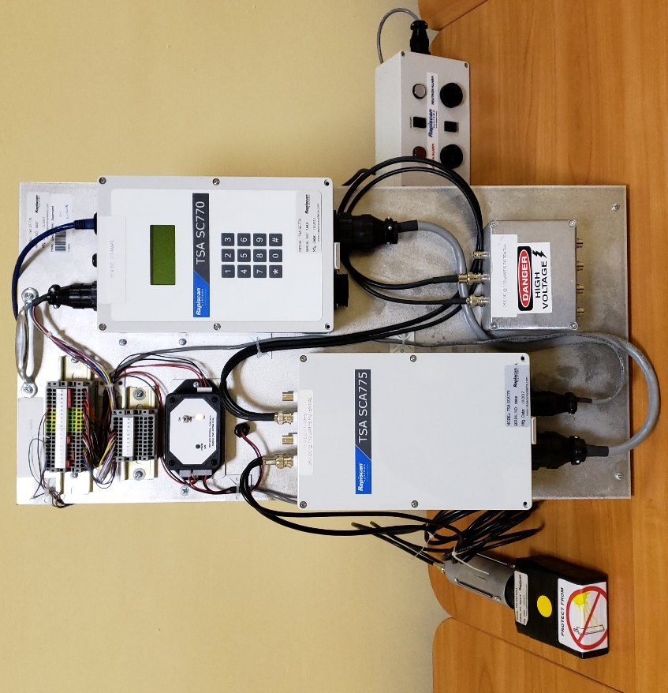
FIG. 1. Desktop RPM.

Operational needs
Once a radiation detection system is installed and functional, site operational activities and system operating organization needs tend to impact the time available for training. The following operational needs must be addressed by training systems:

- Once a system is fully functional, system operators tend to limit lane closures and system downtime as this necessitates implementation of compensatory measures such as rerouting traffic, which is sometimes not an option.
- While maintenance training during equipment installation is undeniably valuable, some tasks cannot be performed until the system is fully functional. Additionally, if maintenance providers are replaced because of attrition or rebids of contracts, their replacements must be retrained on operational equipment.
- Once a system is fully functional, training tends to focus on system/equipment operators. Equipment maintenance is often ignored because of other priorities; consequently, the more reliable the system, the less focus is necessary for maintenance and maintenance training.

Installed equipment configuration
The physical configuration of currently available RPM cabinets significantly limits the number of staff that can be trained at one time. Radiation detection equipment is often mounted on pedestals to improve detection geometry and thus maximize detection sensitivity. Depending on the type of traffic being screened, these pedestals can exceed 1 m in height and require the use of a ladder to access critical components. Owing to safety considerations, only one person is typically allowed on a ladder at a time (Figure 2). The use of a ladder usually means that only one trainee can perform the assigned task, and this limits the instructor’s ability to observe and correct erroneous actions as well as prevents other trainees from watching.
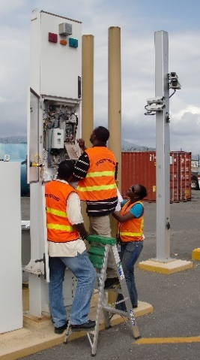
FIG. 2. RPM height may limit visibility during maintenance training exercises.

To reduce the physical footprint of installed equipment, RPM manufacturers tend to make their cabinets as small as feasible. This limits component accessibility and the ability of students to see instructor-led demonstrations or watch as other students practice maintenance tasks. The desktop RPM is configured in an open format, which allows multiple students to see the tasks being demonstrated and facilitates discussions and feedback.
Figure 3 illustrates six students struggling to observe the performance of a maintenance task, whereas Figure 4 shows how the use of a desktop RPM allows six students to easily see and discuss the same task being performed.
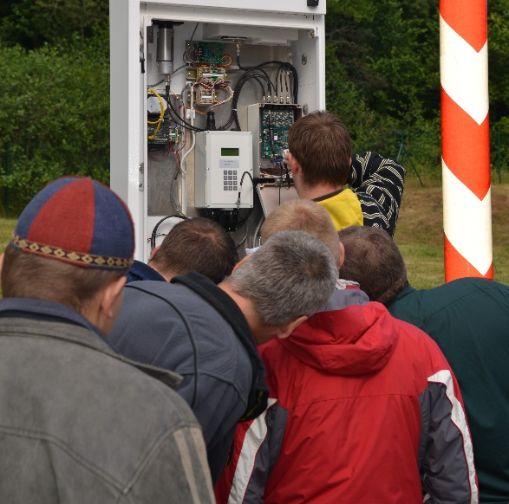
FIG. 3. Six trainees struggling to observe a maintenance demonstration.

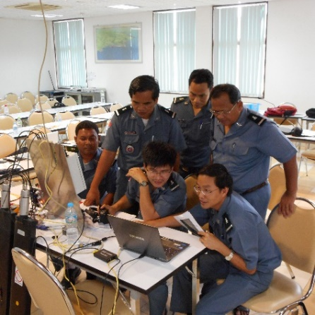
FIG. 4. Six trainees can easily view a maintenance demonstration on the desktop RPM.
Maintenance training courses tend to have multiple instructors, numerous trainees, and oftentimes interpreters. Ideally, each participant should perform each maintenance task. Since only one iteration of a maintenance activity can take place at a time, this extends the amount of time a lane must be shut down for training. Numerous desktop RPMs can be deployed to address this issue and limit the student downtime while others perform hands-on activities.

TRAINING NEEDS DETERMINE THE DESKTOP RPM CONFIGURATION
The development and evolution of the desktop RPM was driven by the need to ensure that maintenance providers have the requisite technical competency to maintain key components of a State’s nuclear detection architecture. At the technician level, the core maintenance competencies include performance of routine maintenance tasks to preserve and verify equipment functional capability, troubleshooting and diagnosis of equipment failures, and performance of corrective maintenance tasks to return failed equipment to a fully functional state. By developing and employing different versions of a desktop RPM, different training needs can be met, and different training challenges can be addressed. In addition to the obvious maintenance training benefits that a desktop RPM can provide, detection system operators, managers, and competent authorities can be familiarized with RPMs, learn how RPMs function, and how faults and failures can affect performance of their jobs as an RDS operator.

Simple portable systems enable training to take place at any location
Portable systems with limited complexity enable training to take place at any location as required. The desktop RPM, as with any other training aid, can never replace true hands-on experience using the equipment it is intended to simulate. Rather, it is designed to complement this training by providing awareness-level training and the ability to practice and gain confidence applying new skills before honing them on operational equipment. Because skills are introduced and practiced in a conducive learning environment, the desktop RPM can help address some of the challenges discussed above, and once the trainees demonstrate some level of proficiency with the basic skills, the training can then be shifted to fully functional and operational equipment.
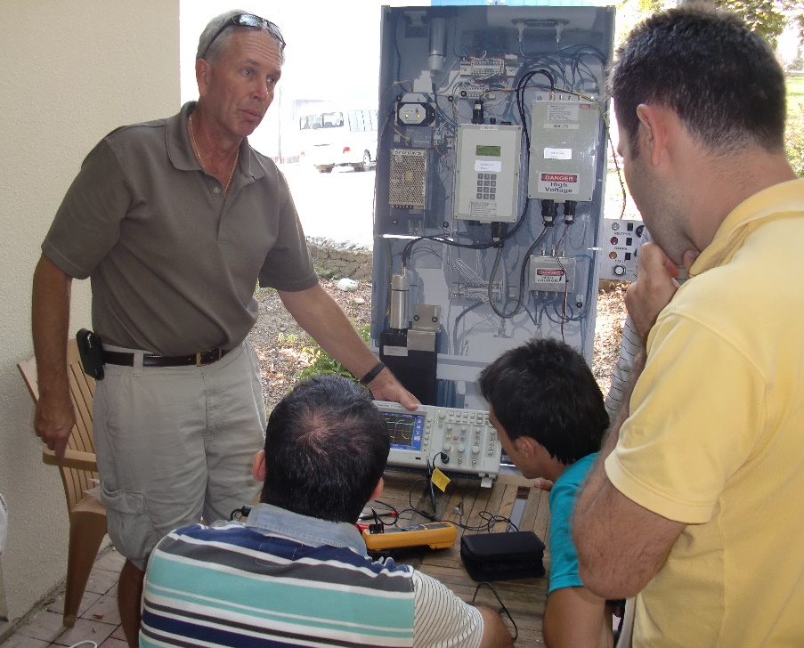
Figure 5 is an image from the inaugural deployment of the desktop RPM. The training team and participants travelled to a remote border crossing to present RPM maintenance training and to perform routine and corrective maintenance on newly operational equipment. Administrative complications prevented the team from accessing the site on the first day, so the desktop RPM was deployed to conduct training at a nearby venue in a safe and comfortable location. The trainees were introduced to the maintenance tasks they would be performing and practiced these tasks to gain initial levels of proficiency. After gaining access to the site the next day, hands-on training with the operable equipment continued at a deeper level facilitated by the experience gained on the previous day.
FIG. 5. Inaugural deployment of the desktop RPM.

More sophisticated versions sacrifice mobility for an expanded scope of functionality
Simulator training, such as with the desktop RPM, can be used to introduce and reinforce fundamentals during both initial and continuing training. If an organization has the appropriate resources and facilities, very sophisticated training aids can be developed that approach the full functionality of the equipment they are intended to simulate.
Figure 6 shows a desktop RPM that is currently in use at a Nuclear Security Support Centre (NSSC). This desktop RPM has the full functionality of an operational radiation portal monitor and includes all wiring and terminal blocks identical to the equipment being simulated. This facilitates advanced levels of training on routine and corrective maintenance tasks, as well as allows for realistic troubleshooting scenarios and activities. Full sized gamma and neutron radiation detectors are included, as well as alarm and fault indications, occupancy sensors, cameras, and even connectivity to the same communications system that is deployed at sites throughout the country.

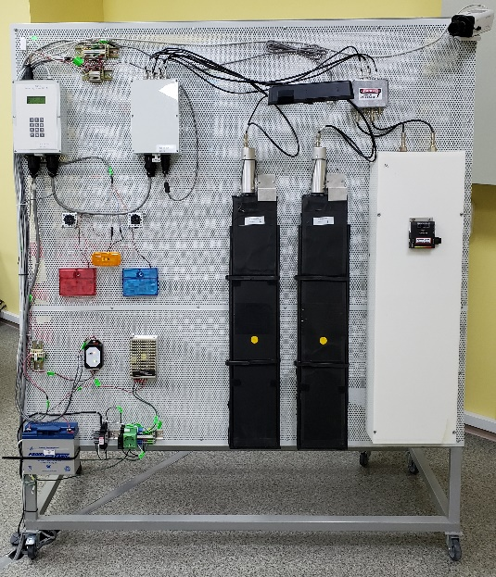
FIG. 6. NSSC desktop RPM.

Equipment familiarization
The International Atomic Energy Agency has developed a concept for the establishment and operation of an NSSC to help strengthen the sustainability of the nuclear security and detection architecture within a state. The role of an NSSC is to support competent authorities, authorized persons, and other organizations with nuclear security responsibilities in sustaining the national nuclear security regime. One of the primary functions of an NSSC in this role is human resource development, specifically through the provision of a national nuclear security training programme. The desktop RPM can assist with this function by providing awareness levels of training on radiation detection system fundamentals to anyone with responsibilities in the operation or sustainment of this facet of their national nuclear security regime.
New or prospective system operators and their supervisors can receive basic training on RDS fundamentals, as well as receive hands-on training with the RDS communications system. They can also be introduced to the internal workings of an RPM and begin to understand how RPM maintenance, faults, and failures can affect performance of their jobs as a system operator. Competent authorities in any role can be provided with awareness-level training on the basics of radiation detection, as well as with an understanding of the roles and responsibilities of RDS operators and maintenance providers including some of the challenges they face in their day-to-day work.

Conclusion
Radiation detection systems and measures are key components of both a State’s nuclear detection architecture and its nuclear security regime. The sustained operation of these radiation detection systems requires trained personnel to operate and properly maintain them. The maintenance of a qualified cadre of maintenance technicians presents numerous challenges to States, but using a portable desktop-sized RPM is a viable and useful solution to mitigate training obstacles. The paper provided an overview of this novel maintenance training aid, as well as numerous examples of how this tool can be configured to meet the myriad training needs of maintenance staff, including basic and advanced RPM maintenance and equipment familiarization.

