RESPONDING TO THE DETECTION OF SPECIAL FISSIONABLE mATERIALS AND OTHER THREAT MATERIALS WITH CASE STUDIES
M.À. DE LA RUBIA RODIZ
Departamento de Aduanas E II.EE
Madrid, Spain
Email: miguel.delarubia@correo.aeat.es
O.W. GILLISPIE
Los Alamos National Laboratory
Los Alamos, NM, United States
Abstract
The paper will discuss challenges posed in confidently adjudicating alarms when nuclear materials or other potential threat materials are detected in secondary inspection. Radiation detection systems are installed at multiple seaports in Spain. The majority of these seaports have a spectroscopic portal monitor (SPM) that is used for secondary inspection along with high-purity germanium handheld detectors. The vast majority of primary alarms that are sent to secondary inspection result in the confirmation of naturally occurring radioactive materials (NORM) as declared on the manifest. A small fraction of the alarms generated on the SPM, however, are threat alarms indicating the potential presence of nuclear material or radioactive industrial and medical isotopes. Responding to the detection of special fissionable material in secondary inspection presents unique challenges that must be addressed to provide an acceptable degree of confidence that nuclear material is not being smuggled. These challenges are exacerbated when special fissionable material is potentially detected in land/sea cargo containers. Three case studies from Spain will be presented that illustrate the technical obstacles and other challenges encountered when adjudicating complex alarms. Two of these studies involve the detection of NORM containing uranium isotopes and one involves the detection of multiple disused Cs-137 sources. Spanish Customs has well-developed standard operating procedures that facilitate the engagement of expert support teams when needed. Challenges encountered include analysis of complex spectra from multiple types of detectors and determination of material composition from these spectra. Handling potentially sensitive information concerning potential risks posed to public safety is also problematic when determination of those risks is ongoing.

INTRODUCTION
The Spanish Central Agency for Tax Administration (AEAT), hereinafter referred to as Spanish Customs, established an agreement in 2004 with the United States Department of Energy’s (DOE) National Nuclear Security Administration (NNSA) to combat the illicit smuggling of nuclear and other radioactive material out of regulatory control (MORC). The partnership between Spanish Customs and DOE/NNSA’s Office of Nuclear Smuggling Detection and Deterrence (NSDD) led to the installation of primary and secondary radiation detection systems at the Port of Algeciras, Port of Valencia, and Port of Barcelona. A Thermo Fisher Scientific Spectroscopic Portal Monitor (SPM) was also installed at the Port of Vigo and the Port of Bilbao in addition to the three previously mentioned ports. Spanish Customs also has nonintrusive inspection (NII) systems with integrated radiation detection systems at the Port of Tarragona and the Port of Tenerife. Spanish Customs’ Border Radiological Control Division (ACRF) is responsible for oversight of the radiation detection systems operated by Customs inspection officers in partnership with Guardia Civil officers. Customs is provided expert support by its contracted Technical Unit for Radiological Response (UTPR). The Spanish Nuclear Safety Council (CSN) reviews data provided by Customs and makes official recommendations and gives direction on how to proceed when MORC or other material violating radiological protection laws and regulations is detected.
Spanish Customs has worked to integrate the operation of the primary and secondary detection systems into the flow of commerce at the seaports, scanning nearly one hundred percent of import and export traffic at the Ports of Algeciras, Valencia, and Barcelona. Alarming conveyances are selected for secondary inspection based on a number of factors, including manifest declaration, country of origin, importer/exporter history, alarm level, and finally random selection. Conveyances that alarm are sent to the secondary inspection facility where they are initially scanned by the SPM. The SPM can generate one of four possible outcomes: Innocent, Suspect, Threat, or no alarm. Innocent alarms are attributable to naturally occurring radioactive material (NORM) isotopes: 40K, 226Ra, and 232Th. Threat alarms are alarms attributed to nuclear material (including 238U) as well as industrial and medical isotopes. Suspect alarms occur when the SPM identifies NORM isotopes, but the count rate is high enough that the SPM cannot rule out the potential presence of masked threat isotopes. The SPM allows Spanish Customs to achieve a secondary inspection rate that is higher than would be achievable using handheld radioisotope identification devices (RID) alone. Innocent alarms are adjudicated based on the SPM results while all Threat and some Suspect alarms are subjected to additional secondary inspections using the ORTEC high-purity germanium (HPGe) RIDs. Approximately five percent of total alarms on the SPM are Threat alarms.
Spanish Customs has established in its standard operating procedure a process for the front-line officer (FLO) to elevate an alarm of concern to higher authority when the FLO cannot make an adjudication decision based on available data from the initial assessment. The FLO first calls the Spanish Customs Emergency Operations Centre (CECOP), which then informs the head of the Border Radiological Control Division. Alarm data provided by the FLO is analysed and if a decision cannot be made, data is sent to the contracted UTPR by ACRF. The UTPR will conduct further analysis (including spectral analysis) and may travel to the site to perform additional non-intrusive inspection as part of the initial investigation response process. The UTPR then makes a recommendation to the head of the ACRF, who may refer the matter to CSN for recommendation and further direction. CSN then analyses the data and makes a recommendation and/or gives direction on how to proceed. If MORC is confirmed during the initial investigation, CSN may require the importer to contract with a UTPR service to open the container and conduct a physical inspection or may recommend the container be returned to its point of origin.
If the contents are NORM above allowable limits in Spain, the container will be returned to the exporter in the country of origin. If the container contains MORC, the material will either be returned to the exporter in the origin country or disposed of in Spain at the geological repository. If Spanish authorities conclude the exporter in the country of origin will not properly and securely dispose of dangerous MORC, the material is placed under the authority of the Spanish radioactive waste authority ENRESA. ENRESA then oversees the transfer of the material to the geological repository for final disposition.
Spanish Customs has encountered multiple logistical and technical challenges in investigating and adjudicating complex radiation alarms.
- FLOs are often faced with contradicting data from multiple instruments.
- Collection of data required for expert support analysis is laborious and not straightforward.
- Difficulty transmitting data to export support teams.
- Challenge of analysing complex spectra from field measurements.
- Determination of 235U levels in material containing uranium requires expertise.
- Controlling sensitive information and its release to the media is necessary but can be difficult.

Complex alarm Adjudication challenges
FLOs staffing the radiation detection systems in Spain generally have many years of experience. Thus, these officers are able to confidently adjudicate most alarms involving MORC (typically industrial sources or contaminated scrap/consumer goods) and transfer responsibility for response operations to the appropriate competent authorities without further assistance. The detection of special fissionable material or neutron sources present a more complex challenge with respect to proper adjudication and thus determining a path forward.
A number of detections of both industrial sources and more complex alarms where nuclear material was potentially detected led ACRF to the conclusion that a more detailed standard operating procedure (SOP) was needed for operator use when adjudicating complex alarms, especially those involving the detection of nuclear material and neutron sources. ACRF staff working with multiple personnel at the United States Department of Energy, Los Alamos National Laboratory under direction of NSDD have developed an SOP for FLOs/Export Support personnel to use when nuclear material and/or a neutron source is detected by the SPM. This guide specifies cases of concern as defined by isotope(s) or neutron source detected and provides further direction on how to proceed. The document also explains what these isotopes are used for and provides reasons they might be detected, including discussing known issues with the SPM pertaining to false identifications. The SPM is essential for achieving a high secondary inspection rate but the nature of the detectors (sodium iodide) and alarm processing algorithm will inevitability lead to false alarms and the false identification of threat isotopes. Multiple HPGe measurements are required when only a gamma threat material is detected to confirm the result from the SPM. Providing this information gives the FLO a sense of the limitations of their equipment and helps build confidence in the equipment they operate through a better understanding of that equipment.
The SOP developed specifies data and other information to be collected and shared with CECOP and ACRF for further analysis. Alarm information to be collected includes the following: radiation portal monitor (RPM) data file(s) and alarm report(s), SPM alarm report(s), and spectroscopic file(s). In addition, the FLO is instructed to take the following HPGe measurements: background, known source, twenty-plus minute dwell measurements at any hot spots, and measurements of each quadrant of the container, and is instructed to include associated collection data with the data files. Also, the FLO is asked to report other details pertaining to the shipment, such as origin and destination point, manifest, and dangerous goods declaration (if any). Images from the NII system should also be included if available.
The SOP also includes an annex that discusses key information the expert support team and ACRF can use when determining if a threat material is present. While experts in Spain have many years of experience analysing spectra, these are typically from the nuclear fuel cycle or other measurements on sources and known materials such as geological samples. Analysis for nuclear security detection require these experts to consider factors such as unknown enrichment levels, shielding, and masking. The spectra they are asked to analyse are often from containers before they are opened, with limited knowledge of the contents. The instruments used to collect the data are also varied and the expert may not have direct access to the data or may be unable to specify collection parameters.
A particular problem encountered in commerce is the detection of 235U in material containing natural uranium. The sensitivity of the SPM and ORTEC both allow for the detection of natural amounts of 235U while not indicating whether the detection is consistent with natural uranium, low enriched uranium, or highly enriched uranium. Spanish Customs requires an ORTEC measurement be made on any container in which the SPM indicates the presence of 235U. ORTEC spectra will be analysed by trained expert support personnel using software for spectral analysis. The following three general rules of thumb will be applied to determine whether the 235U is consistent with natural or processed uranium.
- Uranium ore is relatively easy to discriminate from processed (and subsequently enriched) uranium due to the gamma signature of the 238U daughters (e.g. 226Ra).
- If uranium x-rays are visible in the spectrum, their height relative to the 235U peaks around 186 keV can be used as a clue if the x-ray region is larger than the 186 keV region, indicating the sample is likely depleted. If the 186 keV region is higher, it cannot be used to make that assessment since shielding could suppress the x-ray region more than the 186 keV region.
- If there is a prominent 186 keV peak but no 1001 keV in the ORTEC spectrum, it is enriched. If there is a prominent 1001 keV peak but no 186 keV peak, it cannot be used to make that assessment since shielding could suppress the 186 keV peak more than the 1001 keV peak.

Morc Case Studies from spanish seaports with radiation detection systems
Several case studies are presented below. These case studies pertain to the detection of MORC (industrial isotopes) and NORM containing 235U. These case studies and others have been used by Spanish authorities to develop detailed guidelines for data to be provided when requesting expert support and developing other policies applicable to cases where MORC is potentially detected by FLOs.

Valencia Alarm on NORM with Report of Nuclear Material Detected
The first case study examines a case where nuclear material was reported by the SPM and information was not properly controlled, leading to undue concern when information was improperly shared with the media. On March 1, 2018, three trucks carrying non-containerized bulk phosphate fertilizer from Morocco proceeded in series to exit the Port of Valencia, upon which they each generated a gamma alarm on the RPMs at the Valencia Import Gate. All three trucks were sent to secondary inspection. Each truck was scanned with the SPM which generated a threat alarm for each truck. Fig. 1 shows the distribution of threat isotopes detected in the container and the blue line shows the total gamma counts along the length of the truck. SPM results for the three trucks are as follows.
- Truck 1: U-235, U-238, Pu-239 and Ra-226 (three scans with same isotopes identified on each).
- Truck 2
- First Scan: U-235, U-238, Ga-67 and Ra-226;
- Second Scan: U-235, U-238, Pu-238, Pu-239 and Ra-226.
Truck 3: Data not available.
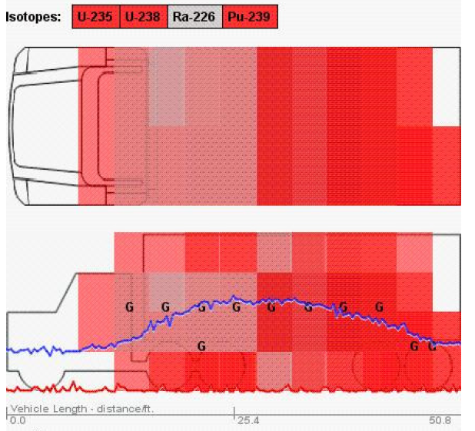
FIG. 1. Isotopes identified, gamma counts, and distribution.
The FLO in charge contacted the CECOP in Madrid and was directed by the head of the Border Radiological Control Division to perform long dwell time measurements on the containers with the HpGe (ORTEC) RID. The FLOs performed three long dwell time (longer than 10 minutes) measurements on the containers and the ORTEC reported 238U and 226Ra. The head of ACRF made the decision to detain the containers and request analysis from the UTPR and CSN to ensure the NORM present was within limits allowed under Spanish regulations. This detection also afforded ACRF the opportunity to check the response protocol of the interagency radiological control team in Spain as is required periodically. These checks allow ACRF to assess coordination and communication between organizations that would be required in the event of an emergency.
After the trucks were detained an unauthorized person informed the news media in Spain of the incident. As seen below in Fig. 2 it was reported that the detained “trucks were carrying radioactive loads, containing substances such as uranium 235 and 238, plutonium-239, radium-226 and gallium 66.”[1] The story appeared in Spanish as well as international media publications.
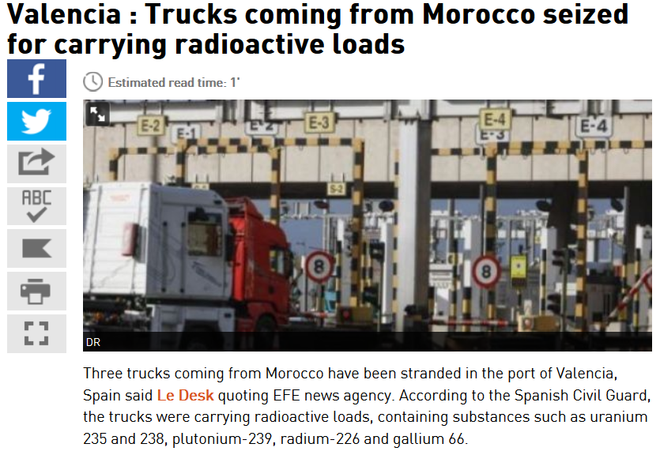
FIG. 2. News article from Yabiladi.com.
Further analysis of the spectra by the UTPR service and analytical lab tests confirmed that the only radioactive isotopes present were those associated with natural uranium and 226Ra. The dose rates were also confirmed to be within the acceptable limits for the type of commerce and the material was released to the importer.
Lessons learned from this event include the following. FLOs need a better understanding of the limitations of certain equipment such as the SPM and when to rely on the ORTEC for confirmatory measurements. It also demonstrates the importance of controlling information until analysis by the expert support team is complete and final defensible conclusions are reached. The protocol signed between the competent authorities in Spain was modified to specify that all information associated with an alarm is confidential and the only agency authorized to release information concerning radiation detection system alarms to the media is AEAT (Spanish Customs).

Algeciras 238U/235U Detection July 2017
This case study examines a case where 235U and 238U were detected by both the SPM and ORTEC in NORM. In July 2017, a gamma radiation alarm occurred on an import lane at the Port of Algeciras. The RPM alarm sigma was 10.9. The manifest stated the contents of the container to be monocalcium phosphate powder for animal food. The container was sent to secondary inspection and SPM reported 238U and 235U as shown below in Fig. 3. Monocalcium phosphate is reported by the International Atomic Energy Agency (IAEA) TRACE App [2] to potentially contain 40K; however, the composition can vary widely based on the source of the phosphate ore and manufacturing process. The TRACE App does not mention uranium as being a potential NORM constituent of monocalcium phosphate.
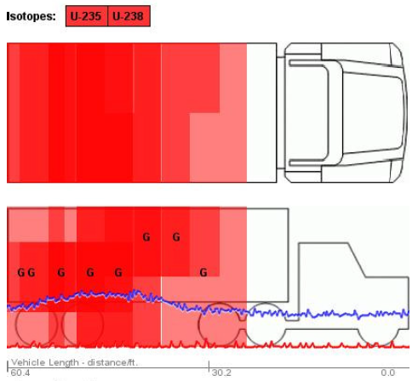
FIG. 3. Isotopes identified, gamma counts, and distribution.
The FLO then performed a verification measurement with the ORTEC, which confirmed the SPM detection of 238U and 235U. Per the SOP the FLO contacted the ACRF and requested assistance adjudicating the alarm. ACRF dispatched the UTPR service, PROINSA, to conduct further investigation. The PROINSA technician used an SAIC Exploranium GR-135 gamma detector and a Thermo Fisher Radeye GN detector to conduct measurements. Data collected by PROINSA on the container showed gamma counts consistent with background in the area and no radioactive isotopes were detected [3].
ACRF provided the alarm data and results of the PROINSA inspection to CSN for a recommendation to detain or release the merchandise. CSN instructed the importer to have a detailed analysis of the contents performed by a UTPR service under its authority to require that this type of product be tested to ensure radiation levels are within acceptable parameters. The importer hired GDES to conduct detailed analysis on the material. The pallets were unloaded as seen below in Fig. 4 under the supervision of GDES and measurements were made on each pallet using spectroscopic detectors.
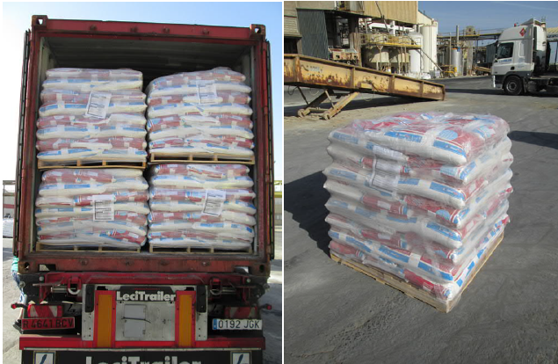
FIG. 4. Pallets of calcium phosphate.
A sample of the monocalcium phosphate material was collected from the pallet with the highest radiation readings and sent to the Radiation Services laboratory at the Polytechnic University of Valencia (UPV) for laboratory analysis. The UPV laboratory used an ORTEC 919E HPGe detector to perform the analysis. The analysis conducted by UPV indicated the presence of NORM with the following specific activities [4]:
- U-238: 3.274 kBq/kg
- U-235: 0.120 kBq/kg
- Th-228: 0.010 kBq/kg
- Ra-226: <0.012 kBq/kg
- K-40: <0.053 kBq/kg
In conclusion, the testing performed by GDES and UPV showed that the radiation levels coming from the pallets were about twice those of natural background in the area, consistent with NORM values expected in this type of material, and below the levels recommended for control in applicable CSN regulations.
The confirmed detection of 235U in this material led Spanish Customs to conclude that they needed to develop a process for analysing data that did not require sending samples to a lab for analytical analysis when the ORTEC confirmed the presence of 235U. Spanish Customs recognizes it is important to analyse these types of materials to confirm that enriched uranium is not being smuggled in shipments of material containing natural uranium. As a result, the Customs UTPR needs to be trained in analysis of complex spectra pertaining to the detection of nuclear security threats.

Valencia 137Cs Detection February 2016
This case study is included even though it does not pertain to the detection of nuclear material or neutron sources because it represents one of the most significant interdictions of MORC by Spanish authorities to date. In February 2016, a gamma radiation alarm occurred on an import lane at the Port of Valencia. The RPM alarm sigma was 240 and the manifest stated the contents were lead battery plates being shipped from Nigeria to a plant near Barcelona for recycling. The front-line officers analysed the primary alarm and manifest declaration and made the decision to send the container to secondary inspection. The SPM identified 137Cs. The FLOs subsequently verified this identification using the IdentiFinder1 and the ORTEC HPGe RIDs.
The FLOs then notified the CECOP. The head of the Border Radiological Control Division analysed the preliminary data provided by the FLOs via CECOP and deployed the UTPR service, GDES, to perform a preliminary investigation. The container was transferred to the hazardous goods holding area within the secondary inspection facility.
GDES conducted the initial investigation and reported a maximum dose rate of 6 micro-SV/h on contact with the outside of the container and verified by spectroscopic analysis that 137Cs was present in the container. The results of the initial analysis were communicated to CSN by CECOP. CSN evaluated the report submitted by GDES and instructed Spanish Customs to require the importer to hire a UTPR service to manage the situation and conduct a physical inspection of the container. The importer hired GDES to open the container and perform the physical inspection.
The GDES team conducted a smear test inside the container to ensure the sources were sealed and not leaking. The first source was discovered and removed from the container. At this point measurements inside the container indicated an additional source was likely present. The physical inspection as seen below in Fig. 5 eventually found four bare 137Cs sources inside the container mixed with lead shielding being sent to the recycling facility. The dose rate from the four sources were each approximately 400 mSV/hr on contact according to measurements performed by the Spanish nuclear waste authority ENRESA.
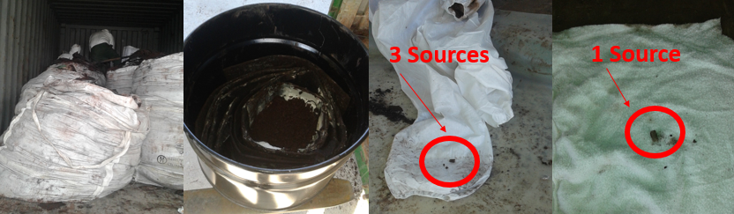
FIG. 5. Cs-137 source recovery operation with sources shown on right.
Spanish authorities concluded that it was not plausible that these sources were accidently placed in the container. They based their conclusions on the fact that the sources were found without the typical shielding container that sources of this type would be stored and transported in. The handling of these sources without the proper shielding could result in serious health consequences in a very short time frame and thus the typical shielding devices themselves have mechanisms to prevent the accidental extraction of the sources. They further concluded that while the presence of a single source inside a container with scrap metal is somewhat frequent the presence of four unshielded sources in the container “indicates intentional manipulation and some degree of premeditation.” [5] The sources were temporarily stored in the radiological materials bunker at the Port of Valencia and then transferred to ENRESA for disposal at the Spanish radioactive waste geologic repository.

Barcelona AmBe Detection October 2016
In this case the seizure of a typical disused neutron source is examined. In October 2016, a neutron radiation alarm occurred on an export lane at the Port of Barcelona. The RPM alarm reported a maximum count rate of 87 counts per second and the manifest stated the contents to be scrap metal. The container was sent to secondary inspection and scanned with the SPM, which confirmed the neutron alarm as seen below in Fig. 6. The FLOs notified the ACRF, which contracted with the UTPR service, PROINSA, to conduct verification measurements.
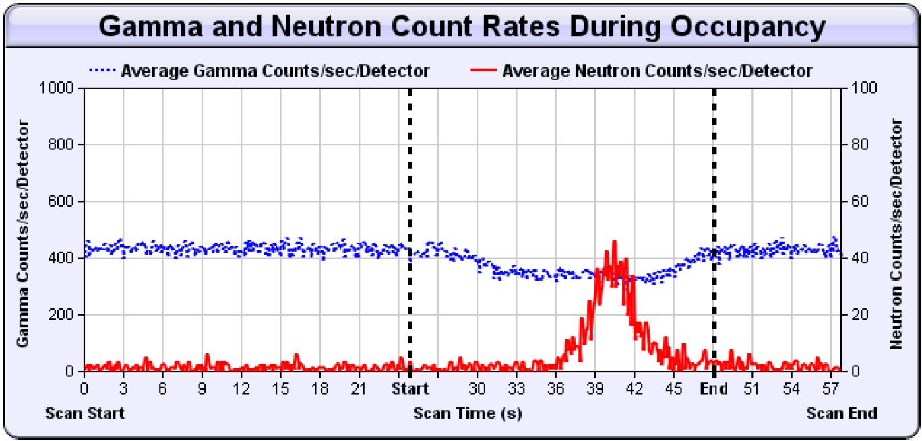
FIG. 6. SPM confirms neutron alarm.
As seen below in Fig. 7 an x-ray scan was obtained and a red dot placed on the x-ray image to show the area of maximum counts per second. PROINSA concluded that a neutron source was in fact present in the container in the middle vertical zone of the right side (driver side) of the container. The container was detained at the Spanish Customs facility in Barcelona and CSN was notified.
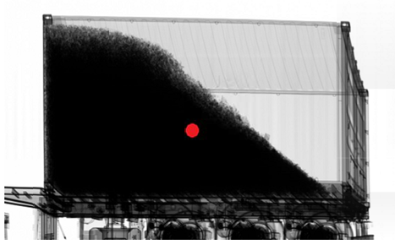
FIG. 7. X-ray image and location of source.
CSN instructed the exporter to return the container to their facility located in Barcelona and contract with a UTPR service to retrieve the source from the container and prepare it for proper disposition. The exporter hired GDES to extract the source from the container. Upon extraction GDES confirmed the source of the neutron alarm was a sealed AmBe source. Source integrity was verified and through coordination with ENRESA the source was sent to the Spanish geological respiratory for final disposition.

Conclusions
The first radiation detection systems were installed in Spain approximately 13 years ago, resulting in dozens of interdictions of MORC in following years. While multiple factors contribute to the success of the system, the primary factor resulting in the majority of the interdictions has been the well trained and dedicated officers of Customs and Guardia Civil executing their duties in accordance with their SOPs and maintaining a questioning attitude towards the data they are presented. However, to properly combat the risk of smuggling, more complex alarms require more in-depth analysis. Spanish Customs is working to develop and/or enhance the following procedures, abilities, and tools to analyse and properly adjudicate these alarms and ensure nuclear materials are not being smuggled.
- Detailed response SOP for FLOs to provide detailed information to expert support personnel.
- Ability for expert support to perform advanced spectral analyse of alarms indicating the presence of 235U.
- Ability to x-ray containers and inspect contents with NII methods.
- Trained expert support personnel to conduct intrusive examinations and recover MORC.
ACKNOWLEDGEMENTS
The authors wish to acknowledge and thank first and foremost the officers of Spanish Customs and Guardia Civil who operate these systems in Spain. Their tireless dedication to the mostly routine task of operating these systems has been responsible for the interdiction of numerous items that posed a security and public health risk to the citizens of Spain and the broader world community. The authors also wish to thank Begona Duro Rodriquez and Aquilino Parra Jiménez from the Border Radiological Monitoring Division for their support of the operations, maintenance, and management of these systems. The authors also wish to acknowledge the cooperation of the Port Authority of Barcelona, the Port Authority of Valencia, and the Port Authority of Algeciras as well as terminal operators for their cooperation in these efforts. Appreciation is also extended to Dr Katrina Stults from Los Alamos National Laboratory for consulting with Spanish Customs to develop the complex alarm adjudication SOP. Finally, grateful appreciation is extended to Ms. Victoria Kennedy and Mr. Tony Leigh for providing translations used in this paper as well as providing services over the past ten plus years to the US and Spanish teams.
References
- Yabiladi News Desk, Valencia: Trucks Coming from Morocco Seized for Carrying Radioactive Loads (2018), https:/en.yabiladi.com/articles/details/62433/valencia-trucks-coming-from-morocco.html.
- IAEA, IAEA Launches Mobile Application Tool for Radiation Alarm and Commodity Evaluation (2017), https:/www.iaea.org/newscenter/news/iaea-launches-mobile-application-tool-for-radiation-alarm-and-commodity-evaluation.
- PROINSA, Servicio de Unidad Tecnica de Proteccion Radiologica para la Agencia Estatal de Administracion Tributaria, report PRI07AE-05, 2017.
- Radiation Protection Technical Unit of GD Energy Services, S.A.U., Caracterizacion y Medidas Radiologicas del Contenedor de Global Feed, S.L., internal report, GD Energy Services S.A.U., Valencia, Spain, 2017.
- DURO, B. and DE LA RUBIA, M., Informe Sobre Deteccion de Fuentes Radioactivas en el Puerto de Valencia, internal report, Spanish Customs, Valencia, Spain, 2016.

