Preparing for a nuclear terrorist attack
by creating a unified response through

national nuclear response frameworks

ABDULMAJEED IBRAHIM
Nigerian Nuclear Regulatory Authority
Abuja, Nigeria
Email: abdulmajeed.ibrahim@nnra.gov.ng

Isa Sambo
Nigerian Nuclear Regulatory Authority
Abuja, Nigeria
isasambo@yahoo.com

Abstract

As the risks of terrorists obtaining nuclear and radiological weapons and materials continue, it is important to plan and prepare for the possibility of terrorists detonating a radiological or nuclear (R/N) bomb. A key preparation component is a national nuclear response framework (NNRF), which detail the policies, procedures, capabilities, and priorities for responding to a nuclear or radiological terrorist attack. Defining the roles and responsibilities as well as coordination mechanisms among national and international bodies will help ensure the framework creates a unified response. In turn, a unified response will help streamline the response and avoid confusion in the field. This paper will detail three important coordination factors within a NNRF: interagency coordination; international coordination; and public communication. The Global Initiative to Combat Nuclear Terrorism (GICNT) identified these key national nuclear framework components during a Nigerian hosted Valiant Eagle Workshop focused on adapting all-hazards response frameworks to nuclear response frameworks. The workshop highlighted a number of key best practices related to NNRFs. A NNRF should take a multi-faceted approach to detailing agencies’ roles and responsibilities. Each responsibility denotes a lead agency as well as defined supporting agencies. Countries should also outline a unified public messaging strategy in preparation of an attack. A unified message will ensure there is no conflicting information disseminated and manage public risk perception. Lastly, the Nigerian workshop stressed the importance of international coordination and communication. NNRFs should address international requirements, protocols, and coordination mechanisms to ensure the attacked nation receives the necessary aid and other countries are safeguarded. Effective bilateral coordination requires strong relationships between institutions in each country and established formal mechanisms for exchanging information.

INTRODUCTION
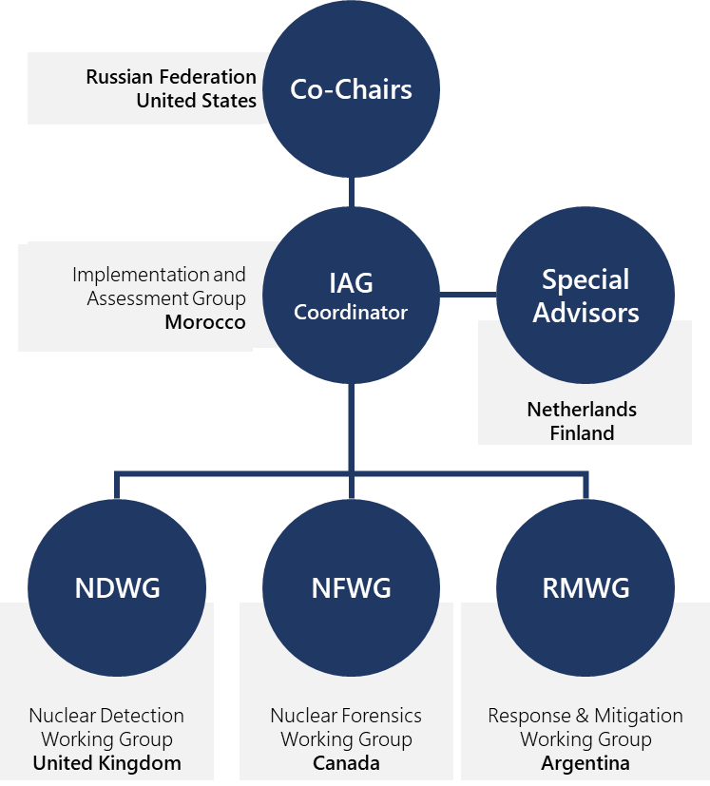
The Global Initiative to Combat Nuclear Terrorism (GICNT) is a voluntary partnership of 89 nations and six international organizations that are committed to strengthening global capacity to deter, prevent, detect, and respond to nuclear terrorism by conducting multilateral activities that strengthen the plans, policies, procedures, and interoperability of partner nations. All partner nations voluntarily committed to implementing the GICNT Statement of Principles, a set of broad nuclear security goals encompassing a range of related objectives. The GICNT was established in 2006 and is co-chaired by the Russian Federation and the United States. Figure 1 depicts the GICNT’s full leadership structure.
FIG. 1. GICNT Leadership Structure.

The objectives of the GICNT are to:

- Integrate collective capabilities and resources to strengthen the overall global architecture to combat nuclear terrorism;
- Convene experience and expertise from the non-proliferation, counter-proliferation, and counterterrorism disciplines;
- Provide the opportunity for nations to share information and expertise in a voluntary, nonbinding framework.

The continued threat of R/N terrorism raises the necessity of initiatives like the GICNT. The threats also sustain the need to prepare for the worst-case scenario, an R/N device detonation. Nigeria recognizes the importance of preparing for an R/N terrorism incident and therefore convened the Valiant Eagle workshop under the auspices of the GICNT’s Response and Mitigation Workshop. This workshop brought together over 70 experts from 17 nations and featured a series of expert presentations, case studies, panel discussions, and a tabletop exercise. The workshop focused on adapting all-hazards response plans into national nuclear response frameworks (NNRFs), which detail the policies, procedures, capabilities, and priorities for responding to a nuclear terrorist attack.
While nuclear security events produce their own set of challenges, response principles often remain the same across different types of mass casualty incidents. Though response to a nuclear security incident is unique, many of the same legal frameworks and emergency response procedures developed for natural disasters or other national-level emergencies could be adapted to meet nuclear response challenges. Valiant Eagle participants analyzed how all-hazards frameworks can be developed to assist in national policy planning for countering the threat of nuclear terrorism, identified best practices for planning and implementing security procedures, and discussed the capabilities needed to detect and respond to a nuclear security threat. Through these discussions, Valiant Eagle identified three critical components countries should include in their NNRFs.
The paper will detail three important coordination factors within a NNRF:

- Interagency Coordination: Coordinating and disseminating guidance for nuclear security response across all levels of government;
- Public Communication coordination: Coordinating pre-approved unified public messages that the government will consistently disseminate to the public prior to, during, and after an attack;
- International Coordination: Coordinating response, assistance, and/or prosecution across borders with neighbouring countries and international organizations.

Interagency Coordination
The workshop highlighted several key best practices related to interagency coordination in NNRFs. NNRFs should outline a multi-faceted command and control structure that details agencies’ roles and responsibilities as well as chain-of-command. Frameworks should clearly define interagency coordination by stating the roles and responsibilities of each agency. Establishing a lead incident response coordinating agency serves as a vital first step in ensuring the effectiveness of preparing and coordinating a response to a potential or actual R/N incident. The NNRF should also clearly identify the roles and responsibilities of additional agencies involved in the response and the respective communication requirements and mechanism among agencies. Each responsibility should have an assigned lead agency as well as supporting agencies. Agencies’ roles will change based on each country’s unique government structure, agencies, and resources. Figures 2 and 3 illustrate Nigeria’s Command and Control Structure to an R/N terrorist incident.

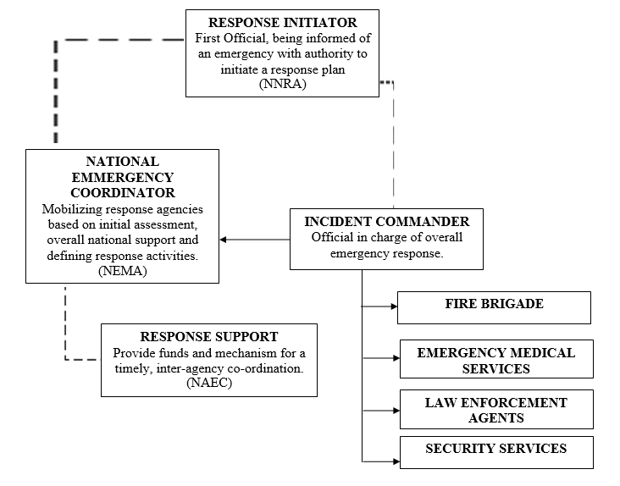
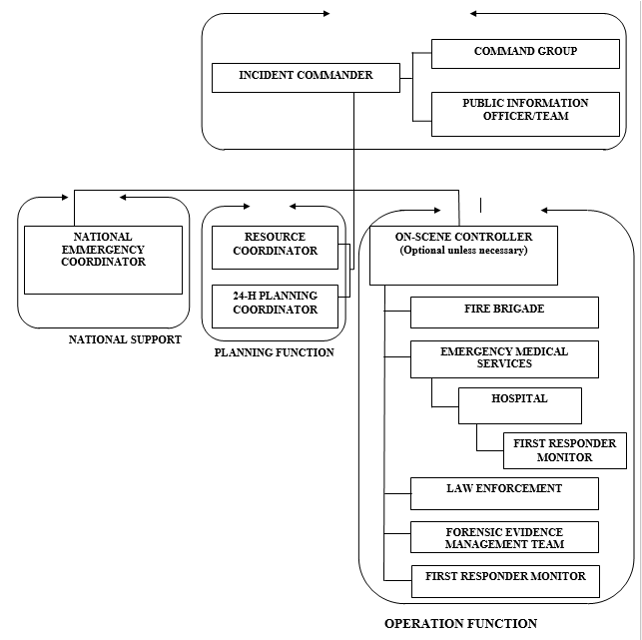
FIG. 2. Nigeria’s Command and Control Structure for Response to Nuclear and Radiological Emergency
FIG. 3. Response Organization at the Local Level Within a Few Hours
Once agencies identify their specific responsibilities, agencies can create elaborate agency specific response procedures that supplement their national NNRF. Personnel, including first responders, law enforcement officials, and technical and scientific experts, should have a working understanding of the NNRF and agency protocols for incident command and control, including determining lead authority at various stages during an incident response. Knowledge of such procedures requires regular training of staff and practical exercises of protocols and command and control functions.
The interagency can conduct field and tabletop exercises to test their NNRF’s policies and procedures and identify gaps. Exercises provide a unique opportunity to analyze coordination and communication mechanisms among agencies prior to, during, and/or after a realistic R/N incident. Recognizing the benefits of exercises, Nigeria included a tabletop exercise in the Valiant Eagle Workshop.
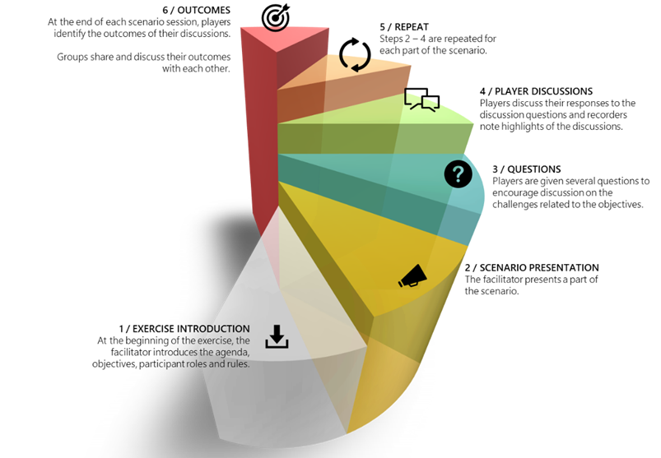
Though Valiant Eagle was conducted as an international workshop, the exercise often focused on national coordination. Valiant Eagle’s exercise consisted of two scenarios that stimulated participants to identify best practices, policies, and procedures. The exercise scenarios occurred in fictitious countries, but participants were encouraged to share protocols and policies from their own countries. Figure 4 depicts the exercise format.
FIG. 4. Exercise Structure.

During each scenario, participants identified interagency coordination best practices and policies. Table 1 outlines a couple exercise scenario outcomes.

TABLE 1. VALIANT EAGLE INTERAGENCY COORDINATION OUTCOMES

Scenario | Outcome 1 | Outcome 2
A terrorist group seeks to obtain R/N material and expand terrorist operations in your country. | Most countries have national emergency response organizations that must work in unison with bodies that specialize in R/N. | Many coordination and communication barriers may occur among agencies while agencies try to assess and prevent an attack, such as information sharing, financing, bureaucratic bottleneck, and language barriers.
An explosion at a major festival has multiple casualties. Due to the mass effect of the radiological dispersal device, first responders must prioritize their response. | Countries should identify their national response priorities before an attack to decrease confusion in the field. Response priorities may change from agency to agency, and agencies must be prepared to coordinate with other response agencies that have differing priorities, such as emergency medical treatment vs. investigating the scene. | By increasing agencies understanding each other’s missions, agencies can more effectively coordinate and work side-by-side in a post-detonation scene. Therefore, countries should train first responders on protocols and procedures that are outside their response responsibilities, such as training fire services about evidence collection so they are aware of what not to do at the scene to avoid evidence destruction.

Public communication
Public communication is paramount during a response. Without effective, consistent public communication authorities cannot achieve their emergency response objective to save human lives and protect the public and the environment. Therefore, countries should outline a public messaging strategy in their NNRFs. To develop the strategy, all communication stakeholders should be present, including those who are responsible for producing, analyzing, and communicating information to the public. There are many important factors to consider in a public communication strategy.
Public communication strategies should be comprehensive and define what is being communicated, why it is being communicated, and who is responsible for communicating it to the public. A key first step is identifying messaging priorities. Then agencies can collaborate to create pre-approved scripted messages, which will aide in quickly disseminating information during an incident and ensure all agencies are releasing the same information. A unified, pre-approved public messaging strategy will decrease the chances of conflicting information and increase clarity. A best practice to ensure a unified public messaging is by identifying a singular communication authority to disseminate all public information. Valiant Eagle identified additional public messaging best practices. These best practices included:

- During a nuclear security event, nations should deliver a unified public message through a central authority, as outlined in the national response plans and protocols, to ensure consistency in communications and to manage public risk perceptions.
- During chaos, most messaging will come from state and local agencies since that is where the crisis occurs. Therefore, national government agencies must include how to coordinate with local and state communication authorities in their public communication strategy.
- Reporters may seek to form a narrative by contacting sources, university professors, and other nongovernment officials. A way to manage media narratives is to provide regular updates to the media, so they do not need to look elsewhere for information.
- Pre-packaged messages and templates will help ensure the information disseminated to the public is accurate.
- Governments should create simple and clear public messages that are easy to read and understand, which will decrease the chance of citizens misunderstanding the message.
- All information regarding the incident and response that was not pre-approved must be validated by the lead communication authority and other relevant authorities before dissemination to the public.
- Creating an international network of experts and policies makers prior to an attack will increase communication efforts among nations. Valiant Eagle provided an opportunity for African nations to strengthen their radiological emergency response network. Figure 5 depicts the Valiant Eagle participants.
FIG. 5. Photo of Participants and Experts

International Coordination
Many aspects and effects of an R/N terrorism incident will not stay isolated in a country; therefore, it is critical to create an international communication and coordination strategy in countries’ NNRFs. This strategy should designate a lead agency that will coordinate with other countries and international organizations. The strategy should also identify key international partners. This may include regional neighbors and organizations as well as radiological specific organizations, such as the International Atomic Energy Association. Once key international partners are identified, countries should understand the type of information and/or assistance their country would receive from their international partners. Lastly, countries should establish communication mechanisms, including maintaining an updated contact list for international partners.
Another important aspect of international coordination is identifying the international laws countries must follow. NNRFs should reference the international laws and/or regulations that impact a country. The laws and regulations a country must follow is dependent upon each country’s ratification of international laws, memorandums of understanding (MOUs) with other countries, and membership in international or regional organizations. Additionally, countries should understand the laws, national or international, that they have ratified pertaining to terrorist prosecution. Identifying the international laws and regulation while building a countries’ NNRF also provides an opportunity to identify gaps in legal requirements needed to coordinate with other countries, such as requesting information and/or extradition of a terrorist suspect. Countries can also identify international coordination gaps by exercising with international and regional partners as well as international organizations.
Valiant Eagle’s exercise included participants from 17 nations, including 13 African countries. The exercise provided an opportunity for African countries to share their knowledge and procedures as well as to better understand how they can cooperate during a nuclear terrorist incident. The country officials identified several international coordination best practices during the exercise. Figure 6 shows Valiant Eagle participant identifying response best practices during the tabletop exercise. These best practices included:

- Nations that are party to the relevant international legal instruments, such as the International Convention for the Suppression of Acts of Nuclear Terrorism (ICSANT) and the Convention on the Physical Protection of Nuclear Material and its Amendment (CPPNM/A), should incorporate the requirements and provisions of those instruments into national legislation.
- Effective bilateral coordination requires both strong relationships among institutions in each country and formalized coordination by protocol or agreement among agencies (such as regulator to regulator).
- Nations should prepare for bilateral coordination through regular meetings between officials and technical experts as well as joint peer exchanges, training, and exercises between partner states.
- Nations should consider plans and protocols for submitting assistance requests to international organizations and regional partners for capacity-building purposes and for support during a nuclear security incident.

FIG. 6. Photo of Participants During the Tabletop Exercise

Challenges and further discussion
Countries should always seek additional ways to strengthen their NNRFs. Valiant Eagle identified four major points of analysis to further explore within the GICNT to strengthen NNRFs and partner nations’ R/N terrorism response capabilities.

- Adapt Existing Plans and Mechanisms: Many countries have well-tested and implemented plans for responding to complex disasters and terrorism incidents. The general principles of incident response coordination can be applied to many kinds of incidents and emergencies. Therefore, nuclear security experts may adapt principles from existing response and incident management plans for nuclear security measures and response to incidents involving nuclear terrorism. In other cases, specific nuclear security measures may be added to existing national security plans with specific provisions for R/N technical and safety measures during an incident response. GICNT may consider further identification of best practices for adapting of existing response plans and incident coordination mechanisms for nuclear security.
- Threat Awareness: Government buy-in is necessary in a limited resource, low threat, and low probability environment. While adaptation of plans may make the most sense in this environment, international and neighborly collaboration may contribute the most towards establishing multilateral frameworks.
- Regional Collaboration: The African region could benefit from the development of a regional forum for African nations to collaborate on topics related to regional nuclear security, working within the African Union.
- Legal Frameworks Implementation: Nations needing additional support implementing provisions and obligations from international legal conventions like ICSANT and CPPNM(A) should consider training programs provided by United Nations Office on Drugs and Crime (UNODC).

Conclusion
The GICNT provides an opportunity for countries to strengthen their capabilities to deter, protect, detect, and respond to R/N terrorism. Nigeria recognized GICNT’s unique ability to gather subject matter experts and policy makers to exchange best practices and policies and therefore partnered with the GICNT to host Valiant Eagle. Valiant Eagle addressed adapting all-hazards response frameworks into national nuclear response frameworks. NNRFs detail in-depth the policies, procedures, capabilities, and priorities for responding to a nuclear terrorist attack. Valiant Eagle identified three core NNRF coordination aspects: interagency coordination, public communication, and international coordination.
NNRFs should identify all agencies involved in an R/N terrorism response. NNRFs should designate a lead agency and supporting agencies for each role and responsibility. Additionally, NNRFs should identify what information agencies must communicate among each other and what communication mechanisms will transmit the information. This information will create the command and control structure for an R/N terrorism incident. Exercises provide an opportunity to test interagency coordination and identify best practices and gaps. During Valiant Eagle’s tabletop exercise, participants identified numerous interagency coordination best practices, such as identifying national response priorities prior to an attack. Agencies should not only prepare for communicating among agencies but also with the public.
Communicating accurate information and directions during an R/N nuclear response remains critical in saving and preserving lives as well as managing public risk perception. To ensure government officials provide constant, consistent, and clear messages, government agencies should cooperate to create pre-approved messages that a designated lead communication agency can disseminate during an R/N incident. Valiant Eagle also highlighted additional unified public messaging best practices, including NNRFs should outline a central and lead authority to disseminate information to the public. It is important to not only prepare nationally but also internationally for R/N terrorism.
An attacked nation can coordinate with international organizations and countries to request various types of assistance. NNRFs should assign a lead agency to manage international coordination as well as maintain an up-to-date contact list of key international partners. NNRFs should also reference the international laws and requirements a country must follow and has ratified pertaining to terrorists’ prosecutions. Valiant Eagle also highlighted other international best practices, such as creating regional and/or neighbourly agreements with nations prior to an attack.
GICNT partner nations, including Nigeria, are always seeking additional areas of analysis to strengthen countries’ capabilities, including NNRFs, to counter nuclear terrorism. Valiant Eagle identified four areas for further analysis to strengthen NNRFs and response capabilities overall. The areas are: Existing Plans and Mechanisms; Threat Awareness; Regional Collaboration; and Legal Frameworks Implementation.

Further information
ACKNOWLEDGEMENTS
Nigeria would like to thank the GICNT, especially the United Nations Office of Counter Terrorism (UNOCT), for coordinating with Nigeria to host Valiant Eagle. Nigeria also extends its deepest gratitude to the Valiant Eagle participants whose expert knowledge and identified outcomes formed the basis of the paper.

