**NUCLEAR SECURITY OF RESEARCH REACTORS:**

**THE EFFECTIVE USE OF INSSP PROCESS**

**AND BUILDING A ROBUST REGIME**

S.E. SHABAN

Nuclear and Radiological Regulatory Authority

Cairo, Egypt

Email: [smh_elsaid@yahoo.com](mailto:smh_elsaid@yahoo.com)

R.A. EL-TAYEBANY

Nuclear and Radiological Regulatory Authority

Cairo, Egypt

M.H. HAZZAA

Nuclear and Radiological Regulatory Authority

Cairo, Egypt

# Abstract

A nuclear security system is designed to provide the necessary protection for humans and the environment around them. Useful applications of atomic energy can never be utilized without the establishment of a strong and effective security system. This system, through its effective pillars, confronts attacks by groups that do not intend to be good to humanity. The IAEA supports States in this regard by providing technical support and advice. States can seek advice and support from the Agency under the umbrella of the Integrated Nuclear Security Support Plan. INSSP aims to conduct an analysis of the gaps in the existing system and fill these gaps.

The paper discusses the importance of nuclear security systems within a research reactor facility and it highlights the most important elements of establishing, maintaining, and sustaining a robust nuclear security regime. It also focuses on the INSSP purpose, INSSP development process, authorities that execute INSSPs activities and categories of INSSP. Finally, the paper overviews how IAEA assists the states in INSSP and the benefit of this assistance to enhance and maintain its national security regime as published in open sources.

**Keywords:** Security, Research Reactors, INSSP.

1. INTRODUCTION

The nuclear cycle is a manufacturing process that includes different exercises in nuclear plants to generate energy from uranium. It starts from mines and ends in nuclear landfill sites as shown in fig.1.Uranium is a popular element located all over the world. It is present in land and sea. It undergoes a rigorous manufacturing process before it can be properly used as fuel for nuclear power plants [1]. The manufacturing process goes through five stages as follows [2]:

Mining: Uranium is the raw material for nuclear fuel and is extracted from the ground like coal and oil. Large quantities are found in various mines in about 20 countries around the world, with more than two-thirds of the amount of uranium extracted from mines in Kazakhstan, Canada, and Australia. Uranium ore is mined during the mining process and then transferred to the mills[1].

Milling: In the mill, uranium is separated from other materials and grinded to the gravel size. Chemicals are then used to analyze the uranium into a liquid solution. Once this solution has dried, it is converted to oxide in the form of a powder called "yellowcake", but at this stage, it is still not suitable for use in electricity generation, as its condition is similar to that of oil when extracted from the ground. The yellowcake is then carefully placed in special metal drums for transfer to uranium conversion facilities[1].

Conversion: There are specialized technical companies to operate uranium conversion facilities, and most of the uranium conversion operations are carried out in Canada, China, France, Russia, and the United States, knowing that these facilities are operated under strict global controls. During the conversion process, scientists use chemical processes to convert the yellow cake into a gas called uranium hexafluoride (UF6), and then put it into special drums. When cooled, it becomes solid and then transferred to the enrichment facility[1].

Enrichment: As in uranium conversion facilities, there are a limited number of countries operating uranium enrichment facilities, including China, France, Germany, the Netherlands, Russia, the United Kingdom, and the United States.

Manufacturing: During the manufacturing process, UF6 gas is converted to uranium dioxide powder (UO2). Then a specialized machine converts this powder into small granules similar in size and shape to a pencil eraser. The powder is then heated in special furnaces to become solid and the granules become stiffer and have very sharp and precise dimensions[1].

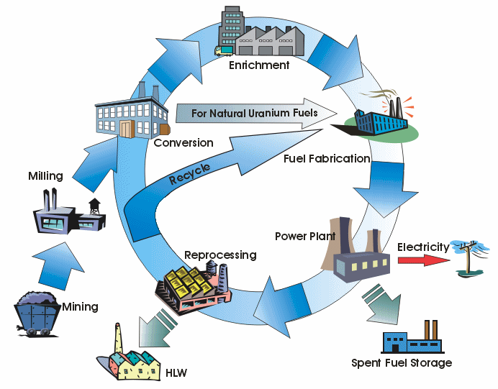

*FIG. 1. The stages of nuclear fuel cycle.*[3]

Nuclear reactions occur within a place capable of containing them and containing the outputs and energy resulting from them, called the reactor. There are two main types of reactors, the first of which is known as the power reactors, while the second is called research reactors.

Research reactors constitute a wide range of civil and commercial nuclear reactors that are not generally used for power generation. The primary purpose of research reactors is to provide a neutron source for research and other purposes[4]. Their product can have different characteristics depending on their use. They are small reactors for power reactors whose primary function is to produce heat to generate electricity. Research reactors are much simpler than power reactors and operate at lower temperatures. They also require much less fuel and produce fewer fission products when using fuel. It is mainly designed to generate high neutron intensity for research purposes. It can also be used for training, material testing and the generation of radionuclides.

Research reactor facilities are built for specific purposes, in terms of their uses and benefits. Therefore, the classification of reactor types is difficult because of the lack of any standardization[5]. The types of research reactors are classified according to the following criteria:

* The designations of the manufacturer of research reactors that produce large numbers and have broadly understood technical terms, such as; WWR, IRT, SLOWPOKE, TRIGA, ARGONAUT
* Heavy water-cooled reactors shall be recorded as HWRs.
* Fueled reactors in the form of a plate of the type of pool reactor are recorded in the reactors pool type.
* Cooled and moderately cooled light-water reactors are recorded by closed cooling systems within the reactors tank type.
* Research reactors with homogeneous solid or liquid fuel are recorded as homogeneous reactors type.
* Critical groups are recorded as they are. fig.2. shows MTR type.



*FIG. 2. The MTR type research reactor.*[6]

The importance of research reactors is that they contain radioactive and nuclear materials. These materials must be secured in such a way that they are protected from any operations that may involve theft or use in any harmful work[6]. States are urgently seeking to develop plans to secure their nuclear facilities, especially those that contain highly attractive materials for inflammatory processes[7,8].

1. INSSP FUNCTIONAL AREAS

The International Atomic Energy Agency (IAEA) provides support to countries that request it to lay strong foundations for building and strengthening its nuclear security system through INSSP. It involves various axes, including the contribution of the IAEA to the establishment of a unit or institute to support nuclear security and training, which will contribute to the development of national cadres, and those related to nuclear and radiation activity.

It also supports increasing the efficiency and capabilities of dealing with nuclear security-related events of loss, theft or smuggling of nuclear or other radioactive materials[9]. It can supplies countries instruments, devices and equipment of high technology, and help in the formation of national experts to work with these capabilities. It participates in developing the physical protection systems for research reactors for peaceful uses of nuclear energy. The IAEA also contributes to building the legal and legislative structure of States to ensure the protection of key pillars of nuclear security in a way that ensures their long-term sustainability[10]. fig.3.dscribes the main functions while fig.4. describes the process of state request.

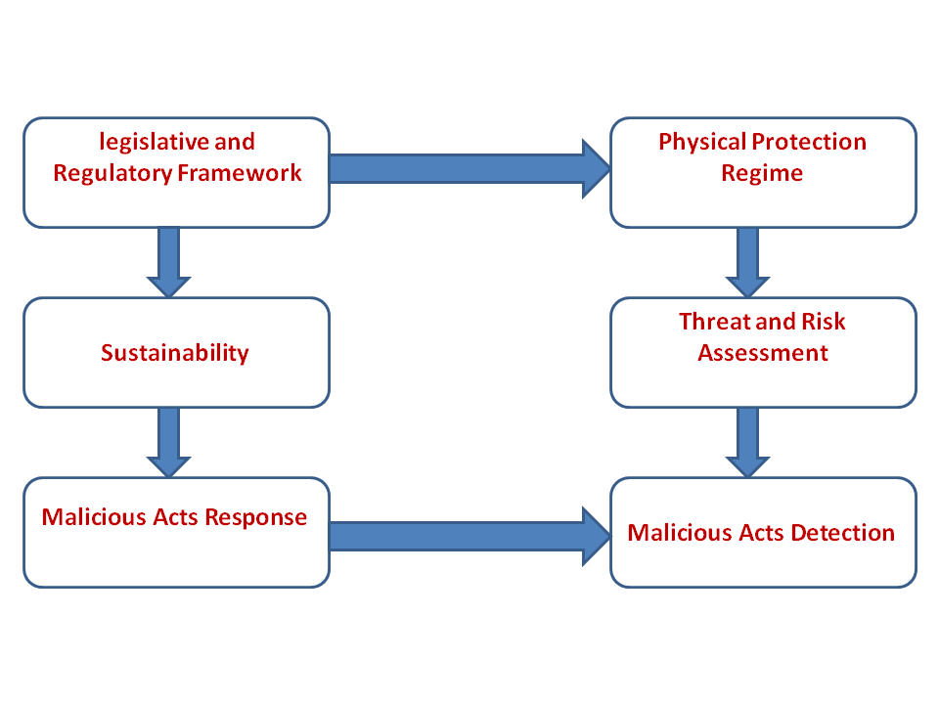

*FIG. 3. Areas covered by INSSP.*

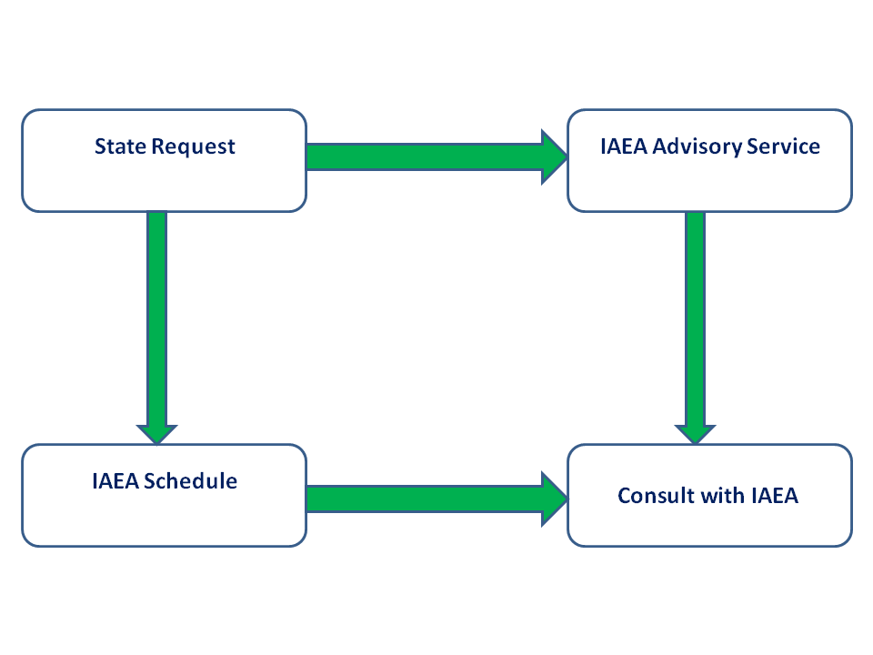

*FIG. 4. The request of INSSP.*

* 1. **Legislative framework:**

The Constitution shall be at the head of the legal and legislative authority of any State and shall be interpreted by its laws and regulations. Every country interested in nuclear energy should pass a law to regulate all nuclear and radiological activities[11]. The process of building a law on the nuclear field is a normal process like any other process in which a law is passed, but the establishment of a nuclear law involves knowledge of all technical terms, processes, and activities within the nuclear fuel cycle. The process of building a nuclear legislative structure should include consideration of full compliance with the State Constitution and other laws, drafting and revision, taking into account stakeholder views [12].

1. INTEGRATED SUPPORT PLAN PURPOSE

The integrated plan provides the framework for a comprehensive approach to addressing specific national security needs also, provides a means for coordinating nuclear security assistance to member states. It enables identifying responsible parties for the completion of nuclear security activities as well as identifying activities necessary to build sustainable nuclear security programs in member states [10].

1. INSSP COMPONENTS

• Matrix Component

* General Summary Level of Activity

• Management Component – Expands on Matrix

* Action (what)
* Timeframe for implementation (when)
* Location (where)
* Task (how)
* Responsible entity (who)

1. ORGANIZATIONS RESPONSIBLE FOR IMPLEMENTATION OF INSSP ACTIVITIES

The application of INSSP is not only applying to nuclear actors within the state, but there are other parties and stakeholders responsible for its implementation. The concerned stakeholders are ministries such as health, interior and foreign affairs, customs and border authorities, as well as some sovereign bodies. fig.5. shows an examples of stakeholders.

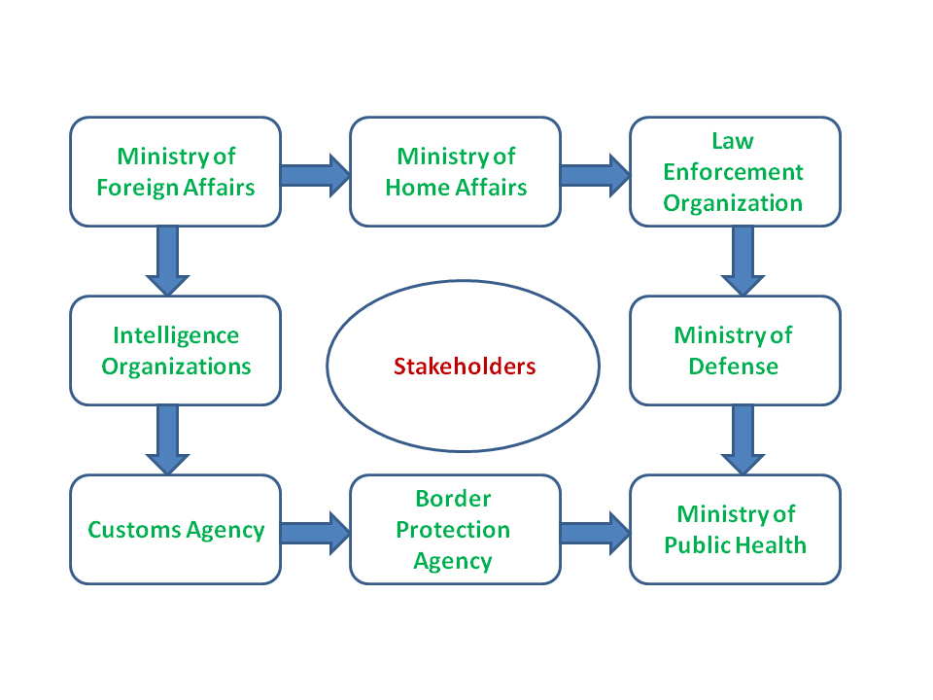

*FIG. 5. Stakeholders of INSSP.*

1. CONCLUSION

Reactors of all kinds, whether powerful reactors or research reactors are attraction sites because they contain nuclear and radioactive materials. Therefore, its protection is not easy but must be in accordance with a tight plan and a set of measures that are difficult to penetrate or tamper with. Building a robust and efficient regime nuclear security is essential for any state. Such a system to be effective should apply fundamental issues that are mentioned in IAEA publications. IAEA helps states in enhancing and developing its regime of nuclear security through IPPAS and INSSP. INSSP aims to develop laws and regulations, prevent, detect, respond and sustain. The IAEA's mission is not done on a voluntary basis but depends on the request and willingness of the state. The role of the state is evident in its implementation of the requirements optimally.

1. REFERENCES

## [1] [VLADO, V.,](https://07101yok8-1103-y-https-www-sciencedirect-com.mplbci.ekb.eg/science/article/pii/B9780444641465000069#!) [Radioactivity in the Environment (Second Edition)](https://07101yok8-1103-y-https-www-sciencedirect-com.mplbci.ekb.eg/science/book/9780444641465), Chapter 6 - The nuclear fuel cycle, Pages 329-396. (2019).

## [2] SCHRIEFER, D. Safeguards, security, safety and the nuclear fuel cycle.  *I. Crossland, Nuclear fuel cycle science and engineering, Woodhead Publishing.*(2012).

## [3] <https://www.researchgate.net/figure/A-schematic-diagram-of-closed-nuclear-fuel-cycle_fig1_265737133>

[4] IAEA, Research reactors: Purpose and Future.(2016).

[5] Böck, H., and Villa, M., Survey of Research Reactors, ENEN, Wigner Course (2004).

[6] ETRR-2, Egypt. <http://www.iaea.org/worldatom/rrdb/>

**[7]** AJLOUNI, ABDUL-WALI, M., and Akef, M., Design of Nuclear Security Regime to Combat Nuclear Terrorism. (2014).‏

**[8]**IAEA, Nuclear security management for research reactors and related facilities, ISBN 978-92-0-111315-3, Vienna.(2016).

**[9]** IAEA, Objective and Essential Elements of a State’s Nuclear Security Regime, IAEA Nuclear Security Series No. 20, IAEA, Vienna. (2013).

**[10]** <https://www.iaea.org/topics/integrated-nuclear-security-support-plan-inssp>

**[11]** IAEA, handbook on nuclear law, STI/PUB/1160. July (2003).

**[12]** ZIDAN, W., The proposed drafting process for nuclear security regulations: Egyptian case study, *International Journal of Nuclear Governance, Economy and Ecology* 4.3: 165-179. (2019).