Nuclear security inspections; the Hungarian way

V. HÓDOSI
Hungarian Atomic Energy Authority
Budapest, Hungary
Email: hodosiv@haea.gov.hu

A.M. VIPLAK
Hungarian Atomic Energy Authority
Budapest, Hungary

Abstract

Hungary is rich in radioactivity related activities as there is a nuclear power plant operating with four reactors, a spent fuel interim storage facility, a research and a training reactors, and two radioactive disposal facilities next to the around four hundred radioactive source users. Because of the amount of possible inspection locations the Hungarian Atomic Energy Authority (HAEA), having all the regulatory rights in all nuclear related fields, had to introduce a multilevel nuclear security inspection system. The paper’s goal is to describe the Hungarian regulations in relation with nuclear security and inspections, the HAEA’s structure, the way the inspections are carried out and the future challenges.

INTRODUCTION
Hungary, as a member of the European Union, has a wide range of use of nuclear and other radioactive materials and also many nuclear and storage facilities. Besides the use and storage, as a transit country, it hosts different level of transports during all year. To ensure that these activities are protected properly from malicious acts the national regulatory, the Hungarian Atomic Energy Authority (HAEA) performs nuclear security inspections. With an increasing nuclear industry and growing regulatory responsibilities the HAEA has worked over their organisation and internal procedures. The paper will describe the regulations, the work of the HAEA in the field of nuclear security, the type of licensees and inspectors and also the correspondent procedures.

Hungarian regulatory system
The uppermost level of domestic application of the obligations undertaken in the international convention is represented by the Act CXVI of 1996 on Atomic Energy (Atomic Act). In accordance with the Atomic Act, the control and supervision of the safe and secure application of atomic energy is the responsibility of the Government. The Atomic Act establishes a so-named divided authority and regulatory regime: the execution of the governmental tasks described in the Atomic Act is divided between the Director General of the HAEA and the ministers concerned. [1]

The HAEA is a central government organization with its own scope of authority and its own tasks and regulatory competence supervised by the Minister of Innovation and Technology. HAEA is independent from both organizational and financial aspects of the organizations using and promoting the use of atomic energy.

The Atomic Act introduces three basic principles in relation to physical protection. The first one it that according to the principle of graded approach the threat against the particular material, equipment or nuclear material shall be taken as basis to design and construction of the physical protection system (PPS). In order to determine the particular threat and so the respective requirements the attractiveness and potential applicability of the material shall be taken into account. The second is the protection-in-depth concept, which requires the application of a complex system of principles, administrative measures and technical solution built onto each other to ensure physical protection, where the system guarantees for the realization of the required level of protection by a combination of various independent protection levels applied in a specific sequence. The third concept of equal protection means that the physical protection system shall provide approximately equivalent protection against each potential intrusion routes and tactics under any (i.e. environmental, meteorological, lighting) conditions. [1]

The Atomic Act also stipulates that the operation of the physical protection system of a nuclear facility, the use, store and transport of nuclear and other radioactive materials, as well as the particular implementation of the deterrence, detection, delay and response physical protection functions shall be described in a physical protection plan. [1]

In nuclear security issues, the HAEA is supported by the National Police Headquarters (NPHQ) as a co-authority, which means that the HAEA cannot give permission or license for PPSs if the NPHQ does not agree with the decision. The HAEA and the NPHQ are responsible for licensing of physical protection plans and inspecting their implementation. The license holders are responsible for the implementation of the system described in their approved physical protection plans and the additional conditions given by the HAEA in the license. All security related regulations are prescribed in the 190/2011. (IX.19.) Government Decree, which had several amendments since it is effective. One of the amendments has established the authorization of programmable systems and have changed the procedure of the authorization of transports requiring level D physical protection, where licensing was changed to a more simple registration process. [2]

Regulation of inspections
The regulations of how-to conduct a nuclear security inspection and what are the rights and obligations of the inspectors and the licensees could be found in the Atomic Act, the Government Decree and the Act CL of 2016 on General Administrative Order (GAO Act).

The GAO Act contains the most common regulations about regulatory inspections, as it controls the official procedures of all Hungarian administrative procedures. In the Act the client of an inspection is defined, the basic step of an inspection is stated and there are also auxiliary instructions, for example how to involve an interpreter. [3]

As a next level the Atomic Act states more specific regulations: the HAEA can conduct inspections on every licensees’ sites. These inspections have no time limit, could be a constant process or performed remotely with the help of electronic data collection and analysis. The inspectors have to minimize the interference with the licensee’s operation and could not perform any operational action. The inspectors have the right to enter all the sites for performing regulatory actions even if they don’t have a permanent entry pass. [1] Therefore all HAEA inspectors have a special ID card to identify themselves at the beginning of inspections.

The most specific regulation could be found in the Government Decree: the HAEA and the NPHQ have the right to inspect the fulfilment of the physical protection plan and the operation of the PPS. These inspections could be announced or unannounced ones. The HAEA and the NPHQ have to synchronize their inspection activity, they could perform one together or independently, but always have to notify each other about an upcoming inspection and send each other the inspection reports. [2]

The licensees
The users of nuclear and other radioactive materials, from a security point of view, are grouped into two types. Both types have different security specifics, regulations and inspection methodologies. The first group called facility level licensees. It covers the Paks Nuclear Power Plant, an Interim Spent Fuel Storage, two radioactive waste storage sites, a Training Reactor at the Budapest University of Technology and Economics, a Research Reactor at the Centre for Energy Research and the two new power plant units under construction. The HAEA, according to the regulations, issued a DBT for all these sites, and the operators have to design and operate their PPS in a performance-based way, to withstand any adversary scenarios within DBT boundaries. These sites have a severe attention from the media and the population, which means that any small security incident might have a huge echo. The HAEA performs dedicated security inspections at these sites. One kind of exception in the group is the Training Reactor, which has a thermal power less then 1 MW, so it has no DBT and could follow the prescribed regulations for the PPS. But because it is in the heart of the capital city, built on an open university campus, the HAEA decided to observe its security with higher attention.

In the other type of licensees are the non-facility level one sites, where radioactive material is used or stored. These are usually universities, hospitals and private companies. In regard of the Hungarian regulation their PPS is designed in a prescriptive way and the HAEA performs complex inspections of security, radiation protection and inventory management. These licensees are not really well known to the public or the media, and usually there are occasionally any security incidents. In 2019 the number of closed radioactive sources in the national inventory is more than 8000 and these are used or stored by around 400 licensees.

THE HUNGARIAN ATOMIC ENERGY AUTHORITY
Hungarian Atomic Energy Authority, as a government office, is a centralized nuclear regulatory body, being responsible for the oversight of the safe and secure use of atomic energy and radioactive materials exclusively for peaceful purposes. The HAEA is the national competent authority in the case of
- non-proliferation (prevention, detection and response to non-peaceful applications by licensees);
- nuclear security including transport security (prevention, detection and response to sabotage and unauthorized removal);
- nuclear safety (realization of operating conditions, prevention of accidents and mitigation of their consequences in all phases of the lifecycle of the nuclear facility and the radioactive waste repository through which the employees and the public is protected against ionizing radiation caused by the facility);
- radiation protection (protection of the public and environment from the harmful effect of ionizing radiation);
- accountancy for and control of nuclear materials;
- national registry of radioactive sources;
- licensing of special form radioactive materials and package designs;
- licensing of nuclear export and import;
- evaluation and coordination of research and development related to the safe application of atomic energy;
- emergency preparedness. [1]

To ensure regulatory independence, as expected by the international community, the HAEA decisions and resolutions cannot be changed or eliminated in a public administration process, only through court proceedings. The HAEA also has the legal right to provide opinion to any proposal, which relates to the laws and regulations in connection with its regulatory authority. The HAEA is stated in the capital, Budapest, and has an onsite inspectorate at the site of Paks Nuclear Power Plant.

The HAEA is led by a Director General (DG), who has the right to issue regulatory decisions or delegate this right to one the subordinates. There are some organisational, as it could be seen on figure 1, units that reports to the DG personally. These are the units responsible for example for human resources, finance, legal questions, emergency management or the security of classified information within the HAEA. Under the DG there is only one Deputy-Director General (DDG), who is responsible to control the regulatory work of the authority. Under the DDG there are four departments and the onsite inspectorate. The departments are overseeing specific regulatory tasks or licensee types. For example, the Reactor Oversight Department is responsible for the safety and radiation protection regulatory tasks in case on nuclear reactors. The regulatory tasks in relation with nuclear security is within the Radiation Sources, Safeguards and Security Department. If any of the other departments has any security related questions or needs a security-related review of a document or application, they can formally ask for the help of the nuclear security inspectors.

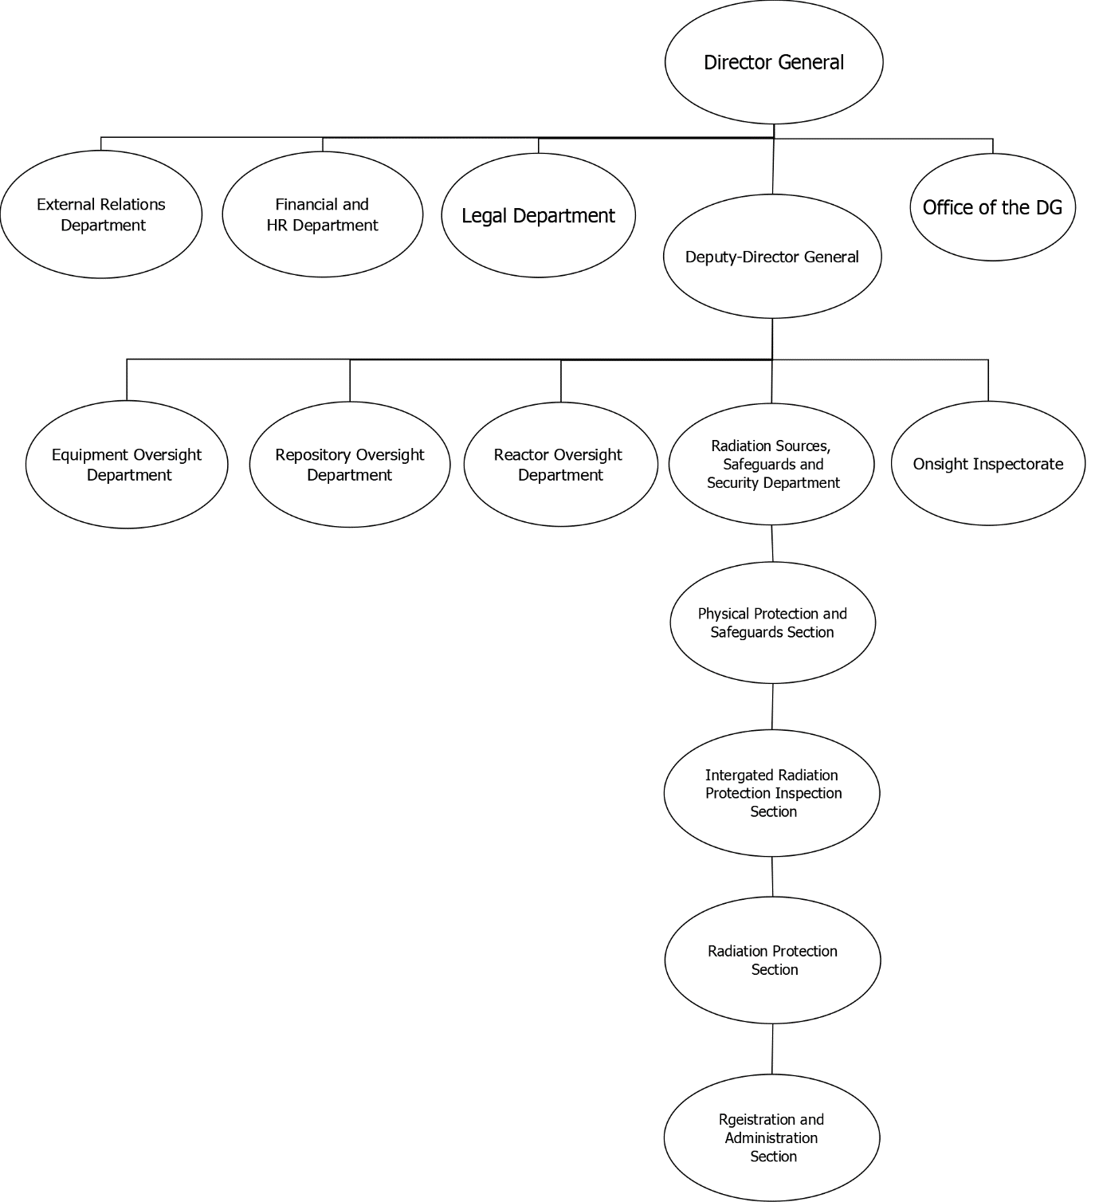
FIG. 1. HAEA organization structure

Within the Radiation Sources, Safeguards and Security Department there are four different sections: Integrated Radiation Protection Inspection Section (IRPIS), Radiation Protection Section, Registration and Administration Section and the Physical Protection and Safeguards Section (PPSS). In the following the Integrated Radiation Protection Inspection Section, the Physical Protection and Safeguards Section and the interaction between them will be presented.

The Physical Protection and Safeguards Section
The Physical Protection and Safeguards Section is responsible for all nuclear security and safeguards related licensing and most of the inspection activities too. In the section there are nine inspectors and a part-time safeguards expert, six out of them are dedicated security inspectors, but the other two is also cross trained and carries out security licensing and inspections regularly.

All the inspectors have university degree as security engineer, from a law enforcement academy or nuclear energy engineer, and they are taking part continuously on domestic and international training. A great help in it is the cooperation with the United States Department of Energy’s support programmes and the training opportunities provided by the International Atomic Energy Agency (IAEA). As a kind of basic training the HAEA tries to send all the members of the PPSS to the International Training Course of the IAEA and the Sandia National Laboratories in Albuquerque, Unites States. Besides being trained, the PPSS provides instructors or experts in IPPAS mission, if it is requested by the IAEA.

The PPSS main task is to carry out all nuclear security licensing processes, dedicated security inspections of sites and transports, security relates enforcements, provide expert support for the other departments, organise internal trainings for HAEA staff if requested and observe all the steps of the new nuclear power plants construction from a security point of view. As the new units will be built right next to the operating four units of Paks Nuclear Power Plant, every phase is examined by the PPSS, whether it will pose a security risk and if yes, then how to mitigate it.

The Integrated Radiation Protection Inspection Section
The Integrated Radiation Protection Inspection Section was established in 2016 after the HAEA took over the regulatory task of radiation protection from the county centres of the National Public Health Service (NPHS). This required that the authority has to perform a huge amount of inspections throughout the country, without any local offices. The section has eight regional inspectors spread around Hungary and two coordinators working in the HAEA in Budapest.

The inspectors of the IRPIS have different educational background but all of them have a university degree in engineering or science. Most of them worked for the NPHS before the reassignment of the regulatory task. They all were trained through the HAEA’s internal training programme, but in the previous years there were occasions when some of them could take part in international training programmes too.

The IRPIS’s main task is to perform complex or pre-operational (required by the radiation protection regulation) inspections in users’ of radioactive material or equipment generating ionising radiation without incorporating radioactive material, carry out enforcement processes in case multiple fields are affected, and to follow the fulfilment of HAEA specified conditions.

Interaction between the sections
Between the PPSS and IRPIS there are formal and informal interactions and communications. The formal ones are through the HAEA’s case manager system: the inspectors can notify each other or whole sections about a creation, modification or approval of documents and can send filed memorandums too. The informal is through the official e-mail system or phone. If any of the regional inspectors has a security related question about a licensee, inspection techniques or deflections than they can contact a security inspector for consultation.

When a nuclear security license approval arrives to the HAEA the PPSS has to examine the documentation, involves the co-authority, manages the rectification and onsite survey if necessary. At the end of the process, if everything fulfils the requirements, the PPSS prepares the official physical protection license document. After the approval, if the user is not facility level, the IRPIS, following their annual inspection plan, will hold a complex inspection at the site. If they find any security related deviation, they notify PPSS which will conduct the enforcement. If there were deviations from more areas, the IRPIS will be responsible for the enforcement process. Every physical protection license, expect transport level B ones, are valid for five years. If a license expires but the licensee is not wiling to submit a new application, the PPSS will start and conduct the enforcement.

All data, plans, regulatory decisions and inspection reports are uploaded to a secure and restricted HAEA database. The inspectors and designate administrators can perform different searches or inquires from this database, narrowing down to time intervals, security levels, licensees or their activities. A future plan is to revise this database and to connect with the case manager system, so all entered data could be easily exported to official letters or decisions and every fulfilment of conditions, specified by the HAEA, could be tracked easily by the inspectors.

inspections
In the regulatory work, not just in the field of nuclear security, it is greatly important that the three different regulatory functions, licensing, inspection and enforcement, are working in harmony and balance. As the inspection is the only option for the regulatory to ascertain that the physical protection system is working efficiently and according to the regulations and the approved physical protection plan, the HAEA divided the inspections based on the type and activity of the licensees. For all the different types internal procedures and special report forms are used to support the work of the inspectors and to ensure the integration between them. In the following the main types and procedures are presented.

Facility level inspections
The HAEA put great effort in dedicated security inspections, carried out by the PPSS, throughout the Hungarian nuclear facilities. The number of inspections is based on an annual plan, which takes into account the risk denoted by the facility and the experiences from previous years’ inspections, but the regulatory organisations always have the opportunity to increase the number throughout the year, if necessary. The reason for extra inspections above the annual plan could be an incident, notification about security violation, etc. The usual number of facility level inspections carried out by the HAEA every year is around 14.

According to Hungarian regulations inspectors have the right to perform an inspection in an announced or unannounced way, depending on the aim of the inspection and management decisions. In case of an announced inspection an informal and later formal notification is sent to the licensee, denoting the time and objectives and the inspectors’ name. [2] The PPSS prepared an internal procedure for executing inspections and for announced ones a three pillars structure was established. This system means, that during one inspection at least one detection or active delay system has to be performance tested, there must be some drills for the internal response forces, which usually covers the measuring of response time, the occupation of pre-appointed response positions or the solving of a hypothetical situation by the shift commander. The third pillar is documentation and log check: one subsystem of the physical protection system is denoted, and the logging of a particular time period is asked to be showed or printed by the license. It could be a certain time frame for the access control system or certain alarm’s log files handled by the Central Alarm Station. The documentation inspection could also cover how the licensee logs the open of the security zones or the handing out of keys. In the last two years joint inspections are also carried out during which the fulfilment of cyber security regulations was also examined.

In case of unannounced inspection, the licensee will not be notified earlier, but the inspectors will hand over the official notification letter on site. These inspections are usually planned on periods when the performance of the internal response forces expected lower, for example late night (graveyard shift), weekend or close to national holidays. These inspections are planned to be shorter, mostly focusing on the performance of the response forces and the operability of the PPS subsystems. This could mean response drills, hypothetical situations, testing of equipment and in all cases the examination whether the Central Alarm Station operates orderly (members of the response force are awake and ready to duty, all doors that have to be closed are really closed, cooling in the server rooms are operating, protective gears are stored properly, etc.).

During the dedicated inspections officers from the NPHQ are usually take part and a joint inspection report is prepared right after the inspection on the site. These reports are made on a computer during announced inspections and in case of unannounced ones the inspectors make it with handwriting.

As the National Police is responsible for the supervision of the Armed Security Officers in nuclear facilities too [4], city and county police can also perform inspections on the sites, but usually these are about how the security officers perform their duties, manage their logs and guards their weapons. In 2019 the HAEA initiated a tighter cooperation with the National Police, within it the aim is that the HAEA could be notified about the local police units inspections’ time and results. The negotiations about the specifics of this cooperation is in progress when the paper was prepared.

Radioactive material users’ inspections
As there are almost 400 hundred entities in Hungary with a license to operate a PPS for the purpose of protecting the used or stored radioactive materials, the HAEA introduced a special, complex inspection programme. During such an inspection a regional inspector if the IRPIS will examine both the fulfilment of the requirements of radiation protection and nuclear security, and also will check whether the inventory is consistent with the data in the national database. To assist the work of the regional inspectors the HAEA prepared and uses a special, check-list like report form. This helps the inspection in a way that every function or relevant data, which has to be examined, of the PPS is listed on it, so the inspector only has to follow it during the execution. Besides it there is also blank space left intentionally on it, so that both the inspector and the licensee’s representative can write remarks there in connection with the inspection.

The average amount of complex inspections in a year is around 240. The plan that who is going to be inspected is determined by a special calculation, which takes into consideration the danger posed by the licensee’s material, previous years’ experiences, the number of inspections that could be carried out in that year and the internal policy, that no licensee should inspected by the HAEA at least every five years. There has been another calculation process prepared, which has more security related elements, but it is not in use at the moment.

Dedicated security inspections are carried out on radioactive material users’ site after incidents, notifications or if during the licensing of the physical protection plan the HAEA or the NPHQ feel the need for it. Usually these on-site licensing reviews are only in case of level B licensees, who present higher risk with Category 1 radioactive sources. The amount of these inspections is around two or three every year and are carried out by the staff of PPSS. During these a normal, non check-list like report form is used.

Transport inspections
As Hungary is a transit country international transportation of goods, including radioactive materials is fairly common, but also there are many domestic transports too. As only in case of level B transports the date and route is required to be approved by the regulatory body, there is no real statistics about how many transports are there in a year. The number known is that there are annually around 30 level B transports, and there are around 50 valid level C transport security licenses and around 100 level D registrations (one license or registration could mean several vehicles). Every year there also a couple of fresh fuel transports to the Paks Nuclear Power Plant, but due to the transported materials value, these fall under a different category in the internal processes of the HAEA.

As the HAEA has no rights or equipment to stop a moving transport on the road the security inspections are carried out at the starting or final destination. At the moment it is quite difficult to inspect a level D or C transport, because the licensees don’t have to notify the HAEA prior the process, which results that inspectors need to be lucky to arrive on the licensee’s site and find an ongoing transportation. That is why most of the transport examinations are carried out in case of level B transports, when the time interval and route is known. These inspections’ programme includes the check of documentation and the indication of necessary warning signs, the presence of delay elements, if applicable, the inspection of the armed escort and the operation of the detection systems. In 2019 2 level B transport inspections were carried out by the HAEA.

The fresh fuel transports are most of the time inspected by the HAEA. The security inspectors of the PPSS use different methods to examine the protection of the cargo: they can get on the transport vehicle and stay on that during the whole process, can have a quick inspection at the initial location or at the final destination, could be at any intermediate stop points or combine these all methods. As all information in relation with these transport activities are classified, inside the HAEA only the senior management and a couple of inspectors know the exact date and route, and all official notifications and reports prepared in a way that no outsider could gather information about the transport in case they manage to acquire them. The inspection programme covers the same area as in case of the other transportations but the examination of some special elements, which are unique and classified in these cases, is added. Every year there are a couple fresh fuel transports, but the exact number is not public.

During all kind of transport security inspections, as there is no computer support present at the location, a check-list like report form is used and filled by hand. It contains the most important security details that an inspector should check (elements of the PPS, like warning signs, locks, communication devices and procedures, detection and delay capabilities, data of the escort) but there is also empty space for the remarks of both the inspectors and the representative of the licensee. The only difference in the report form in case of fresh fuel transports is that only the administrative data and the participants’ remarks are indicated. One of the most important standpoints is that no inspection process can risk the security of the radioactive materials, so the examinations are usually carried out swiftly and in cooperation with the licensee’s staff.

future challenges
With a growing nuclear industry in Hungary, one of the most urgent and important is the increase and the sustainability of the staff both in the regulatory body and private sector. To ensure this the HAEA has already taken many steps, for example achieved that the Hungarian government increased the salary of its employees and started a growth programme in 2015 to secure the necessary amount of inspectors not just for the every day tasks, but for the licensing of the new nuclear power plant units. In case of the PPSS just in 2019 two more inspectors were hired.

As part of sustainability and increase of efficiency the continuous training of the inspectors, especially the regional ones, is a future challenge. Not just because of the financial cost of such trainings, but because it is difficult to extract all or most of the members of a section for a couple of days and there is only a limited amount possibility to send some people abroad to international trainings.

Besides the human resources and training the following years’ challenge, besides the construction of the new nuclear facilities, is to increase the number of dedicated security inspections in Category 1 radioactive users and radioactive transports, because these could also mean a huge risk for the population and the environment if they are not protected adequately.

conclusion
The Hungarian Atomic Energy Authority puts a great effort in carrying out highly efficient and professional inspections in all fields of its responsibilities. With a huge amount of radioactive source users, transportations and with many nuclear facilities, the HAEA had to come up with a system to share the burden of the regulatory functions of licensing, inspections and enforcement, between different organisational units.

With all these achievements, the HAEA still has a lot of work to do to improve and increase its nuclear security inspection capabilities, and also to maintain the high efficiency, which is relevant to ensure the public and the international community that all radioactive materials, whether being used, stored and transported, and nuclear facilities are well protected against malicious acts.

References
- Act CXVI of 1996 on Atomic Energy
- Government Decree 190/2011. (IX. 19.) Korm. on physical protection requirements for various applications of atomic energy and the corresponding system of licensing, reporting and inspection.
- Act CL of 2016 on General Administrative Order
- Act CLIX of 1997 on Armed Security Officers and Park Rangers

