INSSP Implementation in Lebanon:
Ten year of achievements and the way forward

K. ZAHRAMAN
Lebanese Atomic Energy Commission- National Council for Scientific Research
Beirut, Lebanon

R. BAYDOUN
Lebanese Atomic Energy Commission- National Council for Scientific Research
Beirut, Lebanon

F. MALAK
University of National and World Economy
Sophia, Bulgaria

A. RIFAI
Lebanese Atomic Energy Commission- National Council for Scientific Research
Beirut, Lebanon

B. NSOULI
Lebanese Atomic Energy Commission- National Council for Scientific Research
Beirut, Lebanon
Email: b.nsouli@laec-cnrs.gov.lb

Abstract

During the last decades, the use of radioactive materials has widely spread in Lebanon in different fields such as medicine, agriculture, research and industry. The Lebanese government requested the IAEA to conduct an INSerV mission for evaluating the level of nuclear security in the country with a focus on legal and regulatory framework, physical protection of radiological critical infrastructure and the combatting of the illicit trafficking of radioactive sources. The mission was carried out in 2006. The report of the mission was officially received from the IAEA; it includes a number of recommendations and suggestions that were the basic of the Integrated Nuclear Security Support Plan (INSSP) that was prepared in 2008 and lastly updated on February 2019. Different efforts have been made for enhancing the level of nuclear security in Lebanon including the establishment of a new national structure for enhancing inter-agency cooperation and coordination, working under the supervision of the Prime Minister, dealing with the implementation of international binding legal instruments related to CBRN materials and to WMD affairs.

INTRODUCTION
The Lebanese Atomic Energy Commission (LAEC) was established in 1996. It is tasked, by decisions of the Council of Ministers and by the 15512/2005 regulatory decree [1], as national radiological and nuclear regulatory and control body, to have the responsibility for creating the national infrastructure for the safe, secure and transparent use of radiological and nuclear materials that can permit the implementation of related ratified international legal instruments in line with the latest IAEA safety standards and security guides [2,3,4] including the code of conduct of safety and security of radioactive sources .
In Lebanon, large number of radioactive materials have been used since 1960s exclusively in peaceful use of atomic energy. These sources of ionizing radiation are used in various sectors, where the largest number are dedicated to the medical field for diagnosis and therapy. The import of radioactive sources had increased during the last decades, about 1055 sources were imported between 2006 and 2019 for different purposes. All these sources and relevant practices are under the control of the LAEC. However, it was essential for Lebanon to develop a powerful nuclear security measures to combat and mitigate the threats accompanying peaceful use of radioactive materials, and to enhance physical protection relevant to existing radiological facilities.
The starting point for Lebanon for establishing the national nuclear security infrastructure, was the request of its government to the IAEA for conducting an INSerV mission in the second quarter of 2006. The mission was conducted on time. The report of the mission served as guide for setting short and midterm objectives and related plans and activities for establishing, developing and sustaining a workable nuclear security regime in the country, involving all concerned bodies (Army, law enforcement agencies, intelligence, academia, civil defence, LAEC and relevant ministries like foreign affairs, justice, economy and trade and transport) with defined roles and responsibilities.
INSSP of Lebanon was drafted in 2008 by relevant national bodies in cooperation with the IAEA, updated and endorsed in 2010 and updated recently in February 2019. It covers different faces of the nuclear security regime, namely legal and regulatory framework, prevention, detection and human resource development. In addition, a requested IPPAS mission was conducted in February 2019. The last update of the INSSP includes activities related to the suggestions and recommendations reflected in the IPPAS report which is officially handover to the President of the Council of Ministers during a nuclear security visibility event held under his hospices in presence of the IAEA DDG of the NSNS department
The implementation of the nuclear security activities, related to the INSSP, in a well-coordinated manner permits several achievements in the field of :i) physical protection of radiological and nuclear materials, ii) combatting the illicit trafficking of radiological and nuclear materials, iii) management of category I and II disused sources, iv) search and secure of orphan radioactive sources, v) regulatory framework, vi) human resource development via education and training, vii) alternative technology and viii) national and international cooperation and coordination.
In this paper, some achievements related to the above mentioned field are presented and discussed.

Improvement of Nuclear Security Status in Lebanon
Due to the arising of risks and threats accompanying the widespread use of radioactive and nuclear materials, the Lebanese Government had exerted powerful effort since 2006 to combat the illicit trafficking and to enhance physical protection of radiological facilities. For this purpose, the International Nuclear Security Advisory Service (INSServ) mission was requested and was carried out in 2006. This mission aimed to evaluate the requirements for the establishment of an effective nuclear security regime. This include the required infrastructure to address issues related, among others, to radioactive and nuclear materials out of regulatory control, physical protection of radiological and nuclear materials, radiation border control, radioactive waste management, potential unauthorized use of radioactive sources and inter-agency cooperation and coordination with a highlight to their roles and responsibilities.
Based on the recommendations of the INSServ experts, reflected in their official report, and with the assistance of the Nuclear Security Division at IAEA, Lebanon had drafted the first Integrated Nuclear Security Support (INSSP) in 2008. Later, this INNSP was updated in 2012, 2016, and 2019 in order to take into account the implemented activities, the current development and the current priorities.

National stakeholders and their assigned roles
The sovereign responsibility for security resides in the office of Prime Minster - Head of the government as stated in Article 64 of the Lebanese Constitution. The nuclear security responsibilities are distributed among a number of competent national stakeholders. Major roles are played by: Lebanese Army, General Security, Internal Security Forces, Lebanese Customs and Lebanese Atomic Energy Commission. The structure that ensure the coordination and communication among involved stakeholders is the recently established CBRN Commission by a decision of the President of the Council of Ministers No. 228/2018 [5].

Lebanese Atomic Energy Commission - LAEC
According to the Regulatory Decree 15512/2005 of the 105/83 Decree Law, the LAEC and the Minister of Public Health are two organizations to whom are assigned the regulatory functions for all practices dealing with ionizing radiation. Under this law, the main responsibilities of LAEC include:
- Preparing national regulations according to standards and norms,
- issuing certificates for authorization for all practices dealing with ionizing radiation sources, covering some nuclear security aspects; the certificates for authorization are mandatory to issue licenses by the MPH,
- conducting regular inspections for facilities dealing with ionizing radiation, to assure implementation of adequate safety and security measures,
- taking all adequate measures to ensure the fulfillment of authorization requirements,
- establishing national register of radioactive materials in use, storage and transport,
- collaborating with ministries, public and private institutes and relevant international organizations in the field of radiation protection for people and environment,
- providing radiological assistance in radiological emergency,
- organizing training for first responders and national stakeholders involved in the nuclear security regime,
- reporting to relevant international organizations in the framework of ratified binding international legal instruments,
- organizing, in collaboration with other stakeholders, drills and scenarios focused on illicit trafficking and recovery of radioactive materials out of regulatory control.

Lebanese Armed Forces - LAF
The Lebanese Army cooperates with LAEC in nuclear security field, especially in response activities to radioactive materials out of regulatory control. They conduct reconnaissance and searching operations in case of lost, stolen or in case of found of orphan source and they are in charge to ensure security measures (guarding and escorting). The stations of Radiation Early Warning Network System are located in Lebanese Army barracks distributed across the country and under their direct supervision, hence they cooperate with LAEC in prevention part as they contribute in maintenance and testing of these stations. The Lebanese Army had created a unit dedicated for CBRN materials and weapons of mass destruction.

General Security - GS
The General Security - GS is an institute with a comprehensive legal character dealing with national, political, economic and social security. Their assigned roles are consistent with the legal texts governing the work of the Directorate. Their main responsibilities lie on intelligence work that can contribute to the prevention of any nuclear security events. The intelligence work includes administrative and security audits for potential insiders. In addition, the GS, via its intelligence and information management system, is contributing to the enhancement of the physical protection of radiological and nuclear materials and to the national effort in combatting terrorism and illicit trafficking. Furthermore, the GS is supporting LAEC in inspection missions. Besides these tasks, the GS assists relevant stakeholders in any response mission related to nuclear event. This assistance can be delivered through the support in evacuation, coordination with embassies, if needed, gathering the information from border departments and facilitating clearance of foreign experts and assistance team.
Recently, The General Security had established a specialized section to deal with hazardous materials. This section is specialized in Risk and Threat Assessment, tracking the movement of radioactive materials.

Internal Security Forces - ISF
The Internal Security Forces are assigned to manage the internal security of the State, to respond in case of emergencies and to perform investigations. They maintain database with records on trustworthiness. The ISF are in charge of security functions within the national nuclear security regime. Based on the Act No. 17/1990, and with regard to nuclear security, the ISF are in charge of controlling access to nuclear security event area, preserving security, protecting public wellness, people, property and freedom, conducting judicial investigations, sentences and warrants, protecting public facilities and assisting public institutions. They exchange information on crimes and potential threats, including those with nuclear security aspects, through the INTERPOL. The ISF participates routinely in drill exercises involving radioactive materials.

Lebanese Customs
The responsibilities of the Customs are described in the special Custom Law. They perform an essential role in State supervision over taxes and financial duties, and in prevention of smuggling acts, including activities resulting from nuclear security events. They impose import and export restrictions. Hence, their main role in nuclear security regime lies on the detection of radioactive materials that are crossing the borders illegally. In cooperation with the LAEC, they are in charge of the Radiation Portal Monitor at the land, sea and air borders. They communicate strongly with LAEC regarding import and export of radioactive materials with continual tracking and sharing of information.

Management of disused sources
After the issuance of the Regulatory Decree 15512/2005 of 105/83 Decree Law, relevant to the control of radiological and nuclear materials, a national strategy was established and implemented regarding the management of disused sources. This reflects the national commitment to maintain their safe and secure management at long-term. This decree assigns to the LAEC the responsibilities to control all practices dealing with ionizing radiation. Prior to import authorization, the LAEC imposes the presence of a commitment agreement between the user and the supplier to return the source to the vendor at the end of its life cycle [6]. Figure 1 shows the number of export applications per year. These are spent technetium generators, and spent sources used in industrial applications mainly gages, and calibration sources.

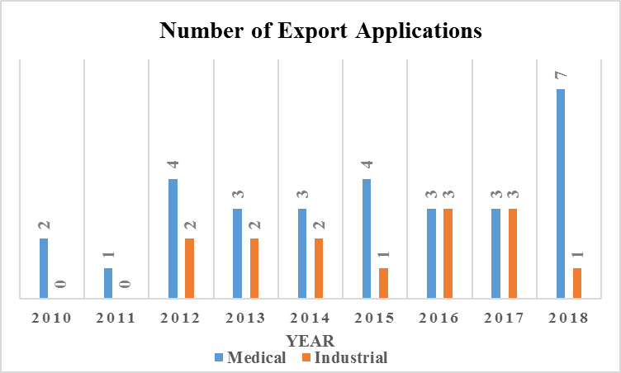
FIG. 1. Number of export applications for disused sources per year

Hazardous disused sources of category I and category II that were used before 2005, were repatriated to countries that are not necessarily the country of origin via five recovery missions with the full assistance of IAEA. Forty-two Co-60 sources used in research and medicine were exported consecutively starting from 2009. Figure 2 represents the number of repatriated sources per year.

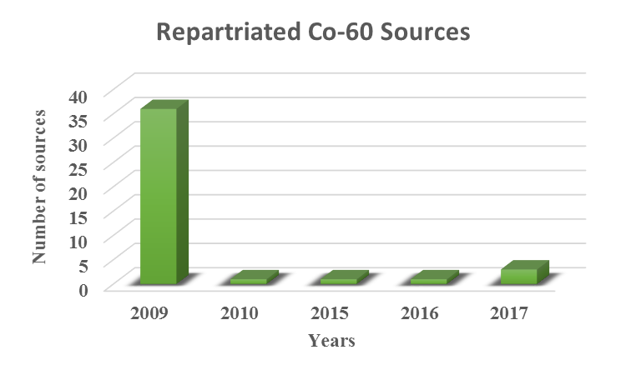

FIG. 2. Number of repatriated Co-60 sources per year through 5 IAEA missions

Management of orphan sources
A national context is applied based on a prevention strategy, detection and recovery of orphan sources. This is assured through the systematic monitoring of exported scrap metals and regular inspection at scrap yard is carried out, as well as through the Radiation Portal Monitors installed at air, land and sea borders. These are under the Lebanese Customs authority in cooperation with LAEC based on a MoU between both institutes. Numerous orphan sources and contaminated metal alloys were detected. After the preliminary analysis of LAEC inspectors, the material, subject of incident is transported to LAEC laboratories for further advanced analysis. The scientific report and all relevant documents are then transferred to the prosecutor to undergo necessary investigations. All detected orphan sources and contaminated materials are stored safely and securely at the temporary radioactive waste storage at the LAEC. Orphan sources and contaminated materials detected at scrap yard or at the borders are treated as radioactive waste. High security level is applied at the storage rooms and access is controlled by different physical protection measures where the authorized access is only restricted to specific designated staff.

Combatting illicit trafficking
Many incidents have been registered in the ITDB involving orphan sources. In Lebanon, these sources and their relevant incidents are one of the most important threats, especially with the presence of Illegal border crossings. The effectiveness of detection and the capabilities to combat illicit trafficking was strengthened through the installation of 12 Radiation Portal Monitors at the borders. Lebanon joined the ITDB system of IAEA in 2004, and more than 150 incidents were reported. Figure 3 represents the number of orphan sources and contaminated metal alloy species versus years.
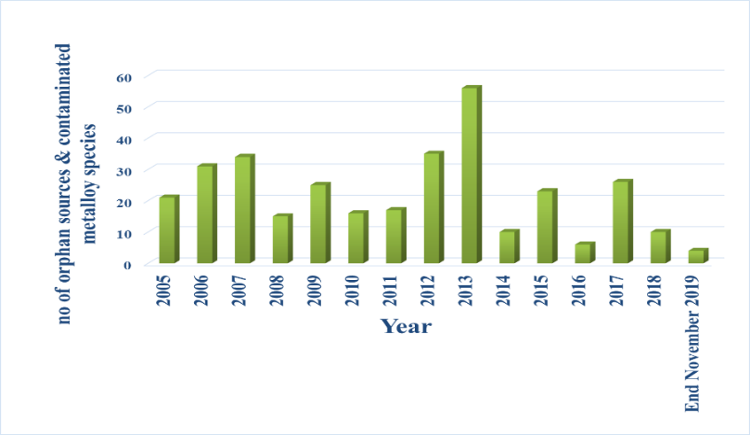

FIG. 3. Number of orphan sources and contaminated metal alloy species.

Preparedness and response to nuclear security events
A national unconventional (CBRN) disaster management plan was drafted in 2010 and reviewed. All relevant competent authorities were designated with their assigned roles in emergency cases. In 2016, a National Action Plan was prepared within the framework of the European Union CBRN Centres of Excellence Risk Mitigation initiative. This plan aimed to reduce CBRN risks and mitigate the consequences of relevant incident, and helped to improve legal texts and strengthen national capacities in the field. The plan includes different scenarios including the unauthorized use and smuggling of radiological or nuclear materials.

Inter-Agency Communication
In 2018, the President of the Council of Ministers established ‘The National Commission for implementing Lebanon’s international obligations related to CBRN materials and to WMD’. This advisory and inter-agency coordination commission is reporting to the President of the Council of Ministers and it works under his supervision. The commission includes representatives from: Lebanese Armed Forces, Interior Security Forces, General Security, State Security, Customs, Civil Defence, Lebanese Atomic Energy Commission, Ministries of Foreign Affairs, Justice, Public Health, Environment, Economy and Trade, Agriculture and Industry.
The main role of the Commission is to ensure cooperation and inter-agency coordination in the different CBRN facets including combatting CBRN terrorism and controlling the trade of dual use CBRN related items.
The main role of the commission is to:
- draft the role and responsibility of each relevant institution in different CBRN facets, to conduct gap analysis,
- propose national action plan to be endorsed by the Council of Ministers,
- represent the Lebanese Government with specialized UN Organizations,
- prepare reports related to ratified international legal instruments and relevant UNSCR,
- cooperate and coordinate CBRN activities with donors, experts, and national bodies,
- propose projects to potential donors for human resource development and capacity building in line with the national needs and priorities,
- Conduct drills covering different kind of incidents related to the use CBRN materials.

Conclusion
During the last decade, the Lebanese Atomic Energy Commission and all relevant national institutions cooperated closely with the nuclear security division at the IAEA for establishing reliable nuclear security regime in the country that covers different nuclear security aspects including legal and regulatory framework, detection, prevention and human resource development. The assistance of the IAEA and different donors, on bilateral and multilateral bases, in implementing coordinated nuclear security activities, related to the INSSP, permits to make several achievements in this field.
The involvement and dedication of the relevant national stakeholders were an asset for developing and sustaining a nuclear security regime in the country. The establishment of a high level national CBRN – WMD commission can show the dedication of the Government and its commitment not only for enhancing nuclear security at the national level but to join the global efforts for rendering the peaceful use of radioactive and nuclear materials more secure.

REFERENCES
[1] Lebanese Republic, Regulating the use of and protection against ionizing radiations, Official Gazette- No 48- 27/10/2005, Decree No 15512, Regulatory Decree of Decree-Law No 105/83, September 6, 1983.
[2] Objective and Essential Elements of a State’s Nuclear Security Regime, IAEA Nuclear Security Series No. 20, International
Atomic Energy Agency, IAEA, Vienna, Austria. 2013
[3] Nuclear Security Recommendations on Radioactive Material and Associated Facilities, IAEA Nuclear Security Series No.
14, International Atomic Energy Agency, IAEA, Vienna, Austria. 2011
[4] Nuclear security series No. 15. Recommendations. Nuclear security recommendations on nuclear and other radioactive
materials out of regulatory control. 2011. International Atomic Energy Agency, IAEA, Vienna, Austria
[5] Lebanese Republic – Prime Ministry, Decision of the establish National Advisory Commission to implement Lebanon's
International commitment’s and combat and counter WMDs, decision NB. 228/2018.
[6] Guidance on the management of disused radioactive sources, International Atomic Energy Agency, IAEA, Vienna, Austria.
2018

